Cher parents/guardians,

We have a couple celebrations during the school year in which students can bring in snacks. In order to make sure we don’t have too much/not enough/similar food, our class has been divided into houses (maisons). Each maison is responsible for ONE celebration throughout the present school year.
I will provide the plates and cups for each celebration. I have allotted each student a specific treat to avoid any similar foods. I have noticed that this system works well, I hope this works for you! As always, let me know if you have any questions or concerns

~Mme Collins

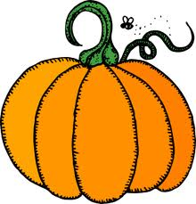

**Orange-le 31 Octobre Rouge-Décembre
Patrick-Baked good* Aiden M-Baked good
Bronwyn-Juice/drink Ian-Chips
Violet-Baked good Tessa-Baked good
Quinnlin-Chips Paul-Fruit/Veggies
Ayden W-Fruit/Veggies Ryan-Juice/drink
Emma-Chips Owen-Chips
Rose-Février Jaune-Juin
Jordyn-Baked good Gage-Chips
Alexander-Chips Oliver-Baked good
Jack-Baked good Avadawn-Baked good
Victoria-Fruit Roy-Juice/drink
Pippa-Juice/drink Stella-Fruit
Miranda-Chips Mme Collins-Chips
*Can be store bought (good for peanut free snacks) or baked at home.
**Merci groupe orange!
Classe 204

