Ellison Education Grant Reflection
Receiving an Ellison Education Grant gave me the opportunity to strengthen our third-grade human body unit in a way that had a real impact on student learning. With the funding from the grant, I was able to purchase hands-on materials that helped students better understand the systems and structures of the human body. This was especially important because about 80% of my students are English language learners. Many of them learn best when they can see, touch, and interact with what they are studying rather than relying only on reading or listening.
One of my goals for this grant was to help students develop a deeper understanding of the human body through hands-on learning. In the past, some of the concepts in this unit felt abstract for students. Learning about organs, body systems, and how everything works together can be challenging for third graders, especially for students who are still developing their English language skills. I wanted to provide opportunities for students to connect scientific vocabulary and concepts to concrete experiences.
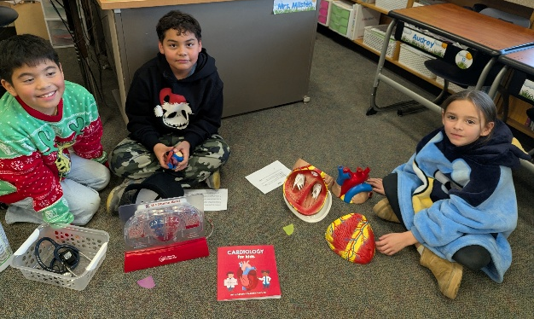
The materials purchased through the grant allowed students to interact with models and learning tools throughout the unit. Instead of only reading about the human body, students could explore it in a more meaningful way. They were able to examine models, discuss their observations with classmates, and make connections between different body systems. These experiences helped bring the content to life and made learning much more engaging.
The impact on student engagement was noticeable almost immediately. Students were excited to use the materials and looked forward to each day’s lesson. They asked thoughtful questions, participated in discussions, and were eager to share what they were learning. I also noticed that many students who are often quieter during whole-group instruction became more involved when they had hands-on materials to explore. The visual and interactive nature of the resources helped build confidence and supported participation from all learners.
Most importantly, I saw growth in students' understanding of the content. As the unit progressed, students became more comfortable using scientific vocabulary and explaining how different body systems function. They were able to make connections between concepts and demonstrate a stronger understanding than I had previously seen.
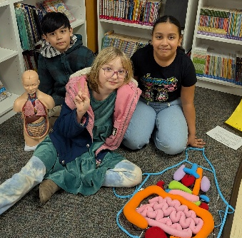
The highlight of the unit was our culminating activity. At the end of the unit, third-grade students shared their learning with other grade levels. We set up stations where students presented information about the human body and invited visitors to interact with the models and materials. This gave students an authentic opportunity to demonstrate what they had learned.
Watching my students teach others was incredibly rewarding. They took ownership of their learning and showed pride in what they knew. Explaining concepts to younger and older students required them to organize their thinking, use academic vocabulary, and answer questions. Many students who may have been nervous at first rose to the challenge and did an excellent job presenting.
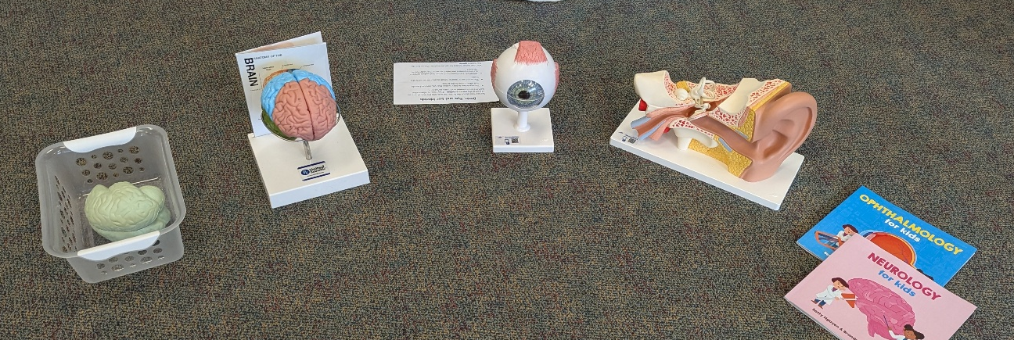
Overall, this project exceeded my expectations. The grant-funded materials increased student engagement, improved conceptual understanding, and made science more accessible for all learners, especially English language learners. The experience reinforced my belief that hands-on learning is one of the most effective ways to help students build understanding and confidence. I am grateful to the Ellison Foundation for making this project possible. The materials will continue to benefit future students, and the success of this unit will influence how I approach teaching about the human body in the years to come.

