Turning Pages Together: A Library That Speaks Every Language
Emerson Elementary Library --Ellison Foundation Reflection Paper
Maggie Doud
While our Emerson Elementary School library is a welcoming space, many students struggled in the past to find books that reflected their language, culture, interests, and experiences. Our school serves 706 students, including 269 multilingual learners, with more than 24 languages spoken at home. The nonfiction collection was also outdated in many areas and did not consistently engage students in meaningful reading and research experiences. Through the support of the Ellison Foundation Grant, we worked to address this issue by expanding our multilingual and nonfiction collections so that every child could see themselves represented in the library and develop a stronger connection to reading. One of the barriers to literacy equity was the lack of access to multilingual and culturally reflective books in our school library.
The goal of Turning Pages Together: A Library That Speaks Every Language was to increase equitable access to high-interest nonfiction and multilingual books while strengthening literacy engagement schoolwide. Grant funds were used to purchase and catalog 197 new books in English, Spanish, Russian, Ukrainian, Arabic, and Vietnamese. The collection focused on student interests, including biographies, animals, places, graphic nonfiction, and popular children’s series. Student voice played an important role throughout the process. We conducted student and teacher focus groups to better understand reading preferences, barriers to access, and areas where representation was lacking within the library collection.
As the new books arrived, we intentionally introduced them through library book talks, classroom partnerships, reading displays, and literacy celebrations. Teachers began incorporating multilingual texts and updated nonfiction into classroom instruction, allowing students to engage with materials that reflected both their identities and academic interests. Families were also invited into the process through Multicultural Night, where students proudly shared reports connected to their home languages and cultures. One of the most meaningful outcomes of this project was the visible increase in student excitement and confidence around reading. Students who previously struggled to connect with library materials eagerly searched for books written in their home language or featuring familiar cultural experiences. Multilingual learners demonstrated greater independence during book checkout and increased participation in reading conversations. Teachers shared that students were more engaged during literacy activities and that the new materials supported stronger classroom discussions and connections.
We quantified the effectiveness of this project through both quantitative and qualitative measures. Library circulation data showed a measurable increase in multilingual and nonfiction book checkouts during the 2025–2026 school year. Student surveys indicated that many students felt more represented in the library collection and more motivated to read. Teacher feedback highlighted increased student engagement, especially among multilingual learners who previously had limited access to culturally relevant texts. Informal student reflections and conversations also provided powerful evidence of impact. Students frequently expressed joy in finding books they could read with their families or books that reflected their personal experiences and identities. In addition to circulation growth, the project strengthened schoolwide conversations around literacy equity, representation, and access. The library became not only a place for reading, but also a space where students’ languages and cultures were celebrated and valued. This work reinforced the belief that literacy development is strongest when students feel seen, respected, and connected to the materials they read.
The Ellison Foundation Grant created meaningful and lasting changes within our library and school community. While our circulation statistics show strong growth, the true success of this project can be seen in the excitement, pride, and joy our students experience every day in the Emerson Library. Through the addition of multilingual and engaging nonfiction resources, the foundation helped expand literacy access, honor student identities, and strengthen a culture of belonging for all learners. The impact of this grant will continue well beyond this school year as students, families, and staff benefit from a library collection where every child can see themselves, their language, and their story reflected on our shelves. We would like to welcome you to Emerson Elementary to experience the book joy firsthand.

Fig 1 DeSTEMber book display
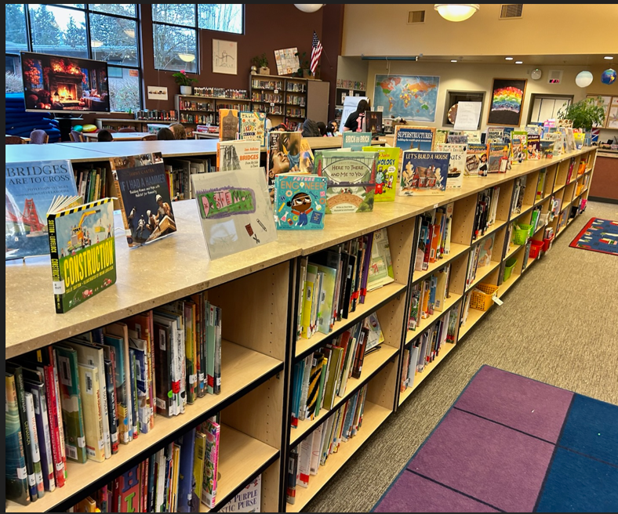
Fig. 2 New book display on the tables for students to choose
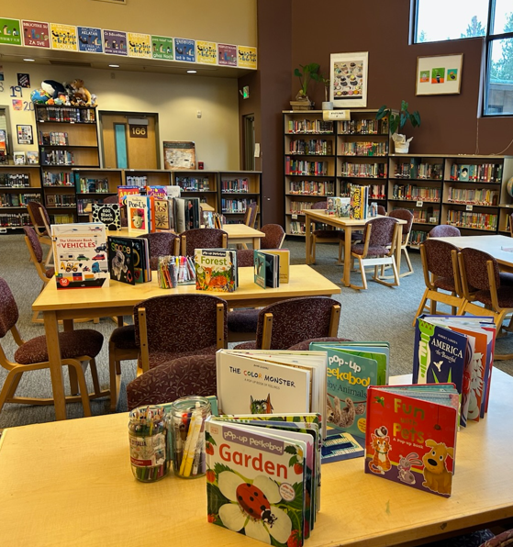
Fig.3 NEW books on the cart
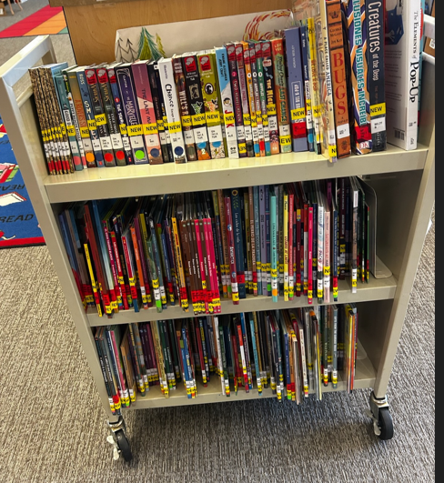

Fig. 4 Library Statistics

2024-25
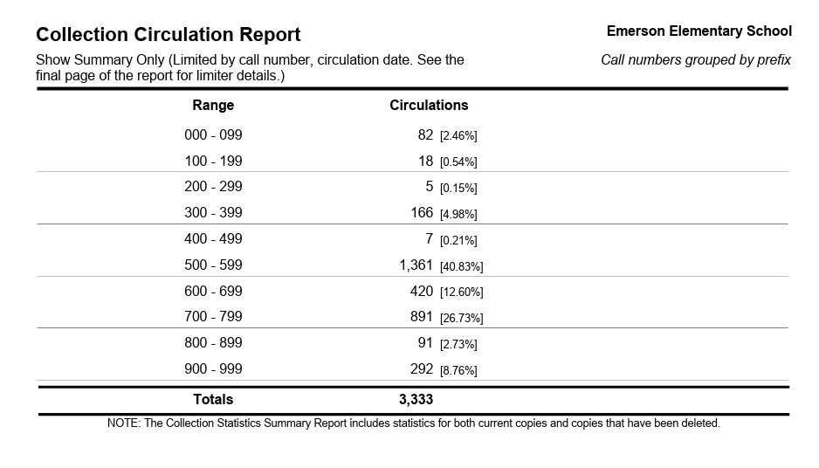
2025-26
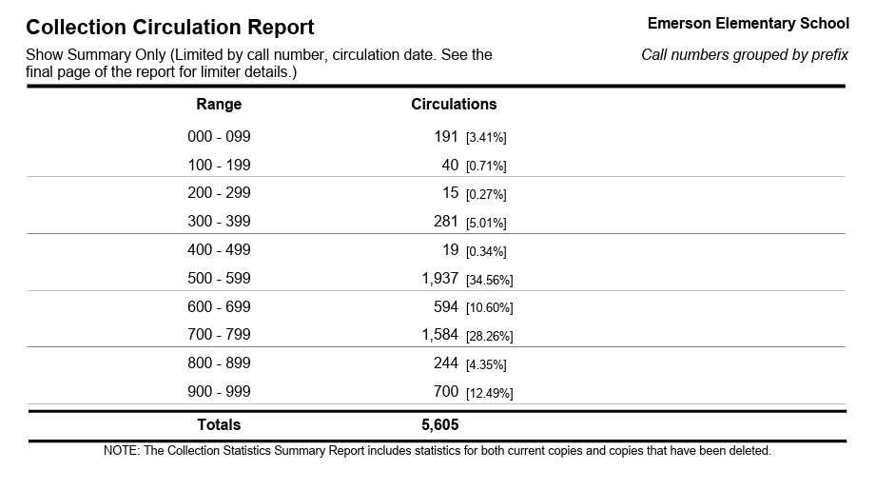

Our nonfiction circulation increased significantly from 2024–25 to 2025–26.

Overall Nonfiction Circulation Increase
- 2024–25 total nonfiction circulations: 3,333
- 2025–26 total nonfiction circulations: 5,605
Increase: 2,272 more nonfiction checkouts

Percentage Increase
The nonfiction collection circulation increased by approximately= 68.2% increase
This data shows a major increase in student engagement with nonfiction texts, especially science, sports/arts, and biography/history topics.

Biggest Growth Areas
- 500s (Science):
  - 1,361 → 1,937
  - 42.3% increase
- 700s (Arts/Sports):
  - 891 → 1,584
  - 77.8% increase
- 900s (History/Biography):
  - 292 → 700
  - 139.7% increase
- 300s (Social Sciences):
  - 166 → 281
  - 69.3% increase

