sEllison Grant Final Reflection
STEAM For Kinders
Jessica Strand and Jennifer Chancellor, Carter Lake Elementary School
Clover Park School District
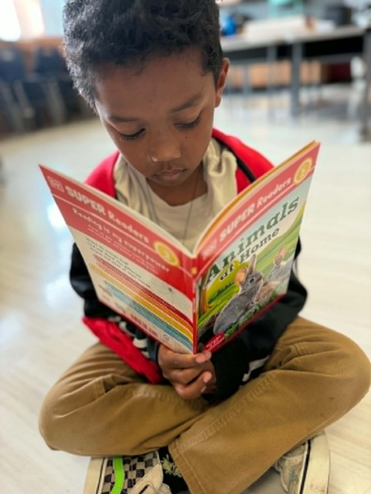
Why We Applied: As kindergarten teachers on Joint Base Lewis-McChord, we primarily teach the children of active-duty servicemembers in the Air Force and Army. We sought to purchase STEAM enrichment activities from Lakeshore Learning to provide hands-on learning experiences for about 90 kindergartners who enroll at any point between September and June, with the intent of closing gaps in concepts and skills, as they frequently move and face disruptions in their educational continuity. Additionally, we knew that STEAM education fosters collaboration, problem-solving and communication, as well as social-emotional learning. The reusable kits we purchased for our grade-level team of four teachers provided engagement opportunities in a variety of learning methods including auditory, visual, hands-on and kinesthetic while enhancing our science instruction. We also used our funds to incorporate the Phonics Sing Along program to strengthen the "A" in STEAM by supporting early literacy development through engaging, multisensory instruction.
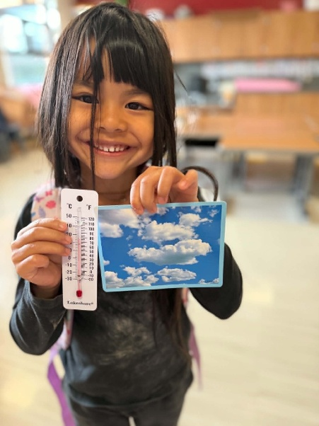
The Instructional Side: The Lakeshore Learning STEAM bins and accompanying nonfiction books, visual supports and supplemental lesson materials focused on the topics of Animals, Plants, Force and Motion and Weather. The STEAM bins and books provided students with meaningful hands-on exploration opportunities that reinforced key science concepts while increasing the use of academic vocabulary and promoting richer student academic discourse during discussions, investigations and collaborative learning activities. It was especially nice to have nonfiction books on those topics for students to explore in our classroom libraries, as our science curriculum is taught through an online program. Because the materials are durable and reusable, we were able to create science centers where students could revisit investigations, deepen their understanding and practice skills over time. Visual aids, posters, hands-on materials and varied instructional resources created equitable access to learning for students with diverse abilities and learning styles, ensuring all learners could meaningfully engage with the content. The additional lesson plans allowed teachers to enrich and extend the core curriculum while supporting inquiry-based learning.
We used the Phonics Sing Along materials during the foundational skills portion of reading to expose students to a new method of learning that enhanced their ability to decode words, improve letter-sound recognition and develop reading fluency skills. Our reading scores this year were the highest in the district for kindergarten, and we believe that having multiple means of engagement was directly correlational.
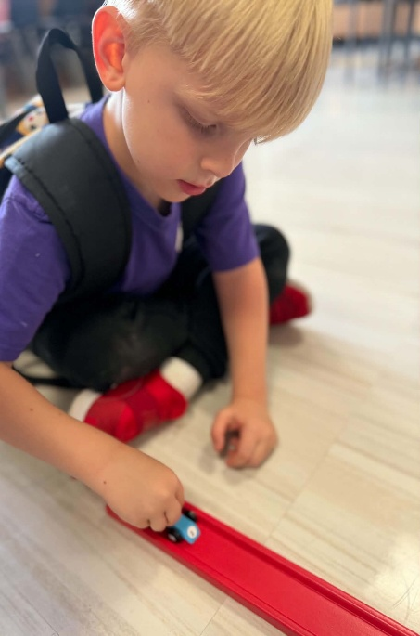
The Social-Emotional Side: Kindergarteners often begin the year with no prior schooling, and in some cases, have had limited exposure to collaborative play or learning. Therefore, learning to share and work with others is paramount from Day 1. We introduced the first STEAM kits to go with our Reading and Science units on Animals early on, as well as the Create-a-Chain Reaction STEM Kit and Building Brick STEM Challenge Kit, which gave them the chance to collaboratively build projects as a Science center, as well as an option for free play on Fun Friday, as students requested being able to use the kits outside of the Science block. It was interesting to see them working with the Building Bricks, as they have some similarities to LEGOs, and yet students quickly caught onto using them with fidelity, following the challenge cards to create a bridge for a car to cross, or a marble maze. It was especially cool that they were able to use that kit to gain knowledge about constructing usable creations, so when the district offered teachers enrolled in a computer science PD the use of KidSpark STEM Kits, which are more commonly used with grades 3-5, we decided to give them a try. Working with partners, they were able to duplicate and expand upon what they had done with the Lakeshore kits on a larger scale!
Students also worked with partners to use activities in the STEAM kits, and one especially popular activity was to work in small discussion groups to answer questions from the task cards, such as “What kind of animal would you want to be?” or “Why do you think a leopard has spots?” This promoted active speaking and listening, taking turns, and collaborative problem solving, while using science vocabulary. They also learned about healthy competition (and that you can’t win every time) by doing racer relays and building the sturdiest pencil holders our of plants using materials and task cards from the kits. Students also worked on sharing skills as we purchased two of each kit and shared them among four classes. Some weeks we had the kit and books, and on others, our friends next door did.
Overall, the grant-funded materials increased student engagement, strengthened scientific thinking and communication skills, and provided lasting resources that will benefit future kindergarten students for years to come. We are immensely grateful to the Ellison Foundation for the opportunity to purchase these materials.

