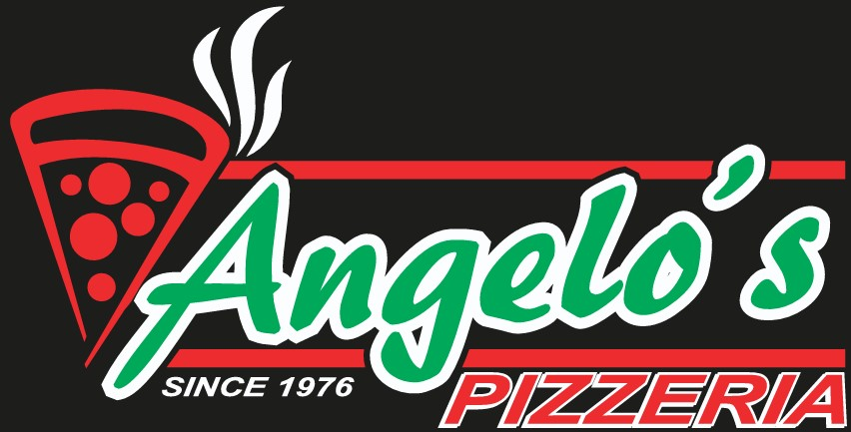
A Little Peace of Angelo’s Catering Menu
1410 Mt. Royal Blvd. • Glenshaw, PA 15116 • 412-443-0683

Salads (Feeds 10–15 people)
Dressing choices: Homemade Ranch, Homemade Italian, Blue Cheese, Parmesan Peppercorn
- Large Garden Salad – $40
Includes lettuce, tomatoes, cucumbers, carrots, onions, olives, green peppers, banana peppers, cheese, and two dressings
- Large Chicken Salad – $70
Includes garden salad, French fries, and grilled chicken (fried chicken can be substituted for an additional charge)
- Antipasto Salad – $70

Appetizers
- Garlic Knots (2 dozen) – $18.99
- Zucchini Planks (40ct) – $50
- Mozzarella Sticks (30ct) – $39.99
- French Fries (½ pan) – $24.99
- Charcuterie Cups – $12 each
- Charcuterie Boxes – $15 each
- Charcuterie Board – $149.99
- Fruit Platter (seasonal) – $40
- Vegetable Platter w/ Ranch – $40
- Bacon Cheese Fries w/ Ranch – $27
Main Course (½ pan, serves 10–15 unless noted)
- Macaroni & Cheese – $50
- Rigatoni – $50
- Lasagna Roll Ups – $55
- Chicken Parm (12ct) – $65
- Homemade Ricotta Gnocchi w/ Sausage Vodka Sauce – $75
- Meatballs (40ct) – $80
- Hoagie Tray – $55 (turkey, ham, Italian + condiments)
- Sandwich Box – $13.99 each (½ hoagie + chips)
- Chicken Fingers (18ct) – $35.99
**** Don’t see it on the menu? Ask us! ****
**Brunch menu also available upon request—ask for more details**

