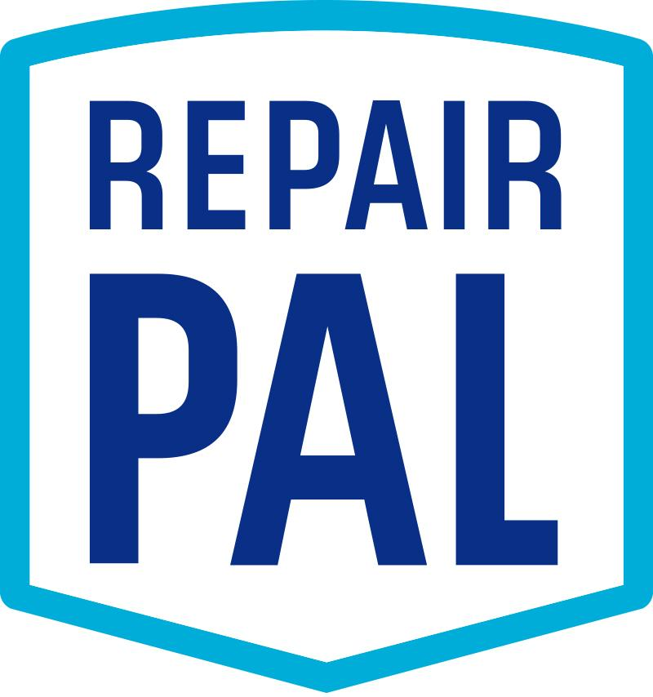
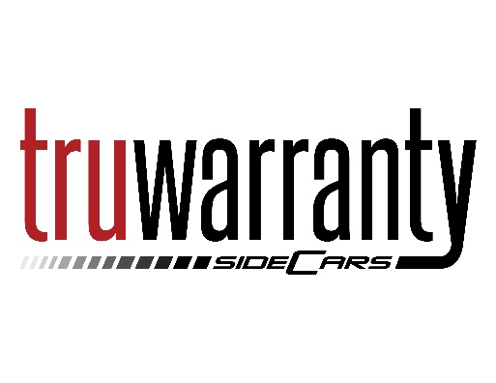
Extended Warranty Q&A – TruWarranty
To begin a claim, contact TruWarranty at 866.217.5309
or visit https://www.truwarranty.co/file-a-claim/ for authorization.
What is the process for getting repairs approved by TruWarranty?
Diagnose the vehicle based on the customer’s concern and determine the repairs/parts needed. Before performing any additional work other than the diagnosis, be sure to identify your shop as a RepairPal network shop.

Will I have to change my labor fees or parts markup rates?
- There are preferred labor rate guidelines when completing these repairs. All of TruWarranty’s contracts have a stated labor rate ranging from $100 to $150 per hour.
- TruWarranty uses ALLDATA exclusively as their labor guide for approvals and claims. In order to participate in this partnership, you’ll need to agree to their times, even if you use another labor guide such as Mitchell or Chilton. While some jobs may show a lower time allowed by ALLDATA, sometimes you will receive more time than your own guide quotes. Typically, these things even out in the long run. There are very rare instances with a large variance in labor times.
- Parts markup is not to exceed OEM MSRP.*
- How this works in practice: you source parts for your customers as usual. You can use an OEM part or an aftermarket part, as you deem appropriate. When you request approval for this repair, you use OEM list price for the parts you used which should create margin between your acquisition cost and the parts price you will be paid.
  - *Very rarely, OEM MSRP (List Price) is not available. In these cases, the part purchased from an outside vendor shall not exceed the cost paid plus 30%.

Can I charge shop supply fees?
None of the Providers pay shop supply fees. You will not be reimbursed for anything you don’t itemize fully on the invoice. You should not add these fees to the invoice.

What do I need to put on my invoice in order to get paid?
- Your invoice should include the date, customer name and address, vehicle year, make, and model, and VIN.
- It should include line item detail about the services and repairs performed.
- It should include parts numbers.
- It should show the breakdown between parts used and labor hours/ charges.
- It should include a total at the bottom.

How much back and forth can I expect once I have the car in the bay?
Once you call in the claim, TruWarranty will give an answer quickly on approval and confirm the customer’s deductible, and any coverage exclusions.

How will I be paid for completed repairs?
Follow the reimbursement instructions provided during the claim authorization phone call. TruWarranty uses VPAY credit card payments via email.

What do I have to do to get signed up with TruWarranty?
Once you opt in with RepairPal, we set you as a preferred vendor with them.

How do I handle non-covered repairs (such as regular maintenance, brakes, etc.)?
The customer would pay you directly. If combined with a claim, the customer would pay you directly for the non-covered services as well as the deductible, with the provider covering the rest.

Is my diagnosis covered?
While not all TruWarranty contracts cover diagnostics, if they do, TruWarranty will cover reasonable diagnostic charges as part of the repair order for covered repairs.

Is tax covered?
This will vary by policy and provider. There are 3 possibilities, and you should allow TruWarranty to guide you:
- Tax is covered and will be reimbursed to you.
- Tax is not covered and needs to be paid by the customer.
- Tax does not apply to the repair at all because:
  - The customer already paid tax on the policy
  - Local laws do not require tax payments on extended warranty work
  - The Provider has filed a tax exemption certificate

My customer needs a rental or loaner car. Is this covered?
Not all TruWarranty contracts cover rental cars. For contracts that do cover rentals, it is handled on a claim by claim basis based on the number of labor hours in the approved claim.

Very important: You must request rental car authorization at the same time you call in authorization for the repair, once the diagnosis is complete and you have an estimate for parts, labor and sublet work. You’ll need to know when you’ll have the repair completed, so it’s important to have accurate ETAs for any parts needed. The Providers will only authorize a rental vehicle for the time needed to receive the parts and complete the repairs in a timely manner. Once the rental has been authorized, the authorization number must be provided to the rental company.

What if my parts are delayed or the job takes longer than I thought? Can the rental car be extended?
TruWarranty contracts that cover rentals have either a maximum of 3 days or a max of 5 days, depending on the policy. They do not increase rental times fo failures from the parts vendors or other delays. This is why timely completion of the repair is critical to customer satisfaction. If issues arise beyond your control, and the customer is upset about the loss of rental car reimbursement, please contact RepairPal so that we may explore other solutions for the customer.

Will my customer need to pay for the rental car up front?
Your customer will be required to leave a deposit for the rental car, according to the rental car provider’s policies. The customer will also be required to pay any additional fees above the covered amount or for extra days.

What happens if my customer rents a car before the repair is approved by TruWarranty?
Your customer runs the risk that they’ll be responsible for the rental car fees, if the repair is not approved by the Provider.

If I am not able to charge a customer the full amount I’d normally charge for the repair (because the full cost isn’t approved by the ESP), can I charge that back to the customer?
No, you cannot charge the customer over and above the approved ESP claim amount, unless the customer opts to have extra work done (such as brake work, regular maintenance, etc.) that isn’t covered at all by their plan.

What do I have to do to prove which repairs are necessary?
- Provide vehicle mileage and VIN, as well as customer name and contact information.
- Provide detailed diagnostic notes and test results.
- Where appropriate, include pictures.

Sometimes, depending on repair severity and cost, you will also need to:
- Do a thorough “tear down” diagnosis.
- Work with an independent inspector who will review and help to determine whether a repair is necessary.
- Collect maintenance or other vehicle service records from the customer.

What if I disagree with TruWarranty?
Contact RepairPal immediately. We can help sort through the issue so that good customer service is provided.

Do NOT badmouth the partner or the policy coverage; the partner is referring customers to you so that you will provide amazing service and they will not continue to do so if you don’t represent them professionally in that process.

Anything else to be aware of?
Yes, here are some other guidelines:
- You may only test drive the customer’s vehicles to verify the concern and repairs.
- You may not use the customer’s vehicle for personal use.
- You may not use the customer’s vehicle for shuttle service.
- The customer’s vehicle cannot be driven home and/or taken to lunch.

