The Exhibitor Management Portal

Overview
Representatives who are assigned as Associated Registrants to an exhibitor profile by Event Organizers may edit and preview content appearing on their exhibitor page, as well as access lead reports through the Exhibitor Management Portal.

Accessing the Exhibitor Management Portal
The Exhibitor Management Portal (hereafter referred to as the ‘Portal’) is accessible through the desktop event website. *Please note that the Portal is currently only accessible through the browser public site, and not the apps.
If you are an Associated Registrant for the event, please follow the steps below:
- Enter the event while signed in as the registered account:
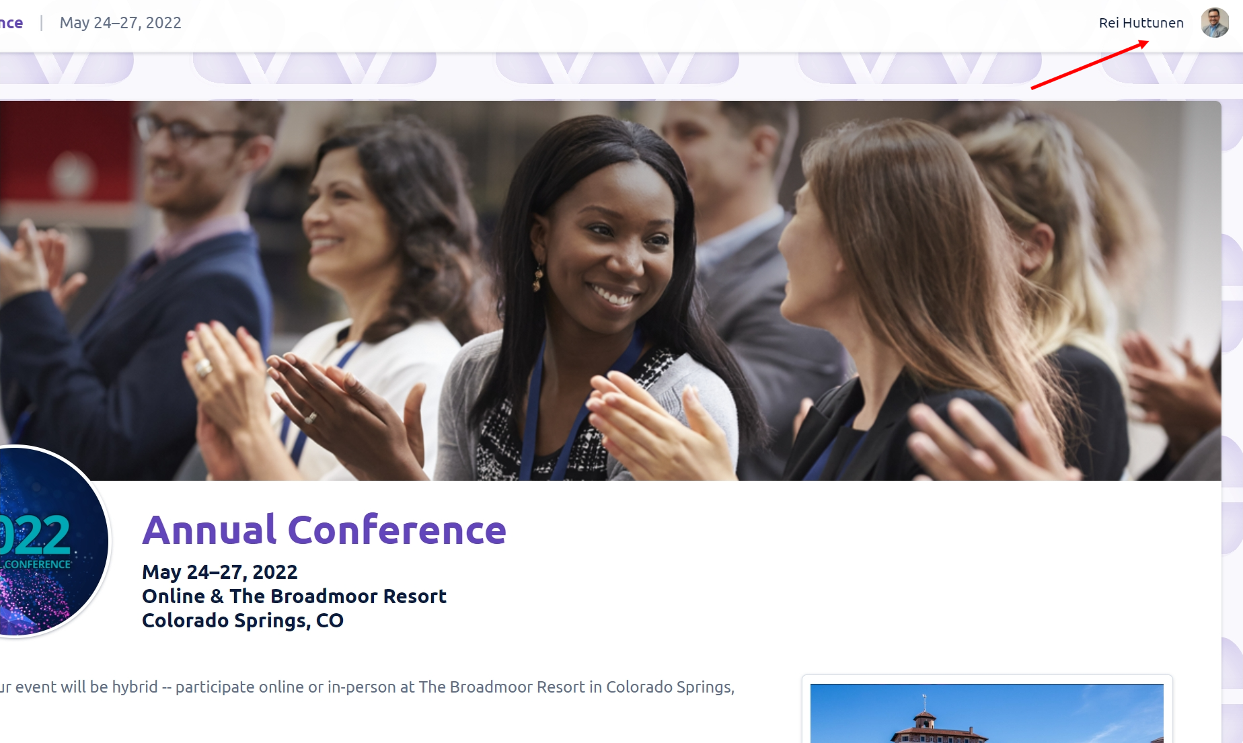
Please make sure that your name appears at the top right-hand corner when entering an event.
- Click the “Exhibitors” tab (Depending on the event, the item may have a different title, such as “Sponsors”) on the navigation panel on the left and select your organization from a list that appears on the right:
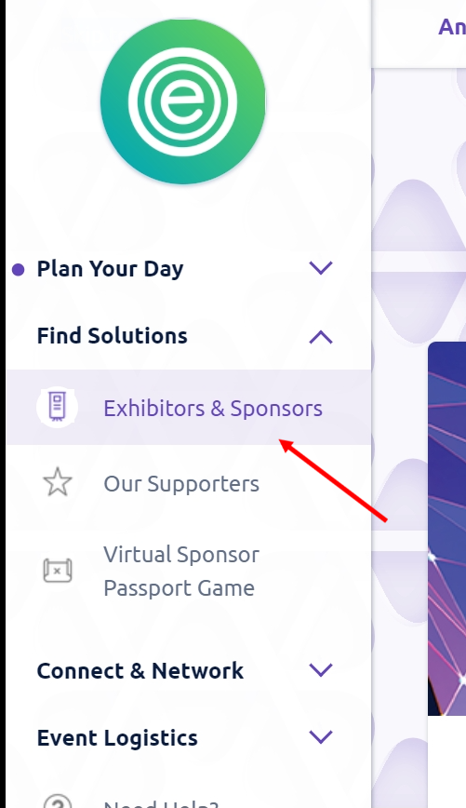
- An “Edit” button should appear on the details page of your organization, near the title. Click “Edit” to enter the Portal:
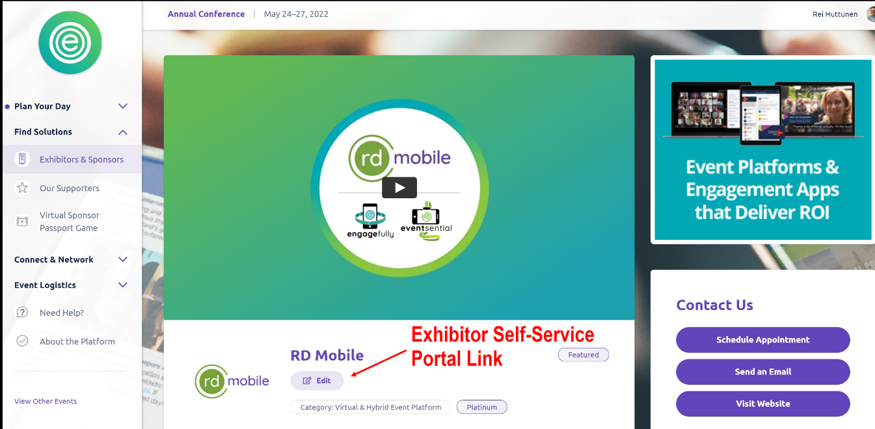
If the “Edit” button does not appear, please contact the event admin to check if you have been added as an Associated Registrant for the exhibitor account.
- We recommend that you save the Portal URL after entering as a shortcut (The URL should look like the following: https://events.rdmobile.com/ExhibitorPortal/Details/{exhibitor ID} )

The Exhibitor Management Portal Dashboard
You can view the current exhibitor page, make edits, preview and approve pending edits, and view exhibitor lead reports through the Portal Dashboard.
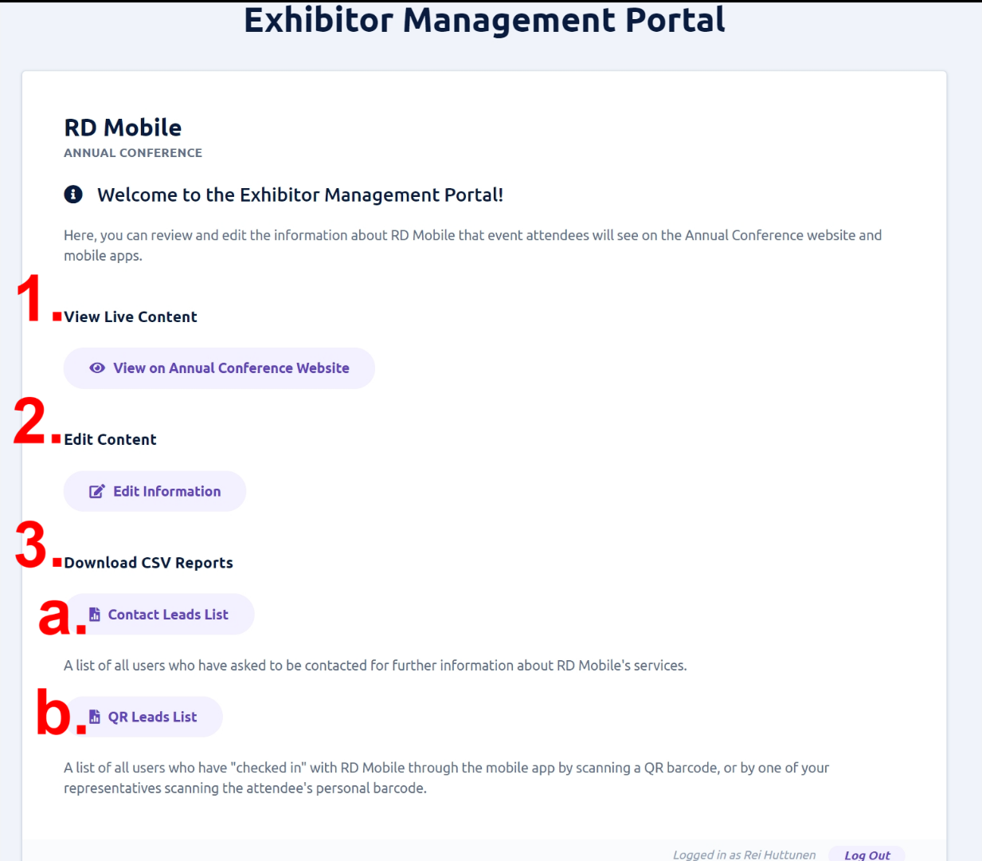
- View the current (live) exhibitor content on the event site
- *Edit Content section with no pending edits - Clicking on “Edit Information” will take you to the Portal Edit Form.
- View reports
  - Download contact leads report
    - A list of all users who have asked to be contacted through the exhibitor page can be downloaded.
  - Download QR leads report
    - A list of all users who have been recorded as leads either by: scanning the QR code printout with their phone, or by one of the Associated Registrants scanning the attendee’s QR code, can be downloaded.
    - Please note that the contactless QR scanning features are largely meant for in-person events, and may not be enabled for virtual meetings.
* 2.1. If there are pending edits that have not yet been published, the Edit Content will appear as:
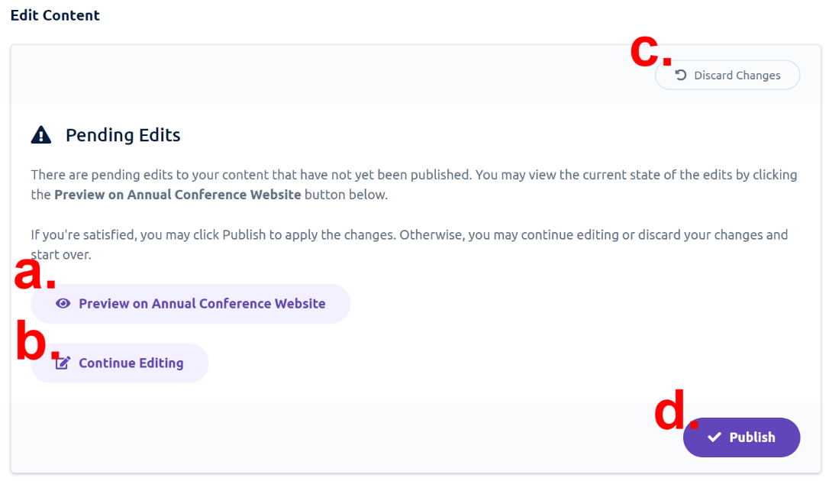
- Preview the edits on the event site
- Continue editing
- Discard the edits
- Publish the edits (update the live exhibitor record with the changes)

Some Tips for Editing Content
- Valid URLs must begin with or "https://" or "http://"
- The Description field/WYSIWYG editor only allows the input of certain very basic HTML styling tags (bold, italic, underline, etc). Attempting to input more complex HTML may cause a validation error.
- Clicking Save should save changes to the draft state. A successful save should return you to the dashboard.
  - If you are not navigated back to the dashboard after saving, there is likely an invalid input. An error message should appear to assist you in determining which field entry needs correcting.

