Welcome & Introductions - 10 Questions, 50 Responses
Opened: February 12, 2017, 12:00 AM
 |  | S1Q3  Greta (Moderator)  Ok, now your turn! Please take a moment to tell me a little about yourself and introduce yourself to me and the group! Please tell me:  - Where do you live (city, state)?  - What is something I should know about your daily life or situation?  - Tell me anything else I should know, like a job, hobbies, spouse/children, etc.  Share a few photos of you, or something that represents you (family photo, something that shares your hobbies, etc.). To add images in this posting click on the Insert Image Icon on our toolbar (the one next to the smiley face) and upload a picture. Once you've loaded it, click on the image one time, and it will insert into your response.  If you haven’t done so already, post your avatar – this helps me put a face to a name when I’m reading your posts. (Click on Update My Profile on the left of your screen to upload a pic!)

 |  |  | Eric M (Participant, February 13, 2017, 9:09 AM)  Hello!  My name is Eric McCabe. I live in Emporia, Kansas. I live with two roommates and my dog, Ralph. I spend a lot of time in parks, as I am a landscape designer by profession.  Here's a photo of some tattoos that I have

Greta (Moderator, March 2, 2017, 1:05 PM)
Wow! is that your dog? That's a great tattoo!

 |  |  | Eagle M (Participant, February 13, 2017, 2:23 PM)  Hello!  My name is Eagle (yes, that's my real name) and I'm born, raised, and live in Denver, CO. I love the outdoors, as you can imagine, and I'm always out hiking or backpacking whenever possible. I've been vegan for the last 6 years and love searching for new vegan restaurants whenever possible.  I'm unmarried, and currently work at a non-profit that teaches sports to children.

Gregg B (Participant, February 14, 2017, 8:12 AM)
Hello everyone, my name is Gregg and I'm a jazz drummer. I live in LA and work for Interscope as a studio musician. I've been doing this professionally for about 8 years. No children yet

Nikko L (Participant, February 15, 2017, 9:43 AM)
Hey my name is Nikko. I live in St. Louis, Missouri, but I also travel a lot thanks to work. I've been a professional disc golfer for about 10 years now and that's pretty much what I spend most of my time doing, although I also like to go rock climbing and kayaking. I live with a few friends from college and I have my dog Brutus, he's about 8 now so he's not as chipper as he used to be but we still like to hang out in the park. When I'm not playing disc golf, I like to just chill with my friends and check out any bands playing around town.

Manabu K (Participant, February 24, 2017, 9:10 AM)
Hello Greta!
My name is Manabu. I am a sports therapist living in Japan. I spend most of my time training and working with golfers. I live with my 5 year old daughter and our tiny cat. We live in Hitachiomiya, near the Rock Hill Golf Course.

Pasi K (Participant, February 24, 2017, 10:07 AM)
Hello,
My name is Pasi. I am originally from Finland but I now live in North Carolina. I'm a park ranger in the eastern end of the Smoky mountains. I live with my sister right now, but am curently working on closing on my own house in the mountains.

Paul M (Participant, March 3, 2017, 12:53 PM)
Hello Greta,
My name is Paul, and I am from Huntington Beach, California. I lvoe fishing, and do it whenever I can. I like to compete in fishing competitions up and down the West coast. I'd love to buy a boat of my own, but until I save up enough, I will continue to use my firend/competition partner's boat.

S1Q4
Greta (Moderator)
Thanks for introducing yourself! I’m looking forward to getting to know you better as this discussion continues. Let’s start off by talking about your current purchasing habits. You mentioned in the screening process that you had a debit or credit card!
Looking at the list below, please select all of the different types of payment methods that you currently use when making everyday purchases:
- Cash
- Check
- Debit card
- Credit card
- Debit card with a chip
- Credit card with a chip
- Pre-paid card
- Other, please specify in the comment box

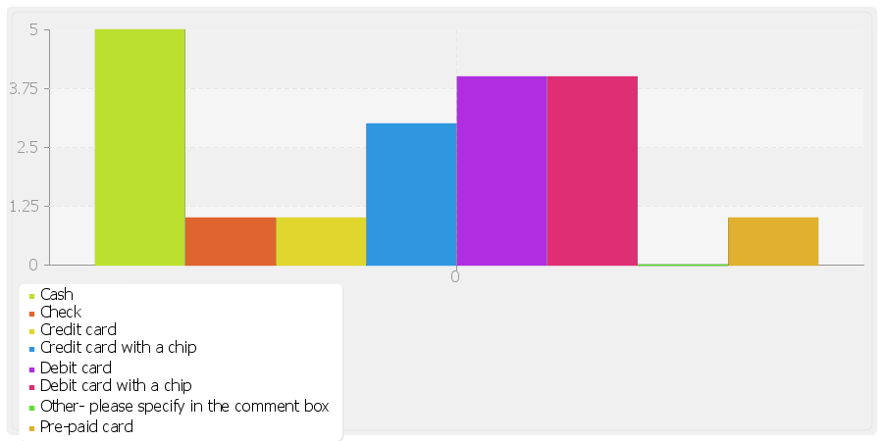

Eric M (Participant, February 13, 2017, 9:15 AM)
Answer:
Cash
Debit card
Debit card with a chip
Comments:

Eagle M (Participant, February 13, 2017, 2:23 PM)
Answer:
Cash
Debit card
Credit card
Comments:

Gregg B (Participant, February 14, 2017, 8:15 AM)
Answer:
Cash
Debit card
Credit card with a chip
Pre-paid card
Comments:

Nikko L (Participant, February 15, 2017, 9:44 AM)
Answer:
Cash
Debit card with a chip
Credit card with a chip
Comments:

Manabu K (Participant, February 24, 2017, 9:11 AM)
Answer:
Debit card with a chip
Comments:

Greta (Moderator, March 2, 2017, 1:07 PM)
Hello Manabu, is this really all you use? Just want to be sure, thanks.

Pasi K (Participant, February 24, 2017, 10:07 AM)
Answer:
Check
Debit card
Credit card with a chip
Comments:

Paul M (Participant, March 3, 2017, 12:54 PM)
Answer:
Cash
Debit card with a chip
Comments:

S1Q5
Greta (Moderator)
Again, looking at this same list, which one payment method would you say that you use the MOST?
- Cash
- Check
- Debit card
- Credit card
- Debit card with a chip
- Credit card with a chip
- Pre-paid card
- Other, please specify in the comment box

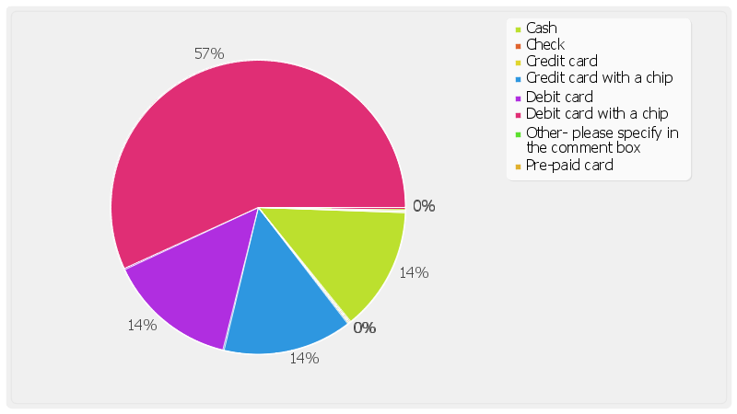

Eric M (Participant, February 13, 2017, 11:09 AM)
Answer | Assigned Groups
Debit card with a chip | Chip card users
Comments:

Eagle M (Participant, February 13, 2017, 2:23 PM)
Answer | Assigned Groups
Cash | Non chip users
Comments:

Gregg B (Participant, February 14, 2017, 8:15 AM)
Answer | Assigned Groups
Credit card with a chip | Chip card users
Comments:

Nikko L (Participant, February 15, 2017, 9:44 AM)
Answer | Assigned Groups
Debit card with a chip | Chip card users
Comments:

Manabu K (Participant, February 24, 2017, 9:11 AM)
Answer | Assigned Groups
Debit card with a chip | Chip card users
Comments:

Pasi K (Participant, February 24, 2017, 10:08 AM)
Answer | Assigned Groups
Debit card | Non chip users
Comments:

Paul M (Participant, March 3, 2017, 12:54 PM)
Answer | Assigned Groups
Debit card with a chip | Chip card users
Comments:

S1Q6
Greta (Moderator)
Do you ever pay with cash, or do you always use your debit or credit card? Why?

Eric M (Participant, February 13, 2017, 9:15 AM)
I use Cash, but not as often as card. On most days of the week, though, my wallet won't have any cash in it.

Eagle M (Participant, February 13, 2017, 2:25 PM)
I have a weird way of budgeting. I take out a set amount of cash each week, and pay for things form that pool thgroughtout the week. So with that in mind, I use cash for about 80% of my purchases.

Gregg B (Participant, February 14, 2017, 8:16 AM)
I use my credit card most of the time, but I do travel out of the country a lot, and when I do, I'moften in spots that don't accept card. But domestically, it's almost always credit card (got to get those points).

Nikko L (Participant, February 15, 2017, 9:45 AM)
Some places only take cash, so obviously I can't use a card there. I use cash with friends too, like to pay them back, but otherwise I always use a card because I just don't have that much cash lying around.

Manabu K (Participant, February 24, 2017, 9:11 AM)
I rarely pay with cash. It has been a long time since I've needed it. And most POI systems in Japan have been card friendly for a long time.

Pasi K (Participant, February 24, 2017, 10:08 AM)
I use cash probably once every other day. Not as often as my debit card.

Paul M (Participant, March 3, 2017, 12:55 PM)
I am primarily debit card, but I use cash about a third of the time. I odn't really have a set reason for choosing one over the other. It's just that if I have cash on me, I'll use it first.

S1Q7
Greta (Moderator)
What words and pictures would you use to describe how you feel about your current financial situation/needs? Why?
To add images in this posting click on the Insert Image Icon on our toolbar (the one next to the smiley face) and upload a picture. Once you've loaded it, click on the image one time, and it will insert into your response.

Eagle M (Participant, March 6, 2017, 1:42 PM)
I chose this picture because I always feel like I'm flush with cash, but it's always small denominations, so it feels more substantial than it is.

Eric M (Participant, March 6, 2017, 1:43 PM)
I'm not super well off, but I am comfortable. I'm not wanting for anything and I don't have any debt.

Gregg B (Participant, March 6, 2017, 1:45 PM)
I would say that I am pretty well off. Most of my money gets put back into my equipment, though, so I odn't have too much time to enjoy the money that I have made. As I said before, I travel for work quite often, and get lots of points on my credit card, but I have yet to take a vacation and enjoy them.

Manabu K (Participant, March 6, 2017, 1:46 PM)
It's a little tighter lately now that it's just me and my daughter, but we get by.

Greta (Moderator, March 6, 2017, 2:08 PM)
I'm sorry to hear that. How recent did this happen and have you adapted pretty well?

Nikko L (Participant, March 6, 2017, 2:05 PM)
I guess I'm pretty ok with my current situation. Everyone could always use more I guess but I don't really have many needs so that's good. I don't know what kind of photo would describe this but I found a generic house with a white picket fence (not my house btw) to kinda show the usual American dream. I have enough to be happy and to not have to worry about my finances so it's a comfortable situation for me.

Pasi K (Participant, March 6, 2017, 2:06 PM)
I do pretty well, since I keep my costs pretty low. My job as a park ranger supplies my car and covers gas, so I've been able to save up a lot of money in the last couple years,

Paul M (Participant, March 6, 2017, 2:07 PM)
This is all I can think of. It's my main financial goal of 2017.

S1Q8
Greta (Moderator)
Thinking about your knowledge level of debit/credit chip cards, how knowledgeable would you say you are? Please make a selection and in the comment box, tell me why!

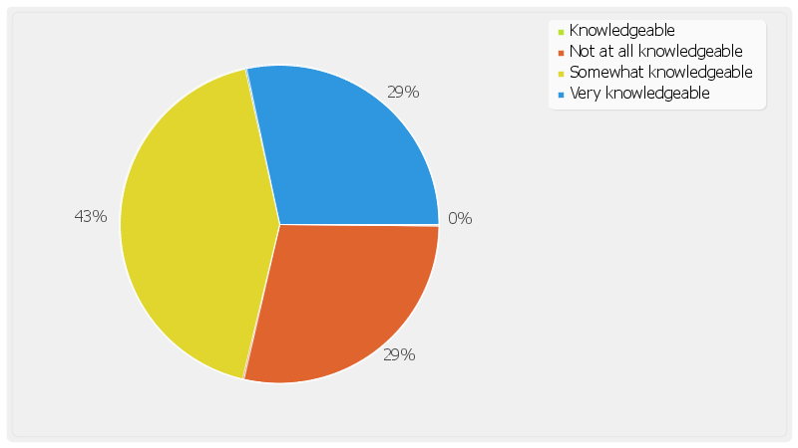

Eric M (Participant, February 13, 2017, 9:56 AM)
Answer | Assigned Groups
Somewhat knowledgeable | knowledgable about chips
Comments: From what I understand, they are supposed to help prevent identity theft, since you can program any number into any card, but it's harder to manufacture the chips.

Eagle M (Participant, February 13, 2017, 2:27 PM)
Answer:
Not at all knowledgeable
Comments: I know it exists but I've never had to use it.

Gregg B (Participant, February 14, 2017, 8:22 AM)
Answer | Assigned Groups
Very knowledgeable | knowledgable about chips
Comments: I had requested a new credit card from the issuer with the chip since I use it over seas so often. I felt that I needed the extra security.

Nikko L (Participant, February 15, 2017, 9:50 AM)
Answer | Assigned Groups
Somewhat knowledgeable | knowledgable about chips
Comments: I know the chip makes it safer and harder to steal my money but I have no idea why or when it's most useful. It's not like I ever had safety issues with my old card so I can't imagine what sort of credit card reader would be able to steal my money anyways.

Manabu K (Participant, February 24, 2017, 9:14 AM)
Answer | Assigned Groups
Very knowledgeable | knowledgable about chips
Comments: We've been using cards with chips in Japan for almost a decade now.

Pasi K (Participant, February 24, 2017, 10:12 AM)
Answer:
Not at all knowledgeable
Comments: I know my credit card has one, but I haven't used it yet.

Paul M (Participant, March 3, 2017, 12:58 PM)
Answer | Assigned Groups
Somewhat knowledgeable | knowledgable about chips
Comments: I know it is is supposed to be safer but I don't know any of the details. I know I have never seen a chip card reader in the Caribbean.

S1Q9
Greta (Moderator)
In your own words, without any research, why can you tell me that newer cards have chips?

Eric M (Participant, February 13, 2017, 10:11 AM)
From what I understand, the chips are harder to replicate and they are harder to read. This should reduce on card skimmers and being able to buy things with stolen identities/card numbers.

Gregg B (Participant, February 14, 2017, 8:26 AM)
Security. The chip makes it harder for people to use a stolen identity since the chip is harder to replicate than a magnetic strip.

Nikko L (Participant, February 15, 2017, 9:51 AM)
The chips are for security, to protect your money and identity when buying stuff.

Manabu K (Participant, February 24, 2017, 9:16 AM)
I beleive we switched over in Japan once the technology was introduced because it prevents identity theft and makes it harder for non-cashiers to read your card.

Paul M (Participant, March 3, 2017, 12:59 PM)
I imagine it somehow protects the banks. I guess identity theft or unauthorized purchases hurts the banks enough to warrant the cost of developing some kind of new technology to combat it.

Your Financial Situation - 9 Questions, 38 Responses
Opened: February 12, 2017, 12:02 AM
S2Q1
Greta (Moderator)
Tell me more about your debit or credit cards with a chip! Specifically, I want to know the following for each chipped card:
- How many do you have? Are they credit or debit cards?
- How often do you use it, specifically using the chip reader and why.
- Which financial institution provides the card?

Eric M (Participant, February 13, 2017, 10:14 AM)
I have two, one Debit Card and one Credit card. I use the debit card for about 75% of my transactions, cash for maybe 20%, and the credit card for 5%.
I only use cash on weekends, since that's when I need to go to the laundromat, so I need to make sure I have some cash handy for the weekend. The credit card only comes out for unexpected purchases, like car maintenance.
Finally, the debit card is from Bank of America and the Credit Card is from Bright Start Credit Union.

Gregg B (Participant, February 14, 2017, 8:35 AM)
I have one debit card, which I don't use too often, and one Chipped Credit Card. Debit card is from Bank of America, and the Credit Card is from Priceline.

Greta (Moderator, February 14, 2017, 12:52 PM)
Why Priceline? That's a weird one. Is it a Visa, Mastercard, or something else?

Nikko L (Participant, February 15, 2017, 9:54 AM)
I have one debit and one credit card with chips. I use mostly my debit card and I use the chip reader whenever the store makes me. Not everyone has a chip reader so I can't use it then but it seems like if they have a chip reader, I don't have the choice. I have to use the reader. So that's when I use it.
My debit card is from my Regions bank and my credit card is a Citi card.

Manabu K (Participant, February 24, 2017, 9:18 AM)
I have only one debit card with a chip. It is from Mizuho Bank, and i use it every day, multipe times per day. I typically buy groceries on my way home from work for dinner.
My daughter also has a debit chip card from Mizuho bank, and it's attached to an account that I fill for.

Paul M (Participant, March 3, 2017, 1:02 PM)
I only have one chipped card, my debit card. It's from Synovus bank.
I use it probably at elast once per day, and I got it from them about two years ago.

S2Q2
Greta (Moderator)
Does the chip make a difference in how your feel about the card?

Eric M (Participant, February 13, 2017, 10:58 AM)
Not all of my cards have chips, only the two that I use the most. It does a feel a little mroe secure, and I like that it feels like my card is more than just a piece of palstic with a little magnetic strip tacked on.

Gregg B (Participant, February 14, 2017, 8:36 AM)
It does, primarily because I use it in Europe so much, where chip cards are the norm. Until I had one, I felt backwards while travelling over there.

Nikko L (Participant, February 15, 2017, 9:55 AM)
Well the chip takes a little longer to read but it's not that bad. Some people have a hard time with the chip so it's annoying to watch other people fail and hold up the line in the store, so that's kinda annoying. It makes the card seem less convenient because you can't just swipe and go.

Manabu K (Participant, February 24, 2017, 9:18 AM)
As I said, it's the standard here, so I don't have anytihng to compare it to at the moment. When it was introduced, it did feel mroe high tech and it was exciting.

Paul M (Participant, March 3, 2017, 1:03 PM)
It was a nnoying at first, when I'd swipe and it wouldn't read it, but I've gotten used to looking for the chip reader first.

S2Q3
Greta (Moderator)
Did you request a debit/credit card with a chip in particular, or did your bank re-issue a new card with a chip?

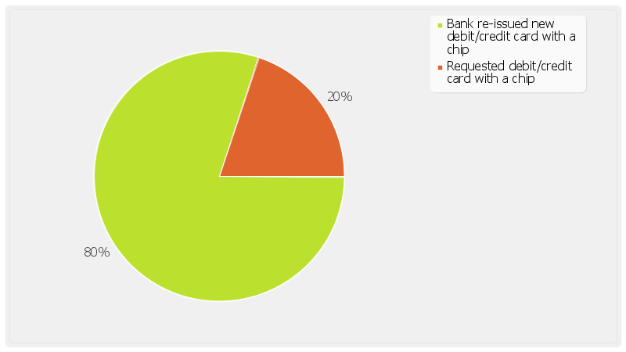

Eric M (Participant, February 13, 2017, 11:00 AM)
Answer | Assigned Groups
Bank re-issued new debit/credit card with a chip | Reissued with chip
Comments:

Eagle M (Participant, February 13, 2017, 2:47 PM)
Probably not until my existing cards expire

Gregg B (Participant, February 14, 2017, 8:36 AM)
Answer | Assigned Groups
Requested debit/credit card with a chip | requested with chip
Comments:

Nikko L (Participant, February 15, 2017, 9:56 AM)
Answer | Assigned Groups
Bank re-issued new debit/credit card with a chip | Reissued with chip
Comments: I actually tried to hold on to my old card as long as possible so that I didn't have to have a chip.

Manabu K (Participant, February 24, 2017, 9:19 AM)
Answer | Assigned Groups
Bank re-issued new debit/credit card with a chip | Reissued with chip
Comments:

Paul M (Participant, March 3, 2017, 1:03 PM)
Answer | Assigned Groups
Bank re-issued new debit/credit card with a chip | Reissued with chip
Comments:

S2Q4
Greta (Moderator)
When did you first get your debit or credit card with a chip, and why did you request a new card at that time?

Gregg B (Participant, February 14, 2017, 8:37 AM)
I had seen it used in Europe, and when I read about it online I saw that it was a security feature that was only just beginning to be accepted in the US. That's why I requested it from Priceline.

Nikko L (Participant, February 15, 2017, 9:57 AM)
My credit card got the chip first, I guess back in 2013? It was my first credit card and it came automatically with it. My bank card expired though so they had to send me a new one and it automatically came with a chip this time.

Manabu K (Participant, February 24, 2017, 9:19 AM)
It must have been about 10 years ago or so.

S2Q5
Greta (Moderator)
When did you first get your debit or credit card with a chip, and do you know why your bank re-issued you a new card?

Eric M (Participant, February 13, 2017, 11:01 AM)
I'd say it's been about a year since I got my first chip card from the bank (the debit card). The Credit card came in from the credit Union about a month ago. Both of these were reissued when the corresponding card expired.

Nikko L (Participant, February 15, 2017, 9:58 AM)
As I said before, my card expired so they just automatically sent a new card with a chip. No one asked if I wanted it or anything.

Manabu K (Participant, February 24, 2017, 9:21 AM)
It must have been about 10 years ago or so. I tihnk there may have been a national law involved, because it seems like all banks were doing it.

Paul M (Participant, March 3, 2017, 1:04 PM)
It came with a mailer that explained what it was and how to use it, but the one page explanation didn't explain why it had been changed. I just assumed it was something that would benefit the bank.

S2Q6
Greta (Moderator)
What was that process like? Was any information provided with your new card? Please explain.

Eric M (Participant, February 13, 2017, 11:02 AM)
Firs the first one, I don't recall if there was any documentation sent with it explaining the chip. If there was, I know I didin't read it. I had it for a while before I had to use the chip.

Nikko L (Participant, February 15, 2017, 9:59 AM)
I don't think there was any new info, and if there was I didn't read it. I just knew they'd send me a chip since that's what they all seem to do now so I didn't think too much about it.

Manabu K (Participant, February 24, 2017, 9:22 AM)
I think it came attached to a letter explaining that it was more secure, but it didn't go into any details. I believe I remember seeing a diagram on the page showing me how I can expect to insert the card into a chip reading slot.

Paul M (Participant, March 3, 2017, 1:05 PM)
It had a diagram of the chip, explained that it had my bank information stored in an encrypted memory chip, and it had a diagram of what a chip reader would look like.

S2Q7
Greta (Moderator)
For the last assignment for today (and through the end of the study), I want you to document and share with me what that transaction experience is like using your debit or credit card with a chip. Whether it’s at a retailer or online, please share with me anything you see that is interesting, maybe makes your purchase easier or more difficult, etc. You can take pictures, videos or post a quick note about your transaction. Other things that will help me would be to include any of the following:
- Where are you? Specifically, what retailer or website?
- Did you find anything interesting? Did the store offer the chip reader?
- Was it easy or difficult and why?
- Is there anything that could’ve made this transaction easier for you?
If you have a mobile device (Android or iOS), you may download our free QualBoard mobile app to more easily complete this assignment, and upload your photo(s) or responses directly from the mobile app! You may delete this app upon completion of the study!
- For iPhone, iPad, or iTouch- the QualMobile iTunes download link:http://itunes.apple.com/us/app/qbmobile-2.0/id955864251?mt=8
- For Android technology phones -the QualMobile Google Play for Android technology download link:http://play.google.com/store/apps/details?id=qualboard.mobile.droid&hl=en
Whenever you have a purchase transaction using your debit or credit card, simply reply to this post at anytime!
To insert images from a mobile device, click the camera icon at the bottom of your screen.

Eric M (Participant, February 13, 2017, 11:31 AM)
I went to the grocery store to pick up a bottle of wine for a friend that is coming over tonight. I had to pay for it with the chip card.
I had tried to swipe it at first, out of habit, but the transaction machine told me that I needed to use the card reader. It worked fine, but I hate the noise that it makes when it tells you to remove the card. It sounds like a kind of "error" noise isntead of like a timer's "ding" noise.

Gregg B (Participant, February 14, 2017, 8:44 AM)
I am in Antwerp today, and I came to this bar for a beer and a little dessert. They had table service, so I just gave them my card. Not sure if they swiped it or used the chip, but in Belgium it is most likely the chip scanner.

Nikko L (Participant, February 15, 2017, 10:02 AM)
Well I mostly only buy online stuff through Amazon, so they have all of my card info online already and they never ask about my chip or anything. I don't think I've ever heard of an online website doing something different for cards with a chip, it seems like there's not anything they could do differently since there's not like an ID code on the chip or anything so what could they do? But I bought a movie last night on Amazon online and it didn't ask me for any info so that was nice.

Nikko L (Participant, February 15, 2017, 10:03 AM)
Oh, here's a pic of the movie

Nikko L (Participant, February 15, 2017, 11:15 AM)
I bought a card game at Target and used my chip reader. I went through the self-check out line since I only had one item and it went smoothly. The machine gave me instructions on how to use my chip as usual, and nothing went wrong. It was a quick transaction.

Manabu K (Participant, February 24, 2017, 9:26 AM)
This is the grocery store I go to everyday after work. I couldn't get a great shot of the actual Point of Sale machine.

Paul M (Participant, March 3, 2017, 1:13 PM)
I took this photo at the grocery store. I was buying some wine.

S2Q8
Greta (Moderator)
For the last assignment for today (and through the end of the study), I want you to document and share with me what that transaction experience is like using your debit or credit card. Whether it’s at a retailer or online, please share with me anything you see that is interesting, maybe makes your purchase easier or more difficult, etc. You can take pictures, videos or post a quick note about your transaction. Other things that will help me would be to include any of the following:
- Where are you? Specifically, what retailer or website?
- Did you find anything interesting? Did the store offer a chip reader?
- Was it easy or difficult and why?
- Is there anything that could’ve made this transaction easier for you?
If you have a mobile device (Android or iOS), you may download our free QualBoard mobile app to more easily complete this assignment, and upload your photo(s) or responses directly from the mobile app! You may delete this app upon completion of the study!
- For iPhone, iPad, or iTouch- the QualMobile iTunes download link:http://itunes.apple.com/us/app/qbmobile-2.0/id955864251?mt=8
- For Android technology phones -the QualMobile Google Play for Android technology download link:http://play.google.com/store/apps/details?id=qualboard.mobile.droid&hl=en
Whenever you have a purchase transaction using your debit or credit card, simply reply to this post at anytime!
To insert images from a mobile device, click the camera icon at the bottom of your screen.

Eagle M (Participant, February 13, 2017, 2:55 PM)
I got car wash today. When I payed, it was via an automatic unmaned payment machine. I had to swipe mmy card through it because I hate sticking cash into a vending machine.
I didn't see any kind of chip card reader slot.

Pasi K (Participant, February 24, 2017, 10:14 AM)
I went to the grocery store today and was paying with my debit card, which doesn't have a chip. My Credit card has one, but it looks like I wouldn't have been able to use it anyhow.

Greta (Moderator, February 24, 2017, 11:33 AM)
Hi Pasi, Have you seen these inactive chip readers before, or was this the first time?

Your Purchasing Experiences - 12 Questions, 45 Responses
Opened: February 13, 2017, 12:00 AM
S3Q2
Greta (Moderator)
How often do you have the opportunity to actually use your debit or credit card(s) with a chip?

Eric M (Participant, February 13, 2017, 11:33 AM)
Today I did three transactions: gas station (swipe), breakfast (chip), and coffee (swipe).
In general, I feel like it's about 50/50 at this point.
I also get the sense that smalller businesses are using mroe chip card readers, as they often have Square or a similar POS system that is more streamlined and newer.

Gregg B (Participant, February 14, 2017, 8:47 AM)
My Chipped Credit Card is my main payment method, so at least twice a day.

Nikko L (Participant, February 15, 2017, 10:07 AM)
I guess not as often as I realized. Gas station pumps don't read the chip or anything, and restaurants don't seem to use it, although I guess I can't really see that if they take my card to the back so I don't really know.

Manabu K (Participant, February 24, 2017, 9:27 AM)
Multiple times throughout the day.

Paul M (Participant, March 3, 2017, 1:14 PM)
At least once a day. I eat out a lot, and the small businesses in my area have Square at the counter and the Square machines have a chip reader.
If I leave my card in the little leather book at a restaurant with table service, I have no idea how they scan it.

S3Q3
Greta (Moderator)
Where do you use your debit or credit card(s) with a chip the most? Are there retailers or circumstances where you use those over another payment method? If so, please explain why?

Eric M (Participant, February 13, 2017, 11:34 AM)
I think it's with local businesses or restaurants where you order at the counter. As I said before, any place that I expect to be using Square or something similar will likely have a chip card reader.
some of the larger chains and businesses (like grocery stores and gas stations) seem a little slower to migrate.

Gregg B (Participant, February 14, 2017, 8:49 AM)
Typically cafes. I don't buy groceries too often and don't often cook for myself. I book many travel things through my cell phone's apps, and my card is stored on those accounts, so while I'm using the chip card's number, I'm not actually phyisically using that card.

Nikko L (Participant, February 15, 2017, 10:08 AM)
I have to use it at Kroger when I buy groceries, so I guess that's the most. It's not that I choose to use the chip over another method, I just don't have a choice. If your card has a chip, you have to use the chip reader, and all of my cards have a chip.

Manabu K (Participant, February 24, 2017, 9:28 AM)
I use it most often at the grocery store. I don't go out too often. I work at a golf course, so I play gof there on my free time, where I don't have to pay any green fees.

Paul M (Participant, March 3, 2017, 1:16 PM)
I would say groceries and casual restaurants

S3Q4
Greta (Moderator)
Do you encounter places with chip readers that "do not use the chip". If so, tell me about that experience, what type of business it was, etc.

Eric M (Participant, February 13, 2017, 11:35 AM)
Yes, there's a chain of gas statiosn called Wawa here in town, and all of their card readers have a little isnert in the chipreader slot that says Chip Reader Not Active or sometihng to that effect.

Gregg B (Participant, February 14, 2017, 9:43 AM)
No, I have not seen this yet. Every place that has had a chip reader has been used by me.

Nikko L (Participant, February 15, 2017, 10:11 AM)
Some places look like they have a chip reader but they'll put a sign that says "out of order" or "do not use." I hadn't thought about it before but now that I'm thinking about it I'm worried they're trying to get around the safety features or something which I don't like. I've seen it at gas stations and at like clothing shops. I think I remember Dicks sporting goods having an "out of order" sign.

Manabu K (Participant, February 24, 2017, 9:28 AM)
I haven't found one of those in years. I don't know why you would have the machine and not use it.

Paul M (Participant, March 3, 2017, 1:27 PM)
I spent last March in the Carribbean. a few places had a chip reader but I didin't come across a single business that used it. The ones that had it didn't seem to know what it was. I did not stay in super fancy hotels, but the run of the mill hotels that I did stay in did not use a chip reader either.

S3Q5
Greta (Moderator)
What has your experience(s) been like at retail stores, specifically, in using your debit or credit card(s) with a chip? It is clear where they are accepted and where they are not? Please be as detailed as possible!

Eric M (Participant, February 13, 2017, 11:37 AM)
I still typically swipe first out of habit, althought I should probably use the chip reader first, if it's available. I feel like it's mroe likely that my card will work via the chip reader than via the swipe.
Usually it's not clear which one to go with, except in the cases as listed above when they have a little insert in the chip reader slot.

Gregg B (Participant, February 14, 2017, 10:43 AM)
I feel like the cashier typically directs you to the correct way to submit the card. But I always search for the chip reader first, and then I swipe if i cna't find one.

Nikko L (Participant, February 15, 2017, 10:15 AM)
You don't really know if they use a chip or not until you get up to the front desk but it's pretty obvious once you get there. The machine will prompt you to insert or swipe but if you try to swipe when you have a chip it'll beep loudly and make you insert the chip. Or it will have the "no chip" sign added to the machine if it could read a chip but the store doesn't want to or can't do it. I've never seen a store that uses the chip but will NOT let you use a card that does NOT have a chip. There are no "chip only" places that I've seen. When they do use the chip though, the clerk will usually mention it first and you can see them directing other people how to use the chip, like if they're an older person and are having a hard time with it the clerk has to walk them through the steps and tell them to leave the chip inserted and wait a long time and stuff.

Manabu K (Participant, February 24, 2017, 9:29 AM)
It's always accepted, so the only time I wouldn't use the chip reader is if it is broken. Some cards no longer have magnetic strips. Mine does, but I've seen some that don't

Paul M (Participant, March 3, 2017, 1:28 PM)
I always stick the card in the chip reade by default, if available. It seems to be the preferred method these days. If it's ever not working, I've seen a handwritten note or message psoted on the machine.

S3Q6
Greta (Moderator)
Thinking about your debit/credit card(s) with a chip, do you feel it affects you personally? Upload a picture that describes how it makes you feel?

Eric M (Participant, February 13, 2017, 11:39 AM)
It doesn't affect me negatively. It takes no more than 15 seconds out of my day, and I have yet to be in a situation where the reader cannot read my chip, while the magnetic strip on a card can often have trouble scanning.

Gregg B (Participant, February 14, 2017, 10:45 AM)
I feel like it keeps me more secure both domestically and abroad, which I need since I use my card as my main form of payment

Nikko L (Participant, February 15, 2017, 10:17 AM)
I actually think this emoji works best for how I feel, it's not really a big deal to me but it's a bit inconvenient to have to wait for the card and it's even worse to have to wait for someone in the front of the line who takes their card out too early and the machine starts beeping and they have to start the whole process over again. The clerks all look like they have to deal with this way too often and it seems like a hassel.

Manabu K (Participant, February 24, 2017, 9:31 AM)
I chose this picture because it represents how the chip reader is available everywhere.

S3Q7
Greta (Moderator)
Do you feel that debit/credit cards with a chip are safer than a regular debit/credit card? Why or why not?

Eric M (Participant, February 13, 2017, 11:40 AM)
I feel it is safer since it takes longer to read. As if that extra few seconds is it decoding something and authorizing some kind of data.

Gregg B (Participant, February 14, 2017, 10:45 AM)
Definitely, I don't need to worry about people using card skimmers

Nikko L (Participant, February 15, 2017, 10:18 AM)
I just know that people tell me it's more safe, I have no idea how they work so no I don't really FEEL safer, especially since I never had a problem with security before the chip.

Manabu K (Participant, February 24, 2017, 9:33 AM)
It must be safer, why else would the bank issue it? It seems like the card would be a bit more expensive to produce when there is a chip and a magnetic strip involved.

S3Q8
Greta (Moderator)
Are there benefits in having a debit or credit card with a chip? If so, what are those and why are they important to you?

Eric M (Participant, February 13, 2017, 11:42 AM)
As I said above, the machines have yet to have trouble reading the chip. If it ever did, it would cause a problem in that I wouldn't be able to swipe as a back up. But I guess the cashier may still be able to manually type in the numbers.

Gregg B (Participant, February 14, 2017, 10:45 AM)
As stated before, security.

Nikko L (Participant, February 15, 2017, 10:18 AM)
Not that I can see

Manabu K (Participant, February 24, 2017, 9:33 AM)
Perceived Security goes a long way.

S3Q9
Greta (Moderator)
What do you like the most about having a debit/credit card with a chip?

Eric M (Participant, February 13, 2017, 11:43 AM)
It's dumb, but I feel like I'm in the future when I slip in the card and it reads it. Like I'm paying for my intergalactic train ticket with the credits I earned mining on the outer rim.

Gregg B (Participant, February 14, 2017, 10:46 AM)
Security is the #1 benefit

Nikko L (Participant, February 15, 2017, 10:19 AM)
I wouldn't say I "like" anything about it. Not that I dislike it! I just don't really notice it as a safety feature.

Manabu K (Participant, February 24, 2017, 9:34 AM)
It feels very high tech and futuristic to stick the card into the slot and pull it out when it's done.

S3Q10
Greta (Moderator)
What do you like the least about having a debit/credit card with a chip?

Eric M (Participant, February 13, 2017, 11:44 AM)
It does take a bt longer than swiping, and you don't get to immediately put ti back in your wallet. So when it's taking logner to read, I feel lazy if I'm sitting there with my wallet open while the cashier is bagging my items. Typically, I would have put my wallet away and started helping her, but now I have to wait for the card to be read.

Gregg B (Participant, February 14, 2017, 10:46 AM)
It take s abit longer than the swiping, but it doesn't bother me.

Greta (Moderator, February 14, 2017, 12:51 PM)
Have there been any "frustrating" situations involving the chip card yet?

Nikko L (Participant, February 15, 2017, 10:21 AM)
I mostly just don't like when people ahead of me don't know how to use it. It can really hold the line up and it seems to make the clerk a little cranky sometimes.

Manabu K (Participant, February 24, 2017, 9:35 AM)
Swiping the reader was faster. And soemtimes I put the wrong end in. Maybe they can put the chip on both sides of the card so it is always oriented correctly.

S3Q11
Greta (Moderator)
Thinking about your retail experiences, was the retail staff knowledgeable or able to provide you with any information about the chip card readers?

Eric M (Participant, February 13, 2017, 11:45 AM)
At first it was a little iffy, but I haven't had any confused cashiers in at least 3 months.

Gregg B (Participant, February 14, 2017, 10:47 AM)
Yes, they have been knowedgable, especially in Europe. Not at first in the US, but now it's fine.

Nikko L (Participant, February 15, 2017, 10:22 AM)
They can tell me how to use it but they've never mentioned info ABOUT the chip. They don't talk about the security or anything.

Manabu K (Participant, February 24, 2017, 9:36 AM)
Definitely- when the transition came, they all knew what we were supposed to do and were able to crrectly direct me through it.

Your Purchasing Experiences & Needs - 11 Questions, 19 Responses
Opened: February 13, 2017, 12:01 AM
S4Q2
Greta (Moderator)
Tell me more about your debit or credit cards! Specifically, I want to know the following for each card:
- How many do you have? Credit or debit?
- How often do you use it and why?
- Which financial institution provides the card?

Eagle M (Participant, February 13, 2017, 2:58 PM)
I only have one debit card and one credit card.
The Credit card is used maybe once every two months, and the Debit card maybe only once or twice a week.
Both came from my local Credit Union here in Colorado.

Pasi K (Participant, February 24, 2017, 10:27 AM)
I have a debit card from Bank of America (no chip, I use this the most) and I have a Visa credit card with a chip which I rarely use.

S4Q3
Greta (Moderator)
Where do you use your debit or credit card(s)? Are there retailers or circumstances where you use those over another payment method? If so, please explain why?

Eagle M (Participant, February 13, 2017, 2:59 PM)
If it's somthing that I don't have enough cash for, then I would use my debit card (but I almost always have cash). The credit card is for emergencies or booking hotels- which I would then pay off immediately.

Pasi K (Participant, February 24, 2017, 10:28 AM)
I use the debit card all the time, Credit card is only if I screwed up in my budgeting or for unexpected expenses. Luckily nothing like this has happened in a while.

S4Q4
Greta (Moderator)
Thinking about your debit or credit card(s), what is most important to you, in terms of your purchase transactions and why is that important?

Eagle M (Participant, February 13, 2017, 3:02 PM)
Security is pretty important to me. I've had money taken out of my account twice. The bank replaced it, but that's part of the reason why I odn't like tossing my card around all over town.

Pasi K (Participant, February 24, 2017, 10:29 AM)
I guess the most important thing is that my identity isn't stolen when I use my card. I try to keep an eye out for card skimmers but they aren't easy to spot. And I'm always worried that I'll leave my card somewhere (such as when you open a tab at a bar) and someone will use it while I'm gone.

S4Q5
Greta (Moderator)
Have you ever heard of debit or credit cards with a chip? These are also known as “smart cards” or EMV cards. (There’s no right or wrong answer!)

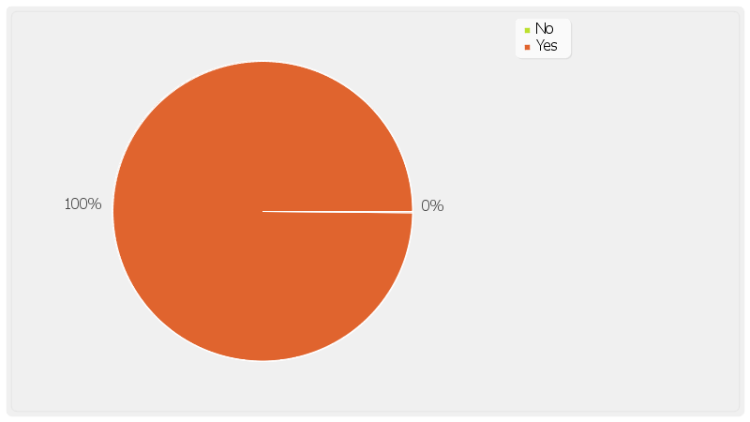

Eagle M (Participant, February 13, 2017, 3:07 PM)
Answer | Assigned Groups
Yes | familiar with chip cards
Comments:

Pasi K (Participant, February 24, 2017, 10:31 AM)
Answer | Assigned Groups
Yes | familiar with chip cards
Comments: Yes, I have a chip in my credit card but I haven't used it yet. I just got it recently.

S4Q6
Greta (Moderator)
How did you first hear about cards with a chip in them? Do you remember what you heard about them at the time?

Eric M (Participant, February 13, 2017, 11:04 AM)
The first time I knew about it was when a cashier told me to use the chip on my card. I told her that I didn't know what she was talking about, and then she pointed out that my card had this "chip" in it.

Eagle M (Participant, February 13, 2017, 2:47 PM)
I was with a friend at a gas station and I saw him pay with the chip card. This was maybe about two months ago. He explained to me what it was, but he didin't know why it was like that.

Pasi K (Participant, February 24, 2017, 10:31 AM)
Of course, but I don't know what I would need to do. I hope I don't need a password or anything like that.

S4Q7
Greta (Moderator)
Would you ever consider getting a debit or credit cards with a chip? In the comment box provided, please tell me why!

Eagle M (Participant, February 13, 2017, 3:08 PM)
Answer:
Yes
Comments: I wouldn't seek it out, but if the bank sent me one, I wouldn't complain. Unless they charged me for it.

Pasi K (Participant, February 24, 2017, 10:32 AM)
Answer:
Yes
Comments: If it is safer, sure. But I hope I can use my same pin. Maybe you don't even need a pin anymore?

S4Q8
Greta (Moderator)
What has your experience(s) been like at retail stores in regards to the new chip card readers? Have you seen them and ever wondered what those were?

Eagle M (Participant, February 13, 2017, 3:10 PM)
I haven't noticed them too much, primarily since I typically pay for tihngs with cash.
But I have seen other people struggle with how they should use their card (swipe or insert).

Pasi K (Participant, February 24, 2017, 10:33 AM)
I've seen other people use them, and I've seen them in the machines but they are usually pretty discreet. I imagine it's like an ATM, where you stick it in and then quickly pull it out.

S4Q9
Greta (Moderator)
Thinking about your retail experiences, was the retail staff knowledgeable or able to provide you with any information about the chip card readers?

Eagle M (Participant, February 13, 2017, 3:13 PM)
I can't really speak to this sicne I use the card so rarely, but the one that I od have doesn't have a chip, so it's all been good.

Pasi K (Participant, February 24, 2017, 10:34 AM)
I haven't asked any of them about it. I have noticed them looking at my card when I pull it out, possibly to check if they can see a chip on the card.

S4Q11
Greta (Moderator)
BONUS task! Anyone who completes this task before the board closes tonight, will be entered into a drawing for an extra $75!!!
Here's your assignment:Do an online search for EMV chip cards and then go to a web site that catches your eye and does a good job of explaining the benefits of EMV cards, or it could just be a web site that has some good visuals! Take a screenshot of that web site and post it here, or you can post a link to the web site here!

Eagle M (Participant, February 13, 2017, 3:14 PM)

Pasi K (Participant, February 24, 2017, 10:35 AM)

=====
End of Transcript

