 Foothill Hospitality

- All products listed are stocked and available through Guest Supply

- Products stocked at Sysco Central California are indicated in Red.

- Orders placed directly from Ecolab must meet the minimum shipping weight of 250# or freight charges will be applied. Weight for each item is given.

Products | Description | Price
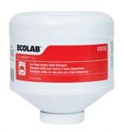 | Aquanomic 2.0 Low-Temp Laundry Solid Detergent  4 - 9.00 lb  Laundry Detergent STOCKED @ SYSCO  Product #6101766  Sysco UPC 5289364  Guest Supply UPC 0040409  Solid detergent for Aquanomic 2.0 program that delivers premium results at a lower wash temperature, leaving linens whiter and brighter. | 38.90#
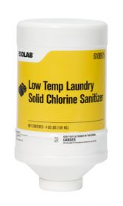 | Low-Temp Laundry Solid Chlorine Sanitizer  2 - 4.00 lb  Laundry Bleach STOCKED @ SYSCO  Product #6100975  Sysco UPC 5288463  Guest Supply UPC 0040408  Solid product that sanitizes linen, lengthens linen life by bleaching soils and preserving linen integrity. | 9.00#
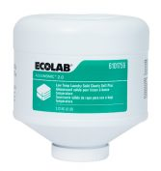 | Aquanomic 2.0 Low-Temp Laundry Solid Clearly Soft Plus  2 - 6.00 lb  Laundry Softener-sour STOCKED @ SYSCO  Product #6101756  Sysco UPC 5289156  Guest Supply UPC 0040410  Aquanomic 2.0 Solid Clearly Soft Plus gives sheets and towels a longer lasting freshness and luxurious softness that delivers a premium experience customers expect. | 13.24#
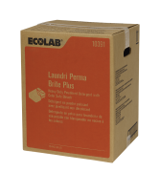 | Laundri Perma Brite Plus  1 - 45.00 lb  Laundry Bleach STOCKED @ SYSCO  Product #6110391  Sysco UPC 7168046  Guest Supply UPC 0022838  Heavy duty, powder detergent and color safe bleach system for commercial and homestyle machines | 46.90#
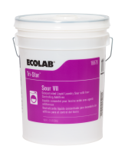 | Tri-Star Sour VII  1 - 5.00 gal  Laundry Softener-sour  Product #6116878  Sysco UPC 6350201  Guest Supply UPC 0016520  Laundry souring agent for controlling high iron and hard water conditions | 54.00#
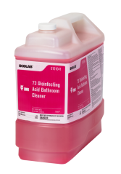 | 73 Disinfecting Acid Bathroom Cleaner (Oasis)  1 - 2.50 gal  Bathroom STOCKED @ SYSCO  Product #6101041  Sysco UPC 3636745  Guest Supply UPC 0033510  EPA-registered heavy-duty and hospital grade bathroom disinfectant ideal to remove hard water build-up and soap scum from showers. Disinfects in 5-minutes compared to industry standard of 10-minutes. Offers a positive user experience with a soapy fragrance. | 24.00#
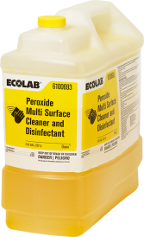 | Peroxide Multi Surface Cleaner and Disinfectant  1 - 2.00 gal  Disinfectants STOCKED @ SYSCO  Product #6100693  Sysco UPC 2990934  Guest Supply UPC 0032025  EPA-registered multi purpose cleaner and disinfectant | 18.70#
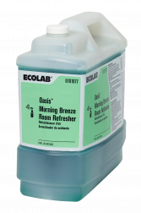 | Room Refreshers - Oasis Morning Breeze  1 - 2.50 gal  Air Freshener STOCKED @ SYSCO  Product #6101977  Sysco UPC 9911873  Guest Supply UPC 0043782  Daily air freshener with odor counteractant technology | 22.40#
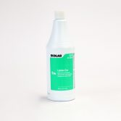 | Lemon-Eze  12 - 32.00 oz  Bathroom STOCKED @ SYSCO  Product #6113094  Sysco UPC 5659917  Guest Supply UPC 0613094  Cream cleanser that quickly removes difficult spots, soap scum buildup, rust, scuffs, grease, rubber marks and more | 34.00#
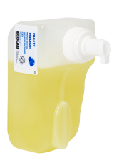 | DigiClean Foam Hand Soap  6 - 750.00 ml  Hand Soap STOCKED @ SYSCO  Product #6123671  Sysco UPC 3339066  Guest Supply UPC 0005222  Green Seal ™ certified gentle foaming hand soap that is ideal for public restrooms. It is designed to keep employees’ and guests hand clean and sanitary. | 12.20#
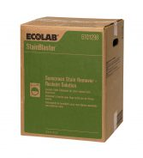 | Sunscreen Stain Remover – Reclaim Solution  1 - 45.00 lb  Laundry - Stainblaster  Product #6101298  Sysco UPC 4407401  Guest Supply UPC 0035951  Powdered laundry stain reclaim product removes sunscreen stains. | 46.90#
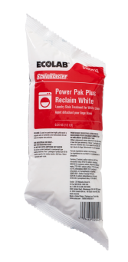 | StainBlaster Power Pak Plus Reclaim White, 12 x 1.2 lb  12 - 1.20 lb  Laundry - Stainblaster  Product #6100909  Sysco UPC 3477344  Guest Supply UPC 0033390  Alkaline powdered laundry stain reclaim product. Effective in removing a wide range of tough stains such as food soils, body soils and makeup. Formulated for use on white linen only. | 17.40#
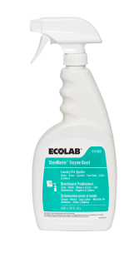 | StainBlaster Enzyme Boost  4 - 22.00 oz  Laundry - Stainblaster  Product #6101068  Sysco UPC 3716564  Guest Supply UPC 0033552  Stain treatment spray designed to help extend linen life by improving stain removal. It is especially effective on Blood, Body Soil, Grass, Food Soils, Eye Makeup, Lipstick stains. | 7.18#
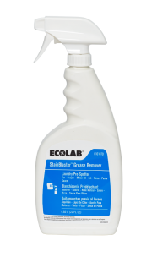 | StainBlaster Grease Remover  4 - 22.00 oz  Laundry - Stainblaster  Product #6101070  Sysco UPC 3716604  Guest Supply UPC 0033551  Stain treatment spray designed to help extend linen life by improving stain removal. It is especially effective on Greasy Food Soils, Mascara, Ink, Greasy Rags, Pizza, Pasta Sauce. | 6.00#
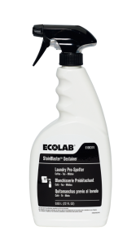 | StainBlaster Destainer  4 - 22.00 oz  Laundry - Stainblaster  Product #6100374  Sysco UPC 2514111  Guest Supply UPC 0030504  Laundry pre-spotter for most bleachable stains such as coffee, tea, fruit juice, and mildew stains. | 6.96#
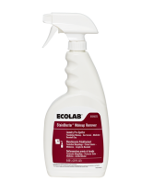 | StainBlaster Makeup Remover  4 - 22.00 oz  Laundry - Stainblaster  Product #6101072  Sysco UPC 3716596  Guest Supply UPC 0033553  Stain treatment spray designed to help extend linen life by improving stain removal. It is especially effective on Foundation Makeup, Baseball Clay, Sunscreen, Medicine. | 8.17#
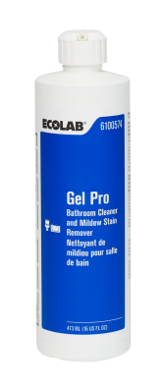 | Gel Pro  12 - 16.00 oz  Bathroom  Product #6100574  Sysco UPC 449344  Guest Supply UPC 0024774  Powerful gel bathroom cleaner and mildew stain remover | 15.40#
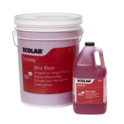 | EcoTemp Ultra Klene  4 - 1.00 gal  Machine Detergent STOCKED @ SYSCO  Product #6113326  Sysco UPC 5636568  Guest Supply UPC 061044B  Calculated based on E-ULT Dishmachine (0.840 GPR)  High-alkaline formula is designed to remove tough grease, starch and protein food soils. | 44.90#
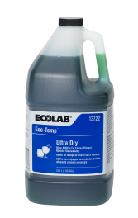 | EcoTemp Ultra Dry  4 - 1.00 gal  Rinse Additive STOCKED @ SYSCO  Product #6113722  Sysco UPC 5636469  Guest Supply UPC 0005415  Rinse additive effective in all water conditions for spotless glassware and flatware. | 37.00#
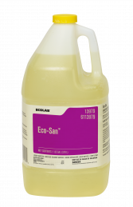 | Eco-San  4 - 1.00 gal  Machine Sanitizer STOCKED @ SYSCO  Product #6113979  Sysco UPC 4214649  Guest Supply UPC 060906  Calculated based on ES-4000 Dishmachine (2.000 GPR)  Sanitizer and destainer for use in low-temperature warewashing machines | 36.50#

Legal Statement
The use-cost estimates in this document are based on extensive laboratory and field testing but actual use-costs may vary and are influenced by a multitude of factors, such as local water conditions. Quoted prices do not include applicable taxes. This document is not an agreement or an offer to enter into an agreement. The terms of any agreement between the parties must be set forth in a definitive written contract which is signed by both parties.

