Meaningful Use 2014:
Stage 2 Menu/Core Measures

Table of Contents
Introduction to Stage 2 in 2014 CEHRT 5
Stage 2 Core Measures 5
Stage 2 - Core #1: CPOE for Medication, Laboratory and Radiology Orders 6
CPOE: Explanation of Measure 6
CPOE: Meaningful Use Measures 7
CPOE: Recording of Numerator in Valant 8
CPOE: Medication Orders 8
CPOE: Laboratory Orders 10
CPOE: Radiology Orders 11
Stage 2 - Core #2: e-Prescribing (eRx) 12
eRx: Explanation of Measure 12
eRx: Meaningful Use Measures 13
eRx: Recording of Numerator in Valant 14
Stage 2 - Core #3: Demographics 15
Demographics: Explanation of Measure 15
Demographics: Meaningful Use Measures 16
Demographics: Recording of Numerator in Valant 17
Date of Birth 17
Sex 18
Preferred Language 18
Race 19
Ethnicity 20
Stage 2 - Core #4: Vital Signs 21
Vital Signs: Explanation of Measure 22
Vital Signs: Meaningful Use Measures 23
Vital Signs: Recording of Numerator in Valant 24
Vital Signs: Patient Chart > Measurements 24
Vital Signs: Mobile Notes 25
Stage 2 - Core #5: Smoking Status 26
Smoking Status: Explanation of Measure 26
Smoking Status: Meaningful Use Measures 27
Smoking Status: Recording of Numerator in Valant 28
Stage 2 - Core #6: Clinical Decision Support (CDS) 31
Clinical Decision Support: Explanation of Measure 31
Clinical Decision Support: Recording of Numerator in Valant 32
Stage 2 - Core #7: Patient Electronic Access 34
Patient Electronic Access: Explanation of Measure 35
Measure 1: Timely Access 35
Measure 2: View, Download, or Transmit 35
Patient Electronic Access: Meaningful Use Measures 36
Patient Electronic Access: Recording of Numerator in Valant 37
Measure 1: Timely Access 37
Measure 2: View, Download, or Transmit 40
Stage 2 - Core #8: Clinical Summaries 41
Clinical Summaries: Explanation of Measure 41
Clinical Summaries: Meaningful Use Measures 42
Clinical Summaries: Recording of Numerator in Valant 43
Send C-CDA to Portal: Clinical Summary 45
Send C-CDA to Portal: Clinical Summary & Health Summary 47
Send C-CDA to Portal: Clinical Summary Declined 49
Stage 2 - Core #9: Protect Electronic Health Information 50
Protect Electronic Health Information: Explanation of Measure 50
Stage 2 - Core #10: Clinical Lab-Test Results 51
Lab-Test Results: Explanation of Measure 51
Lab-Test Results: Recording of Numerator in Valant 52
Lab-Test Results: Lab Panels 52
Lab-Test Results: eLabs 53
Stage 2 - Core #11: Patient Lists 54
Patient Lists: Explanation of Measure 54
Patient Lists: Recording of Numerator in Valant 55
Stage 2 - Core #12: Preventive Care 56
Preventative Care/Patient Reminders: Explanation of Measure 57
Preventative Care/Patient Reminders: Recording of Numerator in Valant 58
Stage 2 - Core #13: Patient-Specific Education Resources 61
Patient-Specific Education Resources: Explanation of Measure 61
Patient-Specific Education Resources: Recording of Numerator in Valant 62
Patient-Specific Education Resources: Diagnoses 62
Patient-Specific Education Resources: Lab Panels 63
Patient-Specific Education Resources: MedlinePlus 64
Stage 2 - Core #14: Medication Reconciliation 65
Stage 2 - Core #15: Summary of Care 66
Summary of Care: Explanation of Measure 67
Measure 1: Referral/Transfer of Care 67
Measure 2: Electronic Transmission and Receipt 67
Measure 3: Conduct Successful Electronic Exchange 69
Summary of Care: Recording of Numerator in Valant 69
Stage 2 - Core #16: Immunization Registries Data Submission 72
Immunization Registries Data Submission: Explanation of Measure 72
Stage 2 - Core #17: Use Secure Electronic Messaging 73
Secure Electronic Messaging: Explanation of Measure 73
Secure Electronic Messaging: Recording of Numerator in Valant 74
Stage 2 Menu Measures 75
Stage 2 - Menu #1: Syndromic Surveillance Data Submission 76
Syndromic Surveillance Data: Explanation of Measure 77
Stage 2 - Menu #2: Electronic Notes 78
Electronic Notes: Explanation of Measure 78
Electronic Notes: Recording of Numerator in Valant 79
Stage 2 - Menu #3: Imaging Results 80
Imaging Results: Explanation of Measure 80
Imaging Results: Recording of Numerator in Valant 81
Image Results 81
Image Order: Results Were Incorporated 82
Stage 2 - Menu #4: Family Health History 83
Family Health History: Explanation of Measure 83
Family Health History: Recording of Numerator in Valant 84
Stage 2 - Menu #5: Report Cancer Cases 86
Report Cancer Cases: Explanation of Measure 87
Stage 2 - Menu #6: Report Specific Cases 88
Report Specific Cases: Explanation of Measure 89

Introduction to Stage 2 in 2014 CEHRT

For Stage 2 reporting in the 2014 Edition of Certified Electronic Health Record Technology (CEHRT), there are a total of 17 Core Measures and 6 Menu Measures. An Eligible Provider (EP) must report on 3 of the 6 Menu Measures and all 17 Core Measures in order to meet Meaningful Use reporting under Stage 2 of the program. An EP starts Stage 2 of Meaningful Use reporting once they have completed two years of reporting under Stage 1. This applies to providers submitting under both Medicaid and Medicare for Meaningful Use.

For providers submitting under Medicaid, the first year in which they report on adopting CEHRT does not count towards the two years of reporting under Stage 1 of the Meaningful Use program. This means that an EP reporting under Medicaid will adopt the CEHRT their first year, then attest under Stage 1 for two more years before moving to Stage 2.

For providers submitting under Medicare, the first two years of their reporting will both count towards their reporting requirement for Stage 1. This means that an EP will move on to Stage 2 reporting once two years of reporting under Stage 1 have passed.

Regardless of which payer is being reported to, an EP must meet the reporting threshold for all measures for which they are not excluding. The reporting threshold is the same for both Medicare and Medicaid. Failure to meet the threshold for any measure in the Core set or in a minimum of 3 of the 6 Menu set measures will result in the provider not meeting Meaningful Use for that year. Failure to prove Meaningful Use will result in both incentive payments not being administered and adjustments being applied for that EP on future payments from Medicare and Medicaid.

Stage 2 Core Measures

Each of the 17 Core Measures need to be reported on in order for an EP to prove Meaningful Use under the 2014 Edition of CEHRT. Many of the Core Measures have an exclusion option which allows an EP to opt out of reporting their numbers for that measure. Excluding out of reporting on a measure counts as meeting the minimum threshold for that measure.

Most of the Core Measures have one or more Numerator, Denominator, and corresponding Threshold. The Valant Premium Psychiatrist Suite is capable of recording each of these values for the measures that have this requirement. The purpose of this documentation is to provide insight into how these values are captured.

Certain Core Measures do not have any Numerator or Denominator reporting criteria. Instead, these measures are Yes/No questions answered by the attesting EP. For these Measures, the Valant Premium Psychiatrist Suite does not record any information. This is because the information required for attestation is recorded outside of the CEHRT. For Yes/No Core Measures, the EP is required to track their compliance outside of the CEHRT and attest using this external data.

Finally, not all Measures under the 2014 Edition of CEHRT were included in the certification of the Valant Premium Psychiatrist Suite as they fell outside of the scope of practice for behavioral health. It is assumed that the Measures which are not included in the Valant Premium Psychiatrist Suite can be successfully excluded by the EP as they do not relate to the scope of that EP’s work.

Full descriptions of each of the 17 Core Measures can be found below. The definition of the Measure as well as the Numerator, Denominator, and reporting Threshold are all included. Additionally, there is an interpretation of the Measure as well as descriptions on how to make use of the Valant Premium Psychiatrist Suite to meet the reporting threshold.

Stage 2 - Core #1: CPOE for Medication, Laboratory and Radiology Orders

CPOE for Medication, Laboratory and Radiology Orders
Objective | Use computerized provider order entry (CPOE) for medication, laboratory and radiology orders directly entered by any licensed healthcare professional who can enter orders into the medical record per state, local and professional guidelines.
Measure | More than 60 percent of medication, 30 percent of laboratory, and 30 percent of radiology orders created by the EP during the EHR reporting period are recorded using CPOE.
Exclusion | Any EP who writes fewer than 100 medication, radiology, or laboratory orders during the EHR reporting period.

CPOE Medication: Attestation Requirements
Denominator | Number of medication orders created by the EP during the EHR reporting period.
Numerator | The number of orders in the denominator recorded using CPOE.
Threshold | The resulting percentage must be more than 60 percent in order for an EP to meet this measure.

CPOE Laboratory: Attestation Requirements
Denominator | Number of laboratory orders created by the EP during the EHR reporting period.
Numerator | The number of orders in the denominator recorded using CPOE.
Threshold | The resulting percentage must be more than 30 percent in order for an EP to meet this measure.

CPOE Radiology: Attestation Requirements
Denominator | Number of radiology orders created by the EP during the EHR reporting period.
Numerator | The number of orders in the denominator recorded using CPOE.
Threshold | The resulting percentage must be more than 30 percent in order for an EP to meet this measure.

CPOE: Explanation of Measure

This measure is based on the type of order entered by the EP during the reporting period. This measure is not based on unique patients nor is it connected to a recorded visit. Instead, the order itself is all that is recorded by this measure with the date of the order determining whether or not it will count towards the numerator in the reporting period.

By definition, all orders entered into the system are done using computerized provider order entry (CPOE). This means that anything entered into the Valant Premium Psychiatrist Suite will count towards CPOE for the purposes of this measure. The two limiting factors as to whether or not an order will apply for an EP are the provider attached to the order and the date associated with the order. If the provider of the order is the EP and the date of the order falls within the reporting period, then this order will count towards the numerator for that EP.

CPOE: Meaningful Use Measures

There are three line items related to CPOE in the Stage 2 list of Meaningful Use Measures. The line items shown in the list relate to the individual reporting options as follows:

Meaningful Use Measure List | Reporting Option
Computerized Provider Order Entry (CPOE) – Medication Order | CPOE Medication Orders
Computerized Provider Order Entry (CPOE) – Laboratory Order | CPOE Laboratory Orders
Computerized Provider Order Entry (CPOE) – Radiology Order | CPOE Radiology Orders

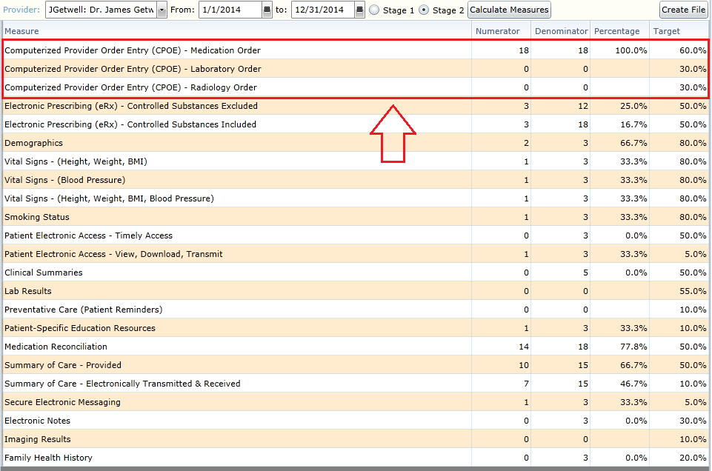

CPOE: Recording of Numerator in Valant

There are three different measures associated with CPOE: Medication, Laboratory, and Radiology orders. Each order type is captured in its own way in the system. The method for recording each type of order is described below. For more information regarding the specific order type, please refer to the documentation located in the Knowledge Base.

CPOE: Medication Orders

There are two methods of recording Medication Orders: using the Medications tab in the Patient Chart or utilizing the Meds & Allergies tab in Mobile Notes.

CPOE: Medication Orders - Patient Chart > Medications

Medication Orders can be done through the Medications tab of the patient chart. To create a new Medication Order, click the New Medication button.

Medication Management in the Valant Premium Psychiatrist Suite, which includes creating new Medication Orders, is done through our ePrescribing partner DrFirst. Any prescription generated within DrFirst constitutes a Medication Order, regardless of how it is sent. This means that prescriptions can be generated using Send, Send and Print, Print w/o Sending, or even Sign w/o Sending and still receive credit for the numerator of this measure.

For more information relating to creating a new Medication Order in DrFirst, please refer to documentation XXXXX.

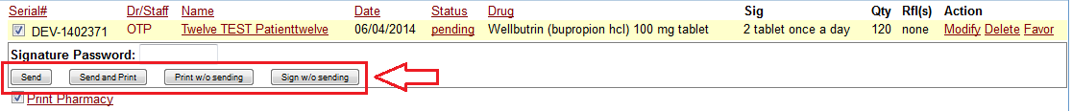

Once a Medication Order has been entered, it will appear in the list of orders under the Medications tab of the patient chart.

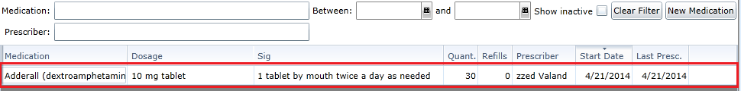

CPOE: Medication Orders - Mobile Notes

To record Medication Orders for a patient using Mobile Notes, a template must be selected that contains the Meds & Allergies tab. Templates which include Meds & Allergies includes: Psychiatric Progress Note, DBP Progress Note, Structured Therapy Progress Note, Intake Note, Child Intake Note, and DBP Intake Note.

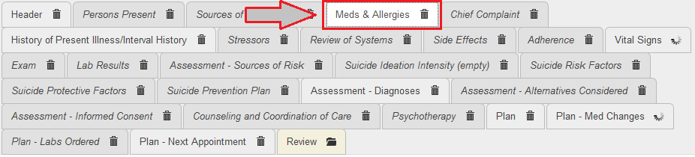

Selecting the Meds & Allergies tab will bring up the section showing the patient’s current Medications and Allergies. To enter a new Medication Order, click the Edit Medications link.

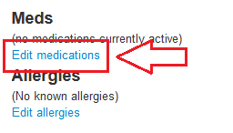

Medication Management in the Valant Premium Psychiatrist Suite, which includes creating new Medication Orders, is done through our ePrescribing partner DrFirst. Any prescription generated within DrFirst constitutes a Medication Order, regardless of how it is sent. This means that prescriptions can be generated using Send, Send and Print, Print w/o Sending, or even Sign w/o Sending and still receive credit for the numerator of this measure.

For more information relating to creating a new Medication Order in DrFirst, please refer to documentation XXXXX.

CPOE: Laboratory Orders

Laboratory Orders are done through the Lab Requests tab of the patient chart. To create a new Laboratory Order, click the New Lab Request button.

For more information about Laboratory Requests beyond what is described below, please see the documentation XXXXX.

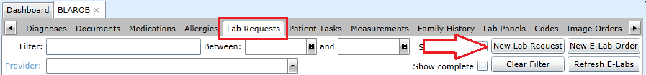

A new Laboratory Order can be entered on the New Lab Request dialogue window. To enter a new Laboratory Order, a date must be supplied, a provider must be identified, a diagnosis must be selected, and one or more orders must be selected. It is important to correctly identify the provider and date of the Image Order as this will determine which EP will be credited for the order as well as determines what reporting period the order falls under.

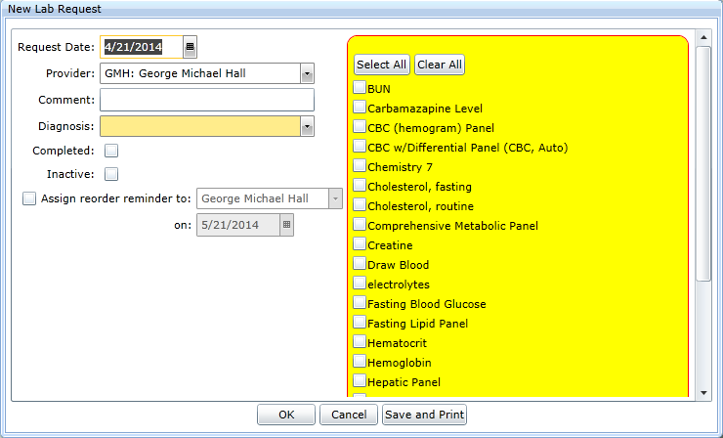

Once a Laboratory Order has been entered, it will appear in the list of orders under the Lab Requests tab.

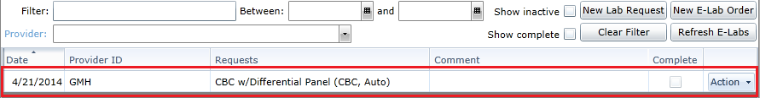

CPOE: Radiology Orders

Radiology Orders are done through the Image Orders tab of the patient chart. To create a new Image Order, click the New Image Order button.

For more information about Image Orders beyond what is described below, please see the documentation XXXXX.

A new Image Order can be entered on the New Image Order dialogue window. To enter a new Image Order, a date must be supplied, a provider must be identified, and a description of the order must be entered. It is important to correctly identify the provider and date of the Image Order as this will determine which EP will be credited for the order as well as determines what reporting period the order falls under.

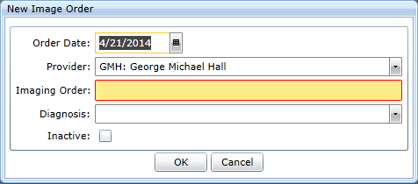

Once an Image Order has been entered, it will appear in the list of orders under the Image Order tab.

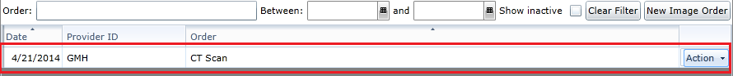

Stage 2 - Core #2: e-Prescribing (eRx)

e-Prescribing (eRx)
Objective | Generate and transmit permissible prescriptions electronically (eRx).
Measure | More than 50 percent of all permissible prescriptions, or all prescriptions, written by the EP are queried for a drug formulary and transmitted electronically using CEHRT
Exclusion | Any EP who:  (1) Writes fewer than 100 permissible prescriptions during the EHR reporting period  (2) Does not have a pharmacy within their organization and there are no pharmacies that accept electronic prescriptions within 10 miles of the EP's practice location at the start of his/her EHR reporting period

eRx - Controlled Substances Excluded: Attestation Requirements
Denominator | Number of prescriptions written for drugs requiring a prescription in order to be dispensed other than controlled substances during the EHR reporting period
Numerator | The number of prescriptions in the denominator generated, queried for a drug  formulary and transmitted electronically using CEHRT
Threshold | The resulting percentage must be more than 50 percent in order for an EP to meet this measure

eRx - Controlled Substances Included: Attestation Requirements
Denominator | Number of prescriptions written for drugs requiring a prescription in order to be dispensed during the EHR reporting period
Numerator | The number of prescriptions in the denominator generated, queried for a drug  formulary and transmitted electronically using CEHRT
Threshold | The resulting percentage must be more than 50 percent in order for an EP to meet this measure

eRx: Explanation of Measure

This measure is based on the manner in which a medication order was prescribed by the EP during the reporting period. This measure is not based on unique patients nor is it connected to a recorded visit. Instead, the manner in which the medication order is prescribed and the date of the prescription is all that is recorded by this measure.

This measure has two options for reporting. EP’s who have the ability to ePrescribe (eRx) controlled substances using DrFirst’s Electronic Prescription of Controlled Substances (EPCS) will want to report using the option where all medication orders count towards the denominator. For EP’s who do not have EPCS turned on, then the reporting option which excludes controlled substances from the denominator should be used instead. It is up to the EP to report on the correct option during attestation as values for both options will be presented.

By default, all orders entered into DrFirst are queried for a drug formulary. As a result, sending the prescription electronically is all that is required in order to have the prescription count towards the numerator.

eRx: Meaningful Use Measures

There are two line items related to e-Prescribing in the Stage 2 list of Meaningful Use Measures. The line items shown in the list relate to the individual reporting options as follows:

Meaningful Use Measure List | Reporting Option
Electronic Prescribing (eRx) - Controlled Substances Excluded | eRx without EPCS
Electronic Prescribing (eRx) - Controlled Substances Included | eRx with EPCS

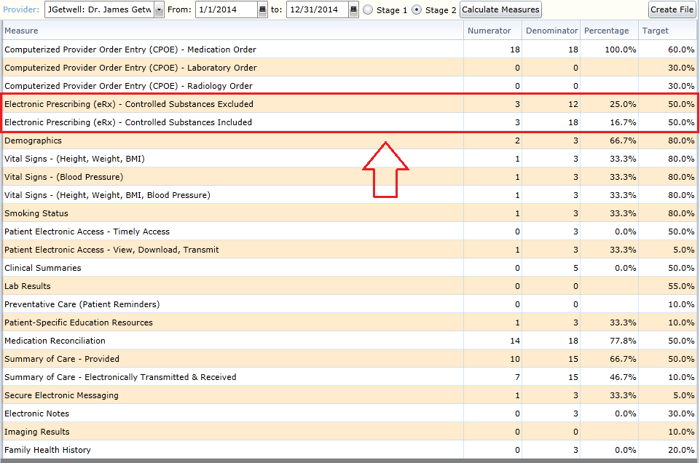

eRx: Recording of Numerator in Valant

This measure focuses on creating medication orders using ePrescribing (eRx) as the method of prescribing. For more information about Medication Orders and prescribing in DrFirst beyond what is described below, please see the documentation XXXXX.

Once a Medication Order has been queued within DrFirst, the provider has several options to choose from in which it can be prescribed. The two options which will count towards the numerator for this measure are Send and Send and Print. Prescribing the medication using either of these options will eRx the prescription to the patient’s pharmacy and the prescribing provider will receive credit for ePrescribing the order.

If an EP has Electronic Prescription of Controlled Substances (EPCS) active with DrFirst, then the eRx reporting option which includes controlled substances should be used during attestation. For EP’s not using EPCS, the eRx reporting option which excludes controlled substances should be used during attestation.

NOTE: The date that the medication order was ePrescribed needs to fall within the reporting period in order for the order to count towards the numerator for this measure. Additionally, the EP needs to be the prescribing provider on the prescription in order to count towards the numerator for that EP.

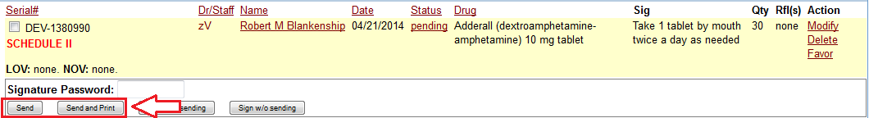

Stage 2 - Core #3: Demographics

Demographics
Objective | Record the following demographics: preferred language, sex, race, ethnicity, date of birth
Measure | More than 80 percent of all unique patients seen by the EP have demographics recorded as structured data
Exclusion | No exclusion

Demographics: Attestation Requirements
Denominator | Number of unique patients seen by the EP during the EHR reporting period
Numerator | The number of patients in the denominator who have all the elements of demographics (or a specific notation if the patient declined to provide one or more elements or if recording an element is contrary to state law) recorded as structured data
Threshold | The resulting percentage must be more than 80 percent in order for an EP to meet this measure

Demographics: Explanation of Measure

This measure is based on unique patients with a recorded visit by the EP during the reporting period. This means that a given patient, no matter how many times seen during the reporting period, can only count once for both numerator and denominator. Likewise, patients with no recorded visits during the reporting period will not count towards either numerator or denominator. Finally, this measure applies to all patients, regardless of age, who were seen during the reporting period.

Recording the Demographics for a patient can occur before, during or after the reporting period. This means that it does not matter when the Demographics are recorded so long as it is done prior to generating the measures for submission to CMS. Additionally, once the Demographics have been recorded for a patient, then that patient will always appear in the numerator for an EP that has a recorded visit with that patient during the reporting period.

Recording the Demographics is not tied to an individual EP within a practice. All EP’s within a practice will receive credit for a patient who have their Demographics recorded so long as that patient has a recorded visit with the EP during the reporting period. This means that, once the Demographics for a patient have been recorded, any EP who has a recorded visit with that patient during the reporting period will have that patient appear in both the numerator and denominator for this particular measure.

Demographics: Meaningful Use Measures

There is a single line item related to Demographics in the Stage 2 list of Meaningful Use Measures. The name of this line item is Demographics.

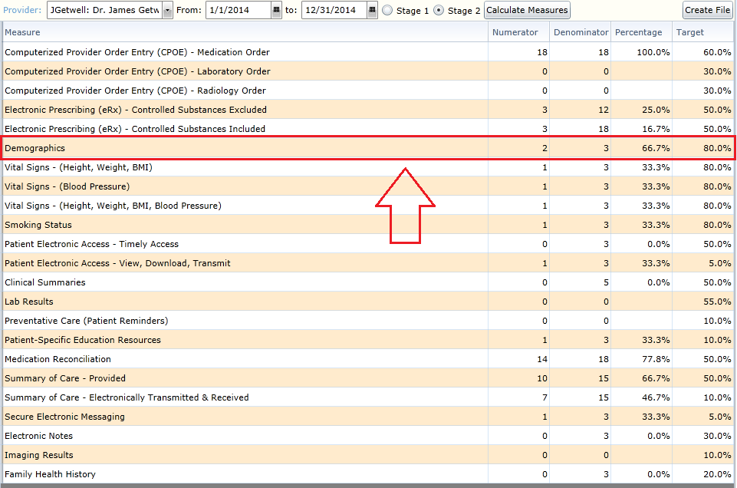

Demographics: Recording of Numerator in Valant

There are several fields which need to be recorded for a patient that relate to their Demographics in terms of this measure. These fields are: Date of Birth, Sex, Preferred Language, Race, and Ethnicity. Each item listed is required to have a value in order for a patient to be considered for the numerator. Accessing the fields required for Demographics can be achieved by going to Persons and Institutions: Patients.

For more information relating to Race, Ethnicity, and Preferred Language beyond what is mentioned in this document, please refer to the documentation located here XXXXXXX.

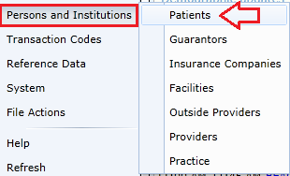

Date of Birth

To set the Date of Birth for a patient, select the patient from the list and navigate to the Demographics tab. The date of birth field is located on the left side under the Main Phone. The field is called Birthdate. The date is in MM/DD/YYYY format and can be entered either by using the date picker tool or through manually entry.

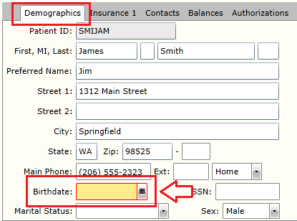

Sex

To set the Sex for a patient, select the patient from the list and navigate to the Demographics tab. The field relating to Sex is located to the left side under the option to record SSN. CMS only allows two options for Sex: Male or Female. A patient must have one of these two options selected in order for them to count towards the numerator for this measure. A patient cannot have both option selected; CMS only allows for a patient to be a single Sex.

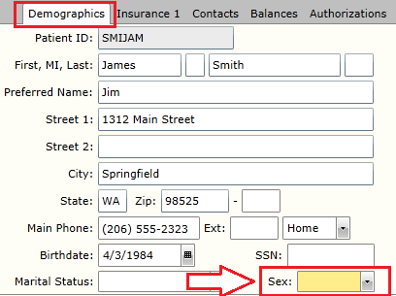

Preferred Language

To set the Preferred Language for a patient, select the patient from the list and navigate to the Misc. tab. The Preferred Language field is the second item listed on the page. Under MU 2014, there are now over 180 options for language in which to choose from. Additionally, there is the option for ‘Declined to Specify’ if the patient chose not to give their Preferred Language.

The Preferred Language can be set for a patient by selecting the language from the drop down list. Alternatively, typing the name of the preferred language will limit the options to only those that match the text provided. CMS uses ISO 639-2 as the coding standard for the representation of names of languages.

NOTE: For convenience, the common Preferred Language options that were required under MU 2011 have been included at the start of the list of languages. These items include Chinese, English, French, German, Italian, Japanese, Korean, Portuguese, Russian, Spanish, and Declined to Specify. After these items, the remainder of the list is organized alphabetically by the name of the language.

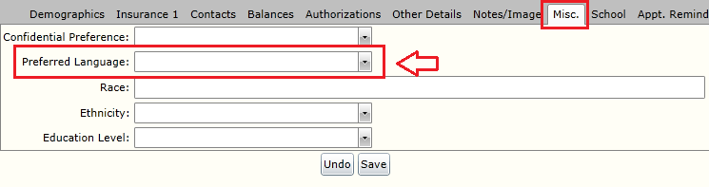

Race

To set the Race for a patient, select the patient from the list and navigate to the Misc. tab. The Race field is the third item listed on the page. Under MU 2014, multiple races can now be selected for a patient. Additionally, there is now an option for ‘Declined to Specify’. At least one race must be chosen for a patient or the option ‘Declined to Specify’ must be selected in order for the patient to count towards the numerator for this measure.

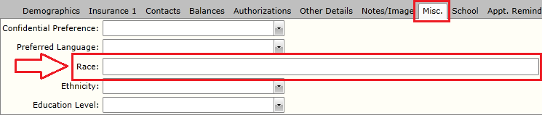

To select a Race for a patient, typing the name of the Race will present a drop down of the options that can be selected. The options that are available for race under MU 2014 are: American Indian or Alaska Native, Asian, Black or African American, Native Hawaiian or Other Pacific Islander, White. Typing the name of the Race will limit the options to only those that match the text provided.

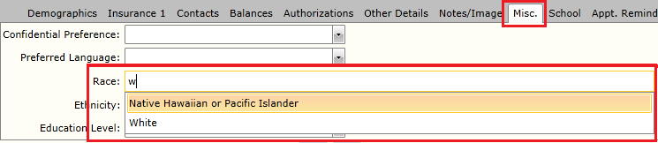

Selecting a Race for the listed option will result in that Race being assigned to the patient. Multiple Races can be selected in this manner. To remove a selected Race, click the ‘X’ icon to the right of the displayed Race.

NOTE: Any number of Race options can be selected for a patient. If the option ‘Declined to Specify’ is selected, no other Race options can be included. If ‘Declined to Specify’ has been selected, the system will prevent saving until either all other Race options are removed or the ‘Declined to Specify’ option is removed from the Race field.
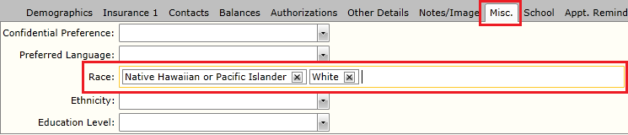

Ethnicity

To set the Ethnicity for a patient, select the patient from the list and navigate to the Misc. tab. The Ethnicity field is the fourth item listed on the page. Under MU 2014, there are two options for Ethnicity allowed: Hispanic or Not Hispanic or Latino. Additionally, there is now an option for ‘Declined to Specify’. At least one Ethnicity option must be chosen for a patient or the option ‘Declined to Specify’ must be selected in order for the patient to counts towards the numerator for this measure.

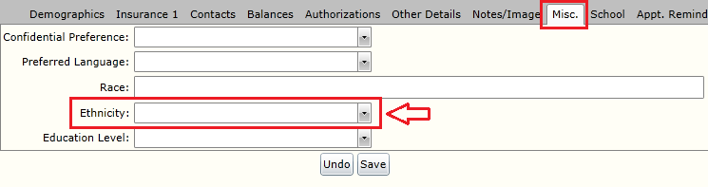

Stage 2 - Core #4: Vital Signs

Vital Signs
Objective | Record and chart changes in the following vital signs: height/length and weight (no age limit); blood pressure (ages 3 and over); calculate and display body mass index (BMI); and plot and display growth charts for patients 0-20 years, including BMI.
Measure | More than 80 percent of all unique patients seen by the EP have blood pressure (for patients age 3 and over only) and/or height and weight (for all ages) recorded as structured data
Exclusion | Any EP who:  (1) Sees no patients 3 years or older is excluded from recording blood pressure.  (2) Believes that all 3 vital signs of height/length, weight, and blood pressure have no relevance to their scope of practice is excluded from recording them.  (3) Believes that height/length and weight are relevant to their scope of practice, but blood pressure is not, is excluded from recording blood pressure.  (4) Believes that blood pressure is relevant to their scope of practice, but height/length and weight are not, is excluded from recording height/length and weight

Vital Signs: Height, Weight, and Blood Pressure all within scope: Attestation Requirements
Denominator | Number of unique patients seen by the EP during the EHR reporting period
Numerator | Patients 3 years of age or older in the denominator for whom height/length, weight, and blood pressure are recorded.  Patients younger than 3 years of age in the denominator for whom height/length and weight are recorded
Threshold | The resulting percentage must be more than 80 percent in order for an EP to meet this measure

Vital Signs: Height and Weight only within scope of practice: Attestation Requirements
Denominator | Number of unique patients seen by the EP during the EHR reporting period
Numerator | Patients in the denominator for whom height/length and weight are recorded
Threshold | The resulting percentage must be more than 80 percent in order for an EP to meet this measure

Vital Signs: Blood Pressure only within scope of practice: Attestation Requirements
Denominator | Number of unique patients 3 years of age or older seen by the EP during the EHR reporting period
Numerator | Patients in the denominator for whom blood pressure is recorded
Threshold | The resulting percentage must be more than 80 percent in order for an EP to meet this measure

Vital Signs: Explanation of Measure

This measure is based on unique patients with a recorded visit by the EP during the reporting period. This means that a given patient, no matter how many times seen during the reporting period, can only count once for both numerator and denominator. Likewise, patients with no recorded visits during the reporting period will not count towards either numerator or denominator. Finally, the age of the patient to count towards the denominator varies based on which option is used for reporting.

This measure has three different options for reporting. If an EP determines that measuring patient’s Height/Weight, as well as Blood Pressure, is within the scope of their work, then patients 3 years of age and older need to have Height/Weight and Blood Pressure all recorded. For patients under 3 years of age, only Height/Weight needs to be recorded.

If an EP determines that measuring a patient’s Blood Pressure is not relevant to the scope of their work, but recording their Height/Weight is, then all patients need to have their Height/Weight recorded. If measuring the Blood Pressure, as well as Height/Weight, is relevant for even a single patient seen by the EP during the reporting period, then this reporting option cannot be used. Instead, the first option must be reported instead.

If an EP determines that measuring a patient’s Height/Weight is not relevant to the scope of their work, but recording their Blood Pressure is, then all patients 3 years of age and older need to have their Blood Pressure recorded. If measuring the Height/Weight, as well as Blood Pressure, is relevant for even a single patient seen by the EP during the reporting period, then this reporting option cannot be used. Instead, the first option must be reported instead.

Finally, if both Height/Weight, as well as Blood Pressure, is not relevant to the scope of an EP’s work during the reporting period, then the provider can exclude themselves from reporting on this measure entirely.

It is up to the EP to report on the correct option during attestation as values for each option will be presented. An EP must report on a single option for a given reporting period, so it is important that the correct option is used. An EP cannot pick and choose which patients belong to a reporting option. Instead, all patients seen by the EP during a reporting period must count towards the same option.

Recording the Vital Signs for a patient is not tied to an individual EP within a practice. All EP’s within a practice will receive credit for a patient who has their Vital Signs recorded so long as that patient has a recorded visit with the EP during the reporting period. This means that, once the Smoking Status for a patient has been recorded, any EP who has a recorded visit with that patient during the reporting period will have that patient appear in both the numerator and denominator for this particular measure.

Vital Signs: Meaningful Use Measures

There are a total of three line items item related to Vital Signs in the Stage 2 list of Meaningful Use Measures. The line items shown in the list relate to the individual reporting options as follows:

Meaningful Use Measure List | Reporting Option
Vital Signs - 2014 Onward - (Height, Weight, BMI) | Vital Signs: Height and Weight only within scope of practice
Vital Signs - 2014 Onward - (Blood Pressure) | Vital Signs: Blood Pressure only within scope of practice
Vital Signs - 2014 Onward - (Height, Weight, BMI, Blood Pressure) | Vital Signs: Height, Weight, and Blood Pressure all within scope of practice

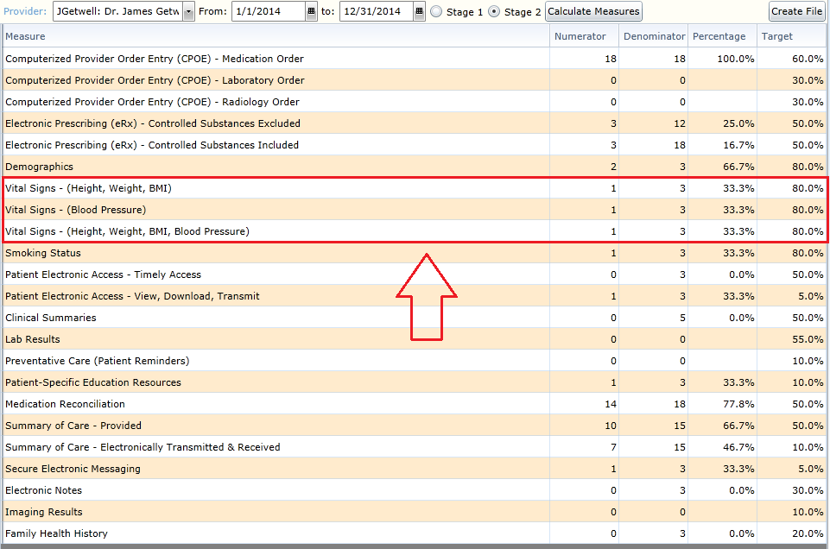

Vital Signs: Recording of Numerator in Valant

There are two methods of recording Vital Signs: using the Measurements tab in the Patient Chart or utilizing the Vital Signs tab in Mobile Notes. Note that the BMI will automatically be calculated for a patient once Height and Weight values have been recorded into their record. The Height and Weight values must have the same date in order for BMI to calculate.

Vital Signs: Patient Chart > Measurements

To record Height/Weight and Blood Pressure for a patient using their chart, the Measurements tab must be accessed and the New Measurement button clicked.

In the Add Measurement dialogue window, the Measurement Type field can be used to select the Vital Sign being recorded. Once a Measurement Type has been selected, the Value field must now be used to enter the result for that Vital Sign. The Value being recorded changes depending on which Vital Sign has been selected. Height is recorded in inches (in). Weight is recorded in pounds (lbs). Blood Pressure is recorded in millimeters of mercury (mm[Hg]).

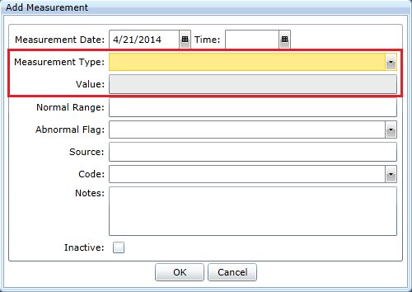

Once a Vital Sign has been entered and recorded into the patient chart, the value can be seen in the table under the Measurements tab.

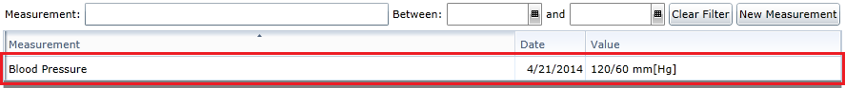

Vital Signs: Mobile Notes

To record Height/Weight and Blood Pressure for a patient using Mobile Notes, a template must be selected that contains the Vital Signs tab. Templates which include Vital Signs includes: Psychiatric Progress Note, DBP Progress Note, Structured Therapy Progress Note, Intake Note, Child Intake Note, and DBP Intake Note.

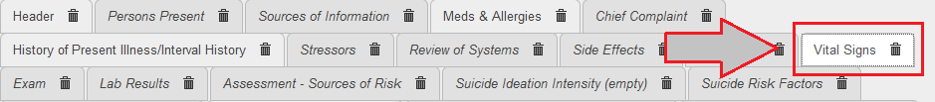

Selecting the Vital Signs tab will bring up the section showing the previous and current Vital Signs for this patient. The current Vital Signs can be updated by clicking on the Edit Vitals button.

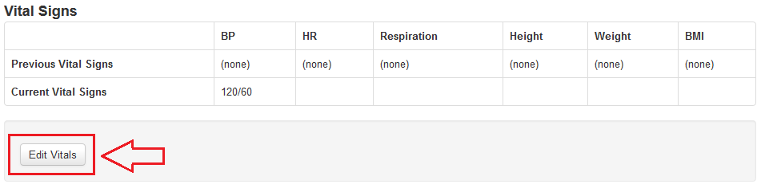

Using the fields for BP, Height, and Weight, the Vital Signs for the patient can be recorded and saved into their chart.

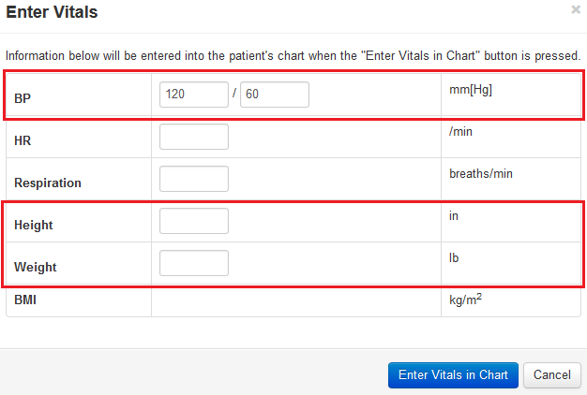

Stage 2 - Core #5: Smoking Status

Smoking Status
Objective | Record smoking status for patients 13 years old or older
Measure | More than 80 percent of all unique patients 13 years old or older seen by the EP have smoking status recorded as structured data
Exclusion | Any EP that neither sees nor admits any patients 13 years old or older

Record Smoking Status: Attestation Requirements
Denominator | Number of unique patients age 13 or older seen by the EP during the EHR reporting period
Numerator | The number of patients in the denominator with smoking status recorded as structured data
Threshold | The resulting percentage must be more than 80 percent in order for an EP to meet this measure

Smoking Status: Explanation of Measure

This measure is based on unique patients with a recorded visit by the EP during the reporting period. This means that a given patient, no matter how many times seen during the reporting period, can only count once for both numerator and denominator. Likewise, patients with no recorded visits during the reporting period will not count towards either numerator or denominator. Finally, this measure only applies to patients who were of age 13 years or older during the reporting period. For the purposes of calculation, patients younger than 13 at the start of the reporting period will not be included in the denominator even if they turned 13 during the course of the reporting period.

Recording the Smoking Status for a patient can occur before, during or after the reporting period. This means that it does not matter when the Smoking Status is recorded so long as it is done prior to generating the measures for submission to CMS. Additionally, once the Smoking Status has been recorded for a patient, then that patient will always appear in the numerator for an EP that has a recorded visit with that patient during the reporting period.

Recording the Smoking Status is not tied to an individual EP within a practice. All EP’s within a practice will receive credit for a patient who has their Smoking Status recorded so long as that patient has a recorded visit with the EP during the reporting period. This means that, once the Smoking Status for a patient has been recorded, any EP who has a recorded visit with that patient during the reporting period will have that patient appear in both the numerator and denominator for this particular measure.

Smoking Status: Meaningful Use Measures

There is a single line item related to Smoking Status in the Stage 2 list of Meaningful Use Measures. The name of this line item is Smoking Status.

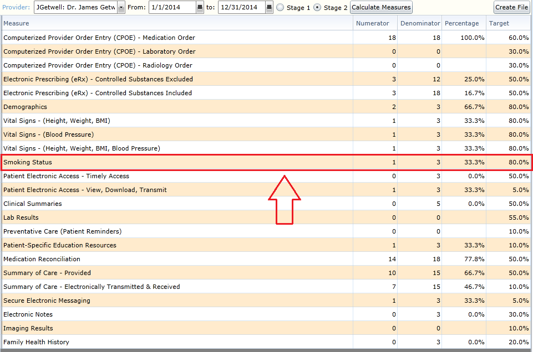

Smoking Status: Recording of Numerator in Valant

Once a patient has a recorded visit with an EP, the Smoking Status for that patient needs to be recorded into the patient’s chart in order for the patient to count towards the numerator for this measure. To record Smoking Status in the patient chart, the Measurements tab must be accessed. This can be done by opening the chart and clicking on the Measurements tab located at the top of the chart.

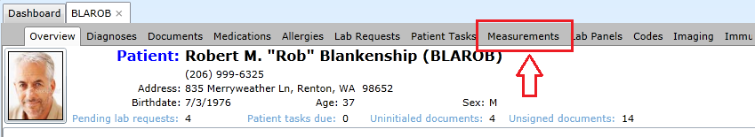

Once in the Measurements section of the chart, clicking on the New Measurement button located in the upper right corner of the page will allow the user to record a new measurement into the chart for this patient.

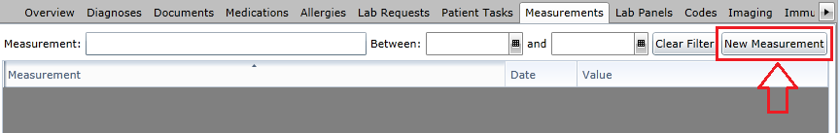

Clicking on the New Measurement button will result in the Add Measurement window opening. To record a new Smoking Status, the Measurement Type field must be used. Clicking on the arrow will present a drop down list of all of the available measurements that can be recorded for this patient. The option for Smoking Status should be selected from the list.
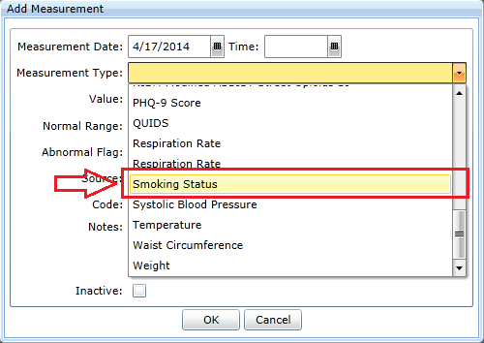

Once Smoking Status has been selected for the Measurement Type, the next step is to record the value for this measurement. Using the Value field, select the Smoking Status for this patient. The options listed are defined by CMS for the Meaningful Use program. One of the items in the list must be selected in order to count towards recording the Smoking Status for a patient.

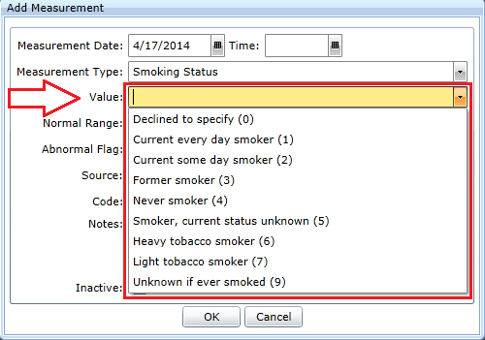

Once a Value has been selected for Smoking Status, clicking the OK button will enter the Smoking Status into the list of Measurements for this patient. Assuming this patient has a recorded visit with the EP, this patient will count towards the numerator for the Smoking Status measure for Stage 2 under Meaningful Use 2014. No further work is required and this patient will always be included in the numerator for any EP who has a recorded visit with this patient during the reporting period.

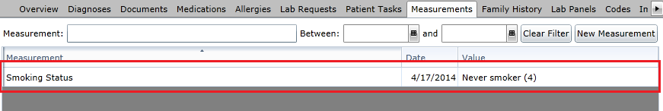

If a Smoking Status was entered incorrectly, the value can be changed by selecting the Measurement from the table above and the using the Action button on the details below. The value can be changed by using the Edit option or the entry can be removed by using the Inactivate option. The History option displays the audit record for all of the changes that were made for this particular entry.

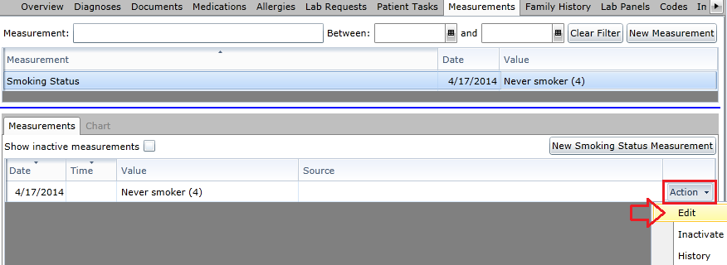

Stage 2 - Core #6: Clinical Decision Support (CDS)

Clinical Decision Support (CDS)
Objective | Use clinical decision support to improve performance on high-priority health conditions
Measure | Measure 1:  Implement five clinical decision support interventions related to four or more clinical quality measures at a relevant point in patient care for the entire EHR reporting period. Absent four clinical quality measures related to an EP’s scope of practice or patient population, the clinical decision support interventions must be related to high-priority health conditions.  Measure 2:  The EP has enabled and implemented the functionality for drug-drug and drug-allergy interaction checks for the entire EHR reporting period
Exclusion | For the second measure, any EP who writes fewer than 100 medication orders during the EHR reporting period

Clinical Decision Support (CDS): Attestation Requirements
YES / NO | EPs must attest YES to implementing five clinical decision support interventions and enabling and implementing functionality for drug-drug and drug-allergy interaction to meet this measure.

Clinical Decision Support: Explanation of Measure

Measure 1:

This measure does not have a numerator, denominator or reporting threshold. Instead, it is a Yes/No attestation by the EP. This means that there is nothing to track within the CEHRT as far as reporting specific numbers. Instead, the EP is supposed to have their CEHRT configured appropriately during the reporting period to ensure that they have met the stated requirements.

Clinical Decision Support (CDS) interventions are configured in the ADMIN side of Valant. A majority of the CDS interventions are directly related to specific Clinical Quality Measures (CQM’s). The Administrator of a practice is able to configure each EP such that a subset or the complete list of CDS interventions are enabled for that provider.

Measure 2:

This measure does not have a numerator, denominator or reporting threshold. Instead, it is a Yes/No attestation by the EP. This means that there is nothing to track within the CEHRT as far as reporting specific numbers. Instead, the EP is supposed to have their CEHRT configured appropriately during the reporting period to ensure that they have met the stated requirements.

Valant uses DrFirst for drug-drug and drug-allergy interaction checks. By default, all accounts with DrFirst have been configured for both drug-drug as well as drug-allergy interaction checks. These options cannot be disabled for any practices setup within DrFirst. As a result, the functionality for drug-drug and drug-allergy interaction checks is always enabled.

Clinical Decision Support: Recording of Numerator in Valant

As mentioned previously, this measure does not have a numerator, denominator or reporting threshold. As such, there are no values to track within Valant. Instead, an EP’s account must be configured correctly to ensure compliance for this measure.

For Measure 1, individual CDS interventions can be configured for any user within the practice by going to the ADMIN area of the program. Once in the ADMIN area, going to Persons and Institutions: Providers will allow interventions to be configured to the providers within the practice. Likewise, Persons and Institutions: Office Staff will allow interventions to be configured to the staff users within the practice.

For Meaningful Use 2014 reporting, only EP’s are required to be configured with active CDS interventions. However, providers not eligible for meaningful use within the practice as well as staff users can both have any number of CDS interventions configured to be active.

For more information relating to Clinical Decision Support (CDS) beyond what is mentioned in this document, please refer to the documentation located here XXXXXXX

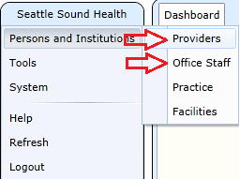

To enable which CDS interventions are active for a provider or staff user, select their name from the list and go to the Decision Support Rules tab for that user. There are a total of 18 individual CDS interventions that can be configured for a user, 12 of which are directly related to Clinical Quality Measures (CQM’s). In order for an EP to qualify for successfully reporting on this measure, at least 5 of the CDS interventions which relate to CQM’s must be active for the entire reporting period.

To enable a specific CDS intervention, check the box under Enable. To enable all CDS interventions, check the box to the left of Enable to check all of the boxes in this column.

For more information about CDS interventions, please refer to the documentation relating to this feature located XXXXX.

NOTE: CDS interventions need to be individual configured for each user within a practice. The default option for new users is to have everything checked for both Enable and Show Link. This applies to both providers and staff users within a practice. CDS interventions are only available to non-super users, meaning that staff users which have a single login in which to access multiple practices will not be able to receive CDS interventions.

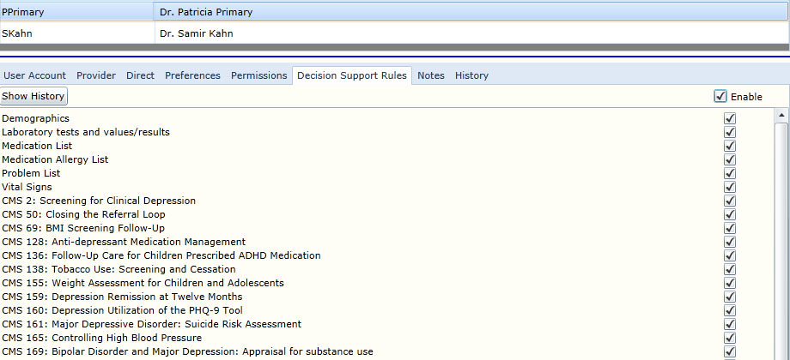

Stage 2 - Core #7: Patient Electronic Access

Patient Electronic Access
Objective | Provide patients the ability to view online, download and transmit their health information within four business days of the information being available to the EP.
Measure | Measure 1:  More than 50 percent of all unique patients seen by the EP during the EHR reporting period are provided timely (available to the patient within 4 business days after the information is available to the EP) online access to their health information.  Measure 2:  More than 5 percent of all unique patients seen by the EP during the EHR reporting period (or their authorized representatives) view, download, or transmit to a third party their health information.
Exclusion | Any EP who:  (1) Neither orders nor creates any of the information listed for inclusion as part of both measures, except for "Patient name" and "Provider's name and office contact information, may exclude both measures.  (2) Conducts 50 percent or more of his or her patient encounters in a county that does not have 50 percent or more of its housing units with 3Mbps broadband availability according to the latest information available from the FCC on the first day of the EHR reporting period may exclude only the second measure.

Measure 1 - Timely Access: Attestation Requirements
Denominator | Number of unique patients seen by the EP during the EHR reporting period
Numerator | The number of patients in the denominator who have timely (within 4 business days after the information is available to the EP) online access to their health information
Threshold | The resulting percentage must be more than 50 percent in order for an EP to meet this measure

Measure 2 - View, Download, or Transmit: Attestation Requirements
Denominator | Number of unique patients seen by the EP during the EHR reporting period
Numerator | The number of unique patients (or their authorized representatives) in the denominator who have viewed online, downloaded, or transmitted to a third party the patient's health information
Threshold | The resulting percentage must be more than 5 percent in order for an EP to meet this measure

Patient Electronic Access: Explanation of Measure

Measure 1: Timely Access

This measure is based on unique patients with a recorded visit by the EP during the reporting period. This means that a given patient, no matter how many times seen during the reporting period, can only count once for both numerator and denominator. Likewise, patients with no recorded visits during the reporting period will not count towards either numerator or denominator. Finally, this measure applies to all patients, regardless of age, who were seen during the reporting period.

This measure is met by electronically providing the patient a Health Summary within 4 business days of their visit. Once a Health Summary has been provided by an EP for an individual patient within 4 days of the patient’s visit, then this patient will count towards the numerator for that EP so long as the visit in question falls within the reporting period. Providing Health Summaries for additional visits for this patient, while certainly encouraged, will not provide any additional numerator values for that EP relative to this measure.

Each EP will need to provide at least one Health Summary within 4 business days of a visit for each individual patient seen during the reporting period in order to receive credit for the numerator for this measure. If more than one EP has a visit with the same patient during the reporting period, then each EP will need to provide their own Health Summary within 4 business days of their visit with the patient in order for that patient to count towards the numerator for that EP.

Measure 2: View, Download, or Transmit

This measure is based on unique patients with a recorded visit by the EP during the reporting period. This means that a given patient, no matter how many times seen during the reporting period, can only count once for both numerator and denominator. Likewise, patients with no recorded visits during the reporting period will not count towards either numerator or denominator. Finally, this measure applies to all patients, regardless of age, who were seen during the reporting period.

This measure is met by having the patient View, Download, or Transmit the aforementioned electronic Health Summary. Unlike other Core and Menu Measures, this option can only be met through direct patient action. As a result, providers are encouraged to take an active part in ensuring their patients perform the actions necessary for this measure to be met.

The action of having the patient View, Download, or Transmit their Health Summary is not tied to an individual EP within a practice. All EP’s within a practice will receive credit for a patient who has viewed, downloaded, or transmitted their Health Summary so long as that patient has a recorded visit with the EP during the reporting period. This means that, once the patient has performed an action related to their Health Summary, any EP who has a recorded visit with that patient during the reporting period will have that patient appear in both the numerator and denominator for this particular measure.

Patient Electronic Access: Meaningful Use Measures

There are two line items related to Patient Electronic Access in the Stage 2 list of Meaningful Use Measures. The line items shown in the list relate to the individual reporting options as follows:

Meaningful Use Measure List | Reporting Option
Patient Electronic Access - Timely Access | Measure 1: Timely Access
Patient Electronic Access - View, Download, Transmit | Measure 2: View, Download, or Transmit

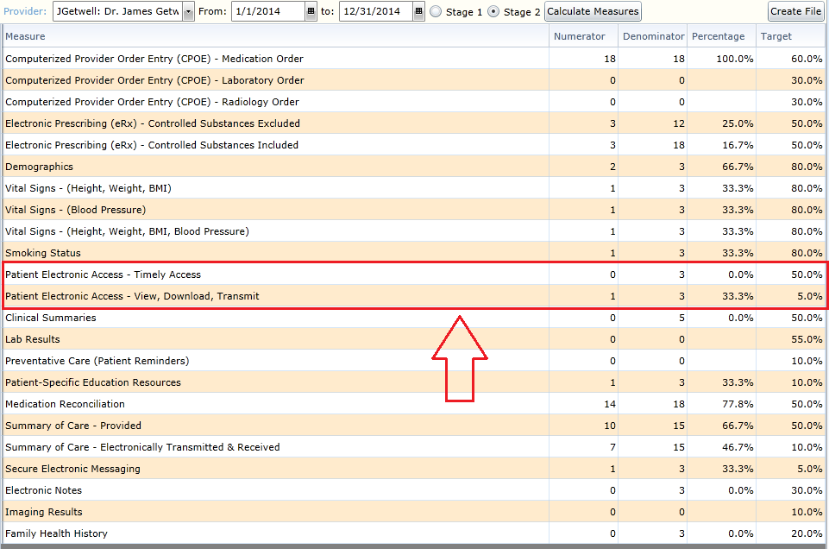

Patient Electronic Access: Recording of Numerator in Valant

Patient Electronic Access consists of two independent measures: Timely Access and View, Download, or Transmit. The Thresholds of both of these measures need to be met in order for an EP to successfully attest for Meaningful Use.

Measure 1: Timely Access

Timely Access refers to the requirement that an EP provide the patient with timely access (within 4 business days) to their health information (Health Summary). The Health Summary uses the Consolidated-Clinical Document Architecture (C-CDA) standard and consists of the following sections:

- Name of EP
- EP office contact information
- Patient name
- Sex
- Date of birth
- Race
- Ethnicity
- Preferred language
- Smoking status
- Problems
- Medications
- Medication Allergies
- Laboratory test(s)
- Laboratory value(s)/result(s)
- Vital signs – height, weight, blood pressure, BMI
- Care plan field(s), including goals and instructions
- Procedures
- Care team member(s)

Each section listed needs to be included with the Health Summary in order for it to be considered valid. This differs from a Clinical Summary, which allows the provider to exclude certain sections from the resulting documentation.

When generating a Health Summary, the provider will not be allowed to exclude any sections. Instead, a Health Summary is defaulted to include all sections automatically. Sections are allowed to be empty on the Health Summary, meaning that a patient is not required to have information relating to that section in order for a Health Summary to be considered complete.

To learn more information about the Health Summary, please refer to documentation XXXXX. For more information relating to Clinical Summaries, please refer to documentation XXXXX.
In order for a patient to receive a Health Summary, they must first be configured with an account in Patient Portal. The Health Summary must be provided electronically in order for an EP to meet the numerator for this measure, so the patient must have an active Patient Portal account. For more information relating to configuring a patient with Patient Portal, please refer to the documentation XXXXX.

Once a patient has been configured with a Patient Portal account, they can be provided a Health Summary by right clicking on their appointment and going down to Send C-CDA to Portal. Hovering over this option will provide several courses of action. The two options which can be used to meet the numerator for this measure are Health Summary and Clinical Summary & Health Summary.

NOTE: A Health Summary must be provided within 4 business days of the scheduled appointment in order to meet the numerator requirements.

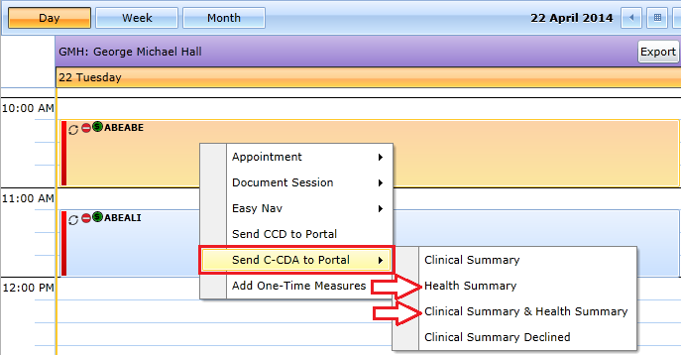

Choosing the Health Summary option under Send C-CDA to Portal will result in the dialogue window shown below. The EP will be identified in the Provider field based on the details of the scheduled appointment. Choosing OK will send the Health Summary to the patient’s Portal account.

NOTE: If the patient is not configured with Patient Portal, choosing the Health Summary option under Send C-CDA to Portal will result in a warning informing the user that the patient requires an active Patient Portal account to use this feature.

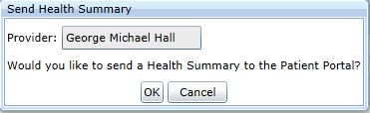
Choosing the Clinical Summary & Health Summary option under Send C-CDA to Portal will result in the dialogue window shown below. The EP will be identified in the Provider field and the appointment date will be used in the Visit Date based on the details of the scheduled appointment. Choosing Send to Portal will send the Health Summary to the patient’s Portal account. The other options shown on this window relate to the Clinical Summary. Please refer to the documentation on Clinical Summaries for more information about these fields.

NOTE: If the patient is not configured with Patient Portal, choosing the Health Summary option under Send C-CDA to Portal will result in a warning informing the user that the patient requires an active Patient Portal account to use this feature.

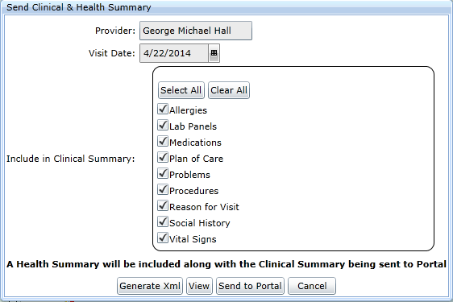

Health Summary in Patient Portal

Once a Health Summary has been sent to a patient, the patient is able to access the document by logging into their Patient Portal account and going to the Clinical Documents tab. The Health Summary will show up on the list of documents for this patient. The patient can choose to View the document, Download the document to their computer, or Transmit the document using Direct to another provider.

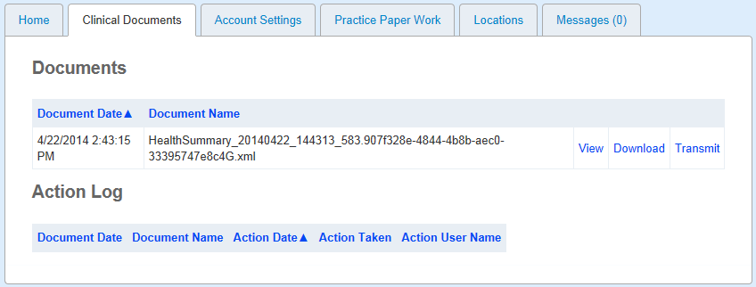

Measure 2: View, Download, or Transmit

View, Download, or Transmit refers to the actions that a patient must take in relation to the Health Summary in order for them to meet the numerator requirements for this measure. In order for a patient to perform an action on a Health Summary, the patient must first be configured with an account in Patient Portal and a copy of a Health Summary must be sent.

For more information relating to configuring a patient with Patient Portal, please refer to the documentation XXXXX. To learn more information about the Health Summary, please refer to documentation XXXXX.

Once a Health Summary has been sent to a patient, the patient is able to access the document by logging into their Patient Portal account and going to the Clinical Documents tab. The Health Summary will show up on the list of documents for this patient. The patient can choose to View the document, Download the document to their computer, or Transmit the document using Direct to another provider. Having the patient perform any of these actions will allow for them to count for the numerator for this measure.

Stage 2 - Core #8: Clinical Summaries

Clinical Summaries
Objective | Provide clinical summaries for patients for each office visit
Measure | Clinical summaries provided to patients or patient-authorized representatives within one business day for more than 50 percent of office visits
Exclusion | Any EP who has no office visits during the EHR reporting period

Clinical Summaries: Attestation Requirements
Denominator | Number of office visits conducted by the EP during the EHR reporting period
Numerator | Number of office visits in the denominator where the patient or a patient-authorized representative is provided a clinical summary of their visit within one (1) business day
Threshold | The resulting percentage must be more than 50 percent in order for an EP to meet this measure

Clinical Summaries: Explanation of Measure

This measure is based the number of recorded visits by the EP during the reporting period. This measure is unique in that it is the only measure which is directly related to the amount of visits that have been recorded by an EP. This means that, based on the visits that have been recorded, the same patient can count towards both the numerator and denominator multiple times during a reporting period for an individual EP. As such, care should be taken to ensure that the proper work is done to ensure that the EP will meet the threshold for this measure.

For each recorded visit the EP conducts with a patient, a Clinical Summary is required to be provided to the patient within 1 business day of the visit. If the same patient is seen more than once during the reporting period, a Clinical Summary must be provided for each unique visit in order to receive credit for the numerator for that visit. The Clinical Summary can be provided electronically or it can be printed in order for an EP to receive credit. Additionally, a Clinical Summary can be refused by the patient. A refusal of the Clinical Summary still counts towards the numerator for the EP with regards to the recorded visit.

Each EP will need to provide a Clinical Summary within 1 business day of a visit for each patient visit during the reporting period in order to receive credit for the numerator for this measure. If more than one EP has a visit with the same patient during the reporting period, then each EP will need to provide their own Clinical Summary within 1 business day of their visit with the patient in order for that visit to count towards the numerator for that EP.

Clinical Summaries: Meaningful Use Measures

There is a single line item related to Clinical Summaries in the Stage 2 list of Meaningful Use Measures. The name of this line item is Clinical Summaries.

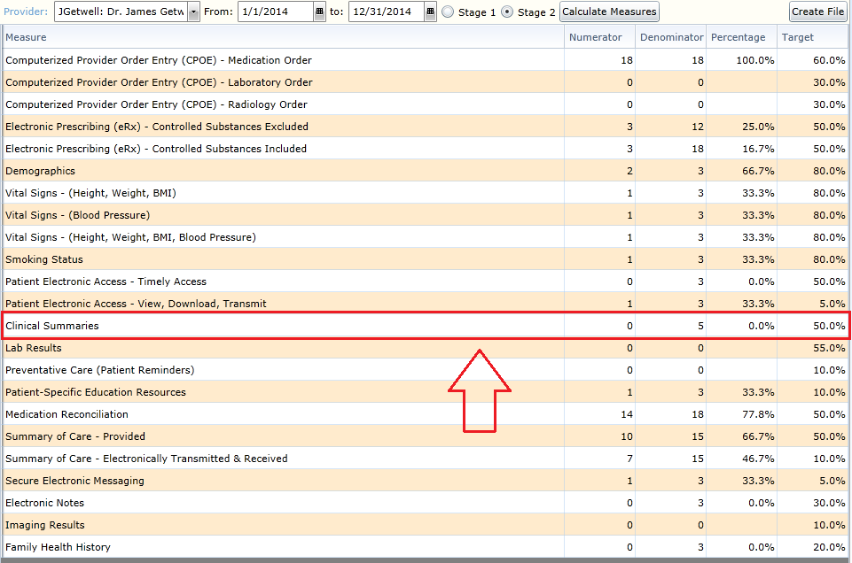

Clinical Summaries: Recording of Numerator in Valant

A Clinical Summary must be provided to the patient within 1 business day of their recorded visit in order to meet the numerator requirement for this measure. The Clinical Summary uses the Consolidated-Clinical Document Architecture (C-CDA) standard and consists of the following sections:

- Provider’s name and office contact information
- Date and location of visit
- Reason for visit
- Immunizations and/or medications administered during the visit
- Diagnostic tests pending
- Clinical Instructions
- Future appointments
- Referrals to other providers
- Future scheduled tests
- Recommended patient decision aids
- Patient name
- Sex
- Date of birth
- Race
- Ethnicity
- Preferred language
- Smoking status
- Problems
- Medications
- Medication Allergies
- Laboratory test(s)
- Laboratory value(s)/result(s)
- Vital signs – height, weight, blood pressure, BMI
- Care plan field(s), including goals and instructions
- Procedures
- Care team member(s)

Unlike the Health Summary, EP’s have the option to exclude certain information from the Clinical Summary. The sections that are excluded on a given Clinical Summary are up to the discretion of the EP and can vary by patient and visit. Sections are allowed to be empty on the Clinical Summary, meaning that a patient is not required to have information relating to that section in order for a Clinical Summary to be considered complete.

For more information relating to Clinical Summaries, please refer to documentation XXXXX.

The Clinical Summary can be provided electronically, printed, or even declined by the patient. Each option listed will count towards the numerator for this measure assuming that it occurs within 1 business day of the office visit. In order for a patient to receive a Clinical Summary electronically, they must first be configured with an account in Patient Portal. For more information relating to configuring a patient with Patient Portal, please refer to the documentation XXXXX.

Once a patient has been configured with a Patient Portal account, they can be provided a Clinical Summary electronically by right clicking on their appointment and going down to Send C-CDA to Portal. Hovering over this option will provide several courses of action. The three options which can be used to meet the numerator for this measure are Clinical Summary, Clinical Summary & Health Summary, and Clinical Summary Declined. Patients without a Patient Portal account can still access each of the options listed, however the ability to actually send the Clinical Summary electronically to Portal will be prevented for these patients.

NOTE: A Health Summary must be provided within 1 business day of the scheduled appointment in order to meet the numerator requirements. There is no means in which to post date when a Clinical Summary is provided. This means that the Clinical Summary MUST be provided in a timely manner in order for a visit to count towards the numerator for this measure.

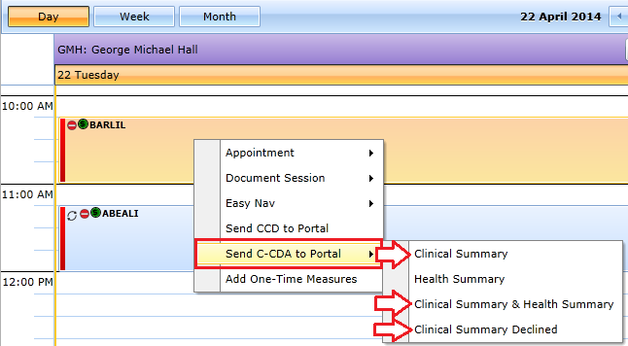

Send C-CDA to Portal: Clinical Summary

Choosing the Clinical Summary option under Send C-CDA to Portal will result in the dialogue window shown below. The EP will be identified in the Provider field and the appointment date will be used in the Visit Date based on the details of the scheduled appointment.

The EP has the option to exclude any of the sections listed from the contents of the Clinical Summary. To exclude a section from the Clinical Summary, simply uncheck the box located to the left of the description of the section to be excluded.

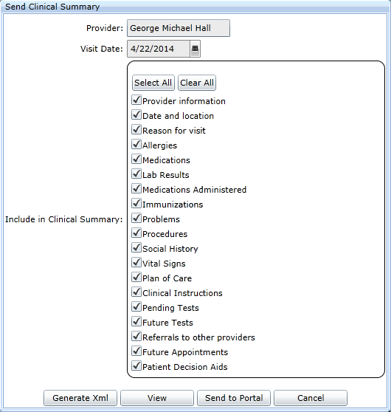

Choosing the Generate Xml button will produce a file consisting of an electronic version of the Clinical Summary. This file can be saved to portable media and given to the patient. Selecting this option will result in a dialogue window appearing which will allow the user to indicate whether or not the Clinical Summary was provided to the patient. Choosing ‘Yes’ on this window will allow the visit to count towards the numerator for this measure, assuming that this action was performed within 1 business day of the scheduled appointment.

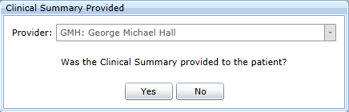

Choosing the View option will open a new page in the browser and display the Clinical Summary for this visit. This page can then be printed and given to the patient. Selecting this option will result in a dialogue window appearing which will allow the user to indicate whether or not the Clinical Summary was provided to the patient. Choosing ‘Yes’ on this window will allow the visit to count towards the numerator for this measure, assuming that this action was performed within 1 business day of the scheduled appointment.

Choosing Send to Portal will send the Clinical Summary to the patient’s Portal account. The patient must be configured with Patient Portal order to use this option. Selecting this option will result in the Clinical Summary being sent directly to the Patient Portal account for the patient scheduled to the appointment. As such, choosing this option will allow the visit to count towards the numerator for this measure, assuming that this action was performed within 1 business day of the scheduled appointment.

NOTE: If the patient is not configured with Patient Portal, choosing the Send to Portal option under Send Clinical Summary will result in a warning informing the user that the patient requires an active Patient Portal account to use this feature. The Clinical Summary MUST be provided within 1 business day of the scheduled appointment in order for the EP to receive credit for that visit. Clinical Summaries cannot be back dated.

Send C-CDA to Portal: Clinical Summary & Health Summary

Choosing the Clinical Summary & Health Summary option under Send C-CDA to Portal will result in the dialogue window shown below. The EP will be identified in the Provider field and the appointment date will be used in the Visit Date based on the details of the scheduled appointment.

The EP has the option to exclude any of the sections listed from the contents of the Clinical Summary. To exclude a section from the Clinical Summary, simply uncheck the box located to the left of the description of the section to be excluded.

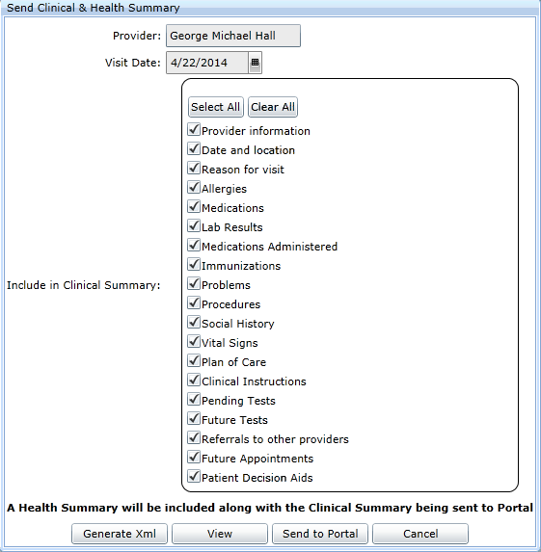

Choosing the Generate Xml button will produce a file consisting of an electronic version of the Clinical Summary. This file can be saved to portable media and given to the patient. Selecting this option will result in a dialogue window appearing which will allow the user to indicate whether or not the Clinical Summary was provided to the patient. Choosing ‘Yes’ on this window will allow the visit to count towards the numerator for this measure, assuming that this action was performed within 1 business day of the scheduled appointment.

Choosing the View option will open a new page in the browser and display the Clinical Summary for this visit. This page can then be printed and given to the patient. Selecting this option will result in a dialogue window appearing which will allow the user to indicate whether or not the Clinical Summary was provided to the patient. Choosing ‘Yes’ on this window will allow the visit to count towards the numerator for this measure, assuming that this action was performed within 1 business day of the scheduled appointment.

Choosing Send to Portal will send the Clinical Summary to the patient’s Portal account. The patient must be configured with Patient Portal order to use this option. Selecting this option will result in the Clinical Summary being sent directly to the Patient Portal account for the patient scheduled to the appointment. As such, choosing this option will allow the visit to count towards the numerator for this measure, assuming that this action was performed within 1 business day of the scheduled appointment.

NOTE: If the patient is not configured with Patient Portal, choosing the Send to Portal option under Send Clinical Summary will result in a warning informing the user that the patient requires an active Patient Portal account to use this feature. The Clinical Summary MUST be provided within 1 business days of the scheduled appointment in order for the EP to receive credit for that visit. Clinical Summaries cannot be back dated.

Send C-CDA to Portal: Clinical Summary Declined

Choosing the Clinical Summary Declined option under Send C-CDA to Portal will result in the dialogue window shown below. Selecting this option will allow the visit to count towards the numerator for this measure, assuming that this action was performed within 1 business day of the scheduled appointment.

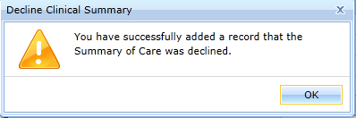

Clinical Summary in Patient Portal

Once a Clinical Summary has been sent to a patient, the patient is able to access the document by logging into their Patient Portal account and going to the Clinical Documents tab. The Clinical Summary will show up on the list of documents for this patient. The patient can choose to View the document, Download the document to their computer, or Transmit the document using Direct to another provider.

NOTE: The options for View, Download, or Transmit in relation to Clinical Summary when selected by the patient will NOT count towards the numerator for Measure 2: View, Download, or Transmit under Core Measure #7: Patient Electronic Access. Only Health Summaries accessed by the patient will be included under the numerator for Patient Electronic Access.

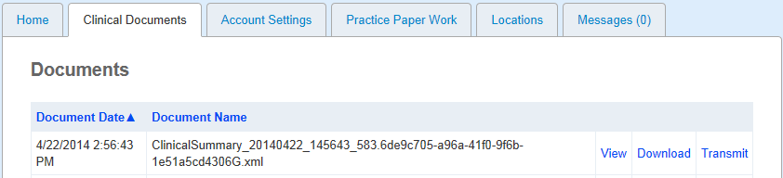

Stage 2 - Core #9: Protect Electronic Health Information

Protect Electronic Health Information
Objective | Protect electronic health information created or maintained by the certified EHR technology (CEHRT) through the implementation of appropriate technical capabilities
Measure | Conduct or review a security risk analysis in accordance with the requirements under 45 CFR 164.308(a) (1), including addressing the encryption/security of data stored in CEHRT in accordance with requirements under 45 CFR 164.312 (a)(2)(iv) and 45 CFR 164.306(d)(3), and implement security updates as necessary and correct identified security deficiencies as part of the provider's risk management process for EPs
Exclusion | No exclusion

Protect Electronic Health Information: Attestation Requirements
YES / NO | Eligible professionals (EPs) must attest YES to conducting or reviewing a security risk analysis and implementing security updates as needed to meet this measure.

Protect Electronic Health Information: Explanation of Measure

This measure does not have a numerator, denominator or reporting threshold. Instead, it is a Yes/No attestation by the EP. This means that there is nothing to track within the CEHRT as far as reporting specific numbers. Instead, the EP is supposed to have performed the work outside of the CEHRT and attest that the work had been done.

In the case of this measure, the EP is required to perform a security risk analysis and implement security updates as necessary to correct security deficiencies identified by the analysis. This needs to be done in accordance with 45 CFR 164.308(a) (1), 45 CFR 164.312 (a)(2)(iv), and 45 CFR 164.306(d)(3).

Stage 2 - Core #10: Clinical Lab-Test Results

Clinical Lab-Test Results
Objective | Incorporate clinical lab-test results into Certified EHR Technology (CEHRT) as structured data
Measure | More than 55 percent of all clinical lab tests results ordered by the EP during the EHR reporting period whose results are either in a positive/negative or numerical format are incorporated in Certified EHR Technology as structured data
Exclusion | Any EP who orders no lab tests where results are either in a positive/negative affirmation or numeric format during the EHR reporting period

Clinical Lab-Test Results: Attestation Requirements
Denominator | Number of lab tests ordered during the EHR reporting period by the EP whose results are expressed in a positive or negative affirmation or as a number
Numerator | Number of lab test results which are expressed in a positive or negative affirmation or as a numeric result which are incorporated in CEHRT as structured data
Threshold | Any EP who orders no lab tests where results are either in a positive/negative affirmation or numeric format during the EHR reporting period

Lab-Test Results: Explanation of Measure

This measure is based the number of Lab Requests generated by the EP during the reporting period. This measure is unique in that it is the only measure which is directly related to the amount of Lab Requests created by an EP. This means that, based on the Lab Requests that have been created, the same patient can count towards both the numerator and denominator multiple times during a reporting period for an individual EP. As such, care should be taken to ensure that the proper work is done to ensure that the EP will meet the threshold for this measure.

For each Lab Request created by the EP, the Lab Panels related to the order need to be incorporated in the CEHRT for that Lab Request to count towards the numerator for this measure. Each Lab Request can count at most once for both numerator and denominator, meaning that Lab Requests which contain multiple results will still only count as one entry for the purposes of this measure.

Only Lab Requests whose result can be expressed as a number or positive/negative value will count towards the denominator of this measure. Every Lab Request generated within the Valant Premium Psychiatric Suite is assumed to have a result which meets these criteria, so every Lab Request created by an EP during the reporting period will appear in the denominator for this measure.

Each EP will need to ensure that the Lab Requests created during the reporting period have results entered in the CEHRT in order to receive credit for the numerator for this measure. If more than one EP has a Lab Request with the same patient during the reporting period, then each EP will need to ensure that the Lab Panels have been entered for their own Lab Request for that result to count towards the numerator for that EP.

Lab Test Results: Meaningful Use Measures

There is a single line item related to Lab Test Results in the Stage 2 list of Meaningful Use Measures. The name of this line item is Lab Results.

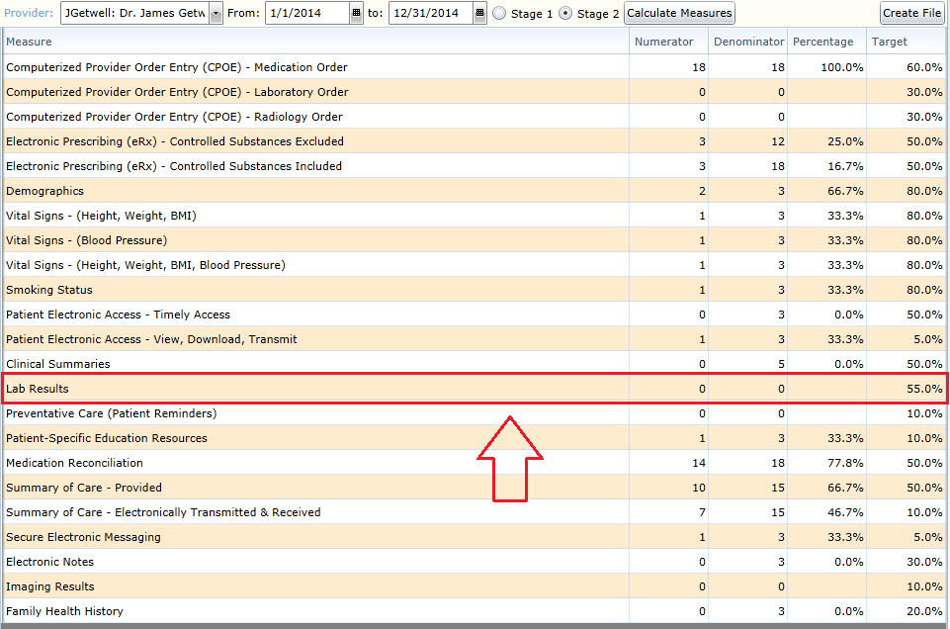

Lab-Test Results: Recording of Numerator in Valant

Recording the result of a Lab Request such that the result will count towards the numerator for the purposes of this measure can be achieved one of two ways: by using the Lab Panel tab in the patient chart or by using eLabs. It is important to note that there must be a Lab Request entered in the patient chart in order for a Lab Panel to be linked to the Lab Request.

For more information on the Lab Panels feature beyond what is described here, please refer to documentation XXXXX. For more information on the eLabs feature beyond what is described here, please refer to documentation XXXXX.

Lab-Test Results: Lab Panels

To upload the results from a Lab Request, navigate to the Lab Panels tab in the patient chart.

Once in the Lab Panels tab, clicking on the New Lab Panel button will start the process of entering the results of the Lab Request into the patient’s chart.

The lower half of the screen will become active once the New Lab Panel button is clicked. The user will be able to enter a Date for the Lab Panel as well as select the name of the Panel being entered. Once this has been done, the results can be entered by using the New Lab Results button. Each result which consists of a number or a positive/negative outcome needs to be recorded for the purposes of this measure.

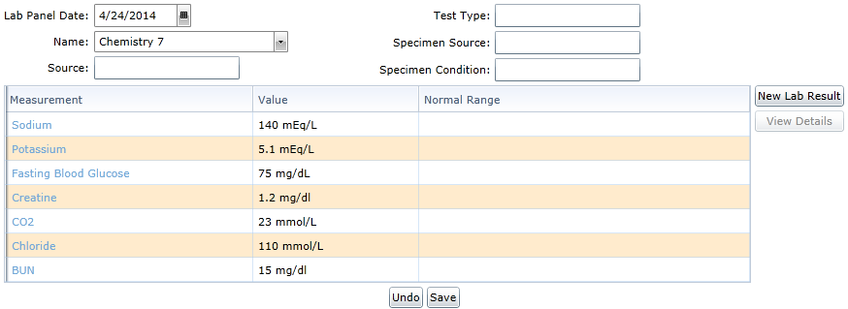
With the results entered, choosing the Save button will cause the Incorporating Lab Results for a Lab Request dialogue window to appear. It is here where the Lab Panel can be tied to an existing Lab Request. A Lab Request must be selected from the list in order to incorporate the Lab Panel to it. Checking the box next to the Lab Request which the Lab Panel relates to and choosing Save will cause the Lab Panel to be incorporated into the patient chart and mark the Lab Request as having its results incorporated. Doing this will make the Lab Request become eligible for the numerator for this measure.

NOTE: A Lab Request must be selected when incorporating a Lab Panel in order for that Lab Request to become eligible for the numerator for this measure.

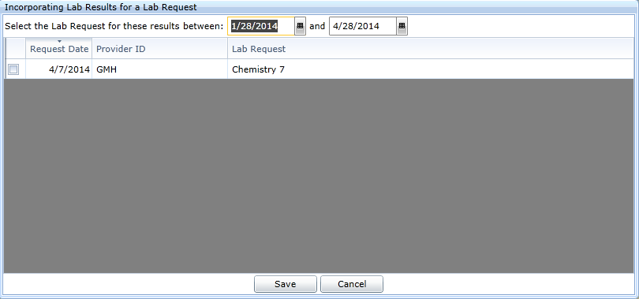

Lab-Test Results: eLabs

If a Lab Request is sent using the eLabs feature, then the electronic result will automatically be incorporated into the patient chart. Additionally, due to the nature of eLabs, the lab result will tied to the Lab Request. This means that, if a Lab Request is sent using the eLabs feature, then the returned results will make the Lab Request become eligible for the numerator for this measure with no further action required by the EP.

Since Lab Requests whose results can be expressed in a positive or negative affirmation or as a numeric result will count towards the denominator of this measure, only those requests sent using eLabs will have the option to appear in the numerator for this measure.

Stage 2 - Core #11: Patient Lists

Patient Lists
Objective | Generate lists of patients by specific conditions to use for quality improvement, reduction of disparities, research, or outreach
Measure | Generate at least one report listing patients of the EP with a specific condition
Exclusion | No exclusion

Patient Lists: Attestation Requirements
YES / NO | Eligible professionals (EPs) must attest YES to having generated at least one report listing patients of the EP with a specific condition to meet this measure.

Patient Lists: Explanation of Measure

This measure does not have a numerator, denominator or reporting threshold. Instead, it is a Yes/No attestation by the EP. This means that there is nothing to track within the CEHRT as far as reporting specific numbers. Instead, the EP is supposed to have performed a task at least once inside the CEHRT and attest that the work had been done.

For the purposes of this measure, an EP needs to make use of the Patient List/Reminders feature within the Valant Premium Psychiatrist Suite. The EP can successfully attest to completing this measure once they have generated a list of patients based on the Diagnosis using the Patient List/Reminders feature. This needs to be done by each EP attesting under Meaningful Use.

Patient Lists: Recording of Numerator in Valant

To generate a report listing patients based on a specific condition, the Patient List/Reminders feature must be used. For more information on the Patient List/Reminders feature beyond what is described here, please refer to documentation XXXXX.

The Patient List/Reminders feature will generate a list of active patients which have the specified values tied to their patient record. For the purposes of this measure, only the Diagnosis filter needs to be used.

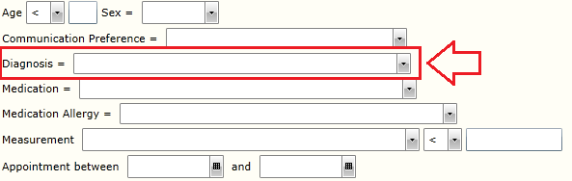

The Diagnosis filter will only list diagnoses which are currently assigned to active patients within the practice. An EP can generate a list of patients who currently have the specified diagnosis as active by selecting a diagnosis from the drop down list and clicking on the Get List button. The resulting list of patients will display in the table below. Once this has been done, the EP can successfully attest to having met the requirements of this measure.

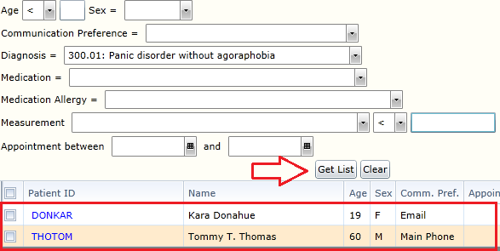

Stage 2 - Core #12: Preventive Care

Preventive Care
Objective | Use clinically relevant information to identify patients who should receive reminders for preventive/follow-up care and send these patients the reminders, per patient preference
Measure | More than 10 percent of all unique patients who have had 2 or more office visits with the EP within the 24 months before the beginning of the EHR reporting period were sent a reminder, per patient preference when available
Exclusion | Any EP who has had no office visits in the 24 months before the EHR reporting period

Patient Reminders: Attestation Requirements
Denominator | Number of unique patients who have had two or more office visits with the EP in the 24 months prior to the beginning of the EHR reporting period
Numerator | Number of patients in the denominator who were sent a reminder per patient preference when available during the EHR reporting period
Threshold | The resulting percentage must be more than 10 percent in order for an EP to meet this measure

Preventative Care/Patient Reminders: Explanation of Measure

This measure is based on unique patients who have had two or more recorded visits with the EP in the 24 months leading up to the reporting period. This means that, unlike other the other Core Measures, this measure is not based on the patients seen during the reporting period. Instead, the denominator of this measure relates to patients that were seen two or more times within a 2 year window before the start of the reporting period. A patient will not count towards the denominator of this measure if they do not have two or more recorded visits in the 24 months leading up to the reporting period.

Like the other Core Measures, a given patient can only count once for both numerator and denominator for this measure. This measure applies to all patients, regardless of age.

CMS has defined a Patient Reminder as being related to preventive/follow-up care that the patient is not already scheduled to receive. From the CMS Final Rule:

We believe that reminders should be limited to new actions that need to be taken not of actions that are already taken. For example, a reminder to schedule your next mammogram is a reminder to take action, while a reminder that your next mammogram is scheduled for next week is a reminder of action already taken.

This means that a reminder relating to a scheduled appointment with the EP will not satisfy the requirements for this measure. Instead, a Patient Reminder needs to be for services outside of scheduled treatment. Examples of this include referrals or to remind the patient to engage in certain activities.

In addition to sending the patient a pertinent Patient Reminder, the reminder itself must be sent using the patient’s preferred communication preference. Patient Reminders sent by a means outside of the patient’s preferred communication preference will not count towards the numerator for this measure. If the patient declines to provide their preferred communication medium, then any means of conveying the Patient Reminder will count towards the numerator.

The act of sending a Patient Reminder is not tied to a specific EP. Once a pertinent Patient Reminder has been sent to the patient, all EP’s within a practice will receive credit for that patient so long as the EP has had two or more recorded visits with the patient in the 24 months leading up to the reporting period. This means that, once the patient has be sent a Patient Reminder, any EP who meets the criteria for the patient falling within the denominator will have that patient appear in both the numerator and denominator for this particular measure.

Preventative Care/Patient Reminders: Meaningful Use Measures

There is a single line item related to Patient Reminders in the Stage 2 list of Meaningful Use Measures. The name of this line item is Preventative Care (Patient Reminders).

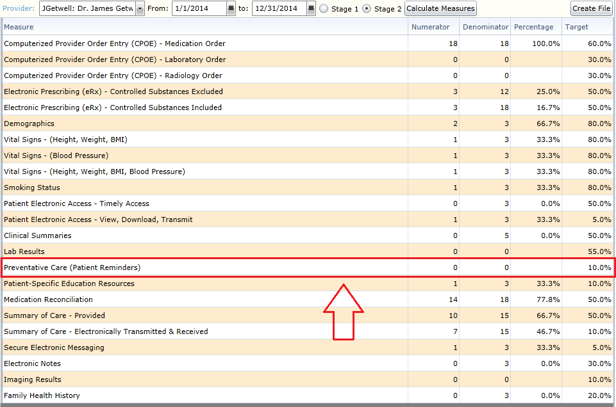

Preventative Care/Patient Reminders: Recording of Numerator in Valant

The Valant Premium Psychiatrist Suite has been certified to track when the EP indicates that a Patient Reminder has been sent using the preferred communication preference for their patient. However, sending the actual Patient Reminder is outside the scope of the certification. This means that an EP will need to ensure that a Patient Reminder is actually sent and that the Patient Reminder was sent using the patient’s preferred communication preference. Once the reminder has been sent using the patients preferred communication method, the EP can record the action using the Patient List/Reminders feature. For more information on the Patient List/Reminders feature beyond what is described here, please refer to documentation XXXXX.

The Patient List/Reminders feature will generate a list of active patients which have the specified values tied to their patient record. For the purposes of this measure, any combination of filters can be used to generate a list of patients for which Patient Reminders can be sent. In the example below, the EP has generated a list of patients who currently have the specified diagnosis by selecting a diagnosis from the drop down list and clicking on the Get List button. Included in the details of the patient list are the patient’s ID, Name, and Communication Preference.

The Communication Preference for a patient can be set in Persons and Institutions: Patients under the Misc tab. The field is called Confidential Preference and the following options can be selected: Email, Mail, Main Phone, Phone 2, Phone 3, Phone 4, and Secure Messaging. Only a single option can be selected for the patient’s Confidential Preference.

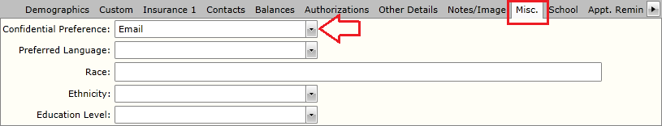

Once a list of patients has been generated, check the box to the right of the patient ID for which Patient Reminders have been sent. With the appropriate patients selected, clicking on the button Reminder sent for preventative/follow-up care will allow the EP to indicate that a Patient Reminder was sent.

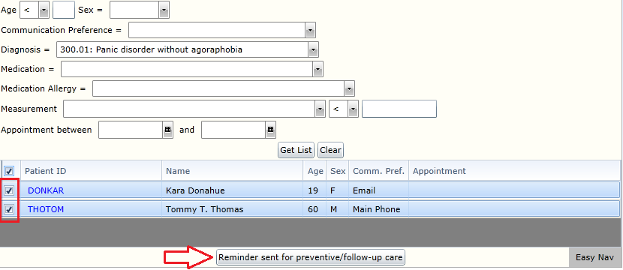
In the dialogue window which results, the EP related to the Patient Reminder as well as the date that the reminder was sent are required fields in order to continue. This dialogue window allows the EP to confirm that an appropriate Patient Reminder was sent using the patient’s preferred communication preference on the date specified. Once the fields have been completed, clicking Confirm will continue to Patient Reminder process.

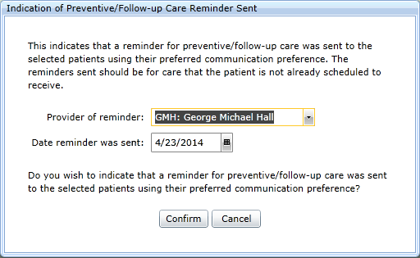

Once the Confirm button has been selected, the EP will be presented with a summary of the information that has been entered. Additionally, there is a warning message informing the user that this feature is only indicating that a Patient Reminder was sent using the patient’s preferred communication preference. It is not sending a reminder to the selected patients.

Assuming the information presented is correct, the EP can once again click the Confirm button to complete the indication that Patient Reminders were sent to the selected patients using their preferred communication preference. Doing so will allow for the selected patients to be eligible for the numerator of this measure.

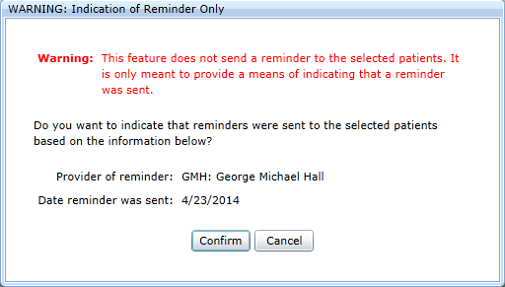

Stage 2 - Core #13: Patient-Specific Education Resources

Patient-Specific Education Resources
Objective | Use clinically relevant information from Certified EHR Technology to identify patient-specific education resources and provide those resources to the patient
Measure | Patient-specific education resources identified by Certified EHR Technology are provided to patients for more than 10 percent of all unique patients with office visits seen by the EP during the EHR reporting period
Exclusion | Any EP who has no office visits during the EHR reporting period

Patient-Specific Education Resources: Attestation Requirements
Denominator | Number of unique patients with office visits seen by the EP during the EHR reporting period
Numerator | Number of patients in the denominator who were provided patient-specific education resources identified by the Certified EHR Technology
Threshold | The resulting percentage must be more than 10 percent in order for an EP to meet this measure

Patient-Specific Education Resources: Explanation of Measure

This measure is based on unique patients with a recorded visit by the EP during the reporting period. This means that a given patient, no matter how many times seen during the reporting period, can only count once for both numerator and denominator. Likewise, patients with no recorded visits during the reporting period will not count towards either numerator or denominator. Finally, this measure applies to all patients, regardless of age, who were seen during the reporting period.

Providing a patient with patient-specific education resources that were identified by the CEHRT can occur before, during or after the reporting period. This means that it does not matter when the education resources were provided so long as it is done prior to generating the measures for submission to CMS. Additionally, once the education resources have been provided to a patient, then that patient will always appear in the numerator for an EP that has a recorded visit with that patient during the reporting period.

Providing a patient with patient-specific education resources that were identified by the CEHRT is not tied to an individual EP within a practice. All EP’s within a practice will receive credit for a patient who have been provided with patient-specific education resources that were identified by the CEHRT so long as that patient has a recorded visit with the EP during the reporting period. This means that, once a patient has been provided education resources, any EP who has a recorded visit with that patient during the reporting period will have that patient appear in both the numerator and denominator for this particular measure.

Patient-Specific Education Resources: Meaningful Use Measures

There is a single line item related to Patient-Specific Education Resources in the Stage 2 list of Meaningful Use Measures. The name of this line item is Patient-Specific Education Resources.

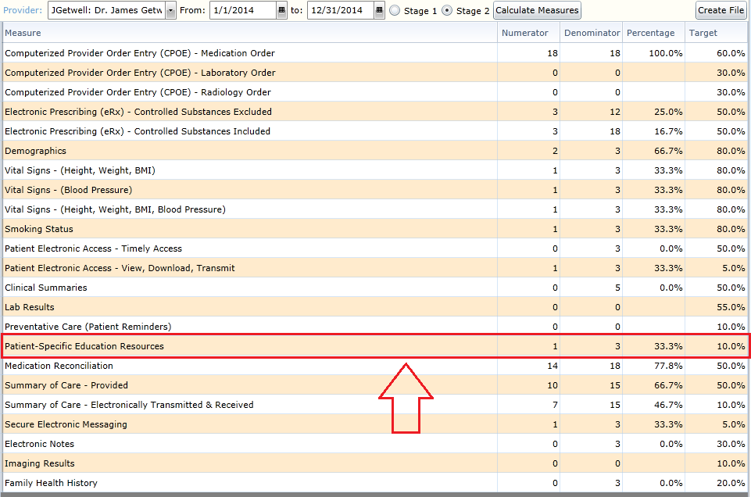

Patient-Specific Education Resources: Recording of Numerator in Valant

The purpose of this measure is to provide the patient with education materials that have been identified by the CEHRT. This means that, in order to receive credit for the numerator for this measure, the link to the educational material needs to come from within the CEHRT. There are three tabs within the patient chart that Patient-Specific Education Resources are identified in the Valant Premium Psychiatrist Suite: Diagnoses, Medications, and Lab Panels.

The source used for Patient-Specific Education Resources in the Valant Premium Psychiatrist Suite in MedlinePlus. The information can be accessed by either using the Infobutton (which appears as a blue circle with an ‘i’ in the center) or by using the context search function (which appears as a link connected to the description). Both options, when used, will allow the EP to indicate that educational material was provided to the patient.

For more information on Patient-Specific Education Resources feature beyond what is described here, please refer to documentation XXXXX.

Patient-Specific Education Resources: Diagnoses

Patient-Specific Education Resources are identified in the patient chart under the Diagnoses tab.

Any diagnosis that has been entered for a patient will have both an Infobutton icon (which appears as a blue circle with an ‘i’ in the center) and a link for the code and description. Clicking on either the Infobutton or the link will open a new tab in the browser and provide education resources for this diagnosis.

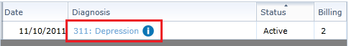

Once the link has been clicked, the user will be able to indicate that the Patient-Specific Education Resources identified were provided to the patient. Choosing Yes from this dialogue window will allow for the patient to be eligible to appear in the numerator for this measure.

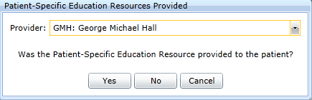

Patient-Specific Education Resources: Medications

Patient-Specific Education Resources are identified in the patient chart under the Medications tab.

Any medication that has been entered for a patient will have both an Infobutton icon (which appears as a blue circle with an ‘i’ in the center) and a link for the code and description. Clicking on either the Infobutton or the link will open a new tab in the browser and provide education resources for this medication.

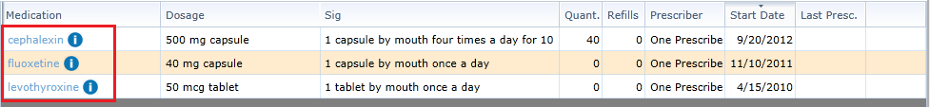

Once the link has been clicked, the user will be able to indicate that the Patient-Specific Education Resources identified were provided to the patient. Choosing Yes from this dialogue window will allow for the patient to be eligible to appear in the numerator for this measure.

Patient-Specific Education Resources: Lab Panels

Patient-Specific Education Resources are identified in the patient chart under the Lab Panels tab.

Any lab panel that has been entered for a patient will have various measurements associated with it. Each measurement tied to a Lab Panel will have both an Infobutton icon (which appears as a blue circle with an ‘i’ in the center) and a link for the code and description. Clicking on either the Infobutton or the link will open a new tab in the browser and provide education resources for this medication.

NOTE: Lab Panel values must have a valid LOINC code entered for the result in order for the patient education material to reference correctly. This means that care must be taken when entering new Measurement Types so as to ensure that the proper LOINC code is tied to each lab result.

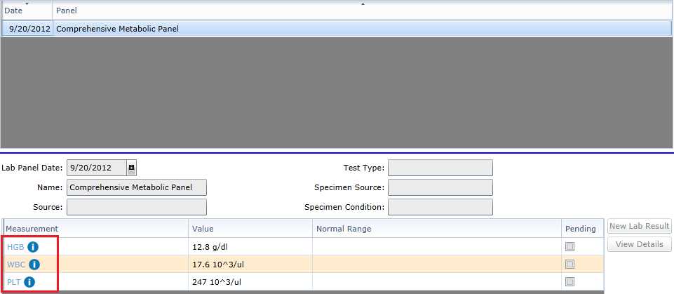

Once the link has been clicked, the user will be able to indicate that the Patient-Specific Education Resources identified were provided to the patient. Choosing Yes from this dialogue window will allow for the patient to be eligible to appear in the numerator for this measure.

Patient-Specific Education Resources: MedlinePlus

The Valant Premium Psychiatrist Suite uses MedlinePlus for Patient-Specific Education Resources. Medline Plus is a website hosted by the National Library of Medicine, a part of the National Institutes of Health, and was created to be the authoritative location for health information. Clicking on the link for either diagnosis or lab panel measurement in the Valant Premium Psychiatrist Suite will open the corresponding page in MedlinePlus. From here, the EP is able to choose what education resources to convey to their patients based on the information presented by MedlinePlus.

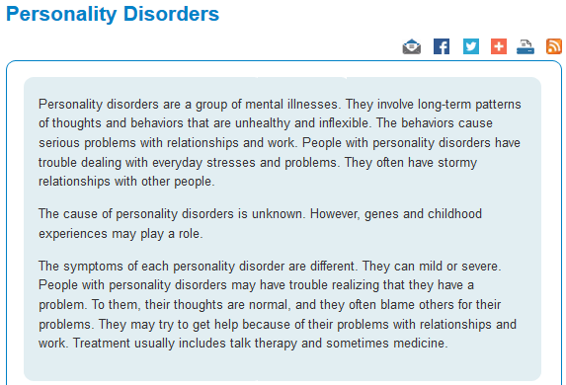

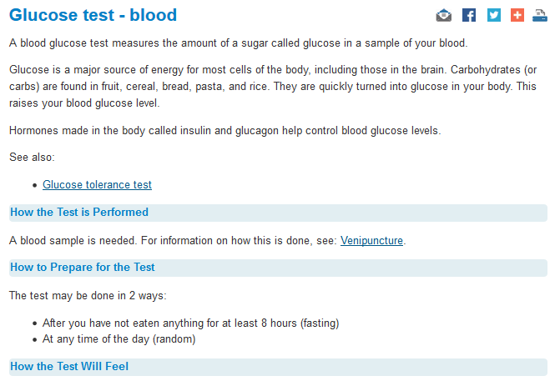

Stage 2 - Core #14: Medication Reconciliation

Medication Reconciliation
Objective | The EP who receives a patient from another setting of care or provider of care or believes an encounter is relevant should perform medication reconciliation
Measure | The EP who performs medication reconciliation for more than 50 percent of transitions of care in which the patient is transitioned into the care of the EP
Exclusion | Any EP who was not the recipient of any transitions of care during the EHR reporting period

Medication Reconciliation: Attestation Requirements
Denominator | Number of transitions of care during the EHR reporting period for which the EP was the receiving party of the transition
Numerator | The number of transitions of care in the denominator where medication reconciliation was performed
Threshold | The resulting percentage must be more than 50 percent in order for an EP to meet this measure

Medication Reconciliation: Explanation of Measure

This measure is based the number of Medication Reconciliations performed through transitions of care received by the EP during the reporting period. Ostensibly, this measure is based on work down by the EP on patients transferring into their care from another provider. This means that, based on the transfers that have occurred, the same patient can count towards both the numerator and denominator multiple times during a reporting period for an individual EP. As such, care should be taken to ensure that the proper work is done to ensure that the EP will meet the threshold for this measure.

For each transfer of care received by the EP, a Medication Reconciliation is required to be performed in order for the transfer to count towards the numerator for this measure. If the same patient transferred into care for the same EP more than once during the reporting period, a Medication Reconciliation must be performed for each unique transfer in order to receive credit for the numerator for that transfer.

Each EP will need to perform a Medication Reconciliation for each Transfer of Care they received during the reporting period in order to receive credit for the numerator for this measure. If more than one EP has received a Transfer of Care with the same patient during the reporting period, then each EP will need to provide their own Medication Reconciliation with the transfer in order for that transfer to count towards the numerator for that EP.

Medication Reconciliation: Meaningful Use Measures

There is a single line item related to Medication Reconciliation in the Stage 2 list of Meaningful Use Measures. The name of this line item is Medication Reconciliation.

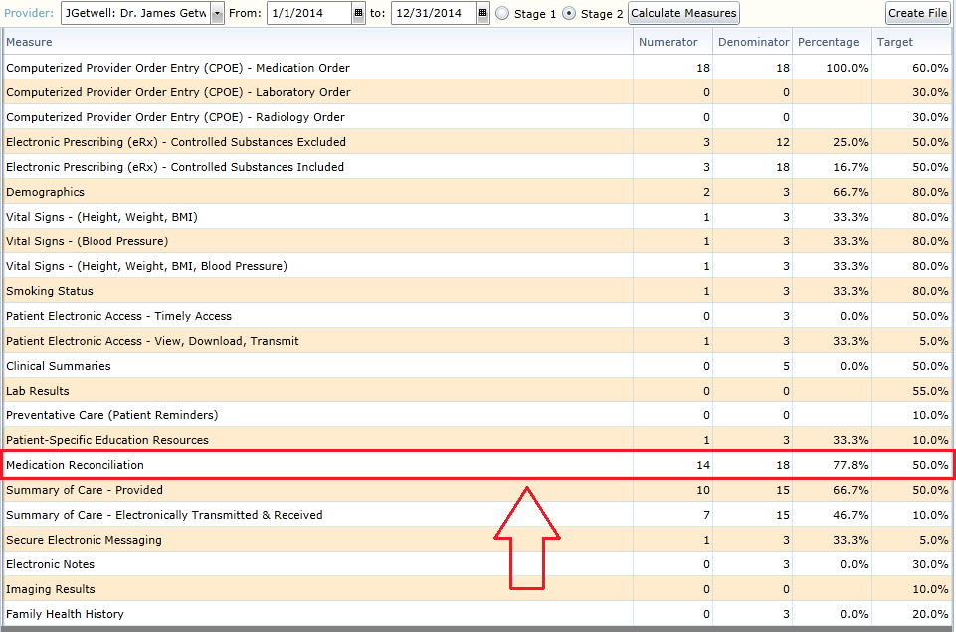

Medication Reconciliation: Recording of Numerator in Valant

The purpose of this measure is to ensure that a patient has their medications reconciled within the CEHRT when they transfer into the care of an EP during. There are two methods of reconciling medications: using the Transfer of Care tab in the Patient Chart or utilizing the Reconcile Summary of Care feature within Direct Messaging.

Medication Reconciliation: Patient Chart > Transfer of Care

A user can indicate that Medication Reconciliation occurred for a patient through the Transfer of Care tab of the patient chart.

Choosing the New Non-Direct Summary of Care button located above the Reconcile Summary of Care (incoming) table will begin the process of manually indicating that a Summary of Care occurred for the patient. This option is to be used when a patient transferred into care without the EP receiving a Direct message containing a Summary of Care for the patient.

The Edit Summary of Care dialogue window will appear once the New Non-Direct Summary of Care button is clicked. It is through this window where a transfer of care can be indicated as well as the fact that Medication Reconciliation occurred.

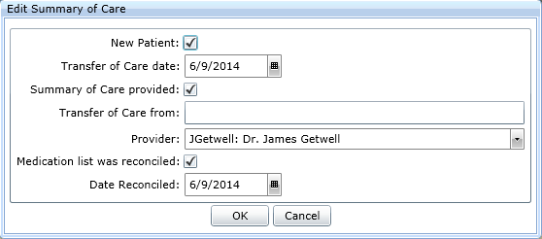
New Patient: This field is used to indicate that the patient for whom the Transfer of Care was received is new to the practice. If this box is unchecked, it indicates that the patient was already in treatment with the practice when the Transfer of Care was received.

This box only has an effect on the Stage 2 version of this measure. Specifically, this checkbox is used with Summary of Care provided checkbox to determine if the Transfer of Care will count towards the denominator of this measure. See the description of the Summary of Care provided field for more information.

Transfer of Care date: This field is used to determine when the Transfer of Care occurred. This date must fall within the reporting period in order for the transfer to count towards numerator and/or denominator of this measure.

Summary of Care provided: This field is used to indicate that a Summary of Care was provided along with the patient transitioning into the EP’s care.

This box only has an effect on the Stage 2 version of this measure. If the Summary of Care provided box is checked, then the Transfer of Care will count towards the denominator of this measure. If the Summary of Care box is unchecked, then the Transfer of Care will only count towards the denominator of this measure if the New Patient box is also checked.

Transfer of Care from: This field is used to indicate where the patient is transitioning from.

This field is entirely optional and does not play any role in determining the numerator or denominator for this measure.

Provider: This field is used to indicate which provider received the Transfer of Care. The provider chosen represents the EP for the purposes of this measure. This means that only the provider attached to the Transfer of Care will receive credit for the numerator and/or denominator of this measure.

Medication list was reconciled: This field indicates that a Medication Reconciliation occurred based on the Transfer of Care. Checking this box will allow the transfer to count towards the numerator for this measure. Failing to check this box will ensure that the denominator increases without the numerator increasing as well.

Date Reconciled: This field indicates when the Medication Reconciliation occurred. This field is required to be filled with a date when the Medication list was reconciled checkbox is checked.

This field does nothing for the purposes of calculating the numerator and/or denominator of this measure. The only reason it exists is for certification.

When entering a new Transfer of Care, the following must occur in order for the numerator to increment for an EP:
- The Transfer of Care date must fall within the recording period
- The Summary of Care provided checkbox must be checked or the Summary of Care provided checkbox is unchecked and the New Patient checkbox is checked
- The Provider field must be set to the EP
- The Medication List was reconciled checkbox must be checked
- The Date Reconciled field must contain a date

Assuming each field listed above has been filled correctly, the line item created will count towards the numerator.

Medication Reconciliation: Direct Messaging > Reconcile Summary of Care

By reconciling a Summary of Care within Direct Messaging, an EP can receive credit for Medication Reconciliation automatically. In order to do this, the EP must first receive a direct message which contains a Summary of Care document as part of the Transfer of Care for a patient. The C-CDA will appear as an attachment to the message. Clicking the Open button on the message will show the details of the Direct Message.

For more information on the Direct Messaging feature beyond what is described here, please refer to documentation XXXXX.

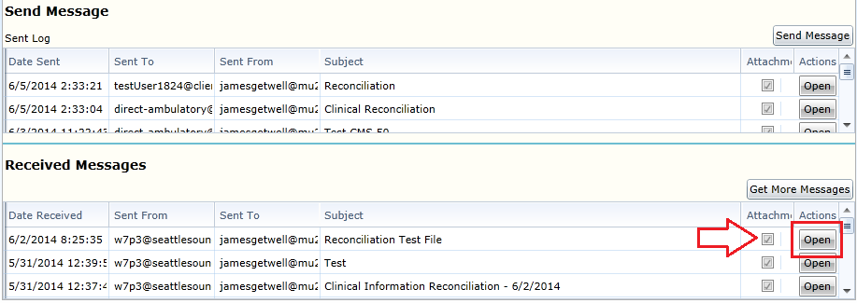

With the details of the message open, the details of the attachment can be viewed. If the attachment is a Summary of Care file (an XML document), then the option to Reconcile Summary of Care will be available. Clicking on this button will begin the process of Reconciliation for the patient.

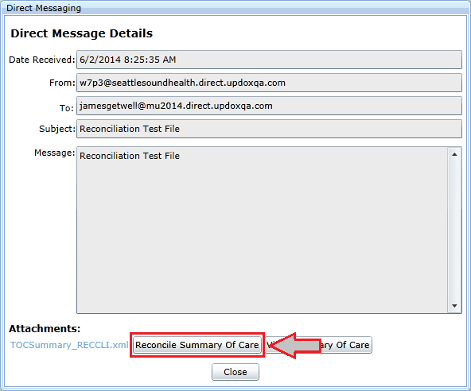

The first step in Reconciliation is to link the patient contained in the Summary of Care document (shown on the left side) to a patient within the practice (shown on the right). The system will attempt to automatically locate a patient within the practice based on the details of the Summary of Care document. The Change Patient field allows for a different patient to be selected for Reconciliation other than what the system selected. The Provider field determines which EP will receive credit for the Transfer of Care.

Once the patient and provider have been selected, clicking Next will continue the Reconciliation process.

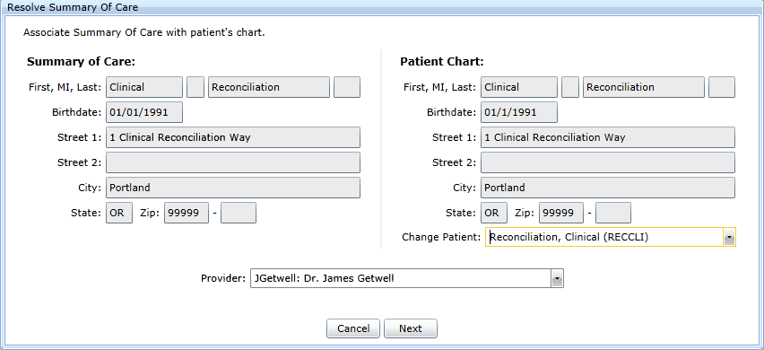

Here is when the majority of the Reconciliation occurs. Problems, Medications, and Medication Allergies can all be reconciled. The items on the left side are contained in the Summary of Care document, while the lists on the right relate to the current values contained in the patient chart. Unchecking an item from either side will remove it from the list during the Merge. Once the line items for each list have been properly culled, clicking the Merge button will combine the two sides together into a single list for each category.

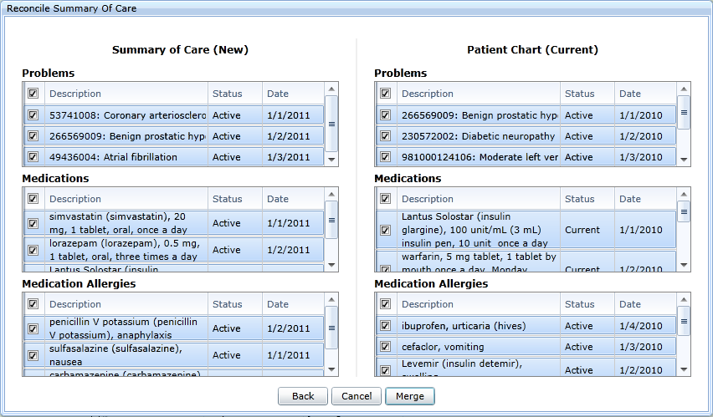

The merged list is presented for each category prior to being saved to the patient’s chart. This is the final review screen before the changes become permanent. Clicking the Save to Patient Chart button will complete the Reconciliation process.

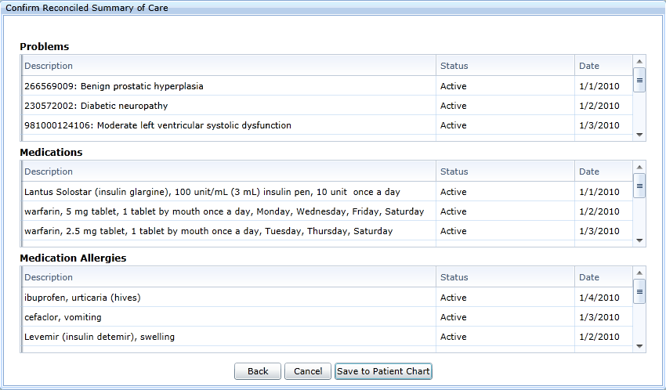

Once the information has been saved to the chart, a line item will automatically appear under the Transfer of Care tab in the patient chart. The line item will indicate the Transfer of Care date, Provider, and the fact that the Medications were Reconciled automatically based when the Summary of Care was reconciled and which provider was selected for the reconciliation. This line item will count towards the numerator of this measure, assuming, of course, that the Transfer of Care date falls within the reporting period.

Stage 2 - Core #15: Summary of Care

Summary of Care
Objective | The EP who transitions their patient to another setting of care or provider of care or refers their patient to another provider of care should provide summary care record for each transition of care or referral
Measure | EPs must satisfy both of the following measures in order to meet the objective:  Measure 1:  The EP who transitions or refers their patient to another setting of care or provider of care provides a summary of care record for more than 50 percent of transitions of care and referrals.  Measure 2:  The EP who transitions or refers their patient to another setting of care or provider of care provides a summary of care record for more than 10 percent of such transitions and referrals either  - electronically transmitted using CEHRT to a recipient or  - where the recipient receives the summary of care record via exchange facilitated by an organization that is a NwHIN Exchange participant or in a manner that is consistent with the governance mechanism ONC establishes for the NwHIN.  Measure 3:  An EP must satisfy one of the following criteria:  - Conducts one or more successful electronic exchanges of a summary of care document, as part of which is counted in "measure 2" (for EPs the measure at §495.6(j)(14)(ii)(B) with a recipient who has EHR technology that was developed designed by a different EHR technology developer than the sender's EHR technology certified to 45 CFR 170.314(b)(2).  - Conducts one or more successful tests with the CMS designated test EHR during the EHR reporting period.
Exclusion | Any EP who transfers a patient to another setting or refers a patient to another provider less than 100 times during the EHR reporting period is excluded from all three measures

Measure 1 - Referral/Transfer of Care: Attestation Requirements
Denominator | Number of transitions of care and referrals during the EHR reporting period for which the EP was the transferring or referring provider
Numerator | The number of transitions of care and referrals in the denominator where a summary of care record was provided
Threshold | The percentage must be more than 50 percent in order for an EP to meet this measure

Measure 2 - Electronic Transmission and Receipt: Attestation Requirements
Denominator | Number of transitions of care and referrals during the EHR reporting period for which the EP was the transferring or referring provider
Numerator | The number of transitions of care and referrals in the denominator where a summary of care record was  - electronically transmitted using CEHRT to a recipient or  - where the recipient receives the summary of care record via exchange facilitated by an organization that is a NwHIN Exchange participant or in a manner that is consistent with the governance mechanism ONC establishes for the nationwide health information network. The organization can be a third-party or the sender's own organization.
Threshold | The percentage must be more than 10 percent in order for an EP to meet this measure

Measure 3 - Conduct Successful Electronic Exchange: Attestation Requirements
YES / NO | - Conducts one or more successful electronic exchanges of a summary of care document, as part of which is counted in "measure 2" (for EPs the measure at §495.6(j)(14)(ii)(B) with a recipient who has EHR technology that was developed designed by a different EHR technology developer than the sender's EHR technology certified to 45 CFR 170.314(b)(2).  or  - Conducts one or more successful tests with the CMS designated test EHR during the EHR reporting period.

Summary of Care: Explanation of Measure

Measure 1: Referral/Transfer of Care

This measure is based the number of transitions of care or referrals performed by the EP during the reporting period. Ostensibly, this measure is based on work down by the EP on patients transferring out of their care or being referred to another provider. This means that, based on the referrals or transfers that have occurred, the same patient can count towards both the numerator and denominator multiple times during a reporting period for an individual EP. As such, care should be taken to ensure that the proper work is done to ensure that the EP will meet the threshold for this measure.

For each transfer of care or referral performed by the EP, a Summary of Care is required to be provided in order for the transfer/referral to count towards the numerator for this measure. If the same patient transferred or referred more than once during the reporting period, a Summary of Care must be provided for each unique transfer/referral in order to receive credit for the numerator for that transfer/referral.

For the purposes of this measure, the means in which the Summary of Care is provided for the Transfer of Care or Referral is inconsequential. The Summary of Care can be sent electronically via Direct, faxed, or even printed and mailed in order for an EP to receive credit.

Each EP will need to provide a Summary of Care for each Referral or Transfer of Care they performed during the reporting period in order to receive credit for the numerator for this measure. If more than one EP has a Transfer of Care or Referral with the same patient during the reporting period, then each EP will need to provide their own Summary of Care with the Transfer/Referral in order for that visit to count towards the numerator for that EP.

Measure 2: Electronic Transmission and Receipt

This measure is based the number of transitions of care or referrals performed by the EP during the reporting period. Ostensibly, this measure is based on work down by the EP on patients transferring out of their care or being referred to another provider. This means that, based on the referrals or transfers that have occurred, the same patient can count towards both the numerator and denominator multiple times during a reporting period for an individual EP. As such, care should be taken to ensure that the proper work is done to ensure that the EP will meet the threshold for this measure.

For each transfer of care or referral performed by the EP, a Summary of Care is required to be provided in order for the transfer/referral to count towards the numerator for this measure. If the same patient transferred or referred more than once during the reporting period, a Summary of Care must be provided for each unique transfer/referral in order to receive credit for the numerator for that transfer/referral.

For the purposes of this measure, the Summary of Care must be sent electronically via Direct in order for an EP to receive credit for the numerator. Additionally, not only must the Summary of Care be sent by Direct message, but the message must actually be received by the recipient in order for the transfer/referral to count towards the numerator. This means that an EP must take care to ensure that their Direct message has been received and that the Direct address used for the recipient was valid.

Each EP will need to provide a Summary of Care for each Referral or Transfer of Care they performed during the reporting period in order to receive credit for the numerator for this measure. If more than one EP has a Transfer of Care or Referral with the same patient during the reporting period, then each EP will need to provide their own Summary of Care with the transfer/referral in order for that visit to count towards the numerator for that EP.

Measure 3: Conduct Successful Electronic Exchange

This measure does not have a numerator, denominator or reporting threshold. Instead, it is a Yes/No attestation by the EP. This means that there is nothing to track within the CEHRT as far as reporting specific numbers. Instead, the EP is supposed to have performed a task at least once inside the CEHRT and attest that the work had been done.

In order to successfully attest to this measure, the EP is required to electronically exchange a Summary of Care document with a recipient that is not using the Valant Premium Psychiatrist Suite. Alternatively, the EP can conduct a test of data submission with CMS directly in order to pass this requirement. It should be noted that an EP will be able to successfully attest to this measure if the EP meets the numerator requirement for Measure 2 of this criteria (so long as at least one of the Direct messages sent with the Summary of Care was to a receipt who is not using the Valant Premium Psychiatrist Suite).

For the purposes of this measure, each EP is required to perform a successful transmission of a Summary of Care (or a test with CMS) on their own. The work down by one EP within a practice will not count for another in terms of this measure. This means that each EP within a practice will need to send at least one Direct message containing a Summary of Care to a recipient who is not using the Valant Premium Psychiatrist Suite during the reporting period in order to successfully attest to this measure.

Summary of Care: Meaningful Use Measures

There are two line items related to Summary of Care in the Stage 2 list of Meaningful Use Measures. The line items shown in the list relate to the individual reporting options as follows:

Meaningful Use Measure List | Reporting Option
Summary of Care - Provided | Measure 1: Referral/Transfer of Care
Summary of Care - Electronically Transmitted & Received | Measure 2: Electronic Transmission and Receipt

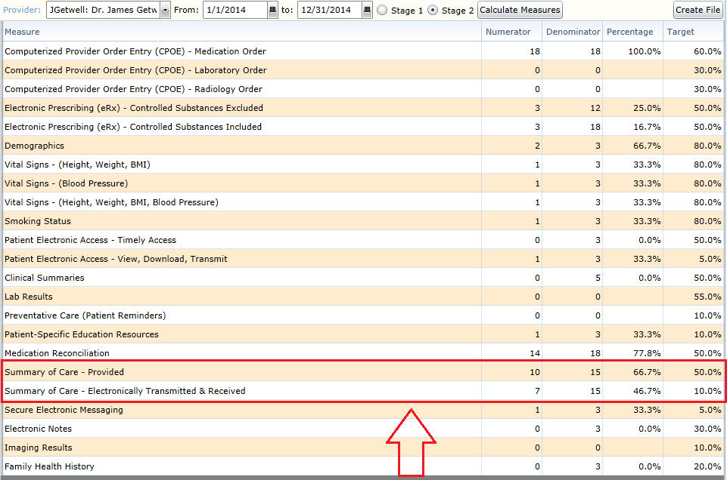

Summary of Care: Recording of Numerator in Valant

This measure is based entirely around the function of transferring or referring a patient to another provider or setting. A Transfer of Care or Referral for a patient can be indicated under the Transfer of Care tab in the patient chart.

For more information on the Transfer of Care/Referral feature beyond what is described here, please refer to documentation XXXXX.

Under the Transfer of Care tab, choosing the option New Transfer of Care/Referral from the lower table will start the Transfer of Care process.

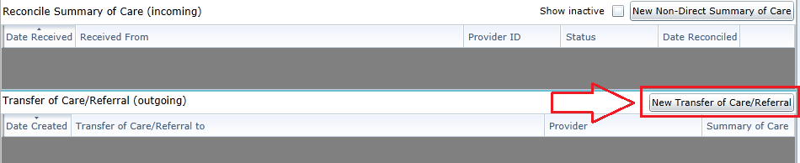

Once the New Transfer of Care/Referral button has been clicked, the transfer/referral can be indicated in the New Transfer of Care/Referral dialogue window which results. There are three main options to choose from which relate to how the transfer of care/referral occurred and only one option can be selected for each transfer of care/referral. The options are:

- Transfer of Care/Referral with a Summary of Care provided using Direct Messaging
  - This option, when used, will satisfy Measure 1 and Measure 2
  - If the recipient of the transfer/referral is a provider not using the Valant Premium Psychiatric suite, then this feature can also be used to satisfy Measure 3
- Transfer of Care/Referral with a Summary of Care provided by a method other than Direct Messaging
  - This option, when used, will satisfy Measure 1 only
- Transfer of Care/Referral without creating a Summary of Care
  - This option, when used, will not satisfy any of the measures

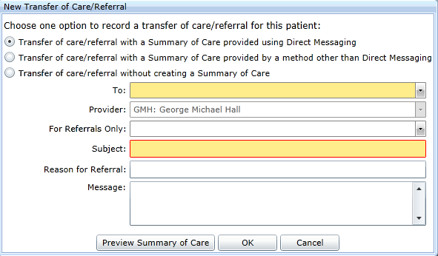

When using the option to send the Summary of Care using Direct Messaging, both a recipient and a subject must be provided. The recipient is chosen from a drop down list of providers who are on the Direct Messaging contact list for the practice. If a recipient outside of this list is to be the receiver of the transfer/referral, then the recipient needs to be added to the Direct Messaging contact list prior to using this feature.

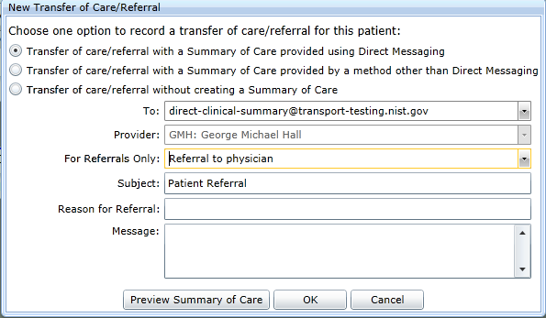

Clicking the OK button after choosing the method of the transfer/referral as well as filling the required fields will result in the transfer/referral appearing in the table. It is important to note that, in order to receive credit for Measure 2, not only must a Summary of Care be sent via Direct Messaging, but that message must be received by the recipient. This means that Direct Addresses for recipients cannot be invalid nor can Summary of Cares be sent to Direct Addresses that are not yet vetted.

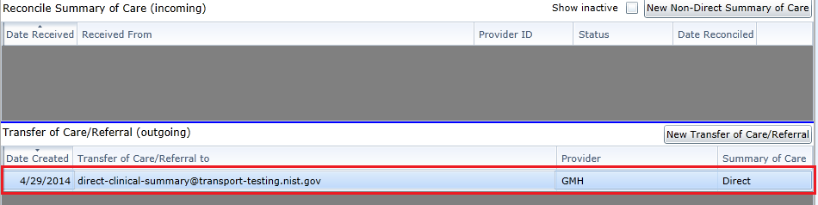

Stage 2 - Core #16: Immunization Registries Data Submission

Immunization Registries Data Submission
Objective | Capability to submit electronic data to immunization registries or immunization information systems except where prohibited, and in accordance with applicable law and practice
Measure | Successful ongoing submission of electronic immunization data from CEHRT to an immunization registry or immunization information system for the entire EHR reporting period
Exclusion | Any EP that meets one or more of the following criteria may be excluded from this  objective:  - the EP does not administer any of the immunizations to any of the populations for which data is collected by their jurisdiction's immunization registry or immunization information system during the EHR reporting period;  - the EP operates in a jurisdiction for which no immunization registry or immunization information system is capable of accepting the specific standards required for CEHRT at the start of their EHR reporting period;  - the EP operates in a jurisdiction where no immunization registry or immunization information system provides information timely on capability to receive immunization data; or  - the EP operates in a jurisdiction for which no immunization registry or immunization information system that is capable of accepting the specific standards required by CEHRT at the start of their EHR reporting period can enroll additional EPs.

Immunization Registries Data Submission: Attestation Requirements
YES / NO | The EP must attest YES to meeting one of the following criteria under the umbrella of ongoing submission.  - Ongoing submission was already achieved for an EHR reporting period in a prior year and continues throughout the current EHR reporting period using either the current standard at 45 CFR 170.314(f)(1) and (f)(2) or the standards included in the 2011 Edition EHR certification criteria adopted by ONC during the prior EHR reporting period when ongoing submission was achieved.  - Registration with the PHA or other body to whom the information is being submitted of intent to initiate ongoing submission was made by the deadline (within 60 days of the start of the EHR reporting period) and ongoing submission was achieved.  - Registration of intent to initiate ongoing submission was made by the deadline and the EP or hospital is still engaged in testing and validation of ongoing electronic submission.  - Registration of intent to initiate ongoing submission was made by the deadline and the EP or hospital is awaiting invitation to begin testing and validation.

Immunization Registries Data Submission: Explanation of Measure

This measure does not have a numerator, denominator or reporting threshold. Instead, it is a Yes/No attestation by the EP. This means that there is nothing to track within the CEHRT as far as reporting specific numbers. Instead, the EP is supposed to have performed the work outside of the CEHRT and attest that the work had been done.

In the case of this measure, the EP is required to submit immunization data to an immunization registry or immunization information system. Due to the fact that Behavioral Health EP’s do not administer immunizations to the patient populations, this measure is one that we expect all EP’s of the Valant Premium Psychiatrist Suite exclude out during their reporting.

Since administering immunizations to patients is outside the scope of Behavioral Health, this measure was deemed outside of the scope of the Valant Premium Psychiatrist Suite. As a result, this measure is excluded from the certification of the Valant Premium Psychiatrist Suite for the 2014 CEHRT.

Stage 2 - Core #17: Use Secure Electronic Messaging

Use Secure Electronic Messaging
Objective | Use secure electronic messaging to communicate with patients on relevant health information
Measure | A secure message was sent using the electronic messaging function of CEHRT by more than 5 percent of unique patients (or their authorized representatives) seen by the EP during the EHR reporting period
Exclusion | Any EP who has no office visits during the EHR reporting period, or any EP who conducts 50 percent or more of his or her patient encounters in a county that does not have 50 percent or more of its housing units with 3Mbps broadband availability according to the latest information available from the FCC on the first day of the EHR reporting period

Electronic Messaging - Patient to EP: Attestation Requirements
Denominator | Number of unique patients seen by the EP during the EHR reporting period
Numerator | The number of patients or patient-authorized representatives in the denominator who send a secure electronic message to the EP that is received using the electronic messaging function of CEHRT during the EHR reporting period
Threshold | The resulting percentage must be more than 5 percent in order for an EP to meet this measure

Secure Electronic Messaging: Explanation of Measure

This measure is based on unique patients with a recorded visit by the EP during the reporting period. This means that a given patient, no matter how many times seen during the reporting period, can only count once for both numerator and denominator. Likewise, patients with no recorded visits during the reporting period will not count towards either numerator or denominator. Finally, this measure applies to all patients, regardless of age, who were seen during the reporting period.

This measure is met by having the patient send a Secure Electronic Message to the EP during the reporting period. Unlike other Core and Menu Measures, this option can only be met through direct patient action. As a result, providers are encouraged to take an active part in ensuring their patients perform the actions necessary for this measure to be met.

Each EP will need to have received a Secure Electronic Message from a patient with a recorded visit during the reporting period in order to receive credit towards the numerator for that patient. If more than one EP has a visit with the same patient during the reporting period, then each EP will need to receive a Secure Electronic Message from that patient in order for that patient to count towards the numerator for that EP.

Secure Electronic Messaging: Meaningful Use Measures

There is a single line item related to Secure Electronic Messaging in the Stage 2 list of Meaningful Use Measures. The name of this line item is Secure Electronic Messaging.

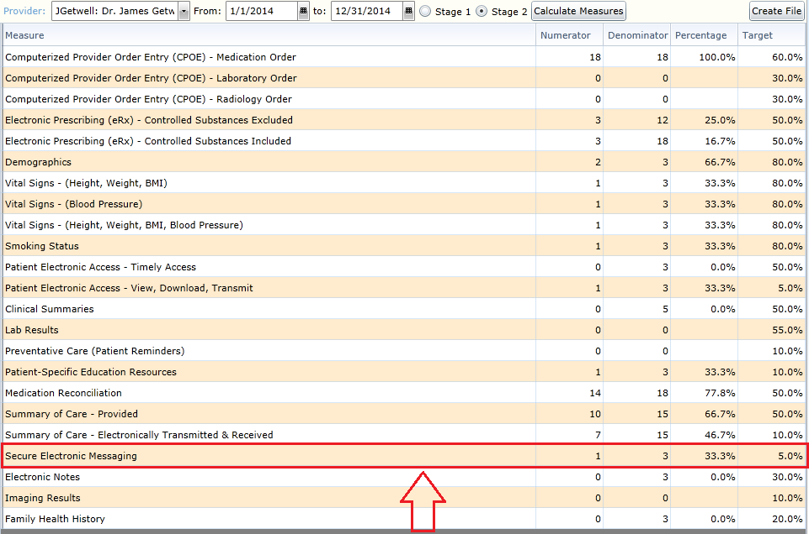

Secure Electronic Messaging: Recording of Numerator in Valant

This measure relates specifically to Secure Electronic Messages that are sent from the Patient to the EP. This means that Secure Electronic Messages sent by the EP or the EP’s practice to the Patient will not count towards the numerator for this measure. Instead, the patient needs to send a message to a specific EP in order for that patient to qualify for the numerator.

The threshold requirement for Secure Electronic Messaging can be met by using the Secure Messaging feature within Patient Portal. Specifically, from a patient can log into their Patient Portal account and access their Secure Messaging area. Once in the area, the patient can either compose a new message or reply to an existing message. Performing either action will make this patient eligible for the numerator for this measure. It is important to note that the recipient of the message must be the EP in order for that EP to receive credit for the numerator.

For more information on the Secure Messaging within Patient Portal feature beyond what is described here, please refer to documentation XXXXX.

Stage 2 Menu Measures

Three of the Six Menu Measures need to be reported on in order for an EP to prove Meaningful Use under the 2014 Edition of CEHRT. Several of the Menu Measures have an exclusion options which allows an EP to opt out of reporting on that measure.

Some of the Menu Measures have one or more Numerator, Denominator, and corresponding Threshold. The Valant Premium Psychiatrist Suite is capable of recording each of these values for the measures that have this requirement. The purpose of this documentation is to provide insight into how these values are captured.

Certain Menu Measures do not have any Numerator or Denominator reporting criteria. Instead, these measures are Yes/No questions answered by the attesting EP. For these Measures, the Valant Premium Psychiatrist Suite does not record any information. This is because the information required for attestation is recorded outside of the CEHRT. For Yes/No Core Measures, the EP is required to track their compliance outside of the CEHRT and attest using this external data.

Finally, not all Measures under the 2014 Edition of CEHRT were included in the certification of the Valant Premium Psychiatrist Suite as they fell outside of the scope of practice for behavioral health. It is assumed that the Measures which are not included in the Valant Premium Psychiatrist Suite can be successfully excluded by the EP as they do not relate to the scope of that EP’s work.

Full descriptions of each of the 6 Menu Measures can be found below. The definition of the Measure as well as the Numerator, Denominator, and reporting Threshold are all included. Additionally, there is an interpretation of the Measure as well as descriptions on how to make use of the Valant Premium Psychiatrist Suite to meet the reporting threshold.

Stage 2 - Menu #1: Syndromic Surveillance Data Submission

Syndromic Surveillance Data Submission
Objective | Capability to submit electronic syndromic surveillance data to public health agencies except where prohibited, and in accordance with applicable law and practice
Measure | Successful ongoing submission of electronic syndromic surveillance data from CEHRT to a public health agency for the entire EHR reporting period
Exclusion | Any EP that meets one or more of the following criteria may be excluded from this  objective:  - The EP is not in a category of providers that collect ambulatory syndromic surveillance information on their patients during the EHR reporting period;  - The EP operates in a jurisdiction for which no public health agency is capable of receiving electronic syndromic surveillance data in the specific standards required by CEHRT at the start of their EHR reporting period;  - The EP operates in a jurisdiction where no public health agency provides information timely on capability to receive syndromic surveillance data; or  - The EP operates in a jurisdiction for which no public health agency that is capable of accepting the specific standards required by CEHRT at the start of their EHR reporting period can enroll additional EPs.

Syndromic Surveillance Data Submission: Attestation Requirements
YES / NO | EPs must attest YES to successful ongoing submission of electronic syndromic surveillance data from CEHRT to a public health agency for the entire EHR reporting period.  - Ongoing submission was already achieved for an EHR reporting period in a prior year and continues throughout the current EHR reporting period.  - Registration with the PHA or other body to whom the information is being submitted of intent to initiate ongoing submission was made by the deadline (within 60 days of the start of the EHR reporting period) and ongoing submission was achieved.  - Registration of intent to initiate ongoing submission was made by the deadline and the EP or hospital is still engaged in testing and validation of ongoing electronic submission.  - Registration of intent to initiate ongoing submission was made by the deadline and the EP or hospital is awaiting invitation to begin testing and validation.

Syndromic Surveillance Data: Explanation of Measure

This measure does not have a numerator, denominator or reporting threshold. Instead, it is a Yes/No attestation by the EP. This means that there is nothing to track within the CEHRT as far as reporting specific numbers. Instead, the EP is supposed to have performed the work outside of the CEHRT and attest that the work had been done.

In the case of this measure, the EP is required to submit syndromic surveillance data to public health. Due to the fact that Behavioral Health EP’s are not a category of providers that collect ambulatory syndromic surveillance information on their patients, this measure is one that we expect all EP’s of the Valant Premium Psychiatrist Suite exclude out during their reporting.

Since the collecting ambulatory syndromic surveillance information of patients is outside the scope of Behavioral Health, this measure was deemed outside of the scope of the Valant Premium Psychiatrist Suite. As a result, this measure is excluded from the certification of the Valant Premium Psychiatrist Suite for the 2014 CEHRT.

Stage 2 - Menu #2: Electronic Notes

Electronic Notes
Objective | Record electronic notes in patient records
Measure | Enter at least one electronic progress note created, edited and signed by an EP for more than 30 percent of unique patients with at least one office visit during the EHR Measure reporting period. The text of the electronic note must be text searchable and may contain drawings and other content
Exclusion | No exclusion

Electronic Notes: Attestation Requirements
Denominator | Number of unique patients with at least one office visit during the EHR reporting period for EPs during the EHR reporting period
Numerator | The number of unique patients in the denominator who have at least one  electronic progress note from an eligible professional recorded as text searchable data
Threshold | The resulting percentage must be more than 30 percent in order for an EP to meet this measure

Electronic Notes: Explanation of Measure

This measure is based on unique patients with a recorded visit by the EP during the reporting period. This means that a given patient, no matter how many times seen during the reporting period, can only count once for both numerator and denominator. Likewise, patients with no recorded visits during the reporting period will not count towards either numerator or denominator. Finally, this measure applies to all patients, regardless of age, who were seen during the reporting period.

To meet the numerator requirement for this measure, a patient needs to have at least one signed note attached to their chart that was both created and signed within the Valant Premium Psychiatric Suite by the EP. By definition, all notes created in this manner are text searchable. Additionally, the term “progress note” denotes any signed electronic note relating to a patient visit. CMS defines this as a category including phone notes and counseling visits.

Each EP will need to ensure that they create and sign at least one note for each patient seen during the reporting period in order to receive credit for the numerator for this measure. If more than one EP has a recorded visit with the same patient during the reporting period, then each EP will need to ensure that they have at least one signed document for that patient in order for the patient to count towards the numerator for that EP.

Electronic Notes: Meaningful Use Measures

There is a single line item related to Electronic Notes in the Stage 2 list of Meaningful Use Measures. The name of this line item is Electronic Notes.

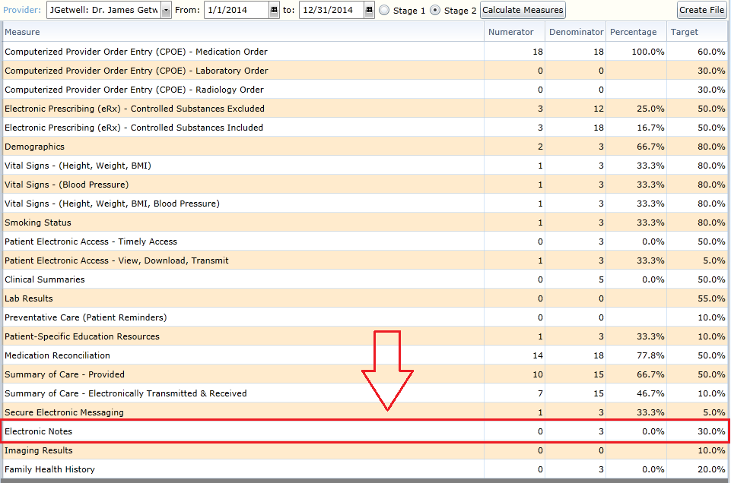

Electronic Notes: Recording of Numerator in Valant

Any clinical document created and signed within the Valant Premium Psychiatric Suite will count towards meeting the requirement of this measure. This means that notes created using the Web Editor, Word Template, or Mobile Notes can all be used to satisfy the numerator. The documents must be clinical notes; as such, non-clinical documents will not meet the numerator requirement. Additionally, documents that have been uploaded will not be used to meet the requirement of this measure as they were not created within the system.

Stage 2 - Menu #3: Imaging Results

Imaging Results
Objective | Imaging results consisting of the image itself and any explanation or other accompanying information are accessible through CEHRT
Measure | More than 10 percent of all tests whose result is one or more images ordered by the EP during the EHR reporting period are accessible through CEHRT
Exclusion | Any EP who orders less than 100 tests whose result is an image during the EHR reporting period; or any EP who has no access to electronic imaging results at the start of the EHR reporting period

Imaging Results: Attestation Requirements
Denominator | Number of tests whose result is one or more images ordered by the EP during the EHR reporting period
Numerator | The number of results in the denominator that are accessible through CEHRT
Threshold | The resulting percentage must be more than 10 percent in order to meet this measure

Imaging Results: Explanation of Measure

This measure is based the number of Image Orders requested by the EP during the reporting period. This measure is unique in that it is the only measure which is directly related to the amount of Image Orders created by an EP. This means that, based on the Image Orders that have been created, the same patient can count towards both the numerator and denominator multiple times during a reporting period for an individual EP. As such, care should be taken to ensure that the proper work is done to ensure that the EP will meet the threshold for this measure.

For each Image Order created by the EP, the image results related to the order need to be incorporated in the CEHRT for that Image Order to count towards the numerator for this measure. Each Image Order can count at most once for both numerator and denominator, meaning that Image Orders which contain multiple results will still only count as one entry for the purposes of this measure.

Each EP will need to ensure that the Image Orders created during the reporting period have results entered in the CEHRT in order to receive credit for the numerator for this measure. If more than one EP has an Image Order with the same patient during the reporting period, then each EP will need to ensure that the Image Results have been entered for their own Image Order for that result to count towards the numerator for that EP.

Imaging Results: Meaningful Use Measures

There is a single line item related to Imaging Results in the Stage 2 list of Meaningful Use Measures. The name of this line item is Imaging Results.

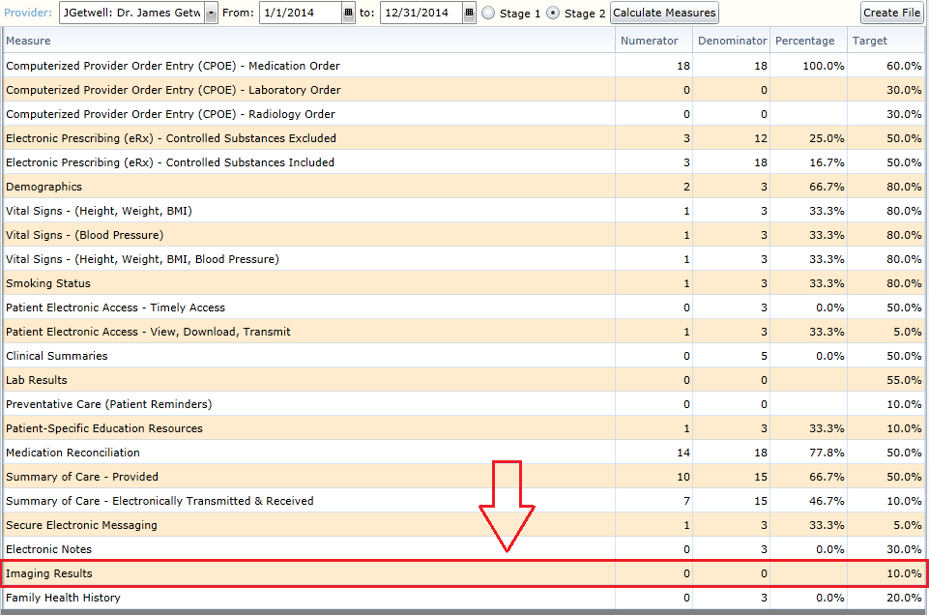

Imaging Results: Recording of Numerator in Valant

Recording the result of an Image Order such that the Image Result will count towards the numerator for the purposes of this measure is a two-step process. First, the Image Results must be uploaded into the Valant Premium Psychiatric Suite. Once this has been done, the Image Order needs to be marked to indicate that the results for this order have been incorporated into the patient chart.

For more information on the Image Results feature beyond what is described here, please refer to documentation XXXXX.

Image Results

To upload the results from an Image Order, navigate to the Image Results tab in the patient chart.

Clicking on the New Image Result button will start the process of uploading the Image Result into the patient’s record.

An Image Result can be uploaded into the patient’s chart through the Add New Image Result window. A Date, Interpretation, and Provider can all be attached to an Image Result. Once these fields have been set, clicking the Browse button will enable the user to attach the results to these details. When the files have been associated, clicking the OK button will upload the Image Results into the patient’s record.

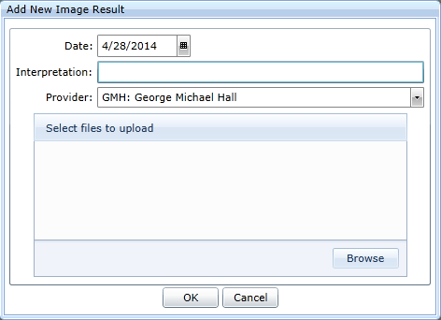
The resulting line item related to the uploaded Image Results will appear in the table of Image Results for this patient.

NOTE: The act of uploading the Image Results to the patient record is only half of what is required in order to meet the numerator requirements for this measure. Once the Image Results have been uploaded, the Image Order itself must be updated to indicate that the results for that order have been incorporated.

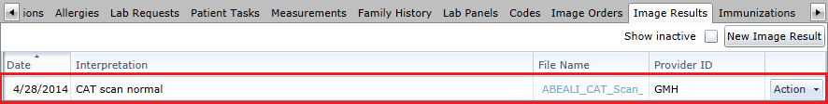

Image Order: Results Were Incorporated
Once an Image Result has been uploaded into the patient’s chart, the Image Order needs to be marked to indicate that the results were incorporated. Image Orders can be accessed by going to the Image Orders tab in the patient chart.

To indicate that results were incorporated to an Image Order, use the Action button and select the option entitled Results Were Incorporated.

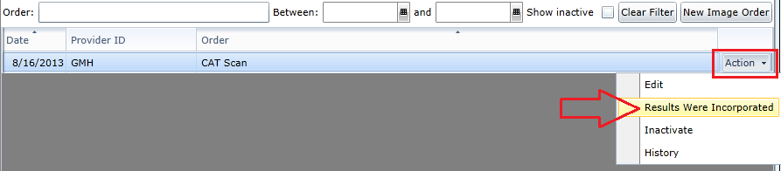

Choosing the Yes option in the resulting dialogue box will mark the Image Order as having its results incorporated into the patient chart. Doing so will enable this Image Order to be eligible for the numerator for this measure.

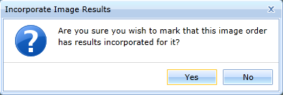

Stage 2 - Menu #4: Family Health History

Family Health History
Objective | Record patient family health history as structured data
Measure | More than 20 percent of all unique patients seen by the EP during the EHR reporting period have a structured data entry for one or more first-degree relatives
Exclusion | Any EP who has no office visits during the EHR reporting period

Family Health History: Attestation Requirements
Denominator | Number of unique patients seen by the EP during the EHR reporting period
Numerator | The number of patients in the denominator with a structured data entry for one or more first-degree relatives
Threshold | The resulting percentage must be more than 20 percent in order to meet this measure

Family Health History: Explanation of Measure

This measure is based on unique patients with a recorded visit by the EP during the reporting period. This means that a given patient, no matter how many times seen during the reporting period, can only count once for both numerator and denominator. Likewise, patients with no recorded visits during the reporting period will not count towards either numerator or denominator. Finally, this measure applies to all patients, regardless of age, who were seen during the reporting period.

Recording the Family History for a patient can occur before, during or after the reporting period. This means that it does not matter when the Family History is recorded so long as it is done prior to generating the measures for submission to CMS. Additionally, once the Family History has been recorded for a patient, then that patient will always appear in the numerator for an EP that has a recorded visit with that patient during the reporting period.

Family History must be recorded for at least one first-degree family member in order for a patient to count towards the numerator for this measure. First-Degree family members are defined as the following: father, mother, brother, sister, son, or daughter. The history of only one of these family members is required for this measure; however the history of any combination of family members can be captured as well.

Recording the Family History is not tied to an individual EP within a practice. All EP’s within a practice will receive credit for a patient who has their Family History recorded so long as that patient has a recorded visit with the EP during the reporting period. This means that, once the Family History for a patient has been recorded, any EP who has a recorded visit with that patient during the reporting period will have that patient appear in both the numerator and denominator for this particular measure.

Family Health History: Meaningful Use Measures

There is a single line item related to Family Health History in the Stage 2 list of Meaningful Use Measures. The name of this line item is Family Health History.

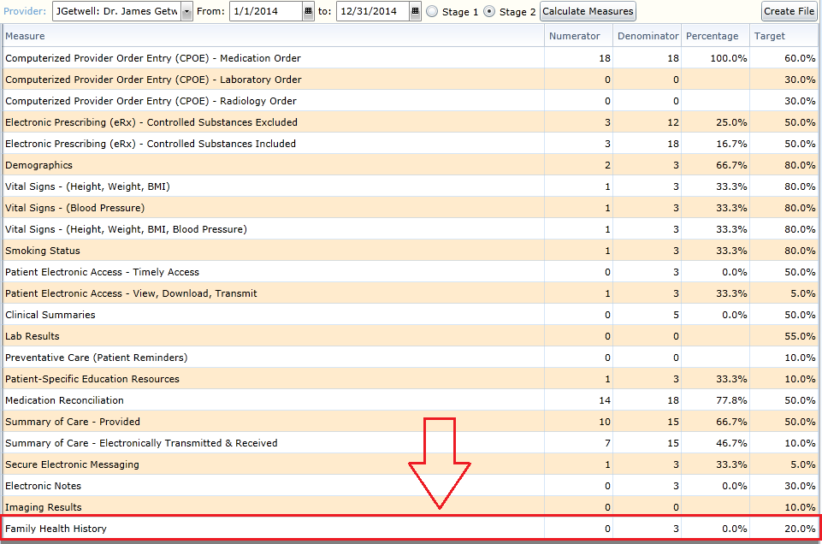

Family Health History: Recording of Numerator in Valant

In order to meet the numerator requirement for this measure, the patient must have the Family Health History recorded for at least one first-degree family member. The Family Health History for a patient is recorded in the Family History tab of the patient’s chart. For more information on the Family Health History feature beyond what is described here, please refer to documentation XXXXX.

Once in the Family History tab, the Health History for a family member can be started by clicking on the New Family Member button.

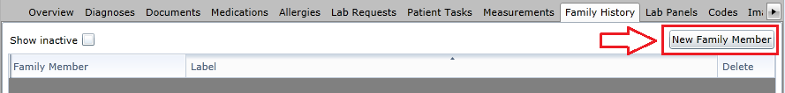

After clicking on the New Family Member button, the lower portion of the page will display a set of fields that are required to record the Family Health History for that family member. The meaning and requirements of each field is described in detail below.

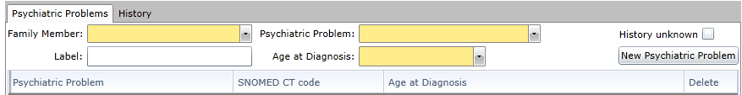

Family Member: Sets the family member whose Health History is being recorded. The list of family members includes: Father, Mother, Brother, Sister, Son, or Daughter. Each family member appears with their corresponding SNOMED code.

Psychiatric Problem: Sets the psychiatric problem(s) for this family member. The list of problems is limited to those relevant to behavioral health. The list of problems includes: ADHD, Alcoholism, Anxiety, Autism, Bipolar Disorder, Dementia, Depression, Drug Abuse, Eating Disorder, Generalized Anxiety Disorder, Mental Disorder, Obsessive Compulsive Disorder, Panic Disorder, Personality Disorder, Post Traumatic Stress Disorder, Psychiatric Hospitalization, Schizophrenia/Psychosis, Social Anxiety Disorder, Suicide, and Suicide Attempt.

Only a single problem can be selected at a time, however multiple problems can be entered for the same family member by using the New Psychiatric Problem button. Alternatively, if the psychiatric history of a family member is unknown, checking the History unknown checkbox will count as recording the Health History for that family member.

Label: This is a free text field that can used to differentiate between various family members. An example where this might be used is when the patient has two brothers and the Health History for both is recorded. The Label field can be used to provide the name for the brother

Age at Diagnosis: Used to indicate what age the family member was diagnoses with the indicated problem.
Once a problem has been specified for a family member, clicking on the New Psychiatric Problem button will add the details of that problem to that family member’s list. Additional problems can be added by changing the fields and clicking on the button again to add that new problem to their list as well.

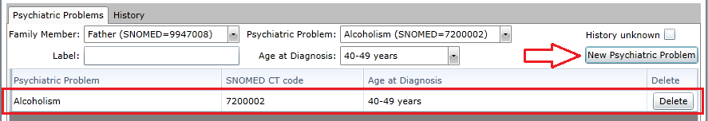

Once the Health History has been defined for a specific family member, choosing Save at the bottom of the page will save that family member into the list at the top. Once the information has been saved, this will have satisfied the requirement for recording the Family Health History for this particular patient. The Health History of additional family members can be recorded as well, however the Health History of only a single family member is required to meet the numerator requirements for this measure.

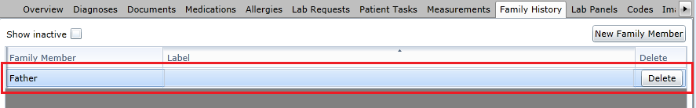

Stage 2 - Menu #5: Report Cancer Cases

Report Cancer Cases
Objective | Capability to identify and report cancer cases to a public health central cancer registry, except where prohibited, and in accordance with applicable law and practice
Measure | Successful ongoing submission of cancer case information from CEHRT to a public health central cancer registry for the entire EHR reporting period
Exclusion | Any EP that meets at least 1 of the following criteria may be excluded from this  objective:  - The EP does not diagnose or directly treat cancer;  - The EP operates in a jurisdiction for which no public health agency is capable of receiving electronic cancer case information in the specific standards required for CEHRT at the beginning of their EHR reporting period;  - The EP operates in a jurisdiction where no PHA provides information timely on capability to receive electronic cancer case information; or  - The EP operates in a jurisdiction for which no public health agency that is capable of receiving electronic cancer case information in the specific standards required for CEHRT at the beginning of their EHR reporting period can enroll additional EPs.

Report Specific Cases: Attestation Requirements
YES / NO | EPs must attest YES to successful ongoing submission of cancer case information from certified electronic health record technology (CEHRT) to a public health central cancer registry for the entire EHR reporting period.  - Ongoing submission was already achieved for an EHR reporting period in a prior year and continues throughout the current EHR reporting period.  - Registration with the PHA or other body to whom the information is being submitted of intent to initiate ongoing submission was made by the deadline (within 60 days of the start of the EHR reporting period) and ongoing submission was achieved.  - Registration of intent to initiate ongoing submission was made by the deadline and the EP or hospital is still engaged in testing and validation of ongoing electronic submission.  - Registration of intent to initiate ongoing submission was made by the deadline and the EP or hospital is awaiting invitation to begin testing and validation.

Report Cancer Cases: Explanation of Measure

This measure does not have a numerator, denominator or reporting threshold. Instead, it is a Yes/No attestation by the EP. This means that there is nothing to track within the CEHRT as far as reporting specific numbers. Instead, the EP is supposed to have performed the work outside of the CEHRT and attest that the work had been done.

In the case of this measure, the EP is required to report cancer cases to a public health central cancer registry. Due to the fact that Behavioral Health EP’s do not diagnose or directly treat cancer, this measure is one that we expect all EP’s of the Valant Premium Psychiatrist Suite exclude out during their reporting.

Since the diagnosing or treatment of cancer is outside the scope of Behavioral Health, this measure was deemed outside of the scope of the Valant Premium Psychiatrist Suite. As a result, this measure is excluded from the certification of the Valant Premium Psychiatrist Suite for the 2014 CEHRT.

Stage 2 - Menu #6: Report Specific Cases

Report Specific Cases
Objective | Capability to identify and report specific cases to a specialized registry (other than a cancer registry), except where prohibited, and in accordance with applicable law and practice
Measure | Successful ongoing submission of specific case information from CEHRT to a specialized registry for the entire EHR reporting period
Exclusion | Any EP that meets at least 1 of the following criteria may be excluded from this  objective:  - The EP does not diagnose or directly treat any disease associated with a specialized registry sponsored by a national specialty society for which the EP is eligible, or the public health agencies in their jurisdiction;  - The EP operates in a jurisdiction for which no specialized registry sponsored by a public health agency or by a national specialty society for which the EP is eligible is capable of receiving electronic specific case information in the specific standards required by CEHRT at the beginning of their EHR reporting period;  - The EP operates in a jurisdiction where no public health agency or national specialty society for which the EP is eligible provides information timely on capability to receive information into their specialized registries; or  - The EP operates in a jurisdiction for which no specialized registry sponsored by a public health agency or by a national specialty society for which the EP is eligible that is capable of receiving electronic specific case information in the specific standards required by CEHRT at the beginning of their EHR reporting period can enroll additional EPs.

Report Specific Cases: Attestation Requirements
YES / NO | EPs must attest YES to successfully submitting specific case information from CEHRT to a specialized registry for the entire reporting period to meet this measure.  - Ongoing submission was already achieved for an EHR reporting period in a prior year and continues throughout the current EHR reporting period.  - Registration with the PHA or other body to whom the information is being submitted of intent to initiate ongoing submission was made by the deadline (within 60 days of the start of the EHR reporting period) and ongoing submission was achieved.  - Registration of intent to initiate ongoing submission was made by the deadline and the EP or hospital is still engaged in testing and validation of ongoing electronic submission.  - Registration of intent to initiate ongoing submission was made by the deadline and the EP or hospital is awaiting invitation to begin testing and validation.

Report Specific Cases: Explanation of Measure

This measure does not have a numerator, denominator or reporting threshold. Instead, it is a Yes/No attestation by the EP. This means that there is nothing to track within the CEHRT as far as reporting specific numbers. Instead, the EP is supposed to have performed the work outside of the CEHRT and attest that the work had been done.

In the case of this measure, the EP is required to report specific cases to a specialized registry. Due to the fact that Behavioral Health EP’s do not diagnose or directly treat any disease associated with a specialized registry sponsored by a national specialty society, this measure is one that we expect all EP’s of the Valant Premium Psychiatrist Suite exclude out during their reporting.

Since the diagnosing or treatment of diseases associated with a specialized registry sponsored by a national specialty society is outside the scope of Behavioral Health, this measure was deemed outside of the scope of the Valant Premium Psychiatrist Suite. As a result, this measure is excluded from the certification of the Valant Premium Psychiatrist Suite for the 2014 CEHRT.

