Segmentation & Data Projects
Contents
Segmentation & Data Projects 1
Segment Form 2
Contact-Related Information 2
Company-Related Criteria 4
Dynamics CRM 8
Accounts 9
Contacts 9
Leads 9
Marketing Lists 9
Advanced Find 12
Eloqua 19
Segments 19
Filters 27
Shared Filters 27
Shared Lists 27
Templates 34
Special Situations: 38
Emergency Client Deployments (With List) 38
Exclusion Filters and Mass Exclusions: 38
Attendee Activities 41
Events 41
Third Party Events 41
Webinars 42

Segment Form
- Whenever a campaign requires us to build out a segment, they are asking us to build a list of records that they wish to send to. There are several criteria and methods of pulling these segments and the Segment Form will provide the information required (if populated correctly) to build that campaign’s list.
- There are a few main areas within the form that specify what kind of information the Project Manager (PM) is requesting.
  - Contact-Related Information such as Job Function & Level
  - Company-Related Information (the vast majority)
- This guide will assist you in understanding what each field represents, the interactions between them within the form, and the pitfalls to avoid when reviewing.
- By default, if not selections are made in any section, no filters will be added for it. The “starting point” for any segment is that we include everyone until the Project Managers specify criteria.

Contact-Related Information

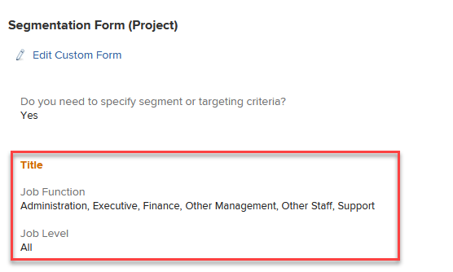
- In the image above, we have the “Title” section of the Segmentation Form. This will provide information on which filters the PM have selected.

Job Function
- The Job Function operates as a high-level grouping of Job Titles to segment records into their “functions” within the Company.
- For instance, you work in Marketing, no matter your level in the hierarchical structure of the department or company, you work within the Marketing Function. Therefore, if I wanted to target YOU for this campaign, I would select Marketing.

Job Function Table

Job Function | Description | Examples
Administration | Administrative individuals who help support others within the company. | Executive Admin, Secretary, Admin
Executive | The decision-making function within the company. | CEO, President, Owner
Finance | The function that manages the company's finances. | CFO, Controller, Audit, Accountant
Human Resources | The internal people management within a company. | Director of HR
Individual | Individuals who we mark in the system not related to a company
IT | The function that manages the company's technology | CTO, CIO
Junk | Marks Job Titles that are not relevant or junk records | Asjdhkjshd, GOOGLE
Legal | The internal legal team for the company | General Counsel, Legal
Marketing | The internal corporate marketing for the company | CMO, Director of Marketing, Digital Marketer
Operations | The function that manages the internal operations of the company | COO, Office Director
Other Management | Titles denoting management but give no specific function | VP, Director
Other Staff | Titles denoting staff-level but give no specific function
Professional | Titles denoting individuals who operate either within a company or outside that serve a specifically trained role | CPO, Architect, Researcher, Scientist
Sales | The internal sales operation within the company | Account Manager, Business Developmet, Sales Development
Support | The internal customer support for the company | Representative, Help Desk

Job Level
- The Job Level operates as a grouping of most hierarchical structures within a company based on an individual’s job title.
- For instance, you most likely operate as Armanino Staff that reports to a Manager. In this instance, you would find yourself under the “Contributor” selection.

Job Level Table

Job Level | Description | Examples
C-Level | The highest level within the company, often named the "C-Suite". | CEO, CFO, COO, CMO, CTO
Executive | The highest level of Management within the company | President, Controller, Co-Chair
Director | Those who direct teams within the company, but report to an Executive or C-Level individual | Director of (DEPT)
Manager | Those who manage staff-level teams within the company | Manager, Senior Manager, Accounting Manager
Contributor | Staff-Level individuals within the company | Specialist, Staff Accountant, SDR

Segment Comments
- At the bottom of the Form sits a free-text field where the PM can provide written details if they need to provide granular criteria for their campaign. Regarding Contacts, this can be those who have engaged in a specific campaign, specific job titles, etc.

Company-Related Criteria

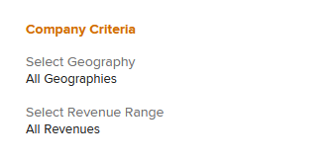
- There are several sections that pertain to the Accounts/Companies that we target. As Armanino is a Business-to-Business Professional Services company, we often specify more about the company in our Marketing, than the individual.
- In this image above, you can see the first set company-related criteria, Geography and Revenue Ranges

Geography
- The geography section notes where the companies the PM wants to target are located. By default, we do not specify and only filter if they select options here.
- [[TRANSLATION TABLE]]

Revenue Range
- Income ranges for companies that PMs wish to target.

Industry

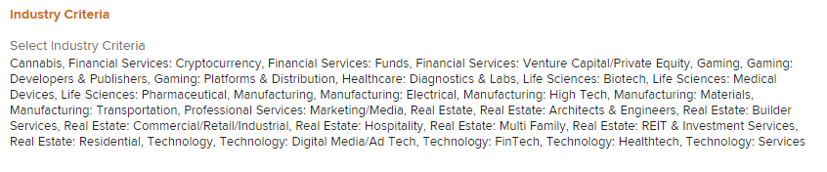
- The most detailed section of our segmentation form. This section contains a list of Armanino’s Industry definitions. These do change over time but contain 70+ options for the PM to select when tailoring their campaign’s targets.
- For Example, Armanino is a Professional Services company. That is both a high-level section as there are sub-level industries to further tailor options.
- For a full list of Industries, please locate the Industry list in the _Data Entry folder on the F-Drive 03 – Industry Picklist

Grouping and Classification

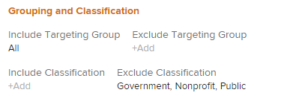
- This section is provided to dig into our relationship with the Company or a larger classification group the company belongs to.

Targeting Group

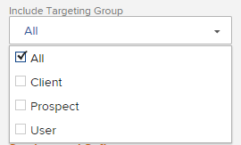
- Our Targeting Groups are a way to target companies by grouping them into these categories.
- Clients
  - This can either pertain to their global status as a “Client of Armanino” regardless of their service or software.
  - Or, if a Service or Software is selected, a Client of that product with Armanino.
  - For example:
    - If someone says, “I want this to go to all clients”, they will select this option for “Client” and provide no Product.
    - Or if someone says, “I want this to go to Sage Intacct Clients”, they will select this option for “Client” and select “Sage Intacct” in the Include Software option set below.

Classification

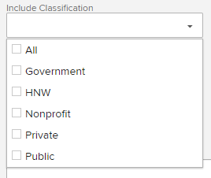
- These classifications are quite wide in scope.
- Shortcut that provides PMs with the option to often exclude groups without manually selecting every industry.
  - This is a limitation of Workfront currently, no easy way to “Select All”.

Classification Table

Classification | Description
Government | Government entities such as city, county, state, and federal bodies.
HNW | Individuals, HNW standards for “high net worth”.
Nonprofit | Organizations with a “Nonprofit” designation.
Private | Corporations that operate without public ownership.
Public | Corporations that operate with public ownership.

Services and Software

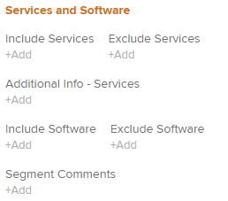
- As a Professional Services company, Armanino provides a range of Software and Services to our Clients. In any marketing campaign, we want to enable our PMs to specify when they wish to target those groups, or even exclude them from campaigns. This section provides those options.

Services
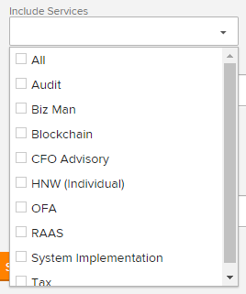
- Armanino offers a wide range of services to our clients. At times, we may want to build a target audience that is a Prospect, User, or Client of that specific service.

Software
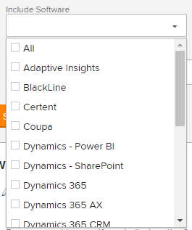
- Armanino offers a wide range of software products to our clients. At times, we may want to build a target audience that is a Prospect, User, or Client of that specific software.

Segment Comments

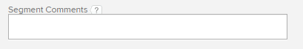
- Free-text field that provides PMs with the option to further clarify any criteria included above or to provide extra criteria that the form does not cover.
- Examples of this are specific methods certain groups use to track Prospects, Lists from Prior Deployments/Events/Webinars.

Dynamics CRM
- CRM is the hub of our Marketing and Sales efforts at Armanino. Originally, all segments were built in CRM and brought over as lists into Eloqua, our marketing automation software. However today, we have improved the sync between our two systems so that we can build segments in either system, though there are some things that can ONLY be pulled from CRM.
- Segment Criteria that Require CRM:
  - Opportunities: Anything pertaining to opportunities must be pulled from CRM as our current and past opportunities are stored in CRM.
  - Marketing Lists
  - Specific Apps/Svcs (Users/Prospects/Clients)
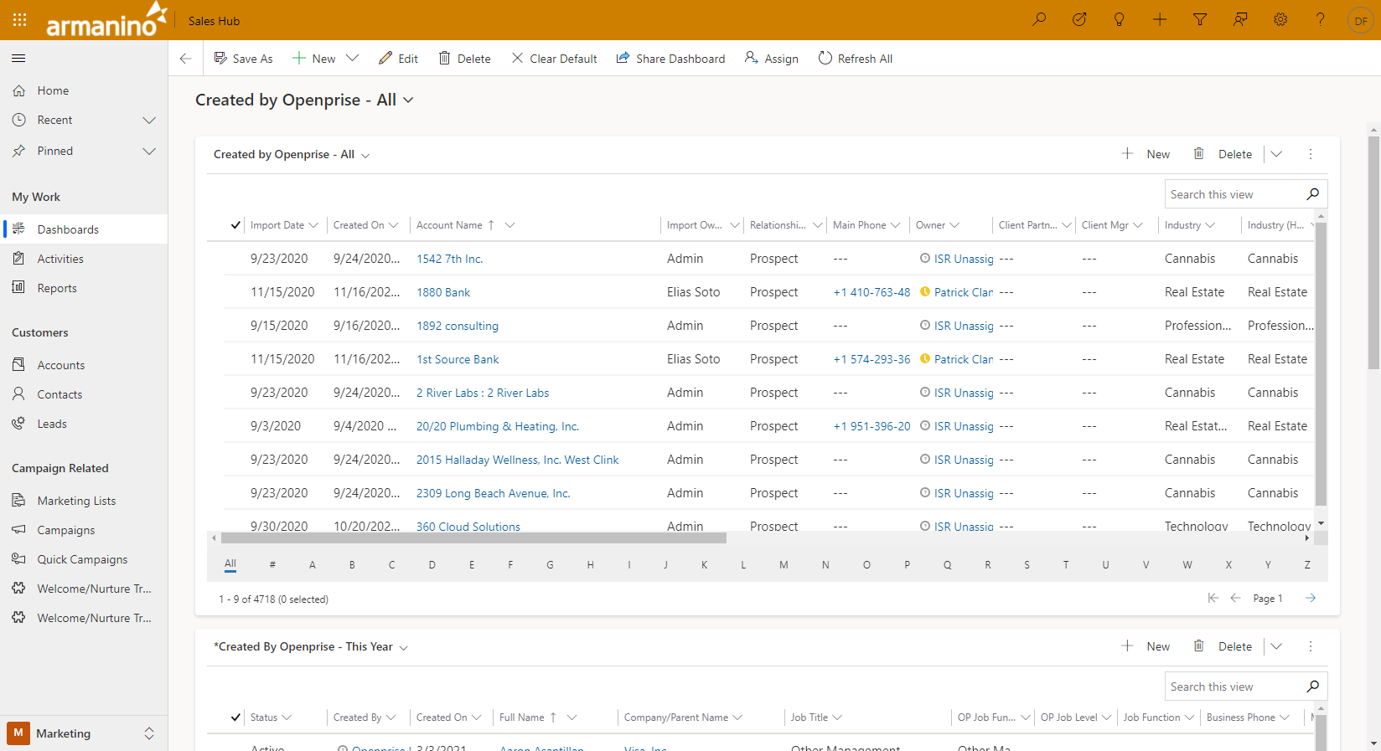

Accounts
- Accounts are a type of record in CRM that represents companies that people work for. Contact records are connected to these in a many (contacts) to one (account) type relationship.
- Therefore, when building a segment in CRM, you may need to reference data that is tied to Accounts rather than Contacts.
  - E.g. Industry, Revenue, Employee Count, etc.
- Can be tied to Opportunities.

Contacts
- Individual records that are tied to Accounts.

Leads
- Individual Records that are standalone and contain Individual and Company data in a single record.
- Are not connected to other records.
- New records from Eloqua (form fills, email subscription) are created as Leads in CRM.

Marketing Lists
- Lists that help group Contacts or Leads for reference later.
- Lists can only contain one type of record, Contacts or Leads.
- There are two types of Marketing Lists:
- Static
  - These marketing lists are manually managed. The owner can build a “view” or “advanced find” (see below) in CRM and add them to the list. What makes these unique is that owners can add multiple, different filters to add to this list. Also, records are not automatically removed from this list.
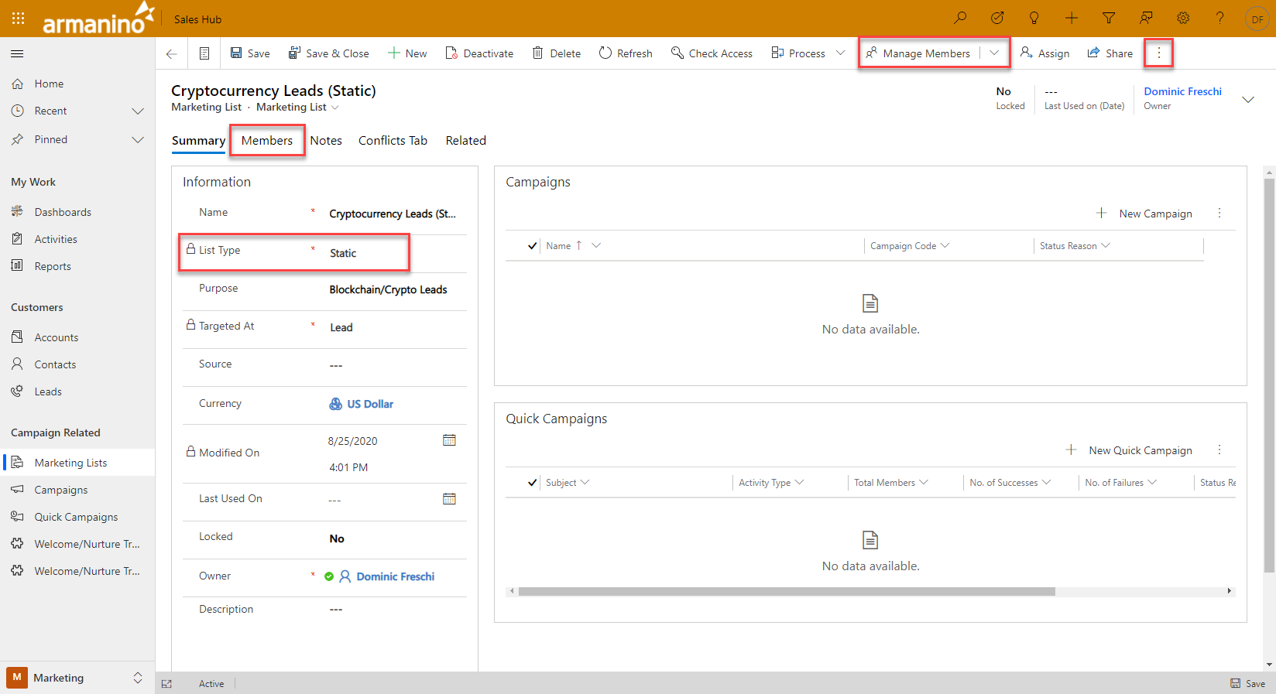
  - Here is the main page of a Static Marketing List.
    - The List Type field will show you whether your list is Dynamic or Static
    - The Members tab underneath the list header will bring up a table of current members.
    - The Manage Members drop-down will provide you with a list of actions you can take to manage the marketing list members.
    - The Export Members button is hidden behind the 3-dot button.
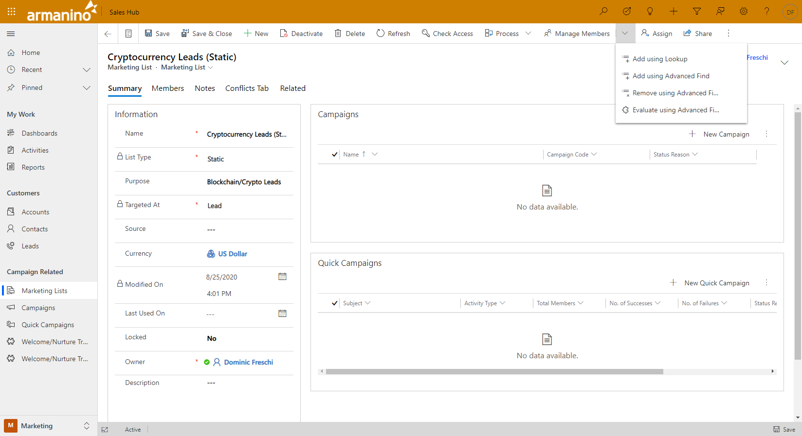
  - Here are the available options under the Manage Members drop-down.
    - Add Using Lookup – add single records
    - Add using Advanced Find – add using filters/views
    - Remove using Advanced Find – remove groups using filters/views
    - Evaluate using Advanced Find – analyze marketing list members

- Dynamic
  - These marketing lists are automatically managed. At the outset, Owners build an advanced find to determine who should be added to this list. They can only add 1 view, and if something changes on the record to remove it from that filter, they are removed from the marketing list.
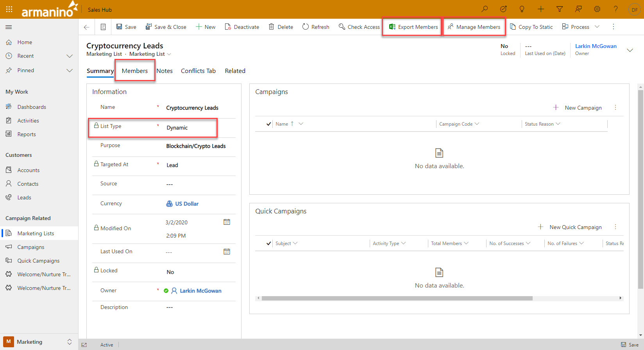
  - Here is the main page of a Dynamic Marketing List.
    - The List Type field will show you whether your list is Dynamic or Static
    - The Members tab underneath the list header will bring up a table of current members.
    - The Export Members button on the top-bar will allow you to export all members currently in the list to an excel spreadsheet.
    - The Manage Members button will allow you to view the Dynamic List’s criteria
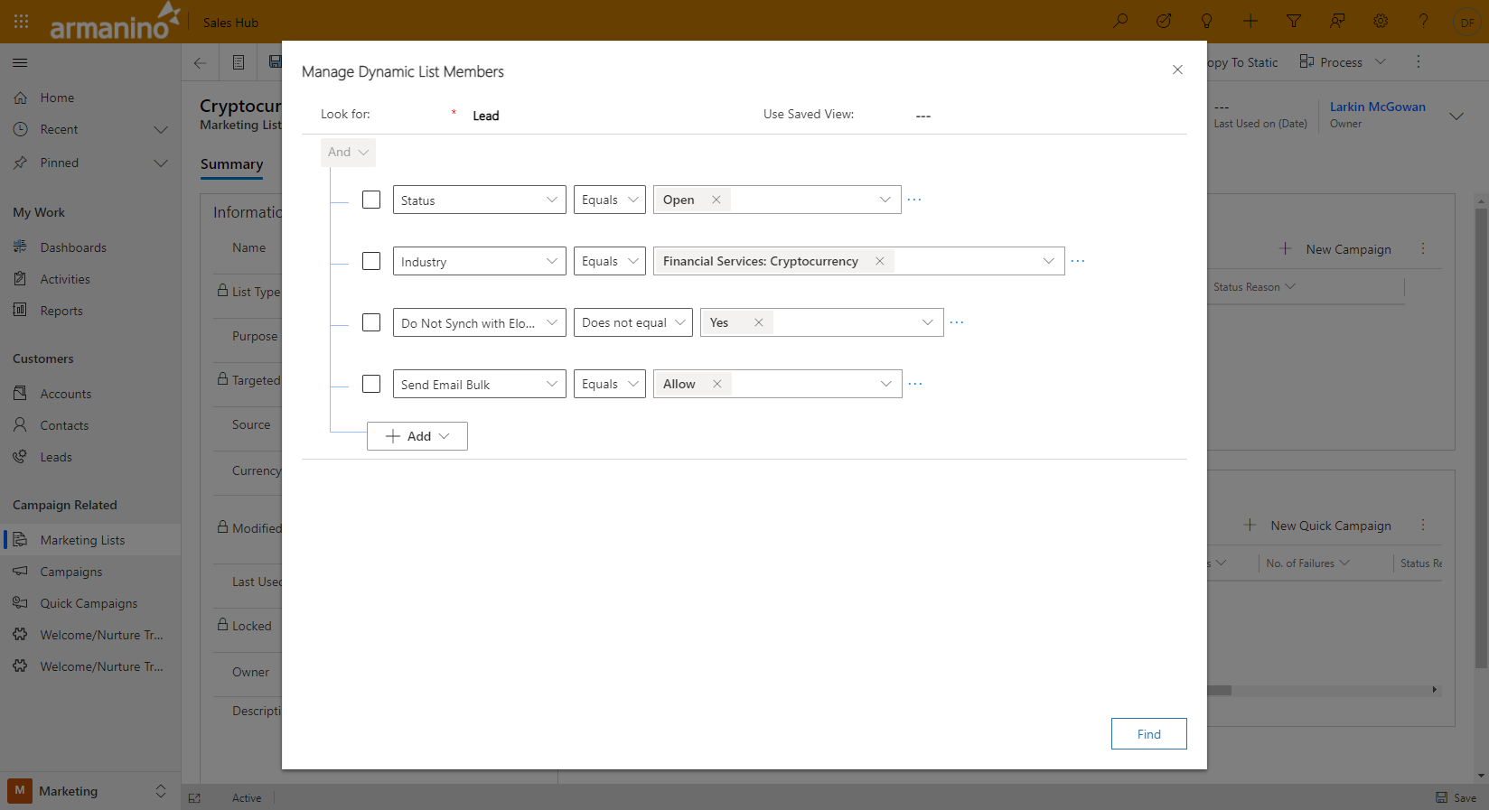
  - When you click the Manage Members button, this window will appear. Here you can customize the list (if you’re the owner).

Advanced Find
- The querying tool for Microsoft Dynamics CRM.
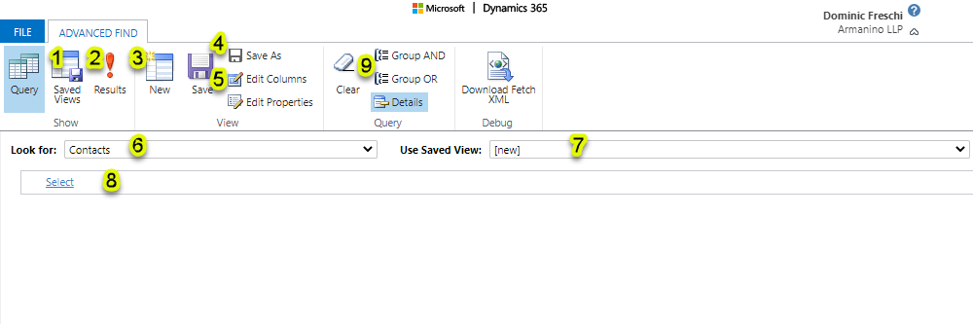
  - Saved Views: configurations and filters you’ve saved for review or later use.
  - Results: will query records based on your current selections.
  - New: start a brand-new advanced find.
  - Save/Save As: Save will default to Save As if the view is brand new, otherwise Save will overwrite current view you’re editing. Save As creates a new save.
  - Edit Columns: changes which fields are populated in your results table.
  - Look For: choose which record type you are starting your view from.
  - Use Saved View: another place for you to select a previously saved view.
  - Select: a drop-down of available fields and related entities for you to build your query.
  - Group AND/Group OR: allows you to change the logic operator within the query (Will need to have selected 2 or more fields in the area below.
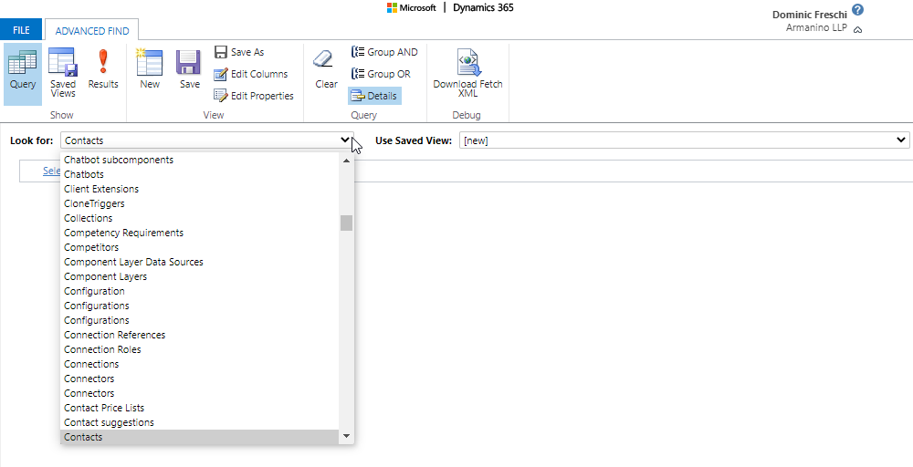
  - Most Used Record Types:
    - Contacts
    - Accounts
    - Leads
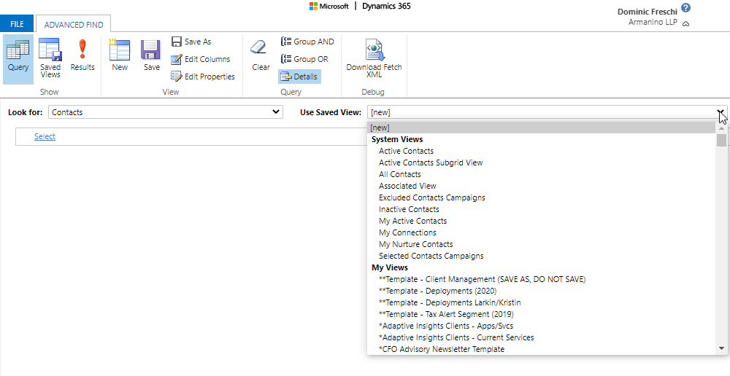
- Here you can view System-wide saved views as well as ones you have created.
- We typically use a templated deployment view as our basis.
  - Seen above as the “**Template – Deployments (2020)”
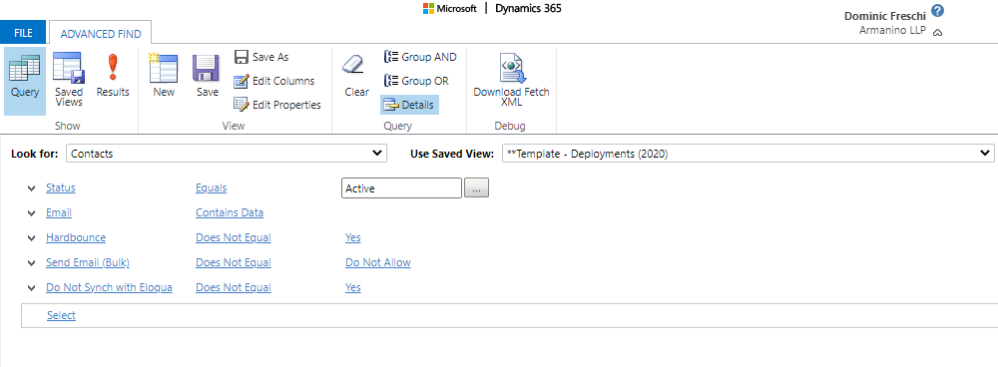
- When you’ve made your selection of a view, the criteria populate and show you the current selections.
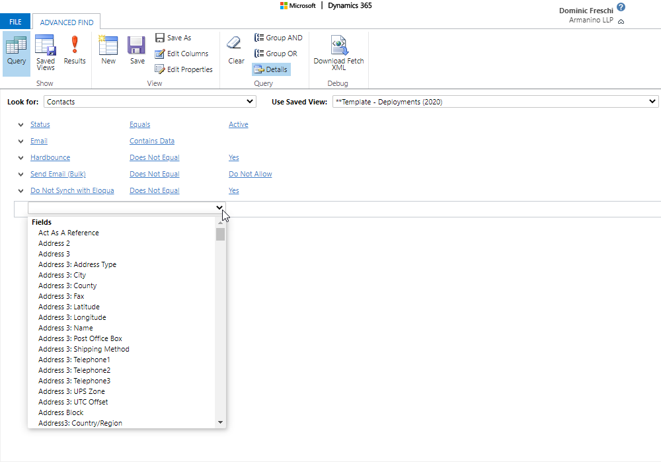
- To add new filters, select the “select” drop-down under the relevant record type.
- This will provide you with a list of Fields associated to those records, as well as Related entities if you continue to scroll down.
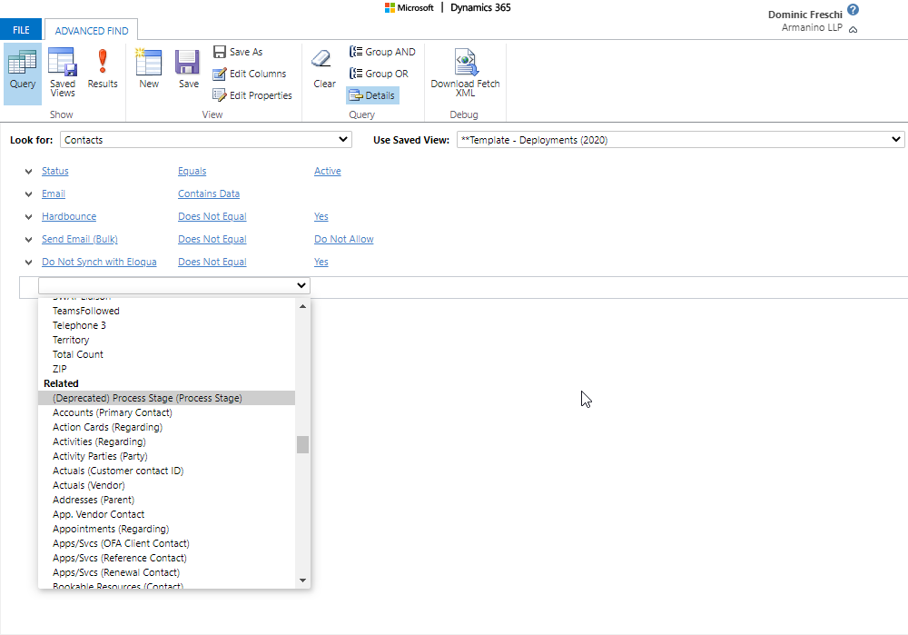
- If you keep scrolling down, you are provided with a list of related entities you can select to also filter for. This becomes important when filtering specific types of records.
  - Contacts do not have an Industry field on their record, that is tied to their “Company/Parent Name (Account)”. To filter based on that field, you will need to reference the Account record and then filter its industry.
    - The same can be said for Current Products/Services, Company Geography, Client/Prospect status.
  - Contacts are typically not associated to Opportunities added to the system. We sell more to Accounts/Companies. Therefore, if a PM is asking for a list of individuals whose Company has an opportunity in some stage with us (Open, Closed-Won, Closed-Lost), you will need to first draw in the reference to the Account (“Company/Parent Name (Account)”), and then within that record, find the Related entity of Opportunity (Potential Customer).
  - Marketing Lists are often pulled as a related entity tied to Contacts & Leads. You would bring up the template, find the Related entity “Marketing Lists”, and then add a filter for “Name Contains ‘__________’”, and this will populate a list of Contacts or Leads that are present in the specified Marketing Lists.
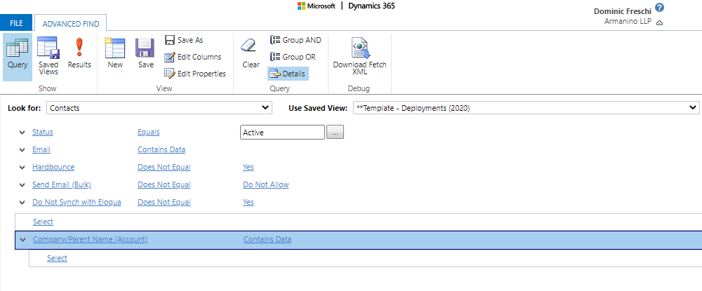
- Here is how the UI displays Related entities. The bottom indented “Select” drop-down relates to the related entity. The one above continues to apply to the initial entity type.
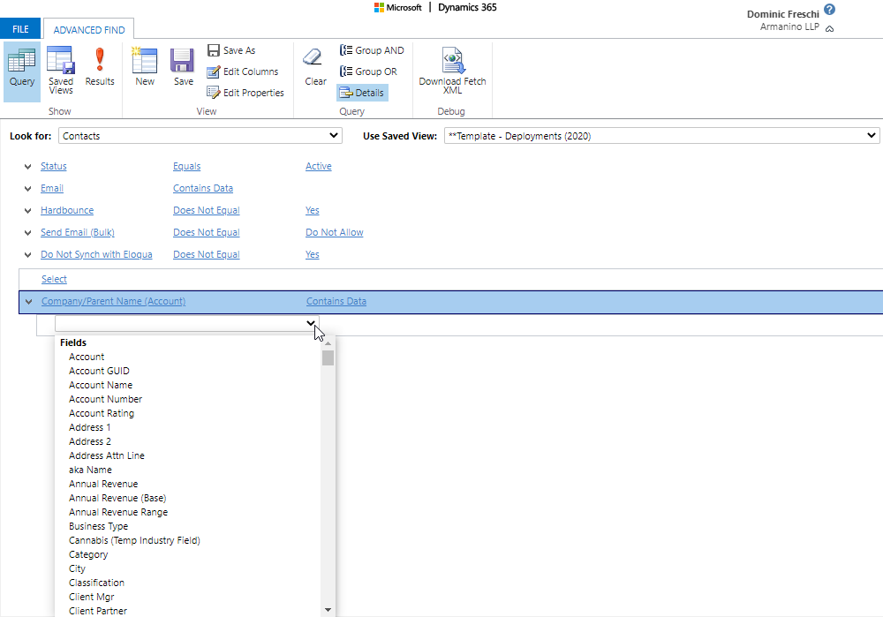
- The Fields the drop-down provides are tied to the related entity.
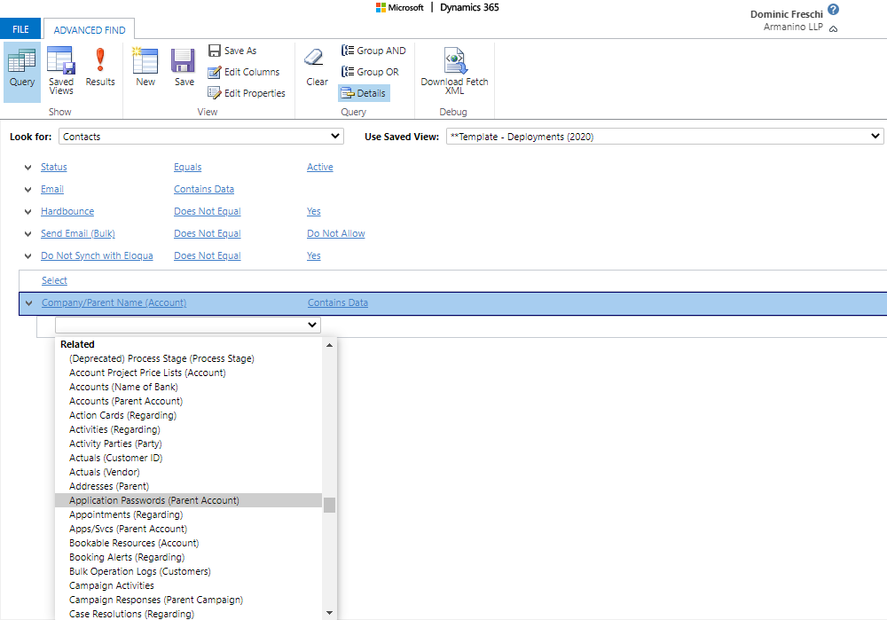
- And here you can see the Related entity section of a Related entity.

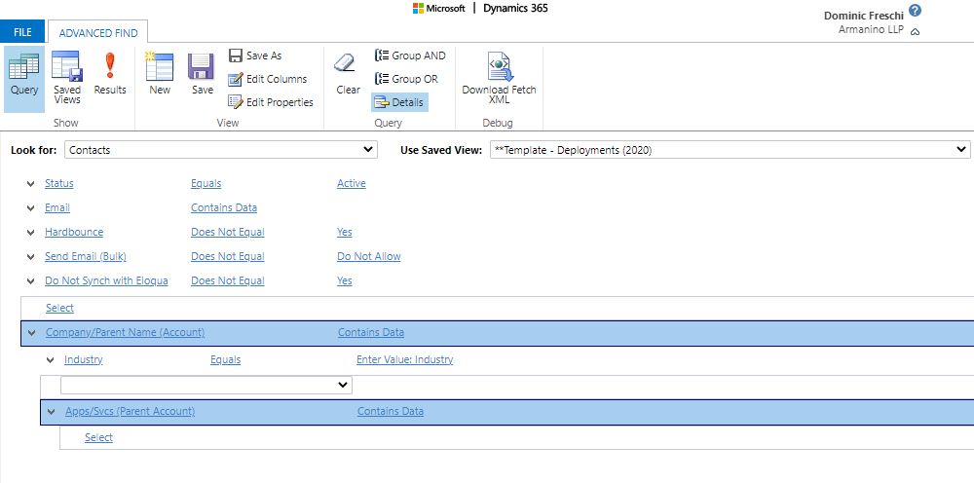
- This is how a Related entity of the initial Related entity will display.
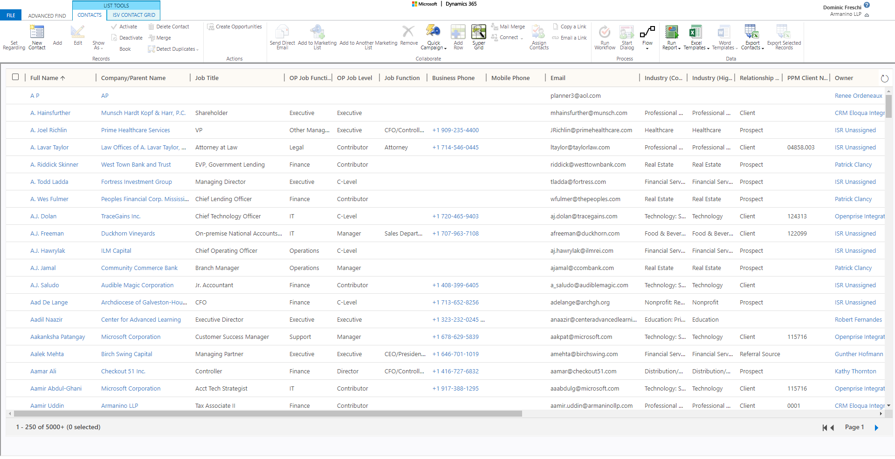
- When you have all your criteria selected (or if you want to check what you have selected for accuracy/quality/quantity) click the red exclamation point for “Results”.
- The page will reload and provide you with a tabular layout of your results laid out with your selected columns.
- Here you can review the results, see a count (it will only show an exact count up to 5,000 records), as well as export your results into an excel file.
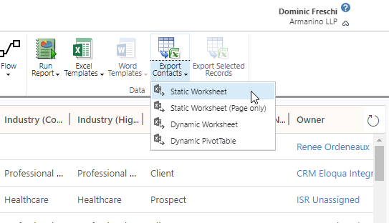
- To export, select the “Export Contacts” drop-down, and select Static Worksheet.
- We use this option because the Dynamic options are preset for re-upload. The static worksheet will give you everything you need to build a segment.

- For more information on CRM Advanced Finds, please visit the link below.
- https://docs.microsoft.com/en-us/dynamics365/customerengagement/on-premises/basics/save-advanced-find-search

Eloqua
- Eloqua is our Marketing Automation software.
- Within Eloqua, we have the ability to build general segments based on a wide-range of criteria that are shared between CRM and Eloqua.

Segments
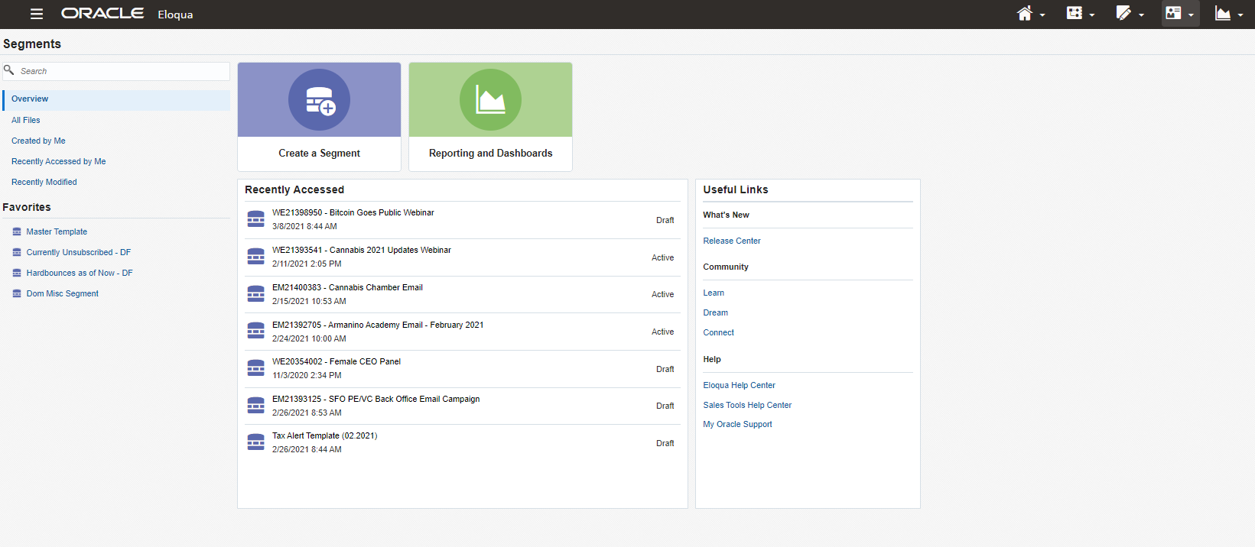
- This page provides you with links to recently accessed segments.
- The main function of this page is to guide you to the option (in red) to Create a Segment.
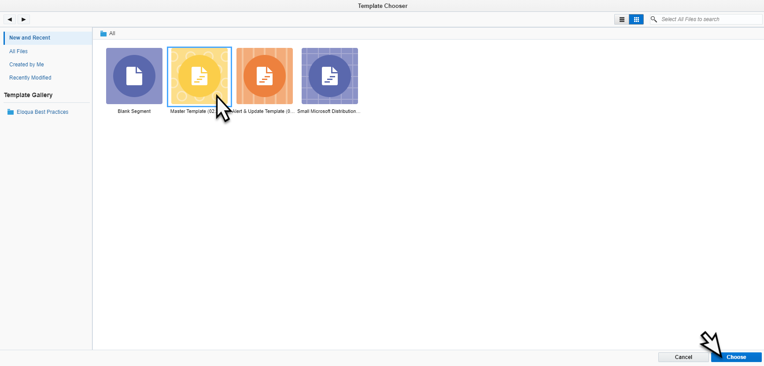
- When you select to create a segment in Eloqua, recently used templates appear as color tiles.
- If you do not see the correct template, you can search for them in the top-right search bar.
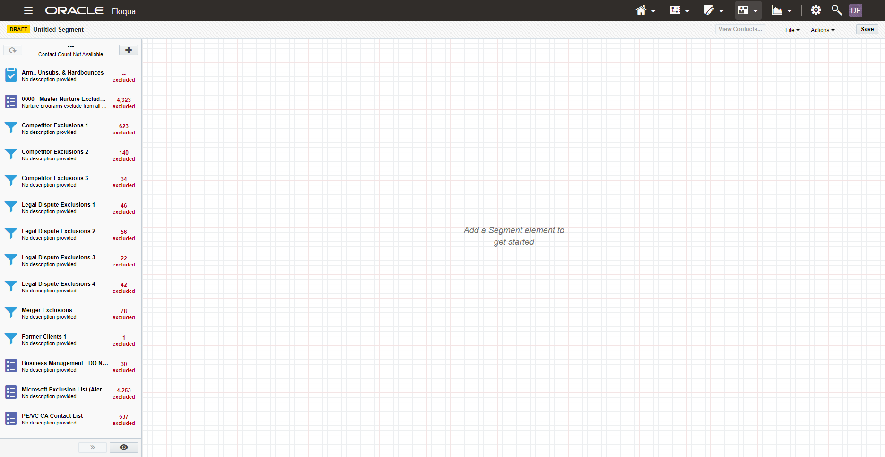
- Here is the Master Template. This is the standard template used to build out segments regardless of its origin (CRM or Eloqua).
- On the left, you have all the default filters that work to exclude particular groups.
  - Exclusions:
    - Unsubscribes and Hard Bounces
    - Nurture Programs
    - Competitors
    - Companies Currently in a Legal Dispute with Armanino
    - Emails from Mergers & Acquisitions
    - Specific Targeted Lists
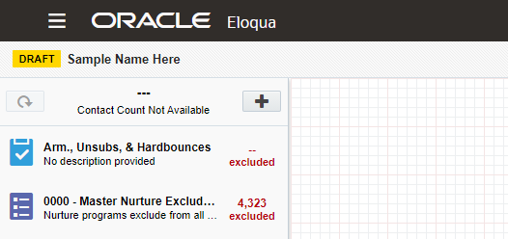
- At the top of the page, you can type over the “untitled segment” text to supply a name. The standard naming scheme is:
  - “[project number]” – “[name of project]”
    - EM2134567 – Sample Project Name
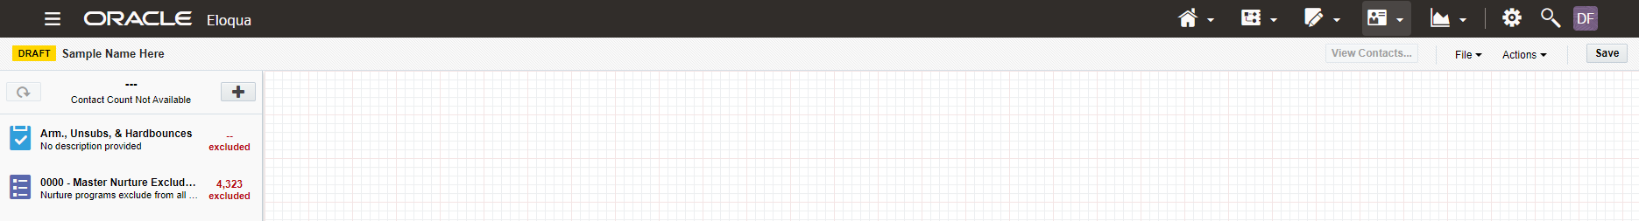
- Once you’ve filled that in, you can head over the right-hand side and click “save”.
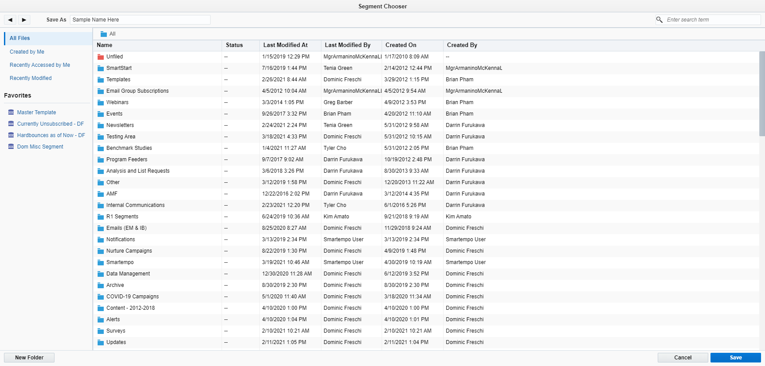
- This file directory will appear and you will need to find the appropriate location for your segment. There are a lot of folders present, but follow what best matches the project code.
  - E.g. “EM21xxxx” should be filed under Emails (EM & IB)>EM 2021
- Once you have the folder selected, click save.
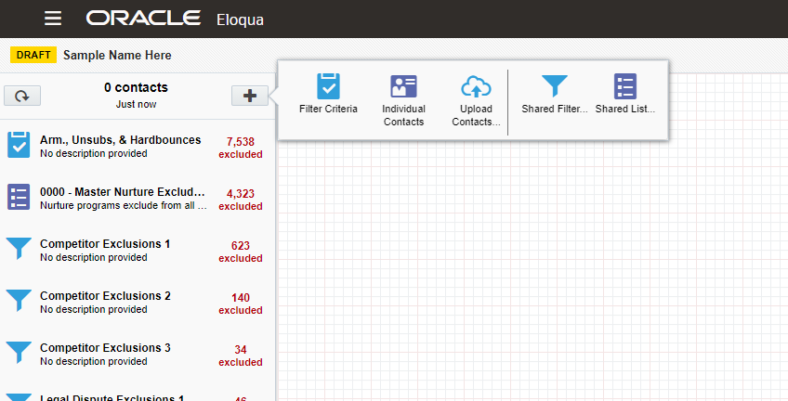
- To build out a segment in Eloqua we need to know what type of criteria are needed and where it is best to pull that information.
- To add specific criteria, click the plus sign at the top and select “Filter Criteria”.
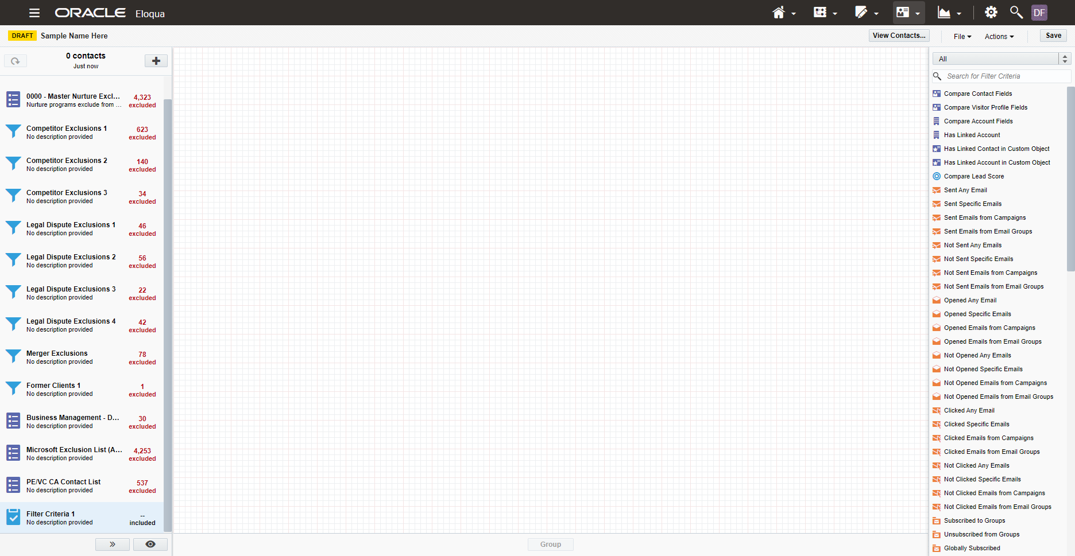
- When you do so, the options available will appear on the right-hand side. Here they provide a long list of possible filter categories.
- The primary categories you will need to be familiar with are the “Contact Fields” and “Account Fields” options.
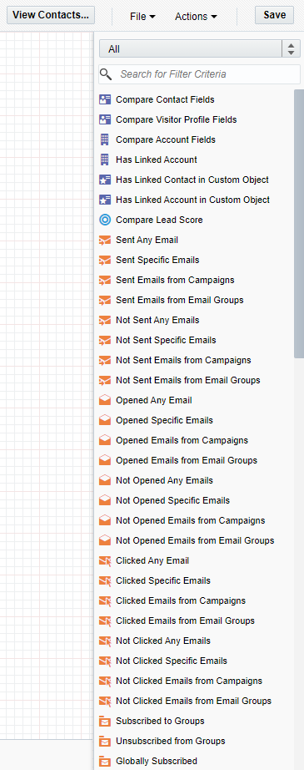
- Here are the options.
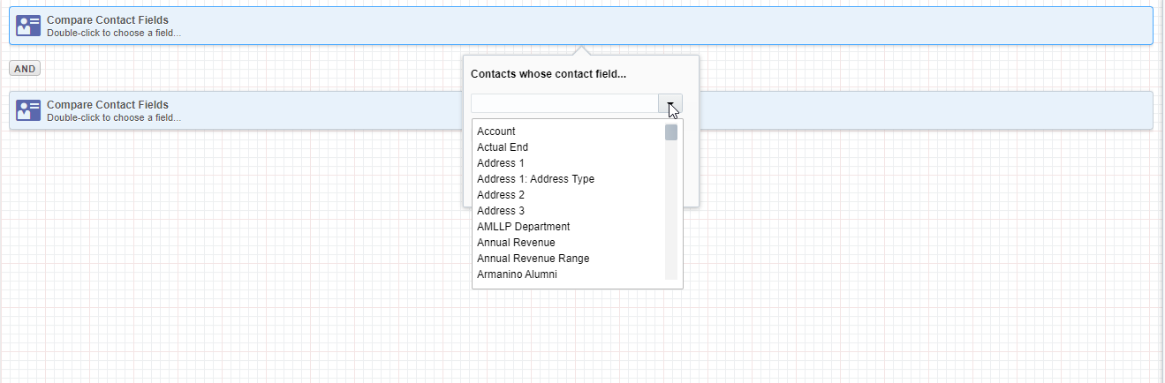
- When you double-click on the options, they populate the middle section with “Operational Filters”. These allow you to specific criteria that the system will filter upon saving.
- Here you can see the drop-down of possible fields open as well.
- You can bring in multiple filters onto a single page, with a limit of 15 per page. Multiple pages can be added to a segment, so this limitation becomes an obstacle to work around at times.
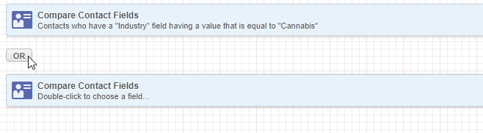
- The And/Or operators in-between filters allow you to change the relationship between the criteria.
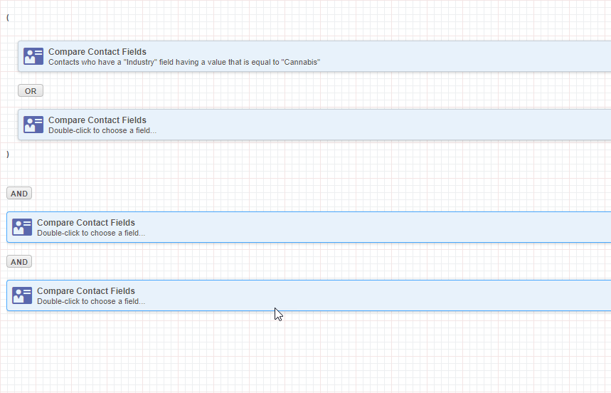
- You can also “group” criteria together, to enable precise controls, allowing you to add criteria between a group of criteria, and other filters.
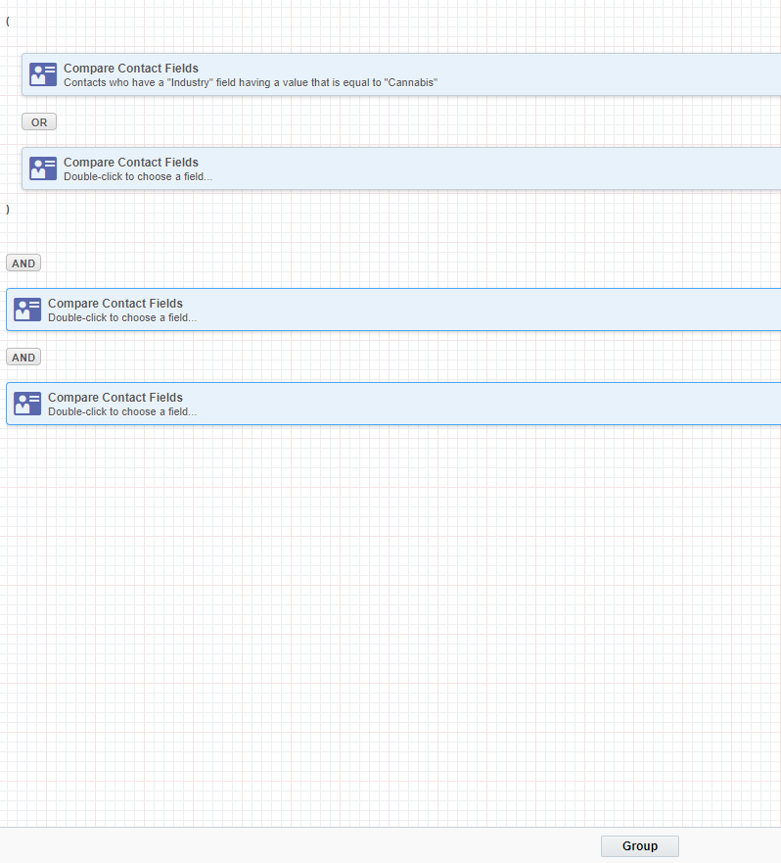
- You simply click on some of the filters, so they highlight in blue, and then click “Group” at the bottom.

- Another major entry point for Eloqua segments is the ability to upload an external list of records (typically exported from CRM).
- Select the “+” at the top and select “Upload Contacts”.

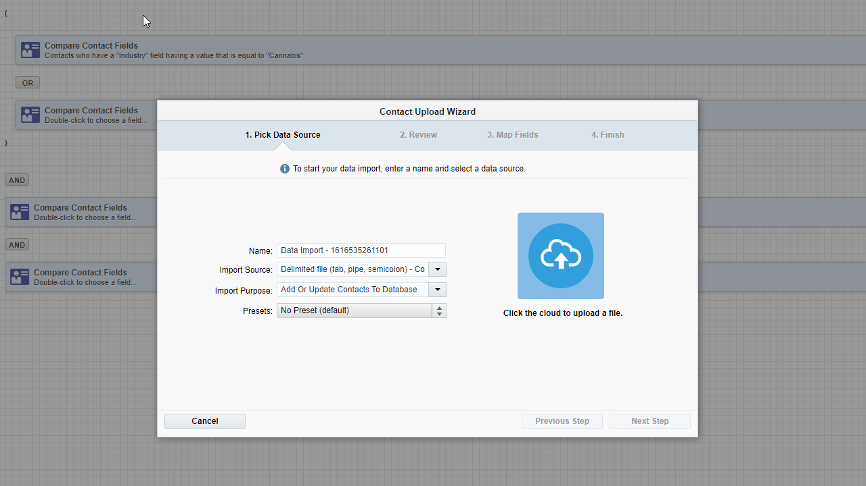
- A window will appear and provide you with the option to either drag-and-drop a file in or to click and locate the file on your machine. Once you do, it will walk you through the standard upload steps.
- It is recommended to upload a file in CSV format (fewest issues) and to parse the information down to a single file with 1 column of email addresses. This will prevent most errors and save time.
  - If you decide to upload the entire file, many fields will not be mapped correctly so you will need to
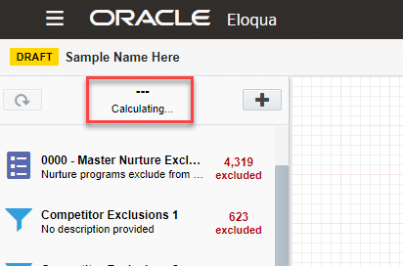
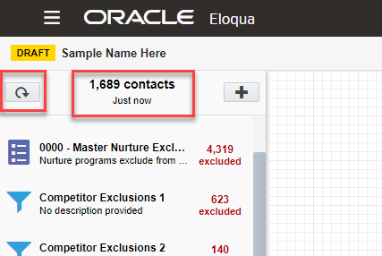
- Oracle’s Documentation on building segments: https://docs.oracle.com/en/cloud/saas/marketing/eloqua-user/Help/Segments/Tasks/CreatingSegments.htm

Filters

Shared Filters
- Shared Filters are preset filters that you can bring into the segment. They are built similarly to the filters inside of a segment, but are standalone and can be used across multiple, different segments.

Shared Lists
- Shared lists are manually or automatically created specific groups of people that can be brought into the segment.

Create or Update Shared List
- From any page in Eloqua, click on the Contact Card at the top-right of the page, and select Contacts.
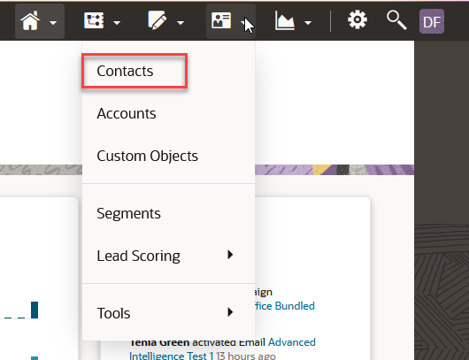
- Then click Upload… at the top of the page.
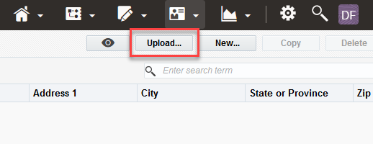
- A pop-up will appear. Begin by entering a Name for the file
  - For best practices, include a descriptive name and the current date.
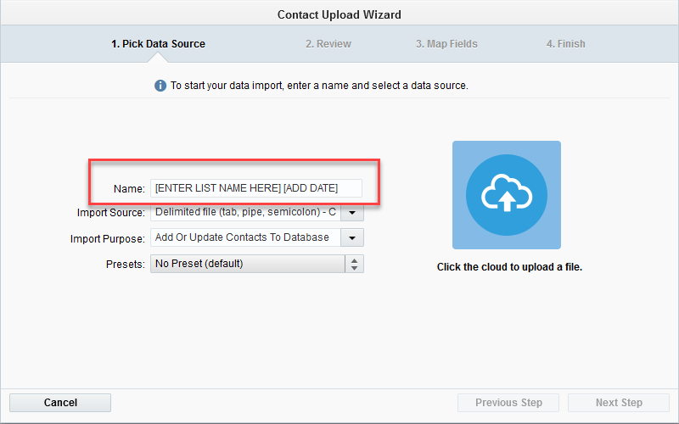
- Eloqua allows you to upload CSV (delimited file) and Excel formats. We recommend using CSV files for upload.
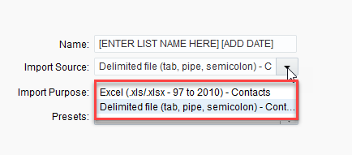
- Import Purpose is defaulted to what you will need to Create or Update a Shared List.
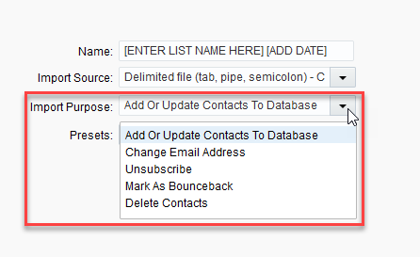
- Then either drag-and-drop your file into the Cloud Icon on the right or click the icon to open a file explorer window to select your file.
- On the next tab, review the data presented to ensure your data is formatted correctly. When done, hit Next Step.
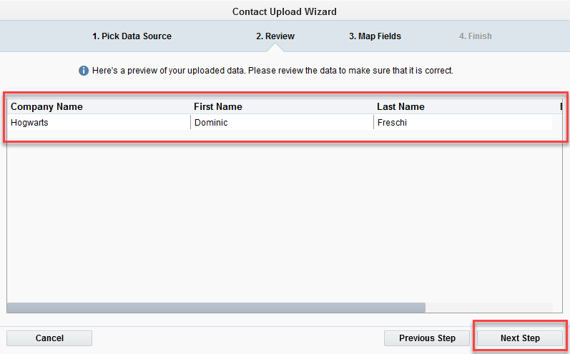

- On the 3rd Tab, leave Uniquely Match Contacts On to Email Address.
- 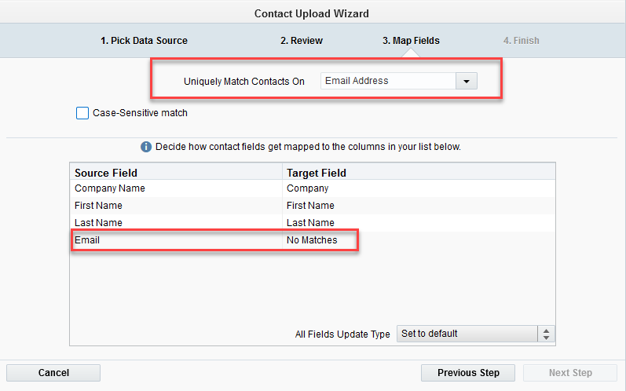
- Review the fields to see if any fields are set to No Matches.
  - This happens when a field in the file doesn’t exactly match the field name in Eloqua
- To fix any set to No Matches, double-click on that field and a pop-up will appear with a drop-down of all available fields.
  - You can scroll or type-search to locate your specific field.
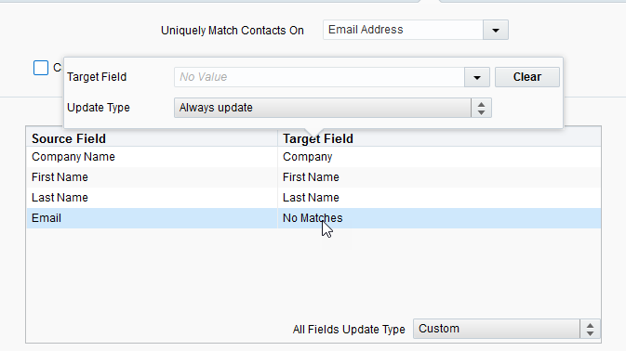
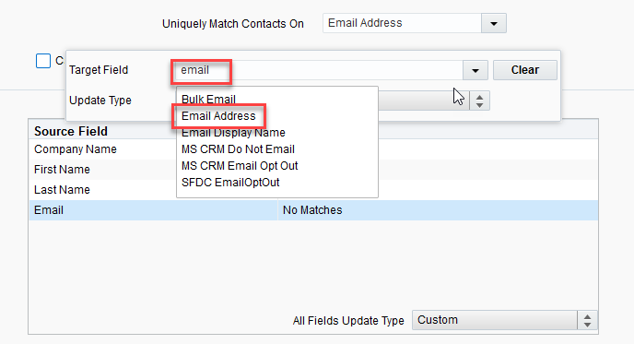
- Select the field and you should see it populate in the table.
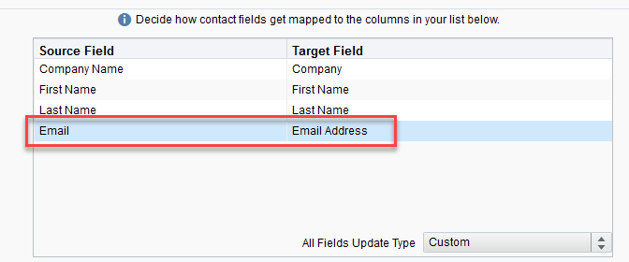
- Once everything is matched, click Next Step.
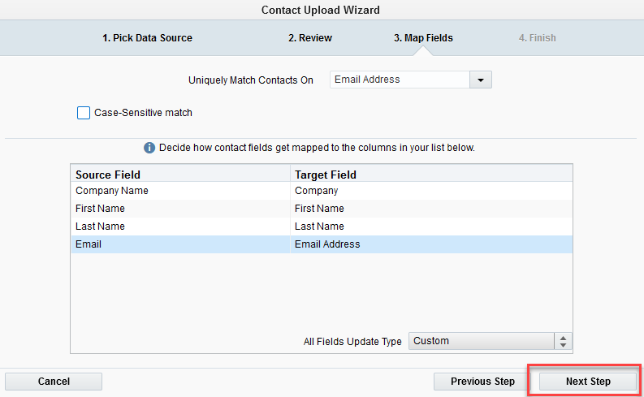

- On the 4th Tab, you are presented with options on how to handle the upload location and operation.
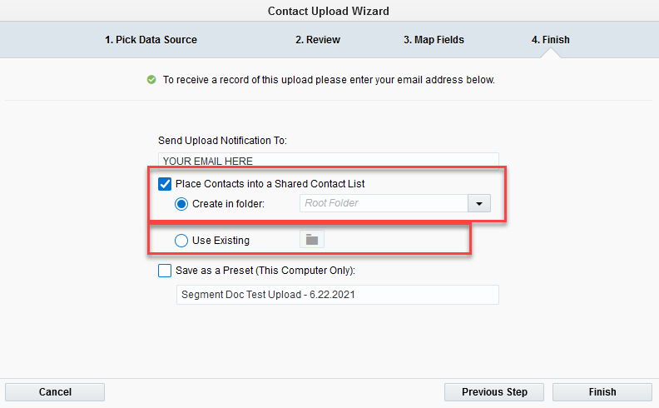
- You can have it either
  - Create a brand-new Shared List within a specific folder
  - Add contacts in your file to an existing shared list.
- To create a brand-new shared list, you click on the drop-down next to Create in Folder. This will present a list of all existing folders for Shared Lists. Doing this will use the name you provided at the beginning tab (you can always navigate backwards to update).
- Select your folder and you should see it populate in the drop-down field.
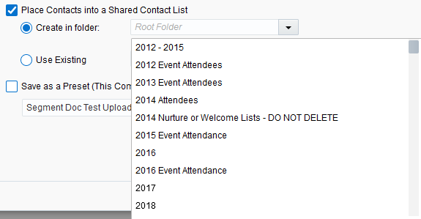
- To update an existing Shared List, select the radio button next to Use Existing, and select the folder icon to search for your target shared list.
- This will present a large pop-up to navigate through and locate your list. Select your list and click Choose.
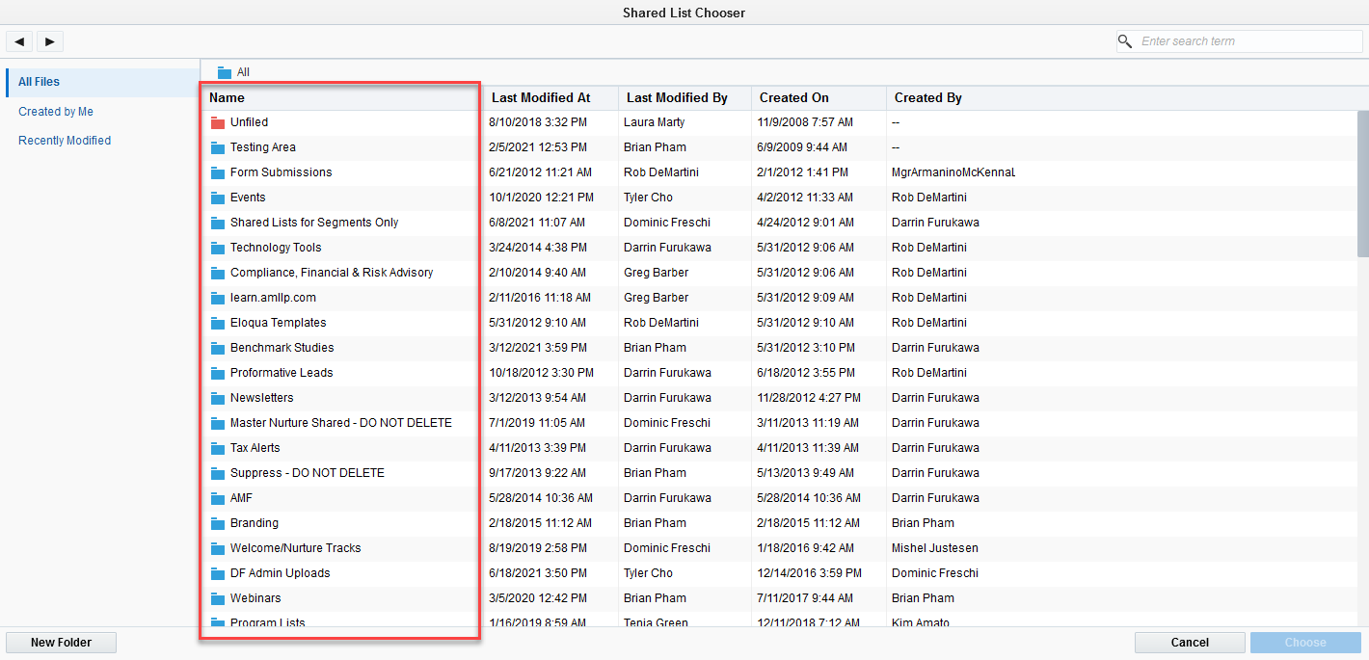
- Once you’ve made your selections, click Finish to process your Shared List Upload or Update.
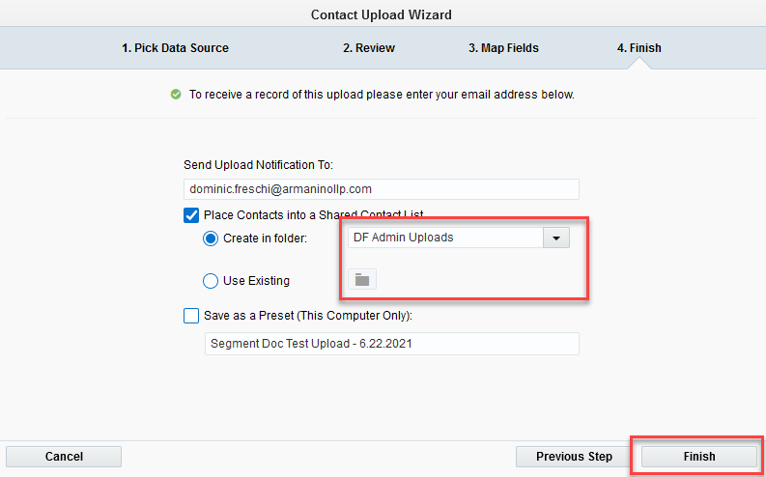
- Once it’s complete, you should receive an email notification from Eloqua.
- You can locate shared lists by clicking on the Contact card icon, heading down to Tools, and selecting Shared Lists. Once this page loads, you can search for your new or updated list.
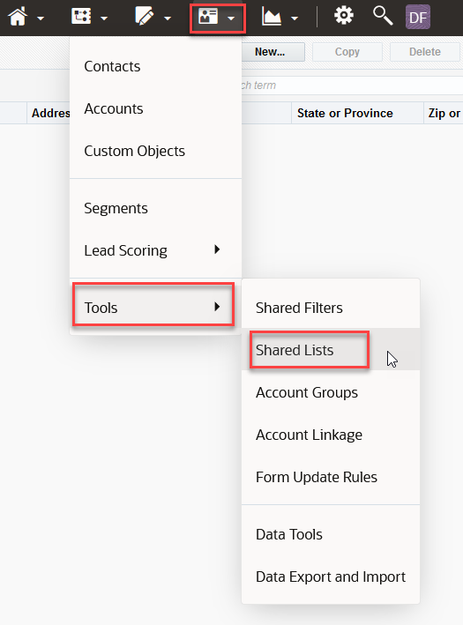

Templates
- Templates are pre-built segments that can either serve as the foundation for any segment, or as the pre-determined criteria for a segment.
- To use Templates, first head to the Segments section of Eloqua and click on “Create a segment”
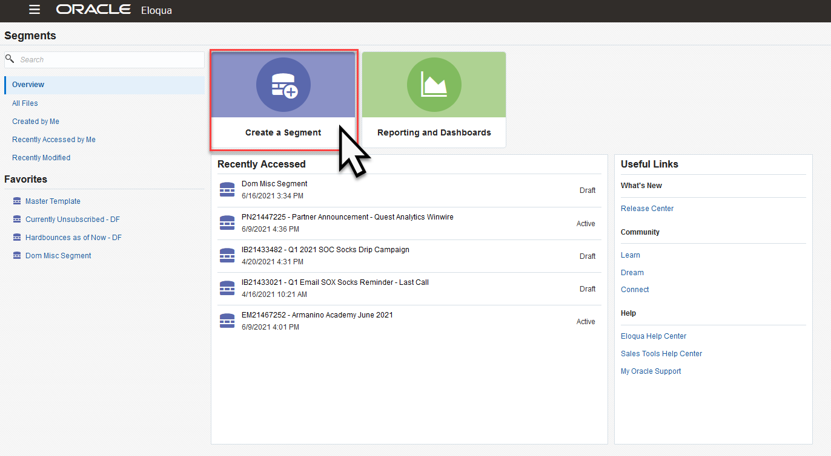
- The window that pop-ups up will show your most recently used Templates as well as newly created Templates.
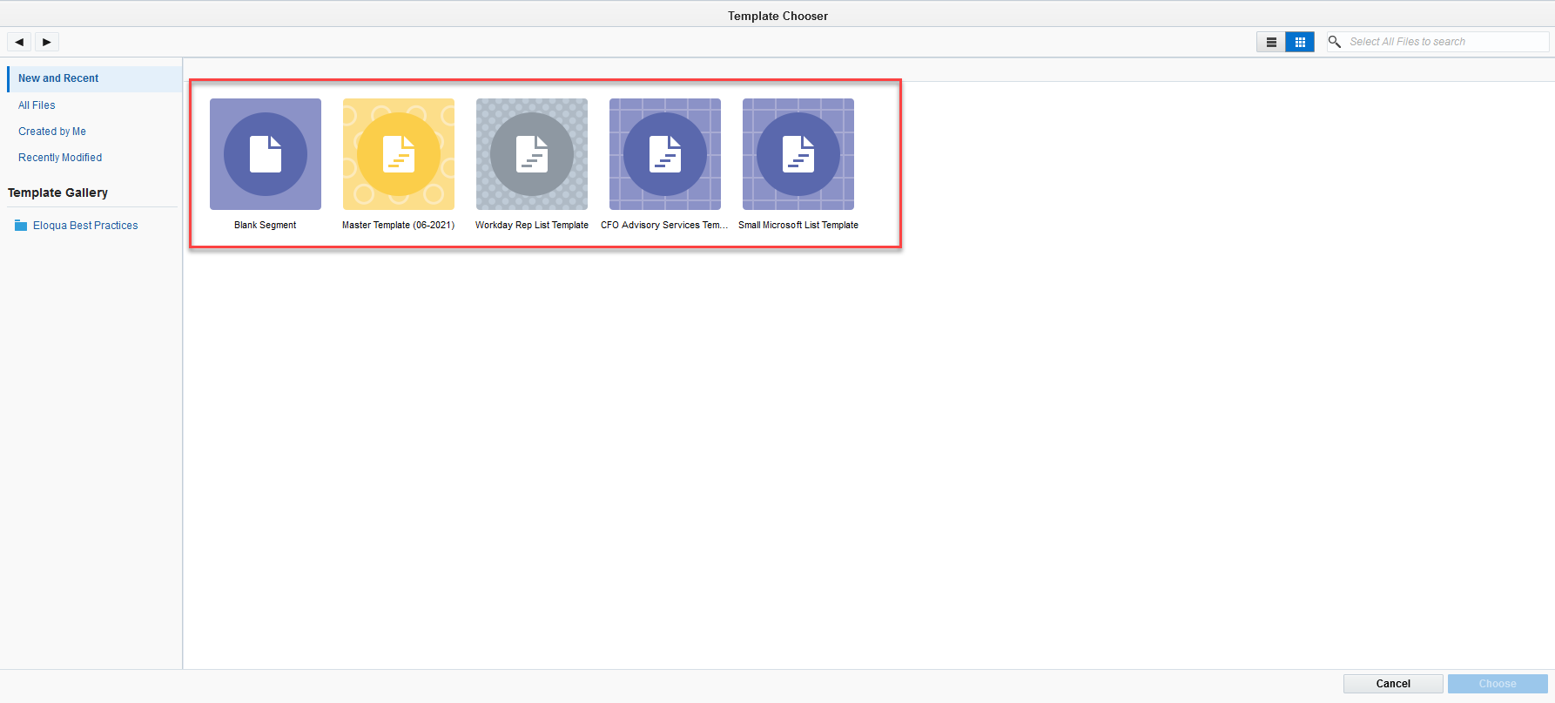

- If the template you wish to select is not shown, head to All Files on the left-hand side and click to show all available templates.
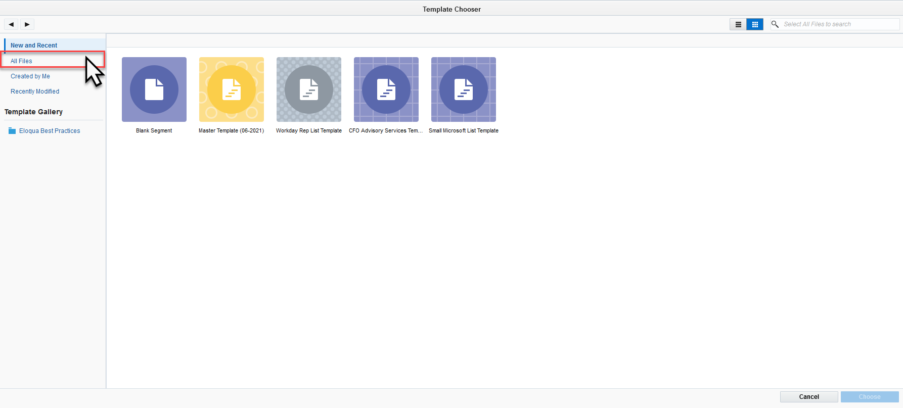
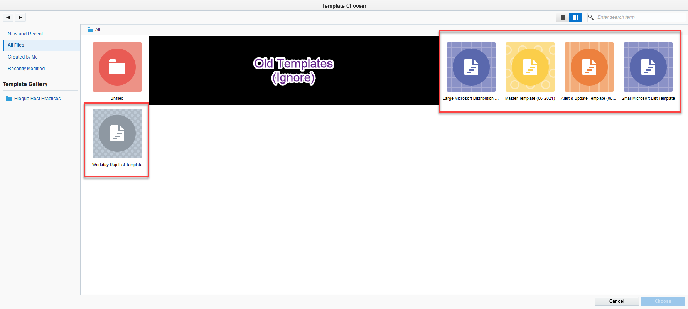
- Once you’ve made your selection, the Select button at the bottom right will highlight. Click to proceed.
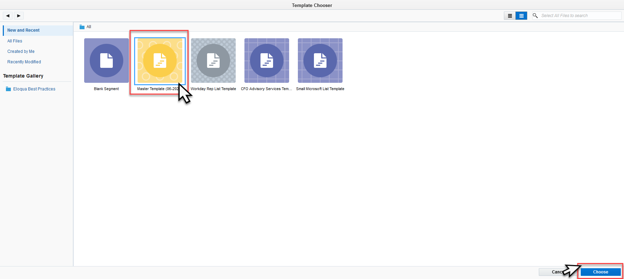
- When you enter the template, you will see a series of existing filters and lists. Depending on the template your actions are either:
  - Make additional edits
  - Save As with the proper name (Done!)
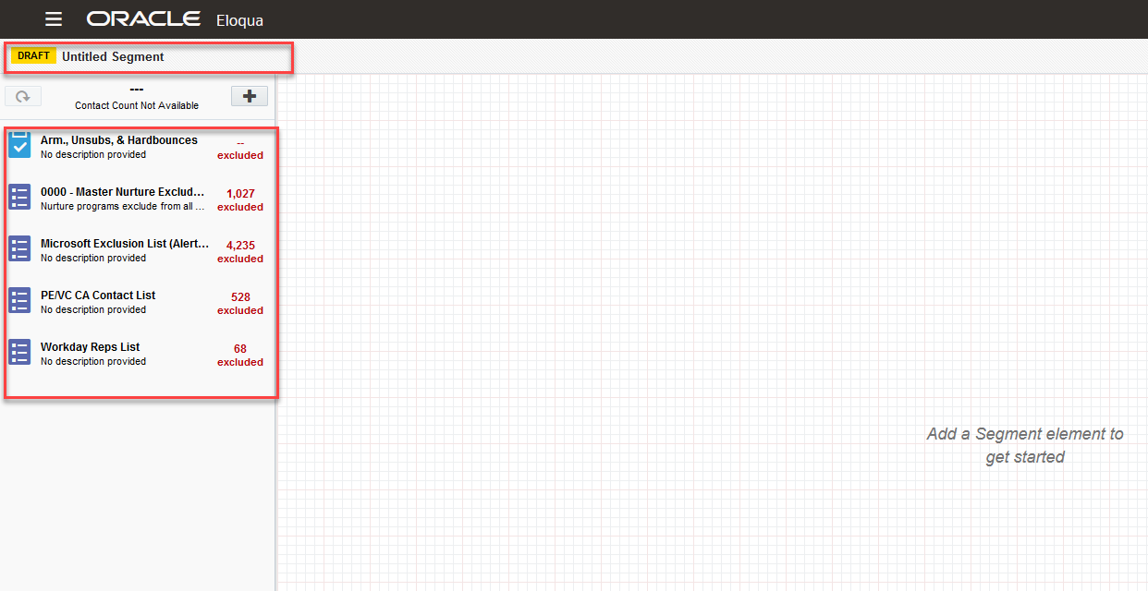

We have specific criteria for each template listed in the Table below (as of 6/21/2021)
Template Name | Description | Criteria
Master Template | Includes primary exclusion filters, no inclusion filters. The Default Template. | Majority of segments, unless otherwise specified.
Alert & Update Template | Includes primary exclusions and high-level inclusion filters for Job Function & Industries. | Called out specifically for Tax Alerts, Alerts, and Updates.
Small Microsoft List Template | Includes primary exclusions except for the Win-Wire shared list, which has been switched to INCLUDE. | Only used for “Win Wire” deployments. Specifically called out in Segment Form.
Large Microsoft List Template | Includes primary exclusions except for the Large Microsoft List (which includes with the Win Wire list). | Only used for very specific updates. Specifically called out in Segment Form.
Workday Rep List | Includes primary exclusions except for the “Workday Rep List”. | Specifically called out for in Segment Form.

- Oracle’s Documentation on building segments: https://docs.oracle.com/en/cloud/saas/marketing/eloqua-user/Help/Segments/Tasks/CreatingSegments.htm

Special Situations:

Emergency Client Deployments (With List)
- If PM provides a list of client emails, one of the most important things to determine is the source(s) of the list. If the list is pulled from CRM, you have an easier time building the segment as there is a good chance they are already in Eloqua (some may still be inactive, removed from Eloqua, and/or Unsubscribed).
- When you receive the list, your first step is to compare it to CRM/Eloqua via the Auto List Comparison tool.
- When you have those results, review the records found.
- If there are many records not in CRM or Eloqua, you will need to go through some extra steps to add them to the system without dropping them into the Welcome Campaign. (Do not want to send Clients a ‘Welcome to Armanino’ email.)
  - To prepare the upload, go to Eloqua Settings > Manage Picklists > Nurture 2019
    - Locate the “Do Not Enter Nurture…” option and copy the ID.
  - Create a new file and populate with the information you have been provided. In addition to those fields, create a “Nurture 2019” field and populate with the copied ID.
    - This will populate the picklist on those Contact records with that proper selection and prevent them from entering the Welcome Campaign.
  - Upload list as a Shared List and save as a new list in the proper folder.
  - This list will be what you add to the segment.

Exclusion Filters and Mass Exclusions:
- At times, PMs will ask to have either Companies or Individual contacts excluded from our deployments. These can be for a myriad of reasons:
  - Do Not Contact (Legal Request)
  - Individual Contact Removal/Unsubscribe
  - Competitor Exclusion
  - M&A Exclusion

Do Not Contact (Legal Request)
- These types of requests will be sent by the Armanino Legal team and will be encompass actions in both CRM and Eloqua.
- Background: Sometimes we enter legal disputes with potential or former clients, and during this time we wish to no longer market towards those companies entirely.
- The first step is to always verify that the request came from the Legal team, and no partner simply wants to exclude that company.
- Once verified, you will travel to the Company’s Account page in CRM, head to the “Marketing” tab, and check the “Do Not Contact” box. This checkbox starts a series of workflows/programs in CRM that will complete the following steps:
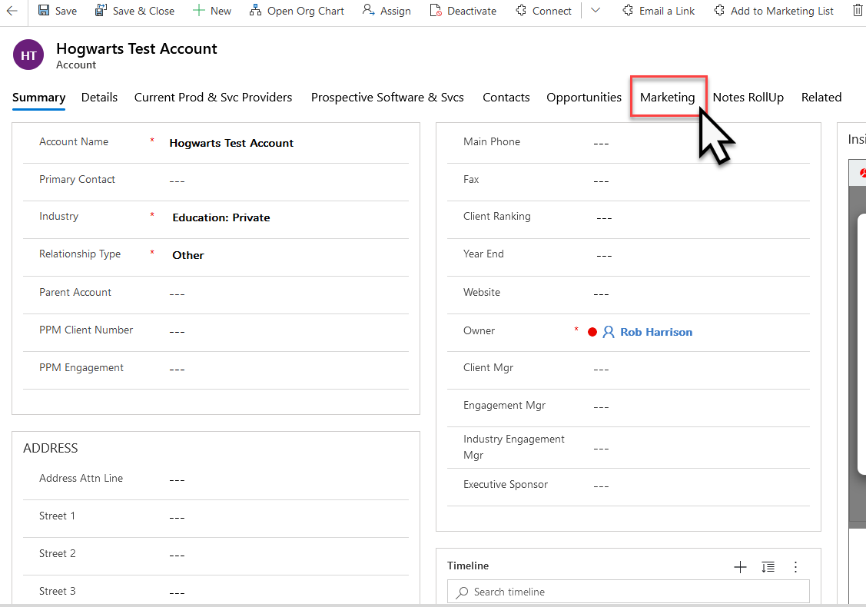

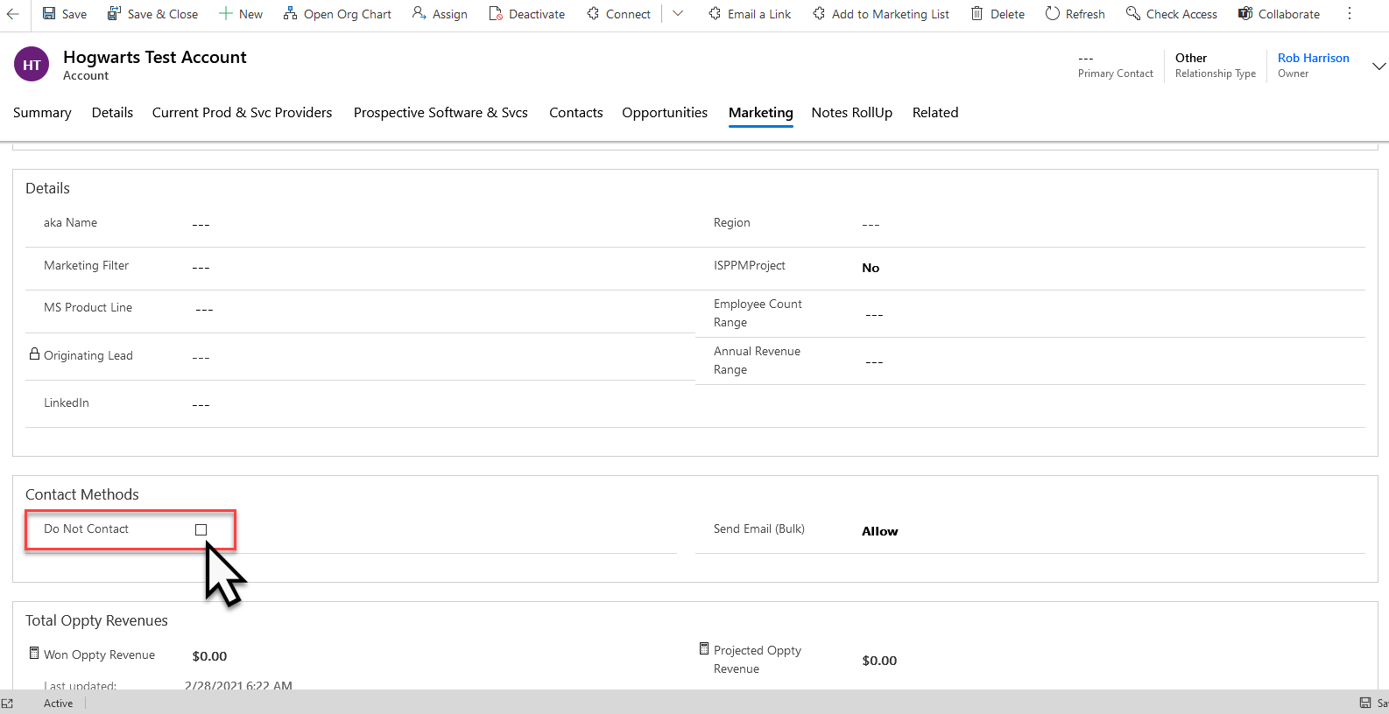
  - Set a status change and Pop-up on all associated records to that Account page, noting that this record is set to “Do Not Contact”. It will also write a Closed Activity noting everyone who views these records on those records.
  - Mark each Contact record as “Send Email Bulk = Do Not Allow” to prevent them from being included in deployments going forward.
  - Close Any Opportunities that are Currently Open in CRM
- Next, in Eloqua, head to the “Shared Filters” and search for “legal”. This will populate the “Legal Dispute Exclusions #” shared filters.
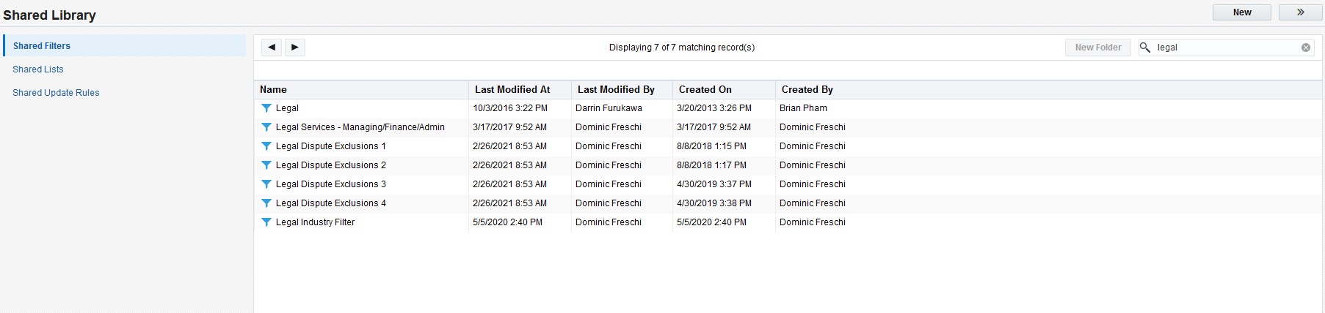
- As noted above, each shared filter can only contain 15 “logic gates” and leads to us having to create multiple filters.
- Starting with the latest one, add a filter for the company’s Domain Name.
- If you had to create a new Shared Filter, you will need to update the “Master Template” and the “Alert & Updates” Template.
  - See Template Section.

Unsubscribe Requests:
- PMs and others will sometimes send you an email requesting to have a specific person unsubscribed from our Marketing Emails.
- Always ask if the individual requested to be unsubscribed and if so, to provide the email requesting it. There will be some special circumstances where they will not have anything, it’s usually best to ask them to “show their work” to be safe.
- Once confirmed, make sure you have the individual’s email address. Copy it.
- Head to Eloqua, and search for that contact. If it populates, double-click on their record.
- In the pop-up, select the “Preferences” in the top option set.

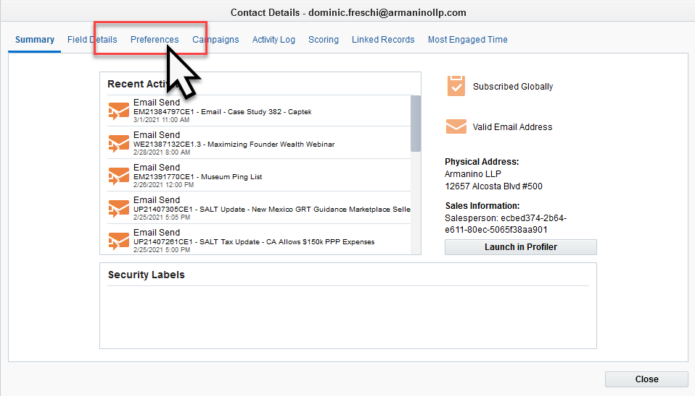

- On the right-hand side, press the “Unsubscribe” button.
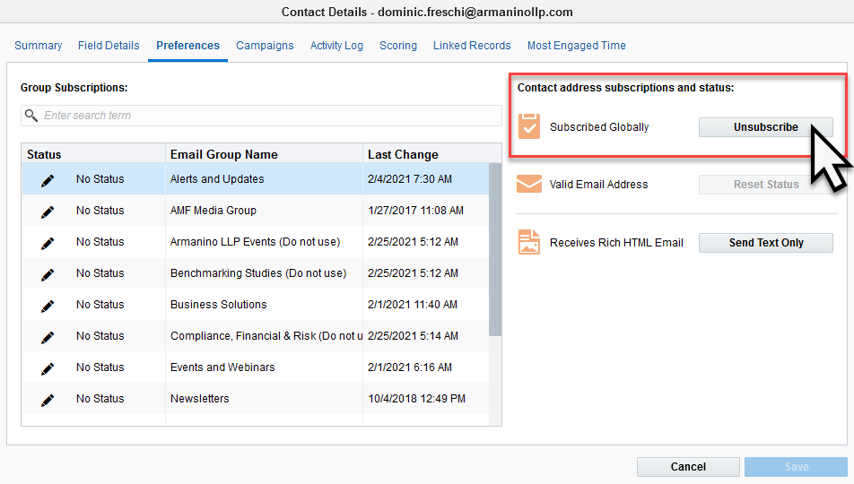
- When completed, select “Save” at the bottom.
- This process will immediately unsubscribe them from deployments in Eloqua, and the data will sync with CRM in about 30 minutes.

Attendee Activities (OLD)

Events
- Most of the time the attendee activities for Armanino hosted events will sync automatically with CRM. This currently runs through our Certain event platform.
- However, there are times when we use other platforms, host an offline event, or gather information from a third-party event. These require specific steps detailed below.

Third Party Events
- Third Party Events comprise Tradeshows, Networking Events, Conventions, etc. These are opportunities for our Marketing and Sales teams to meet and work with prospects and clients.
- We wish to track those who attended these events to introduce them to our marketing, track their attribution as their record was gathered during these events, and to potentially follow-up with a phone call or email campaign.

Webinars
- Currently (March 2021) Armanino-hosted Webinar Attendee Activities do not automatically sync between the host system and CRM. Therefore, we must push activities through to their CRM records.
- The process demonstrated below is the fastest method using custom-built programs in Eloqua.
- Note, there will be some records that exist in Eloqua that do not have a record in CRM. This can be due to multiple emails associated to a single record. In this instance, the Eloqua record for their additional email is kept while only 1 record exists in CRM.
- Note, only 1 attendee set can be processed at one time. If someone has records processing through already and another individual changes the settings, it will cause errors with the data. Please make sure to coordinate with your team.
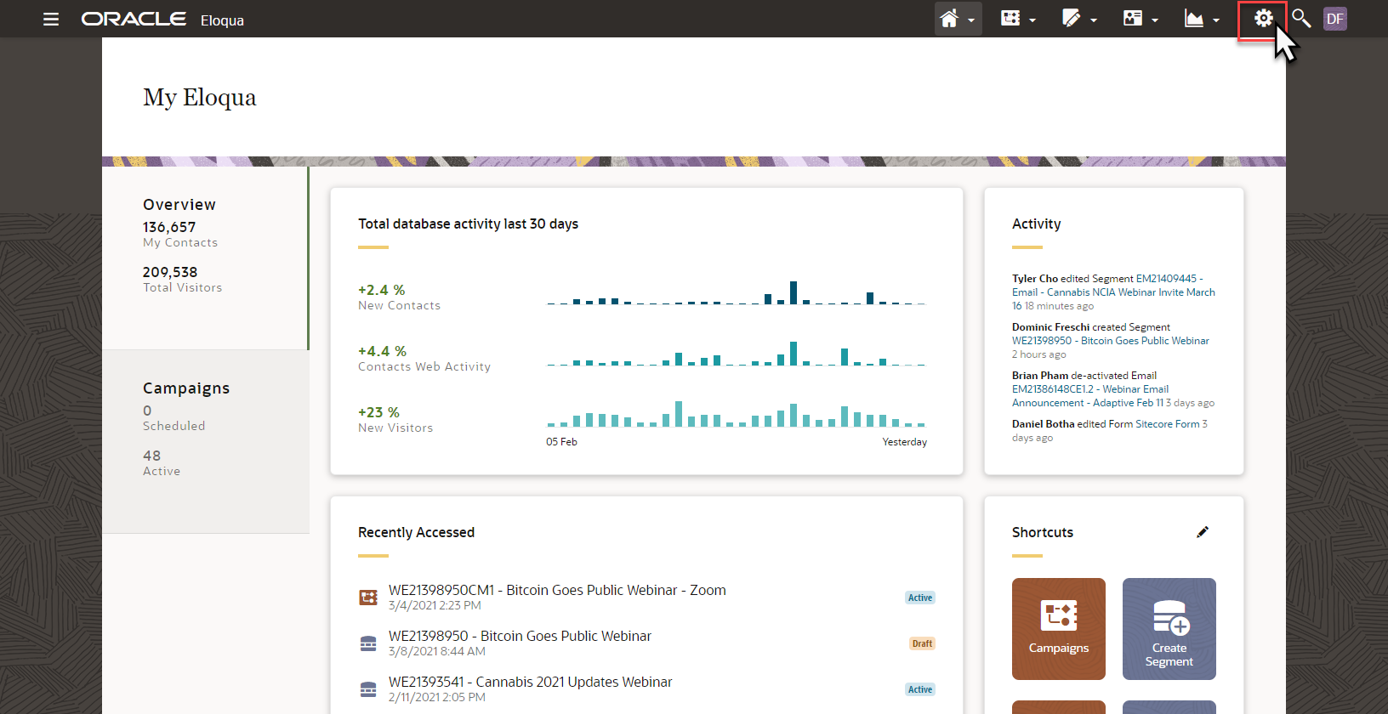
- From the Eloqua Homepage, click the “Gear” icon in the top-right of the screen to open the Settings menu.

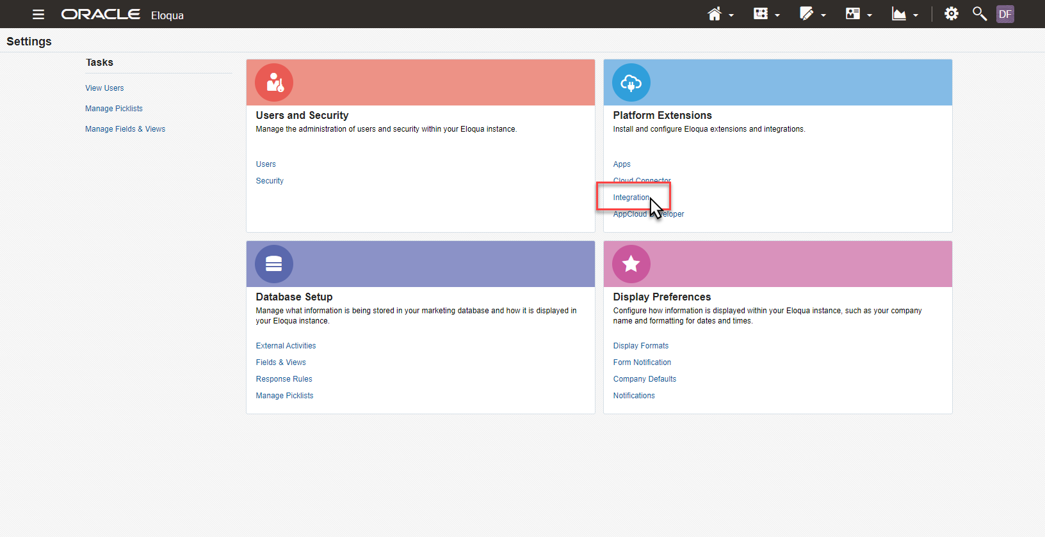
- Then, under the “Platform Extensions” menu, select “Integrations”.
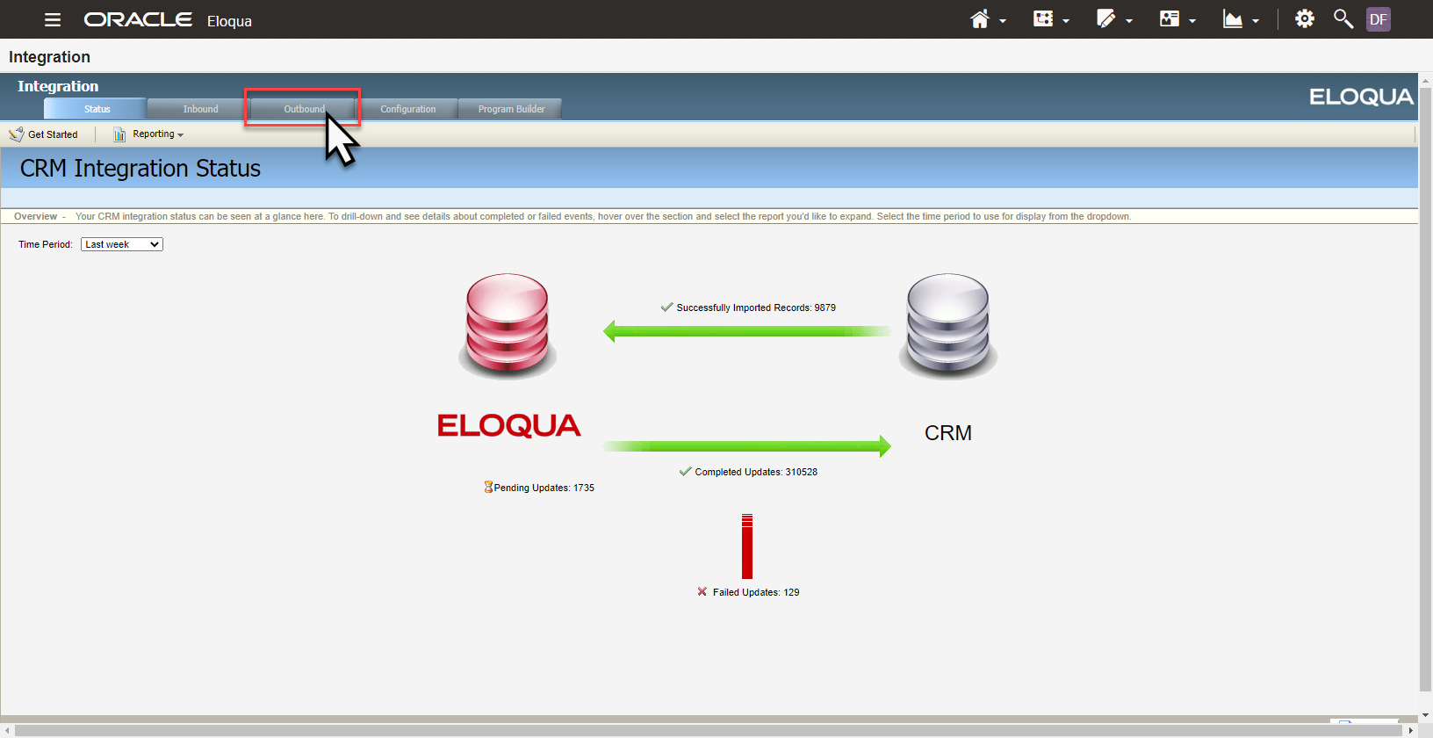
- From the “Integrations” menu, click the “Outbound” tab at the top of the page.

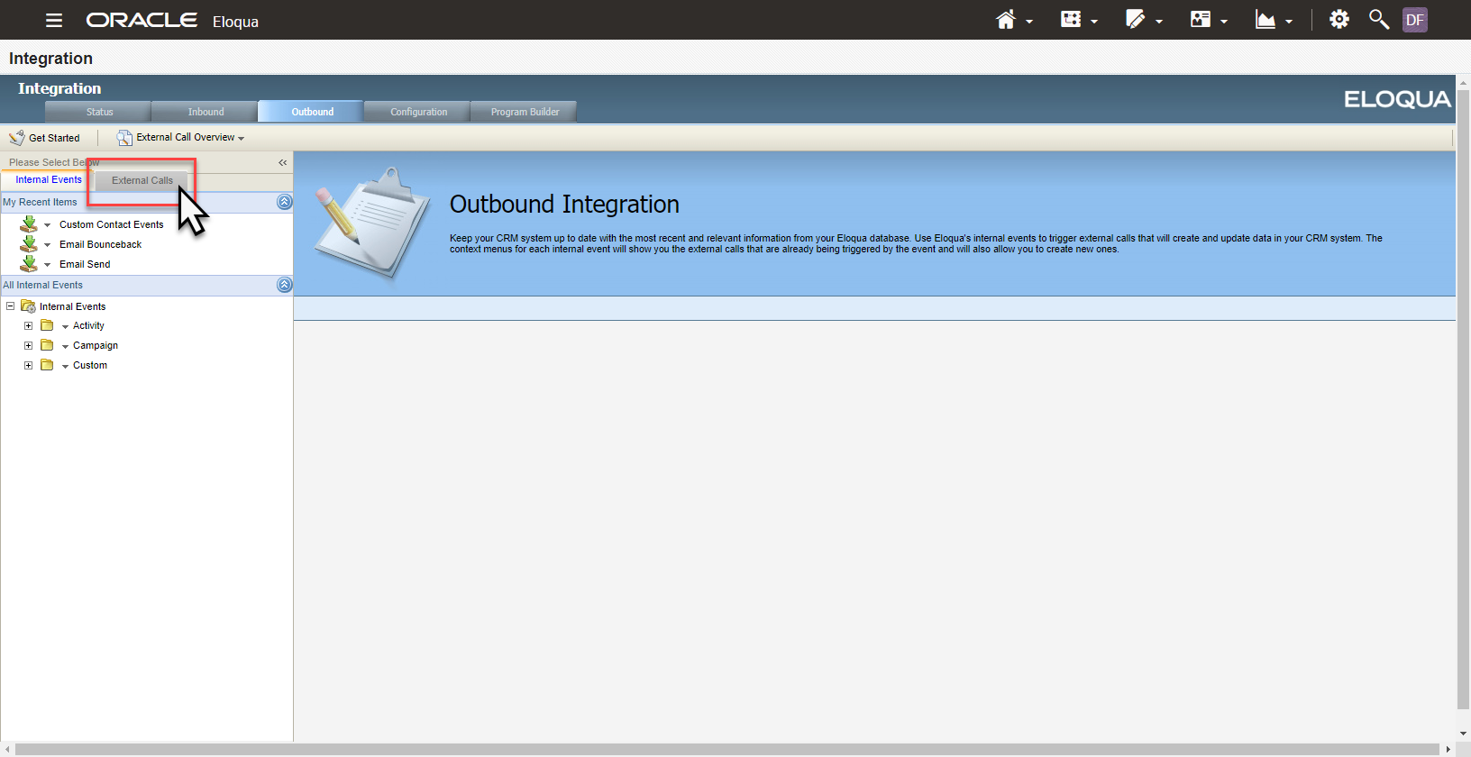

- Click the “External Calls” tab located on the left-hand side of the page.
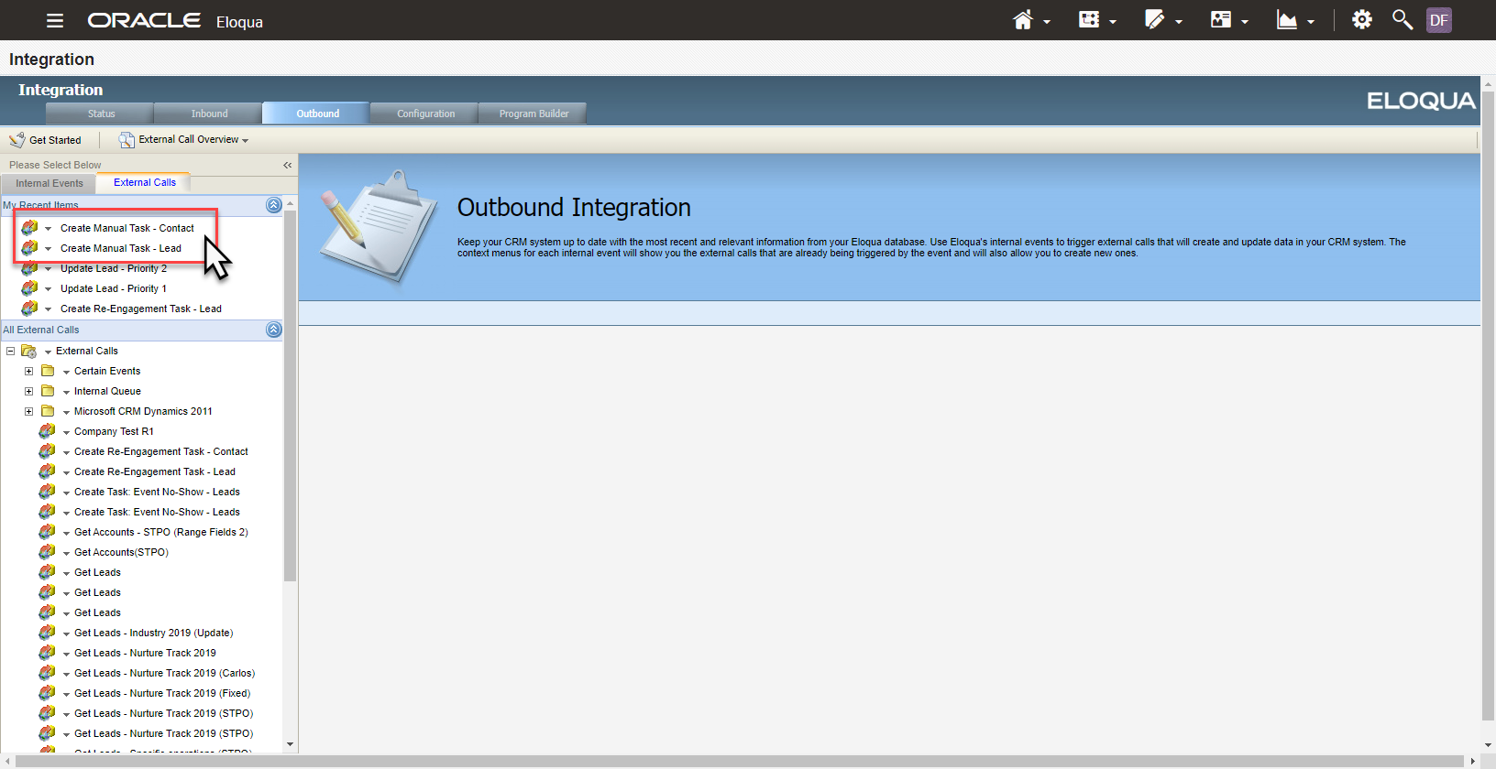
- Next, locate the “Create Manual Task – Contact” and “Create Manual Task – Lead” options.

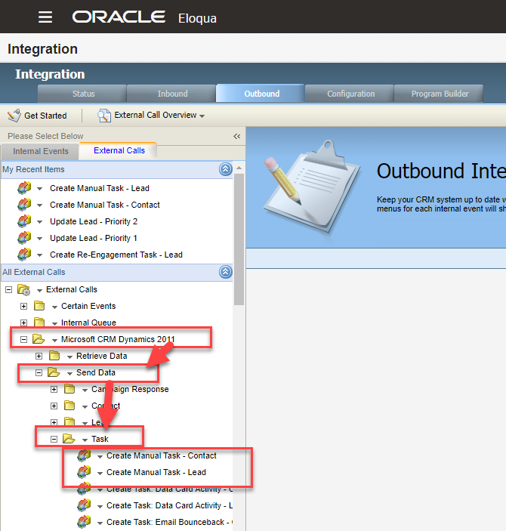
- If the options are not located in your “Recent Items”, navigate below and follow the path “Microsoft CRM Dynamics 2011” > “Send Data” > “Task” > “Create Manual Task…”

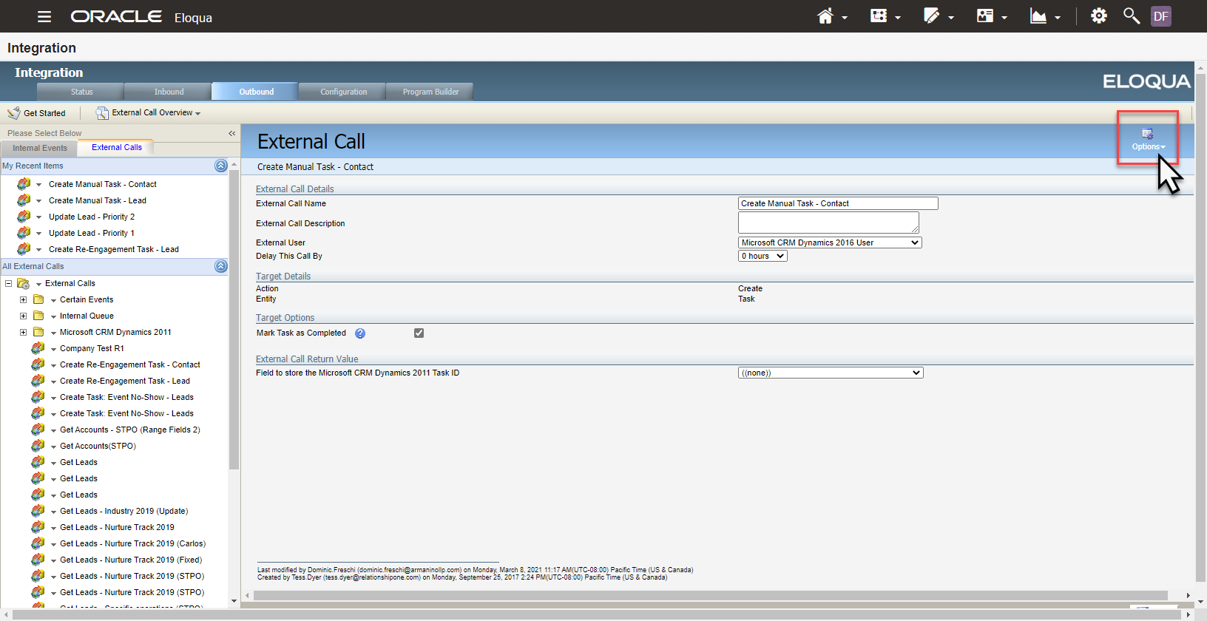
- Click the “Options” menu at the top-right of the screen.

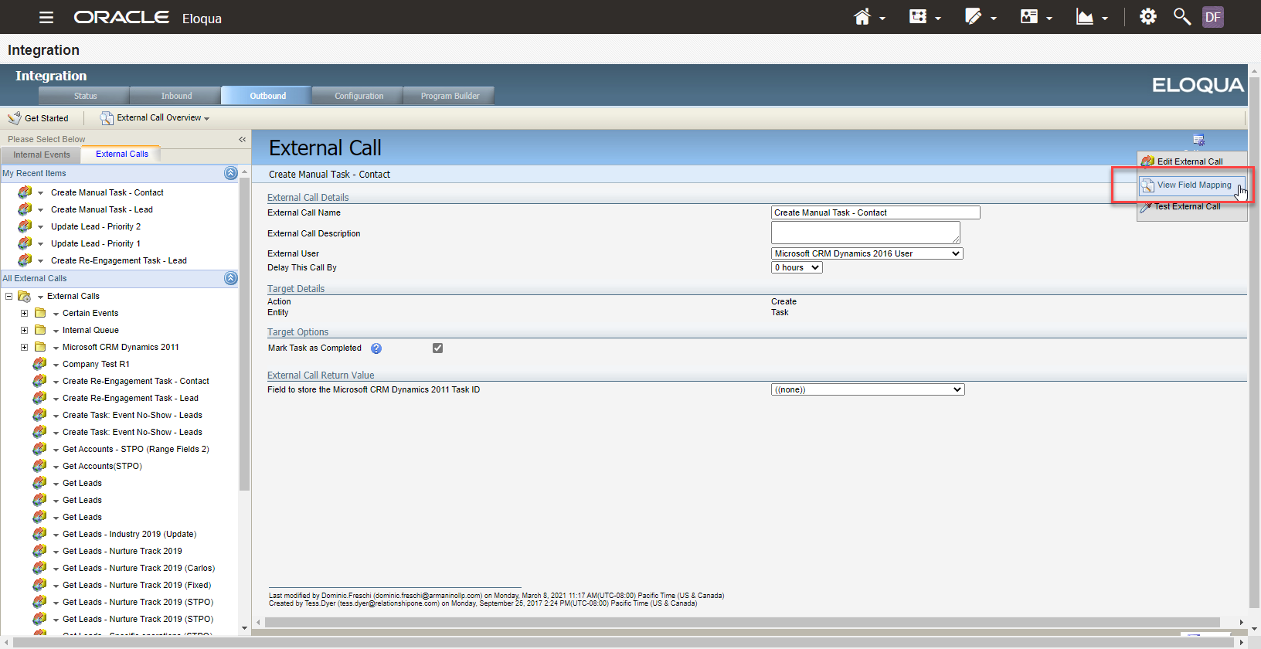
- Select “View Field Mapping”.
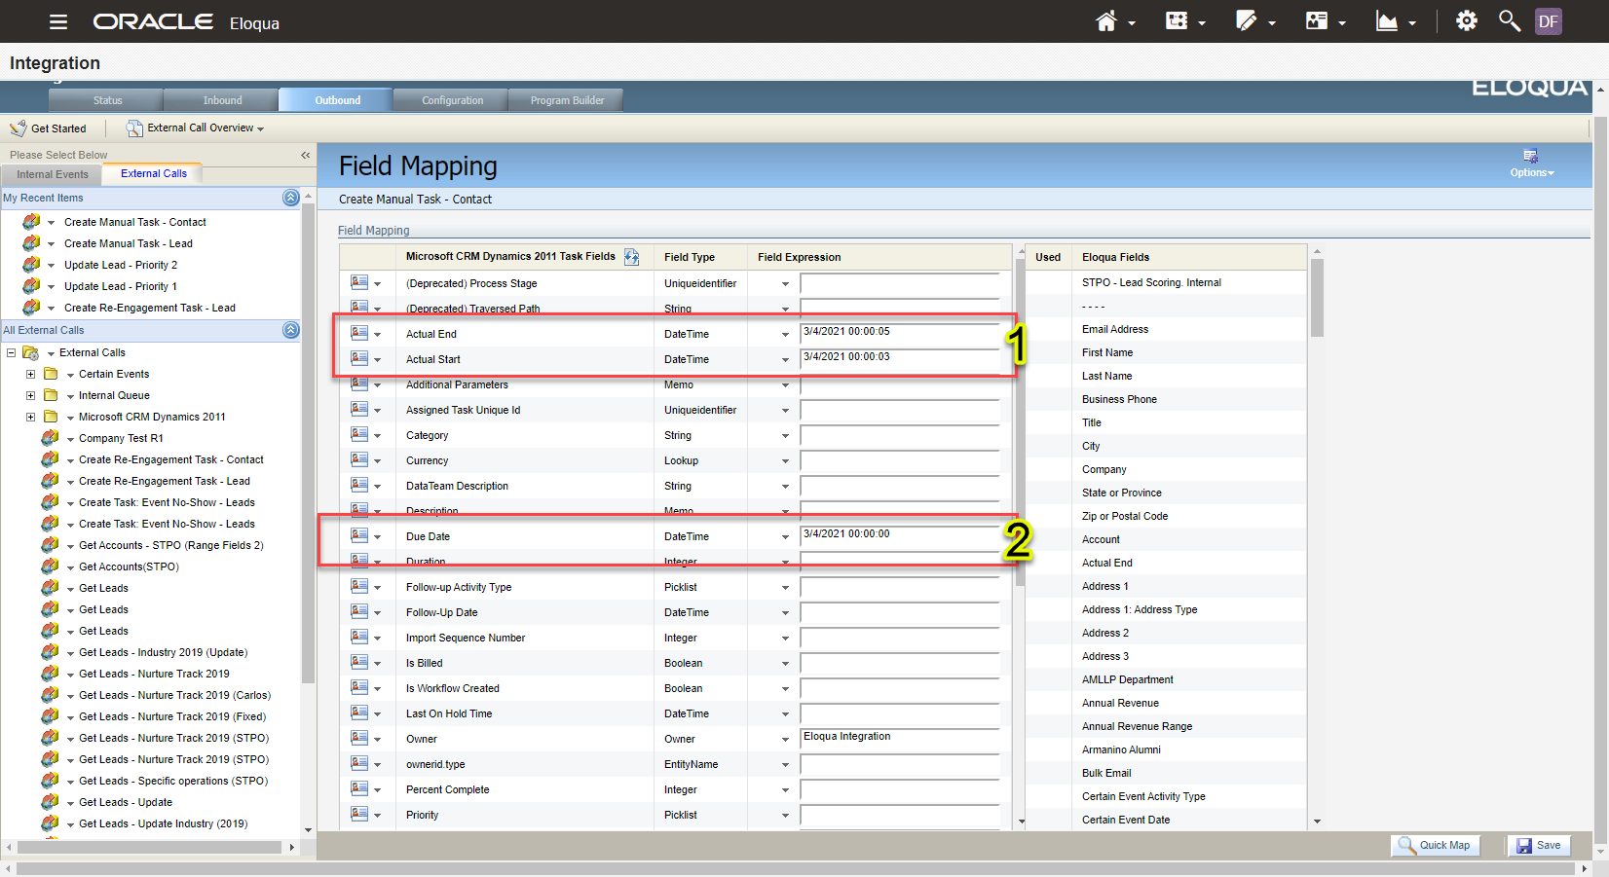
- In the view field mapping menu, you will need to populate the date fields shown here at numbers 1 and 2.
- DO NOT delete the timestamps listed beside each of them. Only update the Month/Day/Year text.
- Secondly, due to server time zone differences, you will need to add 1 day to the date of the event.
  - E.g. If the Webinar was held on 3/15/2021, you will need to provide “3/16/2021”
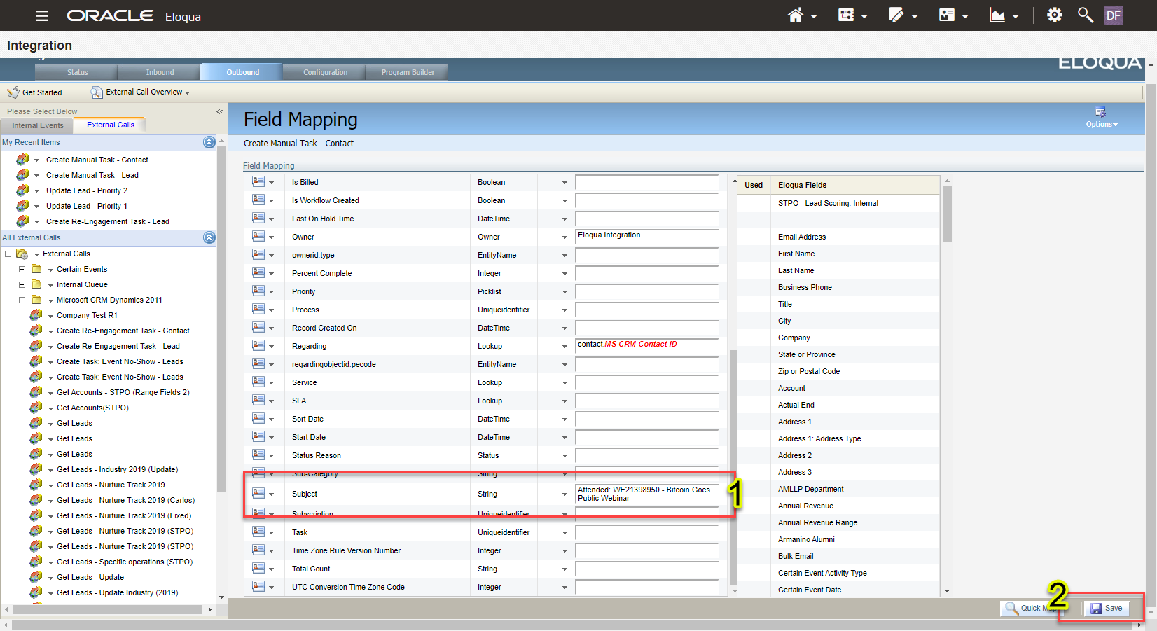
- Scrolling down, locate the “Subject” field. This you can clear entirely and populate with the properly formatted Activity Name:
  - Attended: [PROJECT NUMBER] – [Name of Event]
    - E.g. Attended: WE21393289 - Mammoth/Armanino Joint Cannabis Webinar (Interstate Trade)
- When complete, click the “Save” button at the bottom-right of the screen.

- Depending on which record type you started with, repeat the same process for the other.

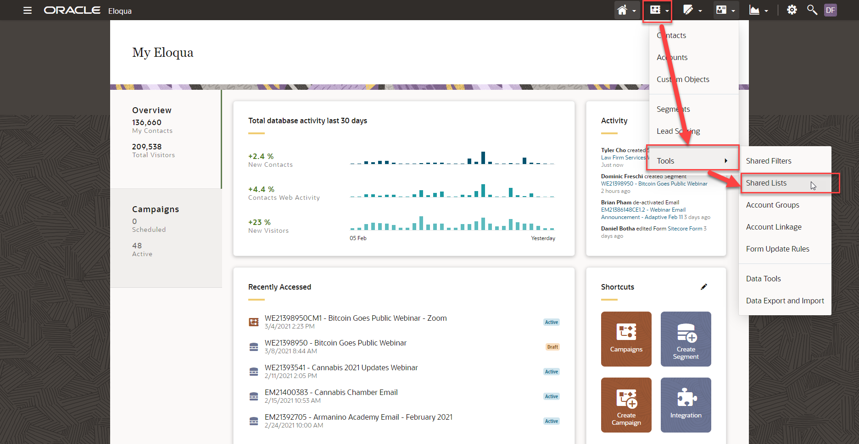
- Next, let’s verify that there is a Shared List for you to use. Select the “Contacts” icon, then select “Tools” and lastly, “Shared Lists”.
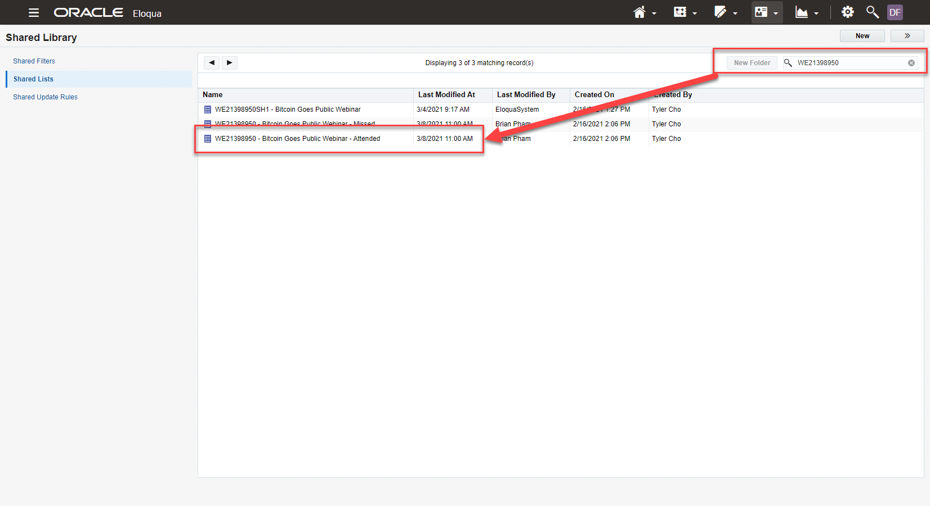
- Here, search using the Project Number and locate the Shared List that has the “Attended” suffix. Verify that it’s populated and continue.
- If it’s not populated, check the Project Canvas to see if Contacts are stuck. If they are, contact the Production Specialist.
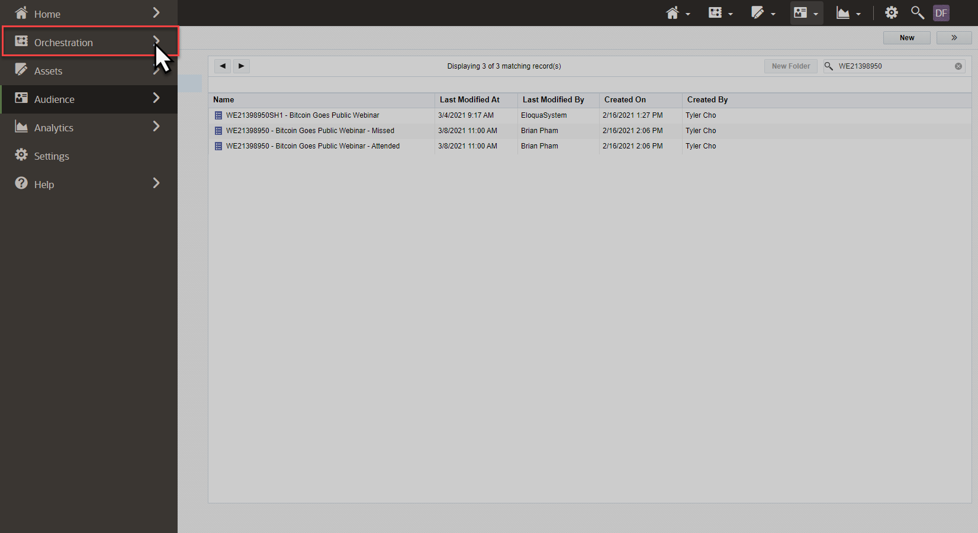
- Once verified, we will need to drop records into a program that will take the data we populated into the Manual Task Creation settings and push them over to specific records in CRM (the attendee list).
- Select the hamburger button at the top-left of any page in Eloqua, then select “Orchestration”.
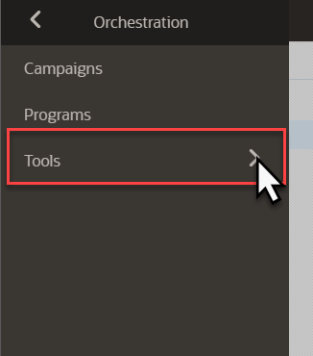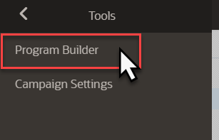
- Next, select “Tools” and then “Program Builder”.

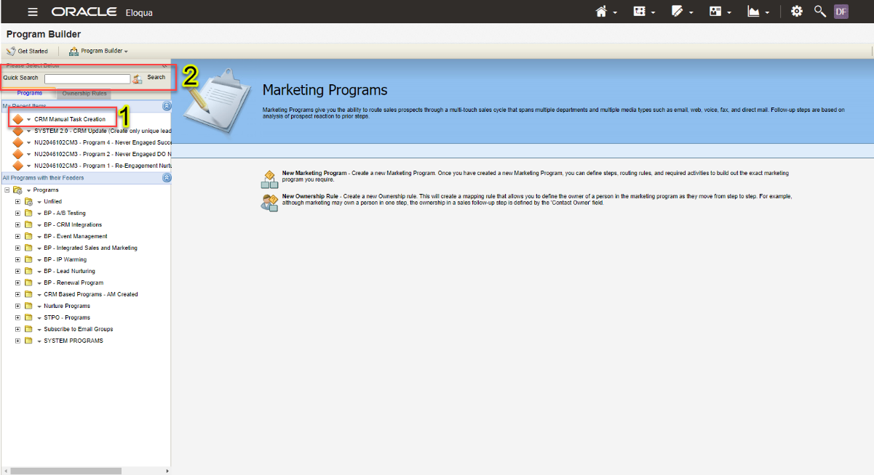
- Here, if you’ve recently used the Program, it will appear at the 1 in the image above, your Recent Items.
- If not, you will need to search for it. Simply type the name into the search field and click “Search”.
  - CRM Manual Task Creation
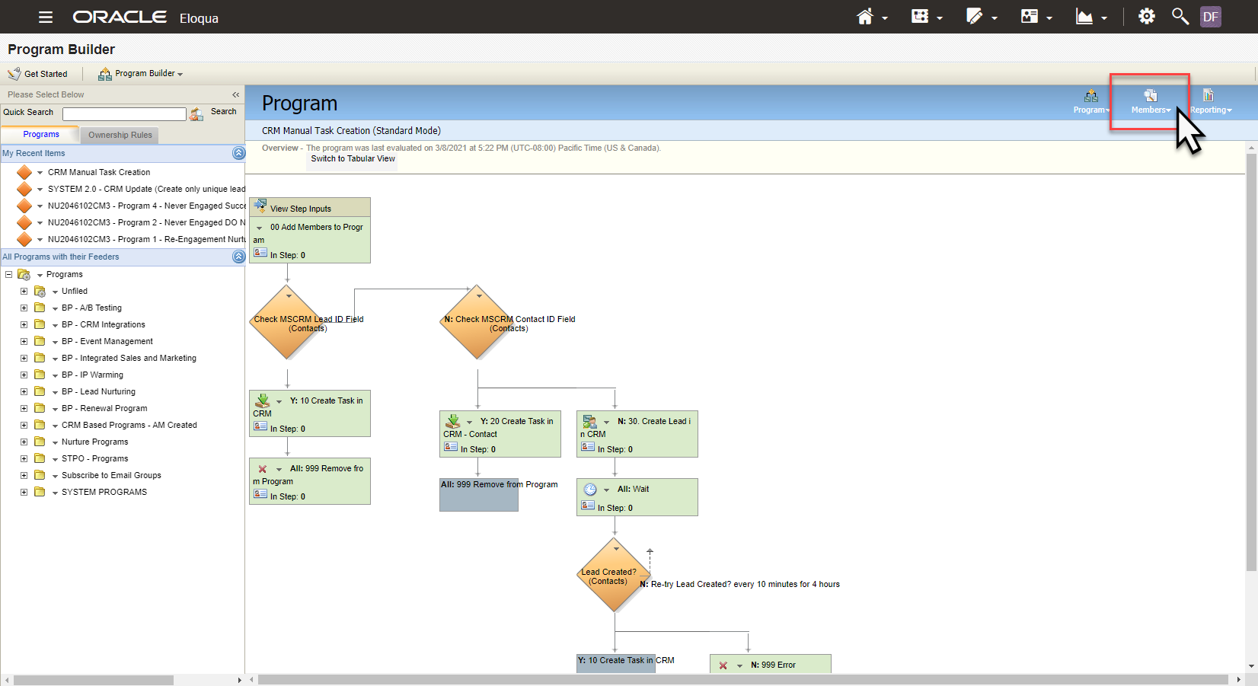
- Once you’ve found the Program, head to the top-left and select “Members”.
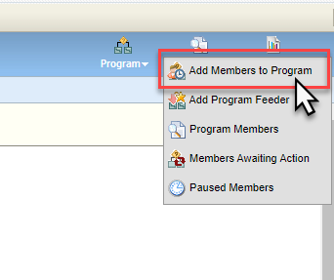
- Next, select “Add Members to Program” and a pop-up will appear in the middle of the screen.
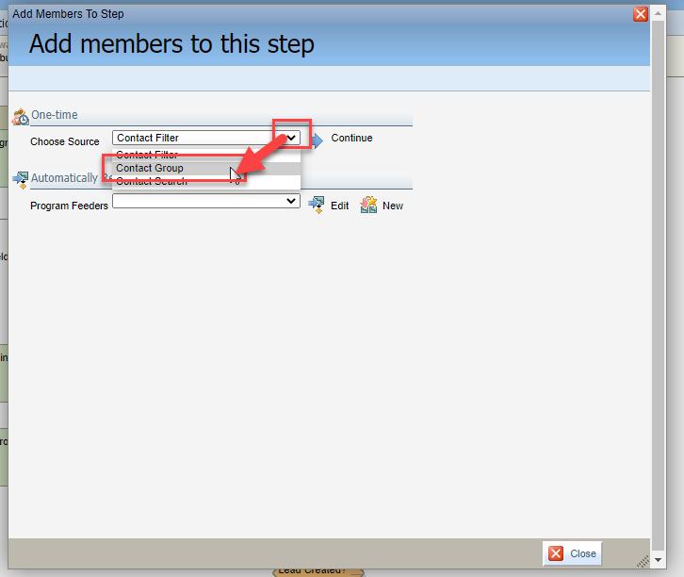
- From here, you will need to find the attendee list using this menu. To start, click the drop-down and change the “Source” to “Contact Group”. Then click “Continue”.
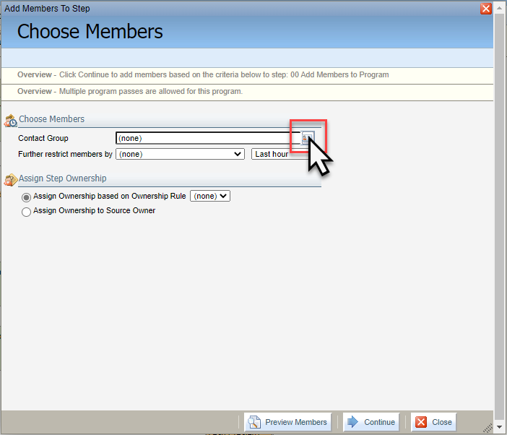
- Next, select the small contact card to the right.
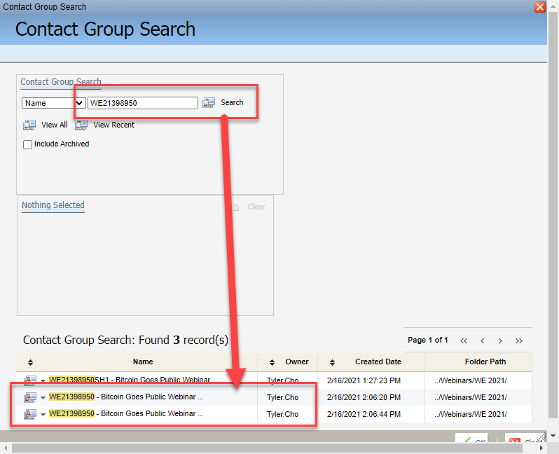
- From here, use the Project Number to search for the specific list.
- Sometimes, the names of the lists can be quite long, so you may need to “hover” your mouse over the name to see the full name. When you find the “Attended” list, select it.
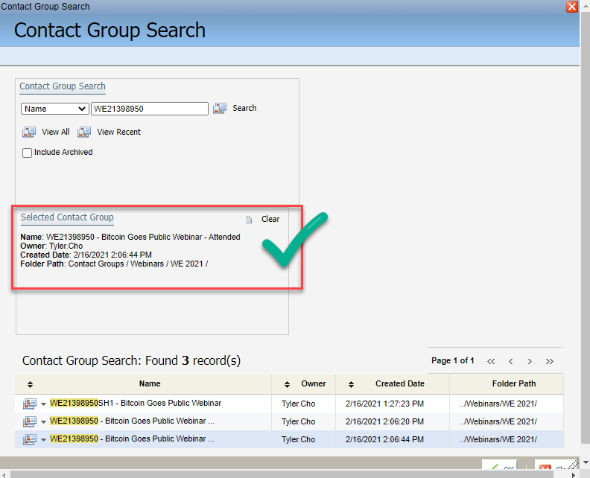
- You will receive a verification as shown above when the list is correctly selected. Once complete, select “Ok”.
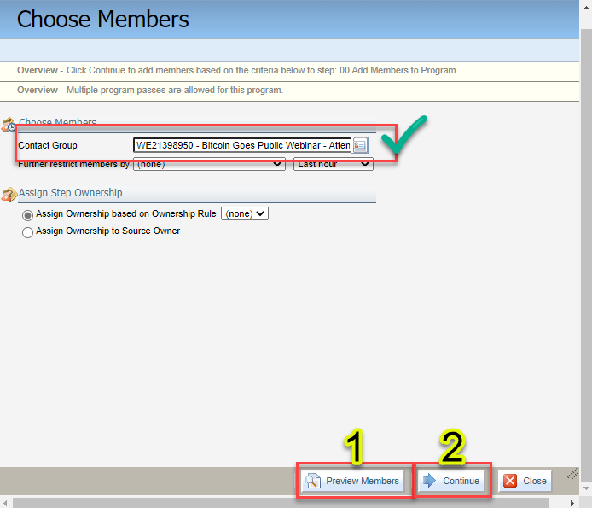
- When the window reloads, you should see the Contact Group field populated with the list you selected. If you want to double-check, select the “Preview Members” button listed as 1 above.
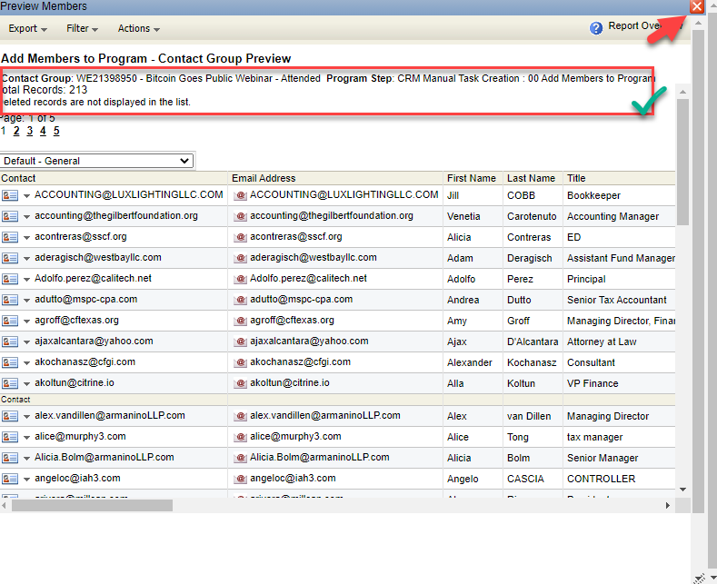
- Here, you can check the list itself, the name of the list, and the count. Once done, click the “x” at the top to return to the previous window.
- Once verified, click “Continue”.
- You will get a notification that “###” records were added to the program. Click Ok and the entire page should reload.
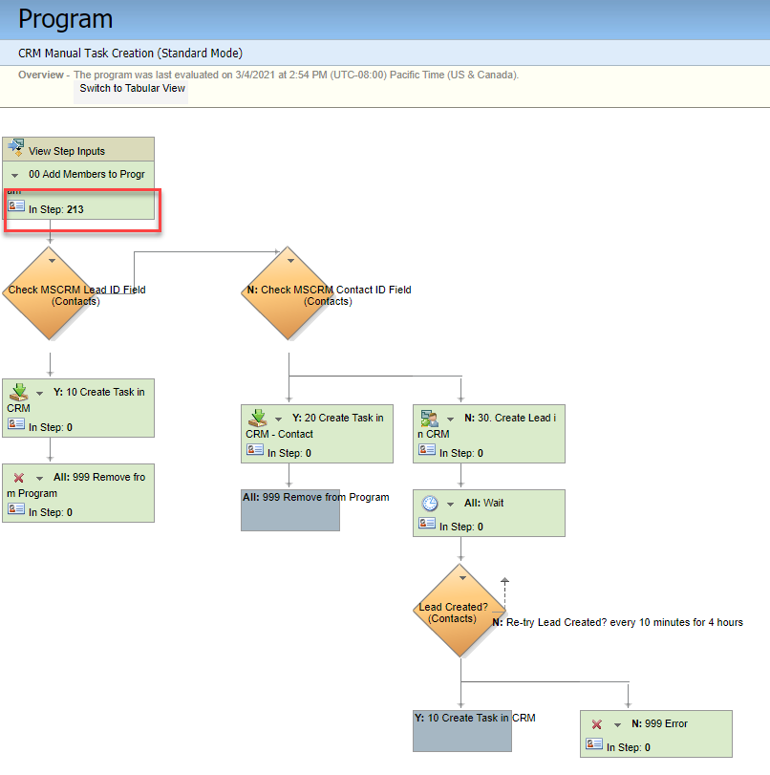
- It may take a few minutes, but you will soon see the records added to the first step as shown above. This program will take some time, so leave it to process for anywhere from 30 min to 1 hour.

Attendee Activities (NEW)

Events
- We no longer use Certain and instead use Bizzabo as our event platform.

Third Party Events
- Third Party Events comprise Tradeshows, Networking Events, Conventions, etc. These are opportunities for our Marketing and Sales teams to meet and work with prospects and clients.
- We wish to track those who attended these events to introduce them to our marketing, track their attribution as their record was gathered during these events, and to potentially follow-up with a phone call or email campaign.

Webinars
- Currently (March 2021) Armanino-hosted Webinar Attendee Activities do not automatically sync between the host system and CRM. Therefore, we must push activities through to their CRM records.
- The process demonstrated below is the fastest method using custom-built programs in Eloqua.
- Note, there will be some records that exist in Eloqua that do not have a record in CRM. This can be due to multiple emails associated to a single record. In this instance, the Eloqua record for their additional email is kept while only 1 record exists in CRM.
- Note, only 1 attendee set can be processed at one time. If someone has records processing through already and another individual changes the settings, it will cause errors with the data. Please make sure to coordinate with your team.

Run a comparison if needed via Core FTP LE
- We create closed activities in CRM through the Core FTP and Openprise.
- Unless you know all the attendees from the event/webinar are in CRM, run a comparison in the CoreFTP. Use the comparison file template here. Input the relevant data and save as the file once you’re done.
- Open the Core FTP and sort for your documents in the left window and drag your comparison file to the comparison folder (List Comparison – 01 – Upload) on the right side.
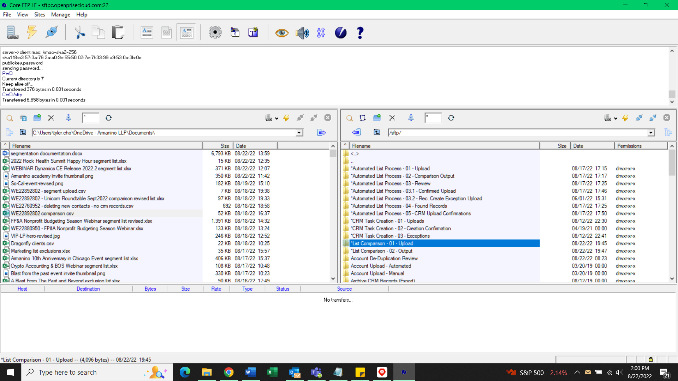
- Once the file is in, the bot will automatically run. Check back after a few minutes.
- The comparison file will show in the List Comparison – 02 – output folder.
- If they are all in CRM, then you can proceed with the Task Creation for the attendees. If they aren’t, then Drea Jordan will need to upload the new contacts from the attendee list to CRM.

Making Closed activities via Core FTP LE
- For the closed activities, use the template here.
- Input the relevant attendee data. Be mindful of the last two columns, Task Name (Subject) and Event date
- The Task Name should be Attended: Project Number – Project Name
  - An example would be Attended: WE21424796 - CA Exodus Roundtable Webinar Series
  - You can find the project name and number in WorkFront.
- The date also needs to be the date the event or webinar was held.
  - Make sure that it’s the same date for everyone.
- Once all the data is ready, do a “save as” in your PC’s documents folder and save it as a CSV (Comma delimited) (*.csv) file.
  - If it’s not a csv file, then Core FTP will not be able to process the document.
- Find the file in your documents in the core ftp and drag it over to the *CRM Task Creation - 01 – Uploads Folder
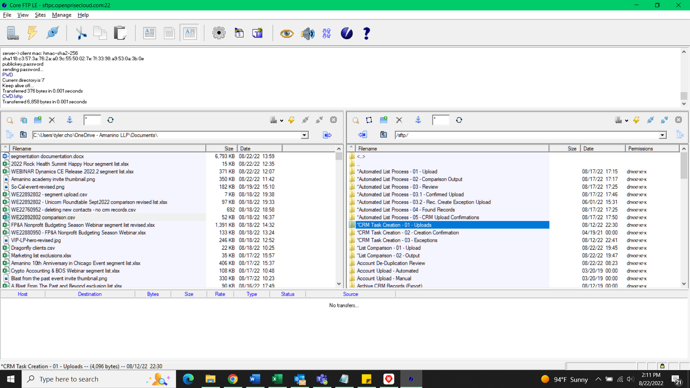
- The file will process every half an hour, so check back after an hour. Depending on the size. It’ll take around an hour to create all the tasks.
- Once it’s processed, it will either create the closed activity task for all attendees and you’re done or there will be some exceptions, in which case, you’ll need to create the closed activities tasks manually in CRM for the ones that didn’t get a closed activity task made.
- You can see the contacts that didn’t get a closed activity made for their record in CRM via exception report file in the file *CRM Task Creation - 03 – Exceptions.
  - Sort date by most recent to see if it’s there. If it’s not, then there were no exceptions, if there were, then we’ll need to create the closed activity task for those contacts that didn’t get one made for them in CRM.

Creating closed activities in CRM
- Look up the contact via their email in CRM. Once you find their record, go to the right hand side to the Timeline and create a new task with the + sign.
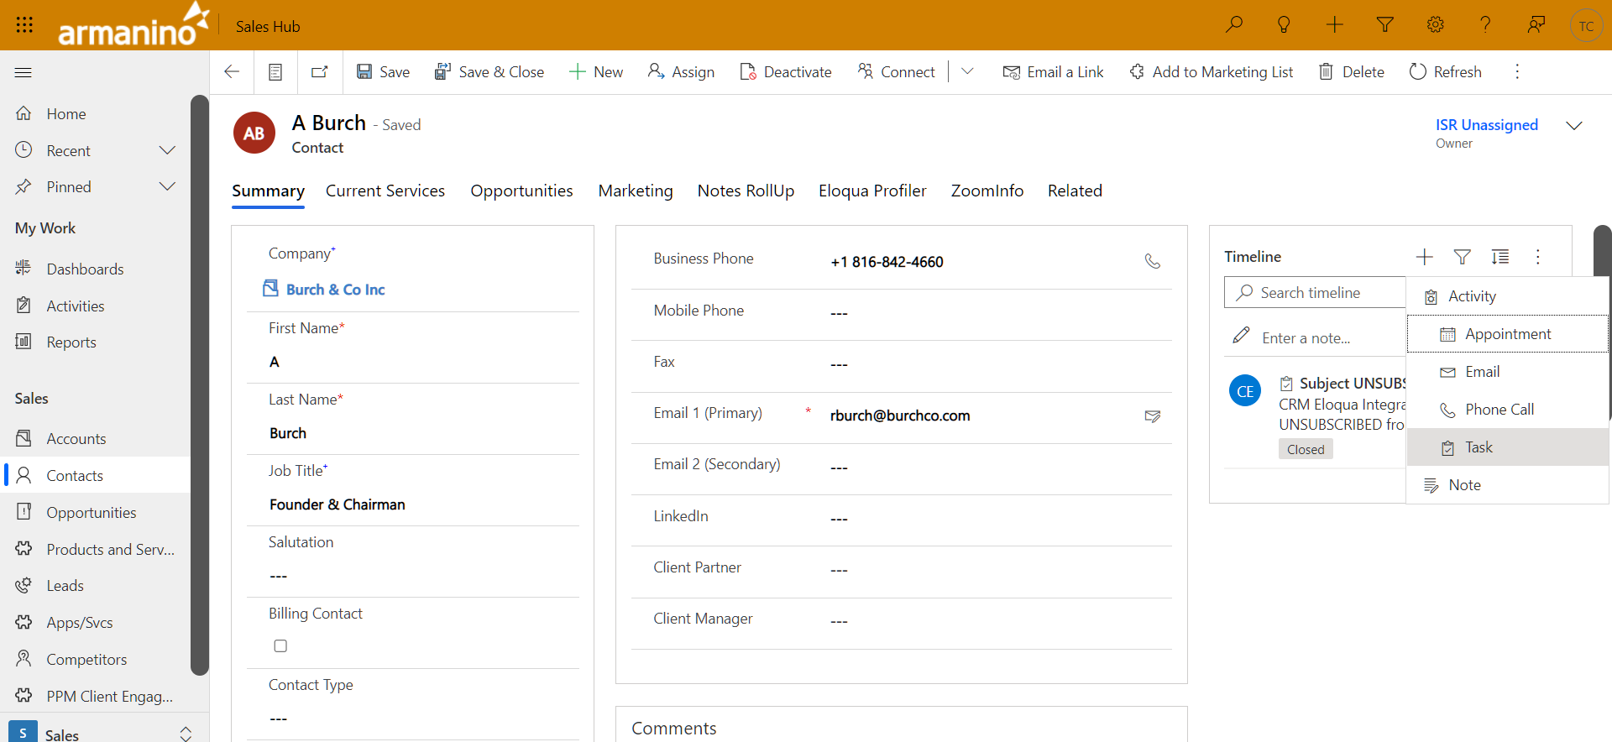
- You’ll then be opened to a new task.
  - Once here, the subject will be the same Subject Task Name you filled out in the task creation template. Attended: Project Number - Project Name.
  - The due date will be the date of the event
  - The duration will be None, so change it to be blank
  - The Actual End date will the date of the event. Unless it spans more than one day.
- Here’s an example below of what it would look like.
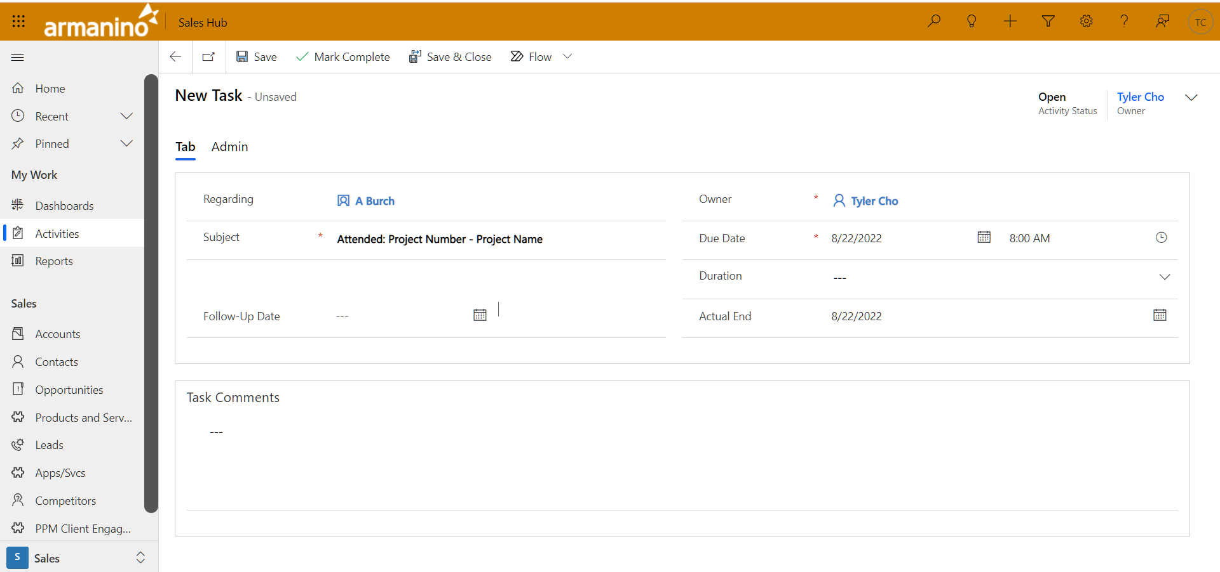
- Once you’re done. Save the task and mark as complete at the top.
- That’s it! You can always delete tasks you made if you messed up. Now do this for the other exceptions and you’re done with the task creation for the attendees.

