Introduction
In the previous session we spoke about how we our eco-system changed from perfect to be ruled under by the kingdom of the devil. Also how God the Sovereign, always been working to recreate a people for Himself and send them into the world as a witness for Himself under the sovereign rule of Jesus Christ. Today we are going to explore what God’s mission is translated into our witness for His name at the place of work.
- What is being missional at work?
- What are some roadblocks to being missional?
- How do I become missional at work?
  - How is my foundation and the structural integrity?
  - How do I work? Do I witness at all? How often do I witness?
- Some tips: to go from being inactive to getting on fire
- Work as a context for sanctification lending itself to missions
- Appendix
  - Which box do I belong to? How can I make progress?
  - Accenture and Merck experience
  - Reference material

Jesus’ great com“mission” applies to all followers in all contexts, especially at work
- All authority is with Jesus
- Therefore
  - If authority of Jesus isn't understood, there is no going
- Go <Main stumbling block for Christians is in this step>
  - Make disciples <All nations>
  - Baptizing them in the name of the Father, Son and Holy Spirit
  - Teaching them to obey everything
- I am with you to the very end of the age

What is being missional at work
Living the great commission (@ work) is being a Missional Disciple

Where do the roadblocks originate from?
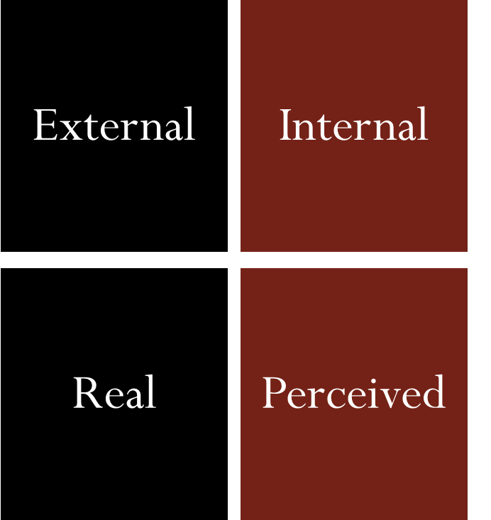
- Unless you attempt you will never know where the roadblock is from
- If you are not attempting to share the gospel, the roadblock is definitely inside of you
- Internal and Perceived roadblocks will start to recede once you attempt to be missional
- For the real risk to appear, we do not have to go searching, it will come to you, as you live missionally
- Who is The sovereign? God is, and He commands us to, “Go...”

Roadblocks from being missional
- HR policy prevents us from discussing religion (E)
- It is part of culture that we do not discuss politics or religion (E)
- I don’t have the time to share, as I am really busy at work (I)
- I don’t know how to bring about gospel conversations (I)
- If they are the elect they will come to know Christ (I)
- I am not motivated to share the gospel (I)
- I am afraid of the questions that they might ask so I avoid these conversations (P)
- I think it is for the “experts” to share the gospel (P)
- I once/sometimes tried to share and I was shut down (R)
- I shared the gospel and I was dinged in my job/career (R)
- I lost my job because I shared the gospel (R)

Foundation and structural integrity
Spiritual disciplines and cost
- Relationship with God because of Christ through the Spirit is the beginning of all meaning to life
- Active fellowship with Christ and his body critical for life’s structural integrity
- Repenting Confessing Obeying for the sake of love is the life style of a follower in Christ
- There is a cost to pay when you choose to love your neighbor and your enemies

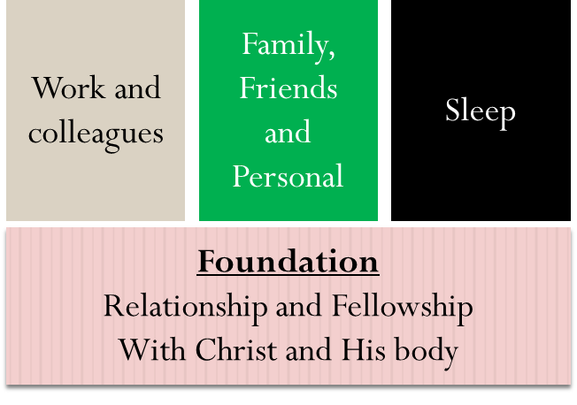

How you work matters. How often do you witness?
- How do you work*?
  - Below par: Efforts below expectation or below the efforts of your colleagues
    - Qualifier: You could be in a toxic setting or you could be faced with a personal challenge
  - At par: Efforts at par with your colleagues
    - Qualifier: You are not expected/culture to work any differently other than just to do work
  - Above par: Your efforts are significantly above your colleagues
    - Qualifier: Does not have to be overwork. Sometimes you could be overworking, check if idol?
- How often do you witness*?
- I don’t: For whatever reason you might have
- Sometimes: When I get an opportunity
- All the time: I cannot stop myself
* Note: These you can personally check with God and or someone who you trust and get an honest feedback. God does not rely on man’s performance management
Some tips: to go from being inactive to getting on fire
- If you are not active and want to be active:
  - Pray for one person who you can witness this week and ask the Holy Spirit to give you an opportunity to have a gospel conversation
  - Think through the list of people who you commonly interact with and ask them if they have anything that you can pray or if they had shared something with you, pray about it and let them know you prayed
- If you want to be more active from being somewhat active:
  - Pray that God will give you a fellow believer who you can pray with in the week even for 10-15 minutes
  - Find a colleague who is a believer or who wants to have a spiritual conversation and read a book with them
  - See if you can start a spiritual conversation/ bible study during lunch break hour, these days in a free slot
- If you want to stay active and get on fire
  - Start a bible study at your work place or start a prayer group at your work place with fellow believers
  - Host some evangelistic events for your colleagues
  - Train others to be disciple makers
Work as a context for sanctification lending itself to missions
- Mordecai:
  - Plot to kill the King had to be faithful to report and protect the King
  - Bow down to Haman not bowing down to man, but to God
  - King’s edict to kill the Jews displayed humility to ask for help and exhorted Esther to see how the Lord was moving, “for such a time as this”
- Daniel:
  - Did not want the King’s food stood up for his faith (Kosher)
  - Interpreted the dream saved the wise men of the kingdom with the help of his friends
  - Inspired his friends to stand up even to the King and not worship
  - Did not bow down to the king gave himself up into God’s hands

Questions for discussion?
- Do we understand and believe this command of the great Com“mission”?
  - If yes, should it change our approach to work?
- Do we hide our identity in Christ at work? If yes, why?
- How do we respond to our co-workers who do not understand these underlying truths of the Word of God?
Appendix – 1
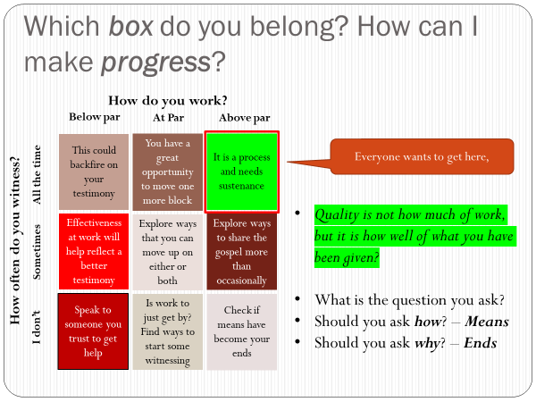

Appendix – 2
Accenture and Merck for Christ
- September 2013 – June 2018 Fridays
  - Accenture for 5 years in the USA, attended and led Bible Studies
- 2010 to July 2018 Tuesdays: Every Tuesdays Chinese language fellowship
- July 2018
  - Joined Merck and joined the Chinese speaking fellowship, I ended up being the only non-Chinese dude!
- September 2018: Moved to Every Friday
  - Chinese fellowship is meeting
  - May 2020 : Turning to a discipleship group
- September 2018: Tuesdays English Study of the Word
  - Converted to English fellowship September 2018
  - Started Bible Study – Romans January 2019, now at Chapter 13
  - Hosted Evangelistic event(s): Go through the belly evangelism
- March 2020: Every Monday prayer time
- May 2020: Discipleship group 5 leaders (3 ladies and 2 men)
- Yammer Stream (Discovered 3 other groups) now we have something every day of the week

Appendix – 3
References
https://www.ministrymatters.com/all/entry/4259/5-evangelism-barriers-and-how-to-deal-with-them
https://www.desiringgod.org/articles/four-reasons-we-dont-share-the-gospel

