Grade 12. SQL Class Test
Database: BP Challenge 2000. Total: 70 marks
You may open the database in Ms Access and create your SQL statements there. Alternatively you can use SQLBrowser to open and run your SQL statements.
This is a four-table database of students from 4 different schools who entered the BP Challenge. For catering purposes, they had to make known their preference between Halaal, Kosher, Vegeterian and “No Preference”. The students could be girls or boys and could be in any grade at their respective schools (grades 8 to 12 inclusive)
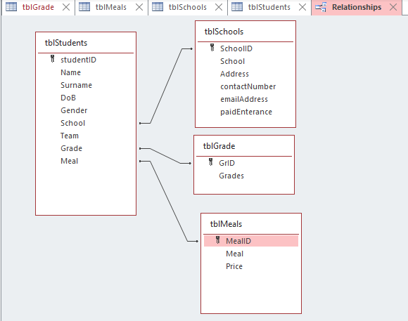

Table Grade
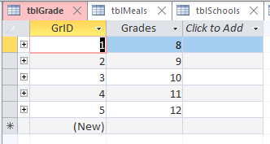
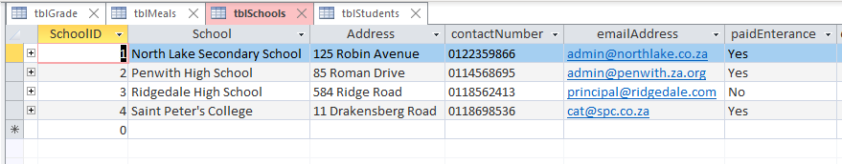
Table: Schools

Table: Meals
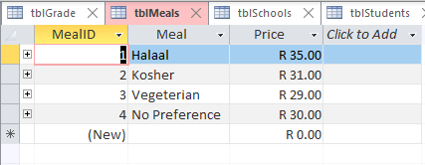

Table: Students (not all students are shown here)
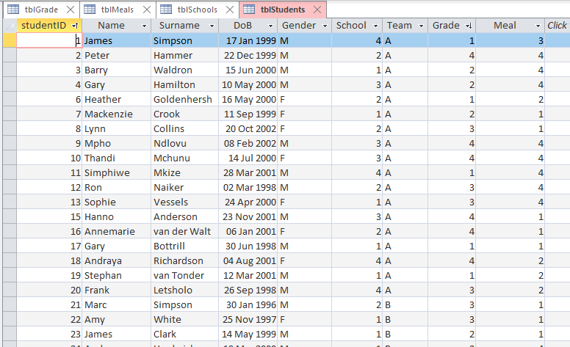

Section One
Open a new Ms Word document. Write your name inside the document and save it using your name and grade and “SQL class test”. Use this document to for your answers for section one and section two.
1.1) Use this 4 table database to explain the benefits and process of normalization. In your answer include the roles of the primary and foreign keys. Explain, with examples for the database, how normalization avoids anomalies.
(10)
Section Two
Write SQL statements for the following questions. Copy and paste your SQL statement into your Ms. Word document with your NAME in the file.
In some cases, a screenshot is provided. If this is the case, then the screenshot is part of the question.
2.1) Did Martin Sebethoma enter the competition?
2.2) Find all the students who have a first name that starts with “J”
2.3) Find all the students who have a first name that starts with “J” but this time, list them alphabetically by their last name.
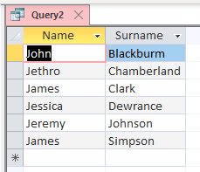
2.4) Find all the students who have a birthday in May.
2.5) Look for any students who were born in 1995 or earlier.
2.6) Ensure that all students who enter the competition have a date of birth.
2.7) We need a list of students, sorted by their surname, with their ages in years (fractions of a year allowed but not compulsory)
2.8) Similar to the question above. We need a list of students, sorted by their surname, with their ages in years – no fractions of a year. Just in whole years.

2.9) We need a list of students, sorted from youngest to oldest, with their ages in years – no fractions of a year. Just in whole years. (sample only is shown below)
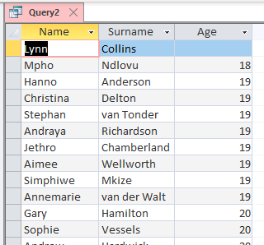
2.10) We need only the name and surname of the oldest student in the competition.
2.11) Using today’s date determine the average age of all the students using their date of birth. Here we don’t want whole years only – we would like the average age rounded to two decimal places. Name the column appropriately.
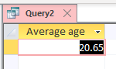
2.12) Make a list of female students only.
2.13) We need the number of students who are in the A team of any school. (only the number). Name the column appropriately.
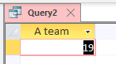
2.14) We need the average price of the meals on offer. Name the column appropriately,
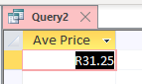

2.15) Determine the number of students in each grade from all the different schools. (note the order)
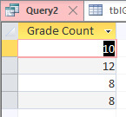
2.16) Make a list of all students (name and surname) who attend North Lake Secondary School.
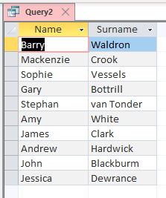
2.17) Make a list of all students who are vegeterian. (yes, ignore the spelling error)
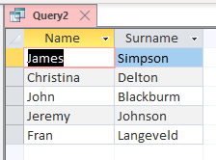
2.18) Are there any vegetarian students at North Lake Secondary School?
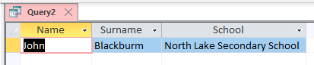

2.19) List all the students, name and surname, who are in grade 9 from any school.
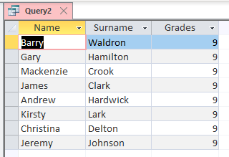

2.20) List all the students, name and surname, who are not in grade 9. (sample only, shown below)
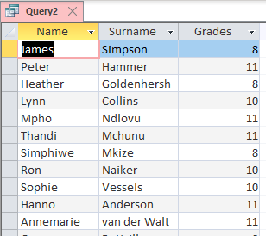

2.21) Write a SQL statement to find the oldest student in grade 9.
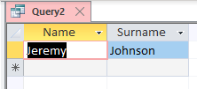

2.22) Lynn Collins is unable to provide proof of her date of birth before the deadline. Therefore she must be deleted from the student table

2.23) Lynn Collins finds her ID document. Despite missing the deadline the school decides to re-instate her back into the team. Her details are as follows
- Lynn Collins
- Date of birth 02 February 2000
- Gender: Female
- She attends Penwith High School
- She is in the A team
- She is in grade 10
- Her meal preference is Halaal
2.24) After Lynn Collins is added back to the A-team, the captain of the B team makes a fuss saying that it was not fair. For this reason, Lynn Collins is moved into the B team for missing the deadline. Write a SQL statement to update her details.
(60)
Total: 70 marks

