School Name
School
Logo
School
Logo
Information Technology

SBA: SQL Test 2022

Grade 12 Time: 45 minutes Marks: 50

Examiner: Dr C Kader Moderators: Mr T de Jager, Mr R Viljoen

This question paper consists of 8 questions -printed on 4 pages (including the cover page)

Instructions
- Fill in your name in the header in the answer sheet.
- Answer ALL questions.
- Insert SQL into the answer sheet.
- Save the document.
- Print the word document with your SQL at the end of the session.
- Return your question paper with your answers.
- NOTE: The queries that you write must be written in a general format and must not be written for specific data supplied or for a specific date/time (unless there are specific values referred to in the question).

Files:
Database file: DecorDB
Answer Sheet: SQL Answer Sheet 2022

NAME:

SCENARIO
A home décor store maintains a database to keep track of their stock, clients and sales.
You have been supplied with a database named DecorDB. This database contains information in four tables:
- The Clients table (Figure 1 & 2) is used to store details and keep track of the clients.
- The Invoices table (Figure 3 & 4) contains information for invoicing purposes.
- The Items table (Figure 5 & 6) consists of information relating to each item in stock
- The SalesPeople table (Figure 7 & 8) is used to store details of salespeople employed by the company.
- Each salesperson has one or more clients, and many clients can buy each item.
- A description of each of the tables is shown in Figure 1, Figure 3, Figure 5 and Figure 7. Figures 2, 4, 6 & 8 show sample data.
It is recommended that you make your own backup of the database you receive before proceeding to make any changes to it.
TABLE STRUCTURE
Clients
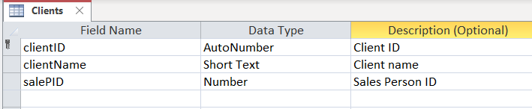
Figure 1
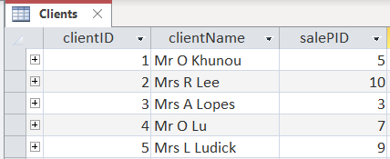
Figure 2
Invoices
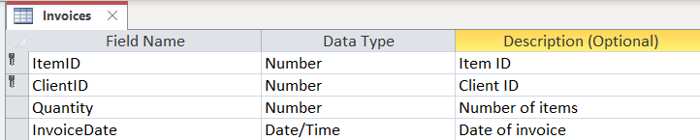
Figure 3
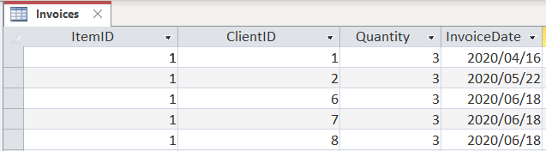
Figure 4
Items
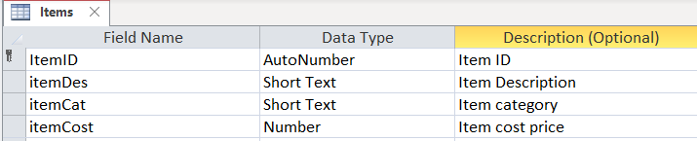
Figure 5
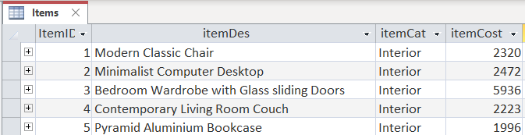
Figure 6
SalesPeople
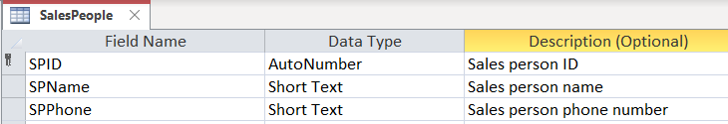
Figure 7
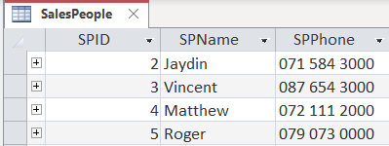
Figure 8

Write Queries for each of the following.
1. | Display a list of all the fields from the Items table in descending order of the item cost. | [4]
2. | Display the number of clients associated with each of the salespeople having sales ID 7 to 9 (inclusive). Use the heading Number of Clients for the number of clients associated with each salesperson. Display only the ID of the sales person and number of clients. | [5]
3. | Display all the fields of the items from the Items table that contains the word Modern anywhere in the item description field in the Exterior category. | [4]
4. | Display the itemID and the average quantity (as Average) sold per item during the month of May. Only display items with an average less than 2. Round your answer off to two decimal places. | [8]
5. | Display all transactions of sold items whose cost price is more than 9000. Display the client’s ID, client name, invoice date, item description and item cost. | [5]
6. | The company wishes to get rid of old invoices. Delete all invoices created in 2019. | [3]
7. | The company supplying garden furniture increased their asking price by 12%. Update the item cost of items 11 and 12 to reflect this change. | [4]
8. | Mr E. Nel (ClientID 20) bought 5 new Modern Classic Chairs (ItemID 1). The date of the sale is 2022/02/02. Add a new invoice item to the invoice table to reflect the sale. | [4]
9. | Create an item code for each item in the Items table under a column named Item Code. The code is made up out of the following elements:  - the first two characters of the item description,  - the length of the item description  - and a random number in the range 10 to 99 (both values included).  Display the item, item description and item code you created. | [6]
10. | Show a list of all items of which nothing has been sold yet. Show the item description and item cost | [7]
 | Total: | [50]

