SQL Summary – Grade 10. Version One. Exercise
SELECT <field(s)>
FROM <table(s)>
WHERE condition(s)
GROUP BY expression
HAVING condition
ORDER BY expression
Arithmetic function: INT( ), ROUND( ), TRUNCATE( ). Formats the single parameter within the brackets. RND - a single random number.
Random numbers: RND(Upper bound – Lower bound ) + Lower bound. Gives a random number from lower bound to upper bound eg 1 to 50.
Date and time: DATE, YEAR, MONTH, DAY, TIME, HOUR, MINUTE. Used with a field of the data type “date”. NOW( ) yields today from the PC.
Aggregate functions: MAX( ), MIN( ), AVG( ), SUM( ), COUNT( ). Returns a single result based on a group of rows.
Compound conditions: NOT, AND, OR
More conditions: BETWEEN . . AND, IN and NOT IN, LIKE, NULL
Quotes. Regular quotes for string data. Hash symbols for date/time . #2019/05/23 9:33:00#. Boolean (True) – no quotes.
String manipulation: LEFT(x), RIGHT(x), MID(x, y), LEN, and “&” which is the concatenation operator in Ms Access (joins strings)
NOTE: Ms Access is case insensitive (unlike Java). We use upper case and lower case to make our queries more readable.

Using a table of Coffee types as an example . . . . tblCoffee
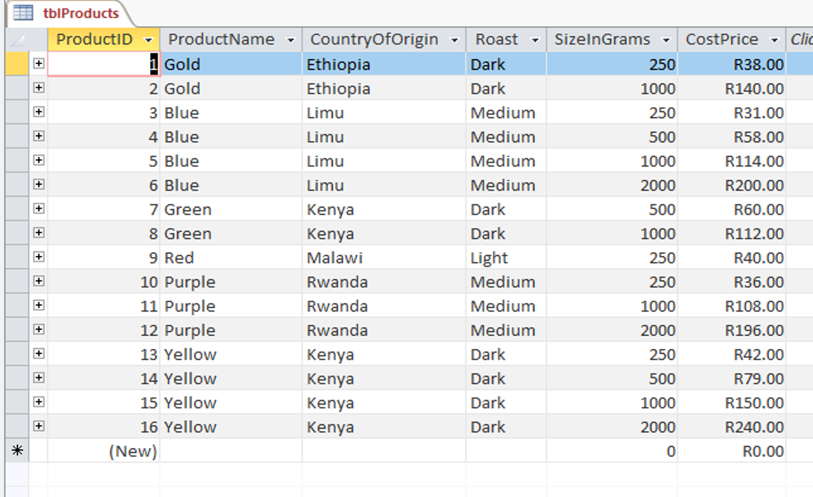
SELECT . . . FROM . . .
1 Select all the fields and all the records from the table above
___________________________________________________________________________________________________________________________________________________________
2 All the fields and records sorted by country A to Z
___________________________________________________________________________________________________________________________________________________________
3 All the fields and records where the roast is dark.
___________________________________________________________________________________________________________________________________________________________

THE BEST . . . THE 5 BEST . . . THE WORST . . . THE HIGHEST . . . THE MOST (EXPENSIVE) (CHEAPEST)
4 Find the coffee package with the lowest cost price
___________________________________________________________________________________________________________________________________________________________
5 Find the coffee package with the highest cost price
___________________________________________________________________________________________________________________________________________________________
6 Write a query to give us the 5 coffee packages with the highest prices
___________________________________________________________________________________________________________________________________________________________
SELECT ONLY CERTAIN FIELDS FROM THE TABLE.
7 Write a query to extract only the product name and roast type
___________________________________________________________________________________________________________________________________________________________
SELECT ONLY CERTAIN FIELDS and SORTING BY ONE FIELD.
8 Write a query to give us the product names sorted by country of origin
___________________________________________________________________________________________________________________________________________________________
FIND ITEMS IN A GIVEN LIST WITHOUT USING COMPOUND OPERATORS (AND , OR)
10 Write a query that gives us only those coffees from Kenya and Rwanda
___________________________________________________________________________________________________________________________________________________________

Using a table of players as an example . . .
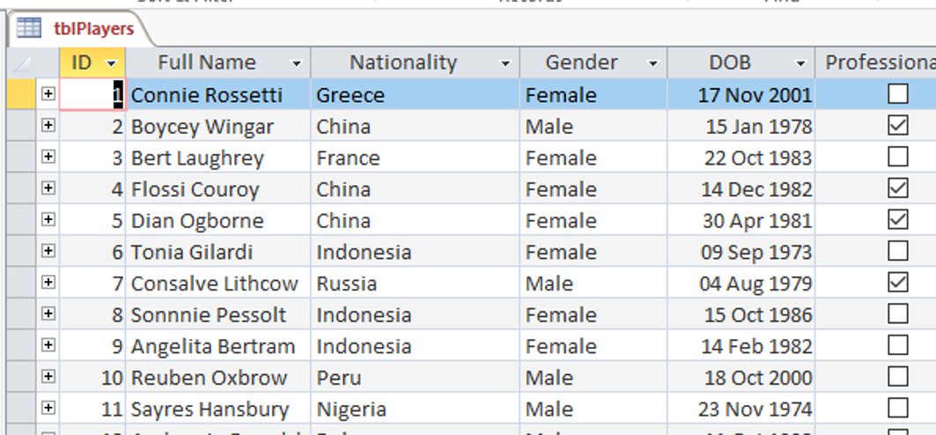
EXTRACT A PORTION OF A DATE - YEAR, MONTH, DAY FROM A FIELD THAT HAS THE DATA TYPE OF “Date”
“ [ ] “ brackets around Full Name because of the space in the middle of the field name
“AS” gives this extracted year value its own label ie “Year”
10 We need a list of all player names showing the year in which they were born. Create a label field called “Year”
___________________________________________________________________________________________________________________________________________________________
11 We need a list of all player names showing the month in which they were born. Create a label field called “Month”
___________________________________________________________________________________________________________________________________________________________
12 We need a list of all player names showing the day on which they were born. Create a label field called “Day”
___________________________________________________________________________________________________________________________________________________________
WE NEVER STORE DATA THAT WE CAN DETERMINE FROM OTHER FIELDS. Examples: ages, totals, averages, participation
DETERMINING AGE FROM DATE OF BIRTH AND SORTING FROM YOUNGEST TO OLDEST
13 Write a query to determine the ages of the players sorted from youngest to oldest.
___________________________________________________________________________________________________________________________________________________________
EXTRACTING BIRTHDAYS THAT MATCH A CONDITION e.g. larger than January but smaller than June
14 Write a query to determine those players born in October, November and December.
___________________________________________________________________________________________________________________________________________________________
COMPARING AGES TO A PARTICULAR CONDITION e.g. smaller and equal to 20
15 Write a query showing the players names who are older than 20 years.
___________________________________________________________________________________________________________________________________________________________
DETERMINGING THE AVERAGE AGE IN YEARS, FROM DATE OF BIRTH
16 Write a query to determine the average age of all the players.
___________________________________________________________________________________________________________________________________________________________
DETERMINING THOSE NAMES THAT SO LONG THAT THEY WILL CREATE PROBLEMS WITH THE PRINTED MATERIAL.
17 We need to know the names of the players whose names are longer than 20 characters in length
___________________________________________________________________________________________________________________________________________________________

Using a table of machines that operate in a factory as an example . . .
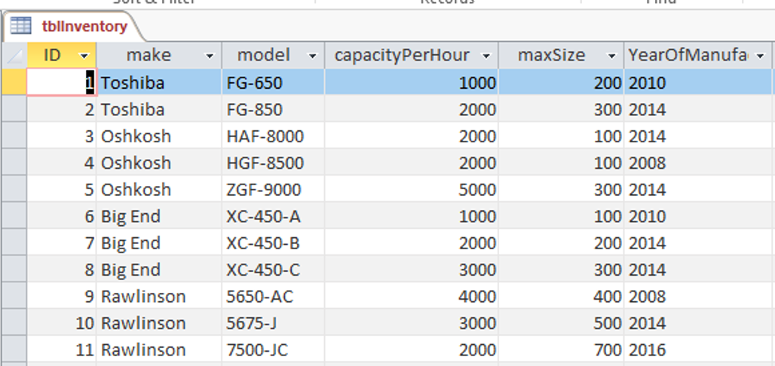
FINDING A MACHINE THAT MATCHES A CONDITION
17 We want to know all the machines built by the company called Big End
___________________________________________________________________________________________________________________________________________________________
DETERMINING TOTAL CAPACITY PER HOUR OF ALL THE MACHINES IN THE FACTORY
18 Calculate the capacity of the entire factory by writing a query that adds the Capacity per Hour together to give us a final value
___________________________________________________________________________________________________________________________________________________________
MAKING A SERIAL NUMBER USING LETTERS FROM THE MAKE, MODEL AND FROM THE CAPACITY eg TF1000, TF2000, OH2000 etc
19 Write a query to produce a serial number using the first letter of Make, the first letter of Model, combined with the Capacity per Hour value eg TF1000, TF2000, OH2000 etc
___________________________________________________________________________________________________________________________________________________________
LEFT and RIGHT allow us to give an index of how many characters we want. In this case we have only asked for one.
Using a teacher’s markbook as an example . . .

Note: We do not type in totals as they can be calculated from the figures already in the table. We say that they are derived fields i.e. derived from data already in the table.

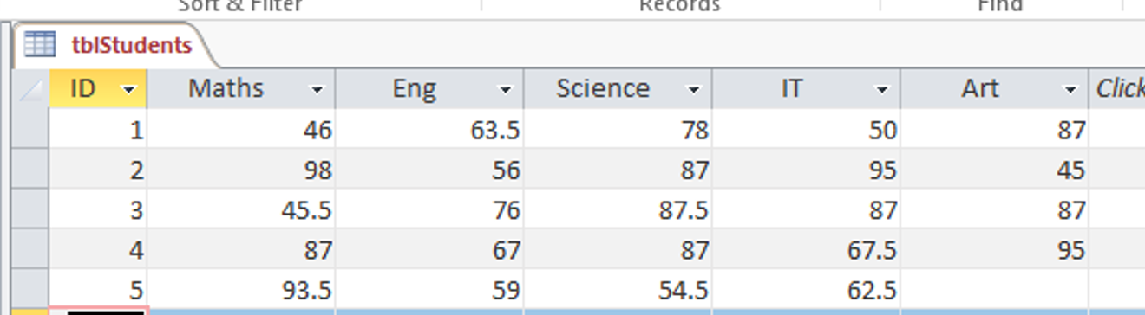

FINDING VALUES THAT ARE MISSING FROM OUR TABLE USING NULL – WE USE “IS NULL” OR “IS NOT NULL”.

20 Write a query to make sure that every student has a mark in every field.

___________________________________________________________________________________________________________________________________________________________

CALCULATING TOTALS AND AVERAGES FROM GIVEN SCORES – note comma after the wildcard

21 Write a query to give the student’s average mark for the five subjects.

___________________________________________________________________________________________________________________________________________________________

EXTRACTING THOSE LEARNERS WHOSE AVERAGE IS HIGHER THAN 70%

22 Write a query to return all those learners who have an average mark greater than 70%;

___________________________________________________________________________________________________________________________________________________________

