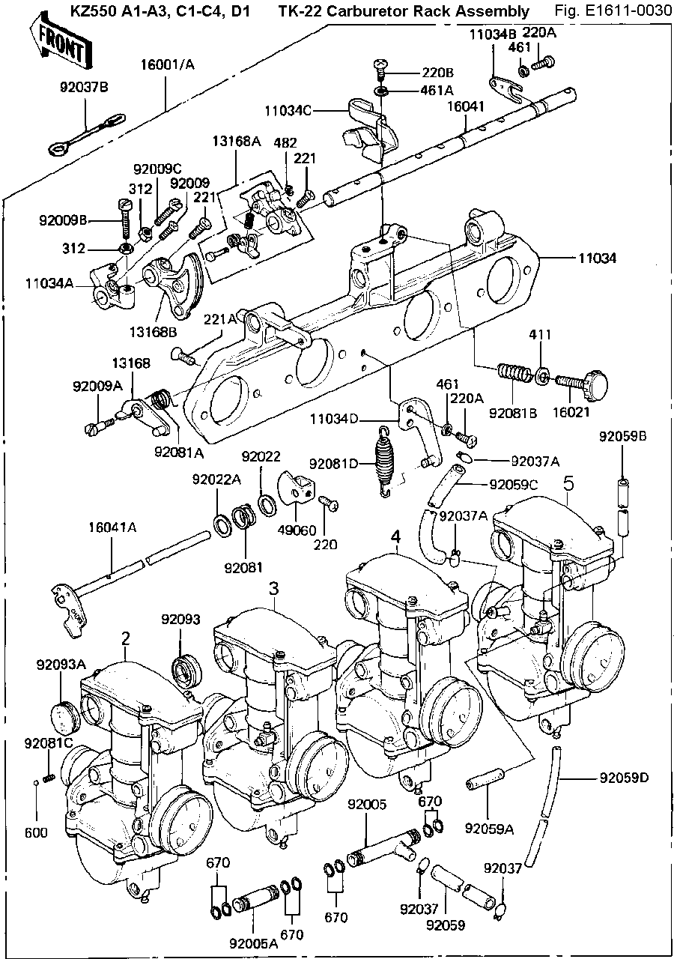
TK-22 Carburetor Rack Assembly
Ref Part QTY Description
Number Number
2 16001-1255 1 Carb, LH, Outside
2 16001-1305 1 Carb, LH, Outside
3 16001-1306 1 Carb, LH, Inside
4 16001-1307 1 Carb, RH, Inside
5 16001-1252 1 Carb, RH, Outside
5 16001-1308 1 Carb, RH, Outside
220 220B0408 1 Screw Pan Head 4X8
220B0408A
220AA0408
220A 220B0514 3 Screw-Pan-Cross 5X14
220B0514A
220AA0514
220B 220B0614 2 Screw Pan Head 6X14
220AA0614
92009-1127 Black
92172-0273
221 221B0514A 2 Screw, Countersink HD,5X14
221A 221B0616 8 Screw, Countersink HD 6X16
221AA0616
92172-0144
312 312B0500 2 Nut 5mm
312B0500A
312AA0500
312G0500
411 411B0600 1 Washer Plain 6mm
411AA0600
411AB0600
92022-1162
92200-1094
461 461F0500 3 Washer Spring 5mm
461F0500A
461E0500
461L0500
461DA0500
460E0500
460F0500
21024-003
461A 461F0600 2 Washer Spring 6mm
461F0600A
461E0600
461L0600
461DA0600
460E0600
460F0600
92022-1580
92022-2023
482 482J3000 1 Circlip, 3mm
600 600A0500 1 Ball Steel 5/32"

670 670B1507 12 O-Ring, 7mm Nominal
92055-1072
11034 11034-1588 1 Bracket, Carburetor
11034A 11034-1590 1 Bracket, Throttle Stop
11034B 11034-1591 1 Plate, Throttle Shaft
11034C 11034-1592 1 Bracket, Throttle Cable
11034D 11034-1593 1 Bracket, Throttle Return
13168 13168-1053 1 Lever Assy, Timing
13168A 13168-1054 1 Lever Assy, Throttle
13168B 13168-1055 1 Lever,Assy, Throttle
16001 16001-1210 1 Carb Rack Assy, A1-A3, C1-C4, USA
16001A 16001-1285 1 Carb Rack Assy, A1-A3, C1-C4, Canada
16001 16001-1412 1 Carb Rack Assy, D1, Black, USA
16001A 16001-1413 1 Carb Rack Assy, D1, Black, Canada
16021 16021-1017 1 Screw, Throttle Stop
16041 16041-1012 1 Shaft, Throttle
16041A 16041-1021 1 Shaft, Choke Lever
49060 49060-1002 1 Cam, Choke
92005 92005-1020 1 "T"Joint, Fuel
92005A 92005-1021 2 Joint, Fuel
92009 92009-1080 1 Screw, Countersink HD, 4X12
92009A 92009-1081 1 Screw, Timing Lever
92009B 92009-1082 1 Screw, Timing Lever
92009C 92009-1083 1 Screw, Throttle Stop
92022 92022-1168 1 Washer, Choke Lever
92022A 92022-1169 1 Washer, Choke Lever
92037 92037-1158 2 Clamp, Fuel Hose
92037A 92037-1159 2 Clamp, Vacuum
92037B 92037-134 1 Clamp, Overflow Pipe
92059 92059-1098 1 Hose, Fuel, 7X12X180
92059A 92059-1099 2 Hose, Air Vent, 4.5X30
92059B 92059-1100 2 Hose, Air Vent, 4.5X300
92059C 92059-1101 1 Hose, Vacuum
92059D 92059-1102 4 Hose, Overflow, 3.5X550
92081 92081-1191 1 Spring, Choke Lever
92081A 92081-1192 1 Spring, Timing Lever
92081B 92081-1193 1 Spring, Adjust Screw
92081C 92081-1195 1 Spring, Choke Lever
92081D 92081-1381 1 Spring, Throttle return, A1-A3, C1-C4
92081-1263
92081D 92081-1382 1 Spring, Throttle return, D1
92093 92093-1033 6 Dust Seal, Throttle Shaft
92093A 92093-1034 2 Dust Cap, Throttle Shaft
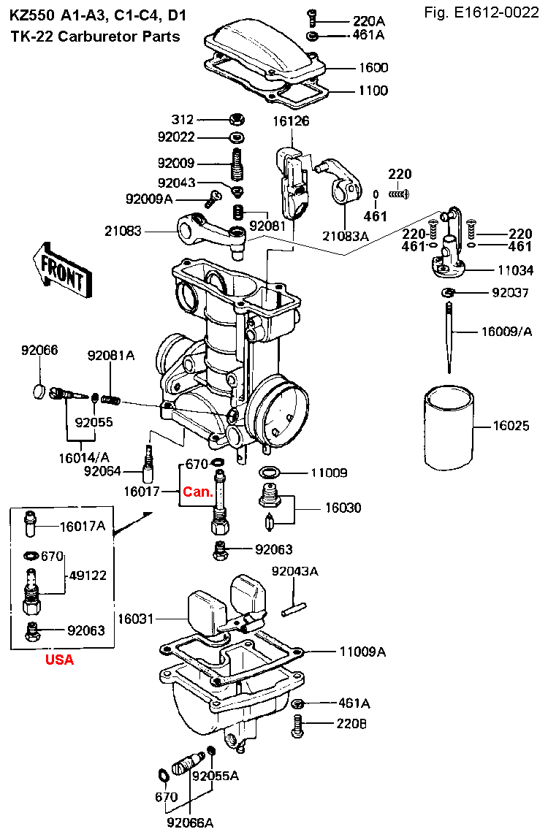
TK-22 Carburetor Parts
Ref Part QTY Description
Number Number
220 220B0312 12 Screw, Pan Head 3X12
220B0312A
220A 220B0414 12 Screw, Pan Head 4X14
220B0414A
220AA0414
220B 220B0416 16 Screw, Pan Head 4X16
220B0416A
220AA0416
214B0416A
312 312B0500 4 Nut, 5mm
312B0500A
312AA0500
312G0500
461 461F0300 12 Washer, Spring 3mm
461DA0300
460E0300
461A 461F0400 28 Washer, Spring 4mm
461E0400
460F0400
21024-002
311220-6154-00
670 670B1505 8 O-Ring, 5mm Nominal, 4.8mmID x 1.95mmCS
92055-087
92055-518
670 92055-1069 8 O-Ring, 5mm Nominal, 4.8mmID x 1.95mmCS
11009 11009-1160 4 Gasket, Float Valve
11009A 11009-1161 4 Gasket, Float Chamber
11009B 11009-1162 4 Gasket, Mixing Chamber
11034 11034-1587 4 Bracket Assy, Throttle
13126 16126-1024 4 Valve Assy, Choke
16005 16005-1008 4 Top, Mixing Chamber
16009 16009-1060 4 Jet Needle, #4D92 USA
16009A 16009-1061 4 Jet Needle, #4D93 Canada
16014 16014-1019 4 Screw, Air Adjusting Canada
16014A 16014-1024 4 Screw, Air Adjusting USA
16017 16017-1044 4 Needle Jet, #V95 Canada
16017A 16017-1057 4 Needle Jet, #V95 USA
16025 16025-1038 4 Valve, Throttle Slide, 2.5
16030 16030-1009 4 Float Valve Assy
16031 16031-1009 4 Float
16126 16126-1024 4 Valve Assy, Choke
21083 21083-1006 4 Arm, Throttle
21083A 21083-1007 4 Arm, Choke
49122 49122-1010 4 Pipe, Bleed USA
92009 92009-1079 4 Screw, Adjust, Throttle
92009A 92009-1080 4 Screw, Countersink HD, 4X12
92022 92022-1167 4 Washer, Plain
92037 92037-1157 4 Circlip, Jet Needle Canada
92043 92043-1065 4 Pin, Spring, Throttle
92043A 92043-1066 4 Pin
92055 92055-1070 4 O-Ring, Air Screw, 3.25mmID x 1.40mmCS
92055-1125
92055-1134
92055A 92055-1071 4 O-Ring, Drain Screw Tip, 2.50mmID x 1.50mmCS
92063 92063-1055 4 Main Jet, #92, A1-A3, C1-C4
92063 92063-1108 4 Main Jet, #94, D1
92064 92064-1028 4 Pilot Jet, #32
92066 92066-1051 4 Plug, Pilot Screw USA
13169-1222
92066A 92066-1065 4 Screw, Drain
92066-1052
92081 92081-1189 4 Spring, Throttle Arm
92081A 92081-1190 4 Spring, Air Screw

