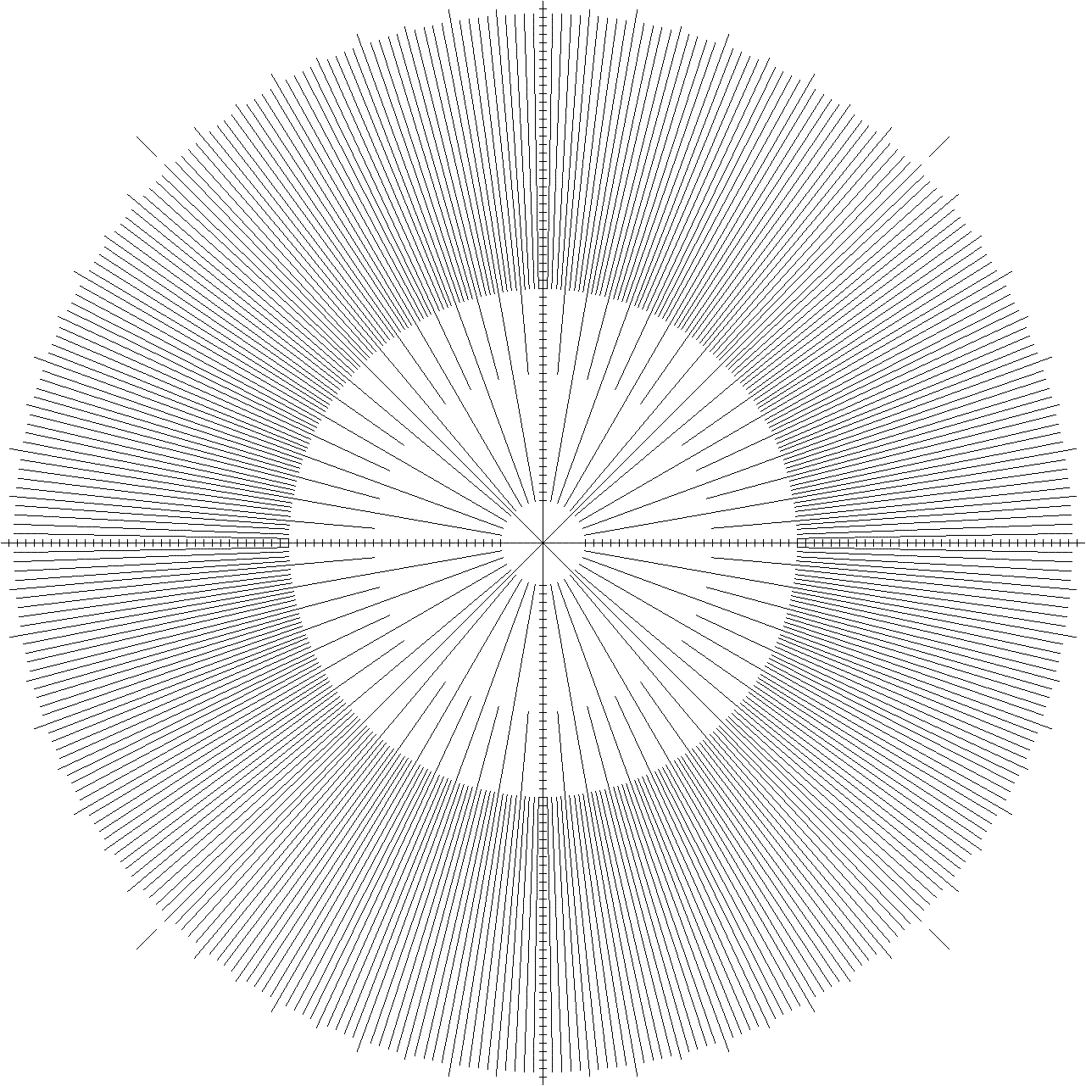

Size 25%
Print as Word Doc to get
horizontal axis to be 85mm long.

