Brooklyn Pickle North
7175 Buckley Road
Liverpool, NY
(315) 671-2185
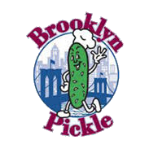

A free 2 oz bag of Dirty Chips with the purchase of any size sub or sandwich.

Offer valid October 2020 through October 2021
at our Liverpool location only.
Brooklyn Pickle North
7175 Buckley Road
Liverpool, NY
(315) 671-2185

A free medium fountain drink with the purchase of any size sub or sandwich.

Offer valid October 2020 through October 2021
at our Liverpool location only.

