Unigraphics NX

Tutorial on Casting- Machining with link.

Step 1: Create a cavity first. With CAD Options.
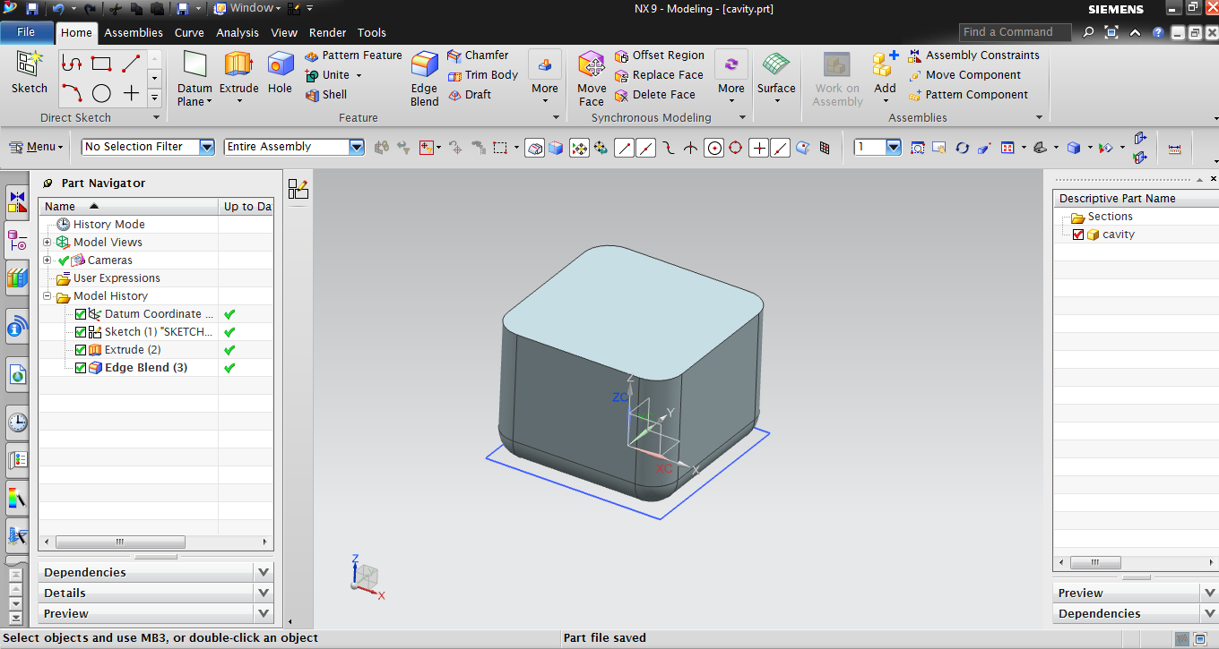

Step 2: Create a core. With CAD Options. Extrude this sketches with none (boolean) i.e no connection with cavity.

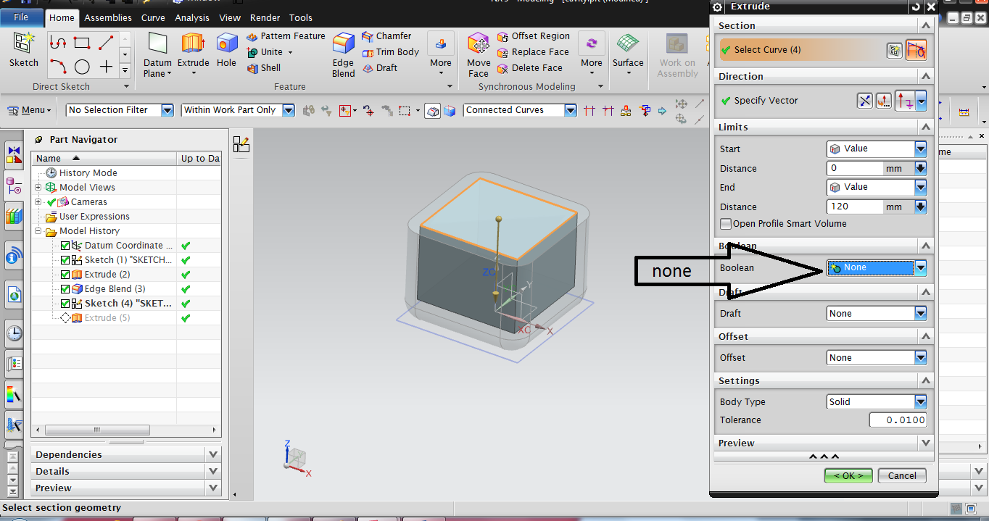

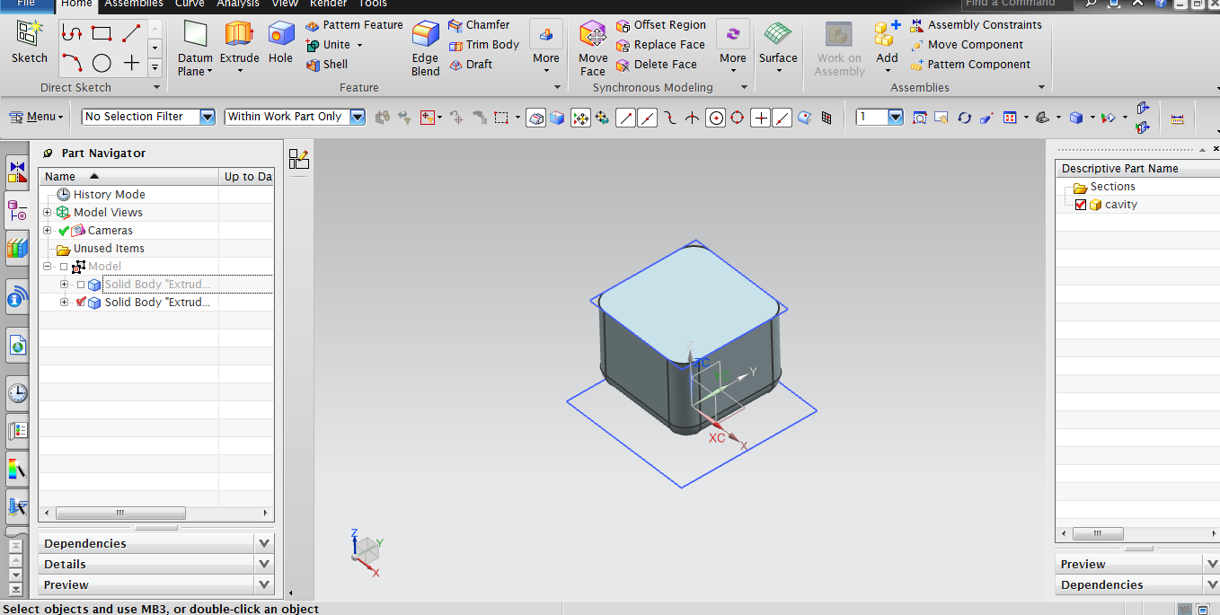

Step 3: Do boolean operation with external boolean.

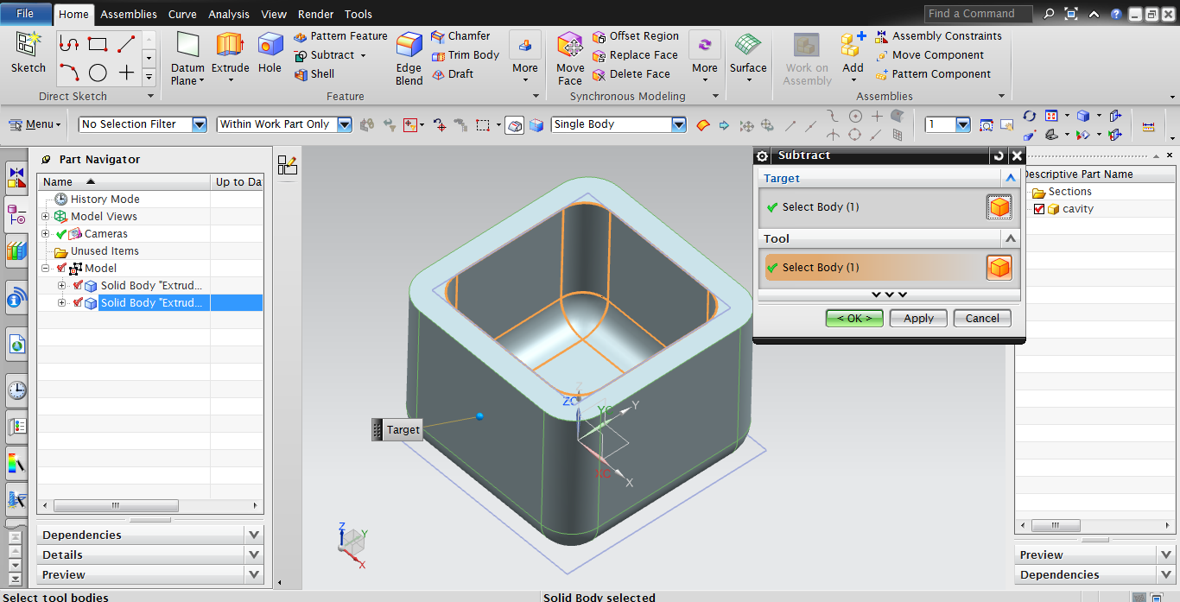

Step 4: After creating a Casting Part. Switch to Assembly environment.

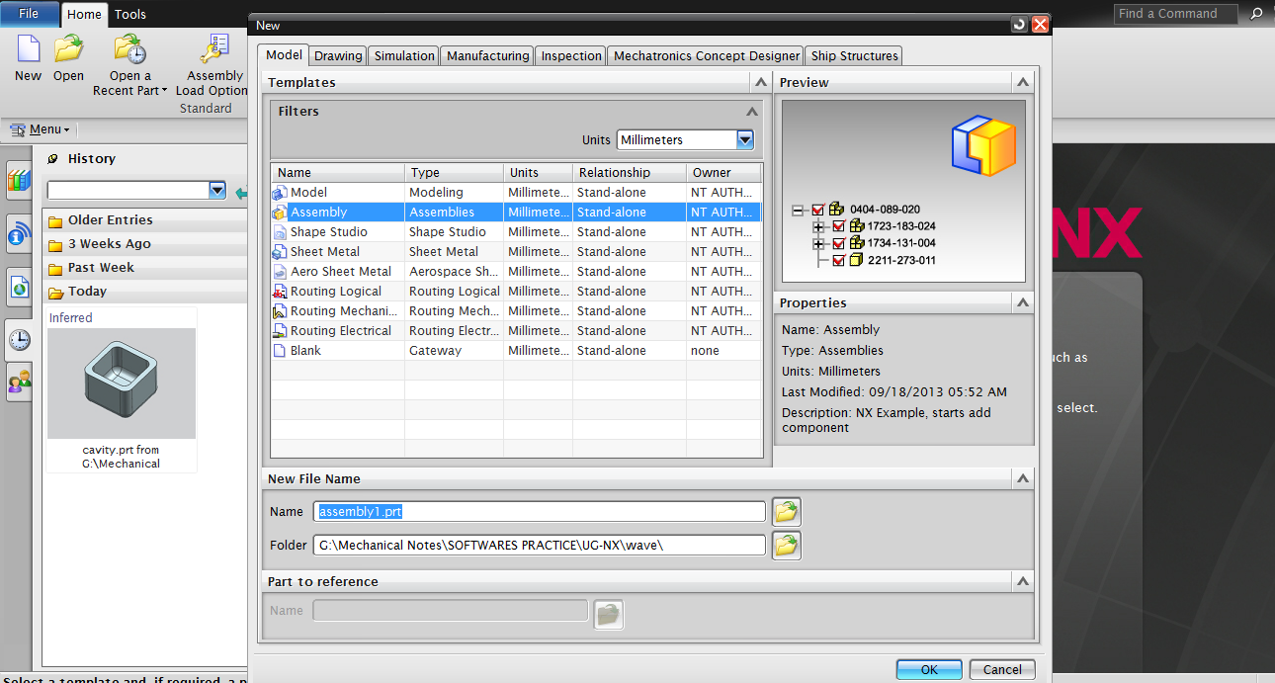
Import that Casted model in assembly.

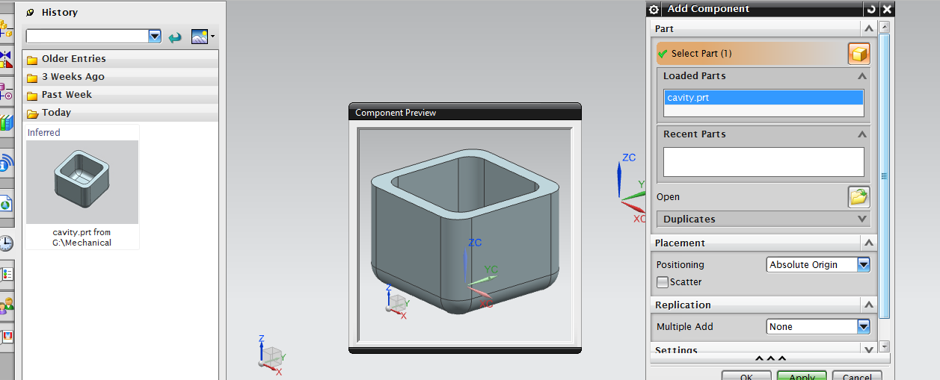
Step 5: Create new component. And renamed it as Machined.

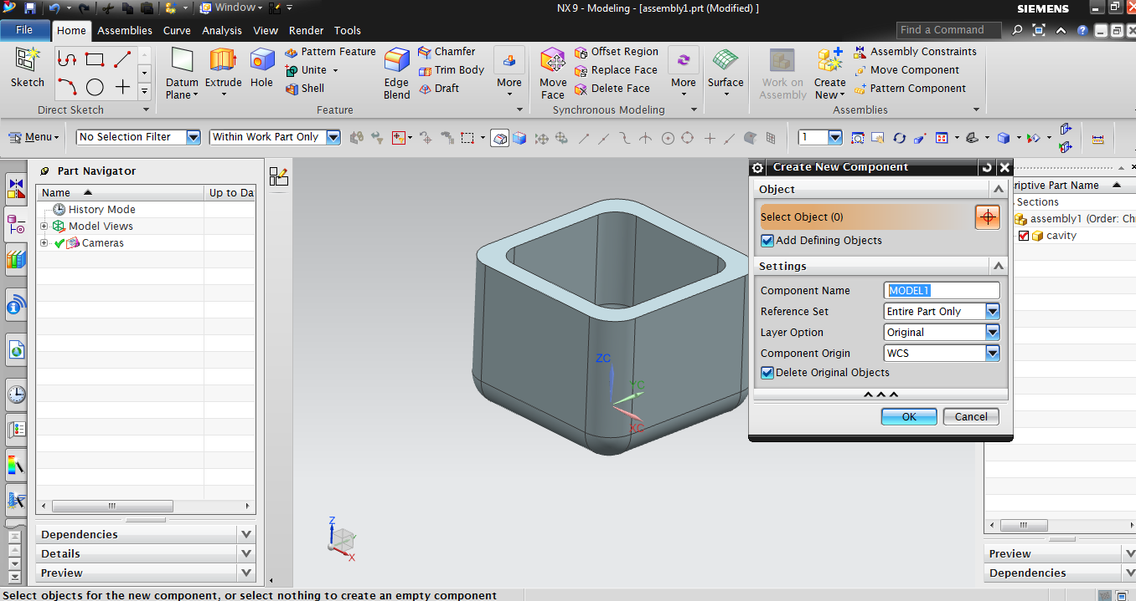

Step 6: Make Machined as a Work part.
Select Wave geometry Linker from assemblies tab, Select BODY
Click ok.
Make sure that “machined’ is a work part.

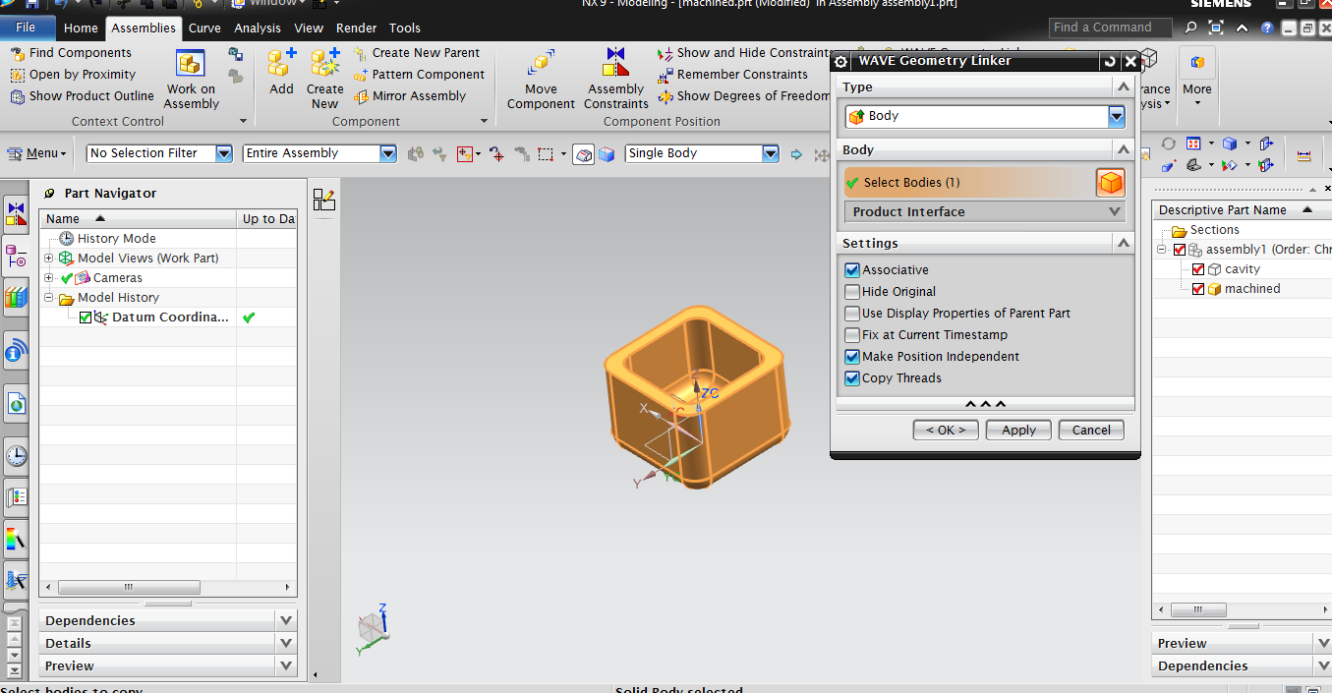

Now. If you make any changes in the Casted part, it will be reflected in machined part.
And if you make changes in the machined part, the casted part will remain the same.

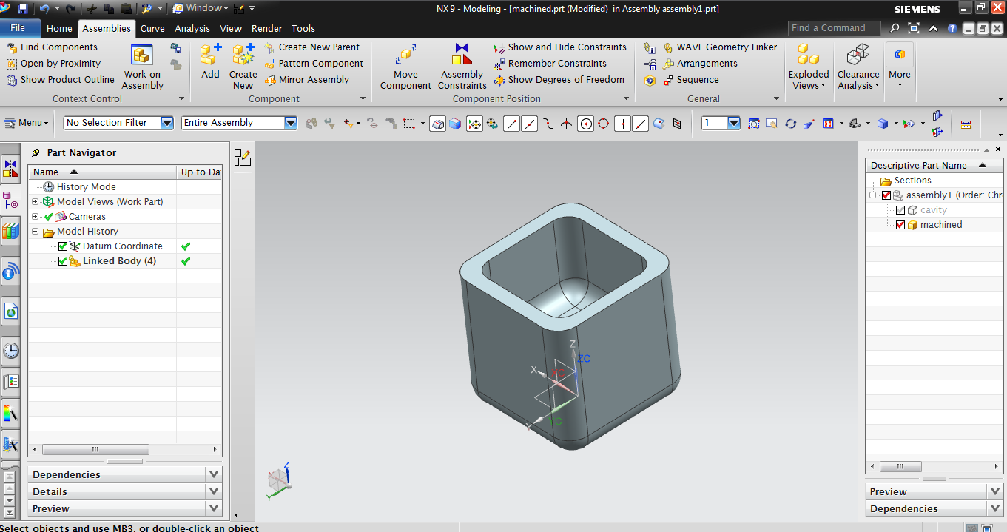

Regards,
Pavan Bharambe

