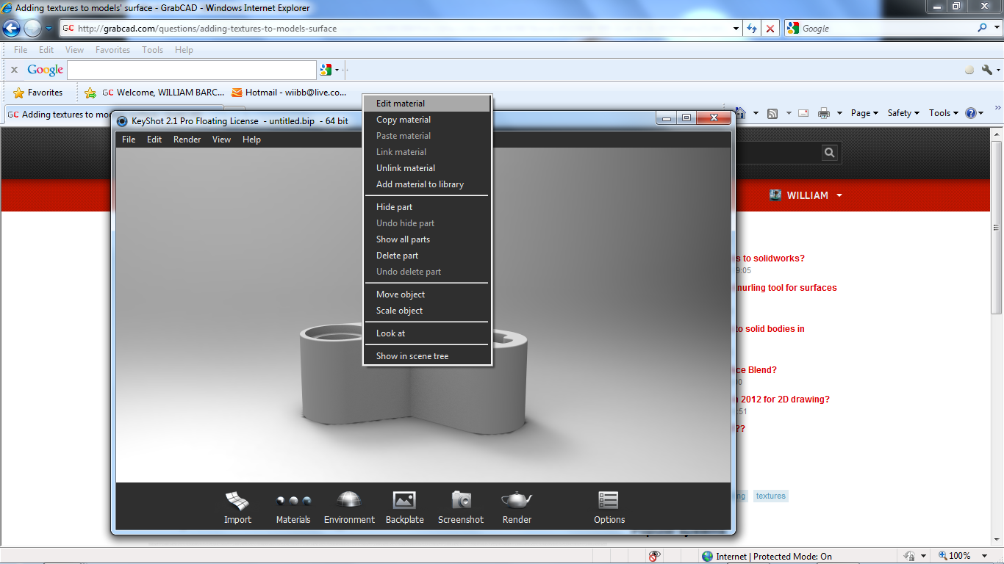
Right click with mouse on the part you want to add the material to.

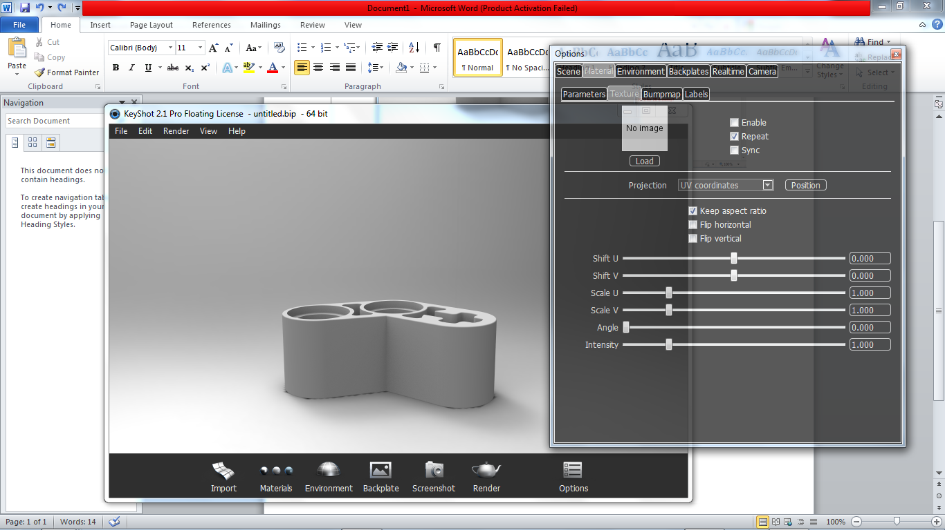
Second Tab along TEXTURES
The click on LOAD
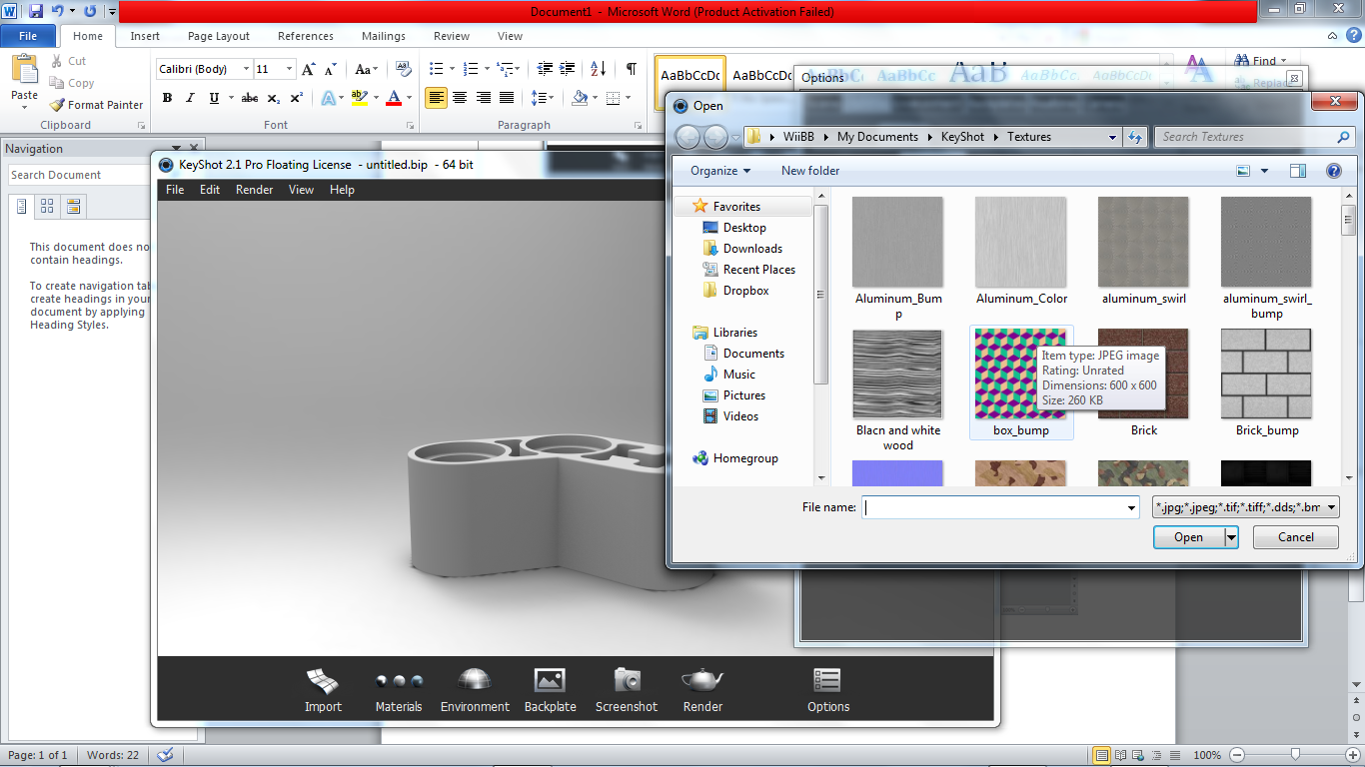
Go to were you keep all your materials
Pick what one you want.
Then double click and the material will be added.
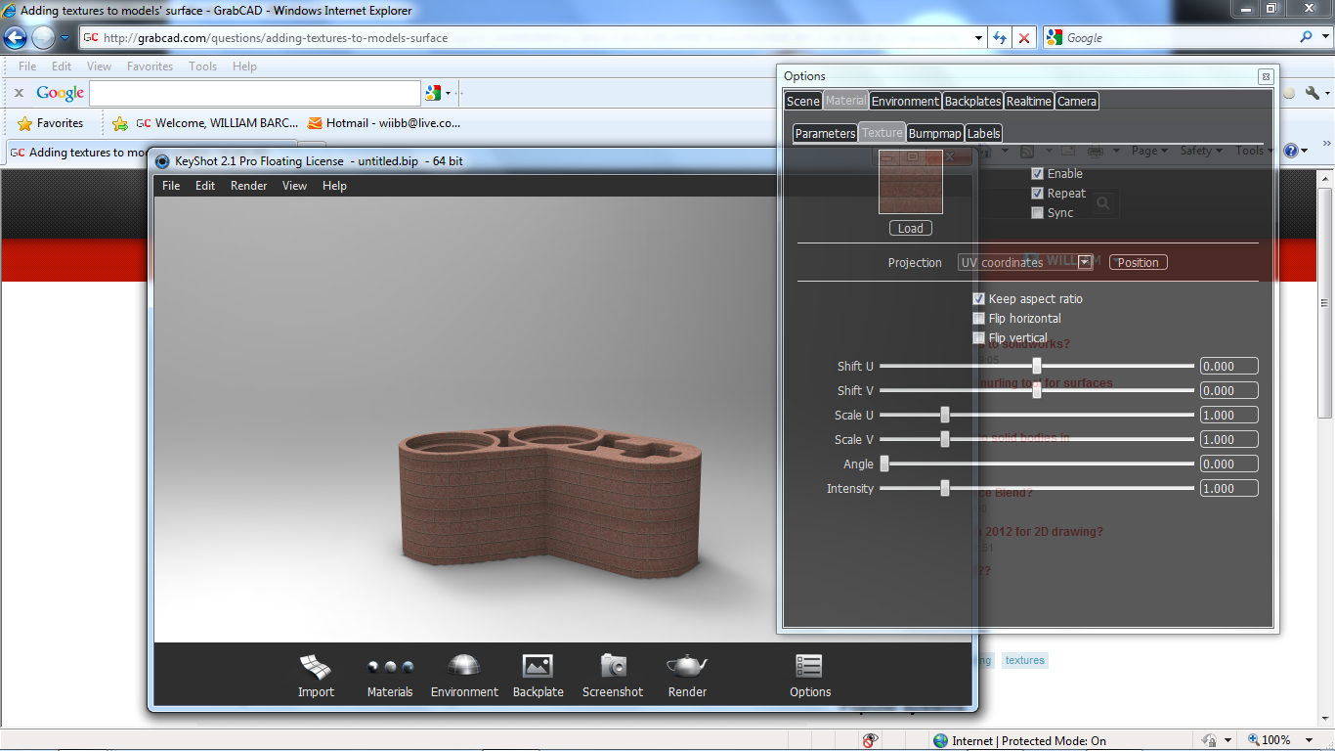
Now from there you can go to the scale U , V , and start to mess around until you are happy with your material

This is the same process as adding BUMB MAPs

