Product Life cycle management
Solid Edge Insight is a fully integrated design management solution based on Microsoft.NET technology. Solid Edge Version (SE) extends the capabilities of Insight for managed collaboration with the introduction of Life Cycle Assistant (LCA). LCA provides an automated workflow to move complete packages of documents as 3D models through the release process. Teams can collaborate more effectively because they know exactly where the latest documents are located and whether or not they are using the correct revisions, as shown in Picture. Insight helps ensure that drawing files are all updated and there are no un-released parts in a released assembly. SE also allows you to apply revision rules to Solid Edge documents, creating dynamic BOMs and providing a mechanism for customers to share data with their ERP/MRP systems. The LCA command will be the focus of this column.
Life Cycle Assistant
The LCA command is available in both Solid Edge and Insight Connect, but it is disabled if you are offline. The command launches a series of dialog boxes to guide you through the process of modifying the status of managed documents.
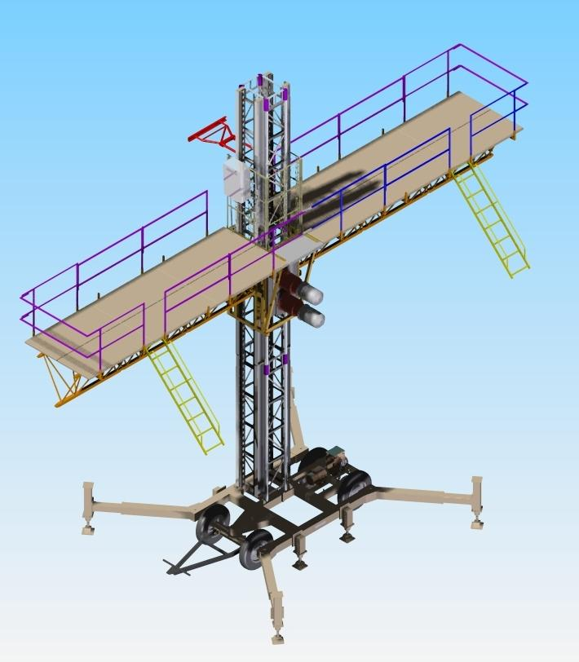
Above picture shows complex designs, such as the assembly depicted here, are excellent examples of the need for managed collaboration throughout the design process. Life Cycle Assistant in SE allows design teams to collaborate more effectively by knowing exactly where the latest documents are and whether they are using the correct revisions.
The Select Documents and Folders dialog allows you to select folders and documents you want to move through the release cycle. You activate this dialog box by selecting the LCA command in Solid Edge when there is no active document or by selecting the command in Insight Connect. You can select a single document, multiple documents, or an entire folder.
The Revision Rules dialog allows you to specify the revision rule you want to generate the list of linked documents. There are four revision rules you can choose from.
- As saved opens the document as it was last saved.
- Latest opens the latest revision in the system.
- Latest released opens the latest released revision.
- External system opens revisions specified by an external system.

Step 1 of the LCA dialog allows you to modify the status of the folders or documents you have selected. To change the status of a document, click on the document status, click the arrow, and then select the new status from the list. You can display the assembly structure in a list view with no levels or in a BOM view. If the Apply Status to Linked Document option is checked when you change the status for an assembly document, the same status is applied to the nested linked documents.
Step 2 allows you to modify the status of the folders and documents for Draft documents that have links. This dialog box is displayed only if the document you have selected has links to Draft documents. To change the status for a document, click on the document status, click the arrow, and then select the new status from the list.
What's Your Priority?
The SE Status values have a priority of importance that the program uses when changing the status of draft documents. The order of status priorities--from lowest to highest--is as follows:
- Available or In-Work
- In Review
- Released or Baselined
- Obsolete
By default, Solid Edge changes the status of the Draft document to match the status of the linked Part or Assembly document if the priority of the Part or Assembly document is higher than that of the Draft document. Suppose you have a Draft document with the status set to Available and you change the associated Part document to In Review. The part now has a higher status than the Draft document, so Solid Edge automatically changes the status of the Draft document to In Review. Conversely, suppose you have a Draft document with a status of Released and you change the status of the Part document to In Review. Since the Draft document has a higher status than the Part document, the status of the Draft document does not change.
Step 3 allows you to change the status of old revisions to Obsolete. This dialog box is only displayed if you are moving documents that have a status of Released or Baseline. The dialog box only displays documents that were created as a revision of another document. Step 4 dialog allows you to go back and make changes to the document statuses or save and process your changes.
The Processing Complete dialog allows you to view the log file that details the results of the command. If you run the command within Solid Edge on an active document, the changes are saved to the managed library when you close and save the document.
Conclusion
Solid Edge Insight provides the tools for managed collaboration and communication at any point in the development cycle, allowing for early input from your complete team.

