Tutorial 1:

Modelling a drill bit

Learn to model a drill bit using the following features:
- Extruded boss
- Swept cut
- Revolved cut
- Fillet

What you should know about me
In this tutorial, I’ll show you one way to design a drill bit in SolidWorks. I’m not a certified teacher and I don’t have any certificates for mastering this program. All I’m going to tell you is what I’ve learned by using tutorials from the internet. So when I’m wrong, please correct me. When I’m doing something right, tell me too. Maybe I’ll write some more, when I get enough response from you

Starting a new part
- Click new , click part  , ok

- Click on top plane and click sketch 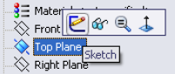

- Click on circle tools and select circle 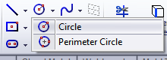
- Click on the origin as its centre and sketch the circle like shown
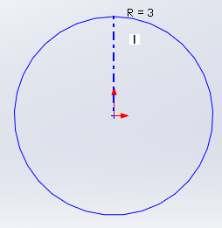
- Click on rectangle tools and select the centre rectangle 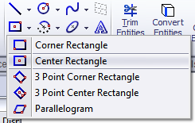
- Click on the origin as its centre and scetch the rectangle like shown 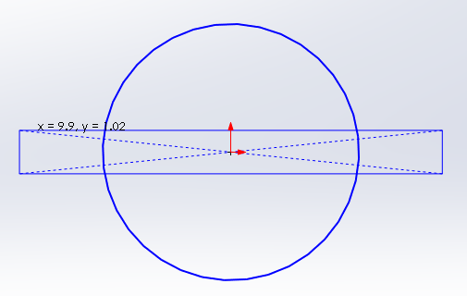
- Click smart dimension 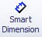 and dimension the sketch like shown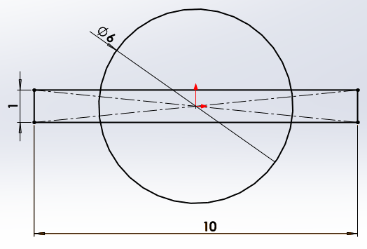
- Click trim entities 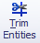 and select power trim 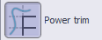 in the featuremanager.
- Remove all entities except the outer contours like shown 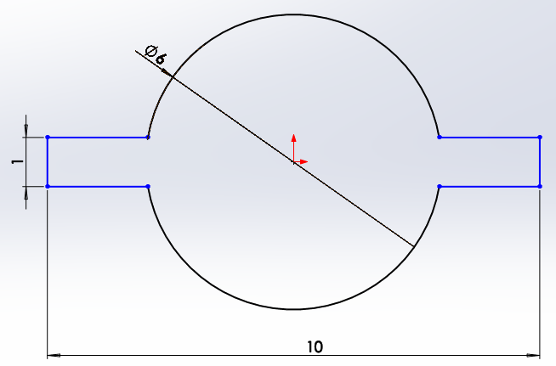
- Click smart dimension and dimension the sketch like shown 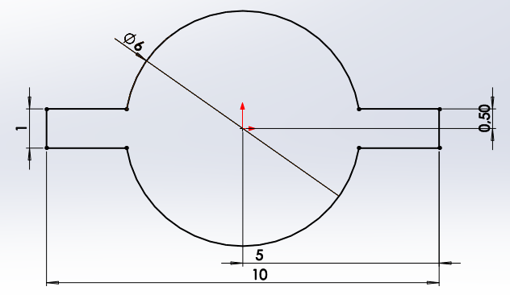
- Click Features, click Extruded boss/base 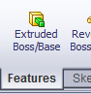, set D1 to 18mm 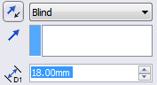
- Right click the upper face of the boss you’ve made and click normal to 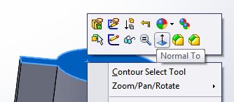
- Right click the face again and select sketch
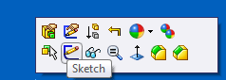
- Draw a circle on the centre like shown 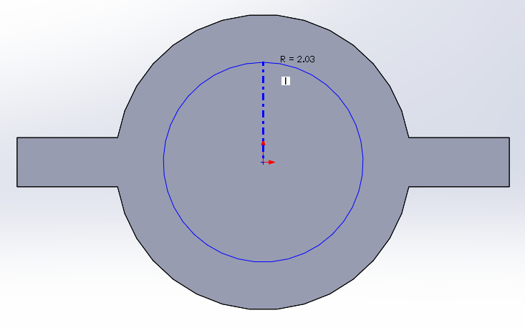
- Select both the circle and one of the outer radii using the Ctrl-key 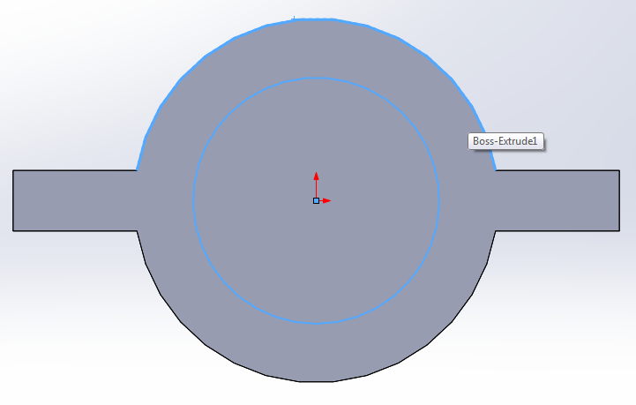
- Add a relation using the coradial button in the feature manager 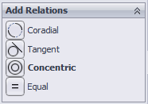
- Click Features, click Extruded boss/base , set D1 to 62mm. Make sure the option merge result is checked 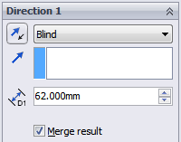
- Right click the upper face of the boss you’ve made and click normal to 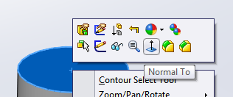
- Right click the face again and click sketch 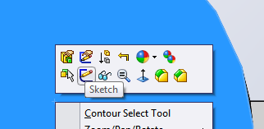
- Draw a circle on the origin like shown 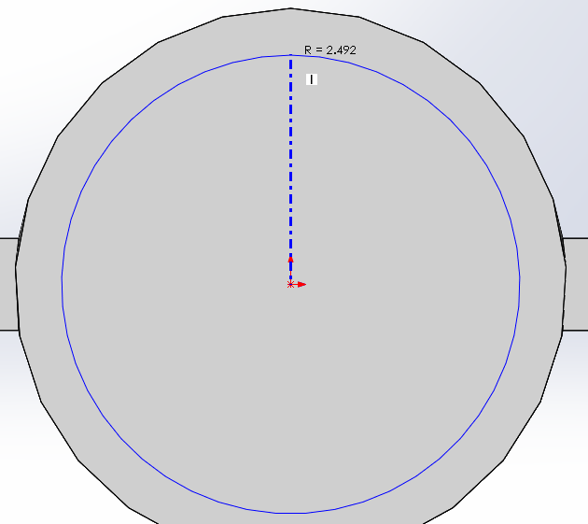
- Click smart dimension and dimension the sketch give the circle a radius of 2.5mm (Ø5mm)
- Select the circle and click insert > curve > helix/spiral 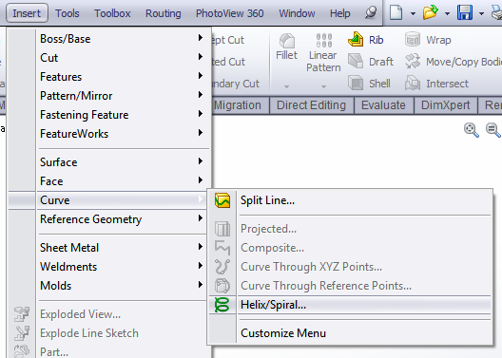
- Enter the parameters in the featuremanage like shown, then click ok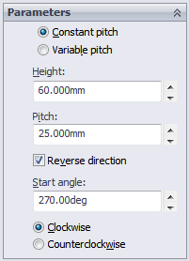
- Right click the upper face of the boss you’ve made and click normal to
- Right click the face again and click sketch
- Click line tools > centerline 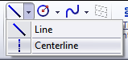
- Draw centerlines like shown. Make sure they’re vertical and horizontal AND coincident with the outer edge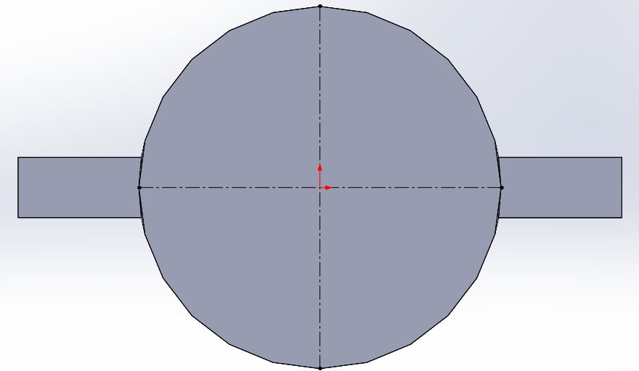
- Draw to circles on the horizontal centerline like shown 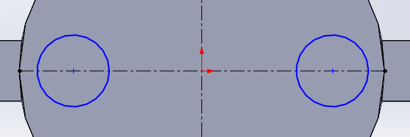
- Draw two lines from the circles to the outer edge like shown 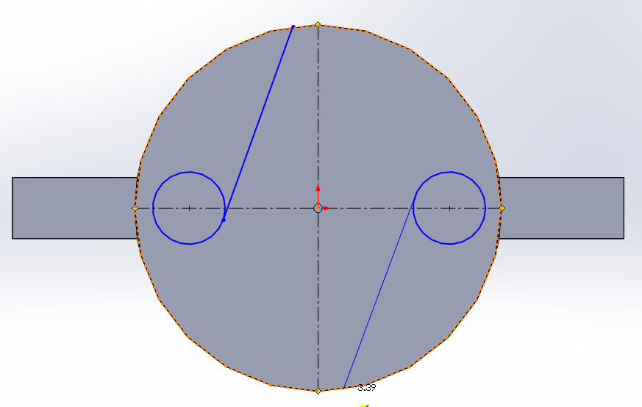
- Draw two circles like shown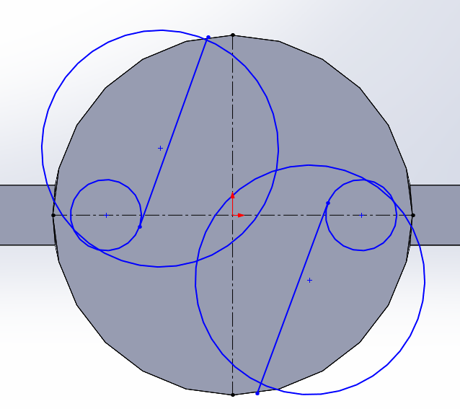
- Select both circles on the left side using the ctrl-key and choose tangent in the featuremanager menu 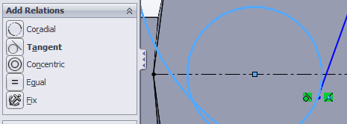
- Repeat this for the circles on the right side
- Select the endpoint of the straight line and the big circle on the left side and give them a coincident relation 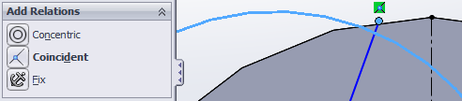
- Do the same for the right side
- Click smart dimension and dimension the sketch like shown 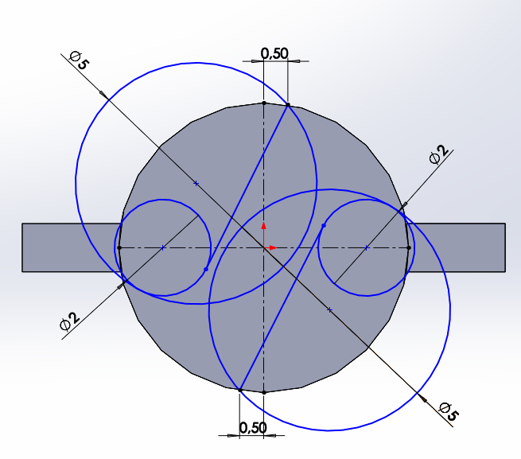
- Click trim entities and select power trim in the featuremanager.
- Trim entities until it looks like this 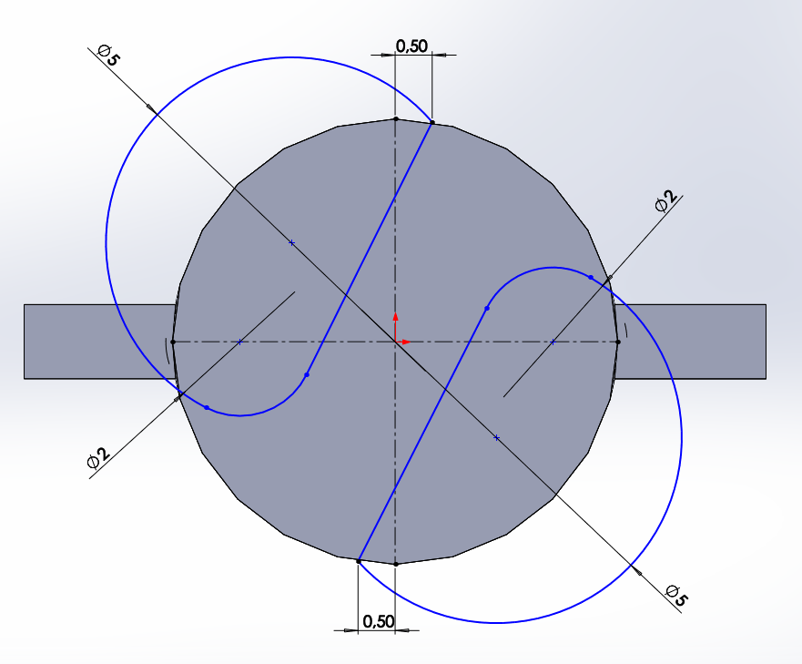
- Leave the sketch by clicking exit sketch 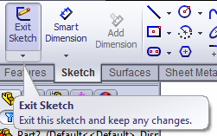
- Click features > swept cut 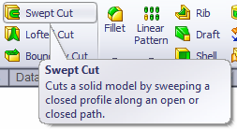
- Click profile box 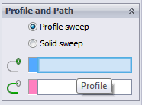 and than click the sketch
- Click path box 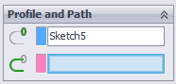 and select the helix we created, click ok.
- Click on the frontplane and click sketch 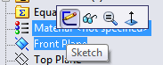
- Draw a vertical centerline starting at the origin like shown 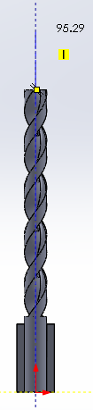
- At the top draw a sketch like shown 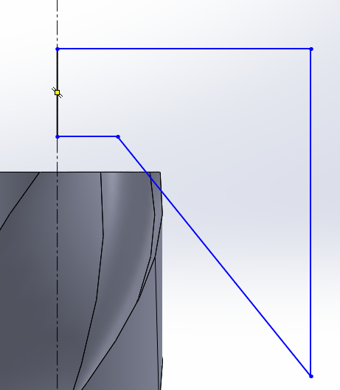
- Click smart dimension and dimension the sketch like shown 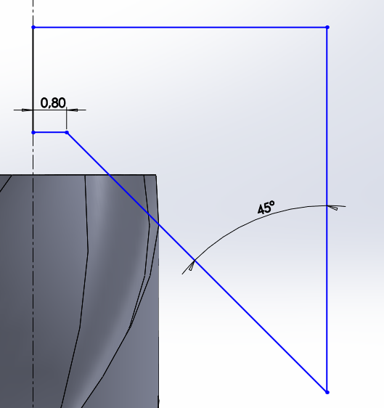
- Select the top face of the dril land the lower horizontal line by using the ctrl-key. Give them a collinear realation 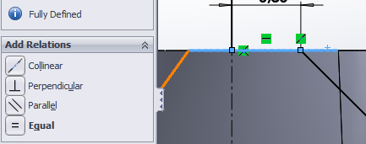
- Click Features, click revolved cut 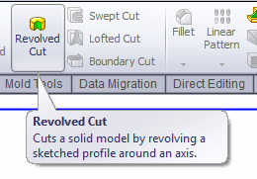
- Select the centerline as the axis of revolution, click ok.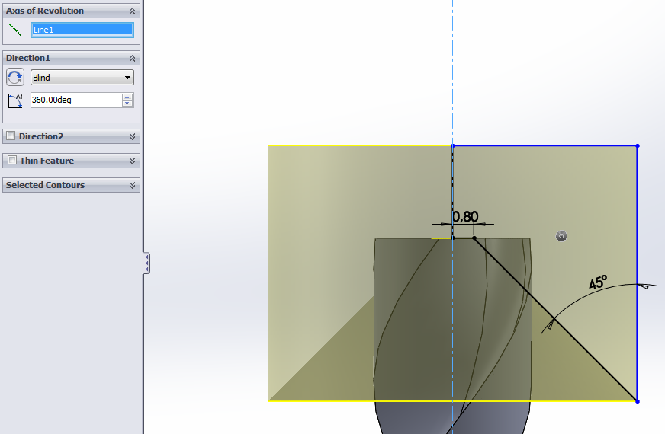
- Click Features > Fillet
- Select the four vertical edges of the first boss we created and give them a radius of 1mm. 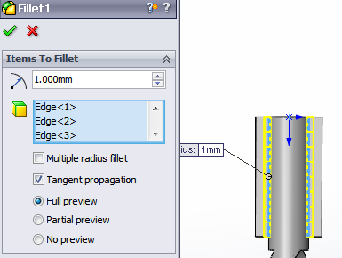
- Click Features> fillet again
- Select the four horizontal edges of the first boss and give them a radius of 2mm like shown 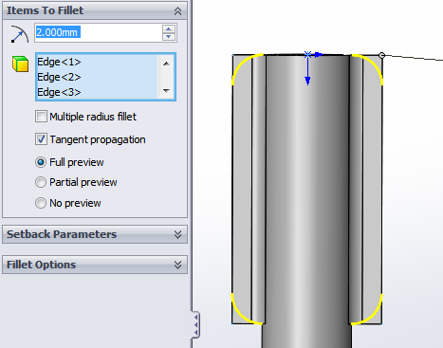
- You’re ready now, Look at the nice result from what you’ve done!

