3 LUG ENDCAP DRIVER TOOL
FOR STRATUS Suppressor

For use on .22LR TAC suppressor.
Material:
ABS Plastic
100% densification
Dimensions:
1" hex
Over all Hight = 0.70”
Lug Hight = 0.09”x 3pls
Lug O/S Rad. = 0.45”x 3pls
Lug I/S Rad. = 0.30”x 3pls
Lug end Rad. = 0.0675”x 6pls
Gap between each Lug = 0.235”x 3pls.
Lug cord length = (0.51” x 3pls)
OD below lugs = 0.91”
OD Hight = 0.16”
Hex Hight = (0.50”)
Not Shown:
0.25” Hex thru center replaces the ID shown

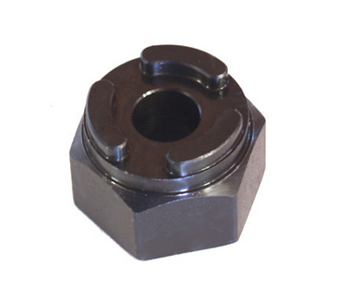
.225”3pl
Lug 3 plc
0.25” Hex instead of a hole.
All Features are intended T/B on Center

