Setup and Definitions:
Using the Workshop chair. It has two main configurations, “Worktop” (Back of the seat is horizontal) and “WheelyChair” (Back of the set is Vertical~ish). Both with all the “pots” all unspressed
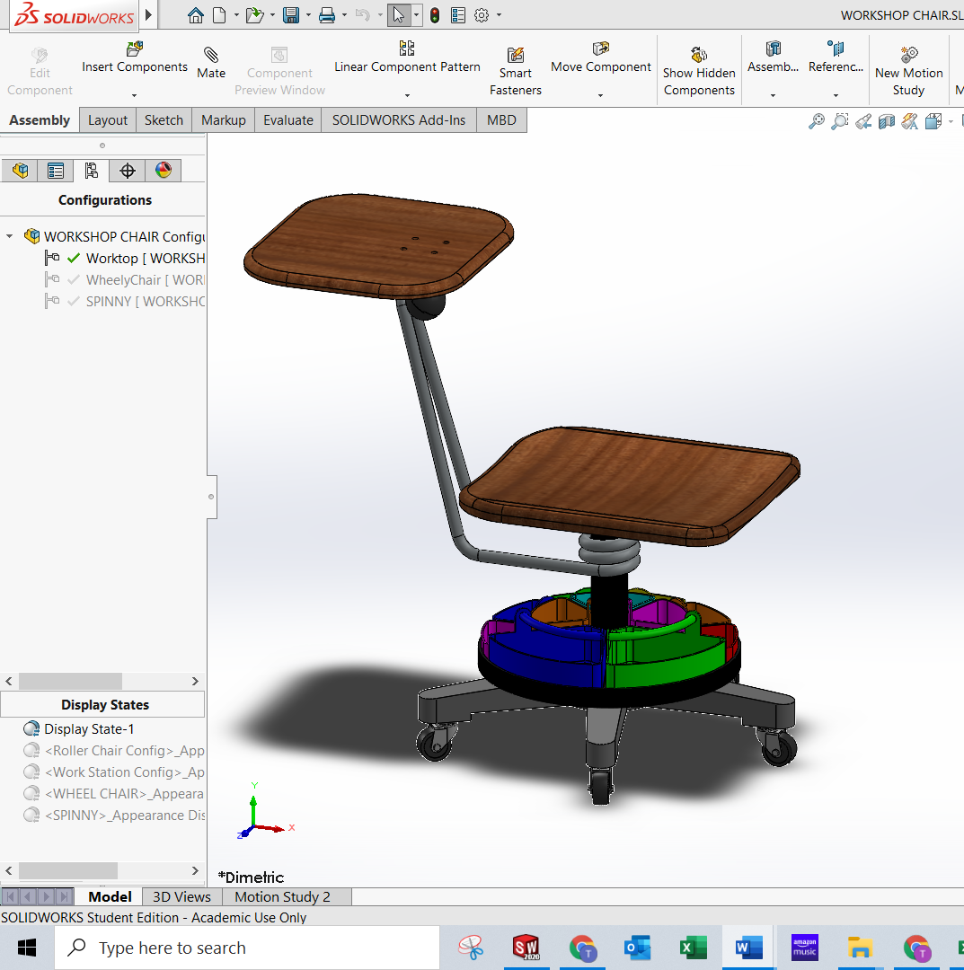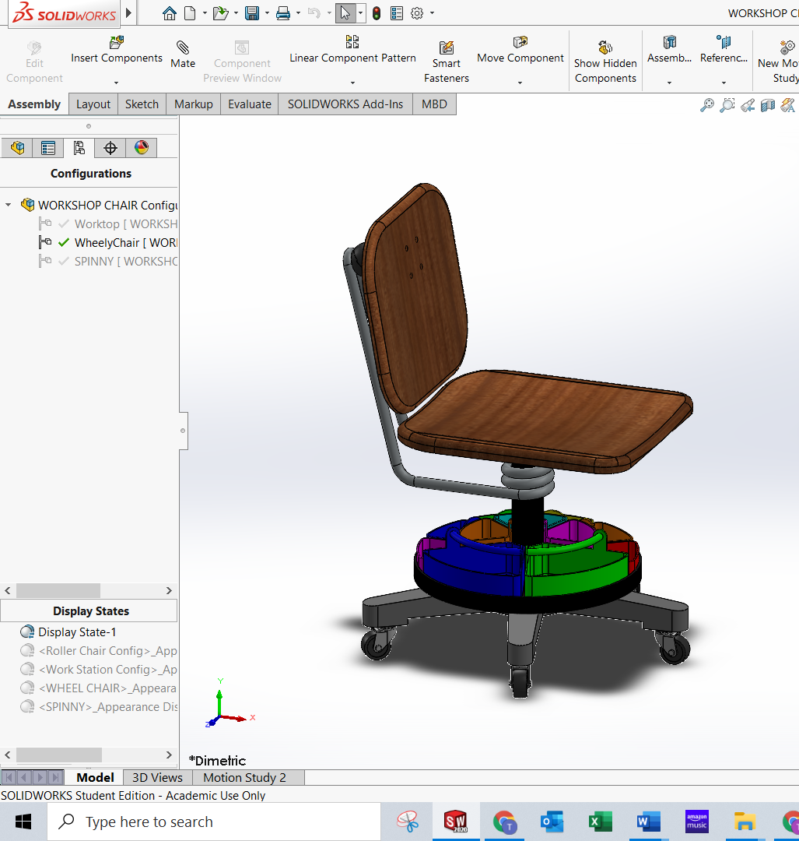

If using the Configure Component feature, I find it helpful to select multiple Parts to get the full effect (hold ctrl while Selecting from the tree).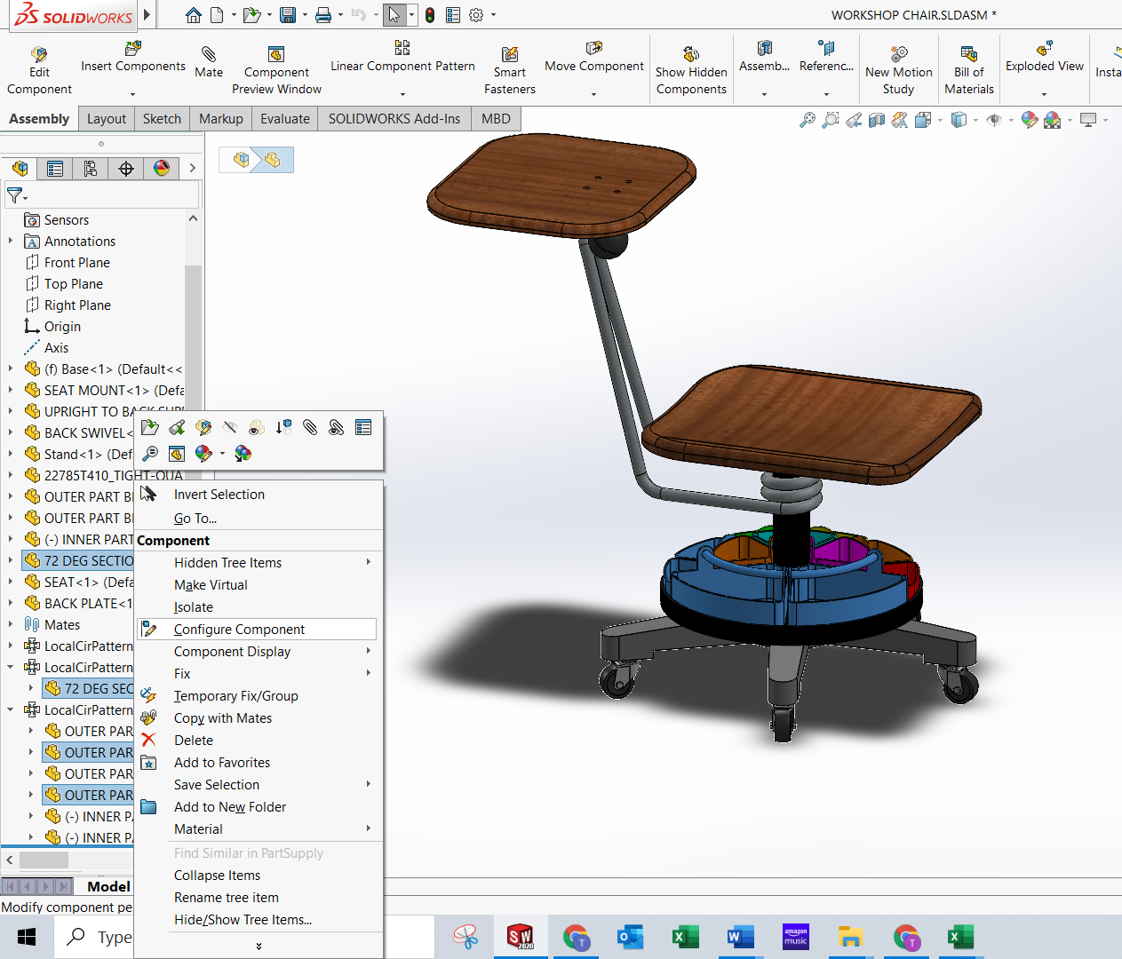
The pop up will now be more useful. You can see that the exsiting configurations are already here, and the parts are not suppressed at all. You can select the parts you want to suppress by just clicking the check boxes with the configurations: 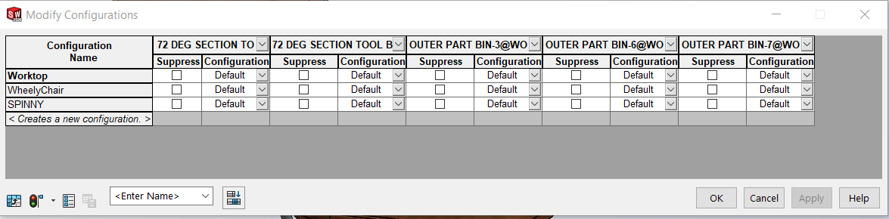
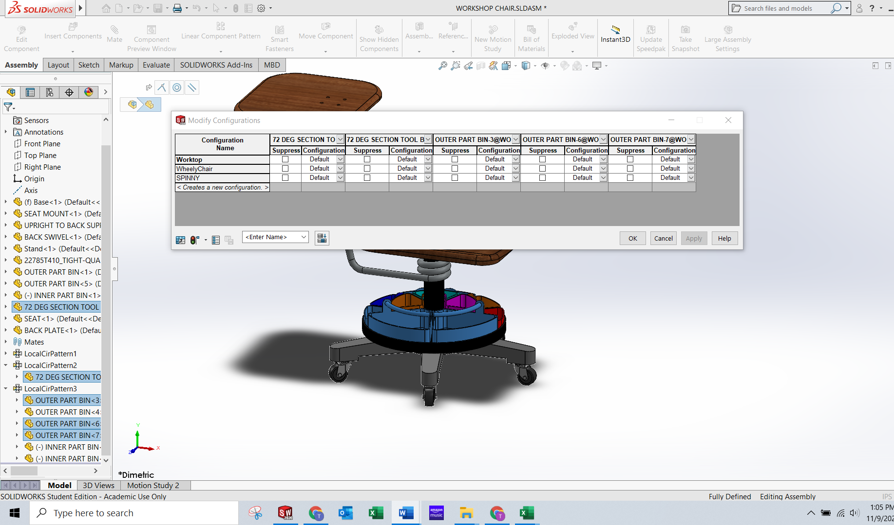 Suppressing the 72 deg bins (large) Becomes:
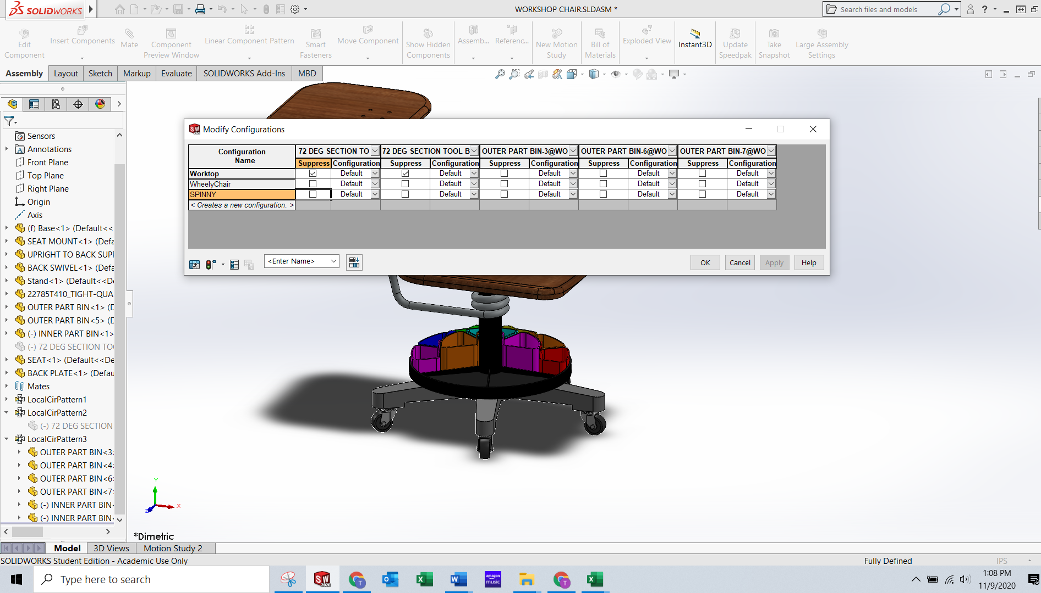
If you want to make a new configuration, you can type in the <…> and it’ll make a new configuration and you can suppress/unsuppressed parts. Here you can see me making a new config and suppressing the small bins and unsurprising the large ones:

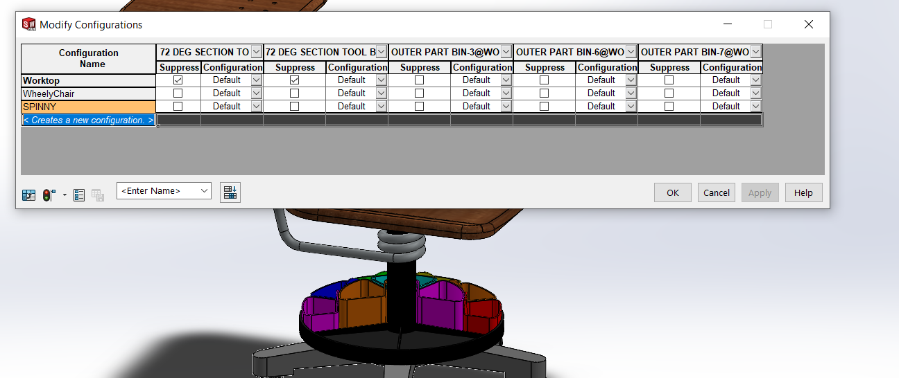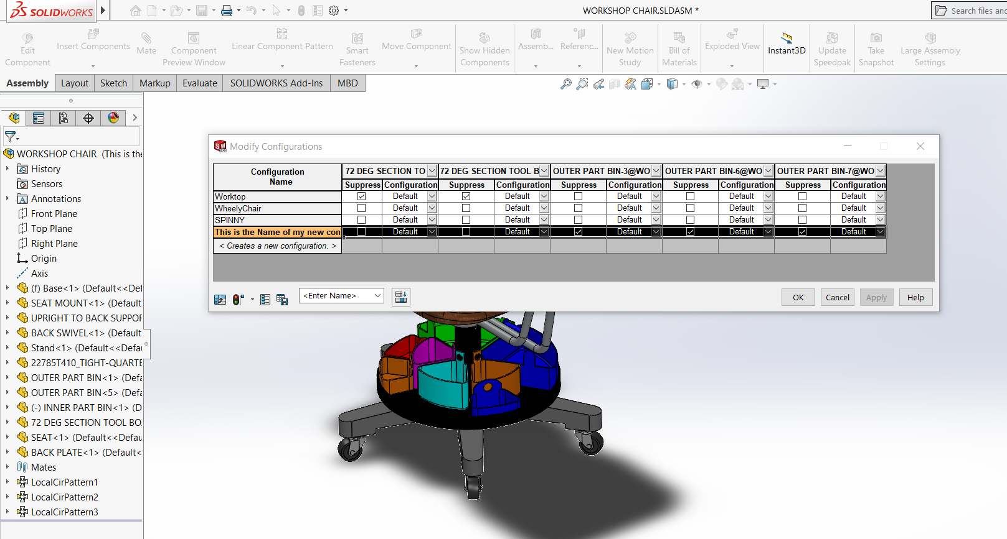
As you can see (kinda) the big pots are now visible, and the selected small pots are suppressed (I did spin to the other side of the chair to show it off). The New Config is also now in the configurations list:
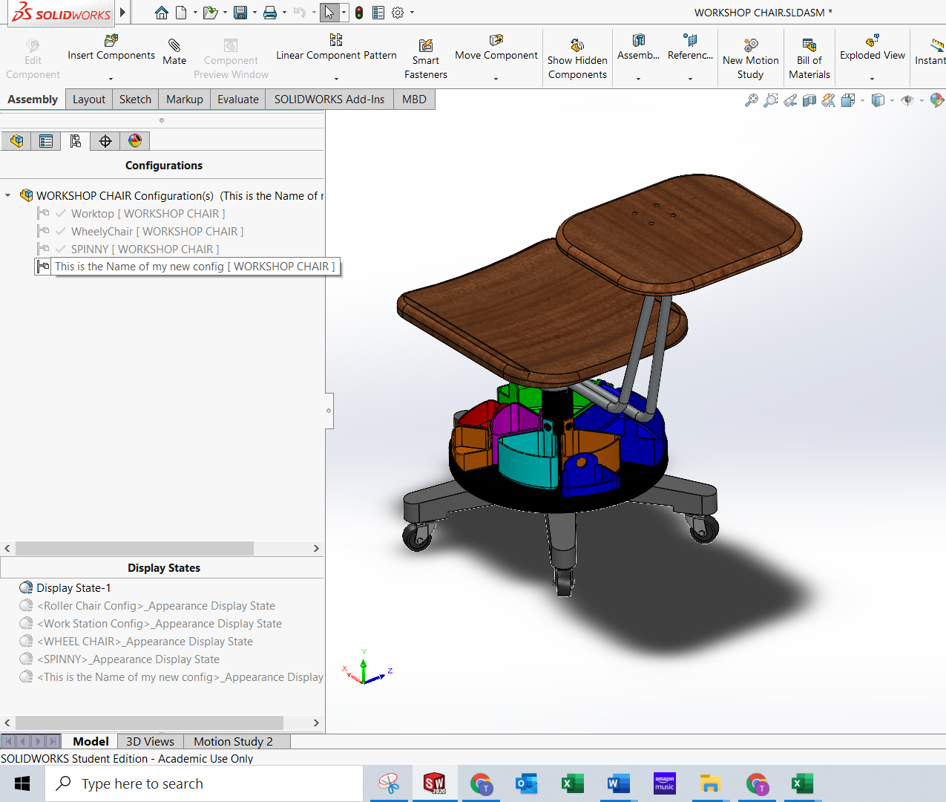

I hope this helps with the idea of quickly suppressing/unsurprising parts in an assembly in different configurations.

