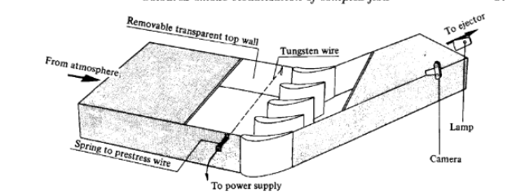
30 degrees

124.2

124.2

108.4

189.53

Thickness of the wall = 12mm

