Grade breakdown of task
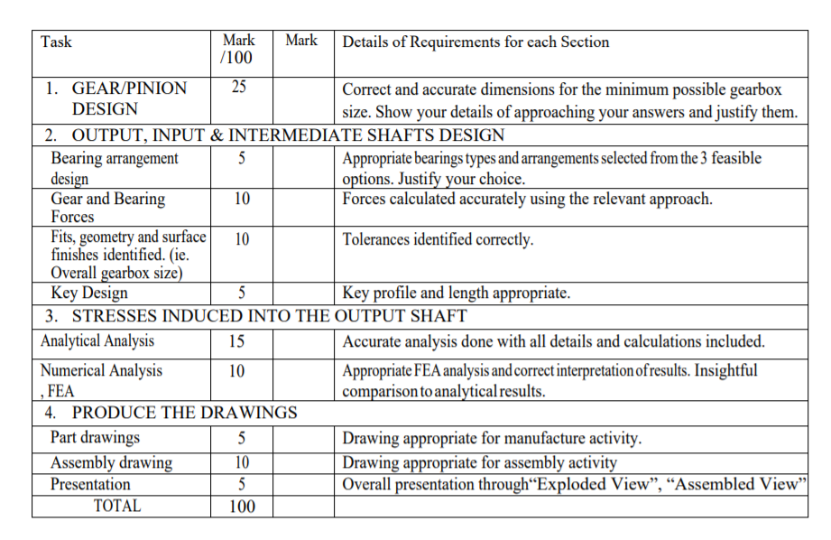
Notes to be fulfilled for obtaining full marks: -
- Two-stage compound reverted helical gear reducer.
- Power Delivered: 15kW
- Input Speed: 1440 RPM
- Speed Reduction: 1:20 (±1%)
- Gears and bearings: Gears and bearings life should exceed 10,000 hours.
- Assume the normal pressure angle (𝜙𝑛) to be 20 degrees for all gears.
- Assume the helix angle (𝜓) to be 30 degrees for all gears.
- The overall Gearbox height Y= 20 cm.
- The overall Gear-box size need to be minimized.
- The chosen portions of the gear train (e) are to be as evenly divided between the stages as possible.
- It is desirable for the input shaft and the output shaft of a two-stage compound gear train to be in-line.

Final Inventor drawing should look like this for the gears + Appropriate casing of the dimensions requested of course.
