Boat Dock design – Grand Lake, Oklahoma
Seeking an optimum dock design for the environmental conditions. Boats to be docked yet undetermined but assume include a 26’ tritoo, OR a wake surfing boat and a 30 ish foot sailboat, And 2 personal water craft. Location is Grand Lake of the Cherokees, Oklahoma. 36.6 ; -94.9
See Pensacola dam, Langley Ok for environmental conditions. Range of water level is 740’ above sea level to 757’. Temperature range from 10 degrees F to 110 degrees F. Winds design up to 90 mph, with tornado potential beyond. Waves can go up to 6’; Exposure of dock location is SE, very main lake exposure to wind, waves. (see photo below). Site Conditions – approximately 12 degree slope into lake. Dock is continuously exposed to waves/damage (occasional storms, large waves, winter ice)
Traditional dock design – Floating docks, constructed of welded or bolted frame structures; when exposed to waves, they are occasionally protected by large anchored/floating wave breaker aka ‘breakwater’ structures. Frequently the floating docks contain “hydro hoist boat lifts” www.boatlift.com to elevate boats out of water using pontoons with vacuum systems to float/deflate. Also may include automatic drop down mooring cover device above stall.
Benefits – no loss of waterfront property, continuous access to the water, ability to elevate boat out of water (partially, deep keel designs may have only partial elevation)
Example Rolling/trolley design – not floating, rigid dock with fixed I-beams, with rail car wheels, pulley system using fixed electric winch and cable. (see photo)
Benefits – stable dock with no damage or motion exposure to wave action; ability to remove dock from water most of the time, reducing exposure, corrosion, keeping boat out of water without vacuum system elevation, access to hull of vessel including deep keel
Concerns – dock is pulled up into the yard taking up real estate. Winch cable crossing yard. Semi-dangerous operation requiring care to prevent people/pets getting in way of moving dock/boat system.
Contractors – typically relatively low to basic welding and mechanical skills. Not very familiar or open to novel/new designs. Maintenance is difficult/undesirable as slow to respond.
Ideal design – safe, boats protected, minimally impacted by waves, wind, weather; low maintenance. Access to boat hull for maintenance.
Emphasis of the design on functionality (environmental conditions), constructability and maintainability, protection of boats from the elements.
Ideas – include floating breakwater technology (PMSdockmarine.com); hydraulic lever arm designs; magnetic levitation approaches, or other creative solutions
Permitting requirements – see grand river dam authority, aka, GRDA
https://www.grda.com/wp-content/uploads/2019/04/Application-for-Private-Dock-09-01-2017-1-1.pdf

Slope example, about 10-15 degree slope. Water level approx. 752’

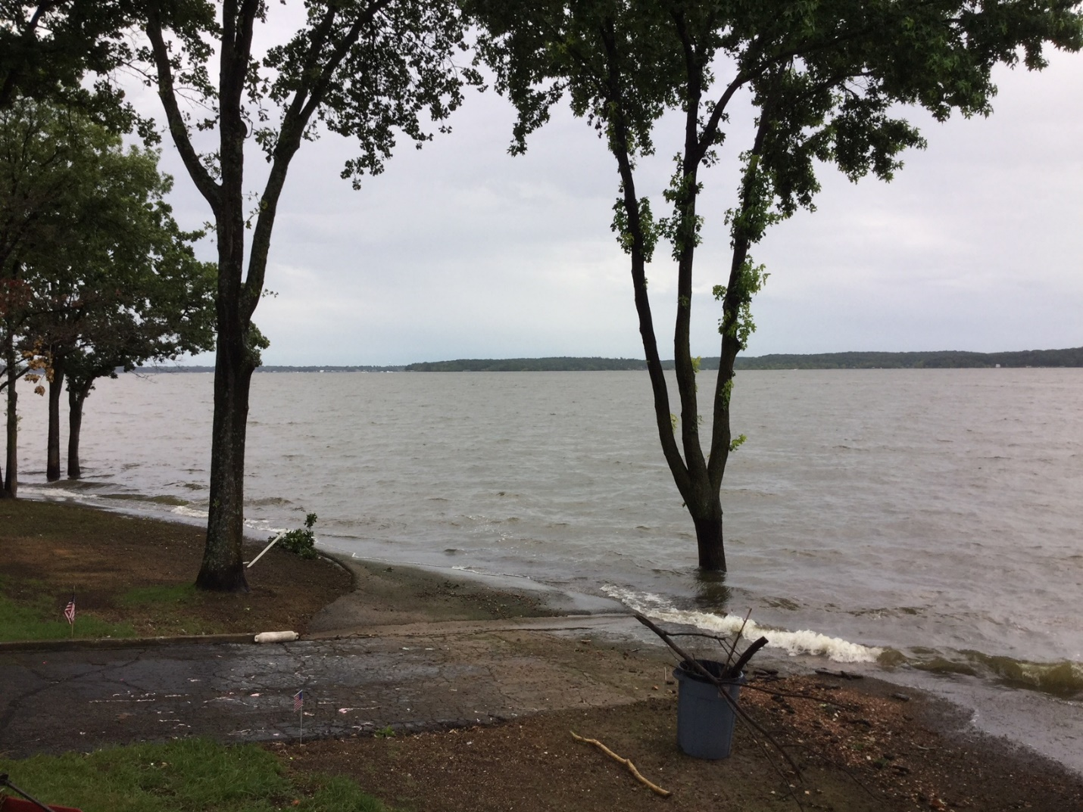

Typical floating dock design, most popular/ubiquitous design. Familiar for construction/ assembly and maintenance practices of the local contractors. Some docks simply bolted together, so become unbolted with wave action.

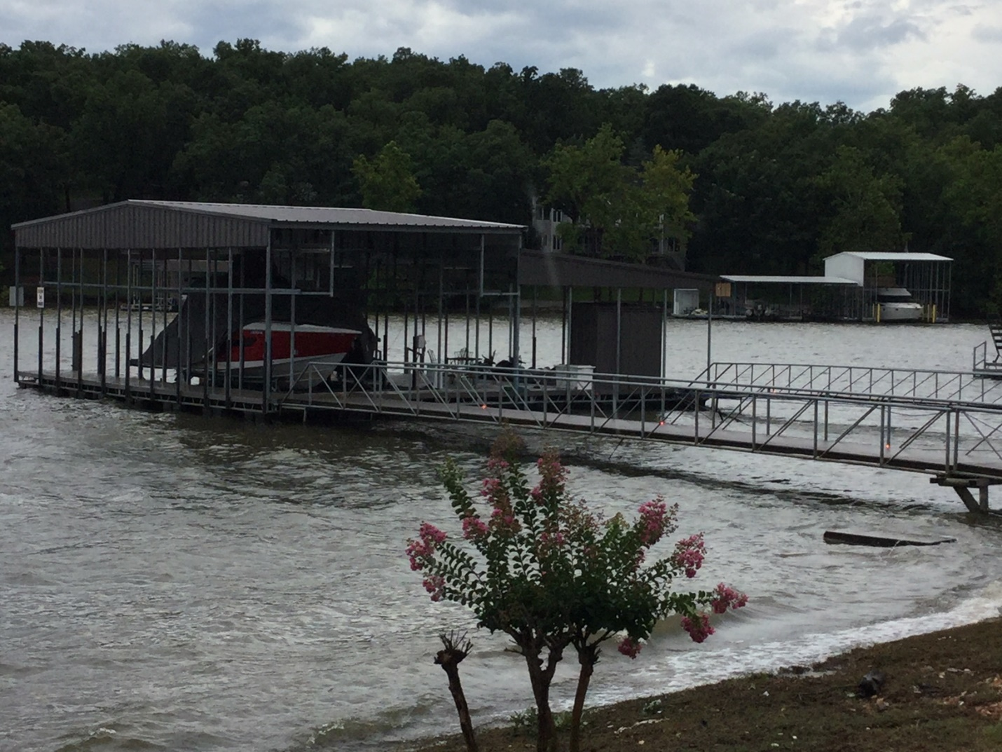
Existing, but Very unusual, almost extinct, ‘trolley dock” design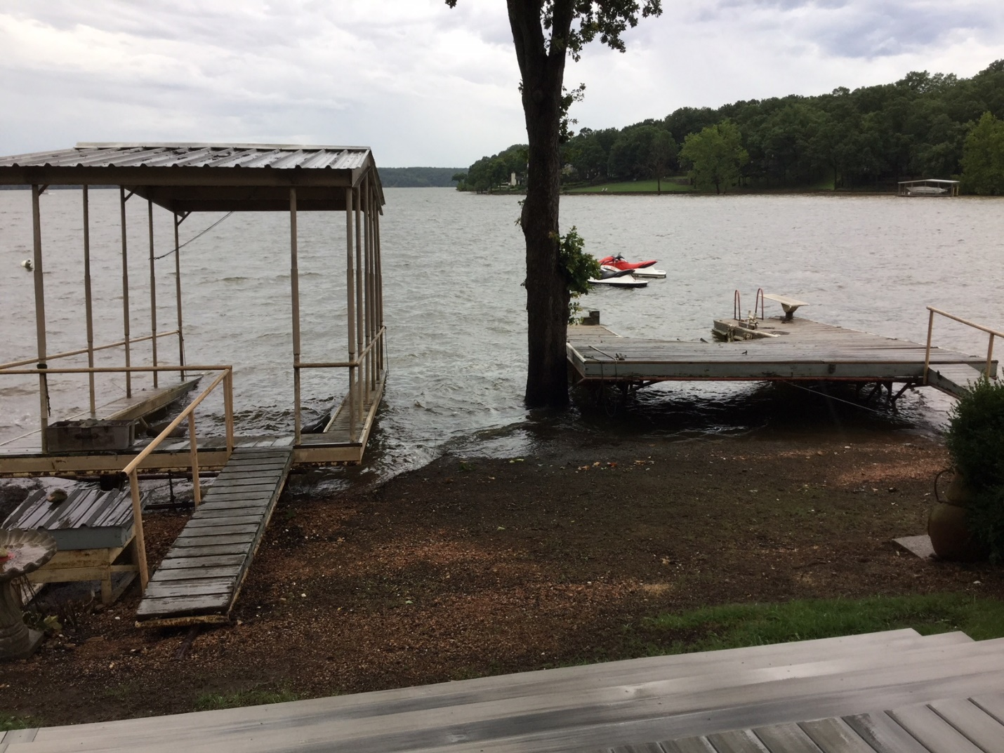
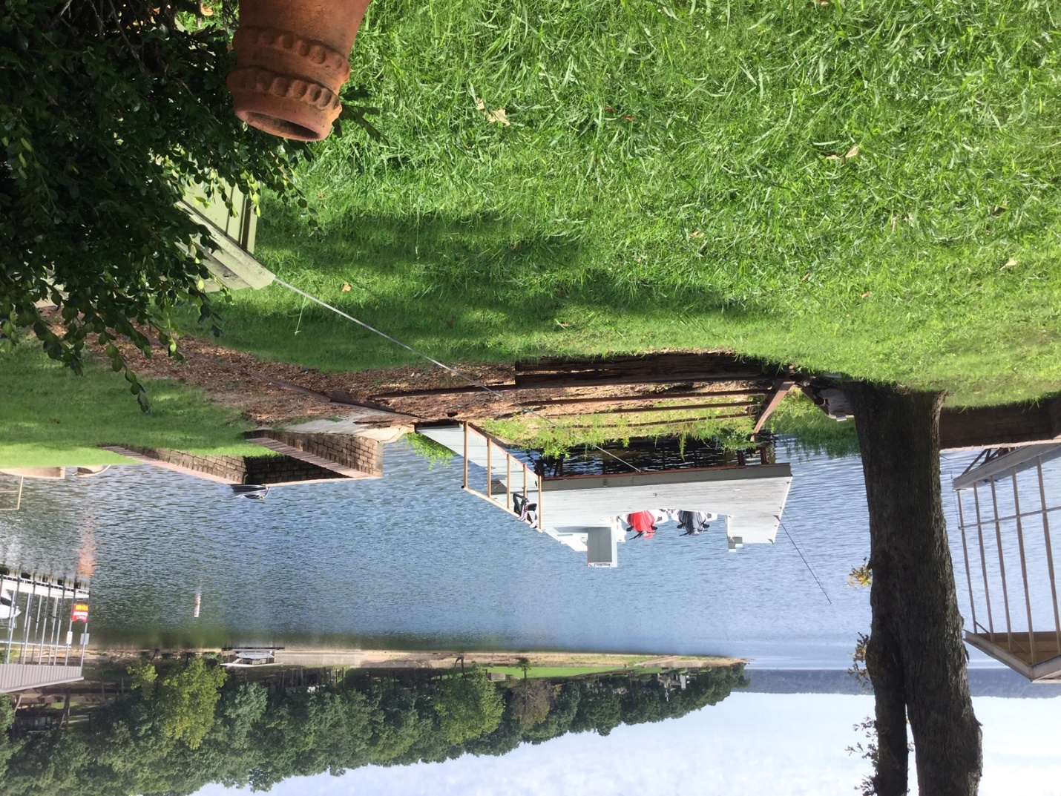
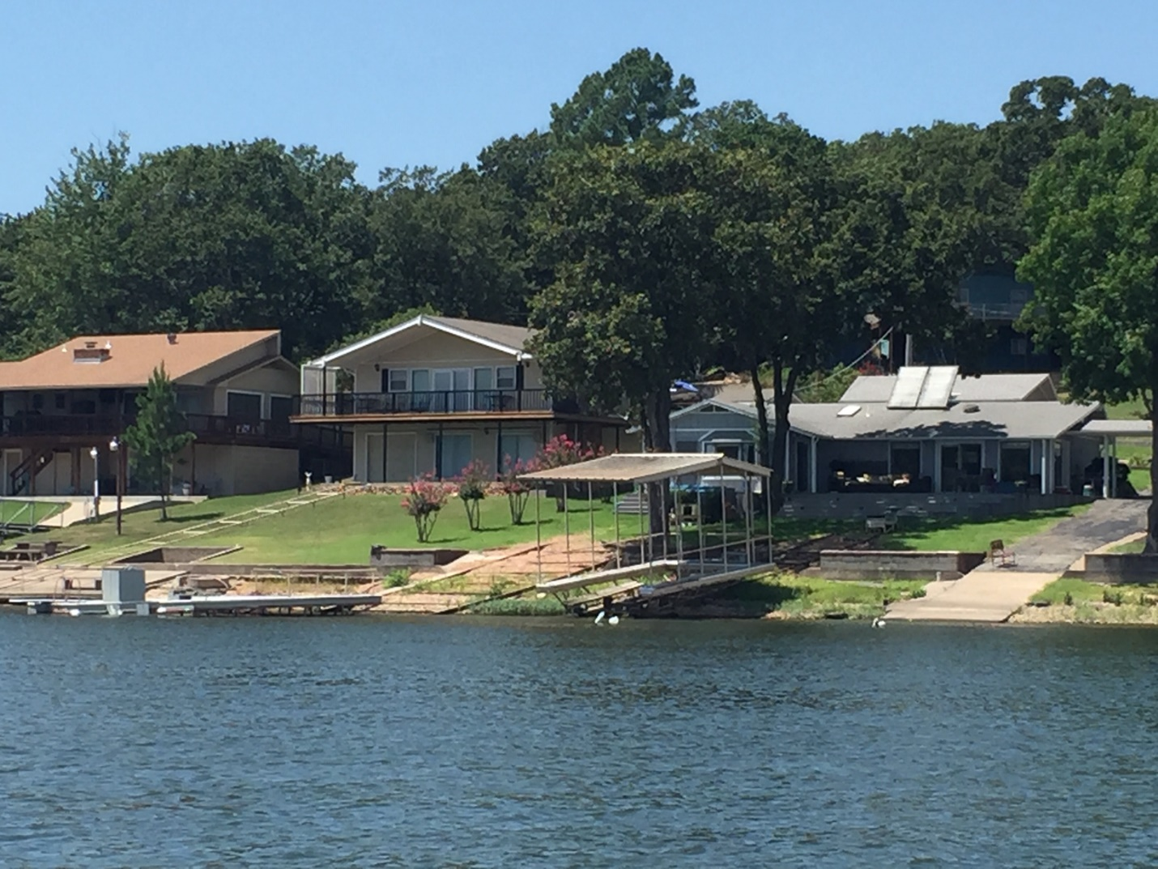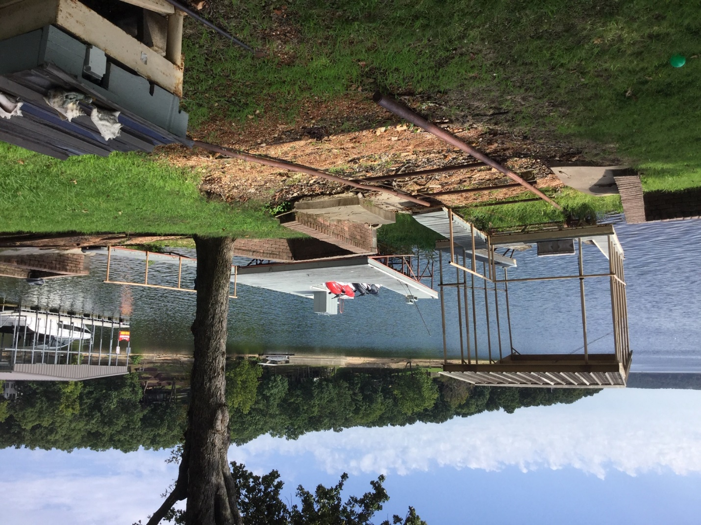
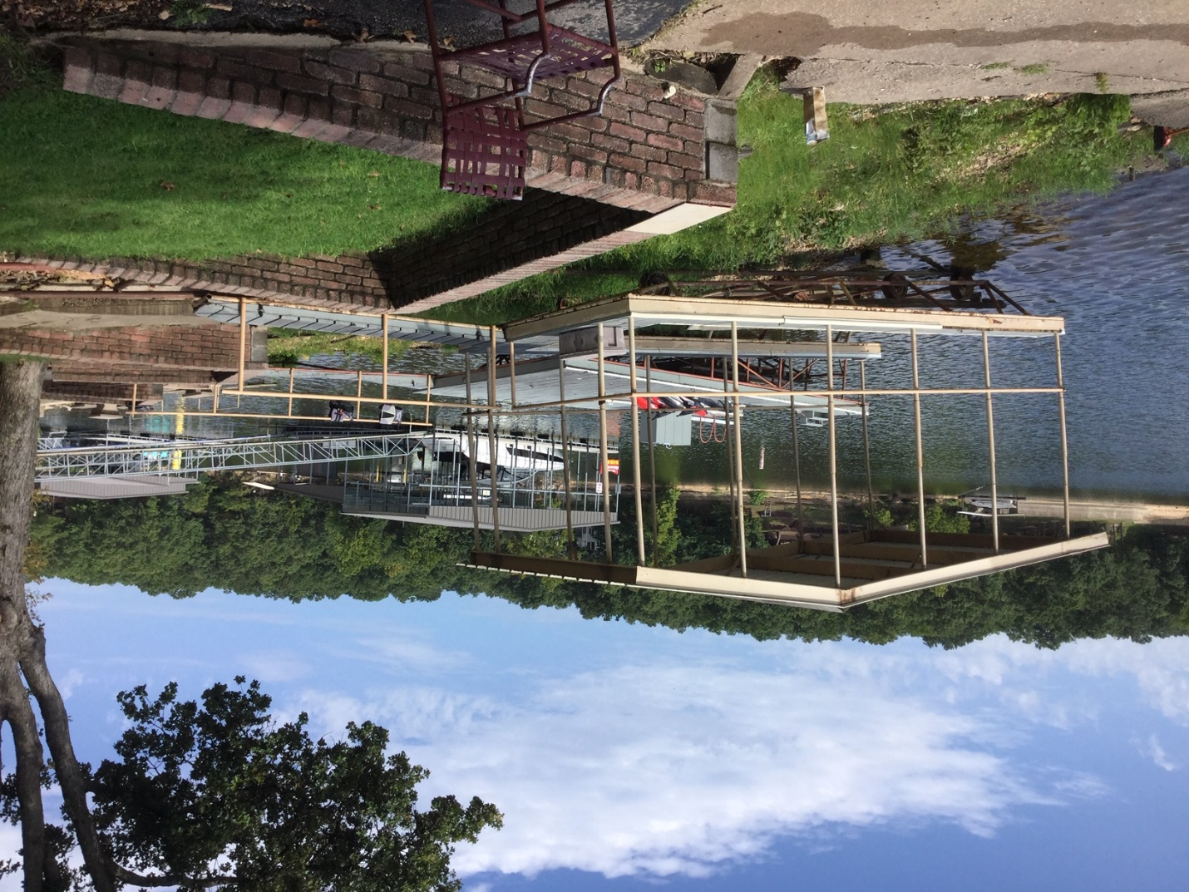
Sample schematic of possible initial dock layout:
