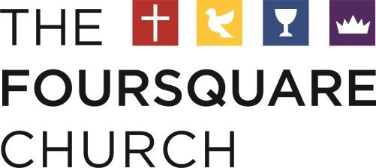

Public Service Loan Forgiveness (PSLF):

9/30/21

A recent change in the Public Service Loan Forgiveness program may allow those employed by a church (including pastors) to have their subsidized and unsubsidized student loans forgiven. An individual who has made at least 10 years of payments while working full time for a qualified employer is now eligible, according to the PSLF website.

The program used to exclude those employed in religious education, worship, or other religious endeavors. However, thanks to a recent court case, religious workers now qualify.

To be eligible for this program, the PSLF notes that:
- You are considered full-time if you meet your employer’s definition of full-time or work at least 30 hours per week, whichever is greater.
- If you work more than one qualifying part-time job, you are considered full-time if you work a combined 30 hours or more between employers.
- Only federal direct loans (also known as William D. Ford Federal Direct Loans) qualify.
- The Federal Family Education Loan Program and the Federal Perkins Loan Program are not eligible, but such loans may become eligible if consolidated into a Direct Consolidation Loan.
- Student Loans from private lenders do not qualify
- The borrower must make at least 120 qualifying monthly payments, meaning the payments came after October 1, 2007, under a qualifying repayment plan, for the full amount due on each bill, no later than 15 days after each bill’s due date – and while working for a qualifying employer.
- When loans are in “in-school status,” a grace period, a deferment, or a forbearance, the site cautions any payments made are not considered to be qualifying ones.

Although this is excellent news for pastors, it does appear that the program has a backlog of applications, low approval rates, and poor loan service management.

To learn more about this program, please visit the PSLF Website. In addition, you may want to set up an account with the PSLF Help Tool to see your potential eligibility.

