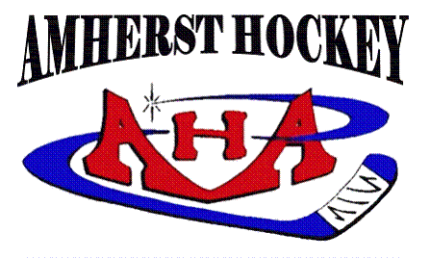
Board Meeting – November 6, 2018

Present: Julie O’Brien, Bryan Burke, Shelley Poreda, Mike Loudon, Michelle Kendall,
Feng Zhao, Karen Skolfield, Nicole Heroux, Tom Beckwith, Dan Feldman,
Stephen Markey, Steven O’Brien

- Approval of October Minutes- Passed

- Executive Board Reports
  - President
    - APD Ropes Course Team Building Exercise-has been a success will schedule for next Fall.
    - LTS/LTP, 2&2 Challenge, Try Hockey For Free Day-15 Adults helped, Kids had a of fun. Would like to have all board if possible at try hockey for free. We had 48 learn to skate kids.
    - AHA Night w/UMass Hockey 2/8/19 & Enhanced Game Experience AHA night is UMASS vs BU. AHA players should wear their jerseys. KIDS will be participating. EGE every team gets 3 nights... coaches can reward kids to go to the game. Can get a puck/ picture with Coach Carvel. Coaches have been assigned to games.
  - Vice President of Hockey Operations
    - Hockey Operating Rules-Looks like we only need to change some dates. Dan recommended we review this document then vote. We approved with necessary edits of dates.
    - Power Skating/Goalie Clinics-Looking to get Mites on at 5:30 in January.
  - Vice President of Association Activities
    - Picture Night-went very well
    - Calendar Raffle-Will be distributed Thursday
    - Coffee Table-Each time you volunteer you get $25 off your bill. Antonio's donate pizza's
    - Thunderbirds Kick Off Night-December 16th AHA night. Squirt RED will be playing before
  - Treasurer
    - Barbara Feldman/Kandace Carlin Donations-We can use funds for anything we want to projector/dryland equipment?
    - Dry Land Investment
    - Accounting Requirements/Costs-Motion to put $2500 towards an Accountant to do taxes. We also need a program for record keeping. Motion was made and 2nd by Thomas Beckwith. (and others)

- Appointment Reports
  - Girls’ Hockey-15 Inhouse Skaters
  - Scheduler- December schedule will be coming out those who do not have a lot of ice t time will have dryland.
    - Dry Land Schedule
  - Communications Director-Request for a board for Mullins. The O'Brien's will donate one.
  - Fundraising Director-Stella will start coming to meetings
  - Registrar Everyone have gotten there necessary info in
  - SafeSport- Not gettting injury reports from coaches
    - Status of Coaches/Team Reps. Qualifications
  - Equipment Coordinators
    - Intermediate Goals-all 6 goals are in. 4 at Mullins /1 is at the middle school
    - Storage Unit- Need to go through the unit and get new unit organized.
    - THFF/Used Gear Sale #2
  - GSL Representative
  - Webmaster
  - Tournament Director-11 teams not including our two squirt teams...Do we want to add the PEEWEE Teams
    - Photographer/Videographer? Still need a photographer

- Old Business
- New Business
  - New white board at Mullins-already discussed/ Bantam Red Coaches want tackling equipment
  - Mike recommend we order a view new jerseys for new people joining the organization
  - One more new PeeWee and one to call
  - Mike Red working on getting more B games.
  - Thinking 1 or 2 more Mites joining
  - Squirts are fine
  - Bantams are getting a lot of injuries.
  - Treasure reports- we will need to prorate some girls and we have an additional person who wants financial aid

