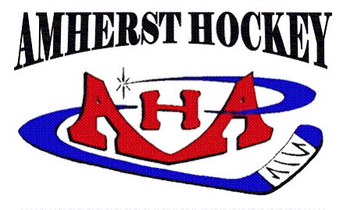
Board Meeting – October 2, 2018

Present: Julie O’Brien, Bryan Burke, Shelley Poreda, Mike Loudon, Michelle Kendall, Jason Carlson, Feng Zhao, Karen Skolfield, Stephen Rich, Krisztina Filep, Nicole Heroux

- Approval of September Minutes – Approved with minor corrections.

- Executive Board Reports
  - President – No report.
  - Vice President of Hockey Operations – state tournament applications sent, all team rosters set
  - Vice President of Association Activities
    - Picture Night – Thursday, Oct 25. Starting at 5pm with Mites. Squirt and Peewee Blue girls will be late to the ice since picture at 6 pm.
    - Calendar Raffle – Coming.
    - DK Hockey Store (Stella) – Updated store, link is up on website, email will go out to AHA families. 10% of each item goes to AHA. Baseball caps will have an order deadline for printing.
    - Thunderbirds Kick Off Night – October 13 GSL night, for any players and teams interested ($14/ticket)
    - Honorary Volunteer Award – new, to recognize non-parent volunteers. Award at banquet.
  - Treasurer – 2 families applied for financial aid. May need new accountant for taxes since revenues require one based in MA (current one is in CT).
    - FB Fundraiser – someone ran a FB fundraiser in AHA’s name. Will investigate further. Also, trying to take over AHA FB page.

- Appointment Reports
  - Girls’ Hockey – GTHFF October 6, all help appreciated and needed on and off ice. Girls teams rosters set, first games on October 7.
  - Scheduler – October ice: 9 practices for Mites, 11 for Squirts/Peewees, 10 for Bantams. Ice availability will drop starting in November to Tues late, Wed Fitzpatrick, Thurs + 1 night at Orr.
    - Dry Land Schedule – start in late October, Monday nights.
    - Power skating – with Caz, Oct 18, 25, Nov 1 (trying to move to Nov 15), Nov 8. 1 hour sessions + 30 min for Bantam checking. Another set in January, will include Mites.
    - GSL games – games start Oct 20, schedule posted Oct 17. We have Mullins ice 7-11am weekends, some may become available for independent games.
  - Communications Director – newsletter sent out 1st of month.
  - Fundraising Director – no report.
  - Registrar – all teams (except girls) are approved with official rosters.
  - Equipment Coordinators
    - Intermediate Goals – have arrived.
    - Storage Unit – current unit is 5x15 @ $70/month, need more space 10x15 @$90/month. Motion to move to bigger locker/increased cost. Unanimously approved.
    - Helmets For GTHFF – have XS and S in storage, ordered 12 M. Cost $45.
    - Used Gear Sale Prep – will load from locker on Friday, deliver to Mullins Saturday.
  - GSL Representative – nothing to report. Meeting at same time to discuss team placements.
  - Webmaster – nothing to report. Request to add player numbers and updated team reps to rosters.
  - Tournament Director – 9 teams registered. Will use Lossone. Need help to cover full weekend of volunteers.
    - Photographer/Videographer? Still looking.

- Old Business – None.
- New Business – None.

Adjourned 8:10 pm.

