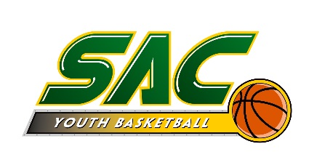

MEDICAL AUTHORIZATION TO RETURN TO PLAY WHEN A CHILD HAS BEEN REMOVED DUE TO A SUSPECTED CONCUSSION

Ohio State Law requires a child who exhibits signs, symptoms or behaviors associated with concussion be removed from a practice or game and not be permitted to reenter practice or a game on the same day as the removal. Thereafter, written medical authorization from a physician (M.D. or D.O.), is required to grant clearance for the child to return to participation. This form shall serve as the authorization that the physician has examined the child, and has cleared the child to return to participation. The physician must complete this form and the form must be submitted to the child’s head coach and the SAC Board President before the child can resume participation in practice and/or a game. To reiterate, this child not permitted to reenter practice or competition on the same day as the removal.

I, ________________________________________, M.D., D.O., have examined the following child, ______________________________, who was removed from a Sycamore Athletic Basketball Club, practice or game due to exhibiting signs/symptoms/behaviors consistent with a concussion. I have examined this child, provided an appropriate return to play regimen, if necessary, and determined that the child is cleared to resume participation in practice and competition on ____________________, 20____.

___________________________________________
Signature of Medical Professional

______________________________________
Date

