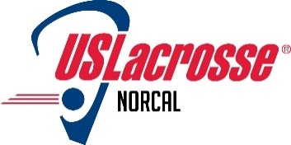

NorCal Chapter of US Lacrosse board meeting Monday, May 20, 2019

Agenda

- Review and adopt minutes from April 15, 2019 meeting (TP) (needs NCCUSL approval)
- 2019 Chapter Financials (SD)
  - P&L
  - B/S
  - IRS and CA state tax returns filed
- Key activities, initiatives and objectives - status
  - HOF – (DA)
    - Board approval to add Laura Bernhard as a Ballot committee member (needs NCCUSL approval)
    - Next steps; extend deadline from May 31 to June 15; Committee to elect chair
  - Approval of financial assistance for NorCal Women’s National team (needs NCCUSL approval)
  - All American and Academic AA process underway; New NCS area girls’ chair; New chairs for boys’ Central and Silicon Valley areas (DA)
  - Outreach
    - Gold Country/Nevada Union HS; Rocklin and Woodcreek – interested in transitioning to CIF for 2020
    - Request for help from Watsonville to establish a GHS team
    - Menlo Middle School – possible NCJLA or independent team w/local middle school “league”; no contact since last board meeting.
    - Fresno, Clovis, Brentwood - Delta Lacrosse, Richmond – Richmond College Prep – Status… anything new?
  - Chapter equipment inventory and status update (IB)
  - Fund raising (AH)
  - CIF championships (all)
  - Recent NCCUSL participation in events
    - NCJLA EOS events – May 4-5; Treasure Island – DTA setup; Lauren Davenport and Lyn Porterfield, May 4th; DTA morning and Lyn Porterfield all day, May 5th. May 18 & 19; Torri and Alex Horovitz scheduled at TI; others? Results (All)
  - Upcoming activities and events, some of which require NCCUSL planning and involvement
    - NCJLA Summer workshop; Saturday, June 8th –Doug Locker volunteered.
    - Should we plan a town hall for CIF coaches?
    - PLL – Aug 10 & 11; Avaya Stadium, San Jose; NCCUSL role?
  - Other items?
- Next meeting date – Monday, June 18, 2018

