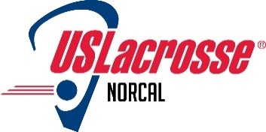

NorCal Chapter of US Lacrosse board meeting Monday, October 15, 2018

Agenda

- Review and adopt minutes from September 17, 2018 meeting (TP) (needs NCCUSL approval)
- 2018 Chapter Financials (SD)
  - P&L
  - B/S
- Key activities, initiatives and objectives - status
  - HOF update – (DA)
    - Venue
    - Updated budget
    - Registration status
    - Assistance needed at event with check in; beverage ticket sales
  - Outreach
    - Sacramento; Sankofa clinic granted; date TBD; Chapter tent needs (PB & CR)
    - Richmond – Richmond College Prep (first stick recipients); Sankofa clinic, Oct 27th; Plan to have booth there. (LD)
    - Oakland, Sankofa clinic, Oct 27th
    - Clovis
    - Other
  - Diversity & Inclusion updates, if any (LD)
  - CEP clinic info posted on NCCUSL website; newsletters (DA)
  - Chapter equipment inventory and status update (IB)
  - NCJLA – update if any (LJ)
  - NCRLA – update, if any (AS)
  - NCWLO - update (DA)
  - Activities and events, some of which require NCCUSL planning and involvement
    - US Lacrosse Western Regional Conference for coaches and officials – Nov 30 – Dec 2; Las Vegas, NV
    - US Lacrosse National convention – Philadelphia, January 11-13, 2019
    - NorCal Lacrosse Convention – tentative Jan 26 or 27; Status update (CT)
    - USA women’s national team games at Stanford in January. Date TBD. Need to promote once we know. Lyn Porterfield and/or Carlos Trujillo working with National team to determine availability for Convention.
- Search for other positions continues; Sponsorship & Fundraising; CIF High School representatives
- Next meeting date – Monday, November 19, 2018

