A Quantitative Assessment of Stereotypical Bias in Text-to-Image Generative AI Models

Keleesha Lowe, Kaung Set Htun, Abdul Kareem
Department of English, CUNY The City College of New York
ENGL 21007: Writing for Engineers
Pamela Stemberg
July 17, 2026

A Quantitative Assessment of Stereotypical Bias in Text-to-Image Generative AI Models

Abstraction
AI generators have consistently exhibited biases and stereotypes in the data it generates. This paper examined the text to image generation accuracy as it relates to gender, race and age of the image generator Nano Banana 2 in the context of professions. The finding indicated that professions which are presumed to be more nurturing in nature were consistently over-represented the female demographic while more athletic and sports based professions even when the real world data suggested otherwise were over-representative of males as it relates to gender distributions.
As for race, multiple groups seem to have been overrepresented with the Asian demographic being the most in the healthcare profession. While the white demographic representation drastically reduced throughout most of the results. A similar pattern was observed for age, individuals over the age of 40 were almost completely absent in these results, a pattern consistent across all three professions. This study provides evidence that biases in AI text to image generators have not changed over the years but instead shift depending on context, sometimes underrepresenting or overrepresenting certain groups depending on the profession or activity being generated.

Introduction
Text-to-image generative AI (Artificial Intelligence) tools have become increasingly more common in many aspects of our professional and individual lives. This raises a real concern as AI has been known to reproduce and amplify demographic biases as a result of the data used to train these models. In a 2026 study by Ashley E. Choi, Megan E. Chung and Louise Y. Sun, they examined this theory as it relates to biases in critical care medicine. Three hundred AI images of physicians were generated using DALL-E 3, Midjourney 6.0 and Stable Diffusion 3.0 and the results were compared against real demographic data from the AAMC records. The results revealed that biases were platform dependent. While Midjourney 6.0 underrepresented female representation 9.3% compared to the real world figure of 27.3%, DALL-E 3 overcorrected to 78.3% representation in the same category (Choi et al.,2026, p.4). DALL-E 3 also generated non-White physicians at nearly double the real world percentages, 90.0% vs. 45.6% (Choi et al., 2026, p.4).
A study by García-Ull and Melero-Lázaro (2023) found that AI image generators reproduced the same kind of stereotyping outside of medicine. When prompted, DALL-E 2 produced fully stereotyped professions in 59.4% of cases, with 21.6% showing full stereotypes of women and 37.8% showing full stereotypes of men (García-Ull & Melero-Lázaro, 2023, p. 5). Another study examining racial bias in AI-generated images by Yiran Yang, found that Meitu, a Chinese AI image generator, correctly depicted race in 79.9% of White figures compared to only 52.9% of Black and 51.0% of Asian figures, and consistently misclassified people of color as White when it got it wrong(Yang, 2025, p. 5429) . Accuracy also depended on gender and the context within the images, with Black women being least accurately depicted in images when alone and Asian men least accurately depicted in photos with multiple races (Yang, 2025, p.5431) Based on these results we conducted a similar experiment using Nano Banana 2 to test whether other image generators still reproduce these biases in 2026. We hypothesize that AI image generator will overrepresent and underrepresent certain groups to fit societal biases used in its training data, reinforcing stereotypes.
Materials and Methods
Image Generation
For this experiment a total of 300 images were generated using Nano Banana 2, a text to image AI generator developed by Google DeepMind. Images were generated using phrases like “realistic badminton players”, “realistic soccer players" and “realistic biomedical engineers” to split images into three gender neutral categories of 100 images each. No additional descriptives were used in order to limit the input biases of the prompt on the generator's default demographic output.

Image Classification and Real Word Data Comparison
The generated images were documented, analyzed and quantified by all research members on the basis of three demographic categories: gender (male or female), race (White , Black Asian, Hispanic, American Indian and Other for multi- racial individuals) and age range (20-30, 30-40 and 40+). As a baseline comparison Zippia and the National Library of Medicine (NLM) were used as references for the real demographic distribution of the categories being investigated. Zippia.com served as the primary demographic breakdown data source for biomedical engineers and soccer players while NLM provided the data for badminton players. Once all data was classified and quantified,the results were summarized using tables and graphs comparing the AI image demographic distributions with the data collected from these external sources.

Results
In our results we observed clear demographic biases amongst the images generated by the Nano Banana 2 AI in contrast to those from Zippia and NLM. Similar to the result from Choi study, the image generator favoured certain groups more than others (Choi et al., 2026, p.4). Of the AI generated images of biomedical engineers, 96% depicted women, compared to only 24.94% in the real-world data. Of the 100 images of soccer players generated, 95.7% were male compared to 78.8% from Zippia. Similarly for badminton 51.20% were male vs NLM 48.20%. The graphs below summarize the distribution of gender, race and age across the generated images for each profession. By looking at those, we can observe patterns in the AI generated images and provide the data used for the subsequent analysis and discussion.

Gender Disparities
Figure a(i)
Gender distributions of Biomedical Engineers
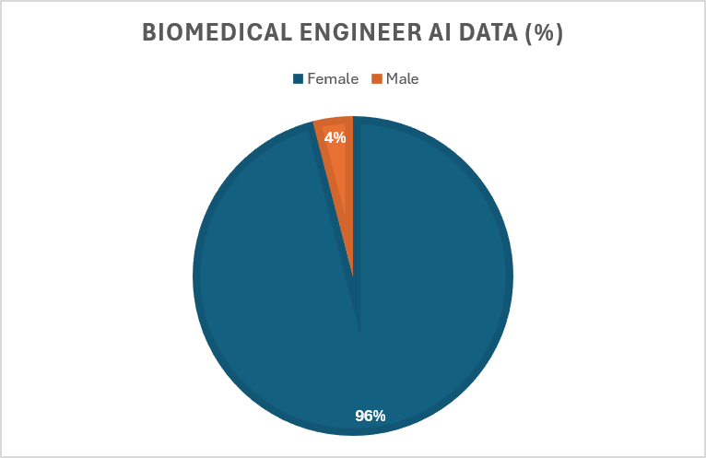
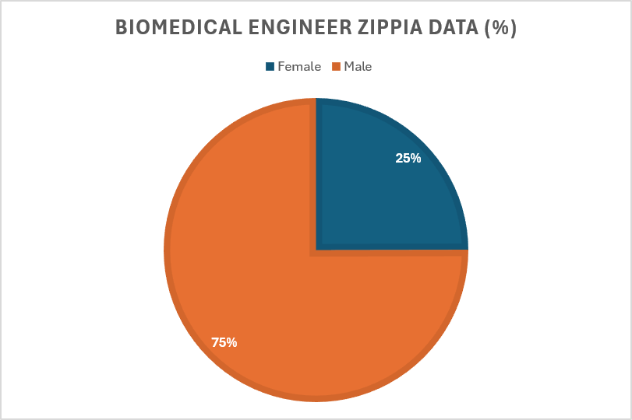

Note. Gender distributions from Nano Banana 2 compared with real world representations from Zippia(2022).

Figure b(i)
Gender distributions of Soccer Player:
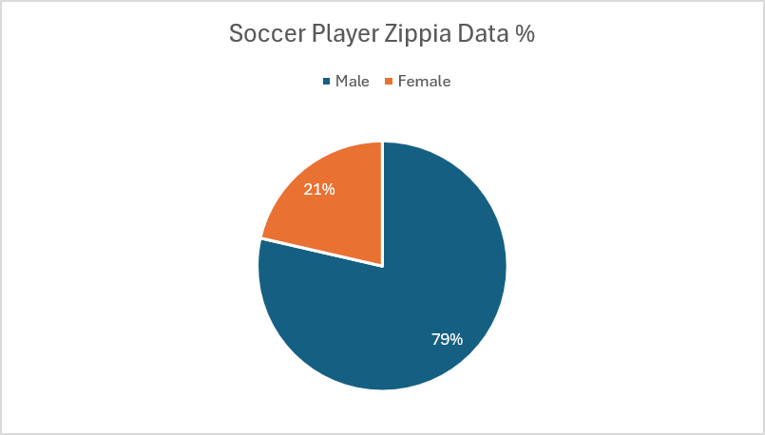
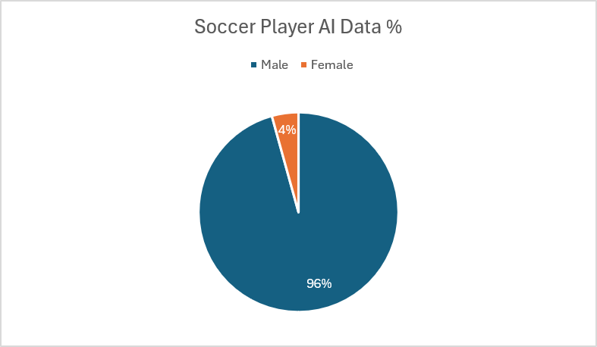
Note. Gender distributions fromNano Banana 2 compared with real world representations from Zippia(2022, Updated 2025).

Figure c(i)
Gender distributions of Badminton Players:
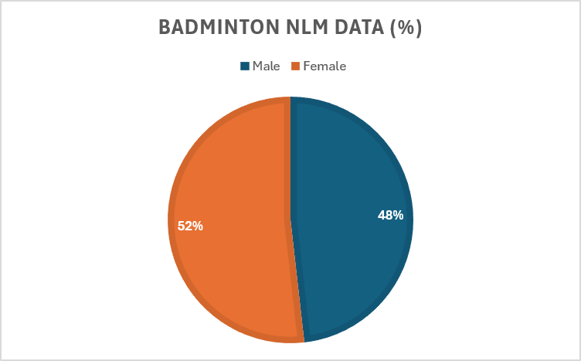
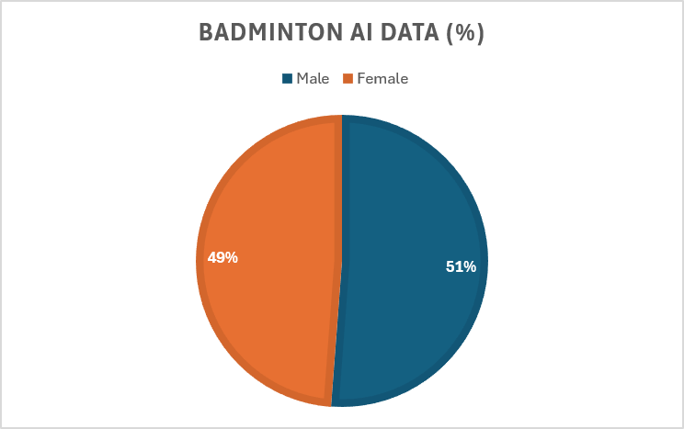
Note. Gender distributions fromNano Banana 2 compared with real world representations from National Library of Medicine(2020).

Race Disparities
Race representation showed a different pattern than gender did. For biomedical engineers, AI images skewed away from white representation (43% AI vs. 58.29% real) and toward Asian (33% AI vs. 20.1% real) and American Indian (9% AI vs. 4.9% real) professionals. While Hispanic representation didn't appear at all (0% AI vs. 10% real). Soccer followed a similar pattern, skewing away from White athletes (48.3% AI vs. 72.8%), while Black/African American (22.4% AI vs. 8.9% real), Hispanic/Latino (12.1% AI vs. 7.5% real), and Asian (11.2% AI vs. 3.7% real) athletes increased.. Badminton was the exception: East Asian representation landed almost exactly on the real number (53.1% AI vs. 53.0% real), while White players skewed slightly high (39.6% AI vs. 32% real) and South Asian players skewed low (4.3% AI vs. 13% real).
Figure a(ii)
Race distributions of Biomedical Engineers:
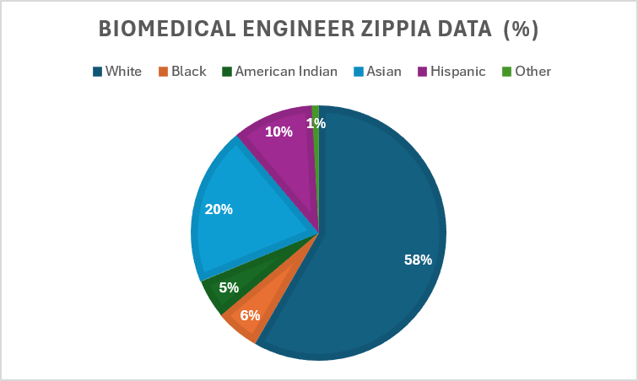
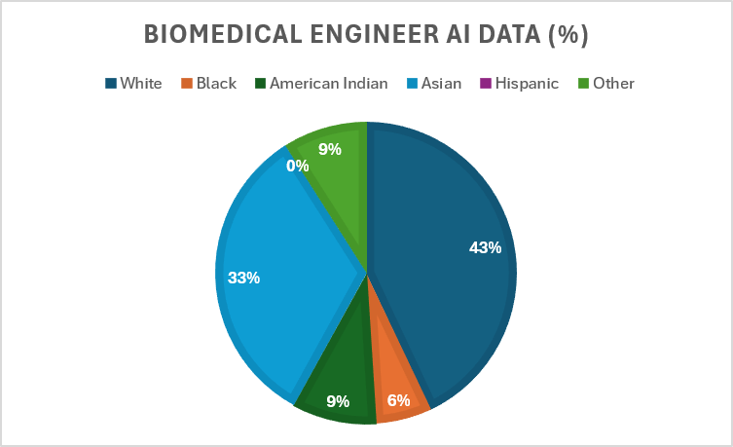
Note. Race distributions from Nano Banana 2 compared with real world representations from Zippia(2022).

Figure b(ii)
Race distributions of Soccer Players:
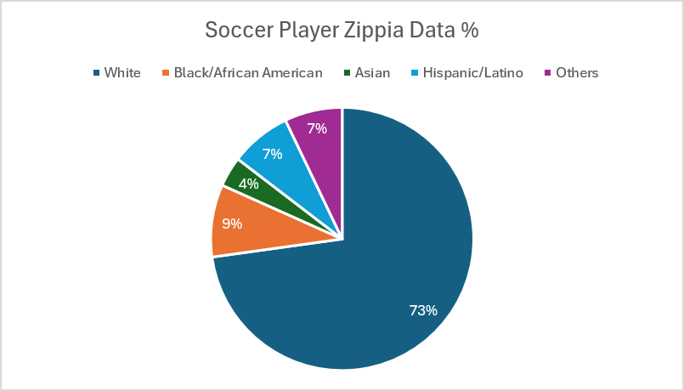
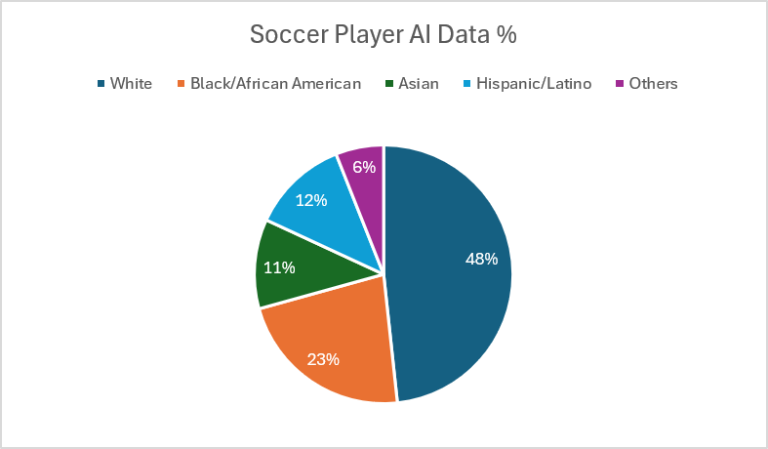
Note. Race distributions from Nano Banana 2 compared with real world representations from Zippia(2022, Updated 2025).

Figure c(ii)
Race distributions of Badminton Players:
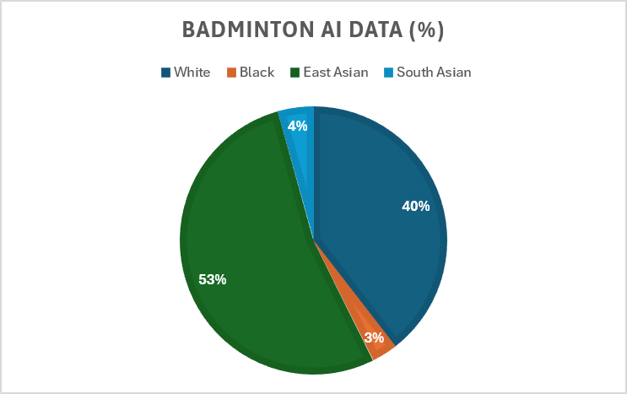
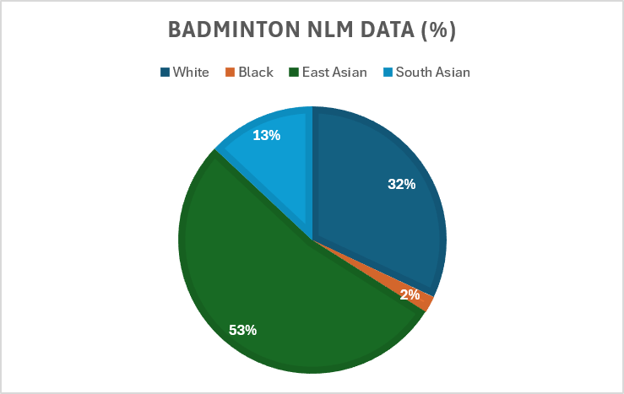
Note. Race distributions from Nano Banana 2 compared with real world representations from National Library of Medicine(2020).

Age Disparities
Age followed a clear pattern across all three categories: images consistently skewed young. Biomedical engineer images skewed toward the 30–40 range (83% AI vs. 34% real), with no individuals over 40 generated at all despite that group making up 32% of the real workforce. Soccer skewed heavily toward the 20–30 range (86.2% vs. 36% real), while the 30–40 (12.1% vs. 31%) and over-40 (1.7% vs. 30%) groups both dropped off sharply. Badminton showed the same shape: the 20–40 range was overrepresented (94.40% vs. 73.10% real), while both the 14–19 (3.10% vs. 18.30%) and 40–60 (2.50% vs. 8.60%) groups skewed low.

Figure a(iii)
Age distributions of Biomedical Engineers:
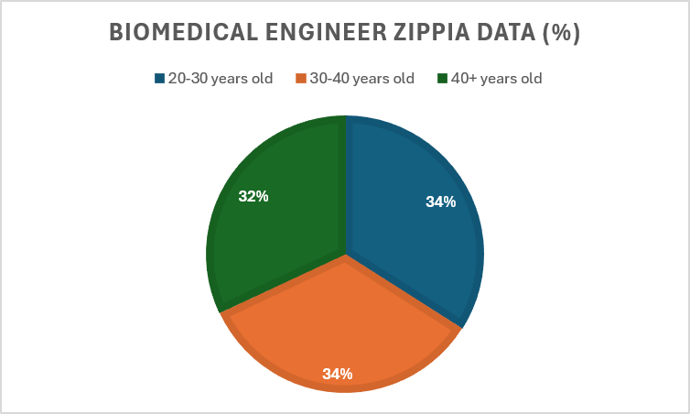
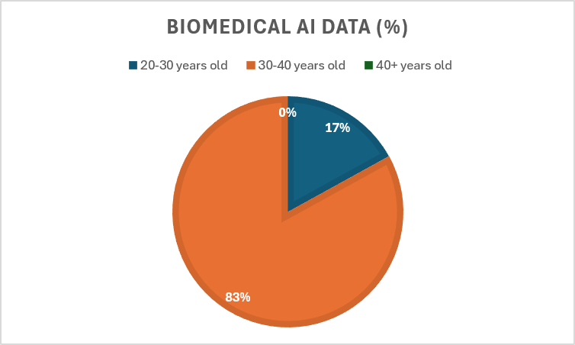
Note. Age distributions from Nano Banana 2 compared with real world representations from Zippia(2022).

Figure b(iii)
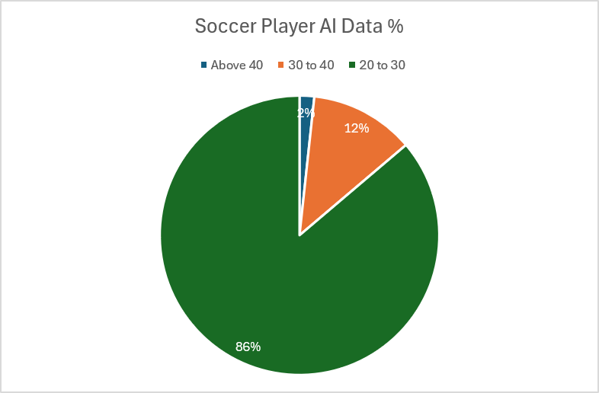
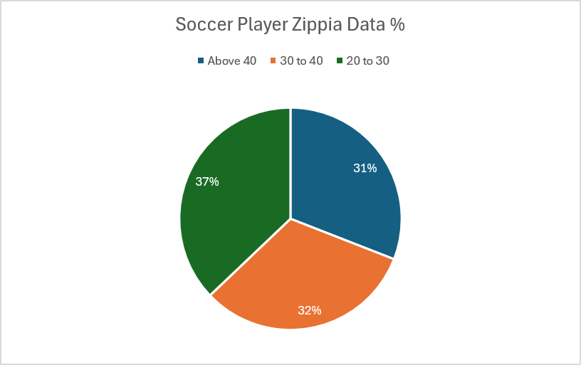
Age distributions of Soccer Players:
Note. Age distributions from Nano Banana 2 compared with real world representations from Zippia(2022, Updated 2025).

Figure b(iii)
Age distributions of Badminton Players:
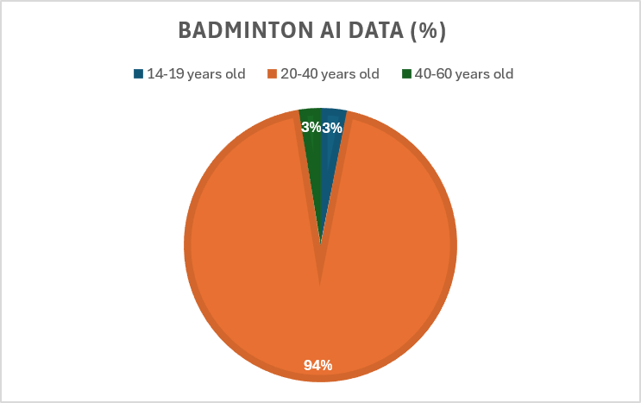
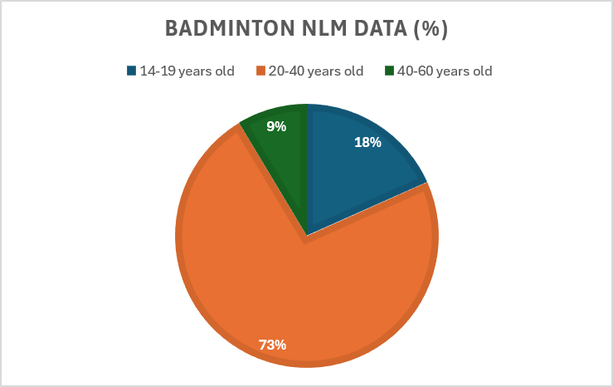

Note. Race distributions from Nano Banana 2 compared with real world representations from National Library of Medicine(2020).

Figure a(iv)
Noticeable Disparities in Biomedical Engineer AI Images:
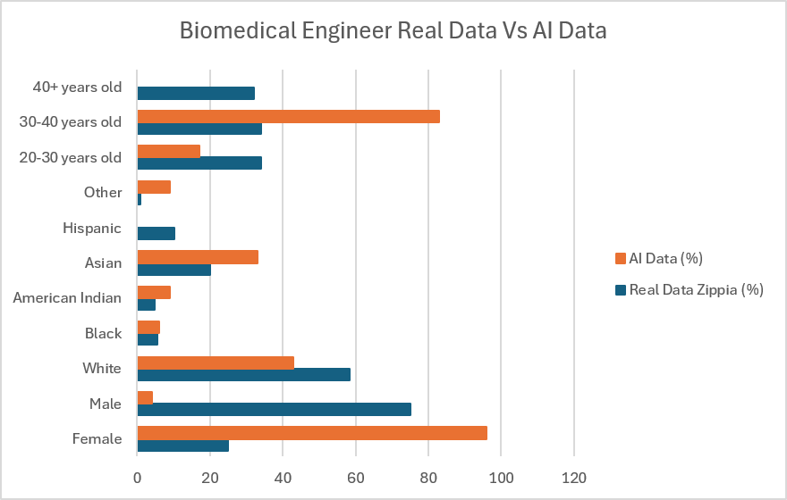

Note.Comparison of demographic distributions in Nano Banana 2 AI generated images compared with demographic data from Zippia.com(2022).

Figure b(iv)
Noticeable Disparities in Soccer Players AI Images:
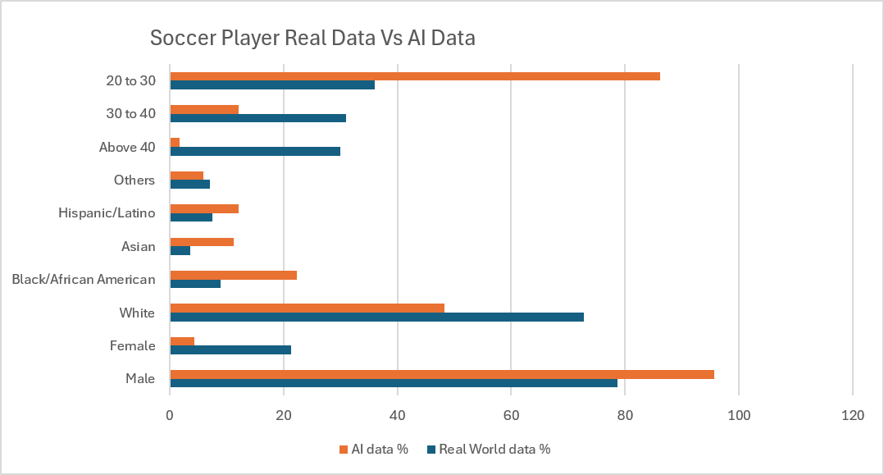

Note. Comparison of demographic distributions in Nano Banana 2 AI generated images compared with demographic data from Zippia.com(2022, Updated 2025).

Figure c(iv)
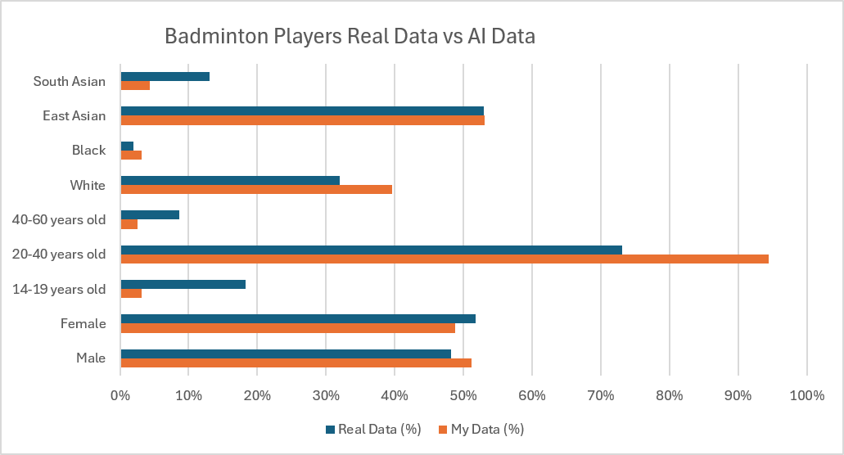
Noticeable Disparities in Badminton Players AI Images:

Note. Comparison of demographic distributions in Nano Banana 2 AI generated images compared with demographic data from Zippia.com(2020).

Discussion
Overall, our results support our original hypothesis that AI image generators will overrepresent and underrepresent certain groups to fit societal biases used in its training data, reinforcing stereotypes. Google Deepmind’s Nano Banana 2 did not accurately represent any of the three professions it was tasked to generate. This pattern suggests that despite the claims of these giant tech corporations that efforts have been made to reduce biases in these AI models the underlying issue was never resolved. But instead shifted into a more profession dependent bias.
Gender
The gender disparities from our research aligns well with the study by García-Ull and Melero-Lázaro (2023). Which found that when DALL-E 2 was tested on gender neutral profession prompts, nearly 59.4% of the images generated leaned into some sort of gendered stereotype (García-Ull & Melero-Lázaro, 2023, p. 5) . Our results supported this claim further. Biomedical Engineering is a profession that is actually male dominated with males accounting for 75.04%, but due to its proximity to healthcare, a field primarily thought to be female dominated, the results skewed heavily in overrepresenting the female demographic. While soccer and badminton, both sports related professions overrepresented the male distribution even though badminton had slightly more female representation in the real world, 51.80%. This is somewhat different from the results of Choi et al.(2026) study. In their study, Midjourney 6.0 underrepresented women across the board regardless of profession, while DALL-E 3 overrepresented them (Choi et al., 2026, p. 4). So both studies found overcorrection is possible.

Race
In the 2025 study by Yiran Yang, the results found that when Meitu got someone's race wrong, it almost always defaulted to White (Yang, 2025, p. 5425). Our results slightly differed from that as the White representation from our results were actually lower than their real world distributions in two of the three professions, with badminton being the only exception (39.6% AI vs. 32% real). It's probably not a coincidence that the one sport where the AI got race right is also a sport strongly associated with East Asian athletes in real competition and media coverage. That would mean the model isn't reaching for "White by default" the way Yang found with Meitu, it's reaching for whatever race is most stereotypically tied to that activity in its training data.For soccer, this bias showed by overrepresenting Black and Hispanic athletes and for biomedical engineering, it showed up as overrepresenting Asian professionals.
Age
This category was the most clear and consistent with the biases it generated. Every category skewed young, and the age group of people over 40 almost completely disappeared from the AI images. Biomedical engineers were the most consistent with 0% of images being generated with its demographic despite them making up close to a third of the real world workforce. García-Ull and Melero-Lázaro (2023) noted a similar pattern in their research when generating AI athletes; they all seemed to skew young (García-Ull & Melero-Lázaro, 2023, p. 8). Our results suggest this isn't just a sports thing. It showed up just as strongly in biomedical engineering, a profession with no obvious reason to skew young. That makes age look less like a stereotype tied to any one field and more like something embedded into the models.
Taken together, these results suggest the bias in Nano Banana 2 isn't random and it isn't one single issue either. Gender and race both seemed to be generated based solely on the nature of the profession. While age looked more like an embedded feature of these AI that tends to generate younger individuals.

Conclusion
This study backs up our hypothesis that Nano Banana 2 doesn't reflect real-world demographics, and it gets things wrong in different ways depending on the category. It overrepresented women in biomedical engineering but overrepresented men in soccer and badminton. Race didn't default to one group either, it shifted based on whatever stereotype fit the profession. And in every category, people over 40 barely showed up at all. Put together, this says the bias in these models hasn't gone away as they've improved, it's just gotten harder to predict. Ultimately, these findings demonstrate that despite recent technological advancements in AI, the underlying training data of these models remains deeply flawed. If developers want generative AI to actually reflect real-world diversity, they need to look a lot more closely at what's in the training data, not just assume newer models have fixed the problem without properly checking the sources of these biases.

References

Abián, P., Simón-Chico, L., Bravo-Sánchez, A., & Abián-Vicén, J. (2021). Elite badminton is getting older: Ages of the top 100 ranked badminton players from 1994 to 2020. International Journal of Environmental Research and Public Health, 18(22), 11779. https://doi.org/10.3390/ijerph182211779
Choi, A. E., Chung, M. E., & Sun, L. Y. (2026). Unmasking bias in artificial intelligence: Sex and racial representation in critical care medicine through text-to-image generators. BJA Open, 19, Article 100562. https://doi.org/10.1016/j.bjao.2026.100562
García-Ull, F.-J., & Melero-Lázaro, M. (2023). Gender stereotypes in AI-generated images. Profesional de la Información, 32(5), Article e320505. https://doi.org/10.3145/epi.2023.sep.05
Google DeepMind. (2026). Google Flow (Version Nano Banana 2) [Text-to-image model]. https://labs.google/fx/tools/flow
Yang, Y. (2025). Racial bias in AI-generated images. AI & Society, 40(7), 5425–5437. https://doi.org/10.1007/s00146-025-02282-1
Zippia. (2026a). Biomedical engineer demographics and statistics in the US. https://www.zippia.com/biomedical-engineer-jobs/demographics/
Zippia. (2026b). Professional soccer player demographics and statistics in the US. https://www.zippia.com/professional-soccer-player-jobs/demographics/

