Statistical Analysis of Coal Mining Accidents and Fatalities Using MATLAB

City College of New York
ENGR 10300
Joshua Smith
Prof. Viviana Vladestcu
Spring 2026

Abstract
This topic goes over the extremely nuanced and well-documented topic of coal mine safety. It is a commonly held belief that coal miners, as well as blue-collar work as a whole, are extremely dangerous occupations and produce a disproportionate amount of accidents compared to other energy production sources. In this report, I will be using the MSHA, or Mine Safety and Health Administration, accident report. This report does an extremely good job at looking at every single type of injury or fatality found in mines across the globe and has a section completely dedicated solely to coal mine accidents, which I utilized in the making of my report.
In order to figure out the real number of accidents, as well as fatalities in coal mines, and categorize injury severity for a better understanding of the subject, I used MATLAB in order to store and categorize coal data found in this dataset, as well as figure out the most frequent injuries found in coal mines. I also used MATLAB to categorize each kind of accident by level of severity using the metric of days lost.
After analysis, I decided to sum every single type of accident and fatality, as well as compare these amounts to amounts found in other widely accepted accident databases for energy production, specifically for nuclear energy as well as solar energy. The general conclusion I had come to was that, compared to other energy production sources, coal mines produce a far greater amount of accidents for the energy produced. However, they are still far less dangerous than I had presumed, with the majority of accidents found in coal mines being minor mishaps.

Introduction
As humanity begins to find new and more efficient ways of creating fuels, we must turn our eyes away from power quantities and look towards human lives and the workers responsible for generating the energy we have today. Millions of human beings risk their lives to make sure there is energy for machinery, appliances, infrastructure, etc. It's the responsibility of our communities to make sure our workers have safe working conditions. As we move forward into the future, we must make sure that energy is safe not just for our planet but human beings as well, and on a day-to-day basis, one of the most dangerous energy sources I have presumed of is fossil fuel, most notably coal.
Coal mining is notorious for being one of, if not the highest risk, highest mortality occupation. It’s commonly believed that coal miners are mistreated, misrepresented, and potentially killed over the course of human history due to unsafe conditions. The idea of people going into dark caves and wrestling with forces of nature never made my heart feel at ease and made me completely averse to the idea of fossil fuels being viable, on top of the many different reasons for clean energy, such as climate, as well as other factors. Due to this spike in curiosity, I looked to the web to find clean data sets that show mortality and accident rates over the course of history and compare those rates to other energy sources, most notably nuclear and solar, which are very prominent energy sources that, to my knowledge, seem to be taking the world by storm as the future of power.
In this report, my goal is to use a public coal mining accident data set to see changes in safety over time, as well as the levels of severity and mortality in U.S.coal mining, whilst comparing the averages in order to conclude how much we endanger our workers for the sake of this archaic method of power generation.
Theoretical Background
The dataset I used for my project is the publicly available MSHA (Mine Safety and Health Administration) accident report database. This dataset was a catalog used to report and categorize every single accident and fatality that occurred in U.S. mines since the year 2000. It catalogs accidents in mines by severity as well as measures the days lost from each incident filed.
Coal Mining and incident analysis are extremely nuanced topics. Not only due to many things that could afflict workers, but also due to what real-life coal miners would even categorize as an accident. For many physical ailments, employees may shrug off or overlook until real physical distress occurs later, whether that be through bruising, internal bleeding, or other factors. In fact, 20% -91% of workplace incidents can even go unreported, which makes finding proper data a crucial part of the research process, which is one of the key reasons why I chose my dataset.
The reason I had chosen this catalog solely, whilst not looking at other energy or coal mining catalogs, was not only due to simplicity's sake but also because the MSHA dataset is extremely comprehensive. It oversees all occurrences that could even be seen as accidents, from major lacerations or fatalities to some things as small as a bump on the head. This data goes on for hundreds of lines and is very descriptive in each and every single occurrence, giving me an excellent platform to do clear MATLAB analysis and see various trends in data, as well as know where most of the data falls for a clearer conclusion and explanation of any results from my analysis.
Code and Analysis
When looking at my dataset, a major hurdle I found in my analysis was finding the exact data that correlates to my project. The MSHA dataset doesn’t just contain coal mining data but also oversees data from mines across the country. The simple task of even being able to categorize this data set seemed to be extremely difficult had I not used MATLAB and been able to utilize the categorization of the mining dataset. The MSHA dataset only puts mines into two types of categories, the first being coal, and the second being a lump sum of every single metal and nonmetal that is being used in the country. This is an amazing fact, as this means I can leverage, clearly separate, and only utilize coal data in my analysis, looking over any irrelevant events.
Using MATLAB, I was able to find all coal or C incidents and group them together for analysis, separate out fatalities and accidents, and then look over each accident by level of severity. All that was left was to simply plot and visual the data for general trends as well as determine the approximate number of accidents in each category I had found to not only see the severity of most coal accidents, but also the most where coal accidents occurred to possibly see opportunities of event mitigation or clearly whether another energy source has a production that could maybe the encounter of specific incident or get rid of it entirely. My flowchart is as follows.
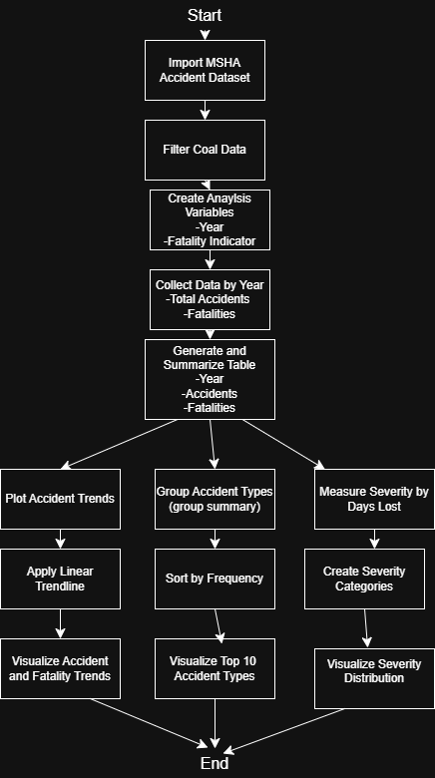
Figure 1 My Flowchart

Results and Figures
Figure 2: Fatalies and Accidents over with Trend fit line with Extrapolation
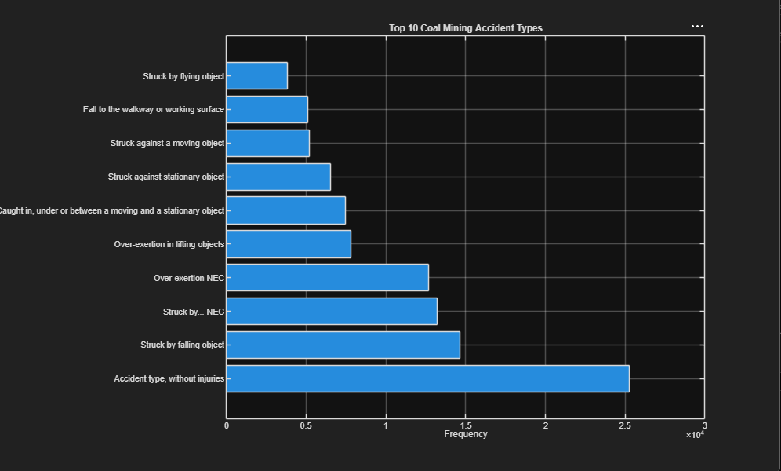Figure 2 Top 10 Coal Mining Accidents
Figure 2 Top 10 Coal Mining Accidents Pie Chart

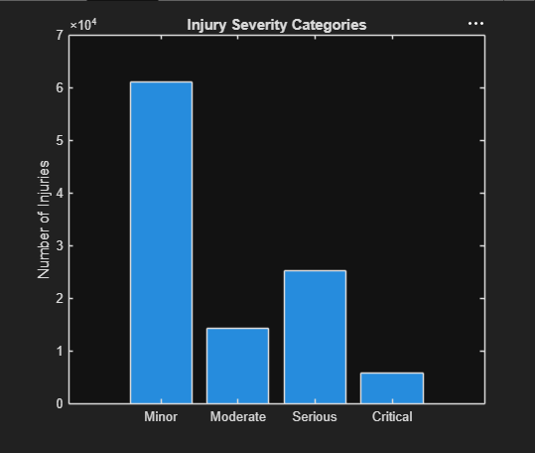
Figure 3: Accident Severity Categories
Discussions
For both accidents and fatalities, we can see a general downward trend, almost nearing zero in the later years, such as 2025 and 2026. Notable things I saw in both graphs were extreme peaks during 2007 and 2010 for fatalities, despite the downward trend and relatively low mortality rates amongst other years. Another big thing I had noticed that almost made me change my conclusion on this subject was accident rates nearing the end of the graph I had noticed in the last data points accidents in coal mines had neared zero and ready to make an obtuse conclusion based on the result however after noticing a steep decline between 2025 and 2026 I can safely say that the most likely possibility of such a low number could be the fact that this graph goes over the most recent coal mining data and this year is only half over which means my graphs trend could be skewed by the lack of information due to the nature of the records. Overall, the trends are pleasing as we see 75% decrease in accidents as well as a 77% decrease in fatalies showing a safer environment for coal to general knowledge.
From the bar graph, we can see that 25% coal mining accidents don’t even result in any real injury, potentially meaning that possible infrastructure has collapsed, or machinery may have been broken down. Despite this large disparity, the follow-up accident types and frequency are still nothing to scoff at, with obstruction due to falling about having a 14% likelihood in the dataset, and more notably being Struck by NEC with a likelihood of 13%. NEC stands for Not Elsewhere Classified and is used to label any sort of machinery that does not fall under any category of labeling in the dataset. This means that any sort of machinery, no matter the magnitude or severity of handling, falls under this category, showing a possible high likelihood of danger due to the nature of the equipment. After looking at the top three leading values it’s important to note the other leading values , with the lowest value not going below 4000 however due to the mixed nature of chart and the which values lead as well as various levels of severity being ranked and more or less mismatched in regards to levels and frequency, I had used one more graph in order to make some more finals conclusions with my data.
As I looked over the types of accidents, my final search was on what types of accidents had occurred over the 25-year period. I had chosen to compile all of my results in a histogram, measuring its severity by days lost, with these criteria.
Minor: less than seven days
Moderate: between 7 and 30 days
Serious: between 30 and 100 days
Critical: over 100 days
After compiling, I found that an astounding number of accidents were minor, with the vast majority of accidents only needing less than 7 days of recovery time, as shown in the bar graph prior. However, just like the bar graph, there are still things in the histogram to take note of , such as a considerable number of injuries being serious, about 30,000 of the total injuries required 1-3 months, which could potentially connect with the high amount of unclassified strikes and injuries. Not only that, but the Moderate and Critical Values are nothing to scoff at, with 10,000 injuries requiring between a week and a month and 5,000 injuries requiring over 3 months. These values cannot be looked over despite the huge and, quite frankly, expected minor injury count.
Conclusions
After looking at my data, I decided to compare the total number of both fatalities and accidents to compare with nuclear and solar energy to see where it ranks among the two and see if my analysis could add context and maybe lessen the disparity between safety regulations on coal compared to nuclear and solar. Here are the amounts for each energy source
After summing all the values, I found that over the past 25 years, coal mines have had about 127,559 accidents with only 558 of them resulting in fatality, and the rest being non-fatal. This number dwarfs incidents found in the NRC Event Notification that logs nuclear energy incidents, as well as by OSHA event tables that only go to 79 total accidents, albeit solar is relatively new and doesn't have a direct log of accidents, such as Nuclear and Coal data. All datasets, however, push me towards one striking conclusion. Coal Mining is still a relatively unsafe practice compared to other energy sources and risks the lives of workers everywhere, whilst still being an inefficient and harmful means of energy production.
Although most accident were written off as minor and there is a clear yearly downward trend , there was still a considerable number of events that had workers take leaves for several months, as well as contain events with infrastructure and machinery not even found in cleaner energy production practices. All in all, after reviewing this dataset, it is my firm belief that we as a society should do away with coal mining despite its long standing and impact on the economy. I desire this change not only for our planet but for the miners, machinists, and engineers who risk their lives trying to provide society with fossil fuel. And although humanity has a long way to go in regards to energy production, the simple fact that there’s a frontier looking to make that change makes me hopeful for a better tomorrow.

Citations
[1] Mine Safety and Health Administration (MSHA) Data Sets Catalog
[2] M. Kyung, S.-J. Lee, C. Dancu, and O. Hong, “Underreporting of workers’ injuries or illnesses and contributing factors: A systematic review,” BMC Public Health, vol. 23, no. 558, 2023, doi: 10.1186/s12889-023-15487-0.
[3] U.S. Nuclear Regulatory Commission Event Notification Reports
[4] Occupational Safety and Health Administration (OSHA) Accident Investigation Search

