The Technical Description on Solar Panels
City College of New York
Brandon Borcoman
Engl 21007
Joshua Smith

Table of Contents
Introduction.................................................................................3
Solar Cell Generation and Physical Components ...........................3
Solar Panel Physical Components.................................................4
Applications.................................................................................7
Conclusion...................................................................................7
Works Cited...................................................................................9

Introduction
In this technical report, we are going to go over the solar panel. A solar panel is commonly known as a device that can convert sunlight into electricity. It is shaped, as the name suggests, like a rectangular panel of various sizes and can be placed in various locations such as rooftops or solar farms for large-scale energy generation. It works by generating electricity via the photovoltaic effect and is composed of various parts made to optimize this effect as well as protect the solar panel. In this technical report, we will cover how electricity is generated by solar panels, the components used to create these panels, and lastly, the many ways solar panels have applications today.
Solar Cell Generation and Physical Components
To build a foundational understanding of solar panels, we must first ask ourselves: how do we turn light, more specifically sunlight, into electricity?
The way common solar panels do that is through the photovoltaic effect. Every single solar panel has an array of solar cells that produce electricity through this process and are the key components of solar power.

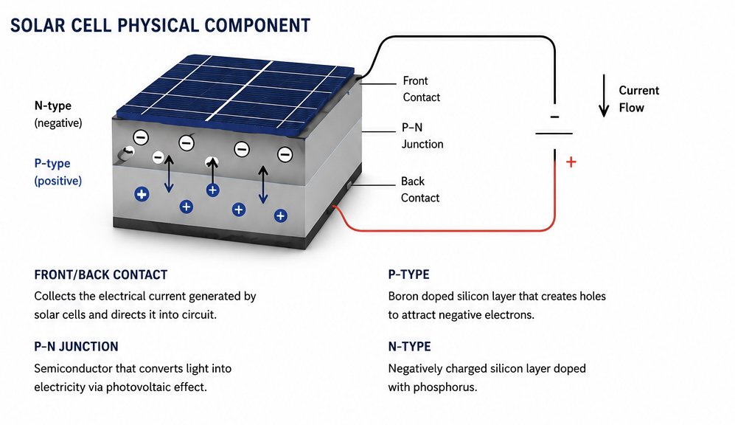
Figure 1: Solar Cell Physical Components

In every single solar panel, there exists a silicon wafer that does extremely interesting things when doped or infused with other elements. In fact, silicon has been used to power most of the modern world's appliances. From your computer to the interfaces that bring people into space, silicon is used almost everywhere. However, the question asked in this technical description is how that applies to solar power.
When sunlight hits a piece of silicon doped, or infused, with phosphorus, electrons in each of the atoms found in the material begin to agitate and fall out of place inside each cell. This happens across the upper half of the cell, also known as the n-type (negative) piece of the cell. Afterward, as the atoms begin to create openings in the cell, the lower half of the silicon, doped with boron and known as the p-type (positive) piece of the cell, collects this empty space, creating a voltage, or difference in charge, which generates power. This process of excitation and collection happens across the cells and is the essence of solar energy. It is used to create power for many different types of applications.
Solar Panel Physical Components
Solar panels are composed of various items, and each plays a critical role in making sure any solar panel purchased is up to code.
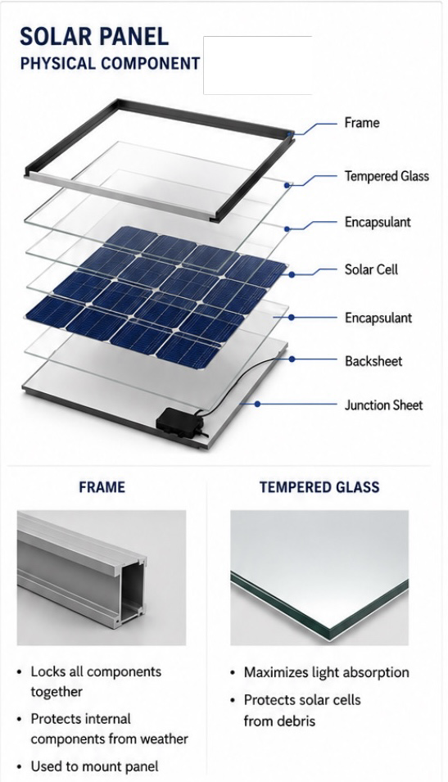
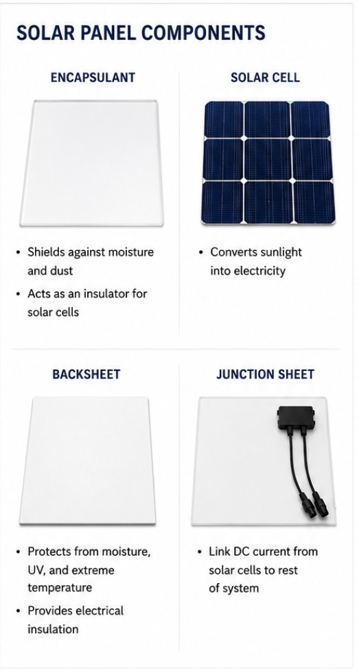
Figure 2 & 3: Solar Cell Physical Components

Frame
The frame of a solar panel is made with the primary function of protecting all other components of the solar panel while supporting the photovoltaic cells mentioned in the previous section. The frame is critical for protecting the device from harsh weather conditions such as wind, snow, rapidly changing temperatures, and mechanical stress, keeping the panel in relatively good condition for a projected time of 25–30 years.
These components are also used for mounting onto various surfaces, often being made with clamps, bolts, grounding hardware, and tracking systems for easy installation and maintenance. The most common kinds of solar panel frames are comprised of aluminum alloys, which are lightweight and useful across multiple different applications.
Glass
The glass of the solar panel, although seemingly minor, plays a very important role in all solar panels by serving as the barrier that protects the solar cells. Solar panel glass is optimized for various reasons, such as protecting the panel as mentioned above, maximizing sunlight transmission to the solar cells, and acting as an insulator between the cells and other components.
Most solar panel glass is made with low-iron tempered glass. These components protect against dust and wind and can transmit up to 94% of sunlight onto solar cells. Like the frame, the glass is made to last for 25–30 years and withstands many conditions.
Encapsulant
The encapsulant of a solar panel is a transparent polymer made to protect the cells from finer, more subtle forms of damage. These components sit at the front and back of the solar cells and perform the role of providing moisture protection, shock absorption, electrical insulation, as well as protection from vibration, mechanical shock, and thermal stress.
These components also serve as another sunlight transmission optimizer, transmitting up to 95% of sunlight, much like the glass mentioned earlier.
Solar Cell
The solar cell is the main and most important component in the solar panel and is the part responsible for generating electricity using the photovoltaic effect mentioned above. Each panel contains about 60–144 cells and produces approximately 0.5–0.7 volts for each cell. This component is the backbone of all solar power.
Backsheet
The backsheet is another protective sheet and is placed on the outer layer between the encapsulant and junction box. This component serves to protect internal components as well as add an extra layer of insulation between the cell and the environment.
Most commonly made with polyvinyl fluoride (PVF), the backsheet is designed to protect against specific hazards such as moisture, dust, chemicals, and UV radiation. Like the other components, it is designed for a lifespan of 25–30 years.
Junction Box
Finally, there is the junction box. It is the second most important component of the solar panel next to the solar cell, as it transfers the electrical current generated by the solar cell into usable electrical output. Located at the rear of the solar panel, the junction box provides electrical output connections, protection for internal wiring, and housing for bypass diodes.
Without a junction box, the capability for safe power transfer would be impossible. The junction box also serves a secondary purpose by providing protection from water, dust, and corrosion, much like the frame and many of the other components mentioned previously. Additionally, it protects electronic components inside the solar panel, allowing heat to dissipate and current to flow safely.
Applications
Solar panels were first used to power satellites and have since come a long way. Solar panels have a myriad of practical applications, including powering vehicles, reducing carbon emissions, providing backup power for the electrical grid, and helping power communities that do not have access to traditional power routes.
A single panel can produce roughly 600–700 kWh per year, which is beneficial for someone looking to reduce energy costs and keep themselves and their family safe in case of an emergency. Solar panels are not just great for consumers, however. They are also being used to take us to the stars, continuing to power satellites and space shuttles while supporting future missions to Mars.
These impactful contributions signal that the purchase of a solar panel is also a purchase toward the future of humanity. When you look at a solar panel, you should not just think of it as an investment in your energy needs, but also as an investment that could potentially help change the planet.
Conclusion
As I finished this technical report, I was simply amazed by the abilities of solar panels. These devices are convenient, easy to install, and fairly simple pieces of hardware that can be used for many different types of applications. They are capable of generating considerable amounts of electricity and are extremely well protected for a very long service life, being made with top-of-the-line components as mentioned above.
I believe that, as a consumer, solar panels are an extremely valuable asset to have and can provide protection during times of mild or extreme distress. I also believe that, as a common citizen, an investment in solar energy and solar panels provides more opportunities to share, create, and optimize daily living. Solar panels are an incredible purchase for anybody looking for an alternative way to generate power for their business, institution, or appliances used in everyday life.

Works Cited
"How Do Photovoltaics Work?" U.S. Department of Energy, Office of Energy Efficiency and Renewable Energy, www.energy.gov/eere/solar/how-do-photovoltaics-work. Accessed 7 June 2026.
"Photovoltaic Cells." Encyclopaedia Britannica, Encyclopaedia Britannica, Inc., www.britannica.com/technology/solar-cell. Accessed 7 June 2026.
International Electrotechnical Commission. IEC 61215: Terrestrial Photovoltaic (PV) Modules – Design Qualification and Type Approval. IEC, 2021.
International Electrotechnical Commission. IEC 61730: Photovoltaic (PV) Module Safety Qualification. IEC, 2023.
Messenger, Roger A., and Jerry Ventre. Photovoltaic Systems Engineering. 4th ed., CRC Press, 2018.
Green, Martin A. Solar Cells: Operating Principles, Technology, and System Applications. Prentice Hall, 1982.
Luque, Antonio, and Steven Hegedus, editors. Handbook of Photovoltaic Science and Engineering. 3rd ed., Wiley, 2019.
Fraunhofer Institute for Solar Energy Systems. "Photovoltaics Report." Fraunhofer ISE, www.ise.fraunhofer.de. Accessed 7 June 2026.
National Renewable Energy Laboratory. "Photovoltaic Research." NREL, www.nrel.gov/solar. Accessed 7 June 2026.
Dunlop, James P. Photovoltaic Systems. American Technical Publishers, 2012.

