Technical Description - Samsung S21 5G - Model SM-G991U
Noel Vazquez-Molina
Department of English, The City College of New York
ENGL 21007: Writing for Engineering
The City College of New York
Professor Duffy
April 14th, 2026

Table of Contents
Page
- Abstract …………………………………………………………….3
- History and Development …………………………………………..4
- Description Of Innovation …………………………………………4-6
- Specifications……………………………………………………….5-6
- Mechanical Description……………………………………………..6-7
- Conclusions……………………………………………………………7
- References………………………………………………………………8

Technical Description: Samsung S21 5G
Abstract
This essay will deep dive into the specifications and creation of the Samsung S21 5G released in January 2021. Samsung is a brand that focuses on electronics that favor their consumers. Samsung was founded in 1938 by Lee Byung-Chull in Korea, first starting as a small grocery trading store, which later entered electronics in 1969 and quickly became the dominant leader in semiconductors, mobile phones ( The Galaxy Series) and television manufacturing. Samsung's Galaxy series comprises a diverse lineup of Android devices, which ranges from premium, AI-focused flagships.
There are many Galaxy series such as Galaxy Z series( focuses on innovative form factors a foldable aspect), Galaxy A series ( designed for a wide audience still providing essential premium features and a high quality camera), Galaxy Tab/Watch/Book ( ecosystem products that have many different uses like the Galaxy Tab S11 Ultra, Watch 8 and Galaxy Book6 pro), and the most famous series the Galaxy S series which is highly known for the advance technology, pro grade cameras and its high performance, with its latest models of this era the S26, S26+, and S26 Ultra. The Model S21 5G offered premium features at a low price which helped in its market position, while setting a new standard with its advanced security Knox Vault.
History and Development
In 1938, Lee Byung-chull in Korea started as a small grocery trading store originally named Samsung Sanghoe, during this time the company mainly focused on trading, food processing, and textiles before expanding into insurance and retail. Starting in the 1969 to 1970s, Samsung electronic was established in 1969 releasing its first black and white television in 1970 marking its first home appliance production. In 1988, Samsung launched its first mobile phone and the company became a world leader in memory chip production and later expanding into LCD technology in the 1980s. Samsung later became the world's top TV manufacturer in 2006 and a leader in smartphone sales with its Galaxy line and till this day Samsung continues to innovate in 5G(Rate of internet), AI and foldable devices.
Description Of Innovation
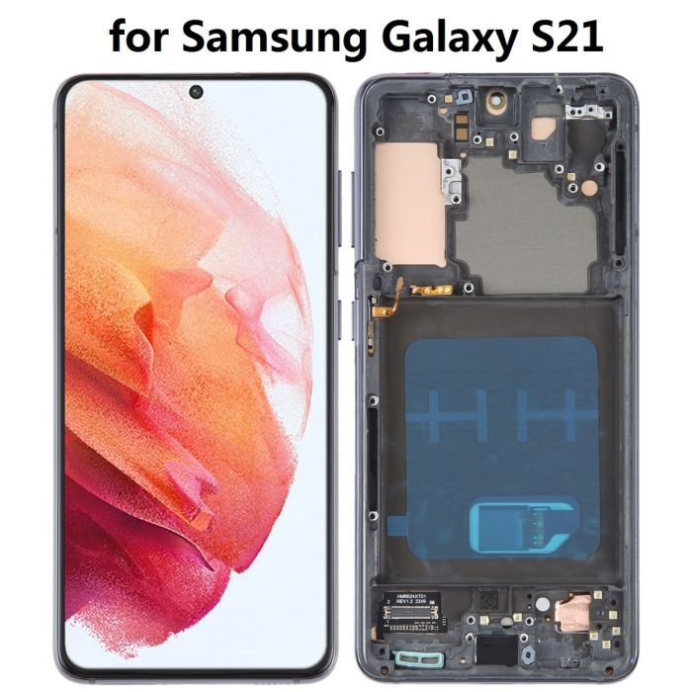
The Samsung S21 5G is a part of the Galaxy S Series within the Samsung brand which is known for its Design Shift, Performance and efficiency, Camera Upgrades, Display and Display tech, and its Security within the system. The display quality is a 6.2 Inch Dynamic AMOLED 2X Infinity-O display which features a smooth adaptive 120Hz(frames per second also known as hertz) refresh rate for more optimized scrolling and battery efficiency.
Figure 1. Shows the display on the Samsung S21 5G with the internal visual without the display cover.
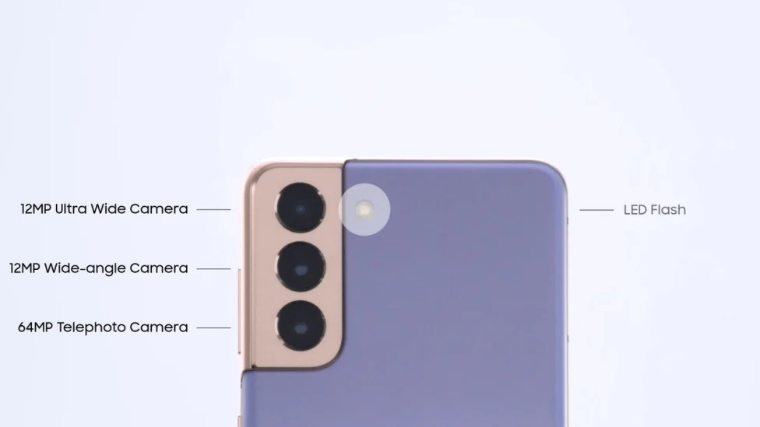
Performance and its speed is driven by the Snap Dragon 88 processor, which offers fast performance for apps, gaming, and multitasking. The S21 includes 8 GB of RAM( Memory storage of active data). The key features of the camera installed is a 180 rotating camera for flexible photo/video capturing. The connectivity and storage, supports 5G Wi-Fi, which allows for many applications to be installed on the mobile phone with Samsung providing the S21 up to 16GB RAM and 256GB storage.The advanced camera system within the Samsung S21 features a 12MP main, 12MP ultra-wide, and a 64MP telephone lens, which allows for high quality photography, 8k video recording and a specialized director's views for capturing videos from multiple angles simultaneously.
Figure 2. Labeling each part of the camera system on the S21 5G and its specification.

Specifications
The table below will highlight the important specifications of the Samsung S21 5G. The table includes information published by Samsung. This information is also being compared to the other models of the same series, like the S21 Ultra, S21+ 5G, S21 5G, and the S21 FE 5G. On this table I will show information about the S21+ 5G and the S21 5G.
Phone Model | Galaxy S21 5G | Galaxy S21+ 5G
Display | 6.2” | 6.7”
Rear Camera | 12MP | 10MP
Battery | 4,000mAh | 4,800mAh
RAM | 8GB | 8GB
Processor | CPU Speed-2.9Hz,  CPU Type - Octa-Core | CPU Speed - 2.9Hz  CPU Core - Octa-Core
Resolution | 2400 x 1080 (FHD+) | 2400 x 1080 (FHD+)
Main Display | Dynamic AMOLED 2X | Dynamic AMOLED 2X
Memory | 8GB | 8GB
Storage | 256GB | 256GB
Form Factor | TouchScreen Bar | TouchScreen Bar
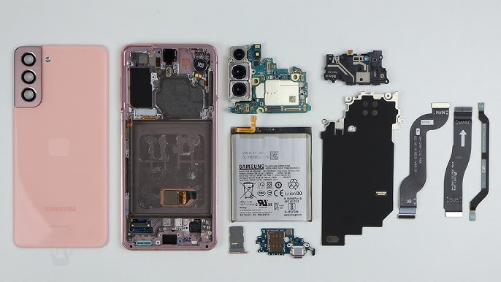
Mechanical Description
Figure 3. Is demonstrating the parts of the internal structure of the S21 5G. Displaying the shell of the S21, internal components like the battery, camera system, motherboard, connectors, memory chip, 5G antenna.

The functions of these parts all correlate to the operation and uses of the phone. The first item shown from Left to the right of the figure is the exterior plastic shell/casing of the phone which holds and protects the interior parts. The second item shows the backboard of the phone holding everything down with adhesive glue. The camera system which is the green plate with 3 circle lens, is a dual layered motherboard which is 2 motherboards sawed together and its camera modules. The silver rectangular item is the battery which powers the phone. The items at the bottom of both the camera system and battery are a flex cable and the charging port of the phone. The rest of the items are protectors of the phone and flex cables that hold each component inside the phone. These components operate through a tightly integrated system of hardware shown, which allows the users to work together with the hardware components. When the user interacts with the device such as tapping the touchscreen or speaking into the microphone, sensors convert these actions into electrical signals and send them to the motherboard. The central processing unit(CPU) interprets the signals and coordinates with random access memory(RAM) and internal storage to execute instructions and retrieve data. At the same time the graphics processing unit(GPU) renders images and animations which are displayed by the phone's AMOLED screen. In addition to the processing taksa, the phone relies on several supporting systems to function efficiently. The battery supplies power to all internal components, while a power management integrated circuit regulates energy distribution to prevent overheating and optimize performance on daily usage. For communication the modern antenna system enables the phone to connect to cellular network, Wi-Fi, and Bluetooth, allowing it to send and receive data. Other components such as the cameras, speakers, and vibration motor, provide additional functionality by capturing images, producing sound and delivering tactile feedback. Together these interconnected systems create a seamless and smooth experience for the user.
Conclusion
In conclusion the Samsung S21 5G, was a crucial creation to Samsung, due to its Strategic pricing and value which made its flagship line more competitive against rivals and become more attractive to consumers and increase overall adoption. The improved camera system allowed the Samsung S21 to have a reputation of best smartphone cameras.The refreshed design and build of the S21 makes it feel more modern and stand out. The performance and 5G leadership allowed for top tier speeds, ensuring that it continues at those speeds for years boosting brand reputation.

References
Device. (2021). Samsung Galaxy S21 5G Repair Help: Learn How to Fix It Yourself. IFixit; ifixit. https://www.ifixit.com/Device/Samsung_Galaxy_S21
Galaxy S21 5G. (2021). Rmx - Galaxy s21 5g | Samsung US. Samsung Electronics America. https://www.samsung.com/us/rmx/galaxy-s21-5g/#
https://www.ifixit.com/User/96985/Michael+Degnan. (2021, February 4). Samsung Galaxy S21 Teardown. IFixit; ifixit. https://www.ifixit.com/Teardown/Samsung+Galaxy+S21+Teardown/140337
Hugh Jeffreys. (2021, January 22). Samsung Galaxy S21 Teardown and Repair Assessment - Interesting Findings! YouTube. https://www.youtube.com/watch?v=jc1MVKh67VQ
NewsRoom, S. (2021). From AMOLED to Space Zoom: Looking Back at the Galaxy S Series’ History of Innovation. Samsung.com. https://news.samsung.com/global/from-amoled-to-space-zoom-looking-back-at-the-galaxy-s-series-history-of-innovation
US, S. (2026). Samsung Galaxy S21 5G and S21 Plus 5G. Samsung Electronics America. https://www.samsung.com/us/app/smartphones/galaxy-s21-5g/

