Assignment: The limits of visual analysis
When is close looking on its own not enough?
20 Points
*Read through all of the directions on this page before beginning!*
- Choose one of the three objects on the following pages.
- Using a timer, spend at least 5 minutes looking closely and describing what you see. I recommend spending at least 1-2 minutes looking first before writing. Some questions you should answer:
  - What do you see?
  - What is going on in this piece?
  - What has the artist done to show you this?
  - Do you have any questions about the work?
- After the timer has gone off or after you are finished writing, take at least a 60 second break.
  - Use this time to unhighlight the blacked-out lines under your object to reveal some basic information about it. Review this information.
- Set another 5-minute timer and describe your object again in a new paragraph. Some questions you should answer:
  - What else do you notice?
  - How has the information about the object changed your perception of it?
  - What questions remain from the first round of close looking? What new questions have arisen for you as you look this time around?
- After the timer has gone off or you are finished answering the above questions, write down two questions about the object that you still have after both rounds of close looking that you would like to learn more about.
- Where might you go to begin answering these questions? Using MLA or Chicago-style citations, suggest three specific scholarly resources (just posting a link won’t get points):
  - A published book (tip: look for one you could check out in CCNY’s library)
  - A person on campus (besides me!)
  - An online resource
- Use the workspace on page 5 to record all of your work and upload it to Brightspace by the next class. Feel free to continue to a second page if you need more writing space!

The following works are all on view at the MET! I encourage you to spend time with them in person for your close looking, but if you cannot get there, the images below are fine, too. If you choose to do this assignment in front of your object at the MET, make sure you DO NOT LOOK at any label information before step 3.

Object 1 On view in Gallery 455
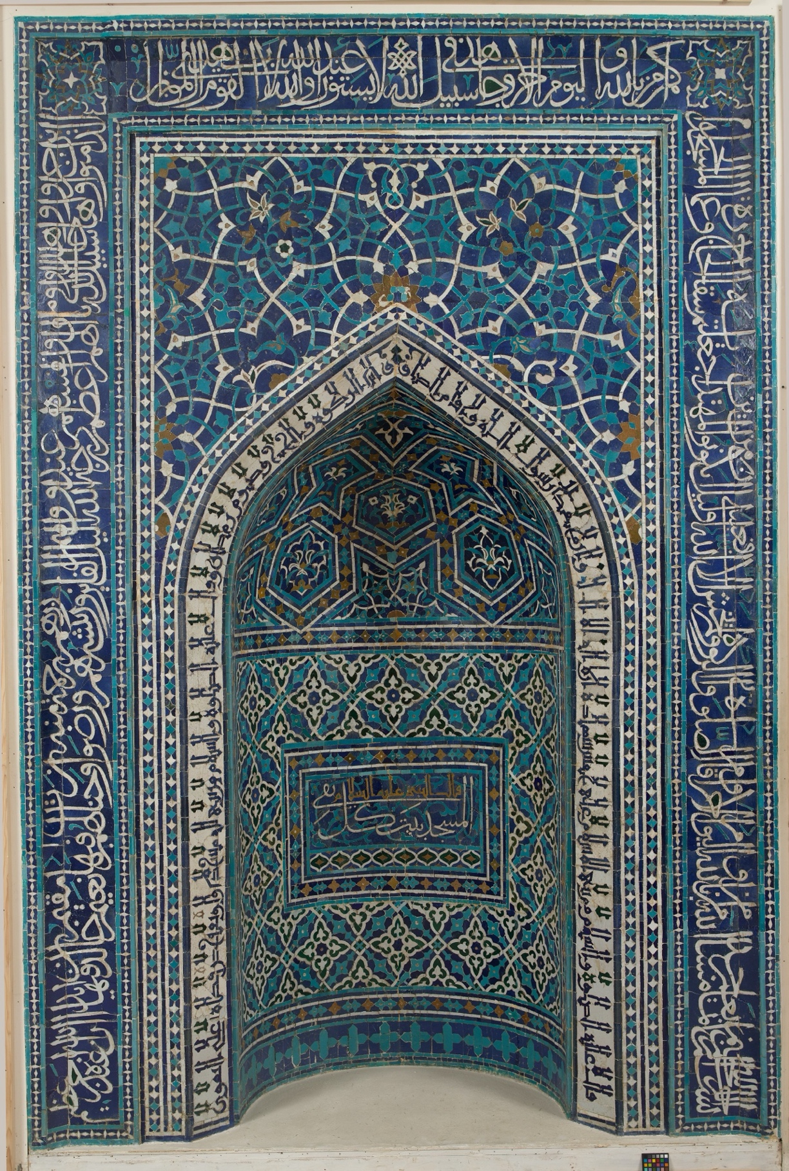
Title: Mihrab (Prayer Niche)
Date: dated 755 AH/1354–55 CE
Geography: From Iran, Isfahan
Medium: Mosaic of polychrome-glazed cut tiles on stonepaste body; set into mortar
Object 2 On view in Gallery 746
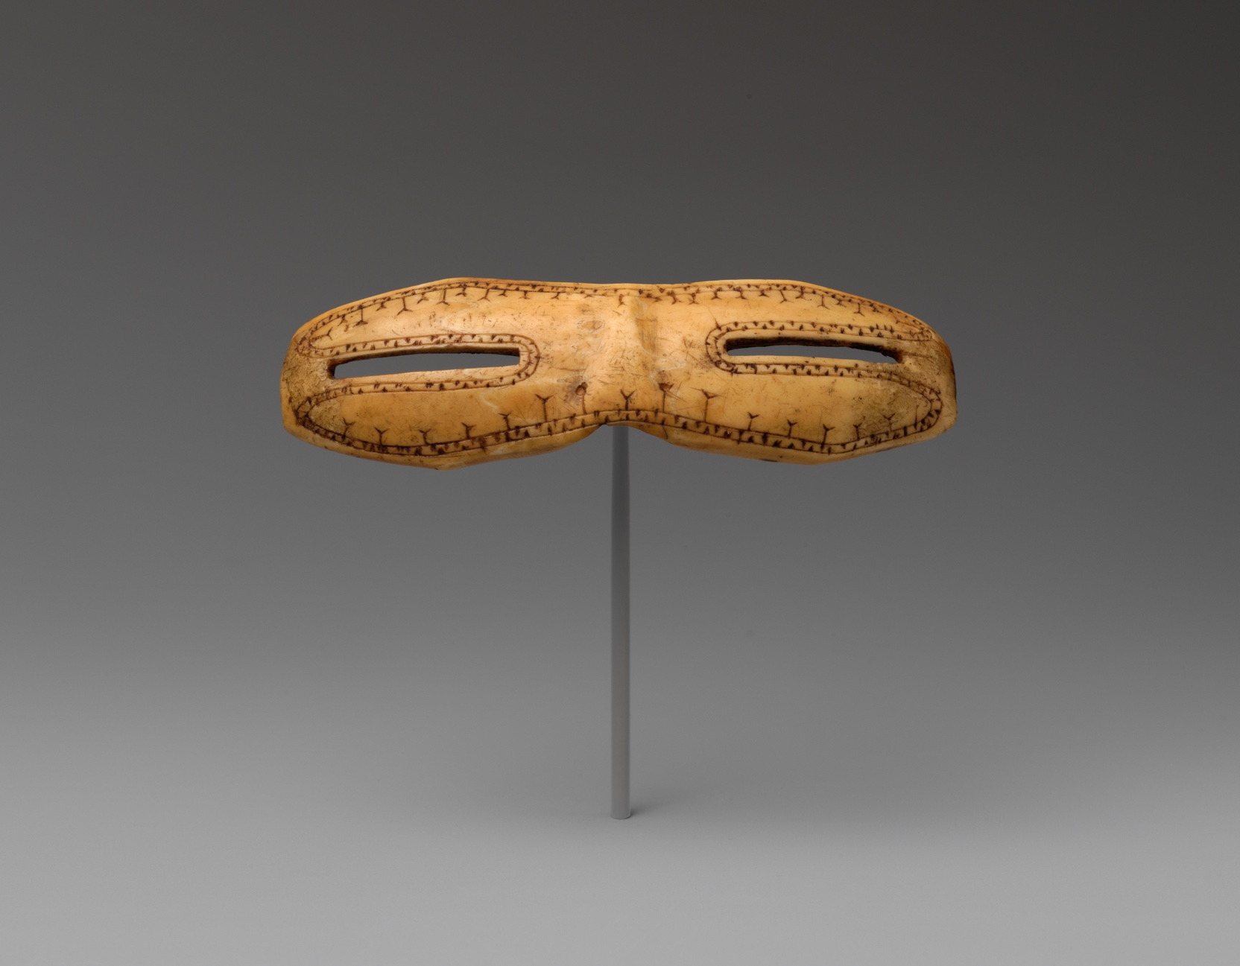
Title: Snow goggles
Date: ca. 800–1200
Geography: Made in Alaska, United States
Culture: Thule, Native American
Medium: Walrus ivory

Object 3 On view in Gallery 153
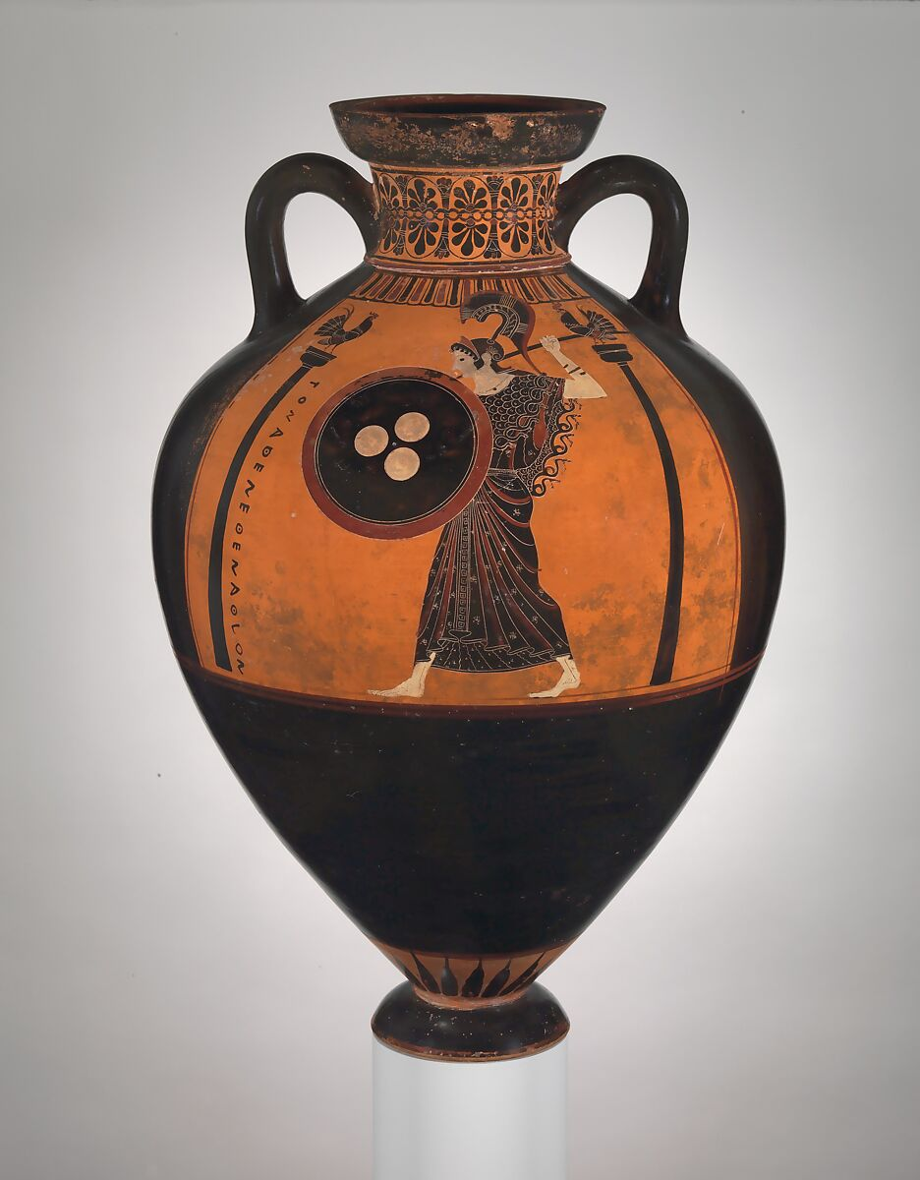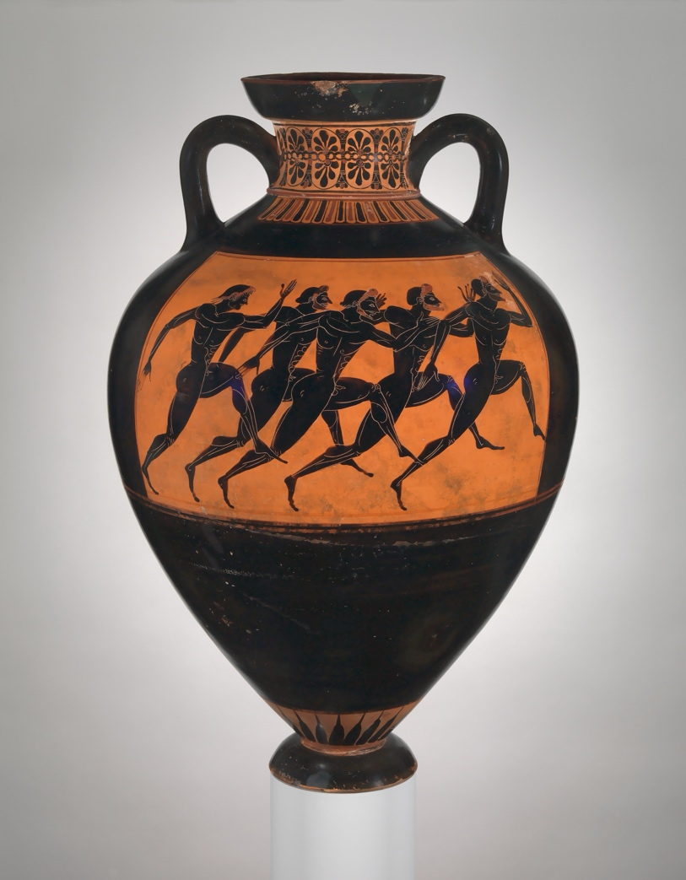
Side One Side Two
Title: Terracotta Panathenaic prize amphora
Artist: Attributed to Euphiletos Painter
Date: ca. 530 BCE
Medium: Terracotta; black-figure

Workspace for Assignment: The Limits of Visual Analysis
Your Name (first and last):
Object #:
Close looking round one: describing what you see (100 words)

Close looking round two: what else do you notice after revealing the label info? (100 words)

Two questions you have about this work that remain unanswered:

Where might I go to learn more? Share what you find
1. A published book (tip: look for one you could check out in CCNY’s library)
2. A person on campus besides me! (tip: find a relevant department and browse the faculty page)
3. A reputable online resource (tip: museum websites are good place to start)

