Neo-Gothic Campus Scavenger Hunt!
*15 Points* DUE BY 9/30 on Brightspace!
Your Name (first and last): Professor Matthews
You can sketch by hand or take photos with your phone and insert in the boxes. When completed, upload to Brightspace either as a Word Doc or as clear photo attachments of the pages.
Buttress  Location (building): Shephard Hall  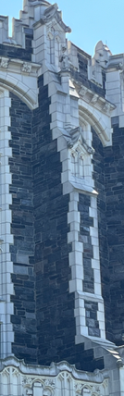 | Lancet window  Location (building): Shepard Hall  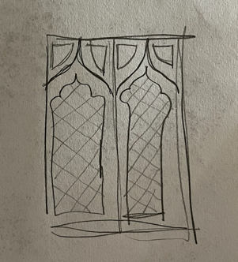
Tympanum  Location (building): Townsend Harris  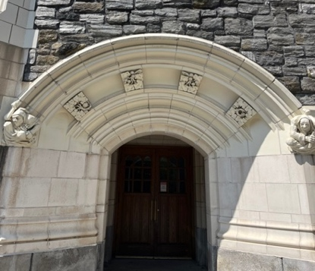 | Quatrefoil  Location (structure or building):
Rib vaulting  (hint: go inside Shepard Hall and look around!)  Location: | Fleur-des-lis  Location (type of structure): Gate  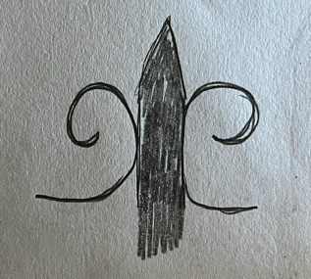
Grotesques (find 3 from 3 different locations)  Locations (buildings): Compton Goethals, Shephard Hall, Wingate  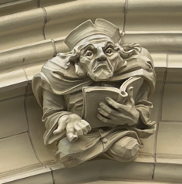  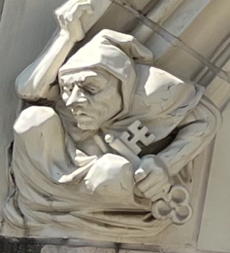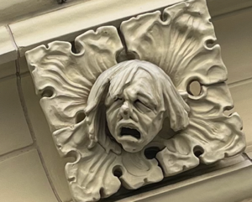 | Coat of arms  Location (building):
Pointed arch  Location (structure and street name): | Pinnacle  Location (building):
Clock on building façade  Location (building): | Gargoyle  Location (building):

Questions:
1) If you found human grotesques, can you identify their professions based on their attributes, clothing, or the buildings they are attached to? If you found any animal grotesques, can you identify which animals they are and what they might symbolize for a college campus or building? If you can’t identify these things, describe how they look. (Write at least 1 full sentencer per grotesque.)
The first grotesque from Compton Goethals Hall is holding an open book while wearing a scholar’s robes and hat, so he is likely a professor or scholar of the humanities.

2) What kinds of ideas or values about higher education does CCNY’s neo-Gothic architecture reflect? (50—75 words)

3) How does CCNY’s campus architecture, both its neo-Gothic and modern elements, inform your experience as a student? Some questions you can consider responding to are: Does it inspire you to study? Does it make you excited to spend time on campus? Does it make you feel negatively about learning? (50—75 words)

