ENG 21007 – Writing for Engineers
Fall 2025

Technical Description: Apple EarPods Lightning Connector
By Cielo Raymundo

  - Background:
Headphones started with phone operators, they were a single earpiece that weighed over 10 pounds and rested on a person’s shoulder. Later came the Electrophone, invented in 1890 Britain, which allowed people to dial in and connect to live performances across London theaters.
It wasn’t until 1910 when Nathaniel Baldwin created the first pair of headphones that resemble headphones we know today. Years later, in 1958 the Koss-SP-3 were created by John Koss. He created them purely for music, this innovation revolutionized how we listened to music.
The Walkman came in 1979, when Sony created the first portable headphones.
Finally, in 2001 the iPod was invented by Apple. This iPod came along with the first pair of Apple wired headphones. Apples headphones were different than those of their competitors, to set themselves apart they decided to make their headphones white. Not only did they decide to stay away from dull colors, but they also stepped away from on ear headphones by including earbuds. Unlike traditional headphones these could fit in a person’s pockets and didn’t mess up their hair.
To make sure that these headphones were associated with Apple, Apple launched a campaign where they showcased the white earbuds across black silhouettes of people enjoying music through the iPod.
After the first pair of Apple headphones, there have been multiple versions of them.
From launching their first premium headphone version, the Apple “iPod In-Ear Headphones” that offered different sized ear tips and had improved sound quality and bass response. Apple has been working on improving their headphone specs.
In 2008, a new version of the premium headphones came out. These headphones featured an in-line remote, microphone, silicone ear tips and were sold for $80.
It wasn’t until 2012 when Apple launched the “EarPods”, these were the first pair of headphones in where they put engineering effort into making their headphones sound and feel good. After three years of design, testing and research they came up with the oval and small grill design we know today.
Since then, Apple has released various versions of their headphones. These headphones have varied in design, tech specs, prices, and target consumers. Some have been sold with Apple devices while some have been sold separately.
Currently the most common Apple headphones are the AirPods, and again there are various versions of these out in the market today.

  - Apple EarPods Lightning Connector:
According to Apple the EarPods design is “defined by the geometry of the ear”, which makes them “more comfortable” than other competitor headphones.
The Apple EarPods with Lightning Connector headphones are shaped in a “P” form. This form was the result of three years of 3-dimensionaly scanning people’s ears. The goal was to come up with a “snug comfortable fit” for as many people as possible and to reach the “highest level of sound quality”.
The individual earbuds are labeled with a “L” and “R” to let people know which ear pod goes in their left and right ear.
The small speakers on the earbuds are also the result of the years of research that Apple conducted. The speaker grill was completely redesigned, resulting in a smaller oval opening on the side of the earbud. This speaker grill design directs sound “right into the ear canal, minimizing leakage and maximizing clarity”. Small openings were also included on each earbud in order to “tune midrange frequencies, provide a consistent listening experience, reduce air pressure, and deliver powerful bass”.
These ear pods are connected with a wire, there is a built in remote on the right wire of the headphones.
The wires are then connected to a lightning connection that when connected to a compatible device completes the set-up of the headphones and are ready for use.
The Principal Parts:
- These EarPods have 3 principal parts:
  - The ear buds - they are located at the “top part” of the headphones, these ear buds go in your ear
  - The remote - the remote controls volume, and audio functionality like skipping, playing, pausing, and back tracking.
  - The connector - it is located at the “bottom part” of the headphones, this is the part that connects the person to the audio on the device.
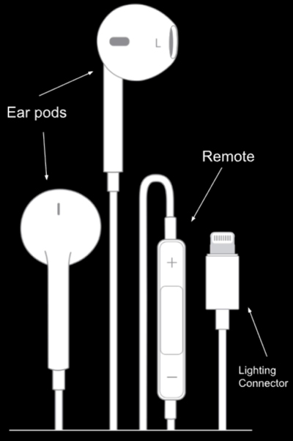
The Main Function:
The main function of these headphones is to provide wired connected audio output/input from a device to a person.

The devices that are usually connected to this type of headphone are apple mobile devices. To be more specific, the compatible devices for these headphones are iPads, iPods, and iPhones, that have a Lightning port and are running on iOS 10 or later.

These headphones have the ability to play, pause, skip, and adjust volume directly on the built-in remote without needing to open/unlock your device.

How they Work:
These EarPods are pretty easy to use. To use them:
- You first would need to make sure your headphones are untangled.
- Then plug in the lighting connector to your Apple device and insert the ear buds into your ears.
- Then, open your connected device and go to something you want to listen to, (maybe a digital streaming app like Spotify) click on your choice of audio.
- Press play on your device, or on the built-in remote that is located on the right side of the headphones, press play by hitting the middle space button.
- From there you can pause your audio by clicking the same button on the remote.
- You can also skip the current audio by double clicking the middle button
- Or triple click to go back to the previous track
- You can also adjust volume levels by either clicking the “+” or “-” buttons on the remote
  - Clicking the “+” will raise the volume while clicking the “-” will lower the volume
- When you are done using the headphones all you have to do is unplug them from your device and from your ears.
- Finally, store away!
  - What Sets them Apart from other Apple Wired Headphones:
The main difference between these Lightning Connector EarPods and the other EarPods are the connector.
As mentioned previously, these headphones have a Lightning connector, the other EarPods have a USB-C connector and a 3.5mm headphone jack.
While the 3.5mm headphone jack give you the most access to different devices, both Apple and non-Apple devices. The Lightning connector EarPods give you access to a variety of Apple devices without needed to purchase extra accessories in order to make them compatible.
The latest version of the EarPods is the USB-C connector, these headphones work with the latest versions of Apple devices and are limited to iPhone 15 and later models, modern iPads.
These are also not the only type of headphones that Apple has produced. As mentioned previously, Apple has also released “AirPods” which are wireless headphones that work through Bluetooth technology. These AirPods have also gone through a lot of design and tech improvements.

Apple has come a long way from their first version of their headphones. All versions of these headphones have their pros and cons. These Apple EarPods Lightning Connector headphones are headphones that are designed to keep you attached to your device. The ear pods have been designed to provide comfort and sound quality, the remote gives you audio control and the connector allows you to connect to a compatible device. All of these parts work together in order to provide focused sound to a person.

Sources:
Shop Accessories. (2025). EarPods (Lightning Connector). https://www.apple.com/shop/product/MWTY3AM/A/earpods-lightning-connector

Apple Support. (2025). Use Apple wired headphones. https://support.apple.com/en-us/108042

LSTN Sound Co. (2020) A Brief History of Headphones. https://lstnsound.com/blogs/main/a-brief-history-of-headphones

Neway. (2020). Apple Lightning VS 3.5mm Headphones: How Do They Differ https://www.neway.mobi/news/apple-lightning-vs-3.5mm-headphones.html

Apple Explained. (2020). History of Apple Headphones. https://www.youtube.com/watch?v=z4F_u8iSwkE

