Linking a Discussion to an existing grade book item
- Go to the Topic in Discussions, click on the drop-down arrow next to the topic and select Edit Topic
- Click on Ungraded
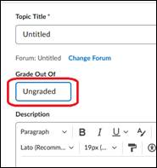
- Enter the max points, and if you’ve already created a column in Grades for the this, select Edit or Link to Existing under In Grade Book
If you didn’t already create a column, just choose Create and link to new grade item.
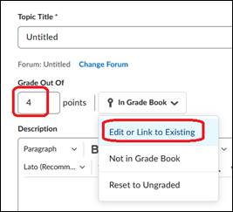
- Select Link to an existing grade item and choose the correct column
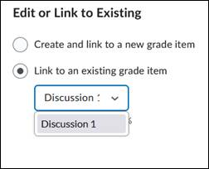
- Click OK and Save to save your changes.

