Brightspace on the go with the Pulse App
New York City College of Technology

Academic Technologies and Online Learning (AtoL)

Overview
Brightspace Pulse, the mobile app designed for students, serves as a valuable companion in your educational journey and contains various features:
- Access your announcements, notifications, calendars, modules, and grades.
- Review course material when you are offline even without data connection.
- Stay up to date with your coursework.

System Requirements:
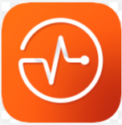
- Compatible with mobile devices.
- Android 6.0 (2015 release) or later for tablets or phones
- iOS 13.0 or later iPhone, and iPad

For more information on system requirements, please visit D2L Brightspace Community at: https://community.d2l.com/brightspace/kb/articles/1775-brightspace-pulse-platform-requirements#brightspace-platform-support

Installing Brightspace Pulse App
- Go to the App Store or click on a link below:
Android
IOS
- Click on the Download button to begin downloading.
- Click on the Open button to begin.

Log-in to Brightspace
- Click on Getting Started.
- Search for your school: New York City College of Technology
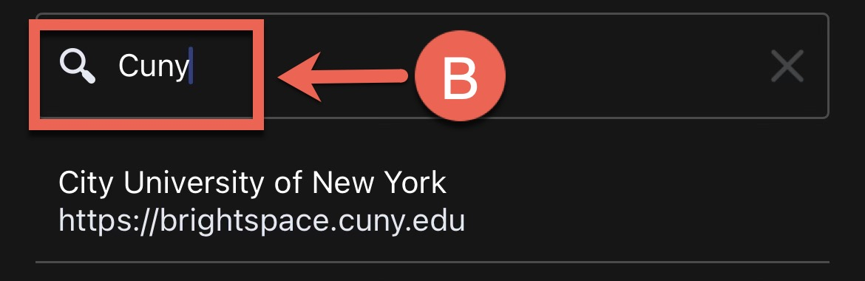
- Log-in using your CUNY credentials Firstname.Lastname##@login.cuny.edu and password.
- Click on Allow.
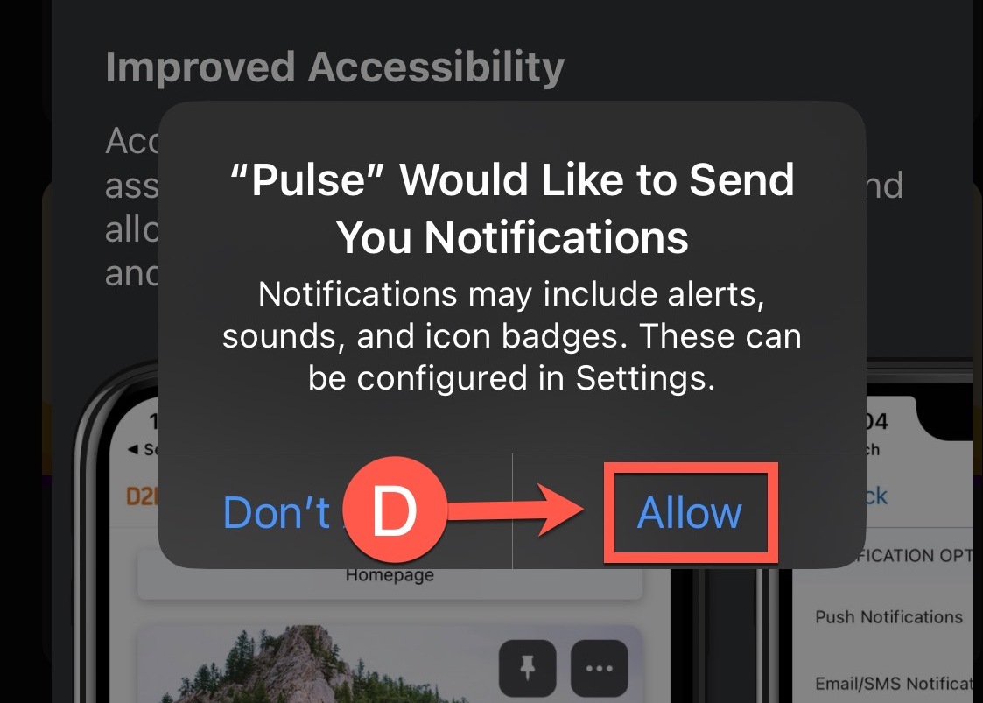

Navigating Brightspace Pulse App

Homepage
- Upcoming: Area where you can view reminders for upcoming assignment deadlines, notifications, and announcements from your courses.
- Courses: Area where you can view and access the courses you are enrolled in.
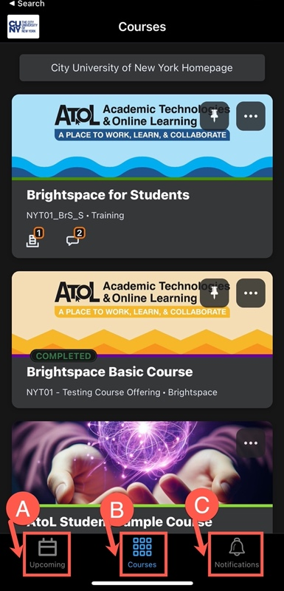
- Notifications: View notifications regarding your course activities such as announcements, reminders about upcoming deadlines, feedback on your submissions or any valuable information about your courses.

Navigating inside your Course
Now that we have looked at the interface on an institutional level, let us dive into how things work within the course setting.

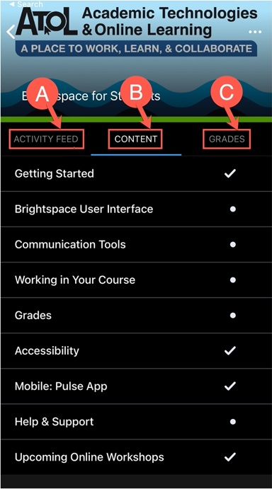
- Activity Feed: Provides a location for instructors to post messages and links to course materials, web links, and files on Google Drive, much like announcements. But it also gives you a place to respond to the instructor (if the instructor activates that option) and have cross conversation with other learners.
- Content: Access course content such as lecture notes, presentations, assignments, and other resources your instructor will post.
- Grades: View your grades for your assessments, assignments, tests, discussion postings, participation, etc.

