
Brightspace: Faculty Handout
New York City College of Technology
System Requirements: 1
How to Access Brightspace 1
Brightspace Course Homepage 2
Course Navigation Bar (NavBar) 4
How to Make a Course Active (Available) for Students 5
How to Create an Announcement 7
How to Create a Module inside your Course (Folder) 9
How to Reorder Modules and Submodules in Brightspace 9
How to Delete a Course Module (Folder) 10
How to Upload a File or Create Course Content 11
How to Upload Multiple Files in a Course 12
How to Create a Link (Web Link) in a Course 13
How to Create a Content Template 15
How to Create a Checklist 16
How to Create an Assignment 18
How to Link an Assignment into a Course Module 21
How to view a Student’s Assignment Submission 21
How to Create a Release Condition 23
How to Create a Discussion 25
How to View and Reply to a Discussion 26
How to Create Groups (Assignment / Discussions) 28
How to Create a Quiz (Exam) 30
How to Create a Question Pool 34
How to Create a Random Question Quiz (Exam) 36
How to Link Zoom to Brightspace 37
How to Create a Zoom Session in Brightspace 38
How to Send an Email to the Class 40
How to Use an Intelligent Agent 41
How to View the Class Progress 43
How to Use Quick Eval 44
View Quick Eval from the Course Home Page: 45
View Quick Eval from the College Homepage: 46
How to Use Brightspace Reports 47
How to Export Course Materials from Blackboard 48
How to Import Course Materials from Blackboard to Brightspace 50
How to Copy a Brightspace Course 52
How to View a Course as a Learner (Student) 54
How to Create a Demo Student 55
How to add a Banner (Header Image) 55
Additional Resources 56

System Requirements:
- Compatible on desktops, laptops, and mobile devices.
- Latest up to date web browsers: Google Chrome (recommended for optimal experience), Firefox, Edge, and Safari.

What is Brightspace?
Brightspace is a cloud-based learning management system (LMS) that runs blended and fully online courses. It comprises integrated platforms: learning environment, learning repository, and portfolio. It was developed by D2L and designed to provide the tools necessary for content creation, assignment submissions, communication, and assessment by combining a collaborative and interactive virtual learning environment.

How to Access Brightspace
Brightspace can be accessed in two different ways. First, you can log in by entering your CUNY (City University of New York) username and password at https://brightspace.cuny.edu. Please note that if you are affiliated with multiple colleges, you might be directed to the CUNY Brightspace homepage rather than the City Tech homepage.
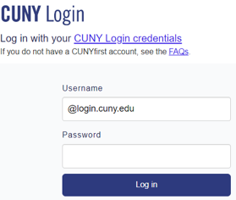

Alternatively, you can access Brightspace through the CityTech’s website megamenu. Simply go to Quicklinks and select Brightspace from the menu.
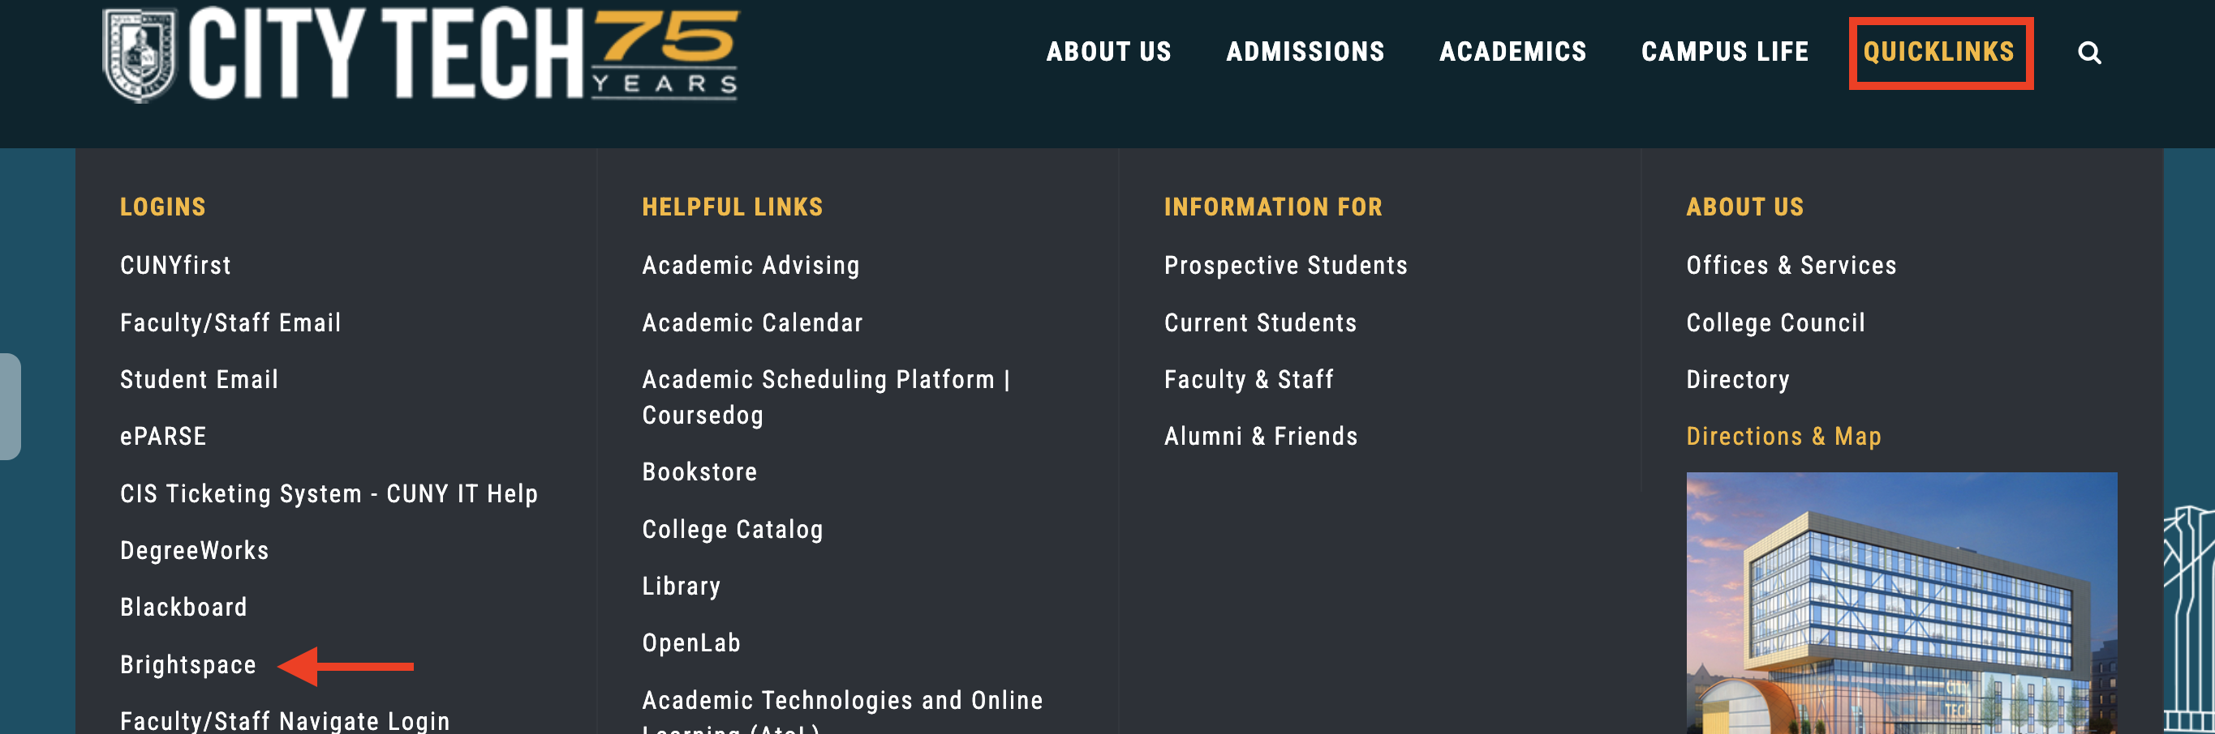

Brightspace Course Homepage
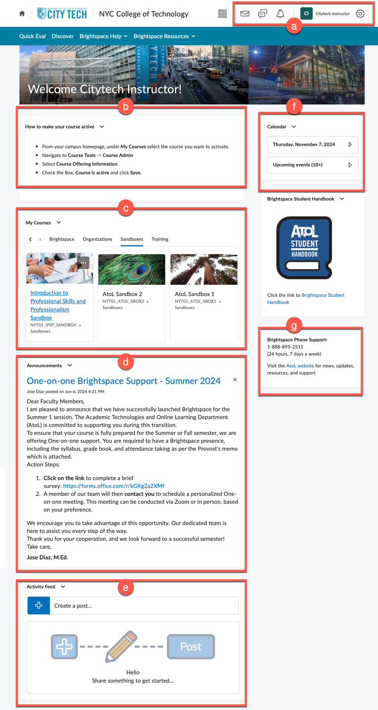
- Mini Bar: Handy tool located at the top of the screen, allows quick access to key features such as courses, emails, and notifications.
- Custom Widget: Widget used by the college to add important information on Brightspace.
- My Courses: Module where you will find a comprehensive list of the courses you are an instructor on.
- Announcements: Announcements from your college campus will be posted in this area.
- Activity Feed: Communication tool that allows you to post reminders or updates to students while providing two-way communication between you and the students.
- Calendar: Integrates with other tools in Brightspace to display deadlines based on due dates for assignments, quizzes, content and discussions.
- Brightspace Phone Support: This widget includes contact information for Brightspace assistance 24 hours / 7 days a week. Our department’s AtoL website has been included. Please visit to view our news, updates, resources and access our 1-to-1 virtual support.
Note: The college homepage cannot be customized.

Course Navigation Bar (NavBar)
You can access essential features such as Announcements, content, your user profile, calendar and important resources from the course homepage. Brightspace's intuitive design facilitates seamless navigation, allowing you to effortlessly create content.
Navigation Bar
This area known as the Navbar contains links to tools within your course. The navigation area will look different depending on where you are in Brightspace (e.g. City Tech College homepage versus in a course).
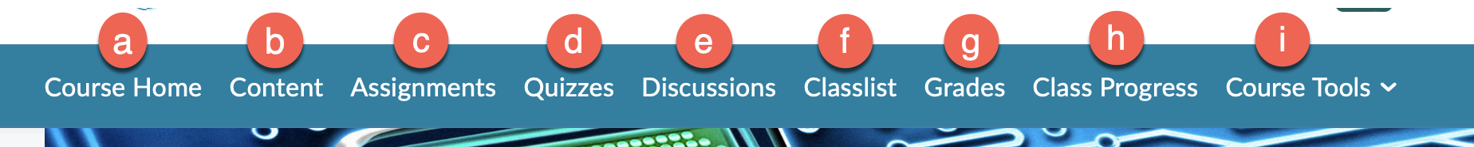
- Course Home: Go back to the Course Home page while being anywhere within your course.
- Content: Add modules (folders), files, and link existing activities.
- Assignments: Create assignments for your students to complete and include settings such as due dates, availability, submission attempts, grant special access and manage Turnitin.
- Quizzes: Dedicated section where you can create quizzes, assessments, and exams for your students.
- Discussions: Create and manage discussions online while promoting student engagement and collaboration.
- Classlist: View list of students enrolled in the course, track the last time your student access Brightspace and email your students from here.
- Grades: Set up and manage your grade book, enter your students’ grades, and provide feedback from this section.
- Class Progress: Track and monitor the progress of your students throughout the course.
- Course Tools: Contains various tools such as course admin, announcements, attendance, CUNY demo student, calendar, checklist and groups. Manage all course settings through Course Admin.

How to Make a Course Active (Available) for Students
- Select the course you want to activate.
- Navigate to Course Tools and click on Course Admin.
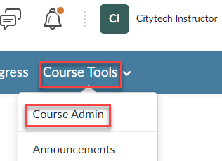
- Click on Course Offering Information.
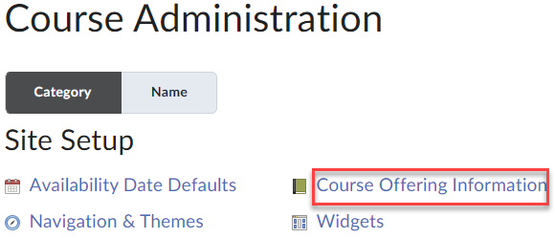
- Check the box next to Couse is active.
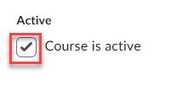

How to Upload a Syllabus in Brightspace
The syllabus can be added to either the Overview section of Brightspace or the Table of Contents. To place the syllabus in the Overview area, follow the instructions provided below. For adding it under the Table of Contents, refer to the How to Upload a File or Create Course Content section.
- From the course home page, click on Content.
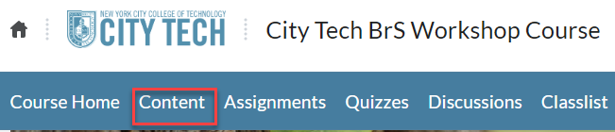
- Click on Overview located on the left.
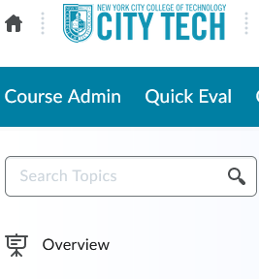
- Drag the file into the attachment area from your computer.
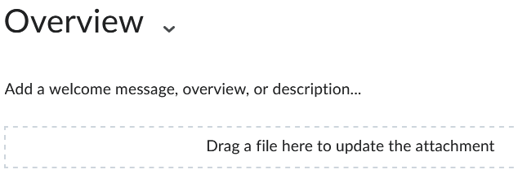

How to Create an Announcement
- From the course home page, click on Course Tools -> Announcements.
- Click on New Announcement.
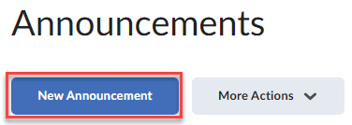
- Enter a title in the Headline box and provide your message in the Content area for the announcement.
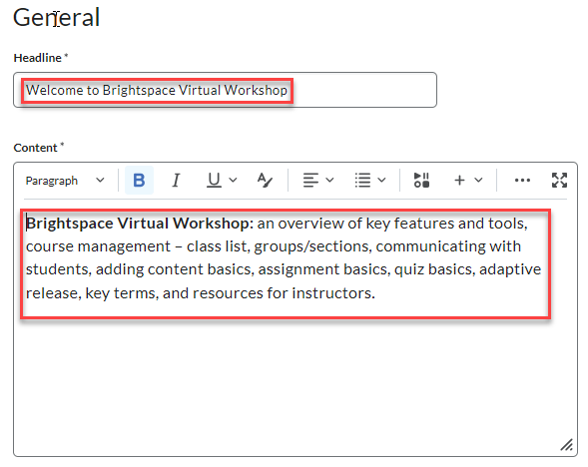
- Scroll down to the Availability section for optional settings.
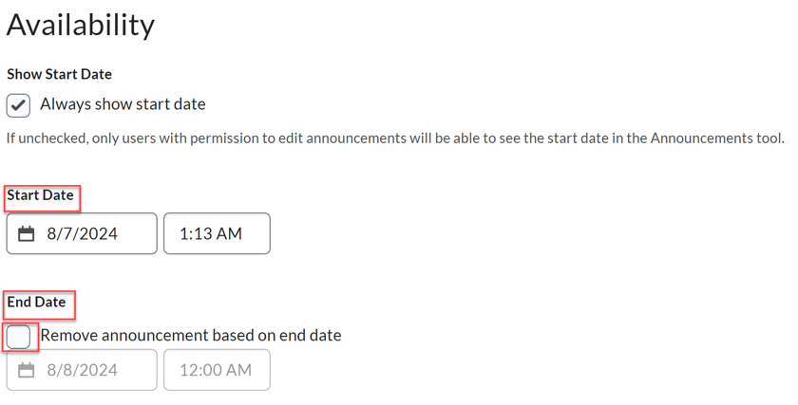
- Attach a file, set any Release Conditions if necessary and click Publish.
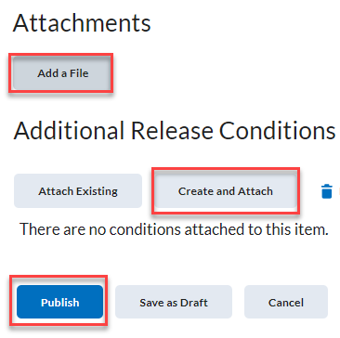
Refer to the How to Create a Release Condition section for additional information.
- Alternatively, you can create an announcement directly from the course homepage by clicking on the drop-down menu next to Announcements and selecting New Announcement.

How to Create a Module inside your Course (Folder)
- From the course home page, click on Content.
- Click Add a module under Table of Contents.
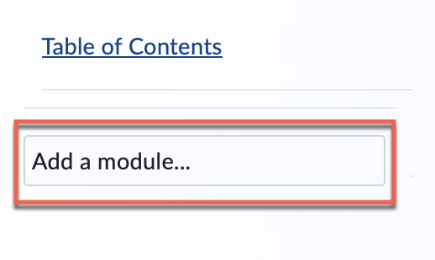
- Enter a name for the module (folder) and press the Enter key on your keyboard.
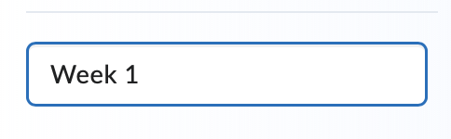
Note: You can add sub-modules inside a module.

How to Reorder Modules and Submodules in Brightspace
- From the course home page, click on Content.
- Locate the modules (folders) you want to reorder.
- Hover your mouse over the dots to the left of a module; the cursor will change to a four-pointed arrow.
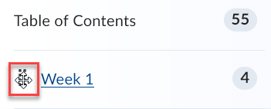
- Click and hold on the mouse button next to the dots.
- Drag and drop the module to the desired position; you will notice a line will appear while you are dragging it.
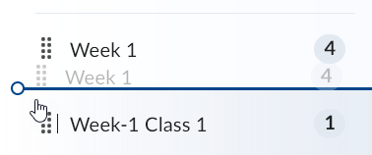

How to Delete a Course Module (Folder)
- From the course home page, click on Content.
- Select the module you want to delete from the left-hand side under Table of Contents.
- Click on the drop-down arrow on the right-hand side of the area and select Delete Module.
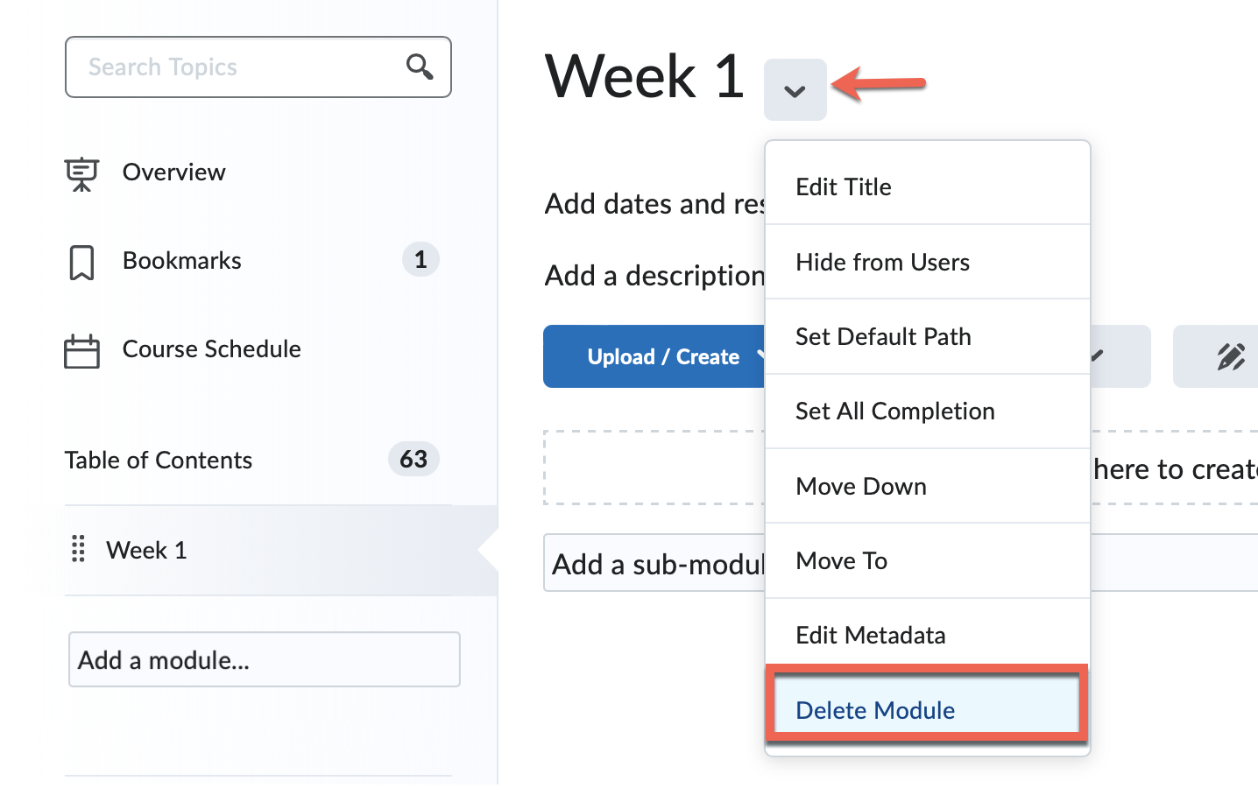
- A prompt will appear.
  - Select “Remove the module…” radio button to delete the module’s link from the Table of Contents and keep all files.
  - Select “Permanently delete and remove…” radio button to delete the module and ALL the content within the module.
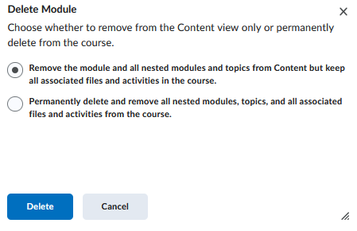

How to Upload a File or Create Course Content
- From the course home page, click on Content.
- Click on a course module from the left-hand side.
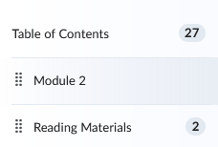
- Select Upload / Create and then choose Upload Files.
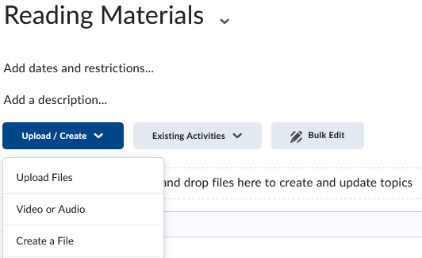
- Click on My Computer.
- Click on Upload or drag and drop a file.
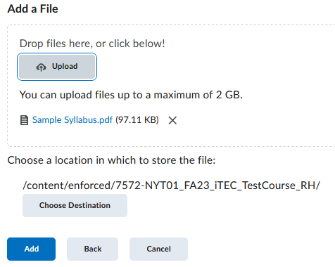
- Select Add.
Note: Create a File provides a formatting toolbar and other options, while Upload Files is used for quickly posting materials to the course.

How to Upload Multiple Files in a Course
- From the course home page, click on Content.
- Select a module where you want to add the files or create a new module.
For creating a new module, refer to the How to Create a Module inside your Course (Folder) section.
- Click Upload / Create and select Upload Files.
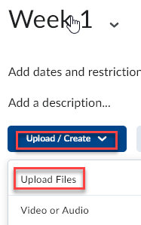
- There are two methods to upload your files:
  - Click on Upload and select My Computer to browse for the files.
  - Drag and drop multiple files into the Add a File area.
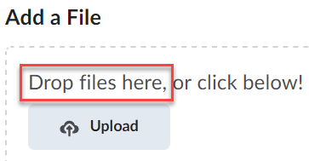
- Click on Add.
Note: You cannot upload an entire folder, but you can create a module or sub-module and add your files there.

How to Create a Link (Web Link) in a Course
- From the course home page, click on Content.
- Select a module where you want to add a web link.
- There are several ways to add or create a URL link within a course.
- Method 1:
  - Click Upload / Create then select Create a Link.
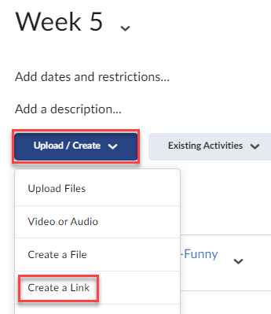
  - Enter the title that will appear as text for the link, the URL link and click on Create.
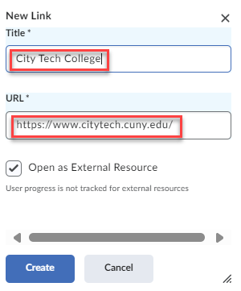
- Method 2:
  - Click on Create a File.
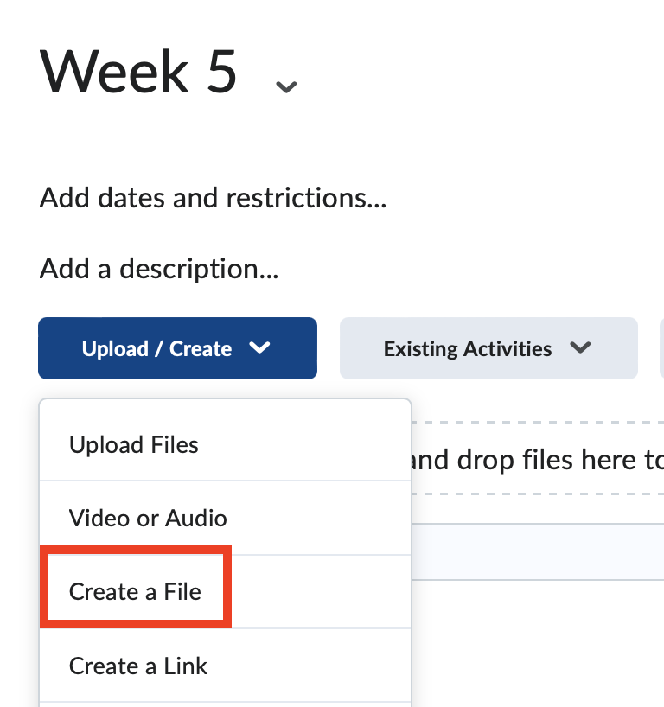
  - Enter the title.
  - Click on the Link icon from the content editor.
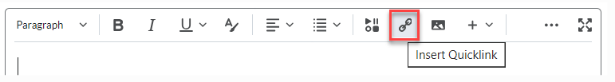
  - Click on Link.
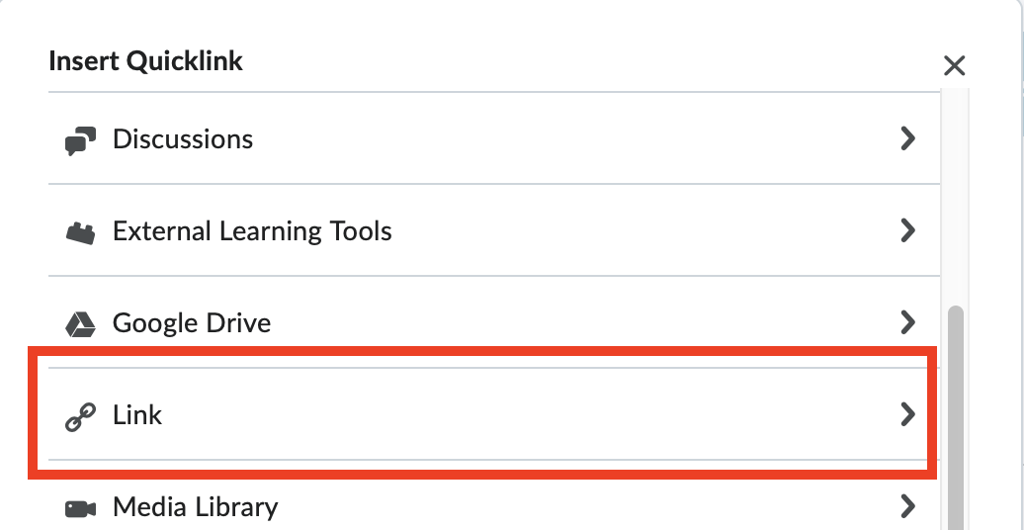
  - Enter the URL link, title that will appear as text for the link, and click on Insert.
  - Click on Save and Close.
Note: You can add a link from any content editor within Brightspace.

How to Create a Content Template
Content templates are used to create your lessons with a standardize design. The templates include placeholders for images, videos, text and various elements.
- From the course home page, click on Content.
- Select a module where you would like to create a template.
- Click Upload / Create -> Create a File.
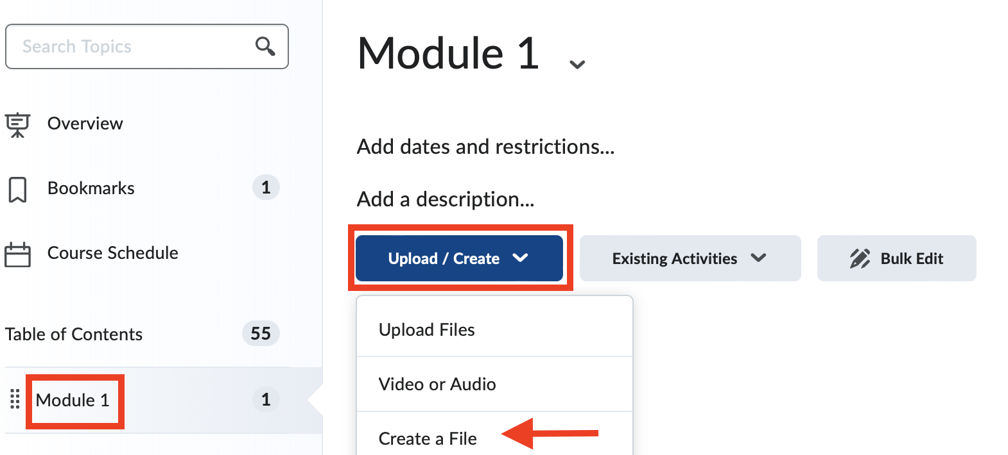
- Enter a title.
- Click Select a Document Template drop-down arrow and choose a template.
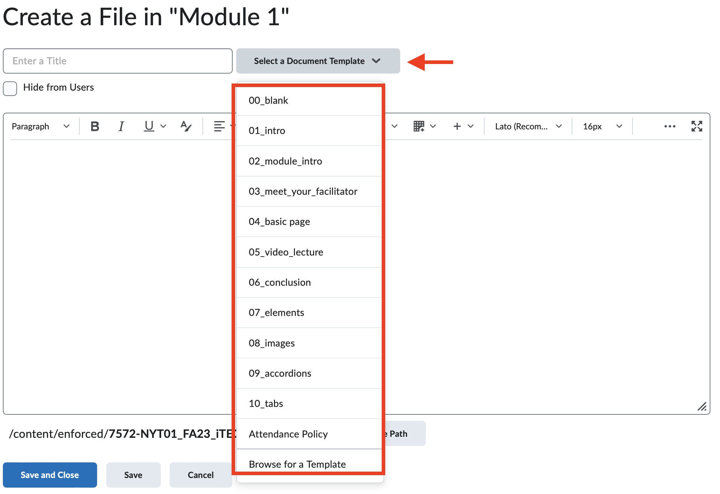
- Edit the content.
- Click Save and Close.

How to Create a Checklist
Checklists can be helpful to a student’s progress within the course by allowing them to stay organized.
- From the course home page, click on Content.
- Select a module where you would like to create a checklist.
- Click Upload / Create -> New Checklist.
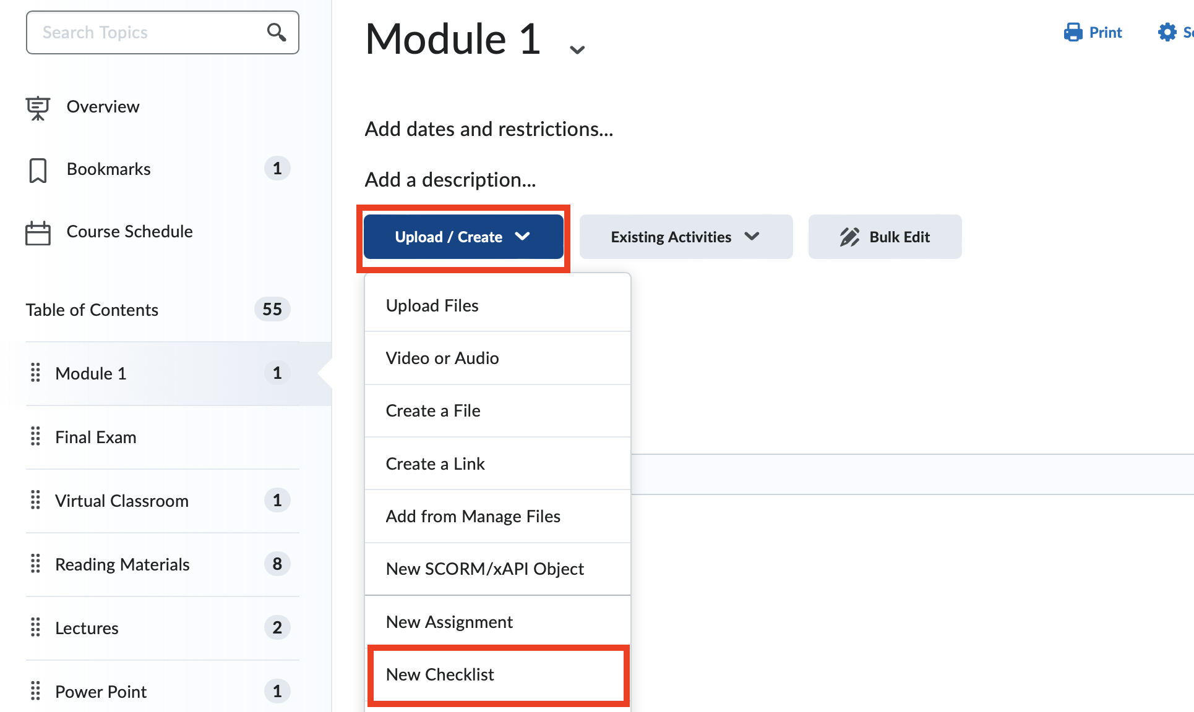
- Enter a Title (e.g., "Week 1 Assignments"), instructions and select Save.
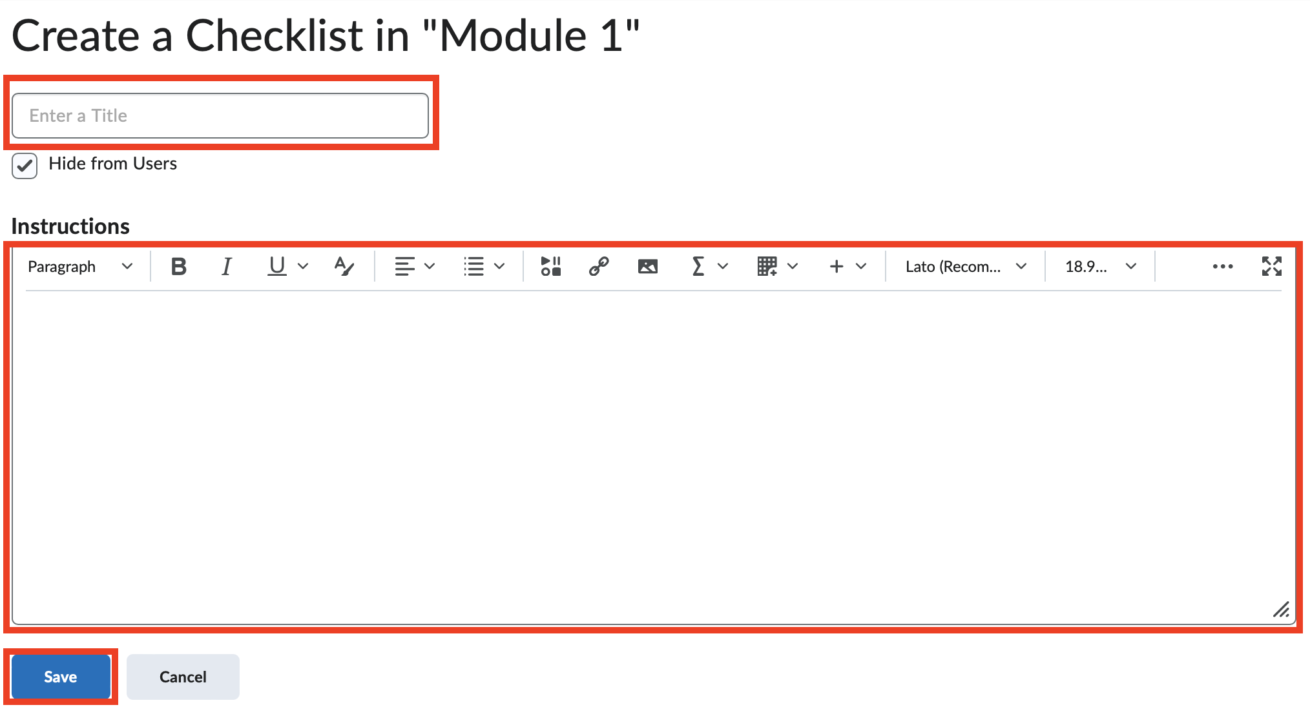
- Click Add a New List.
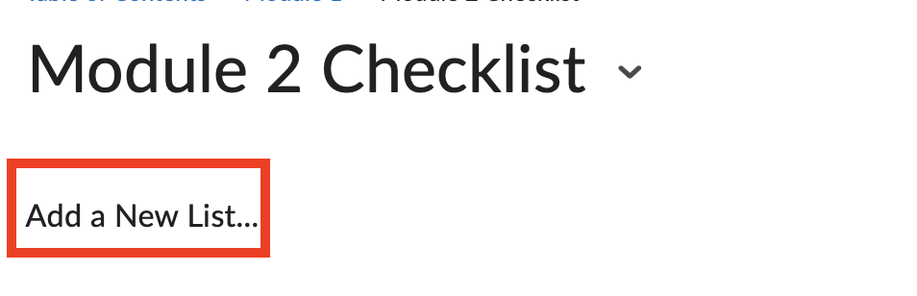
- Click on List 1 heading to change the title.
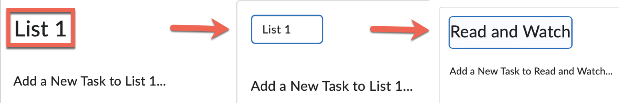
- Click Add a New Task to List 1… (Add a New Task to Read and Watch).
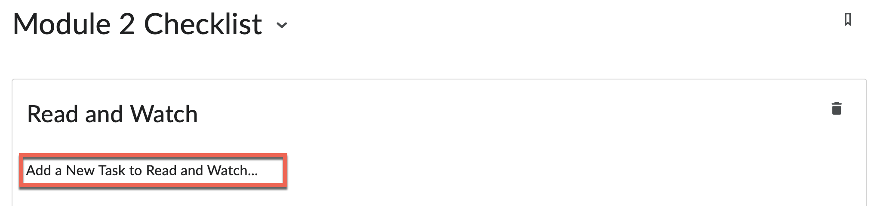
- Add a due date and description (optional).
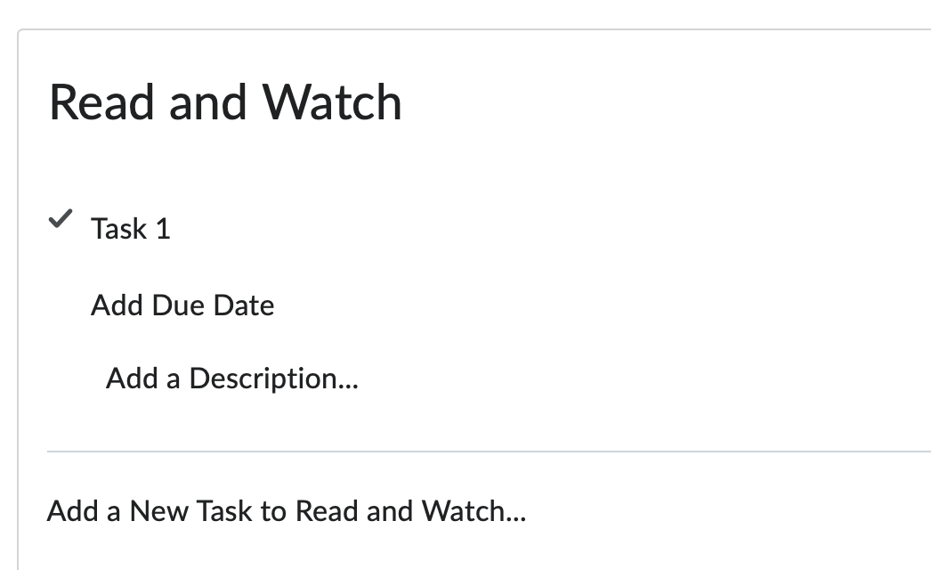
- Click Task 1 to change the title of the task (Read Chapter 5) and press Enter from your keyboard.
- Click Add a New List… for a new checklist heading.
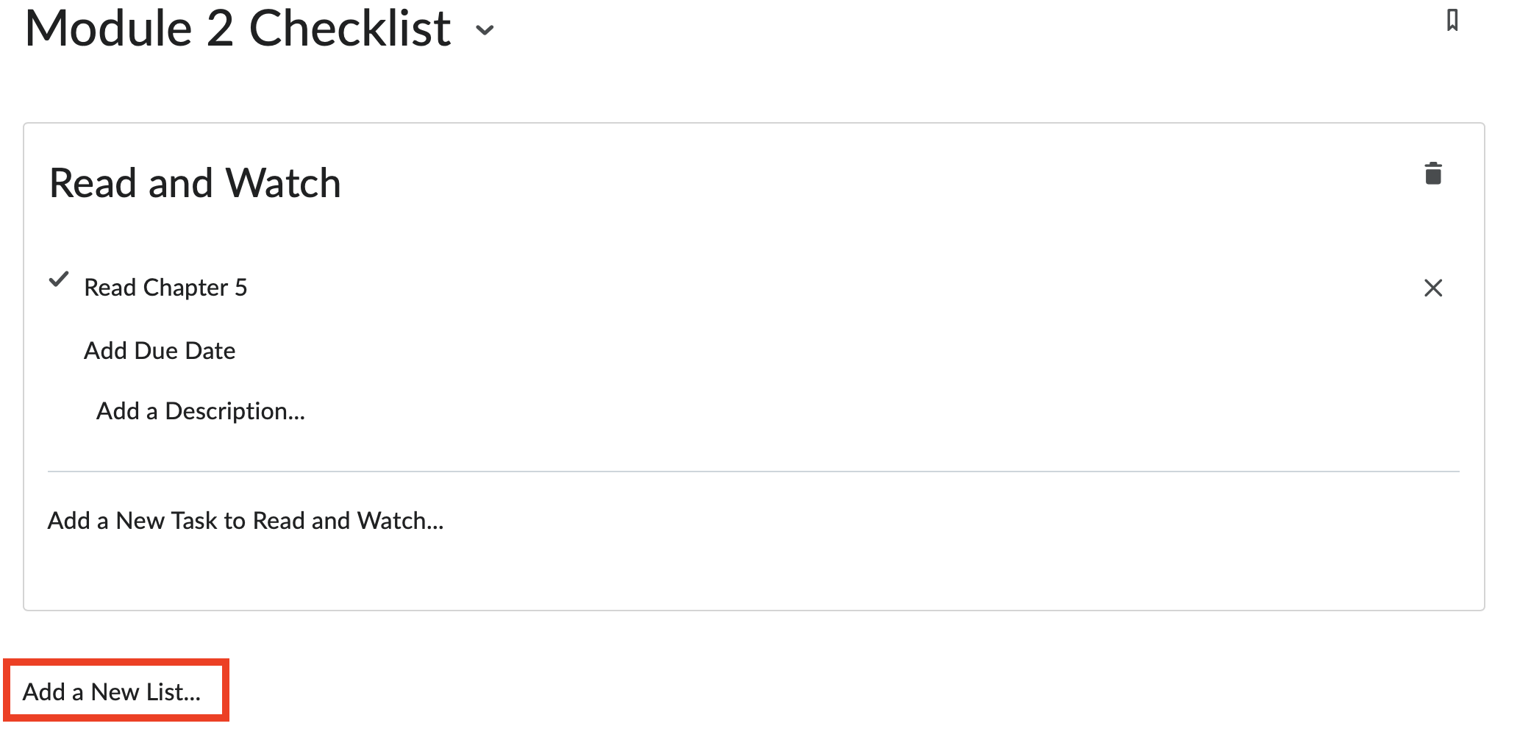
- Select the Hidden toggle switch to make the checklist visible to students.
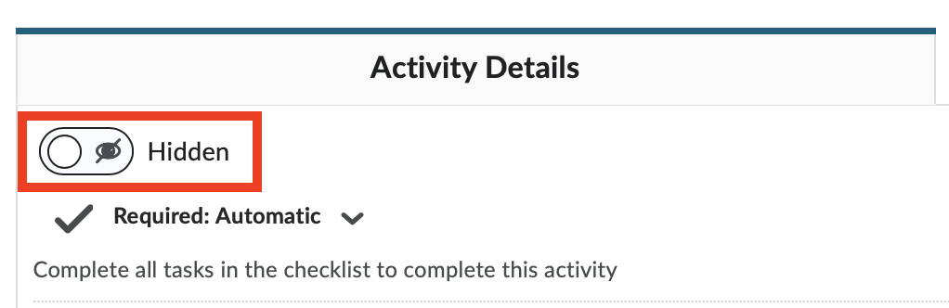

How to Create an Assignment
- From the course home page, click on Assignments.
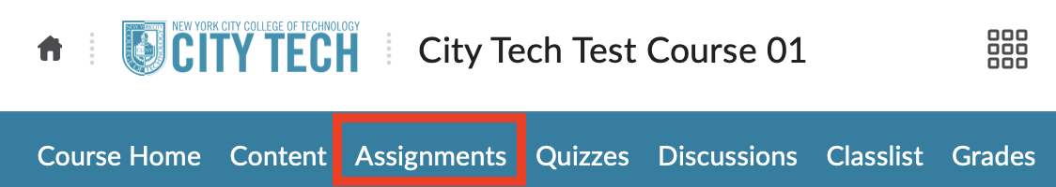
- Click on New Assignment.
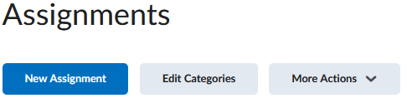
- Fill out the details in the assignment.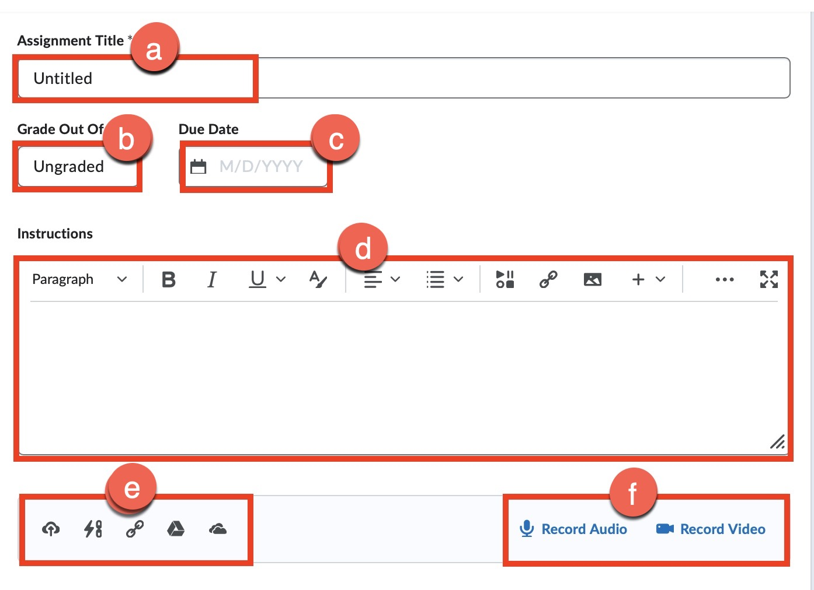
- Assignment Title: Enter a name of the assignment.
- Grade Out Of: Enter points for the assignment.
- Due Date: Enter the due date of the assignment (optional).
Note: Students can still submit the assignment after the Due Date. However, it will be marked late.
- Instructions: Enter instructions for the assignment.
- Add files, weblinks, and other resources from both your local device and the cloud.
- Add audio and video recording as well.
Note: Audio and video are restricted to a maximum duration of 30 minutes per recording. You can create more than one recording.
- Availability Dates & Conditions: Click on the arrow and change the settings as needed.
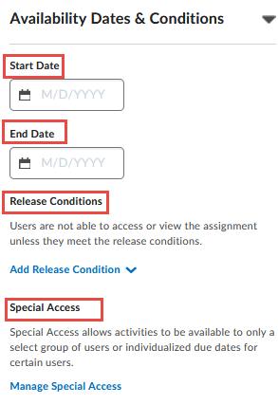
Note: Students won’t be able to submit an assignment after the End Date
- Submission & Completion: Click on the arrow to customize the assignment by submission type, number of submissions, etc.
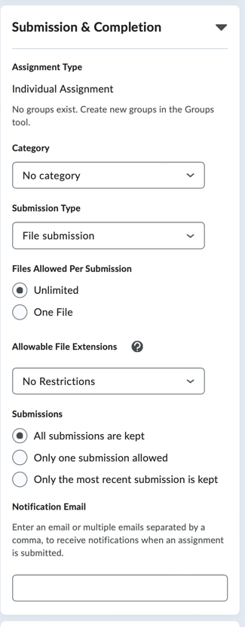
Submission Types:
- File submission: Students can upload an assignment file from their computer.
- Text submission: Allows students to directly type their assignment as text or link to their assignment within the text editor.
- On paper submission: Creates a column to enter student grades in Grades but student will submit their assignment as a physical copy.
- Observed in person: Allows your students to work on their assignment during in-person lecture. You can provide feedback for the assignment.
- Evaluation & Feedback: Click on the arrow to upload a rubric, enable annotation tools and enable Turnitin (optional).
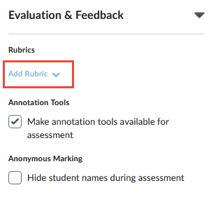
- Select the Hidden toggle switch to make assignment visible to students.
- Click Save and Close.

How to Link an Assignment into a Course Module
- From the course home page, click on Content.
- Locate and open the module where you would like to link the assignment.
- Click on Existing Activities and select Assignments.
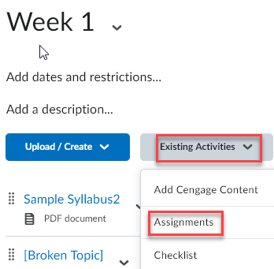
- Select an assignment from the list.

How to view a Student’s Assignment Submission
There are two methods to viewing and grading a student’s submission.
Method 1:
- From the Assignments page, click on the drop-down arrow next to an assignment.
- Select View Submissions.
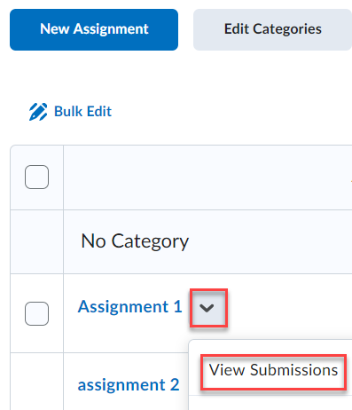
- Click on Go to Evaluation to view the student’s submission.
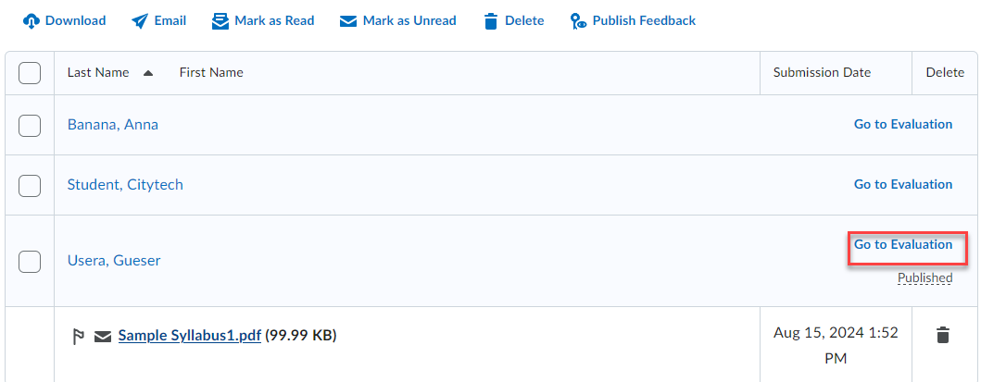
- Review the student’s submission, enter the grade and click on Publish.
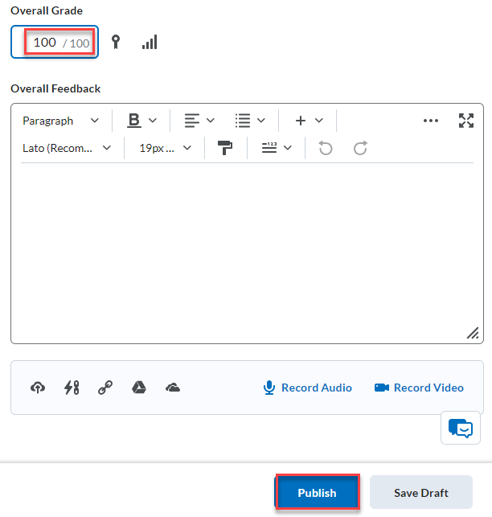

Method 2:
Assignment submissions can also be graded from the Grades link.
- From the course home page, click on Grades.
- Locate the column with the assignment title to grade.
- Click on the Unread submission file icon for a specific student.
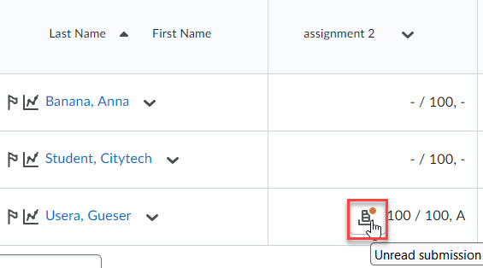
- Review the student’s submission, enter the grade and click on Publish.

How to Create a Release Condition

- Locate an item to add a Release Condition.
- Click on the down arrow next to an item -> Edit Properties in Place.
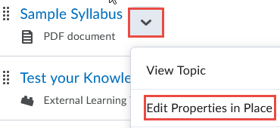
- Click Add dates and restrictions.
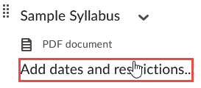
- Click Create.
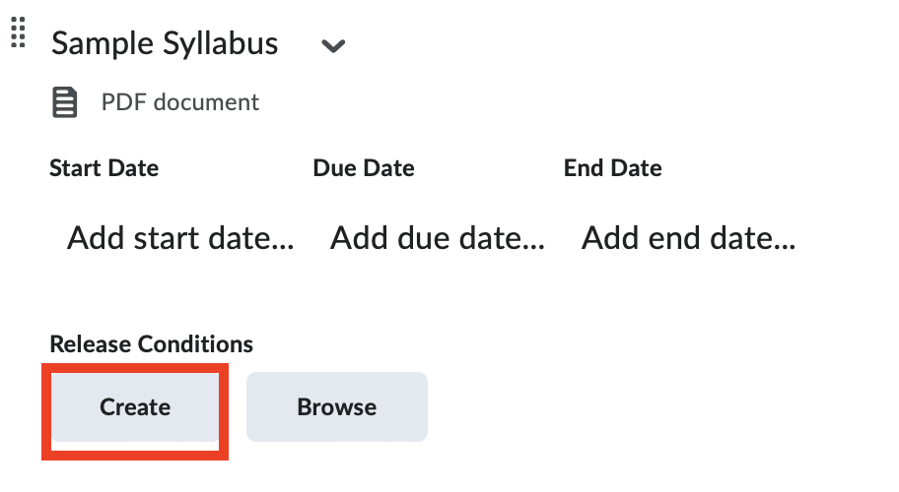
- From the Create a Release Condition pop up window, select a Conditions Type, Topic and click on the Create button.
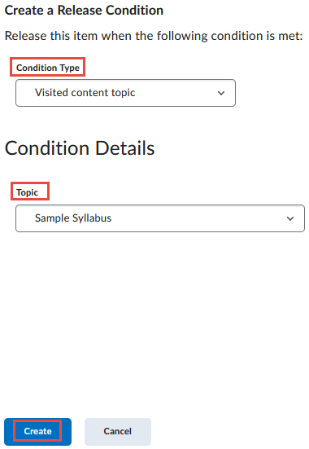
- Click Update when ready.
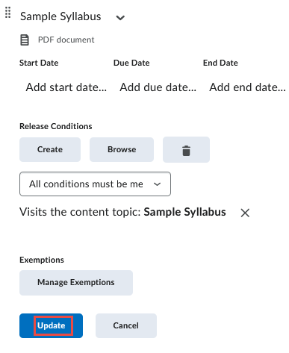

How to Create a Discussion
There are two parts in creating a Discussion for your students to engage with you or their peers. First, you will need to create a Forum which is a container or category for the topics. Next, you will need to add a topic(s) to the forum.
- From the course home page, click on Discussions.
- Select New and click on New Forum.
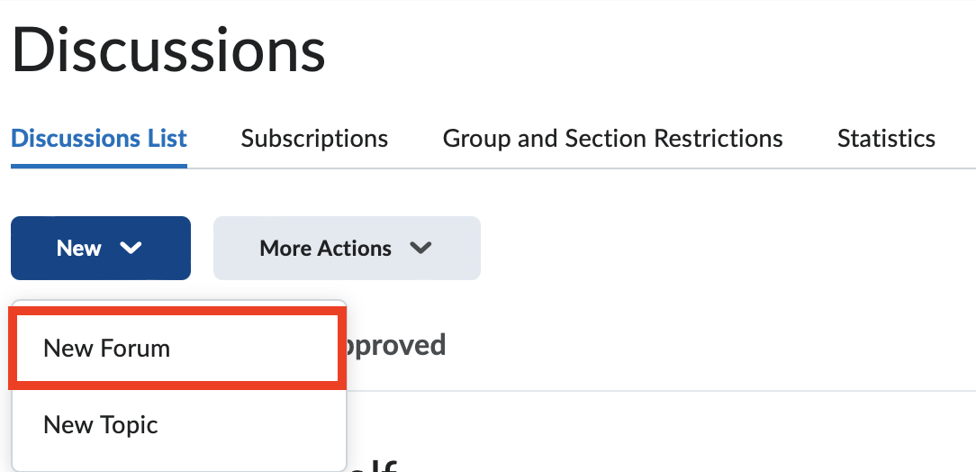
- Enter title, description of the forum and select Create a new topic in this forum with the same title checkbox.
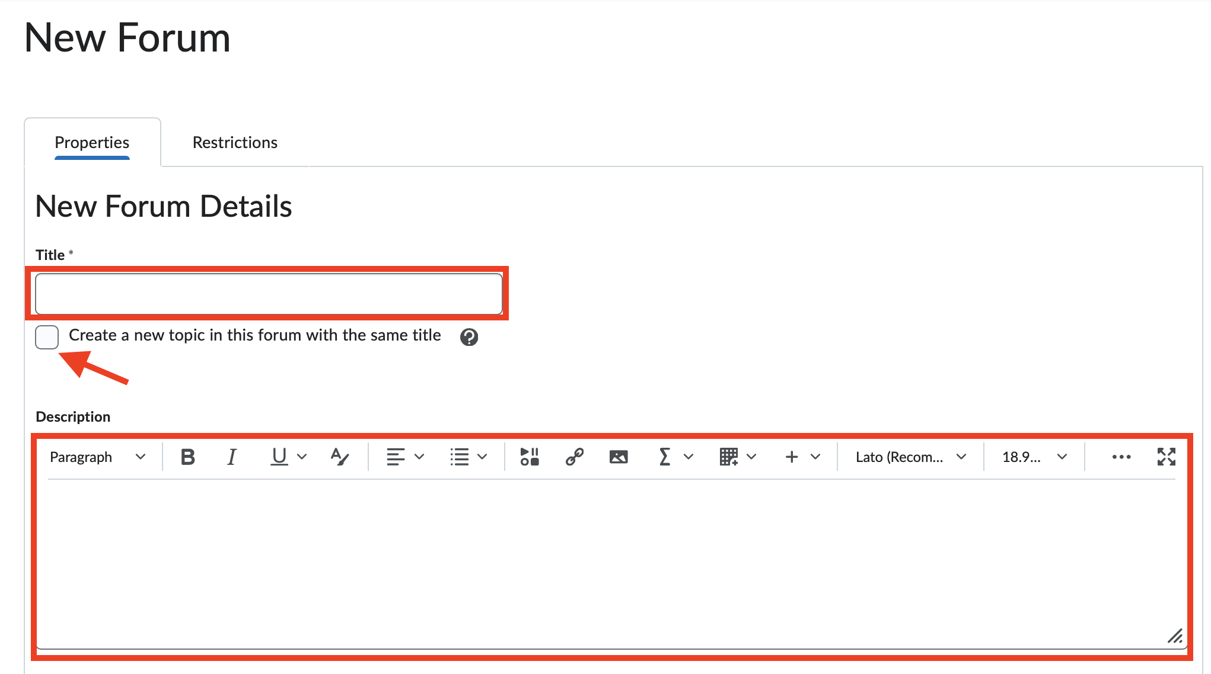
- Select the necessary options.
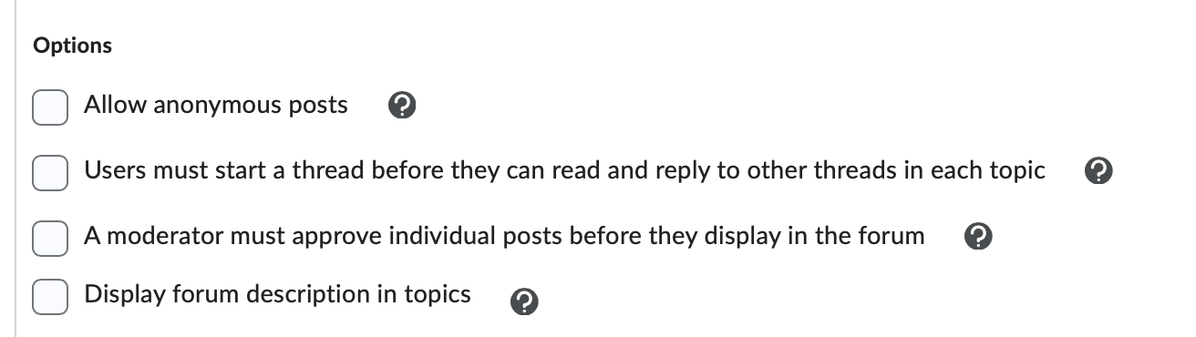
- Click on the Restrictions tab to customize the forum.
  - Select your settings and click on Save and Close.
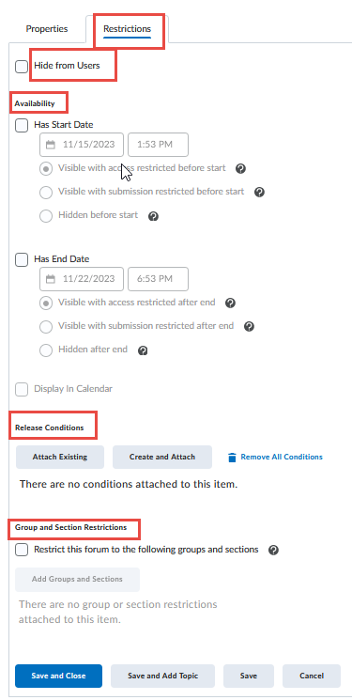
- Click Save and Close.

How to View and Reply to a Discussion
- From the course home page, click on Discussions.
- Select a Topic.
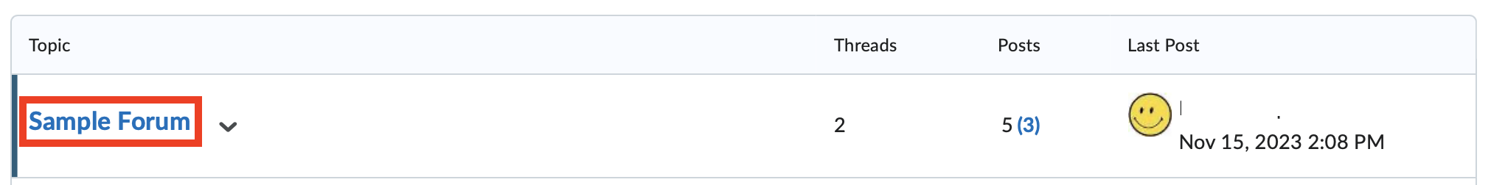
- Select on a student’s discussion post to view it.
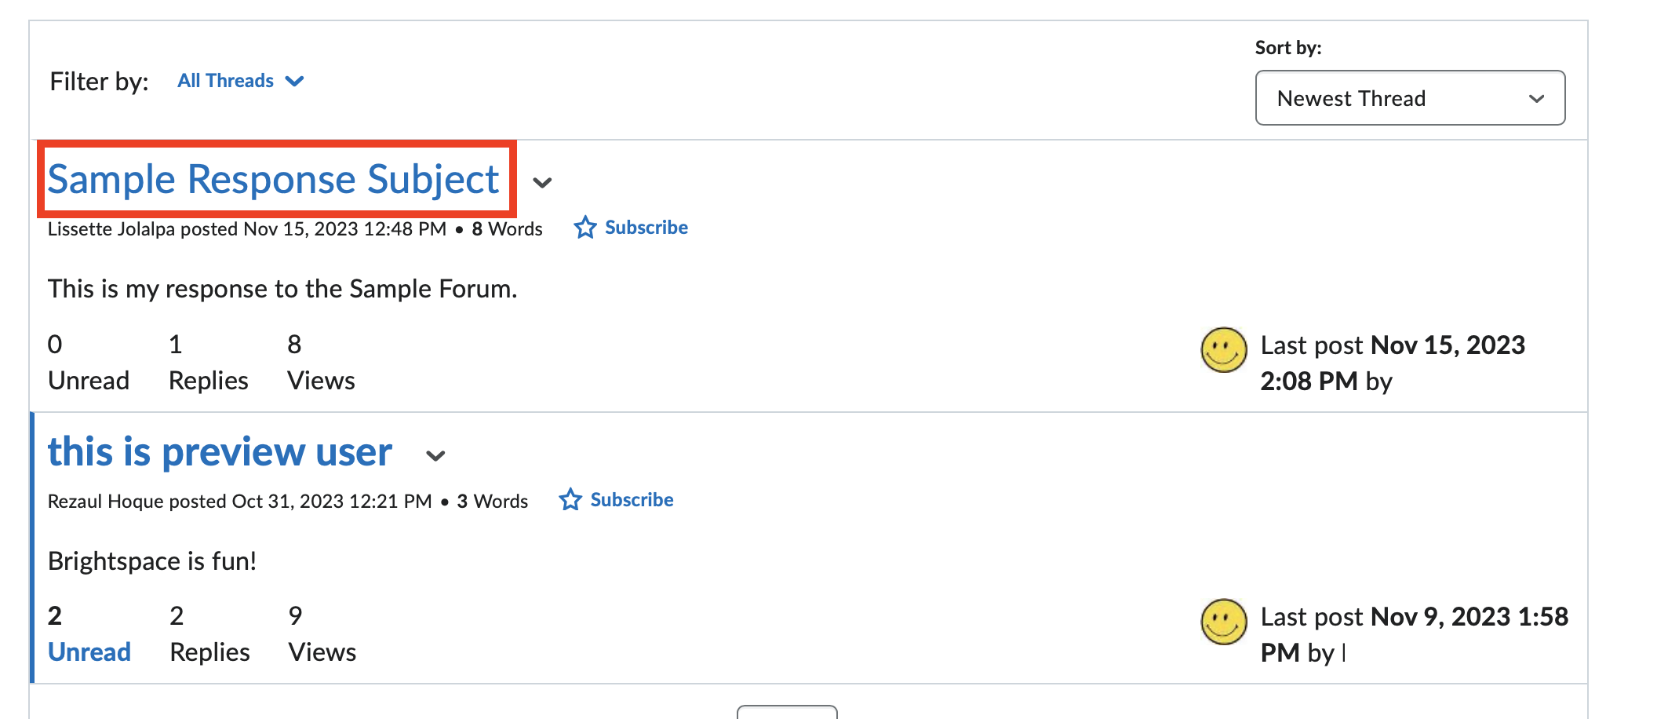
- Select Reply to Thread.
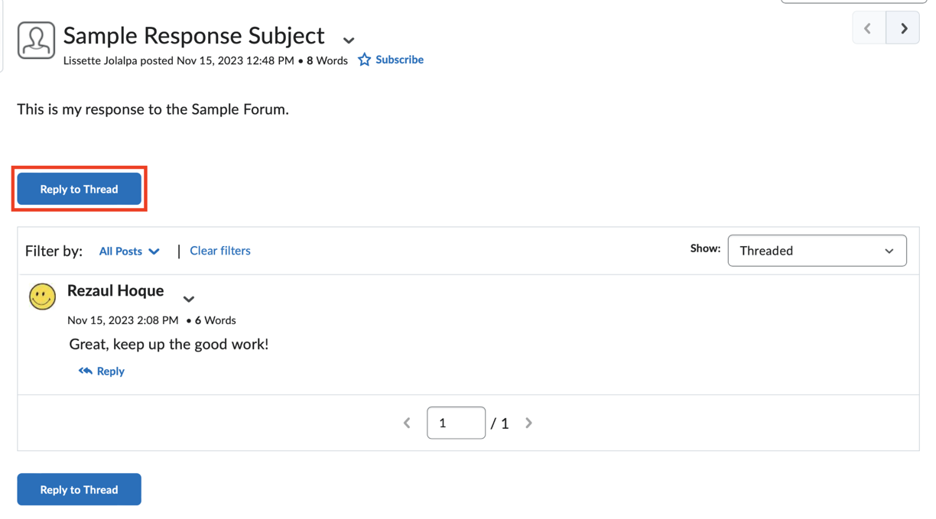
- You can select to add the original post text into your response.
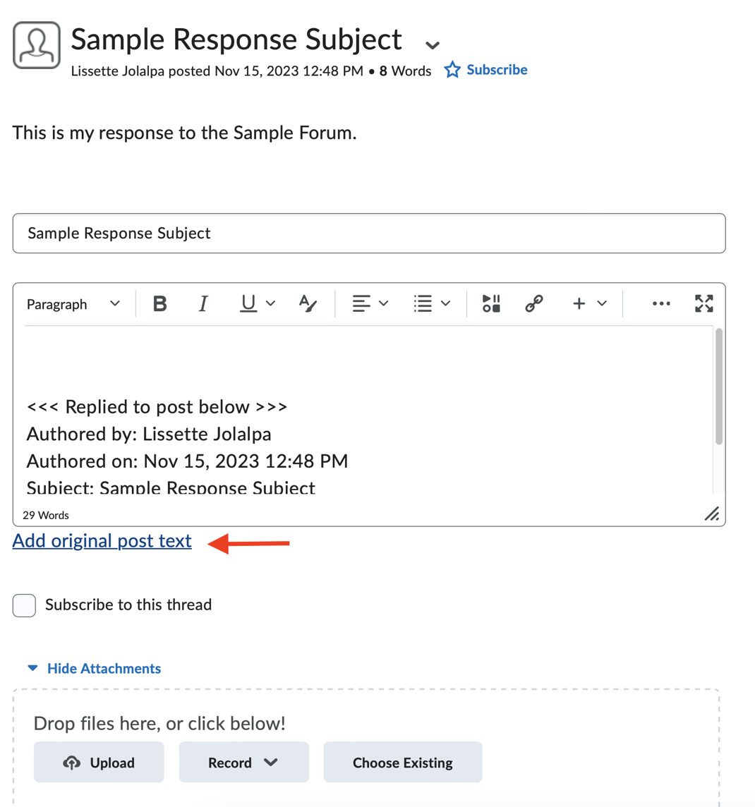
- Click on Post when you are ready.

How to Create Groups (Assignment / Discussions)
- From the course home page, click on Course Tools.
- Select Groups.
- Click on New Category to start setting up your groups:
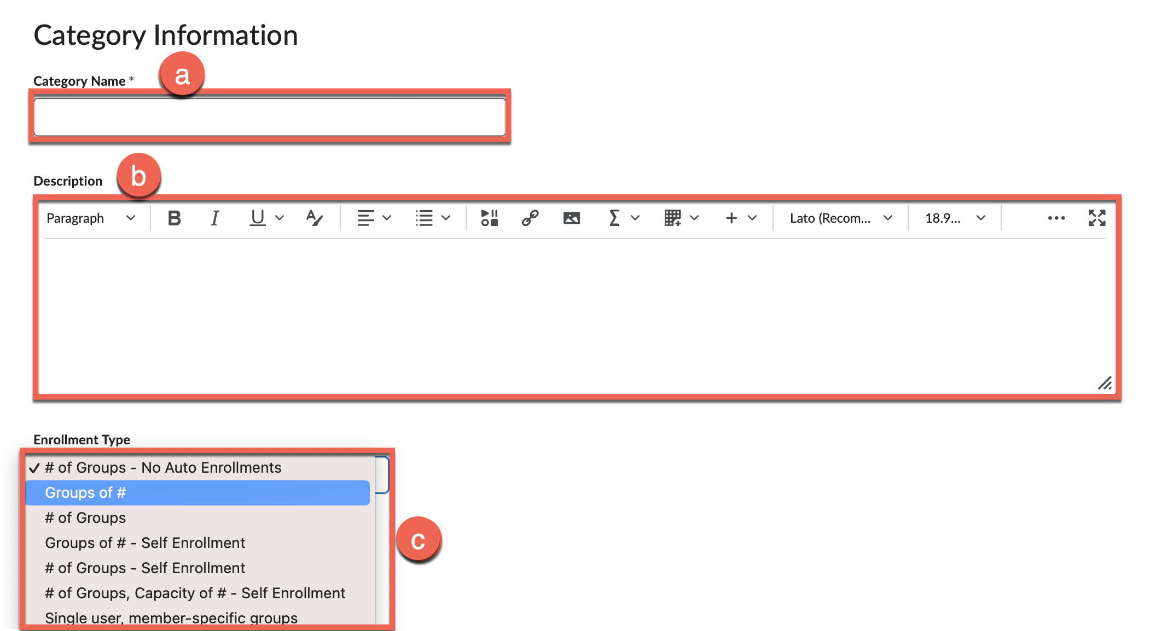
  - Category Name: Enter a category name for the group.
  - Description: Enter a description (optional).
  - Enrollment Type: Decide on Group Options such as whether to automatically assign students to groups or to manually assign them later.
- Configure Group Settings:
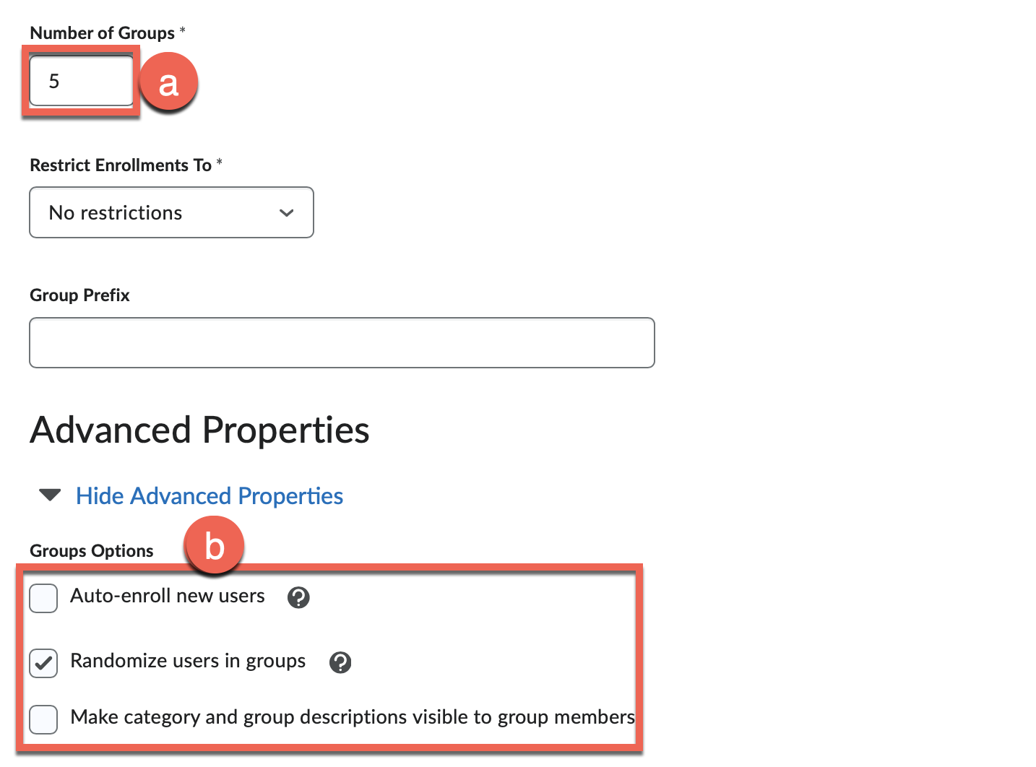

- Number of Groups: Choose how many groups you want to create or the maximum number of students per group.
Note: This option will change depending on your selection for Enrollment Type.
- Group Options: Choose to automatically enroll users into the groups or randomize users in the group. You can choose to enable category and group descriptions visible to members.
- Configure Additional Options:
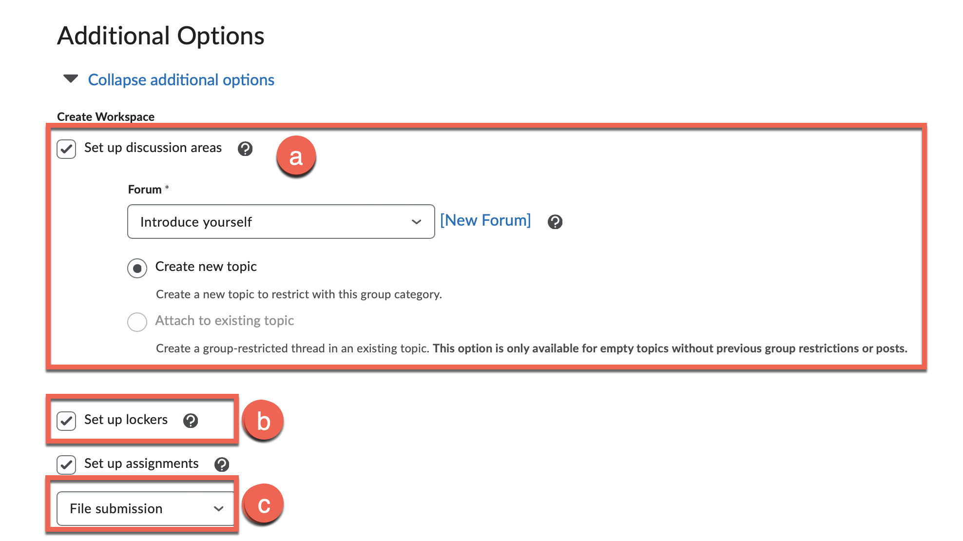
- Set up Discussion Area: Enable this option if you want to create a discussion for every group.
    - Forum: Click on New Forum and enter a Title and Description for your discussion.
    - Make sure Create new topic is enabled.
    - Click on Save.
- Set up lockers: Enable this option if you want to create a place for each group to share files.
Note: Only the members in the group can view the files shared within the locker.
- Set up Assignments: Enable this option if you want to create an assignment for each group.
- Click Save when you after you have reviewed the group settings.

How to Create a Quiz (Quiz/Exam)
- From the course home page, click on Quizzes.
- Click on New Quiz.
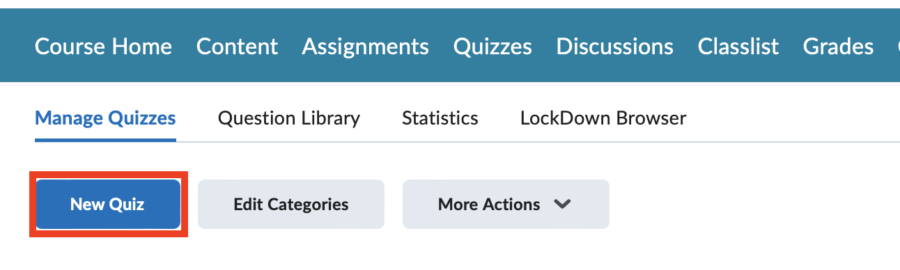
- Fill out the details of the quiz / exam.
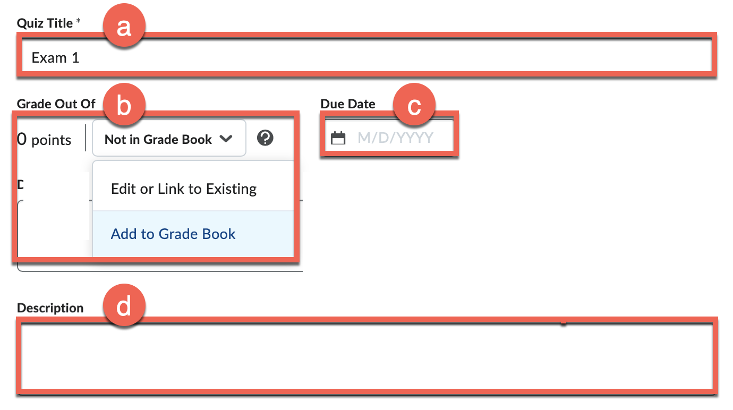
- Quiz Title: Enter a name of the quiz.
- Grade Out Of:
  - Not in Grade Book: To make this quiz gradable, click on the Not in Grade Book drop-down arrow and select Add to Grade Book.
  - Enter the max points for this quiz within the Grade Out of textbox.
- Due Date: Enter the due date of the quiz (optional).
Note: Students can still submit the quiz after the Due Date. However, it will be marked late.
- Description: Enter instructions for the quiz (optional).
- Click on Create New -> New Question.
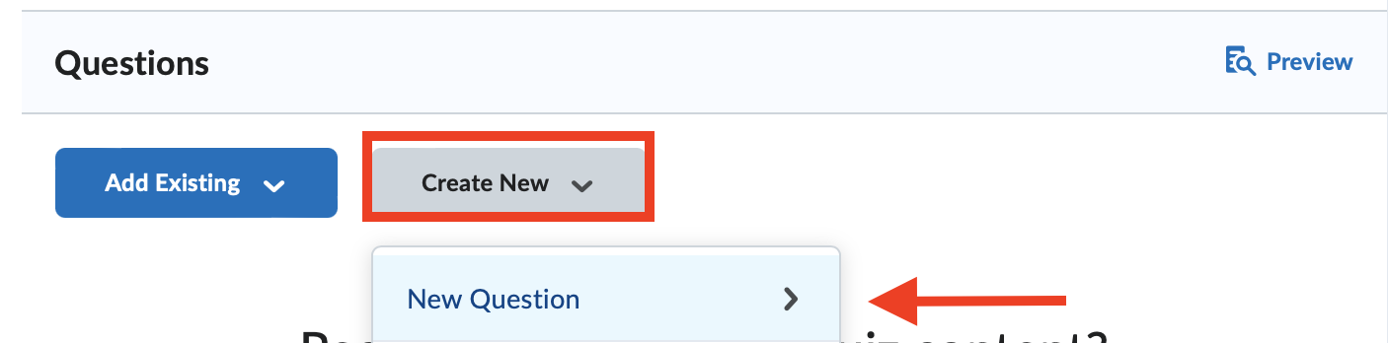
  - Select from the drop-down arrow the question type (e.g. multiple choice, true/false, written response).
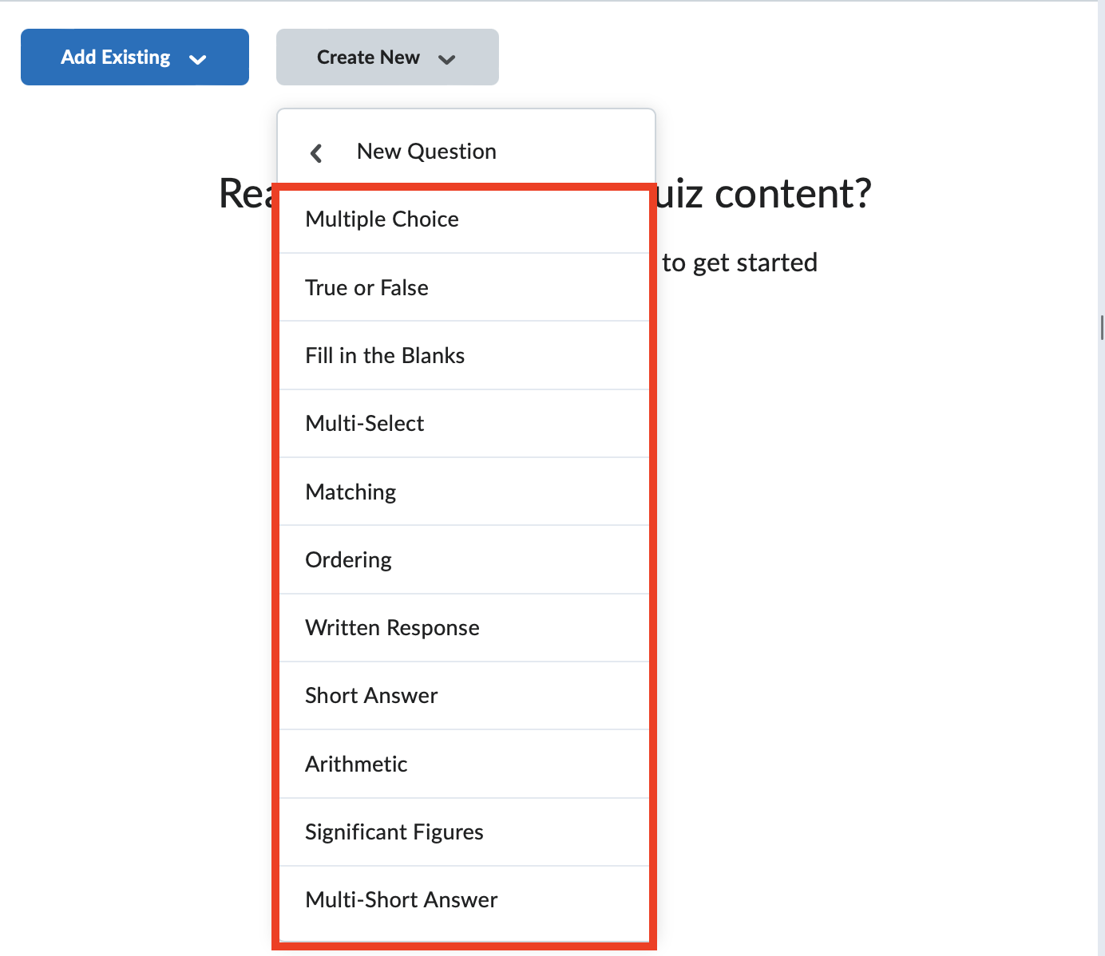
- Click on Save after adding every question.
- Availability Dates & Conditions: Click on the arrow and change the settings as needed.
  - Manage Special Access: Allow specific students different access times or extra times for any accommodations.
- Timing & Display: Click on the arrow and change the time and display settings.
  - Set time limit: Enable this option to enter a time limit in minutes.
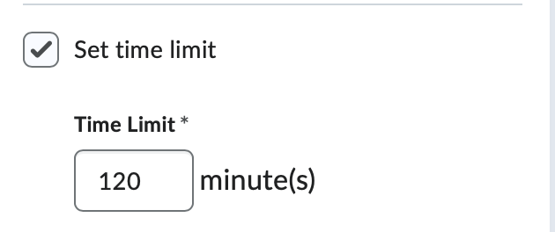
  - Timer Settings: Specify what occurs after the time has expired (e.g., prevent further responses).
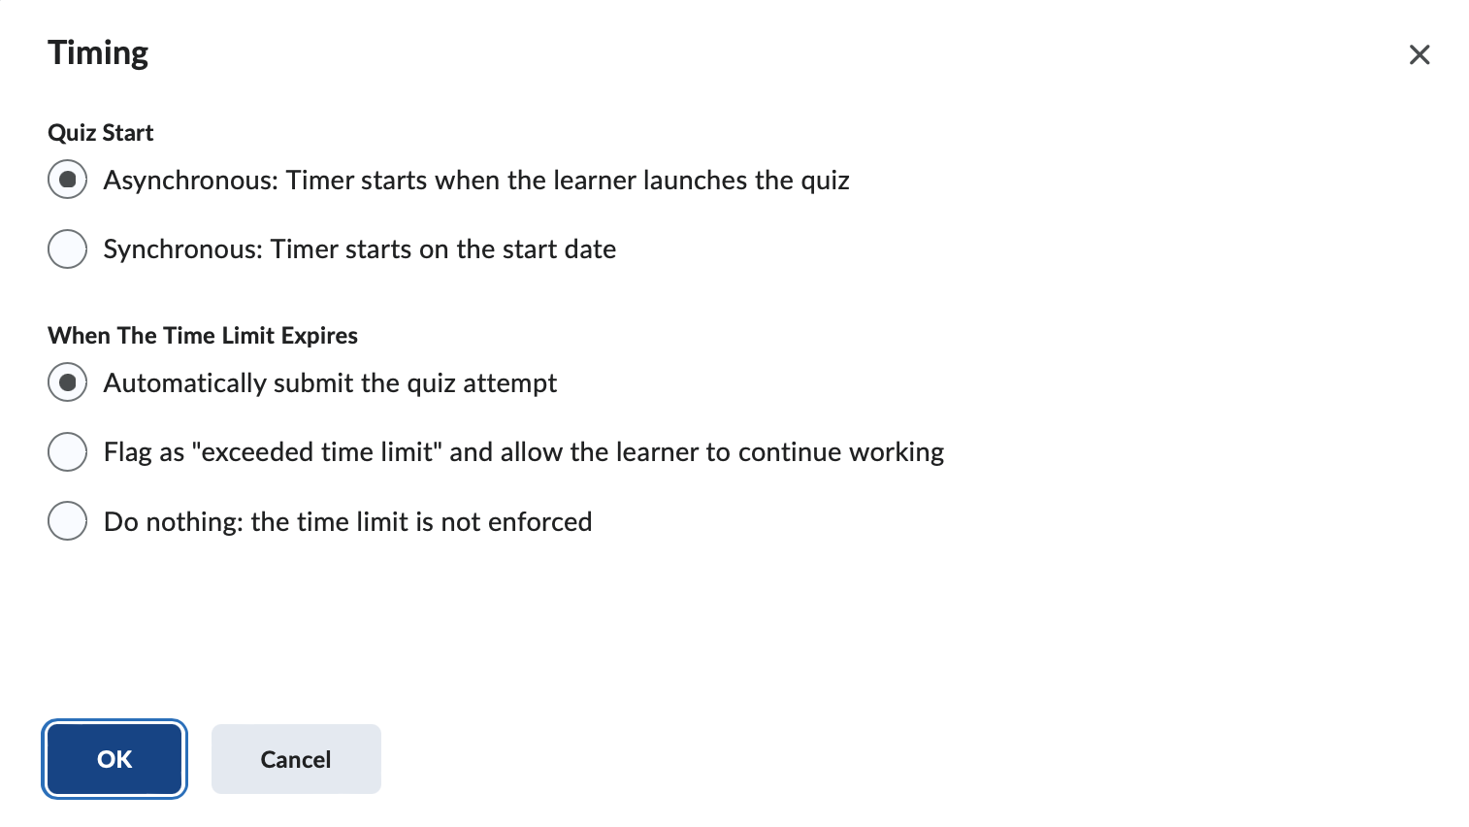
Note: By default, quiz is set as asynchronous and is auto submitted when the time is up.
  - Paging: Select how many questions the students can view per page.
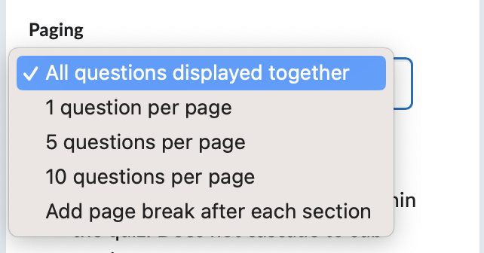
Note: By default, all questions displayed together.
  - Shuffle Quiz: Enable option to shuffle the questions in the quiz for each student.
  - Display:
    - Allow hints: Enable this option to give students clues during the quiz on specific questions they need help answering.
    - Disable Email, Instant Messages, and Alerts within Brightspace: Check this box if you would like to disable communication between students during the exam on Brightspace.
- Attempts & Completion: Click on the arrow to expand the menu.
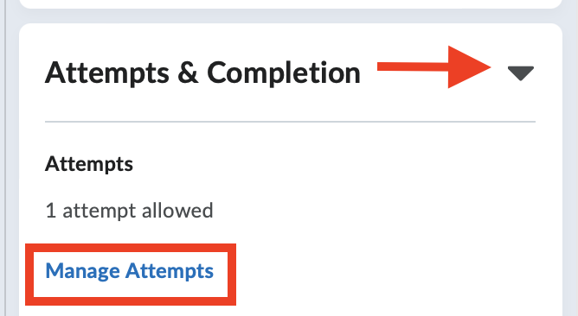
  - Click on Manage Attempts and select the number of attempts a student can take the quiz, the grade calculation and select OK.
- Evaluation & Feedback: Click on the arrow to expand the menu.
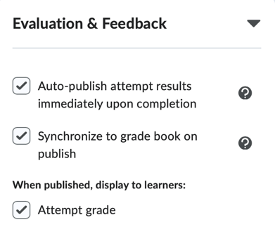
  - By default, the results are immediately published upon completion, synchronized to the grade book when published and displayed to the students. To change these settings, uncheck the boxes next to each option.

  - Choose which questions and answers to display to students. From the No Questions drop-down menu, select which questions to show them.
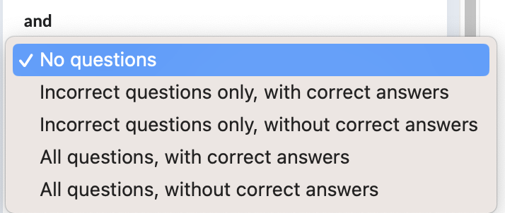
- Select the Hidden toggle switch to make quiz visible to students and click Save and Close.
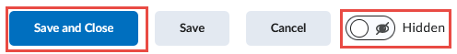

How to Create a Question Pool
- From the course home page, click on Quizzes.
- Select Question Library tab.
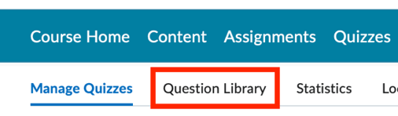
- Click New -> Section.
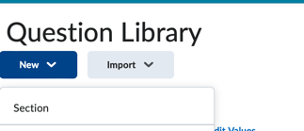
Note: A section helps organize and categorize your question pool by different topics.
- Give the section a name. (e.g., "Chapter 1, True or False"), select your settings and click Save.
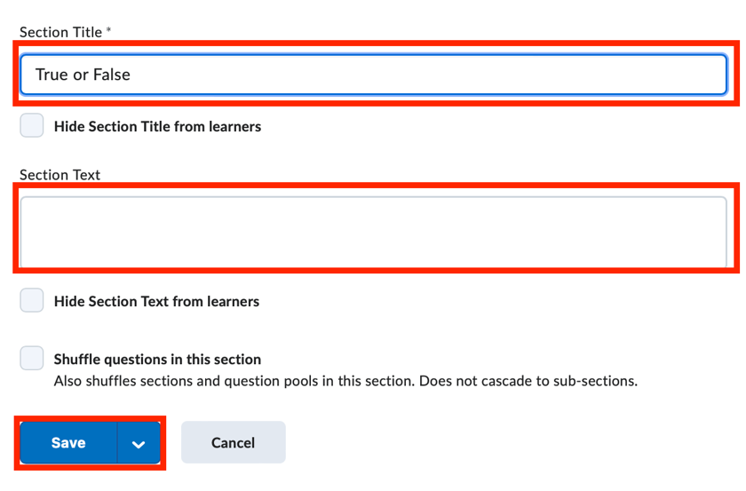
- Click on the name of the section you created.
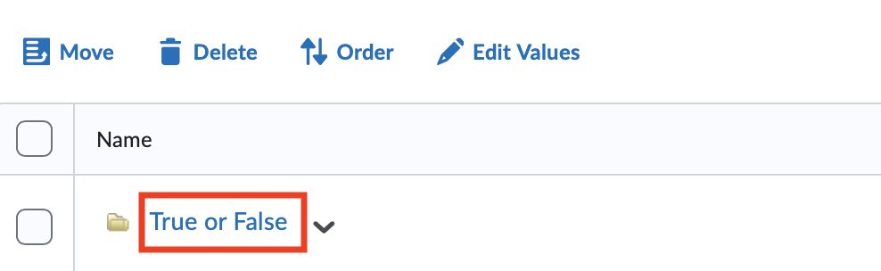
- Click New and select a question type from the menu to create a question.
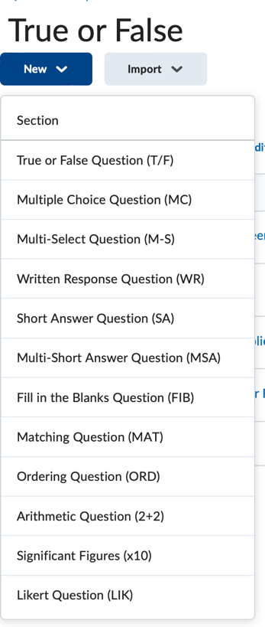
- You can also import a question by uploading a file or browsing existing questions.
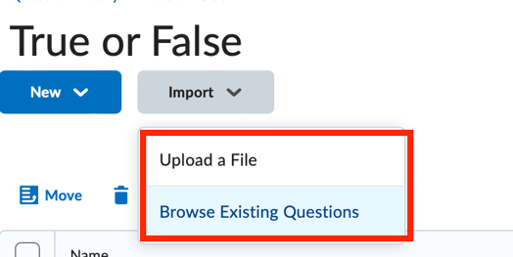

How to Create a Random Question Quiz (Quiz/Exam)
A random question pool reduces the likelihood of students cheating.
- From the course home page, click on Quizzes.
- Click on New Quiz.
- Click Create New -> Question Pool.
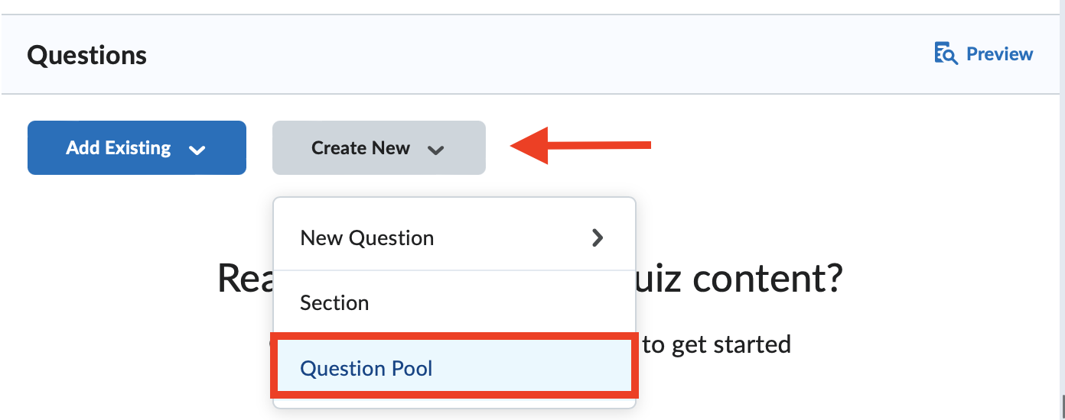
- Enter a Question Pool title and select Browse Question Library.
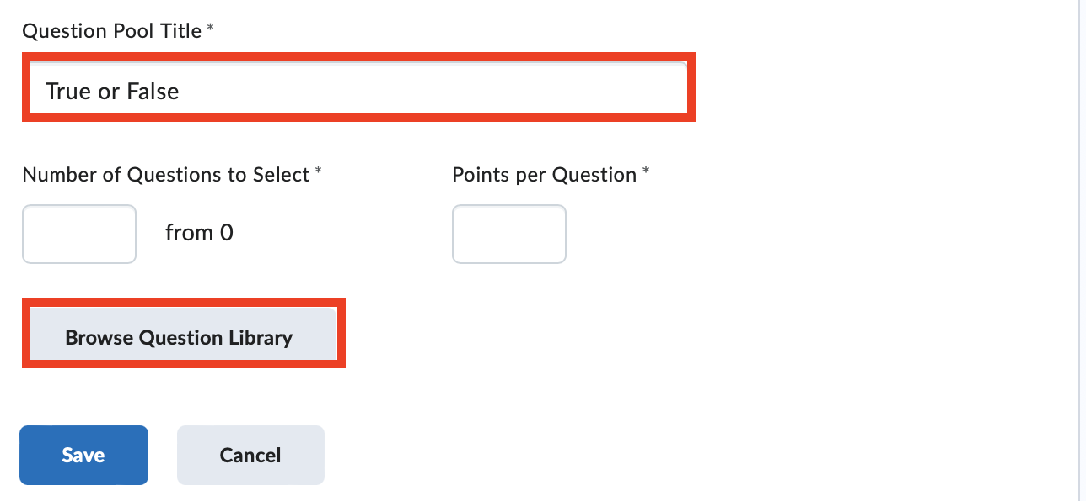
- Select the section you created in How to Create a Question Pool section.
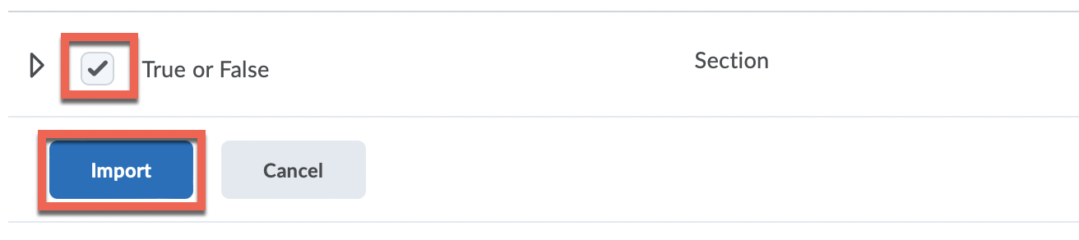

- Fill out the details:
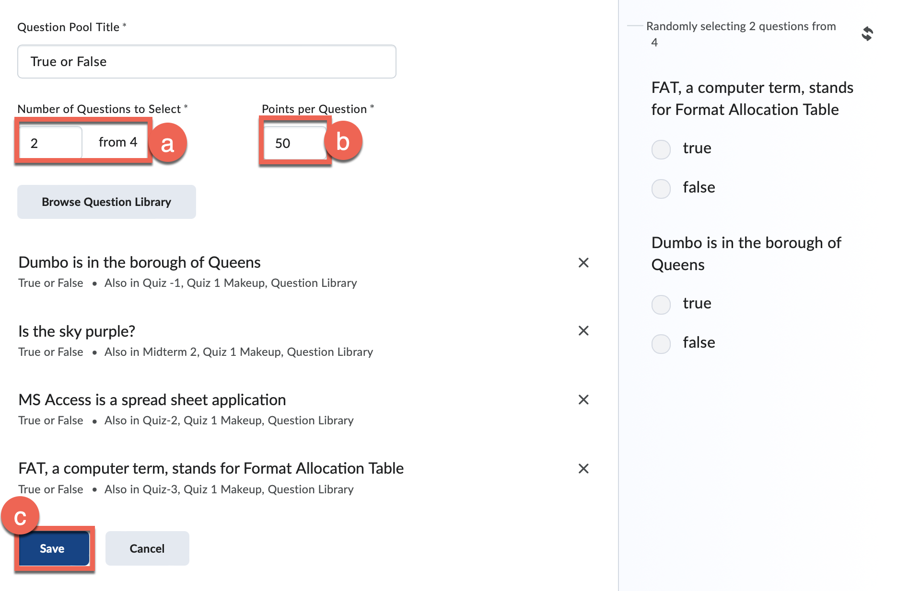
  - Number of Questions to Select: Specify how many questions you want to select from the question pool for the quiz.
  - Points per Question: Enter the point value for each question.
  - Click Save.

How to Link Zoom to Brightspace
- From the course home page, click on Content.
- Locate the Module you wish to add the Zoom link into or create a new one.
- Select a Module to enter the Zoom link.
- Click on Existing Activities and select External Learning Tools.
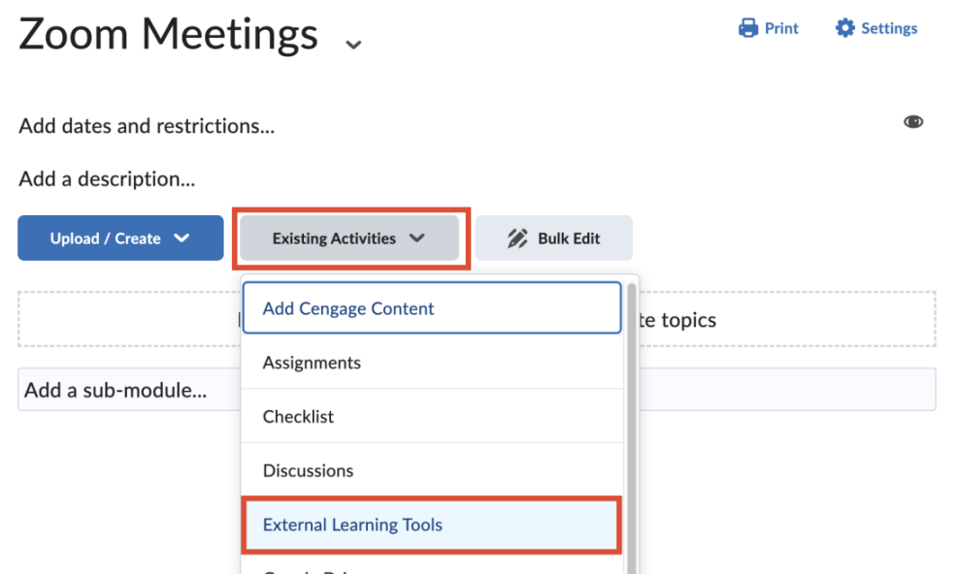
- Select Zoom-NYCCT.
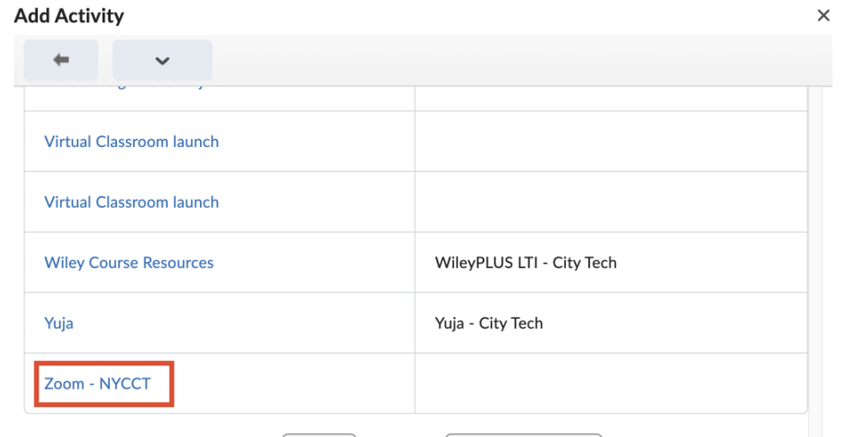

How to Create a Zoom Session in Brightspace
- Select the module where you previously linked Zoom into.
- Click on Schedule a New Meeting.
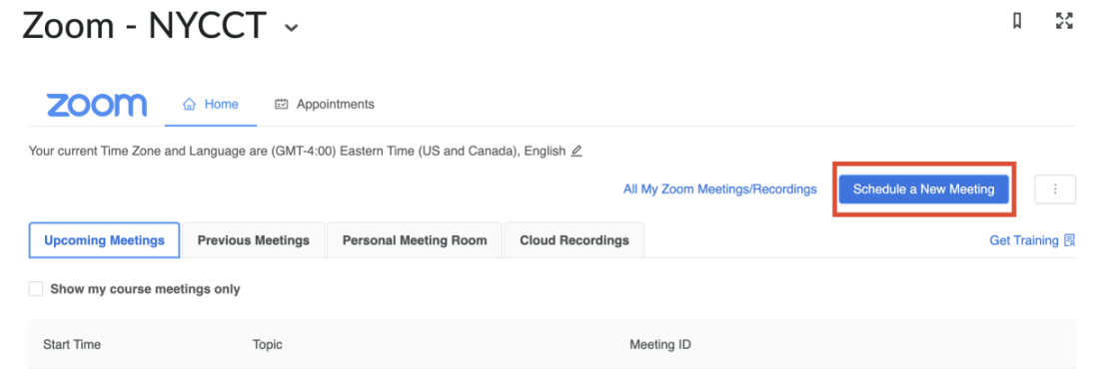
- Enter the details: topic, description, date, time and duration for the meeting.
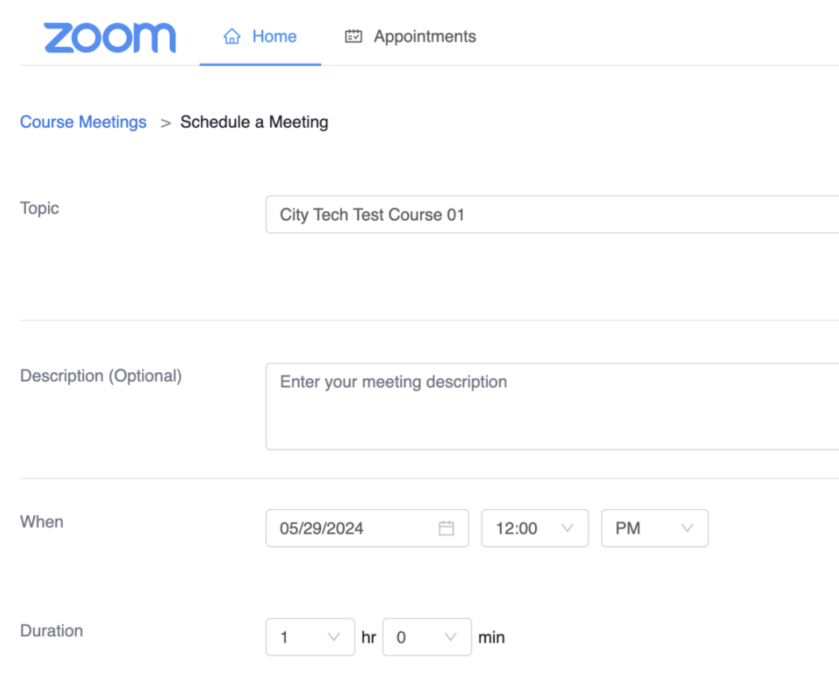
- Click on Save.
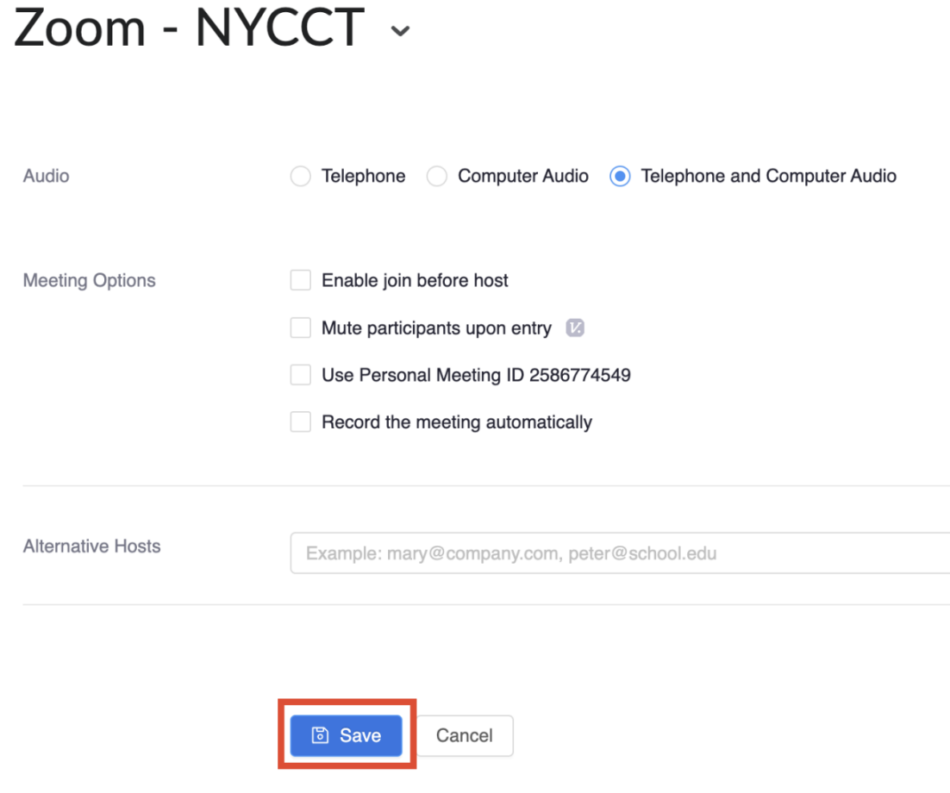
Note: Students will have access to your Zoom sessions by selecting the Zoom-NYCCT link. If receive an error message when creating sessions, create a link via https://cuny.zoom.us/ and copy/paste the link into your course announcements.

How to Send an Email to the Class
- From the course home page, click on Classlist.
- Select Email Classlist to email your entire class.
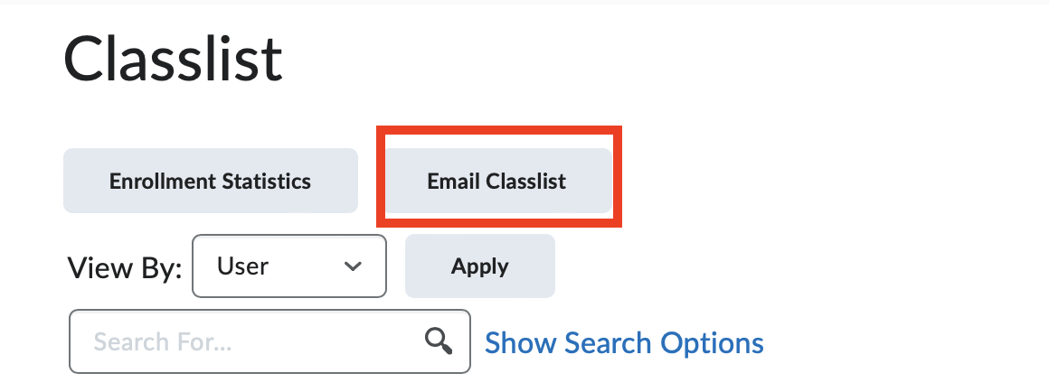
- Click on Send Email.
- Enter the subject, message in the body and add any attachments or recordings.
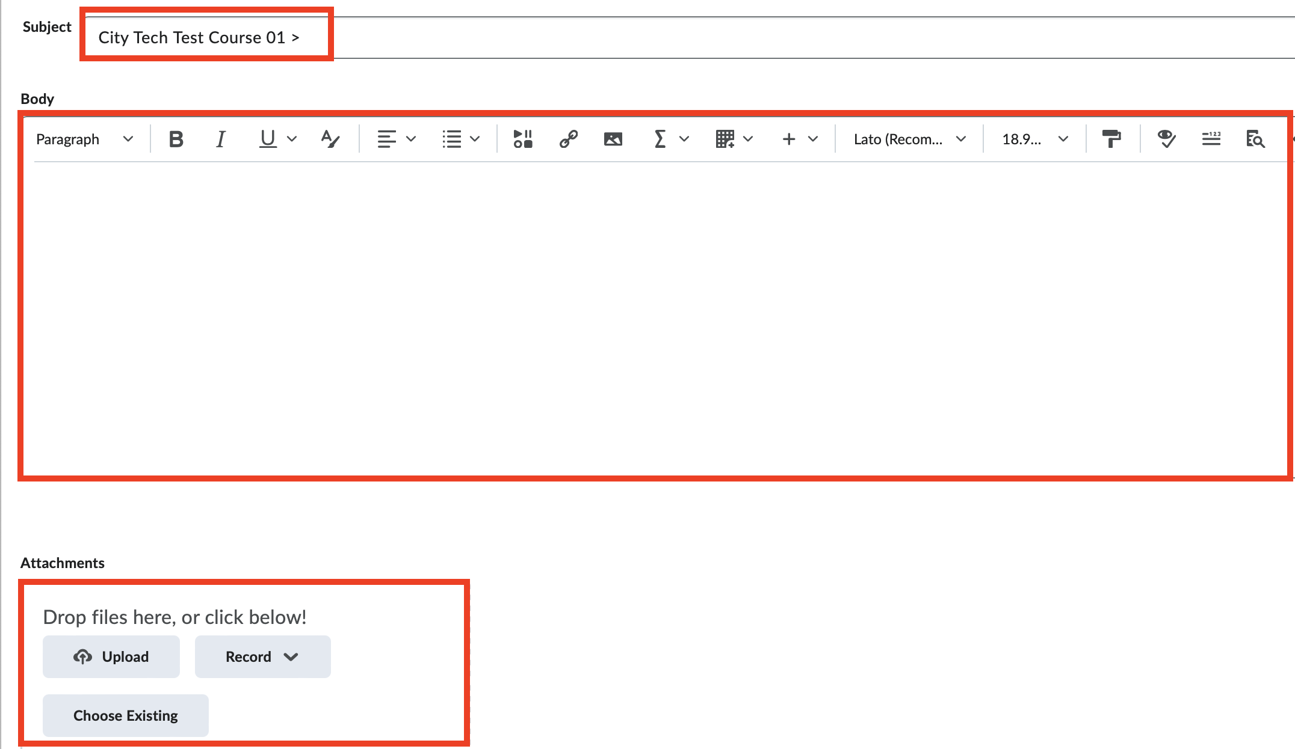
- Click on Send.

How to Use an Intelligent Agent
Intelligent Agent is a tool used to automate tasks within a course based on meeting specific conditions set in place. Once a condition is met, a task will be performed. For example, send reminders to students if they haven’t completed an assignment or quiz by the due date. You can even set an intelligent agent to send students a reminder when they have not accessed your course within a few days.
- From the course home page, click Course Tools -> Course Admin -> Intelligent Agent.
- Click on New Agent.
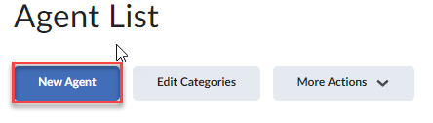
- Fill out the details for the agent:
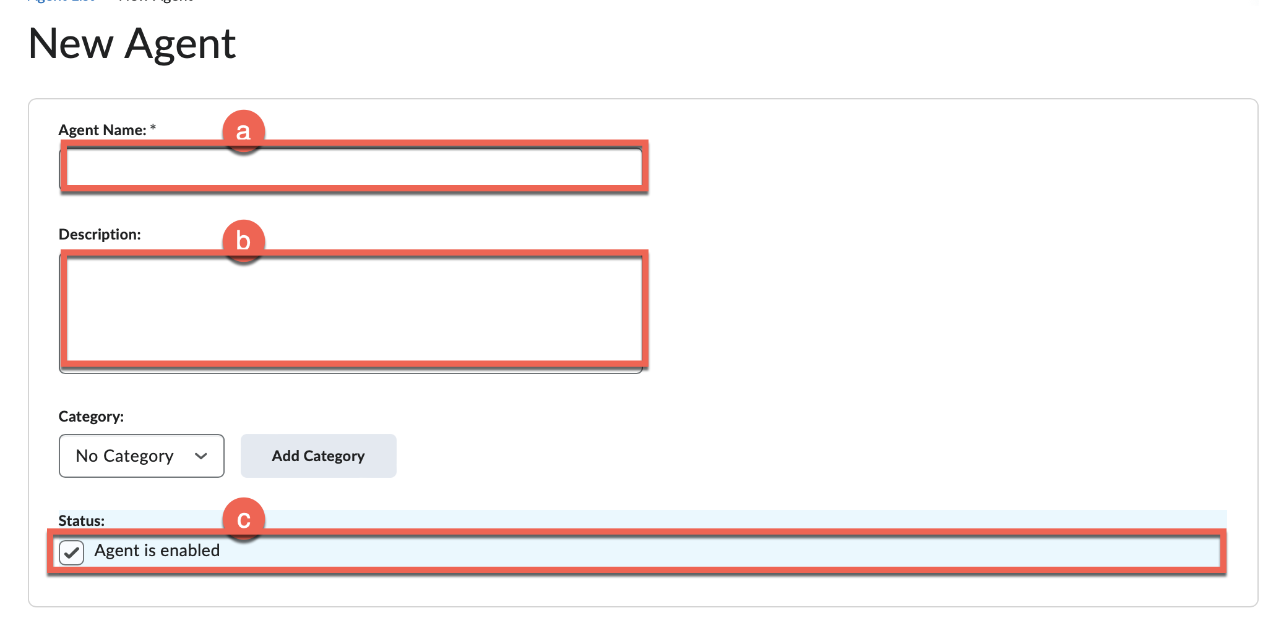
  - Agent Name: Enter a meaningful title for the agent.
  - Description: Enter a description of what the agent is intended for (optional).
  - Status: Check the box to enable the agent.
- Scheduling:
  - Click on the arrow next to Scheduling to expand the menu.
  - Select the frequency of the agent.
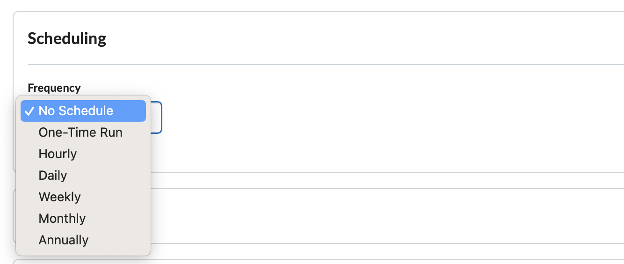
- Criteria:
  - Click on the arrow next to Criteria to expand the menu.
  - Role in Classlist: Select a which user role the agent applies to.
  - Take Action on Activity: Choose any conditions from this section that will trigger the agent.
  - Release Conditions: Select the release conditions that will trigger the agent from the list.
- Actions:
  - Click on the arrow next to Actions to expand the menu.
  - Repetition: Select when the action should be triggered once the criteria is met.
  - Send an Email: Determine if you want to send an email to the students when the criteria are satisfied.
- Click Save and close.
- To view the agent:
  - From the Course Admin page, click Intelligent Agent.
  - The agent should be listed there.

How to View the Class Progress
Class Progress is a tool used to monitor student progress. It provides a visual summary of when students last accessed Brightspace, the amount of course content they have completed, and their overall grade within the course.
- From the course home page, click on Class Progress.
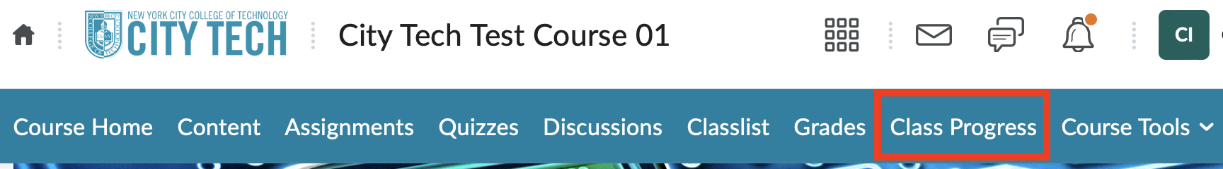
- View a summary of your class progress.
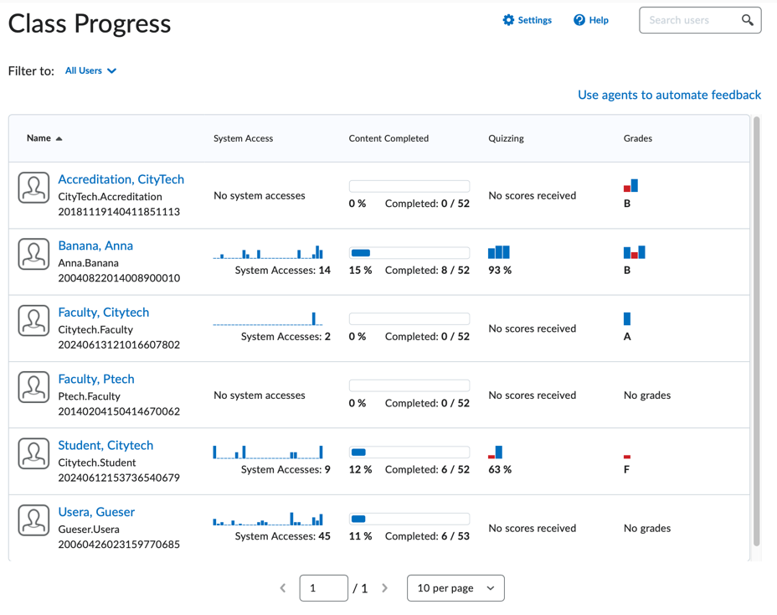
- Click on a students’ name to view their progress summary.
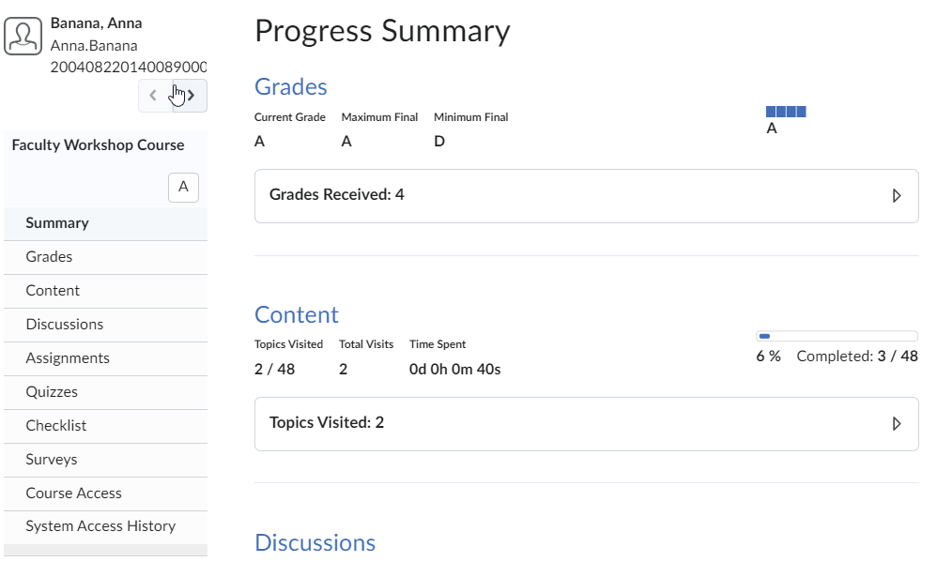

How to Use Quick Eval
Quick Eval is a tool used to store all the assessments that are submitted by students and need grading. Once those assessments are graded, they will no longer be visible from this section. You can view ungraded submissions for all your courses from the college home page or for a specific course from the course home page.

View Quick Eval from the Course Home Page:
- From the course home page, click on Course Tools -> Course Admin -> Quick Eval.
- View any ungraded submissions for your students within that course displayed on the page.
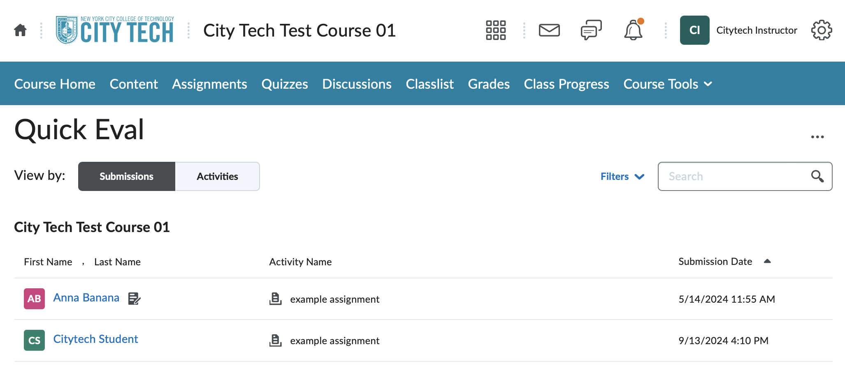
- Filter by Activity Name or Date by clicking on the Filters arrow.
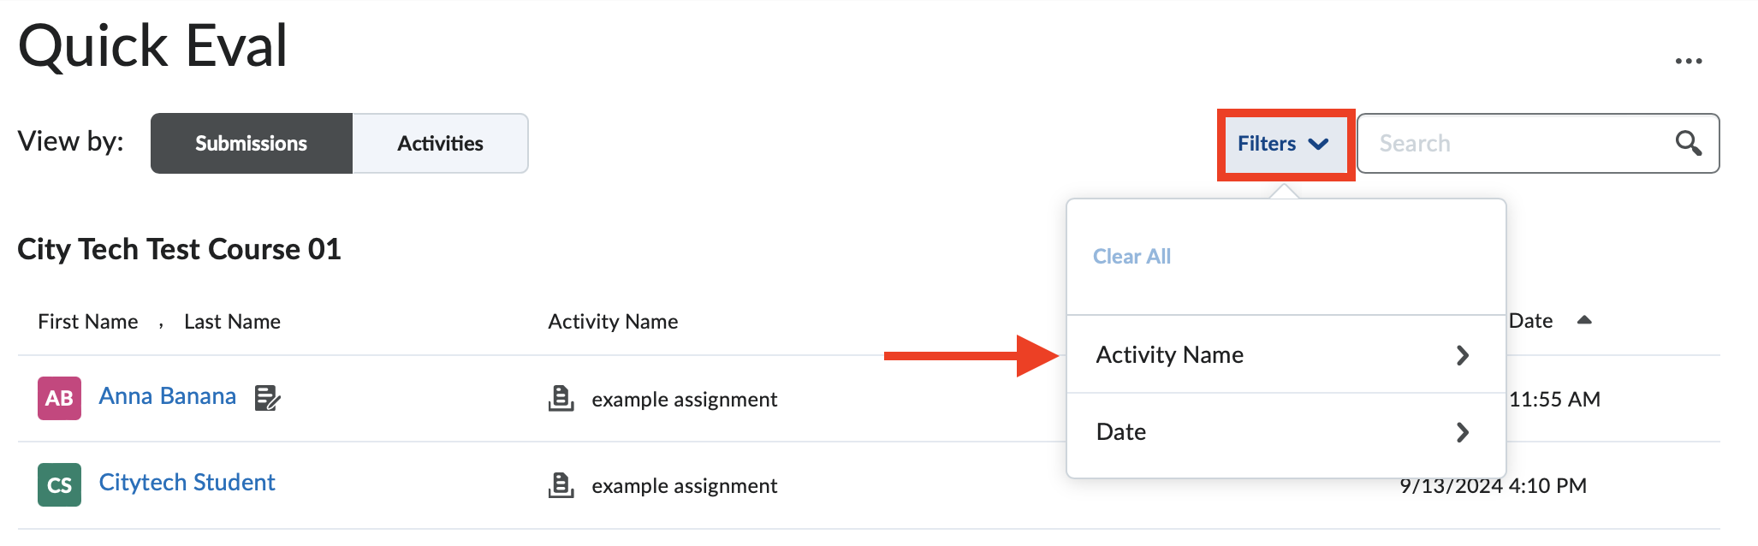
- Click on a student’s name to view the assessment.
- Fill out the details:
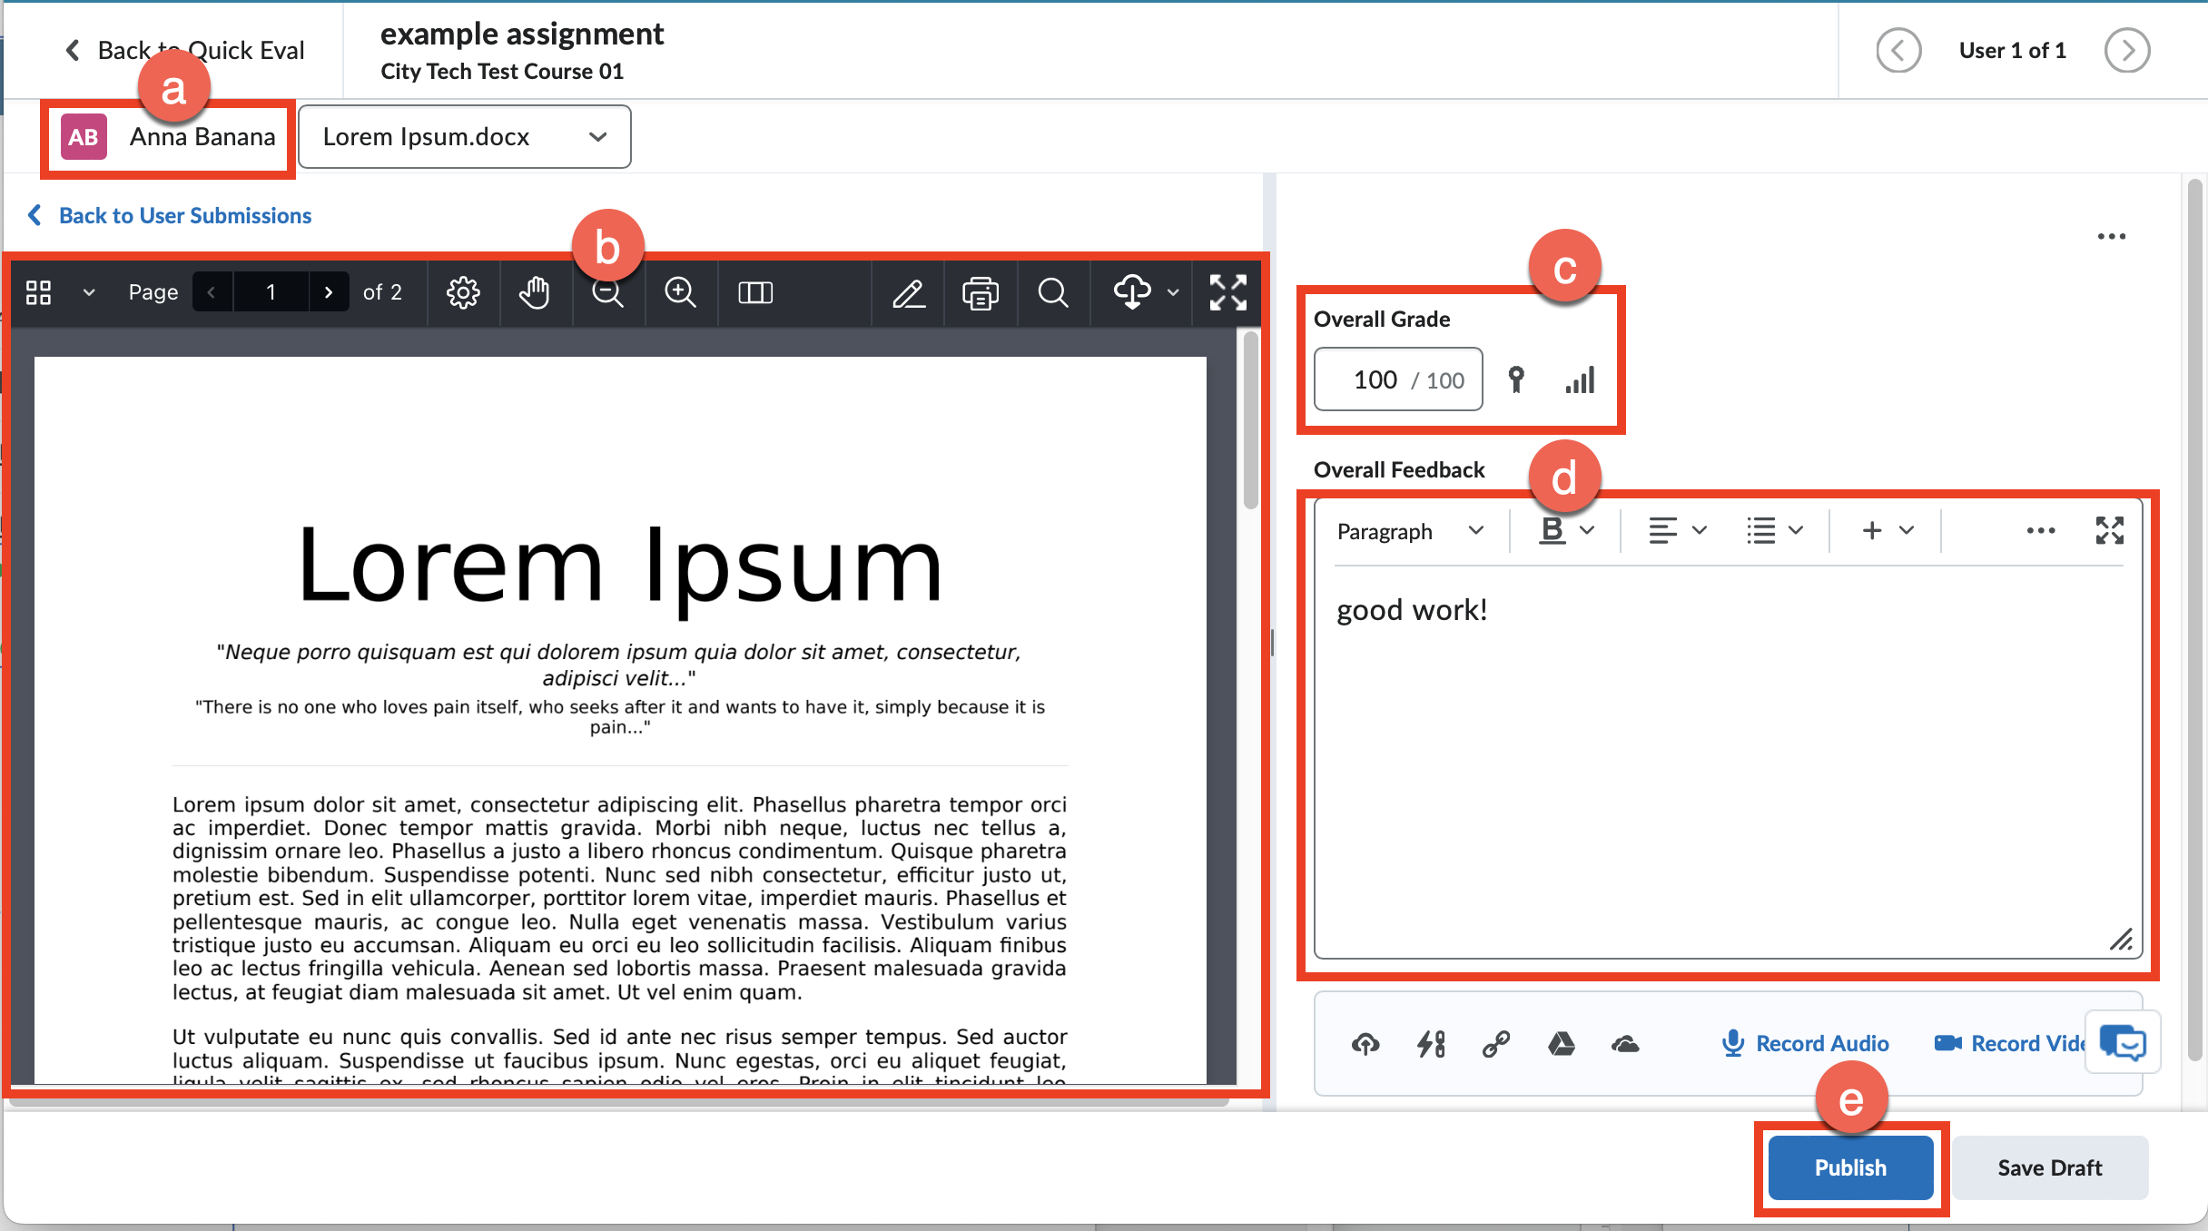

  - Student’s Name.
  - Student’s submission.
  - Overall Grade: Enter the grade.
  - Overall Feedback: Enter feedback for your student.
  - Publish: Publish the grade.

- Click on Activities tab to view details for the assessments in your course.
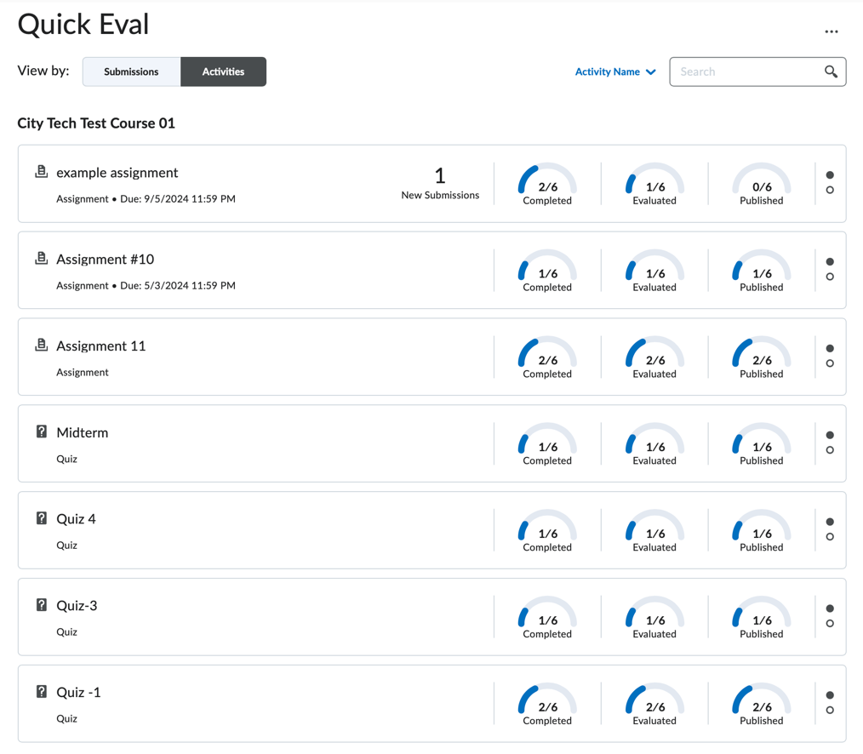

View Quick Eval from the College Homepage:
- From the college home page, click on Quick Eval.
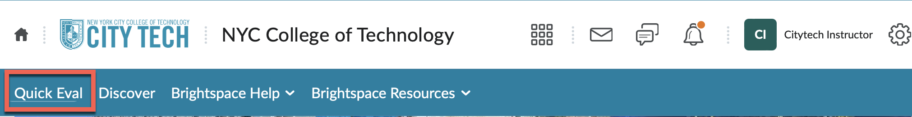
- Review all ungraded submissions from your students across multiple combined courses.
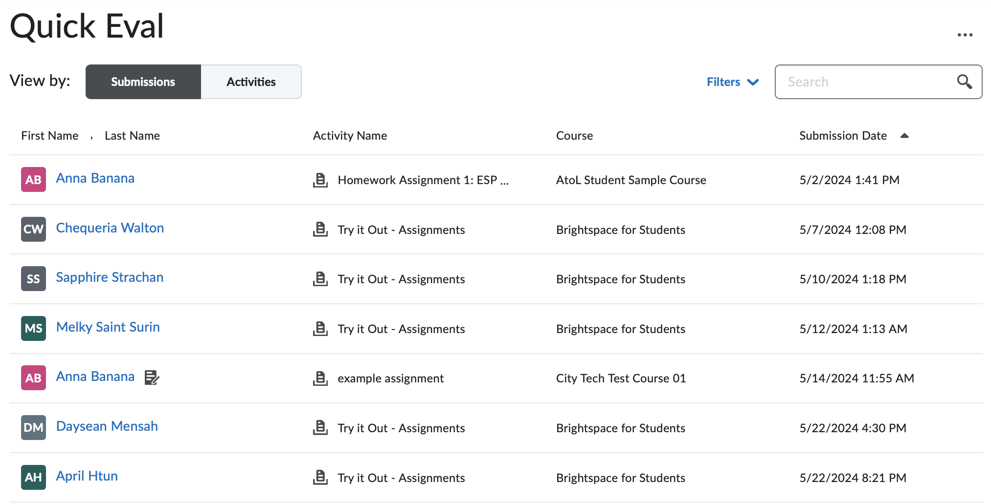
- Review steps 3 - 6 to view a student’s submission from the section above.

How to Use Brightspace Reports
- From the course home page, click Content.
- Click on Table of Contents from the side bar.
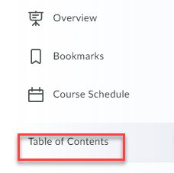
- Click Related Tools -> View Reports.
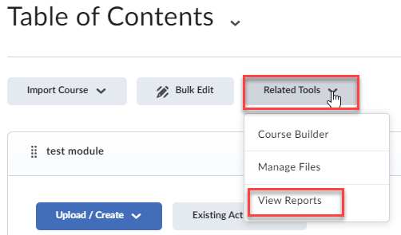
- Reports:
  - Content: Displays the number of students who have viewed each item and the duration they spent on it.
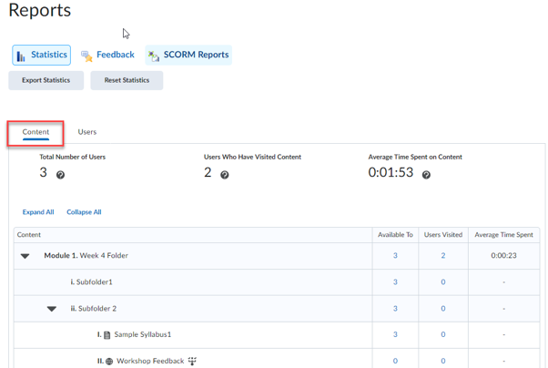
  - Users: The user view indicates the number of items each student has accessed, along with additional details for each individual student
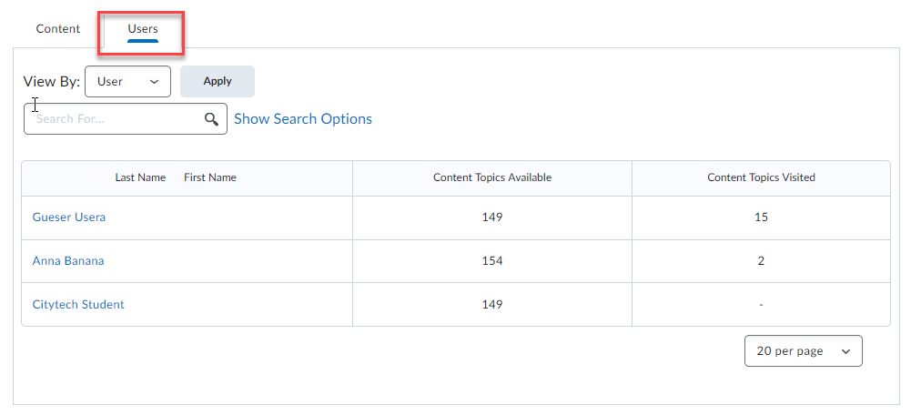
Note: You can view additional reports with Class Progress, refer to How to View the Class Progress.

How to Export Course Materials from Blackboard
- Log-in to Blackboard.
- Select the course you want to export.
- Click on Packages and Utilities under Course Management.
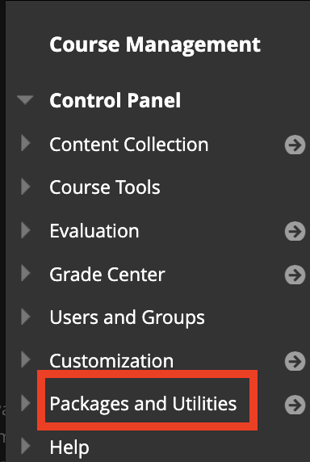
- Select Export/Archive Course.
- Click on Archive Course tab.
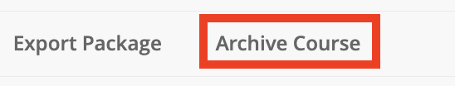
- Select the settings:
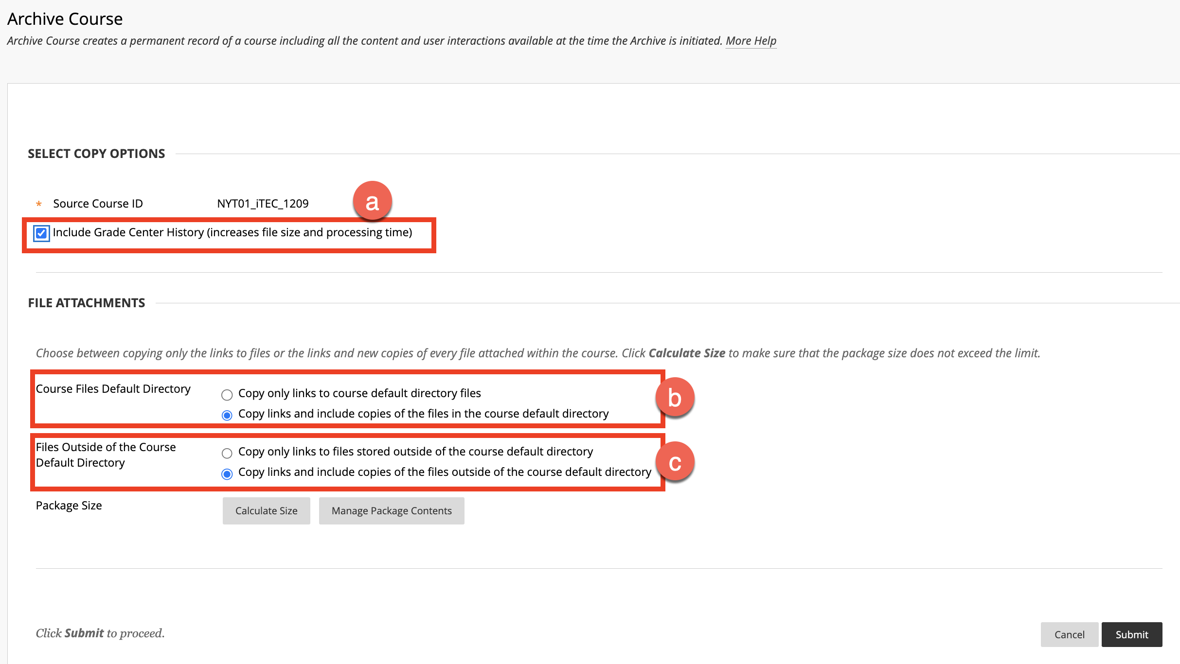
  - Select the checkbox if you would like to include the grade center history. (Optional)
Note: This can be used if a student decides to contest their grade.
  - Course Files Default Directory: Select Copy links and include copies of the files in the course default directory.
  - Files Outside of the Course Default Directory: Select Copy links and include copies of the files outside of the course default directory.
- Click on Submit.
- Click on Refresh to view your package.
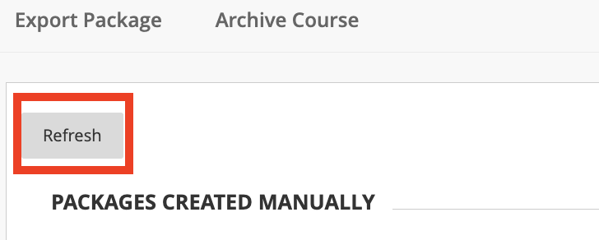
- Click on the link to download the package to your computer.
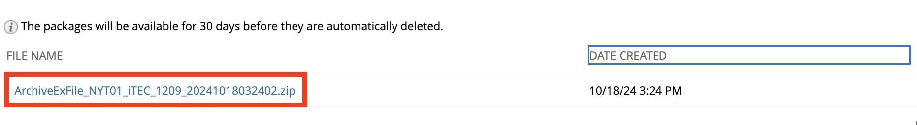

How to Import Course Materials from Blackboard to Brightspace
- From the course home page, click on Course Tools -> Course Admin -> Import/Export/Copy Components.
- Select Import Components and click Start.
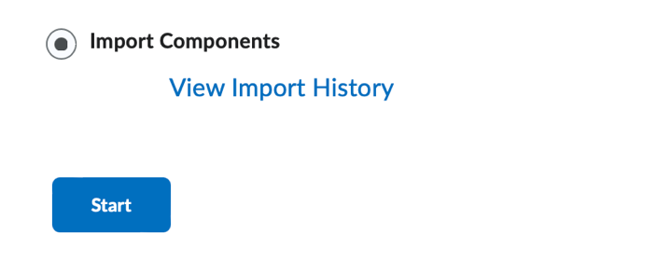
- Click the Upload button or drag and drop the zip package from Blackboard that you previously downloaded to your computer.
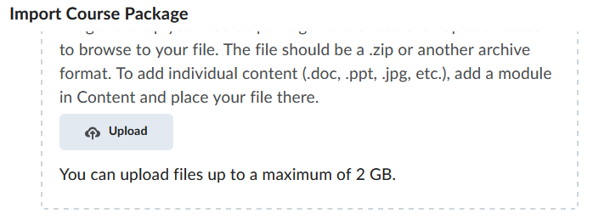

- Click on Import All Components.
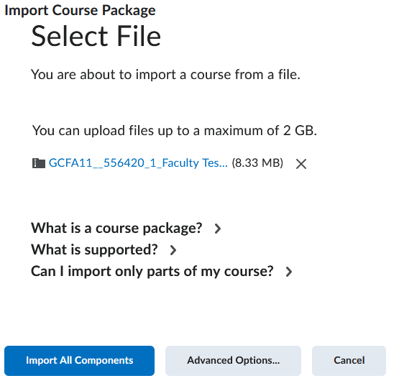

Note: For exporting a package from Blackboard, refer to the How to Export Course Materials from Blackboard section.

- View the conversion process.
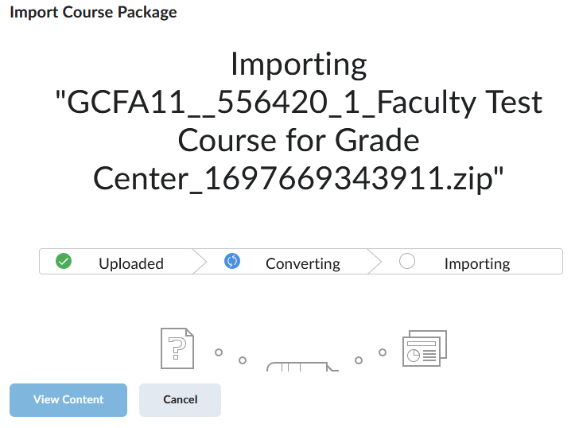

- To view the content within the package, click View Content.
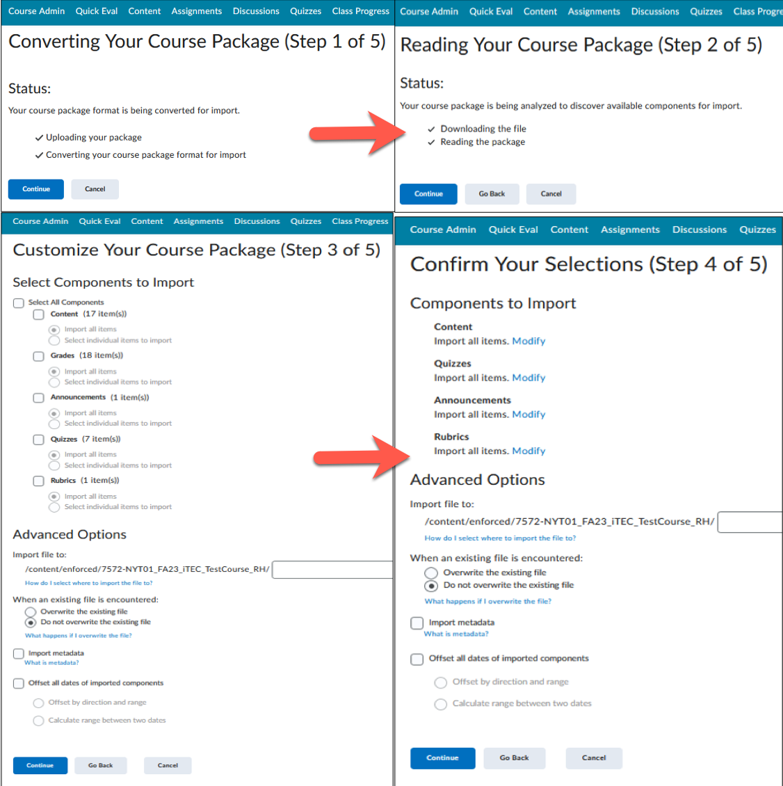
- After the import, review the content or materials to ensure everything has been imported correctly.
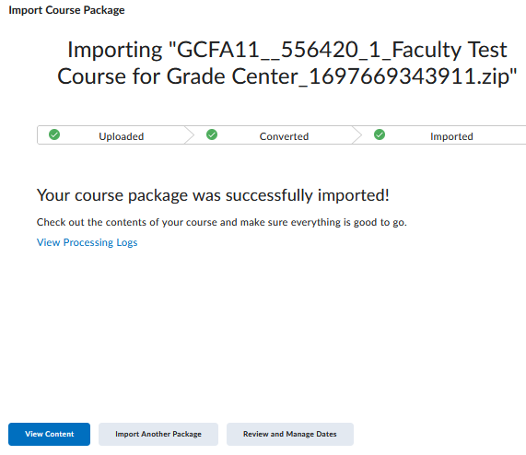

How to Copy a Brightspace Course
Copy components or content from one course to another, avoiding the need to create everything from the beginning.
- Select the destination course (course you want to copy content to).
- Click Course Tools -> Course Admin.
- Select Import/Export/Copy Components.
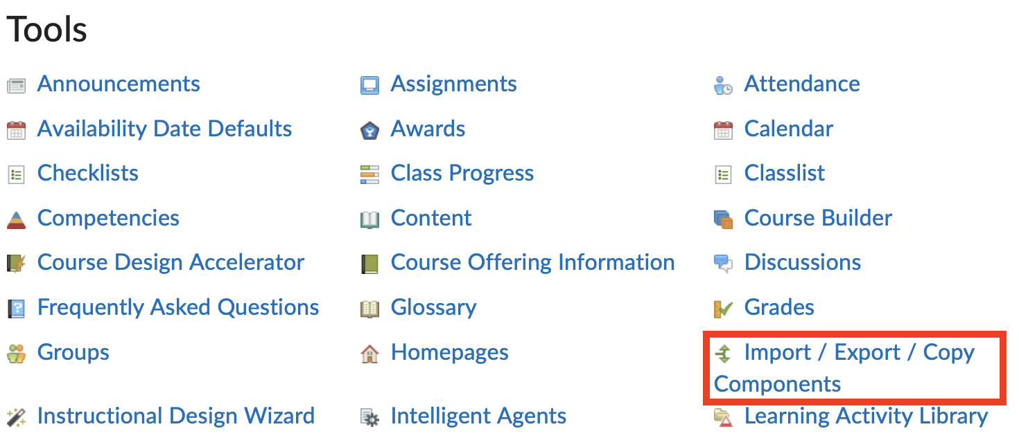
- Select Copy Components from Another Course -> Search for offering.
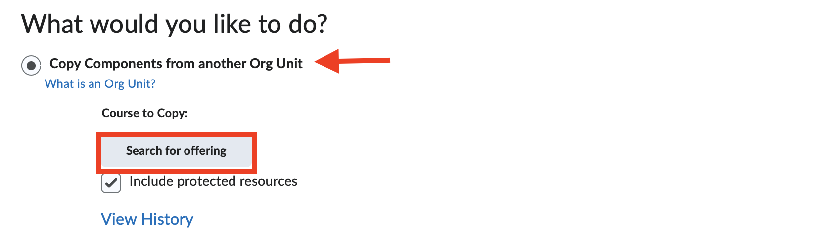
- Search for Offering:
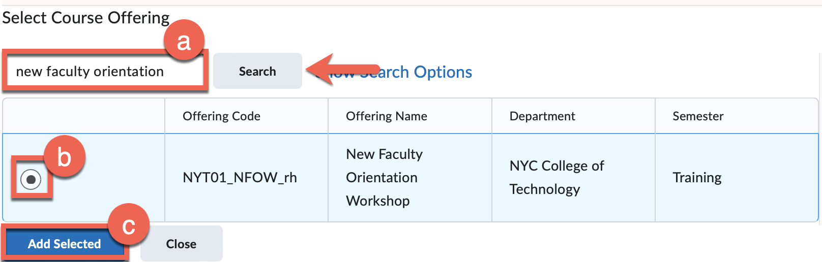
  - Locate the course you want to copy from (source course) and click Search.
  - Select the radio button for the source course
  - Click on Add Selected.
- Click on Copy All Components.
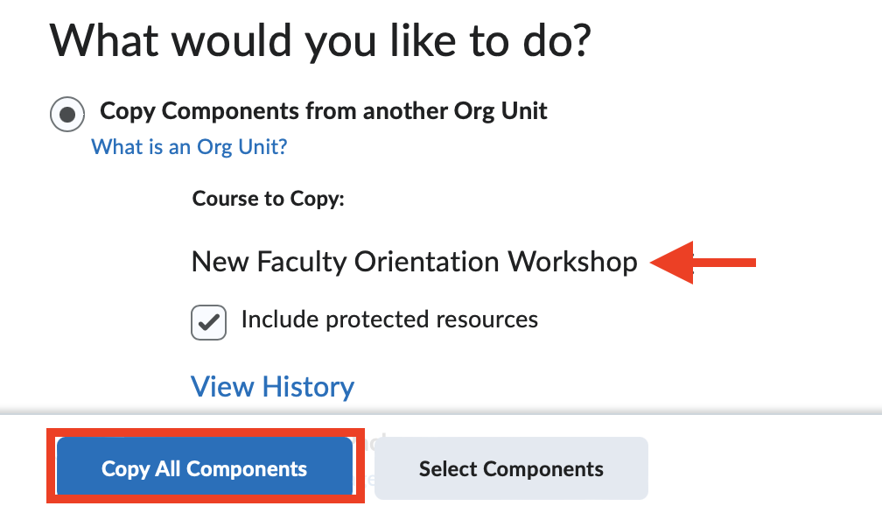
- The course copy process will start.
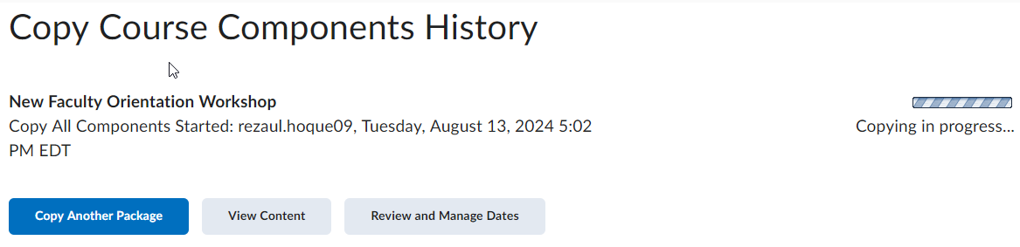
- You will receive a confirmation prompt when the course copy has been completed.
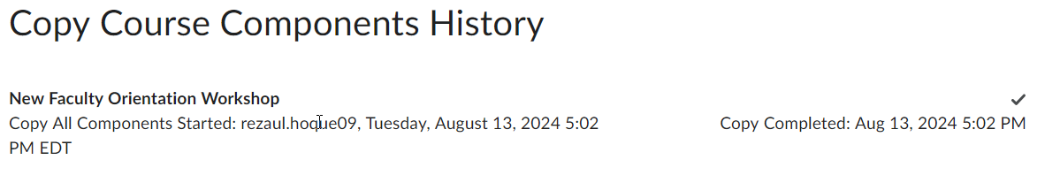

How to View a Course as a Learner (Student)
- From the top-right corner, select your name.
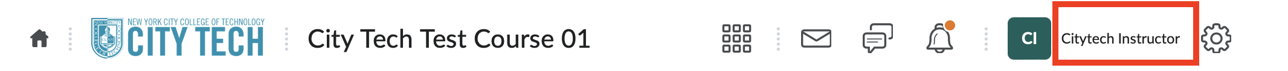
- Click on View as Learner.
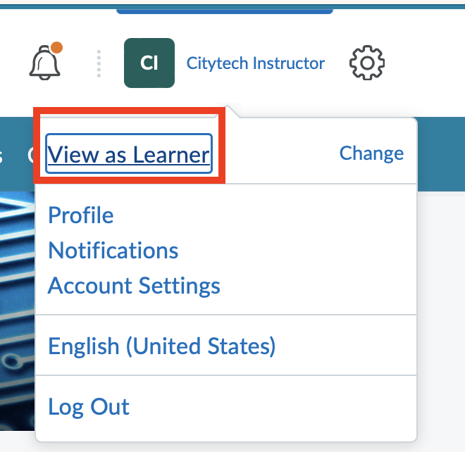
- To remove Learner mode, select your name.
- Click on the X mark.
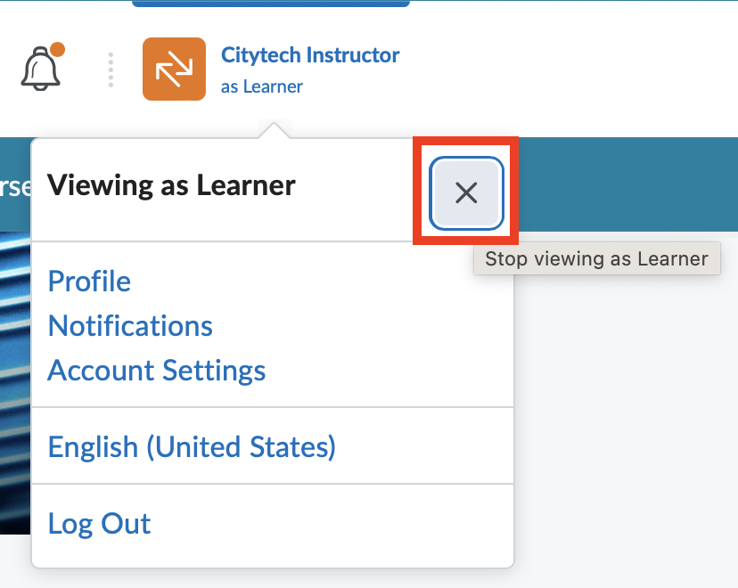

How to Create a Demo Student
Instructors can create a demo student to preview a course from a student’s perspective. As a demo student, instructors can fully interact with the course as a student would, including completing quizzes, submitting assignments, and checking grades and feedback.
Important
      - A demo student is associated with an individual course.
      - Only one demo student at a time can exist in a course.
      - Demo students should be deleted once instructors are finished previewing the course so as not to affect class data.
- From the course home page, click on Course Tools -> CUNY Demo Student.
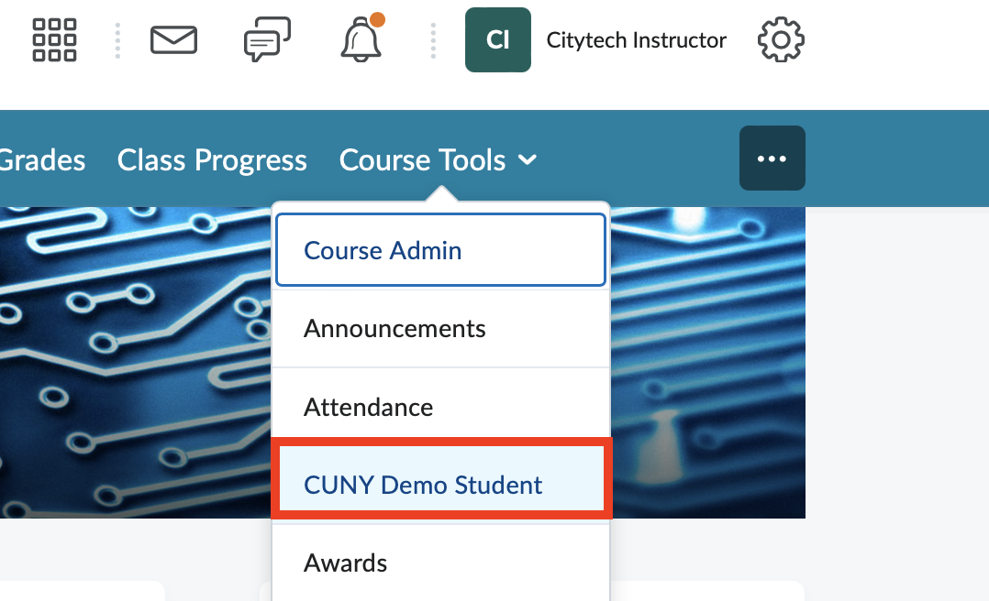

How to add a Banner (Header Image)
- From the course home page, hover over the banner.
- Click on the ellipsis icon and select Change Image.
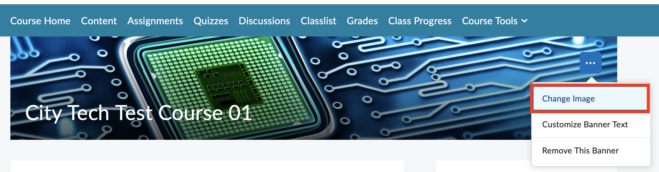
- Select an image or upload your own by clicking on Upload.
- If you are uploading an image, click My Computer and drag and drop a file from your computer.
- Click Add.

Additional Resources
- Brightspace Phone Support: 1-888-895-2511 (24 hours, 7 days a week)
- AtoL One-on-One Support: Please visit the AtoL One-on-One Support page
- Brightspace Workshops: Please visit the AtoL Faculty Brightspace page
- AtoL Videos: Please visit the AtoL YouTube Channel
- Grade

