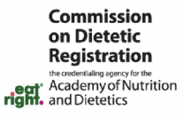
Continuing Professional Education Certicate of Attendance
-Attendee Copy-


participant Name:Yingyi Deng
Participant cDR Number:
provider Name: Hero Bread provider code: 4394F85
Activity Title: Fiber Forward: Resistant Starch, TikTok Trends, & Insights for the Modern RD

QR code

Activity Number: 18987

Date completed: 11/04/2025
Number of cpE US Awarded: 1

performance Indicator(s): 5.1.1, 9.1.1, 9.2.2, 9.2.4
provider Logo


provider signature Retain original copy for Records

