ENGL 21007
Andrea Kodra
Introduction To “The Steam Boiler”
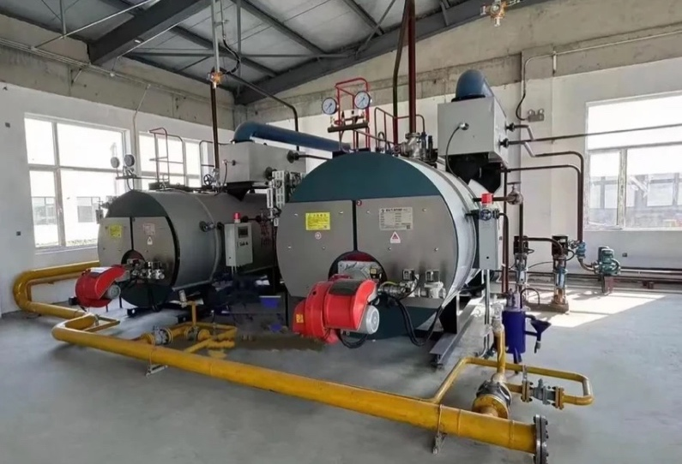
A steam boiler is a machine that heats water until it turns into steam, which is then used to transfer energy for heating and power applications. Although this process may seem simple, steam boilers have played a major role in shaping modern technology. Before electricity became widely available, steam-based systems were among the primary methods used to generate and distribute energy. Steam boilers heated buildings, powered factory equipment, and supported transportation systems such as steam locomotives, making them essential to everyday life during the early stages of industrialization.
Figure 1 “Steam Boiler.” Bosch-IndustrialHeat.com, Feb 4th 2023, https://www.bosch-industrial.com/global/en/ocs/commercial-industrial/steam-boilers-669471-c/

As shown in Figure 1, a basic steam boiler system consists of a heat source, a water-filled chamber, and pipes that carry steam to its destination. Understanding how water is converted into steam and circulated through a system helps explain why steam boilers were so effective and why their basic design principles are still used today.

History
Steam boilers became widely used during the Industrial Revolution in the late 1700s, when societies began relying more on machines instead of manual labor. Engineers discovered that when water is heated inside a sealed container, the steam produced creates pressure strong enough to do useful work. Early steam boilers were not very safe or efficient, but over time, engineers improved their designs by using better materials and safety features. These improvements allowed steam boilers to become more reliable and widely used across many industries.
Figure 2 The History of Cleaver-Brooks Hydronic Boilers, 14th May, 2019,https://www.youtube.com/watch?v=UR9XI5g17LE
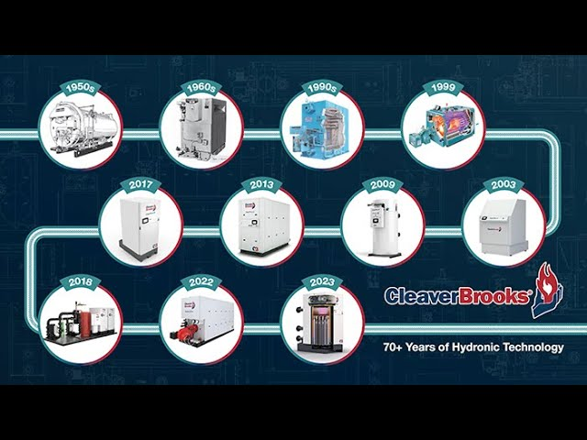
Even today, steam boilers are still important. They are commonly used in hospitals, schools, and large buildings to provide heat, as well as in various industrial processes. However, for the sake of simplicity, this technical description will focus specifically on steam boilers used in heating systems. Focusing on heating systems makes it easier to understand how steam boilers work without getting into more complex industrial applications.
By looking at steam boilers through their use in heating systems, it becomes easier to see how basic ideas like heat, pressure, and energy are applied in engineering. This example shows how engineers take simple concepts and turn them into practical systems that people depend on every day.
Technicality – “How steam is created.”
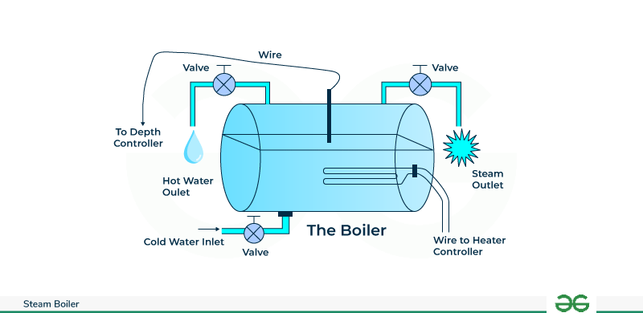
Figure 3 "Steam Boiler Diagram." HealingWithHorsesRanch.com, Feb 4th, 2024, https://www.healingwithhorsesranch.org/?l=74705984061840

1. Fuel and air enter the burner
The process begins when a thermostat calls for heat. Fuel (such as natural gas or oil) and air enter the burner at the base of the boiler. The burner ignites the mixture, creating a controlled flame. This flame is carefully regulated so it produces steady heat without overheating the system.

2. Heat is transferred into the boiler water
The flame heats metal surfaces inside the boiler called heat exchanger surfaces or boiler tubes. Hot combustion gases move through these tubes, and heat transfers through the metal into the surrounding water. The metal never touches the water directly but acts as a bridge that transfers energy safely.

3. Boiler water temperature rises
As heat continues to enter the system, the water temperature increases. The boiler maintains a specific water level using sensors and automatic valves. If the water level is too low, the boiler shuts down for safety. At normal pressure, water heats toward 212°F (100°C).

4. Water changes into steam
Once the water reaches its boiling point, it changes phase into steam. Steam contains much more energy than hot water because it stores both heat and latent energy. As steam forms, pressure begins to build inside the boiler vessel.

The Heat Cycle
By Step 4, the boiler has successfully heated water until it turns into steam. At this point, we know heat has been created, but heat sitting inside the boiler alone is not useful. For the system to warm a building or provide hot water, that heat must be moved from the boiler to the spaces and fixtures where people need it. The following steps explain, in simple terms, how the system captures the energy in steam, delivers it to rooms and water systems, and then safely recycles the water to repeat the process also known as “The heat cycle”.
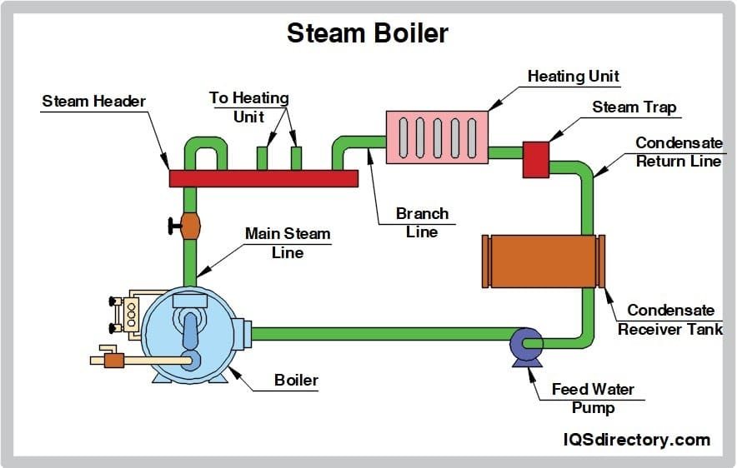
Figure 4 "Heat Cycle Diagram" , HealingWithHorsesRanch.com, Feb 4th, 2024, https://www.healingwithhorsesranch.org/?l=74705984061840

5. Steam naturally moves out of the boiler
Steam takes up more space than water, which causes pressure to build inside the boiler. Because of this pressure, steam naturally flows out of the boiler into connected pipes. No pump is needed to push the steam—pressure does the work.

6. Steam travels through pipes to where heat is needed
The steam flows through metal pipes that run throughout the building. These pipes guide the steam toward radiators, baseboard units, or heating coils. The piping system is designed so steam can reach many rooms at once.

7. Steam releases heat into rooms
When steam enters a radiator or heating unit, it touches cooler metal surfaces. As this happens, the steam cools down and turns back into liquid water. This change releases heat into the metal, which then warms the surrounding air in the room.

8. Rooms are heated by warm air, not steam
People are not heated by steam directly. Instead, the radiator heats the air around it. Warm air rises, cool air moves in, and this circulation gradually warms the entire room.

9. Steam turns back into water after giving up heat
After releasing its heat, the steam becomes liquid water again. This water is still warm and is now called condensate. The system is designed so this water does not stay trapped in the radiator.

10. Condensate flows out of the heating units
Special devices or sloped pipes allow condensate to leave the radiator while keeping steam inside. This step is important because trapped water would block incoming steam and reduce heating efficiency and cause the radiators to make loud banging noises.

11. Condensate returns to the boiler
The warm condensate flows back to the boiler, either by gravity or with the help of a pump. Returning this water saves energy because the boiler does not need to heat cold water from the beginning again.

12. Steam heat can also make hot water
Some systems use steam to heat water for sinks and showers. Steam passes through a metal coil or heat exchanger, warming clean water without mixing with it. The steam then condenses and returns to the boiler just like the heating steam.

13. The process repeats as long as heat is needed
Once the building reaches the desired temperature, the boiler slows or stops. When more heat is needed, the boiler creates more steam, and the entire process begins again automatically.

Conclusion
The steam boiler is an efficient and reliable system that converts water into steam in order to store and transport thermal energy. Once produced, the steam travels through pipes to provide space heating or hot water. As illustrated in Figure 2, the steam releases its energy by condensing back into water, known as condensate, which is then returned to the boiler to be reheated. This continuous cycle allows the system to operate for long periods while conserving both energy and water.

Although steam boilers are often associated with the Industrial Revolution, they remain relevant in modern life. Today, steam boilers are still widely used in large buildings, hospitals, universities, power plants, and industrial facilities because of their durability, efficiency, and ability to deliver heat over long distances. Many of the principles developed during early steam systems such as pressure regulation, heat transfer through condensation, and water reuse are still applied in modern boiler technology. This lasting use demonstrates that steam boilers are not just historical devices, but foundational systems that continue to support modern infrastructure.

