Make a move, don’t be a fool

Enough is enough. Over the past few months, there has been different circumstances in which student from CUNY colleges and certain private colleges across the country have been affected by the recent actions of President Donald Trump. International students who currently hold visas to study in the U.S, are being affected by the recent round of visa revocation actions. The current election of Donald Trump has forced new laws and actions across the country to target illegal immigrants who have crossed the country wrongfully. But, in these actions, student visa holders are also being affected in a certain way. Across the country, there have been over 1,500 students who’ve had their visa revoked for no reason. These students now live in fear, due to the possibility of being arrested and sent back to their country.

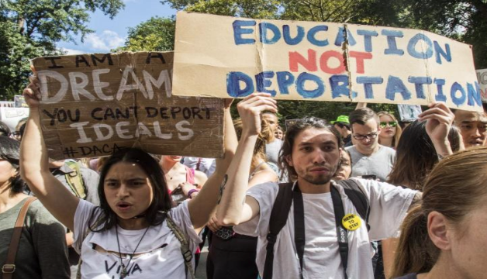

The initial visa revocations have had lasting impacts, with some students losing job opportunities or leaving the country due to fear of detention. Legal experts warn that the episode could harm the United States' reputation as a welcoming destination for international students. As the situation evolves, universities and advocacy groups continue to monitor the government's actions, emphasizing the need to uphold constitutional rights and ensure due process for all students.
