VOL CLXIX… No. 21,100 NEW YORK WEDNESDAY, MAY 14, 2025. $1.00
Do Right and
Avoid Wrong!
“The Quickest and
Most Reliable News Source"
DEPORTATION AFFECT STUDENTS IN COLLEGES ACROSS THE COUNTRY

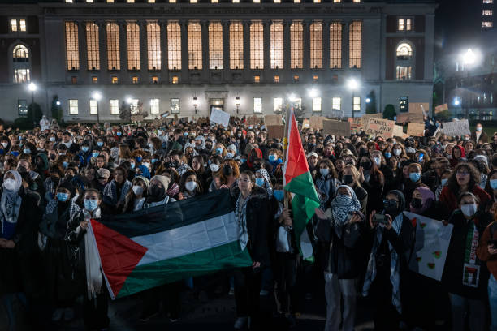

Enough is enough. Over the past few months, there has been different circumstances in which students from colleges around the nation have been affected by the recent actions of President Donald Trump. Students across various colleges live in fear day-to-day due to the possibility of getting detained by ICE officials. International students and even U.S citizen students are worried that one day, ICE will arrive to their colleges and begin calling students for a questionnaire.
Eventually, these questionnaires lead to detainment and put students at risk of deportation. Another action that has been affecting international students is visa revocations. In the past three months, there has been over 1,500 students across the country who’ve had their visa revoked for unknown circumstances.
Although there is no exact reason for these visa revocations. Students have been gathering to protest against these actions. In recent weeks, we have encountered other international students who have been detained by ICE for taking part of Pro-Palestine protests.. Students believe that they are getting persecuted for speaking out on the current world issues.
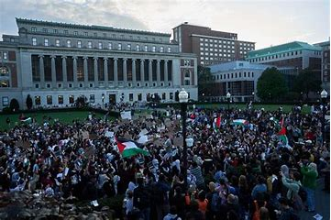
There is extreme fear in these students nowadays and they truly believe that their freedom of speech right is being violated. Currently, a Columbia University student, Mohsen Mahdawi was recently arrested in Vermont after having an appointment with immigration for his U.S citizenship. Mohsen was scheduled a U.S. naturalization interview with customs and he was arrested at his interview place. He remained detained by ICE officials and there was no news about him. That was until a couple of days ago. He was released by ICE but with no news on whether he will stay on the country or eventually he will get deported. It is still unknown but, it’s one of the many stories which scare international students across the country.
There has been a numerous count of students who have also been arrested by ICE and body knows what their status is. It has become a true mess on what’s current going on. It is unfair to the international students who come to this country legally to have a better education. Every student should be allowed to have a good education without having to fear that one day they will be deported back to their countries.
MAKE A MOVE, DON’T BE A FOOL
Make sure to join us this week for an all-day protest against Censorship and Freedom.
Students have gathered in NYC and have collectively scheduled a protest against the violation of their freedom of speech and the deportation of students across the country. It is important that everyone is aware of the current issues going on because it is a difficult moment which students are going through, and it is important for them to know that we are here to help and protect them.
The Details of the protest are as follows:
- Location: Central Park
- Time: 10:30 AM
- Bring Posters and Flags to protest for our rights!!!

