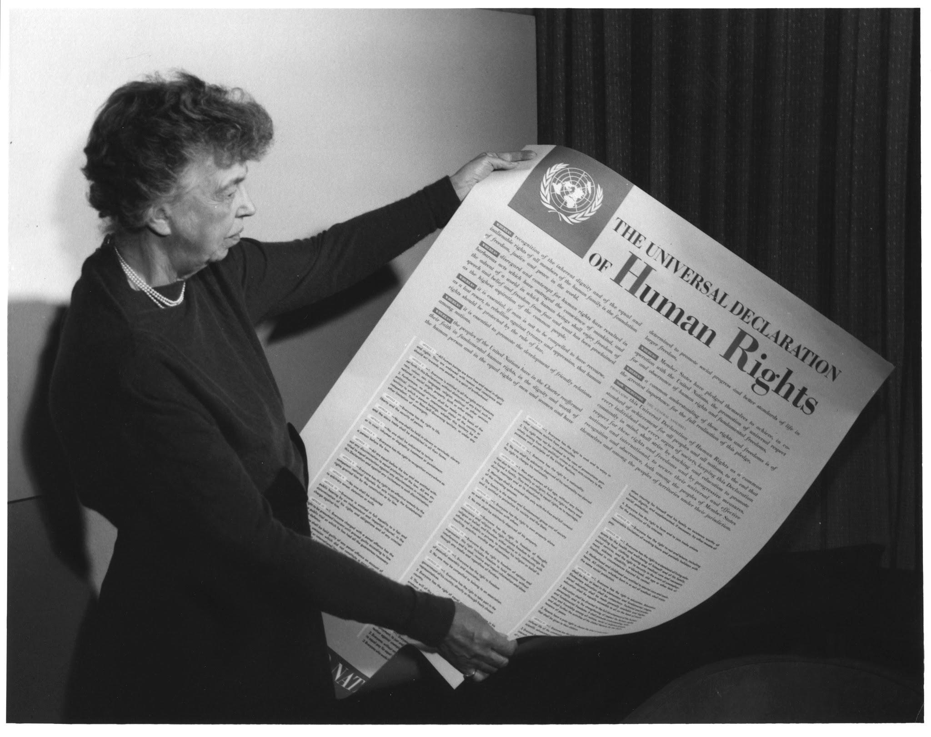
Exploring the Universal Declaration of Human Rights: Social Justice Writing Prompts

Prepared by Tim Krause, ESOL Instructor
Portland Community College, 2020

Introduction

This collection of social justice writing prompts introduces students to the United Nations’ Universal Declaration of Human Rights (UDHR). The UDHR can serve as the course theme for a whole term or the inspiration for an individual assignment. Students can read the UDHR in both English as well as their first language. Students then explore topics of their choice from the UDHR in a variety of essay formats.

Through these writing prompts, students gain a general understanding of the purpose and content of the UDHR. They identify political and social tensions around human rights, and they draw connections between lofty aspirations and real-world situations, not only in the U.S., but in their home country and the various cultures of their classmates. Students learn to express in writing their ideas about issues that are important to them, while also contextualizing the issues that impact their classmates. In other words, these writing prompts help students to think more about themselves and their relationship with the world around them.

Using the UDHR as a framework for a writing class has several advantages:
- Its contents are meaningful and relevant to both individual experiences and current global events.
- It can be useful to study how the same message is expressed in various written forms, from the original formal language to simple English language to a student’s first language.
- Using the UDHR provides a unique structure in which to compare and contrast a variety of cultural norms and personal philosophies.
- Because the document was originally written in 1948, there is room for students to consider shifts in world culture over time and imagine what could be changed or added to this historic document.
- The scope of the UDHR is large enough that it can accommodate student individuality within a common theme. It also provides multiple ways for students to engage using different rhetorical styles.

Contact

Tim Krause, ESOL Instructor
timothy.krause@pcc.edu


This project was supported by a grant from the
Portland Community College Internationalization Initiative.

Unit 1: Getting Started

CLASS PREPARATION
Students first brainstorm “human rights” and “universal human rights.”

Students watch a video about human rights and the UDHR:
- What Are the Universal Human Rights?
- The Story of Human Rights
- The Universal Declaration of Human Rights - Add Your Voice

Students read and discuss the UDHR in simple English on the Youth for Human Rights site.

Students locate the original text of the UDHR on the United Nations site.

Students locate the UDHR translation into their first language on the United Nations site. Note: If the translation is not immediately displayed, it might be because the website does not support the character set of its alphabet. Look for the PDF icon to open a PDF document with the text in the language’s native script.

Students share reactions to the document, such as:
- What did you know about the UDHR before this class?
- What was new or surprising to learn about the UDHR?
- What intrigues you about the UDHR? What do you want to know more about?
- Compare/contrast the different formats of the same document. How are they the same? How are they different? Why are they different?

Additional resources:
- Facing History and Ourselves
- Illustrated Version of the Universal Declaration of Human Rights
- Wikipedia entry for Universal Declaration of Human Rights (available in multiple languages)
- NPR story about the UDHR

DISCUSSION BOARD PROMPT
Think about writing in English and writing in your first language. What is the same? What is different? What is easy? What is difficult? What cultural differences are there in addition to vocabulary and grammar? Write a short paragraph now. Then return later to reply to the posts of at least two classmates.

DISCUSSION BOARD PROMPT
In your opinion, what are some rights that all people around the world should have? Identify and describe three. Write a short paragraph now. Then return later to reply to the posts of at least two classmates.

EMAIL PROMPT
The UDHR will be the inspiration for your writing this term. To choose your first topic, follow these steps:
- We read and discussed the simple English version of the UDHR in class. Now go to the original version of the UDHR and review the 30 articles, or rights. (Remember: You can also read this in your first language so that you understand it better.) Choose a specific word, concept, or idea that you want to study.
- Look up the word, concept, or idea in a dictionary (Macmillan American Dictionary and Cambridge English Learner’s Dictionary are two good, free online dictionaries, but you can use any dictionary you like; do not use only Google Translate). Record the information like this:
- Word, concept, or idea
- Name of dictionary that you used
- Dictionary definition (copy it in "quotation marks")
- Write a definition of this word in your own words (paraphrase)
- Send all of these things to your instructor in an email. Here is an example:
Hello, Teacher,

My name is Ordelia Halsey. I am in your Level 7 Writing class. Here is the word from the Universal Declaration of Human Rights that I want to use for my definition essay:

Word: liberty

Name of dictionary: Macmillan American

Dictionary definition: "the freedom to think or behave in the way that you want and not be controlled by a government or by other people"

My definition: I can do what I want without the government stopping me.

Please let me know if this is a good choice for my definition essay.

Thank you!

Ordelia Halsey
Then check your email for a reply from your instructor. Your instructor will tell you if this word is suitable for this assignment, or if you should choose another. Your instructor will also help to make sure you understand the word that you choose before you start writing your essay.

COMPANION ACTIVITIES
Suggested composition lessons:
- Writing process
- Formatting of academic documents
- Basic paragraph and essay structures
- Reported speech (including paraphrasing, summarizing, and quoting)

Suggested grammar lessons:
- Verb tenses
- Four most common errors in ESOL writing (comma splices, fragments, run-on sentences, and subject-verb agreement)

Suggested vocabulary lessons:
- Key academic words from the 30 articles of the UDHR in simple English
- Tips for how to study new vocabulary

Unit 2: Definition Essay

CLASS PREPARATION
Students learn and practice various strategies for definition essays as well as the grammar and vocabulary to support them. The instructor’s examples and model essay use a topic from the UDHR. Then students choose a term from the UDHR to define in a definition paragraph. Students expand this paragraph into a full essay. After students receive feedback from the instructor on the draft, they write a revision. After students receive feedback from the instructor on the revision, students share their full essay with the class. Students read and respond to at least one classmate’s essay in the form of a short letter: What did you like about this essay? What worked well? Give specific examples and explain your opinion.

DISCUSSION BOARD PROMPT
Think back to the email proposal you sent to your instructor. What word, concept, or idea did you choose from the UDHR? How do you define it? Try to use at least three of the definition strategies that we learned in class. Write a short paragraph here now. Then return later to reply to the posts of at least two classmates.

DISCUSSION BOARD PROMPT
Choose one of the following quotes. Explain it in your own words. Write a short paragraph now. Then return later to reply to the posts of at least two classmates.
- "To deny people their human rights is to challenge their very humanity." - Nelson Mandela
- "A right delayed is a right denied." - Martin Luther King, Jr.
- "We cannot all succeed when half of us are held back." - Malala Yousafzai
- "Human rights are women's rights, and women's rights are human rights." - Hillary Clinton
- "Be the change you want to see in the world." - Mahatma Gandhi
- "In a few decades, the relationship between the environment, resources, and conflict may seem almost as obvious as the connection we see today between human rights, democracy, and peace." - Wangari Maathai

DEFINITION PARAGRAPH / DEFINITION ESSAY PROMPT
For this assignment, imagine that you are ready to leave PCC and continue your studies at International University. You have completed the application and taken the placement tests. The admissions office knows that you are a bright student. However, they are also looking for students who understand social justice. Therefore, they ask applicants to write an essay to define an idea from the UDHR. Start with the paragraph that you wrote. Expand that single paragraph into a full essay. Choose one or more definition strategies and add sufficient detail and description to extend the meaning beyond the dictionary.

COMPANION ACTIVITIES
Suggested composition lessons:
- Purpose and structure of definition essays
- Writing stronger introductions
- Basic internet research

Suggested grammar lessons:
- Adjective clauses
- Adverb clauses

Suggested vocabulary lessons:
- Common words and phrases used in definition essays
- Academic Word List vocabulary from model definition essays

Unit 3: Cause-and-Effect Essay

CLASS PREPARATION
Students learn and practice various strategies for cause-and-effect essays as well as the grammar and vocabulary to support them. The instructor’s examples and model essay use a topic from the UDHR. Students then choose an issue they wish to examine from the UDHR. They will explore its causes, its effects, or both. As before, they begin with a paragraph. Students then expand this paragraph into a full essay. After students receive feedback from the instructor on the draft, they write a revision. After students receive feedback from the instructor on the revision, students share their full essay with the class. Students read and respond to at least one classmate’s essay in the form of a short letter: What did you like about this essay? What worked well? Give specific examples and explain your opinion.

DISCUSSION BOARD PROMPT
Choose a new topic from the UDHR. Think about its causes or effects. Write a short, clear cause-and-effect paragraph now that simply identifies the topic or situation and lists its causes or effects (not both). Then return later to reply to the posts of at least two classmates. Example: People often move to another country to find a better life. For some, it is a choice and an opportunity. For others, however, the move is a necessity. They need protection, so they seek asylum, which is one of the basic guarantees included in the Universal Declaration of Human Rights. According to the U.S. Citizenship and Immigration Services, the primary reasons that people request asylum in the United States are fear of persecution due to race, religion, nationality, membership in a particular social group, and political opinion. Understanding the reasons for asylum can help others to create a safer space that respects the rights of all people.

DISCUSSION BOARD PROMPT
One effective way to wrap up an essay is to offer a prediction. Start a new post. Copy and paste the conclusion from your cause-and-effect essay. Then add a final thought. Explain to the reader what happens either when the basic human right is maintained or when the basic human right is taken away. Then return later to respond to the posts of at least two classmates.

ESSAY PROMPT
For this assignment, imagine that you work for the educational office of the United Nations. You will be hosting adult students from PCC. Your supervisor asks you to prepare a report about an important issue in the UDHR. What do you think PCC students should learn about this issue? You may choose to write about its effects so that students understand the scope of the problem. Or you may choose to write about its causes so that students understand what can (or cannot) be done to change the situation. You may also choose to write about how its causes and effects are a chain reaction and cannot be separated. Start with the paragraph that you already wrote. Expand that single paragraph into a full essay.

COMPANION ACTIVITIES
Suggested composition lessons:
- Purpose and structure of cause-and- effect essays
- Writing stronger conclusions
- Basic library research

Suggested grammar lessons:
- Noun clauses
- Passive voice

Suggested vocabulary lessons:
- Common words and phrases used in cause-and- effect essays
- Academic Word List vocabulary from model cause-and- effect essays

Unit 4: Discussion or Argument Essay

CLASS PREPARATION
Students learn and practice various strategies for discussion or argument essays as well as the grammar and vocabulary to support them. The instructor’s examples and model essay use a topic from the UDHR. Students then identify a basic human right that is missing from the UDHR or one that should be changed. They present both pros and cons for this addition or change. As before, they begin with a paragraph. Students then expand this paragraph into a full essay. After students receive feedback from the instructor on the draft, they write a revision. After students receive feedback from the instructor on the revision, students share their full essay with the class. Students read and respond to at least one classmate’s essay in the form of a short letter: What did you like about this essay? What worked well? Give specific examples and explain your opinion.

DISCUSSION BOARD PROMPT
Think back to the UDHR. It was written in 1948. A great deal has changed since then, from technology to cultural norms. Write a short paragraph now that answers the following three questions. Then return later to respond to the posts of at least two classmates.
- What is missing from the list of human rights? What should we add to the list? … OR ... What should be changed about the list?
- Why would some people disagree with you? Why would they think your idea should NOT be a human right?
- Why would some people agree with you? Why do they think it should be a human right?

Here is an example:
- The right to "erasure" -- in other words, the right to remove oneself from the internet and social media.
- Some people might think that some information -- such as criminal records -- should be public information. Others might say their freedom of speech allows them to publish information, including information about other people.
- The internet and social media are sometimes dangerous places. Criminals sometimes steal another user's identity. Furthermore, some people are private and do not like to share their personal information with strangers.

DISCUSSION BOARD PROMPT
The UDHR was published by the United Nations in 1948. However, many countries do not accept it as official law. Think about this. Why hasn’t this happened yet? What are the reasons for making it a law? What are the reasons for not making it a law? Write a short paragraph now. Then return later to reply to the posts of at least two classmates.

ESSAY PROMPT
For this assignment, imagine that you are writing an essay for a popular magazine. Readers of this magazine like to learn more about contemporary social issues. They want to hear all sides of a story so that they can make an informed decision. The magazine has many stories about the UDHR. Your editor, however, thinks it is old and needs to be updated. Your editor asks you to think about this: What human right would you add to the UDHR? Or what existing human right needs to be changed? Start with the paragraph that you already wrote. Expand that paragraph into a complete essay. At least one body paragraph should describe why some people would be against this idea. At least one body paragraph should describe why some people would support this idea. Optional: You may add your opinion in a final body paragraph or in the conclusion; however, your opinion is not required.

COMPANION ACTIVITIES
Suggested composition lessons:
- Purpose and structure of discussion or argument essays
- Supporting main points with more specific details
- Using outside sources of information
- Evaluating outside sources of information
- Effective use of writing tools

Suggested grammar lessons:
- Gerunds and infinitives
- Modal verbs and hedging

Suggested vocabulary lessons:
- Common words and phrases used in discussion and argument essays
- Academic Word List vocabulary from model discussion or argument essays

Unit 5: Wrap-up

CLASS PREPARATION
Students choose one of their previous essays to revise and publish in a class anthology.

DISCUSSION BOARD PROMPT
According to the Encyclopedia Britannica, Eleanor Roosevelt, the wife of President Franklin D. Roosevelt, was a diplomat to the United Nations and an important humanitarian. “She was, in her time, one of the world’s most widely admired and powerful women.” She once said, "Where, after all, do human rights begin? In small places close to home-so close and so small that they cannot be seen on any map of the world." What does this mean to you? What can we do here at PCC or in Portland? Why is it important? Write a short paragraph now. Then return later to reply to the posts of at least two classmates.

DISCUSSION BOARD PROMPT
Think back about your experience reading and writing about the UDHR. How did you feel at the beginning of the course? How do you feel now? What has changed for you personally? Write a short paragraph now. Then return later to respond to the posts of at least two classmates.

