JDK 21 Installation Guide -Windows
https://www.oracle.com/java/technologies/downloads/#java21
- Select JDK21 Tab.
- Select Windows Tab.
- Click the download link;
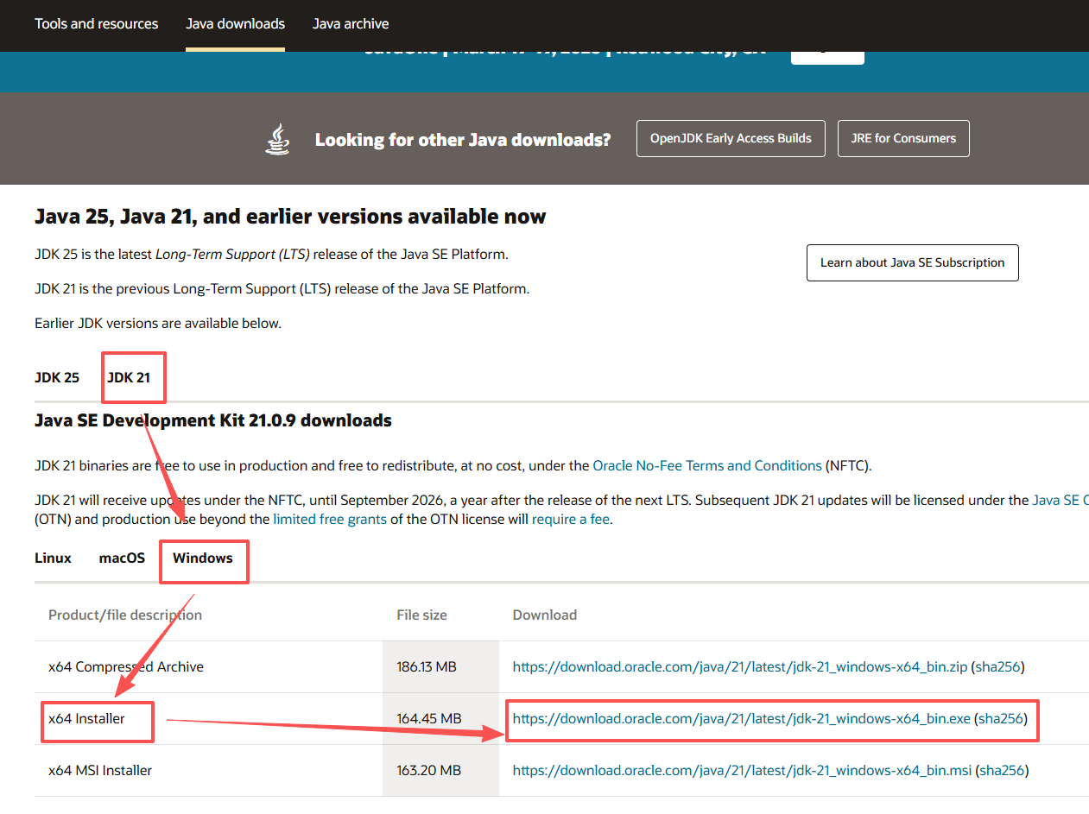
- Double click the downloaded file to install.
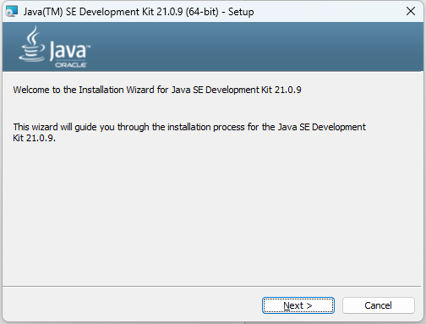

- Click Next, and select your installation folder. Please remember this folder path.
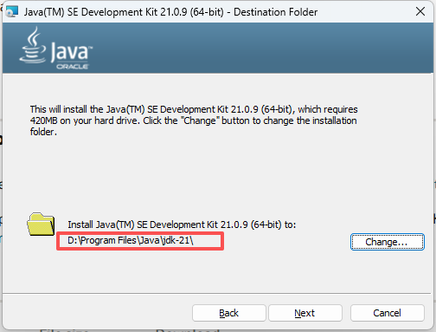
- Click Next and complete the installation.
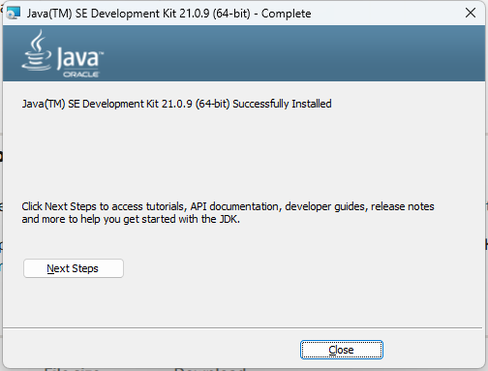
- Right click your icon “This PC” and select the properties
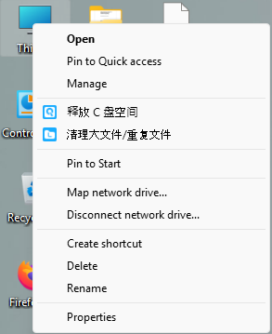
- Go to “System”, and then scroll down and click “advanced system settings”. A new small setting page appears. Select “Environmental Variables”.
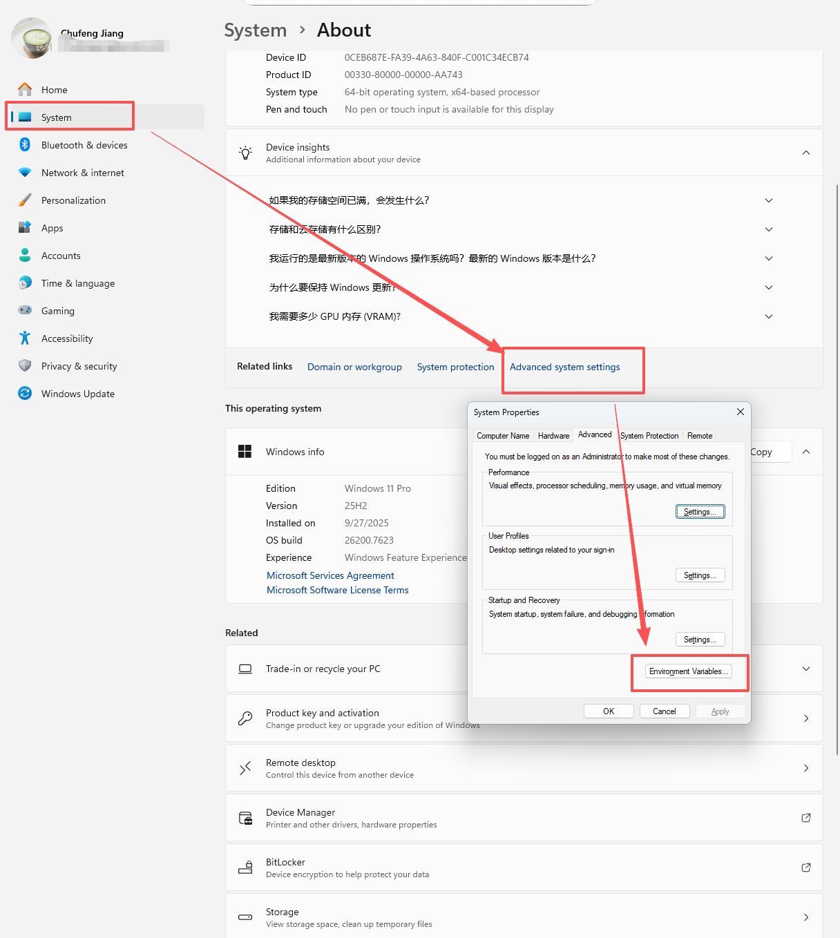

- Click “System Variables”, and select “Path”, then click “Edit”
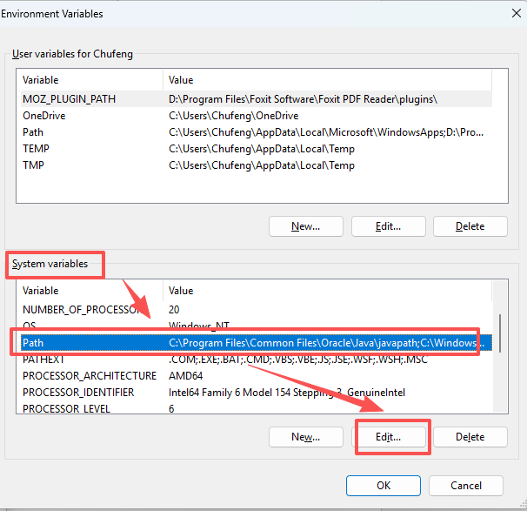

- Click “New” and add the path in step 5 joint with “\bin” to the row. Then click "OK”.
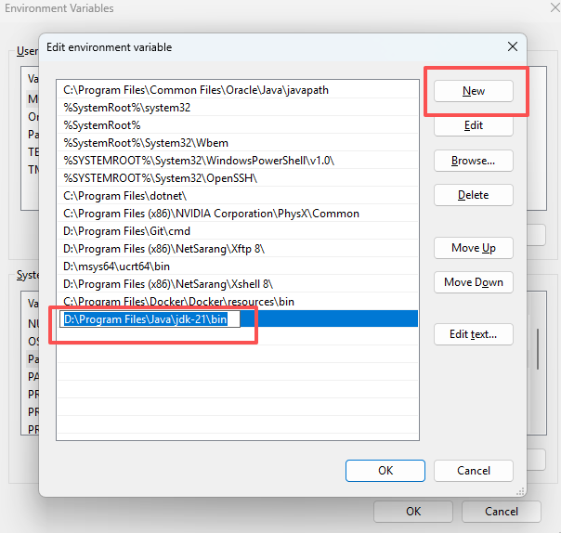

- Open your command prompt or Terminal.
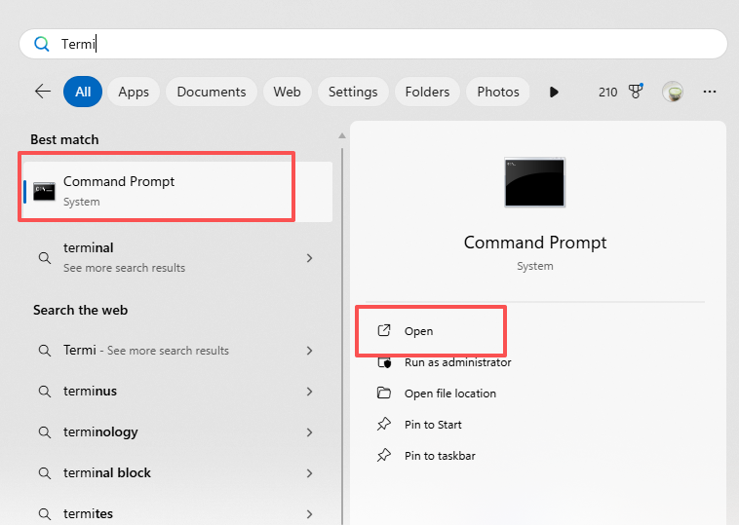

- Enter “java –version”, if the version number prompt then the jdk is well installed. Otherwise, you have to repeat the process until successfully install the jdk21.
