

ENG 150: 042 College English II COURSE SYLLABUS

Class: Instructor:
ENG 150-042
JP Essey
Term: Office: 1015N
Fall 2025
Meeting Time: Tues./Thurs. 6:20 -7:35 Office Hour: Tues. 5:15-6:15
Meeting Location: Academic Building, L09 Phone: 718.270.4949
E-mail: nessey@mec.cuny.edu

The Living Past, Present, and Future

“I believe that the more you know about the past, the better you are prepared for the future” said Theodore Roosevelt. To be aware of changes in oneself as well as one's community is to be more attuned. We will use this basic starting point to have a conversation where we explore relevant issues of our history, our present time, and scenarios that await us down the road. This conversation is saddening, fascinating, surprising, at times perplexing, and fulfilling. Yet, it is not a linear process, or, sometime, an evident process. We are complex, mutable beings constantly changing and re-creating our self or selves. This idea taken together with the idea that we live in a community, raises questions as to how much responsibility does an individual have towards one's immediate community as well as society at large. How can one improve the quality of one's life and that of society at large? "Change is the only constant in life," said Heraclitus over 2600 years ago. This is the theme of the discussion of the class as we change and grow during the semester.

Many times in history a single person saw an injustice and rebelled against the accepted norm. As Margret Mead said, "Never doubt that a small group of thoughtful, committed citizens can change the world. Indeed, it is the only thing that ever has."
The purpose of these discussions is to help students develop a better understanding of themselves as individuals and as members of a diverse community. I hope that the study of this theme would better prepare students to be more cognizant and successful in a variety of communities, including their home community, their extended community, and the more global community.

Welcome

This class is a rigorous class that will entice you and provide you with tools to expand your reading skills, deepen your writing skills, sharpen your critical thinking faculties, and more thoroughly appreciate our multi-faceted culture and world through the written word as well as visual images whether in photographs, art or advertising. Though it is challenging, it is equally rewarding.

University Course Catalog Description

This composition course continues the emphasis on the various types of critical and expository writing students will need in the content area courses they will take throughout the college curriculum. Students will improve their writing skills through the writing and revision of weekly essays and through the completion of two research papers that use MLA research style.

Requirement Fulfills:
Required Core Foundation Cluster

Course Overview

In this course we will read and write extensively. We will look at languages as a way to understand, interpret, and shape the world, as well as ourselves. Our study of language will enable critical analysis in a variety of ‘narratives’ ranging from the written form to the photographic form and to film/moving images. We will review library research skills culminating in 2 extensive research projects formatted in MLA style. It is hoped that the readings will provide us an opportunity to make connections between our self and our culture. Furthermore, students will have the chance to have focused discussions regarding our readings. Through this it is hoped that students will have the opportunity to develop an advanced sensibility toward, and the tools necessary for, their own critical analysis of future readings in any variety or aspect of texts.

Course Objectives / Student Learning Outcomes (SLOs)
§ To enable the student to become a stronger, deeper reader and writer, with a particular focus on writing well developed essays written around a central thesis.
§ To develop both practical and impractical life skills.
§ To help develop the practical and crucial life skill of interpretation, whether listening to a radio, involved in a conversation, watching a movie, or reading a text.
§ To help develop the impractical but beautiful aspects of Language – its beauty, its fun, its ability to make us feel, and its ability to allow us to postulate.
§ As we read these challenging readings, students will have the chance to not only expand their vocabulary and their ability to extract meaning from sophisticated syntax, but also to learn to infer information about audience and purpose, thus better preparing themselves to interpret the complex, often veiled messages encountered in the media, law, and business.
§ To be able to revise essays based on critiques from peers and/ or instructor to expand the scope, coherence and clarity of the work.
§ To learn to incorporate the ideas of others into one’s own writing.
§ Students will learn to complement the knowledge they glean in class with knowledge they gather on their own through library research. In addition to becoming familiar with standard library research techniques and source citation in MLA style, they will also distinguish between paraphrasing, and quoting sources.
§ Summarize, quote and paraphrase assigned readings and research materials, avoiding plagiarism.

Course Prerequisites

Successful completion of ENGL 112 with a grade of "C” or better.

Course Credits
3 credits; 3 class hours

Required Texts and Materials
Please note that this is an OER-ZCT course (Open Educational Resources- Zero Cost Textbook.)
This ENGLISH 150 section will be taught using Open Educational Resources (OER).
All needed textbooks and/or lab materials will be available to the student free of charge within the Blackboard (Bb) component, associated with this course. All students are expected to have a Bb account and use it during the semester.

- Becoming America: An Exploration of American Literature from Precolonial to Post-Revolution
By Wendy Kurant. (Kurant)
- Writing the Nation: A Concise Introduction to American Literature 1865 to Present
By Amy Berke, Robert Bleil, Jordan Cofer, and Doug Davis. (Berke et. al.)
- Writing and Literature: Composition as Inquiry, Learning, Thinking, and Communication
By Tanya Long Bennett. (Bennett)

All course materials are in compliance with the course LOs and objectives per CUNY pathway directive.

Supplementary Texts and Materials
+ Roget’s Thesaurus
+ A good dictionary, such as Longman’s American Dictionary, Merriam Webster’s

Basis for Final Grade

The class grade is determined by the score on the class assignments and class participation taking into account de-merits for excessive tardiness or absences or use of a mobile phone in class.

Assignments
Assignments must be uploaded to Brightspace by due date..

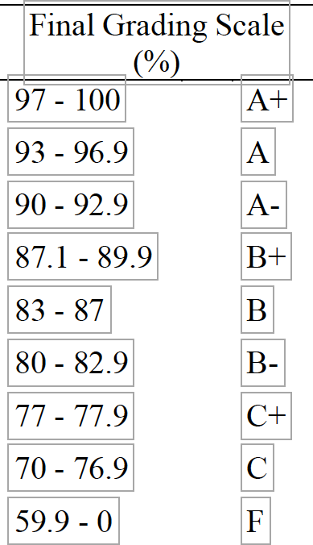

Grade Dissemination
- Response submissions are either + or -. A “+” signifies all is fine. A “–“ signifies that something is lacking.
- Summaries are number and letter graded.
- Essays are number and letter graded.

Grading Scale Numbers

1-4: 4=100%, 4- = 95%, 3.5 = 90%, 3= 85%, 3- = 80%, 2.5 = 75%, 2 = 70%, 2- =
special attention needed.

Assignment Points
Assignment Percent of Final

Essay1 (Reflection, 3-4 pages), 1 Draft 5 points
Essay 2 Practice 5 points
Research Essay 1, 4-5 pages) 2 Drafts 10 points + 10 points
Outline (Research Essay 2) 5 points
Reflective Annotated Bibliographies 10 points
Research Paper 2 (7 -10 pages) 2 Drafts 10 points + 10 points
Reading Responses 10 points
Summaries 10 points
Remediation Project 10 points
Reflection on Research Paper 5 points

Grades

Grades for each assignment will be posted on Blackboard as the semester progresses. Below is the general grading rubric used for this class:

A range (90-100): All formal writing assignments will have been revised and carefully proofread. Generally speaking, and when applicable, “A” writing has clarity and precision; a distrust of generalizations; clear, well-defined ideas; well-developed paragraphs; thoughtful incorporation of outside sources; appropriate usage of quotations; interesting and varied sentence structure; consistently correct grammar and usage. If an argument is being made it will have a distinct claim, ample evidence, clarification of terms, and most likely an awareness of counterarguments. In other forms of writing—memoir, anecdotes, interviews, poetry, etc.—there will be an attention to details and specifics, whether writing about physical objects or abstract concepts. The writer will probably demonstrate a willingness to take rhetorical risks and experiment with style. All assignments will indicate a careful attention to the complexity and variability of language, and in general indicate a desire to be unique, not imitative; unexpected, not obvious or obligatory; and complex, not two-dimensional. “A” writing pushes the implications of its statements, and always seeks to "unpack" and pursue the ideas and concepts raised therein.

B range (80-89.9): All writing assignments will have been revised and carefully proofread. Arguments might not be as complex or as artfully executed as “A” arguments. “Creative” work might occasionally lean toward the obvious or derivative. Some work might have benefited from further revision. In general, work will be close to “A” level work, but occasionally lacking in polish, complexity, or depth. The degree of skill, complexity, and revision reflected in the work will determine whether the grade is a B+, B, or B-.

C range (70-79.9): Simple or weak arguments, generalizations, a lack of precision, awkwardness in incorporating outside information, minimal revision or quick or nonexistent proofreading: these are some of the characteristics of “C” papers. In general, “C” level work, while satisfactory, will nevertheless indicate a need for more revision, more concentration and attention, and perhaps better time management. The degree of skill, complexity, and revision reflected in the work—as well as the student’s attention to deadlines—will determine whether the grade is a C+, C, or C-.

D range (60-69.9): Writing will probably suffer from grammar and usage errors, generalizations, as well as lack of concentration and precision. Signs of serious revision will be rare or nonexistent. Problematic claims in arguments; lack of originality or willingness to experiment in other forms of writing. Most students falling into the “D” range have not put nearly enough time into their work.

F (0-59.9): Writing will have any of the following characteristics: weak, unsupported ideas; unoriginal or unarguable claims; numerous generalizations; an absence of particulars and specifics; carelessness; consistently incorrect grammar and usage; very little if any serious revision. Many assignments will be short and undeveloped. Writing will often be shorter than the minimum number of pages.

NC. This grade is reserved for students who complete ENGL 150 with a grade below “C” provided they have made significant documented progress, even if they do not meet minimum passing standards to earn a “C” grade. The “NC” grade can only be given once in ENGL 150, after which the permission of the Chairperson of the Department of English will be required. Students who receive the “NC” grade are expected to repeat the course in the following semester. The “NC” grade will not be calculated in the GPA.

Late Work Policy
A student may have 1 late assignment without penalty. A second assignment that is late will be penalized 1/3 grade. No other late assignments are accepted.

Extra Credit Policy: No extra credit is available as the course load is heavily weighted. Grades of "Incomplete": University policy does not allow INC grades for this class.
Revision Policy: Essays are usually revised 3 times. Summaries, if done on time, may be revised as many times as needed.
Essay Commentary Policy: Feedback is given on essays regarding content, organization, language use, punctuation, formatting, and MLA adherence. Feedback is in written comment and numerical form.

Group Work Policy: Students will work in a group setting most every class period with each group changed every class to give students as large of a variety of group make-up as possible.

Technology and Media
Media: We will view documentaries; access the internet, view paintings and students may have the

chance to give a PowerPoint presentation regarding their first research essay.
Email: It is required that your Medgar Evers student e-mail is active and current to receive announcements and be able to use BlackBoard. All class assignments, announcements and information regarding your class are posted on Blackboard. Please check daily for changes, announcements and updates. This is a requirement. You may get assistance regarding e-mail or Blackboard in either room B2033 or B2018 depending on your need. You may change your Medgar Evers e-mail to a personal one on BlackBoard so that you may receive class announcements at that personal e-mail instead. Please see Steve in B2033 for help.
Any and all e-mail related problems must be handled through either of the 2 offices mentioned. A class list of e-mails will be made available to classmates for those who wish to participate. This is voluntary and separate from the Blackboard list.

PHONES: Please respect the professional environment you are in and turn off your phone. Phones are disruptive to the entire class and hinder the learning environment.

Classroom Devices: We will view videos and access on-line material as appropriate for the assignment.
Course Policies:

- All essays must be typed, doubled-spaced, use 12-point/Times New Roman font and follow MLA conventions for formatting and documentation.
- All students are advised to retain two contacts from the class in case of emergencies or absences. A class list will be made available for those that want to participate.
- All assignments are expected on due date even when you may be absent.
- All students are expected to participate in routine class discussions.

Disability Access: Federal law prohibits discrimination on the basis of a
disability. Under the guidelines of the Americans with Disabilities Act, the College will provide reasonable accommodations to persons with documented disabilities. Therefore, if you are in need of or have any questions regarding accommodations or services, please contact Mr. Anthony Phifer, Director, Office of Services for the Differently-Abled (Bedford Building Room 1024) at 718-270-5027 or aphifer@mec.cuny.edu. Any information provided to the office will be confidential and will not be released without your permission. It is the responsibility of the student to self-identify as a DA student.

Attendance & Professionalism Policy: Students are expected to be in their seats prepared for the lecture at the start of class. Arriving late is unprofessional, discourteous, and disruptive

Academic Conduct Policy: Academic dishonesty of any type, including cheating and plagiarism, is unacceptable at Medgar Evers College. Cheating is any misrepresentation in academic work. Plagiarism is the representation of another person's work, words, or ideas as your own. Students should consult the Medgar Evers College Academic Dishonesty Policy and
Procedure Handbook for specific regulations and procedures related to academic integrity.
Academic dishonesty is punishable by failure of the test, examination, term paper, or other
assignment on which cheating occurred. In addition, disciplinary proceedings in cases of
academic dishonesty may result in penalties of admonition, warning, censure, disciplinary
probation, restitution, suspension, expulsion, complaint to civil authorities, or ejection.

Easy access to MEC Student Handbook policy on Academic Integrity. 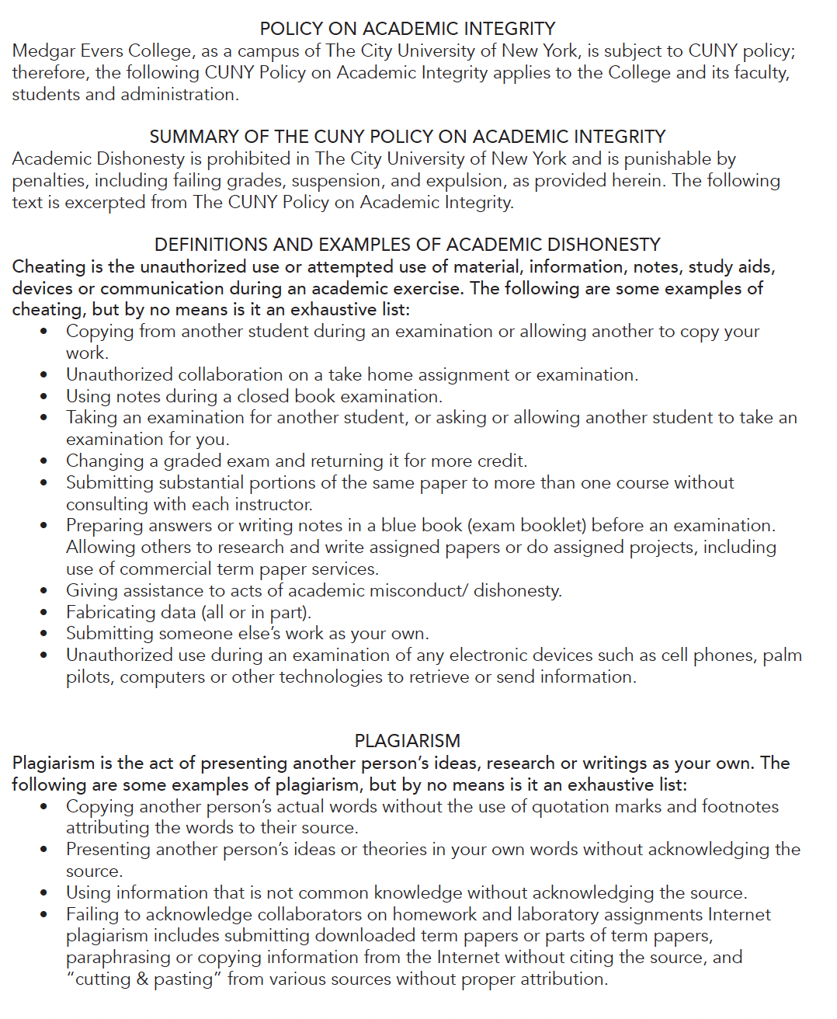

Grade Appeal Procedure and General Course Concerns
If you find there is a discrepancy upon receiving your final grade at the end of the semester, you have a right to dispute your grade. In order to do so, you must observe the Grading Dispute protocol by following the steps in this order:
1. You must speak with the professor who gave you the final grade.
2. If after speaking to the professor, you are still not satisfied with your final grade, you can contact the Composition Coordinator, Dr. Cristina Migliaccio at CMigliaccio@mec.cuny.edu, to discuss the matter further.
3. If you are still unsatisfied with the results after meeting with the Coordinator, you can schedule a meeting with the Department Chair, Dr. Susan Fischer at safischer@mec.cuny.edu.

*Students who do not follow this protocol will not have their grade appeal reviewed until they can demonstrate they have followed these three protocol steps in the appropriate order.

Support Services And Resources
If you feel you need additional help with your writing (at any stage of the process),
you can sign up for individual or group tutoring at the MEC Writing Center, located in B- 1045A.
You may also be asked to visit the Writing Center based on the discretion of the Instructor if necessary; it will be very helpful for students who need extra support and practice in preparation for various writing assignments. Students will receive points towards their final grades for consistent appointments in the Writing Center. For more information, email the director, Aisha Williams (aiwilliams@mec.cuny.edu) or call 718- 804-8287.

Writing Center B1045A 718-804-8287
The Center is available for student assistance on an individual basis. They offer excellent assistance and students are strongly urged to use this valuable resource.

Academic Computing Labs: B2014 718-270-5134 Academic Support/Resources/Services B1045 BlackBoard Support B2033 718-270-4866

Children On Campus
The college has an obligation to its students, faculty, staff and visitors to conduct its operations and maintain its facilities in a manner consistent with its mission as an institution of higher education. For this reason, young children who are not registered in the child care center should not be brought to the campus, and, of course, may not attend classes with their parent or guardian. There may be occasions when brief visits by children of students may be necessary. Children may visit college offices and facilities, other than classrooms, for limited periods of time when their parent or guardian is conducting routine business at the college. Regular repeated visits by children are not permitted. In no case are children permitted in labs, shops, construction/repair sites, or other areas where potential hazards exist. Children brought on campus must be directly supervised at all times by their parent or guardian.

http://www.mec.cuny.edu/Human-Resources/Children-on-Campus.aspx

Video Touchscreen Century of the Self Killing Me Softly Faking I

Schedule

Please note that the dates are approximate depending upon class work.
 | WEEK | READING | WRITING | Assignment Due/ Notes
 | 1 | Ice Breakers  Setting Goals | The Writing Process Prewriting
 | 2 | Truth, Du Bois | Thesis Exercises, Summarizing, Convincing Argument, Research Skills | Essay 1 (E1D1) due Summaries 1- 3 due  Reactions 1+2 (R1+2) due
 | 3 | Logic. Annotating, Reading Literature  Walker | Principles of Composition, Introductions | Essay 1 (E1D2) due Summaries 4-6 due  Reactions 3 & 4 due (R3&4)
 | 4 | Douglas |  | Summaries 7-9 R5-7 due
 | 5 | Theme  Perkins | An Approach of Style | R3,4,5,6 due
 | 6 | start Shelly | Writing Workshop | Essay 2 (E2D1) due
 | 7 | Morrison
 | 8 | Morrison | Peer Review Intro to Grammar | E2D2 due
 | 9 | Morrison | Workshop Subject/Verb
 | 10 | Workshop
 | 11 | Morrison | Workshop Verb Tenses  Frag./ROs/CSs | Annotated Bib. due
 | 12 | Workshop |  | E3D1 due
 | 13 | Workshop | Punctuation Relative Clauses
 | 14 |  | Workshop Comprehensive Review
 | 15 | Presentations | Wrap-up | E3D2 due
 | 16 | Presentations | Wrap-up | * E3D2 due  * Research Essay & Project Reflections

